Sparse Biomarker Discovery from Low-Montage Resting-State EEG for tDCS Treatment Response in Adults with Major Depressive Disorder
Abin Daniel Zorto^{a,∗}, Jijomon C. Moncy^{b}, Wenyi Xiao, Mhd Saeed Sharifª and Cynthia H.Y. Fu^{b}
aIntelligent Technologies Research Group, University of East London, University Way, London, E16 2RD, UK bSchool of Psychology, University of East London, University Way, London, E16 2RD, UK

A R T I C L E I N F O

Keywords:
resting-state EEG
transcranial direct current stimulation major depressive disorder
biomarker discovery low montage EEG
A B S T R A C T

This study evaluated a sparse low-montage resting-state EEG framework for identifying clinically interpretable biomarkers associated with remission outcomes in a home-based transcranial direct current stimulation (tDCS) randomised sham-controlled trial in adults with major depressive disorder.
Using 4-channel eyes-closed EEG, we conducted a controlled sweep of 150 successful runsacross two model families, an advanced hybrid 1D CNN-LSTM and a linear support vector machine (SVM), varying window size (2–10 s) and per-fold feature budget (inner-k 1–70) with leave-one-participant-out group equalization and SMOTE during training.
The strongest configuration (hybrid model, 6 s windows, inner-k=1)achieved patient-level ROC-AUC 0.816, PR-AUC 0.579, balanced accuracy 0.786, accuracy 0.810, and MCC 0.571 over 21 held-out participants. The best SVM configuration (8 s, inner-k=30) reached ROC-AUC 0.510 and MCC 0.277. Notably, this performance was obtained with sparsity, selecting 1 feature per fold and yielding only 7 unique recurrent features overall, with a permutation-tested ROC-AUC advantage over chance (𝑝 = 0.008). Hard-set overlap across folds was modest (mean pairwise Jaccard 0.190; Kuncheva index 0.187), while recurrent features showed perfect mean effect-direction consistency.
These findings show that clinically relevant patient-level discrimination can emerge from highly sparse representations of low-montage EEG. The strongest run concentrated its signal in a small recurrent biomarker set centered on temporal spectral entropy and frontal-temporal difference measures. The findings suggest a compact, interpretable biomarker that converges with previous power spectral density-based findings, supporting low-montage resting-state EEG as a basis for pretreatment stratification.

Introduction
Major depressive disorder (MDD) remains a leading cause of global disability and is characterized by marked heterogeneity in clinical presentation, neurobiology, and treatment response. Despite the availability of pharmacological and psychotherapeutic interventions, a substantial proportion of patients fail to achieve remission, motivating increasing interest in neuromodulation approaches such as transcranial direct current stimulation (tDCS) (Woodham et al., 2021). While randomized controlled trials and recent large-scale studies support the feasibility and clinical potential of tDCS, including fully remote, home-based delivery, treatment outcomes remain variable at the individual level (Woodham et al., 2025, Hampsey et al., 2026).
Practical design and implementation guidance has also helped standardize how tDCS studies are conducted [6], while broader translational neuromodulation work has framed such interventions within a wider neuroplasticity-based clinical agenda [7]. More recently, home-based delivery has moved from concept to clinical trial: a fully remote phase 2 randomized sham-controlled study demonstrated home-based tDCS in major depressive disorder [8], and qualitative follow-up work found the approach acceptable to participants [9]. These advances make pretreatment stratification a practical clinical problem.

∗Corresponding author.
 u2091940@uel.ac.uk (A.D. Zorto); J.Chettuthara-moncy@uel.ac.uk (J.C. Moncy); S.Sharif@uel.ac.uk (M.S. Sharif); c.fu@uel.ac.uk (C.H.Y. Fu)
ORCID(s):
A central challenge is pretreatment stratification: identifying which patients are more likely to achieve remission before treatment begins. Electroencephalography (EEG) is a potential modality for this purpose due to its portability, low cost, and high temporal resolution.
Wearable EEG hardware has made ambulatory recording increasingly feasible , broader clinical overviews continue to support diagnostic, prognostic, and therapeutic uses of EEG-based markers [11], and recent technical guidance has emphasized both the promise and the implementation challenges of EEG biomarkers in major depressive disorder [12]. Reduced-channel systems improve portability and ease of deployment [13], whereas denser acquisitions provide richer spatial detail at the cost of greater setup burden [14].
Standard recording practice therefore remains important even in low-montage settings [15].
The literature on EEG biomarkers in major depressive disorder is encouraging though methodologically uneven. Reviews and biomarker overviews have repeatedly highlighted spectral, asymmetry, vigilance, entropy, and complexity signatures as potentially informative marker families [16–18]. Related discussions of neuroimaging and EEG biomarkers have emphasized the clinical opportunity, but also the need for more robust treatment-response models and better translational discipline [19–21]. More recent meta-analytic work on EEG-based treatment prediction reaches a similar conclusion: useful signal is present, but translation depends on stronger methodology and standardization [12, 22, 23]. Machine learning studies have extended this literature into antidepressant, placebo, and neuromodulation response prediction, while also exposing recurrent concerns about external generalization,

feature stability, leakage-safe selection, and interpretability [24–26]. Related nonlinear and entropy-oriented studies point to the same caution about dimensionality and signal instability [27–29]. Entropy-focused EEG work has reinforced the relevance of complexity measures [30–32]. Leakage-specific and data-centric critiques make the underlying design problem explicit [33, 34].
That tension is especially sharp in relatively small neuromodulation studies. Rich models can improve representation learning, but relatively small cohorts also increase the risk of unstable feature selection, inflated performance estimates, and overly confident biomarker claims. Nested evaluation and within-fold processing are therefore central design issues rather than implementation details in this literature [21, 33]. Clinically deployable EEG biomarkers also need interpretability and low-density feasibility, and recent data-centric frameworks have started to move in that direction [34]. Emerging response-prediction studies in depression and related neuromodulation settings show substantial promise [35–37]. Related reviews and pilot studies also make the methodological fragility clear [38–40]. More recent response-oriented studies continue that pattern [41–43]. A recent systematic review of EEG connectivity changes in depression treatment reaches a similar conclusion [44].
Within the same home-based 4-channel MDD program analysed here, power spectral density (PSD)-based and PLV-based analyses have observed that the baseline EEG carries treatment-response information across multiple signal representations [45, 46]. PSD-based deep learning approaches identified temporoparietal spectral features (notably TP10 theta–alpha power) as informative for treatment outcome prediction [45], while connectivity-based analyses highlighted frontal–temporal and temporoparietal network patterns [46]. Together, these findings suggest that response-related signal is present and reproducible across feature families, but remains poorly characterized in terms of interpretability, stability, and minimal feature representation.
The present study builds directly on this context and uses the same baseline EEG cohort as our prior PSD- and connectivity-based analyses [45, 46], but addresses a distinct question. Rather than optimising predictive performance within a predefined feature family, we test whether a strictly leakage-controlled, foldwise sparse feature-selection pipeline can identify a small, recurrent, and interpretable biomarker set under participant-level validation. We compared two classifiers over the same feature-selection sweep to test whether low-montage resting-state EEG could recover a small recurring set of biomarkers associated with tDCS response in adults with MDD. The analysis prioritized parsimony, biomarker interpretability, and leakage-resistant participant-level validation. Our working hypothesis was that useful patient-level discrimination could be achieved with a small per-fold feature budget and that the most recurrent features would show stronger effect-direction consistency than hard-set overlap. This approach reframes biomarker discovery from a high-dimensional modelling problem toward a minimal, interpretable signal identification problem.

Methods

Dataset and preprocessing
The analysis used pretreatment EEG from 21 adults with major depressive disorder enrolled in a fully remote, multisite, double-blind, randomized sham-controlled home-based tDCS trial [8]. The analyzed cohort contained
7 remission cases and 14 non-remission cases in the patient-level outcome labels, with 18 female participants and a mean age of 37.1 ± 9.7 years. Table 1 summarizes the cohort, acquisition, and sweep configuration.
Baseline recordings were collected during eyes-closed rest with a 4-channel montage (AF7, AF8, TP9, TP10) sampled at 256 Hz. Figure 1 shows the recording sites together with the corresponding headset placement. The available study exports comprised 10 s segments with 2,560 samples per channel, and the underlying recording sessions were stored either as a single 10 min file or as two 5 min files depending on participant. Across the cohort, the export set contained 1,203 windows, including 393 remission-labeled and 810 non-remission-labeled windows. This acquisition setup uses a limited frontal-temporal montage with clear portable-deployment relevance [10, 14]. The montage also constrained the downstream feature space toward frontal, temporal, cross-hemispheric, and frontal-temporal interaction measures.
For the present sweep, the processing configuration applied participant-level per-channel demeaning before upsampling, followed by a fourth-order Butterworth low-pass filter at 60 Hz, a downsampling step back to 256 Hz, and zero-overlap window slicing. The sweep then compared non-overlapping analysis windows of 2, 4, 6, 8, and 10 s, so the model inputs included both the native 10 s exports and shorter subdivisions derived from the same recordings. These choices materially affect downstream EEG feature distributions, especially in low-density or portable pipelines [11, 13, 48]. They also intersect with standardization and signal-quality concerns in wearable EEG settings [12, 15].

Feature extraction
Feature extraction was performed on each preprocessed window. With all four channels available, the extractor generated 247 EEG-derived measures per window spanning channel-local descriptors, regional asymmetry terms, frontal-temporal interaction terms, synchrony summaries, and a small set of TP10-specific derived measures. Each channel contributed 39 local measures, comprising 21 spectral descriptors, 12 time-domain and Hjorth descriptors, and 6 entropy or nonlinear complexity descriptors, for 156 channel-local measures overall. The remaining 91 measures summarized asymmetry, frontal-temporal balance, cross-channel synchrony, and TP10-focused derived descriptors. This broad feature basis allowed multiple interpretable feature families to be tested within a leakage-safe sparse-selection framework rather than pre-committing the analysis to a single biomarker hypothesis [34, 49]. Table 2 summarizes the extracted feature families and their computational rationale.
For each of AF7, AF8, TP9, and TP10, we computed 39 channel-local features. Spectral features were estimated from Welch power spectral densities [50] and included absolute band power in the delta, theta, alpha, beta, and gamma ranges, total power, relative band power normalized by total power, frequency-weighted power, spectral edge frequencies at 90% and 95%, and PSD summary statistics (mean, standard deviation, maximum, minimum, median, skewness, kurtosis). These measures were included because

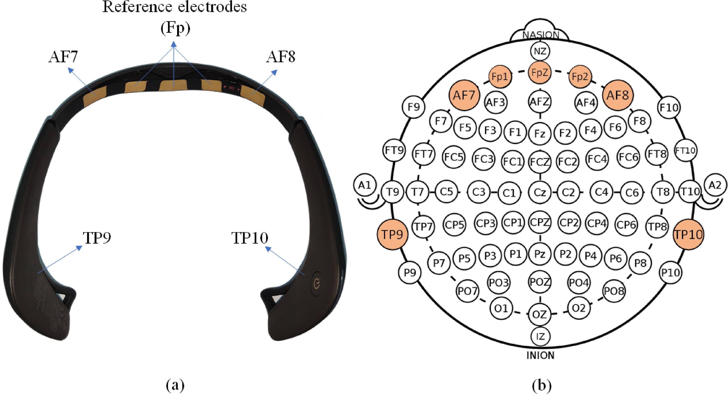
Figure 1: Four-channel low-montage EEG setup corresponding to the recording configuration used in the study, showing the AF7, AF8, TP9, and TP10 recording sites together with the corresponding headset placement [47].

spectral content remains one of the most widely used and interpretable feature families in depression EEG work [16, 48, 51]. Temporal-channel spectral content has also appeared repeatedly in pretreatment response studies [52].
Time-domain descriptors were also computed for each channel. These included mean, standard deviation, variance, skewness, kurtosis, root-mean-square amplitude, peak-to-peak range, zero crossings, and mean absolute deviation, together with Hjorth activity, mobility, and complexity [49, 53]. These features summarize amplitude dispersion, local oscillatory rate, signal roughness, and short-window morphology. They are computationally light and well suited to low-montage resting-state EEG, where clinically useful features must remain interpretable and robust under short windows.
Entropy and nonlinear complexity measures were computed per channel to capture irregularity beyond simple power summaries. The extractor included sample entropy, spectral entropy, correlation dimension, Hurst exponent, Lyapunov exponent, and detrended fluctuation analysis. Complexity measures were calculated on a demeaned, standardized version of each signal, with long windows subsampled for numerical stability. These descriptors were retained because depression EEG studies have repeatedly implicated entropy, variability, and broader complexity structure [30, 54, 55]. That pattern also appears in pretreatment response and large-scale resting-state evaluations, even when the exact direction of effect depends on cohort, montage, and temporal scale [32, 52, 56].
The four-channel montage also supports a range of regional interaction features derived from cached band-power estimates. Traditional frontal asymmetry
(AF7/AF8) and temporal asymmetry (TP9/TP10) were computed for each frequency band in two forms: a log-ratio index,
AI =$\left(\frac{P_{R}}{P_{L}}\right),$
and a normalized difference,
ND = $\frac{P_{R}- P_{L}}{P_{R}+ P_{L}}$
Using the same band-power cache, we also computed hemispheric asymmetry by averaging AF7+TP9 and AF8+TP10 within each hemisphere, ipsilateral frontal-temporal ratios and normalized differences on the left and right hemispheres, and diagonal frontal-temporal interactions for AF7-TP10 and AF8-TP9. These measures were included because reduced-channel depression EEG studies repeatedly point to laterality, temporal involvement, and frontal-temporal balance rather than to a single isolated electrode [31, 48, 57].
Pairwise synchrony features were added for six anatomically meaningful channel pairs: AF7-AF8, TP9-TP10, AF7-TP9, AF8-TP10, AF7-TP10, and AF8-TP9. For each pair we computed maximum normalized cross-correlation and Pearson correlation, and the extractor also retained a legacy set of raw cross-correlation summaries across all channel pairs. These features were intended to capture short-window synchrony and coupling patterns that have been emphasized in resting-state depression EEG and neuromodulation response work [31, 32, 44].
Finally, the extractor included three exploratory TP10-specific derived descriptors: peak prominence,

Table 1
Cohort, acquisition, and sweep configuration summary. Trial descriptors derive from the parent home-based tDCS study [8]; acquisition totals and sweep settings derive from the analyzed EEG exports and current experiment configuration.

Characteristic Value

Parent trial and cohort descriptors
Parent trial Fully remote, multisite, sham-controlled home-based tDCS trial for MDD [8]
Participants 21
Outcome groups 7 remission, 14 non-remission
Sex (female/male) 18/3
Age (years, mean ± SD) 37.1 ± 9.7
EEG acquisition and export descriptors
Rest condition Eyes-closed resting state
EEG montage 4 channels (AF7, AF8, TP9, TP10)
Channel coverage Frontal (AF7, AF8), temporal (TP9, TP10)
Sampling rate 256 Hz
Recording structure 10 min total; single file or two 5 min files
Available export segment length 10 s (2,560 samples/channel)
Total exported windows 1,203
Remission windows 393 (32.7%)
Non-remission windows 810 (67.3%)
Class ratio 2.06:1 (non-remission:remission)
Current sweep methodology settings
Sweep window sizes 2, 4, 6, 8, 10 s
Inner-k sweep 1, 5, 10, 15, 20, 25, 30, 35, 40, 45, 50, 55, 60, 65, 70
Feature selector SelectKBest (𝑓 -classif)
Training adjustments LOPO-group equalization + SMOTE
Validation Leave-one-participant-out
Evaluation level Patient-level aggregation

Table 2
Summary of extracted EEG feature families per analysis window.

Feature family Measures Count Why included

Channel-local spectral Absolute and relative delta, theta, alpha,
beta, and gamma power; total power; frequency-weighted power; SEF90 and SEF95; PSD mean, standard deviation, maximum, minimum, median, skewness, and kurtosis
21/channel (84
total)
Canonical resting-state EEG descriptors with clear band-level interpretation and strong precedent in depression EEG

Channel-local time domain and Hjorth

Channel-local entropy and nonlinear complexity
Mean, standard deviation, variance, skewness, kurtosis, root-mean-square amplitude,
peak-to-peak range, zero crossings, mean absolute deviation, Hjorth activity, mobility, and complexity
Sample entropy, spectral entropy, correlation dimension, Hurst exponent, Lyapunov exponent, and detrended fluctuation analysis
12/channel (48
total)

6/channel (24
total)
Captures amplitude dispersion, oscillatory rate, roughness, and short-window morphology with low computational cost
Captures irregularity and complexity beyond band-power summaries

Band-power asymmetry and frontal-temporal interactions
Frontal and temporal asymmetry, hemispheric asymmetry, ipsilateral frontal-temporal ratios and normalized differences, and diagonal
AF7-TP10 and AF8-TP9 interactions across frequency bands
70 total Tests laterality and
frontal-temporal balance within the four-channel montage

Synchrony and coupling Pearson correlation and maximum normalized
cross-correlation over six anatomical channel pairs, plus legacy cross-correlation summaries
18 total Summarizes short window
coupling and cross-channel coordination

TP10-specific derived descriptors
Peak prominence, peak concentration ratio, and an asymmetry-weighted peak-prominence term
3 total Targets concentrated temporal spectral structure with straightforward interpretation

Total EEG-derived features Combined feature space per window 247 total Broad hypothesis space for
leakage-safe sparse selection

peak concentration ratio, and an asymmetry-weighted peak-prominence term. These summarize whether the TP10 spectrum contains a sharp dominant peak, how concentrated that peak is relative to total power, and whether that concentration covaries with ipsilateral frontal-temporal beta balance. They were included because temporal-channel spectral content has recurrently appeared in low-montage depression EEG analyses, while still remaining interpretable enough to survive foldwise sparse selection if informative [48, 51].

Sweep design and validation
The experiment sweep compared two model families over the same feature-selection protocol: an advanced hybrid 1D CNN-LSTM and a linear SVM. All runs used sequential window ordering, SelectKBest with ANOVA 𝐹 statistics, leave-one-participant-out evaluation, leave-one-participant-out training-group equalization, and SMOTE within training folds [58]. The sweep varied the per-fold feature-selection budget (inner-k) across 15 values from 1 to 70 and repeated the search across 5 window sizes, yielding 150 successful runs in total (75 per model).
This design matters for interpretation. Leave-one-participant-out evaluation remained subject independent throughout, so no participant contributed both training and test windows to the same fold. Feature selection, participant-group equalization, and synthetic oversampling were all restricted to the corresponding training participants, which is important because leakage at these steps can materially inflate reported biomarker performance [33]. The inner-k parameter controlled how many features were selected inside each training fold. The feature-selection stability panels in the study describe shared pipeline behavior because both classifiers consumed the same selected features for matched sweep settings.

Models
Both classifiers operated on the fold-selected handcrafted feature vectors produced by the current inner-k setting. Patient-level outputs were derived by averaging held-out window probabilities within each participant before computing ROC-AUC and the other clinical metrics. Table 3 summarizes the model architecture and training setup used in the sweep.
The SVM baseline used a linear kernel with C=1.0 and probability output enabled. When SMOTE was active inside the training folds, class weighting was not applied in parallel, so synthetic oversampling and explicit class weighting were not used simultaneously.
The hybrid model treated the selected feature vector as a learned one-dimensional representation before recurrent modeling. In the best-performing 6 s, inner-k=1 run, the input features were first projected to a 128-dimensional embedding with normalization and dropout, then mapped into a 64-position latent representation for three convolutional blocks. These blocks used channel progressions of [64,64], [128,128], and [256,128] with
kernel sizes [5,3], [3,3], and [3,1], together with batch normalization, max pooling, and dropout after each stage.
Sequence modeling then used two bidirectional LSTM layers with 128 and 64 hidden units, followed by eight-head self-attention with residual layer normalization and dropout. The recurrent summary was globally pooled and concatenated with pooled multi-scale CNN outputs through feature-pyramid fusion before two dense blocks of 256 and 128 units and a final two-logit output layer. Training used AdamW, cosine warm restarts, label smoothing, gradient clipping, mixed precision, and early stopping with best-state restore.
The architectural choices were intended to distribute the modeling burden across complementary stages. The projection layer compressed the sparse selected features into a stable latent representation before deeper processing. The convolutional front end summarized short-range interactions and produced progressively richer multi-scale feature maps. The bidirectional LSTM layers then provided recurrent processing after the convolutional front end, while self-attention allowed the model to reweight informative positions after recurrent encoding. Feature-pyramid fusion retained both shallower and deeper convolutional summaries, which is useful when the most discriminative structure may not reside at a single representational depth. The dense head provided a final nonlinear compression stage before binary classification. Batch normalization, dropout, label smoothing, gradient clipping, and early stopping were included to stabilize optimization and limit overfitting in a relatively small cohort.

Outcome metrics and biomarker summaries
The primary endpoint was patient-level ROC-AUC, computed from participant probabilities aggregated over held-out windows. Secondary patient-level metrics included PR-AUC, balanced accuracy, accuracy, F1, MCC, precision, recall, and specificity. The pipeline also reported bootstrap confidence intervals and a permutation test for the patient-level ROC-AUC summary. All main study claims use patient-level metrics. Window-level scores appear only as intermediate outputs.
To characterize biomarker behavior across leave-one-participant-out folds, we used several post hoc summaries: mean pairwise Jaccard overlap, Kuncheva index, unique feature count, top-feature share, class-conditional selection deltas, and effect-direction consistency. These summaries are descriptive. They characterize recurrence and directionality across folds and do not support causal interpretation. Low overlap can coexist with recurring features that retain consistent class-separation direction when selected [12, 16, 17].

Results

Sweep-level comparison
Across the 150 successful runs, the hybrid model outperformed the SVM baseline on the main patient-level

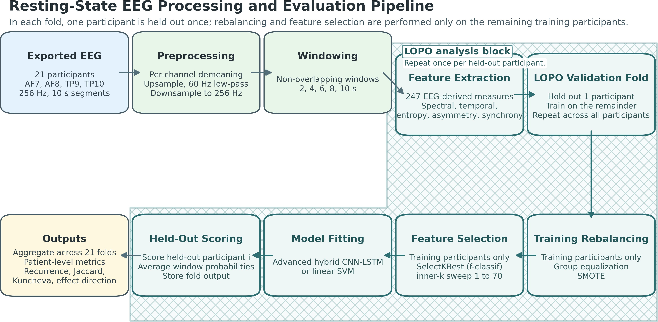

Figure 2: End-to-end analysis flow used in the study. In each leave-one-participant-out fold, one participant was held out once, and participant-group equalization, SMOTE, and feature selection were all applied only within the remaining training participants before held-out scoring and biomarker summarization.

Table 3
Model architecture and training summary for the two evaluated classifier families.

Component Configuration

Input to both models Fold-selected handcrafted feature vector from the current inner-k setting. Patient-level predictions were computed by averaging held-out window probabilities within each participant.
SVM baseline Linear-kernel SVM with C=1.0 and probability estimates enabled. When SMOTE was active in the training folds, class weighting was disabled to avoid double balancing.
Hybrid input embedding Linear projection from the selected feature vector to 128 latent units, followed by normalization, a nonlinear activation, dropout 0.1, and remapping to a learned one-dimensional sequence of length 64.
CNN trunk Three 1D convolutional blocks with filter progressions [64,64], [128,128], and [256,128]; kernel sizes
[5,3], [3,3], and [3,1]; max-pooling factors 2, 2, and 1; batch normalization; and dropout [0.1,
0.2, 0.3].
Recurrent stage Two bidirectional LSTM layers with 128 and 64 hidden units followed the CNN trunk.
Attention and fusion Eight-head self-attention with dropout 0.1 and residual layer normalization, followed by global mean pooling. Multi-scale pooled CNN features were concatenated through feature-pyramid fusion.
Dense head Two dense blocks of 256 and 128 units with batch normalization, nonlinear activations, and dropout 0.3 and 0.4, followed by a two-logit output layer.
Optimization AdamW with learning rate 0.001 and weight decay 0.01; cosine warm restarts to a minimum learning rate of 10−6; batch size 8192 before fold-size adjustment; label smoothing 0.05; gradient clipping at 1.0; mixed precision; maximum 100 epochs; early stopping patience 5 with best-state restore.

discrimination metrics over most of the sweep landscape. The performance advantage was visible when averaging over window sizes (Figure 3) and when averaging over inner-k settings (Figure 4). The best individual hybrid run occurred at 6 s windows with inner-k=1, whereas the best SVM run occurred at 8 s windows with inner-k=30.
Figure 4 shows that the relationship between ROC-AUC and inner-k differed across the two model families in the low-budget region. The hybrid model retained clearly
stronger ROC-AUC across the sparsest budgets and achieved the highest individual ROC-AUC in the entire sweep at inner-k=1. The linear SVM did not show the same pattern and reached its best ROC-AUC only at the broader inner-k=30 setting. Sparse per-fold selection therefore aligned with peak discrimination only for the more expressive model.
Figures 5 and 6 show a second related pattern. Increasing inner-k increased both hard-set overlap and

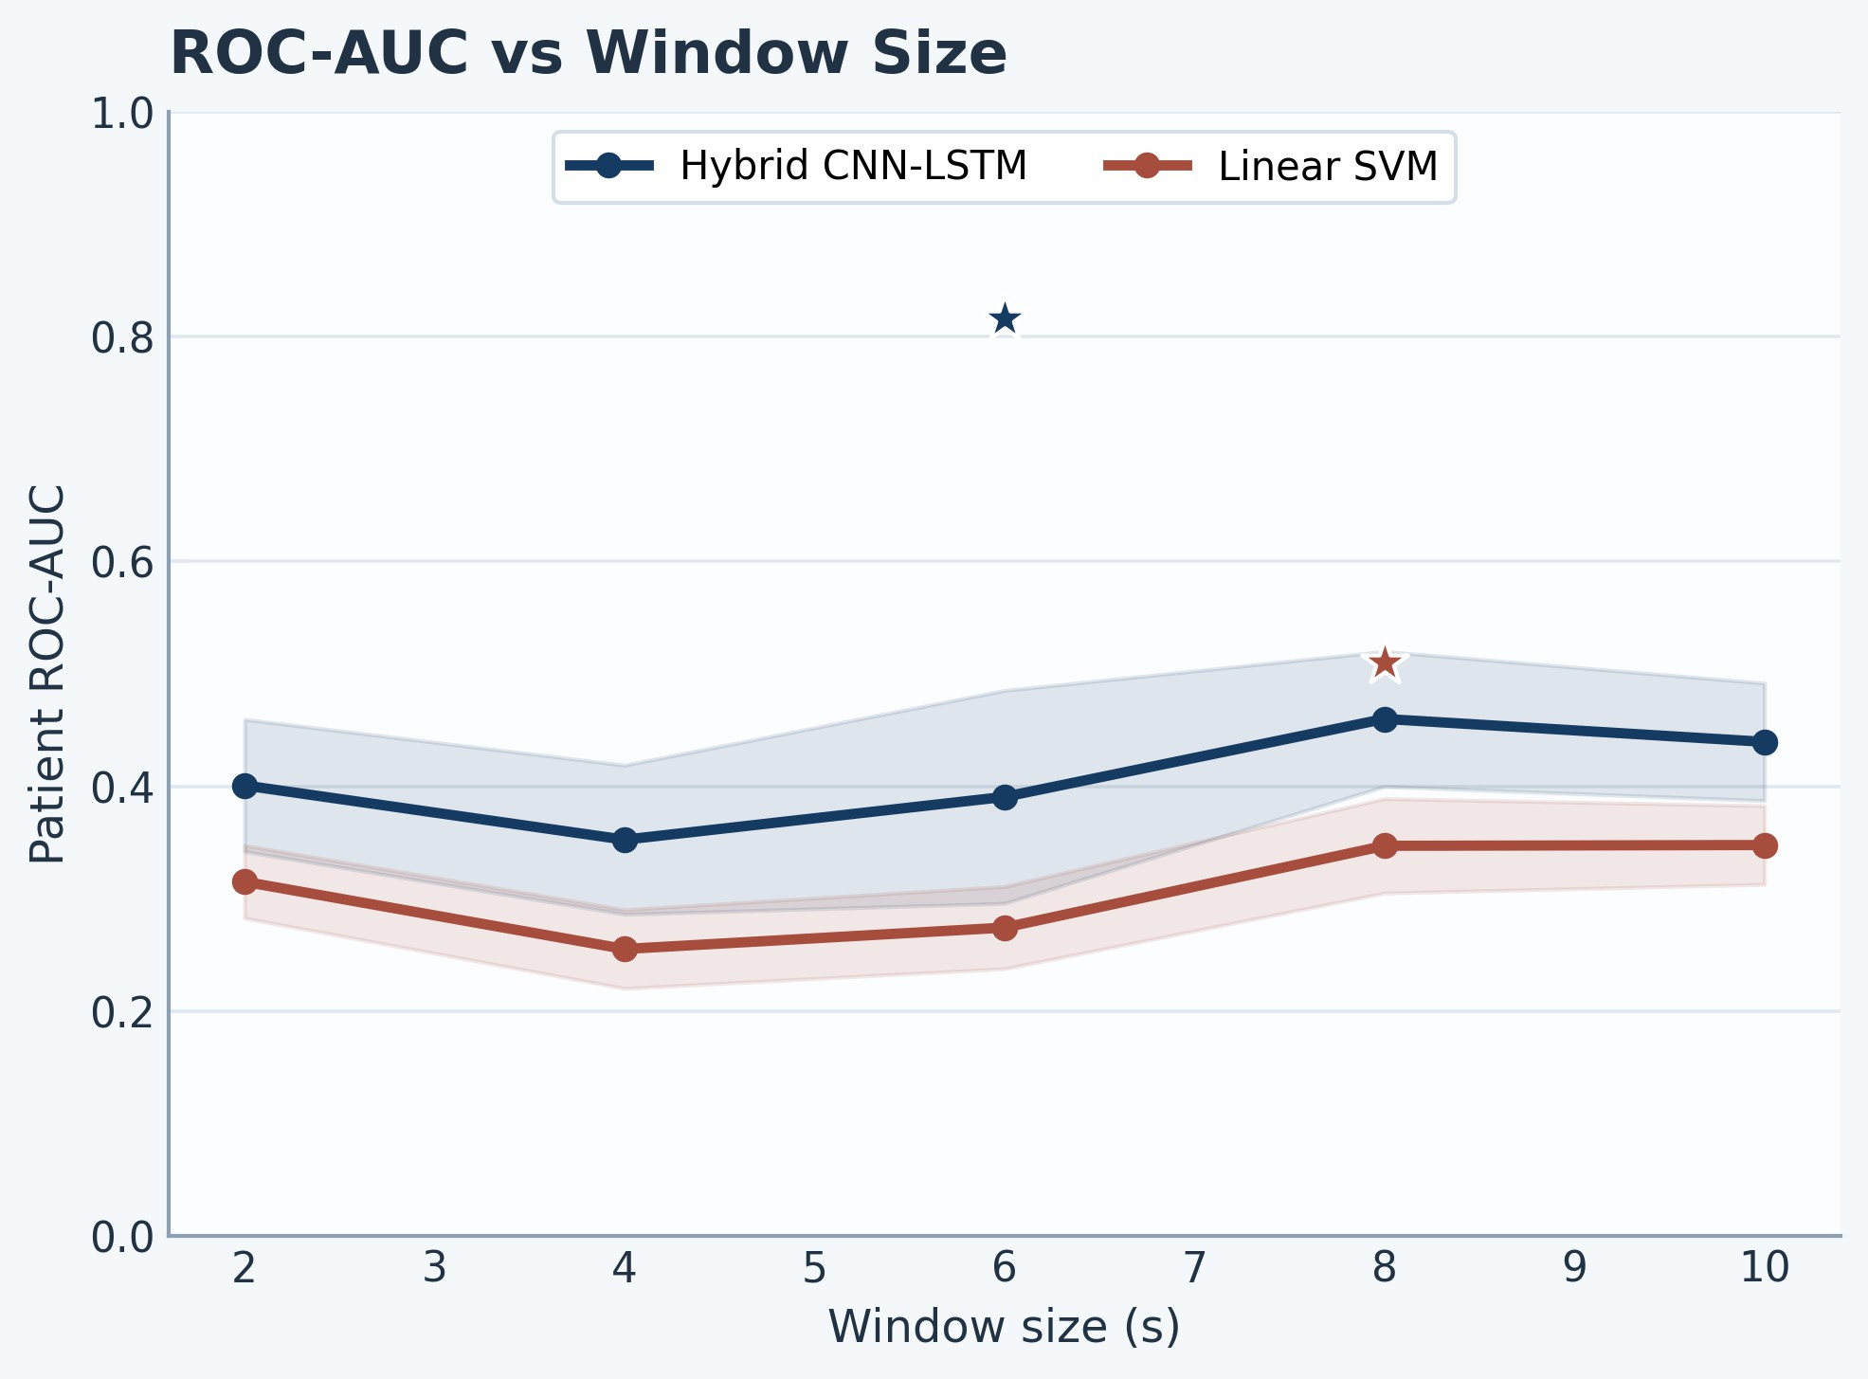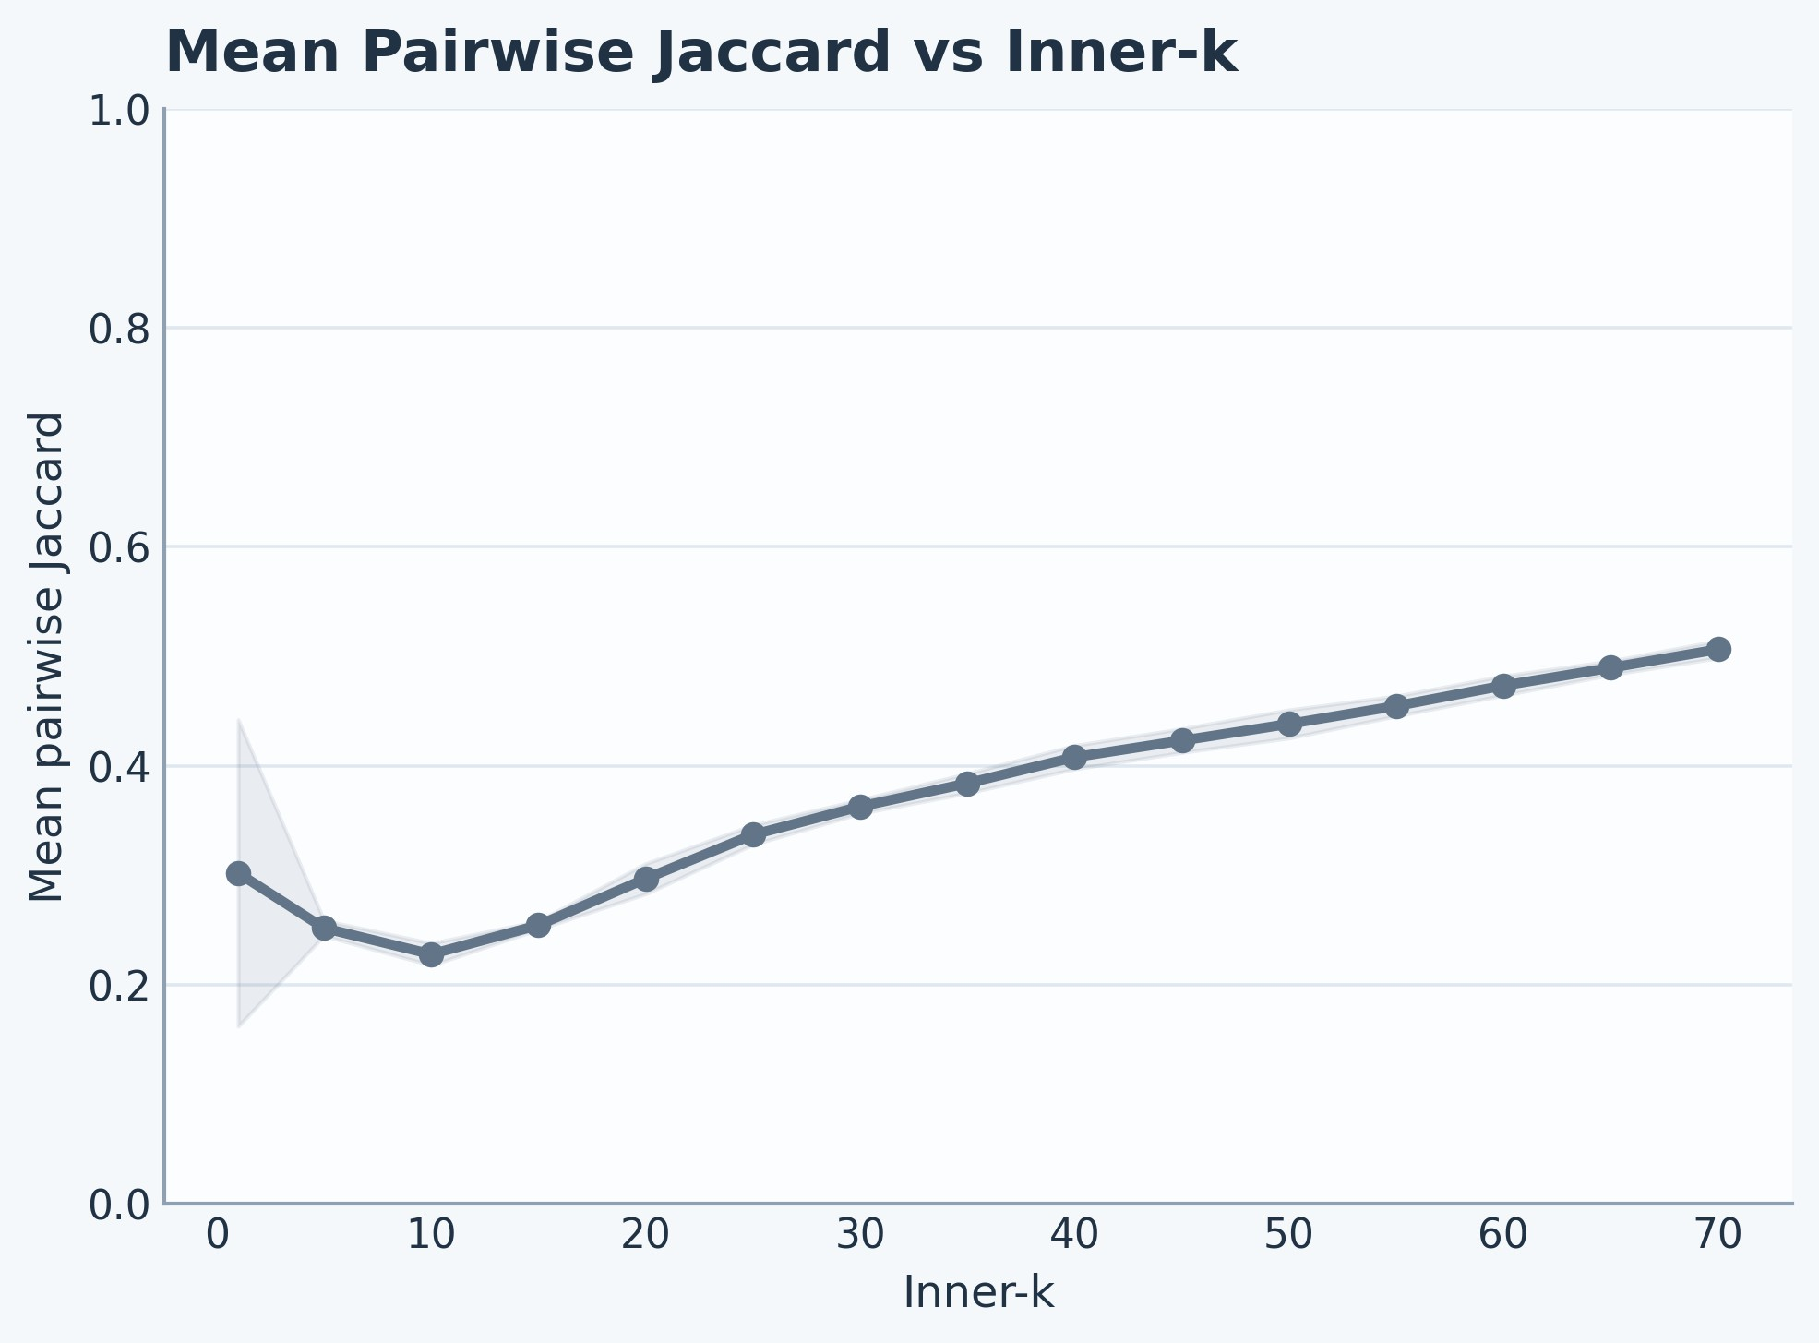

Figure 3: Patient-level ROC-AUC by window size across the sweep. Stars mark the best individual hybrid and SVM runs.
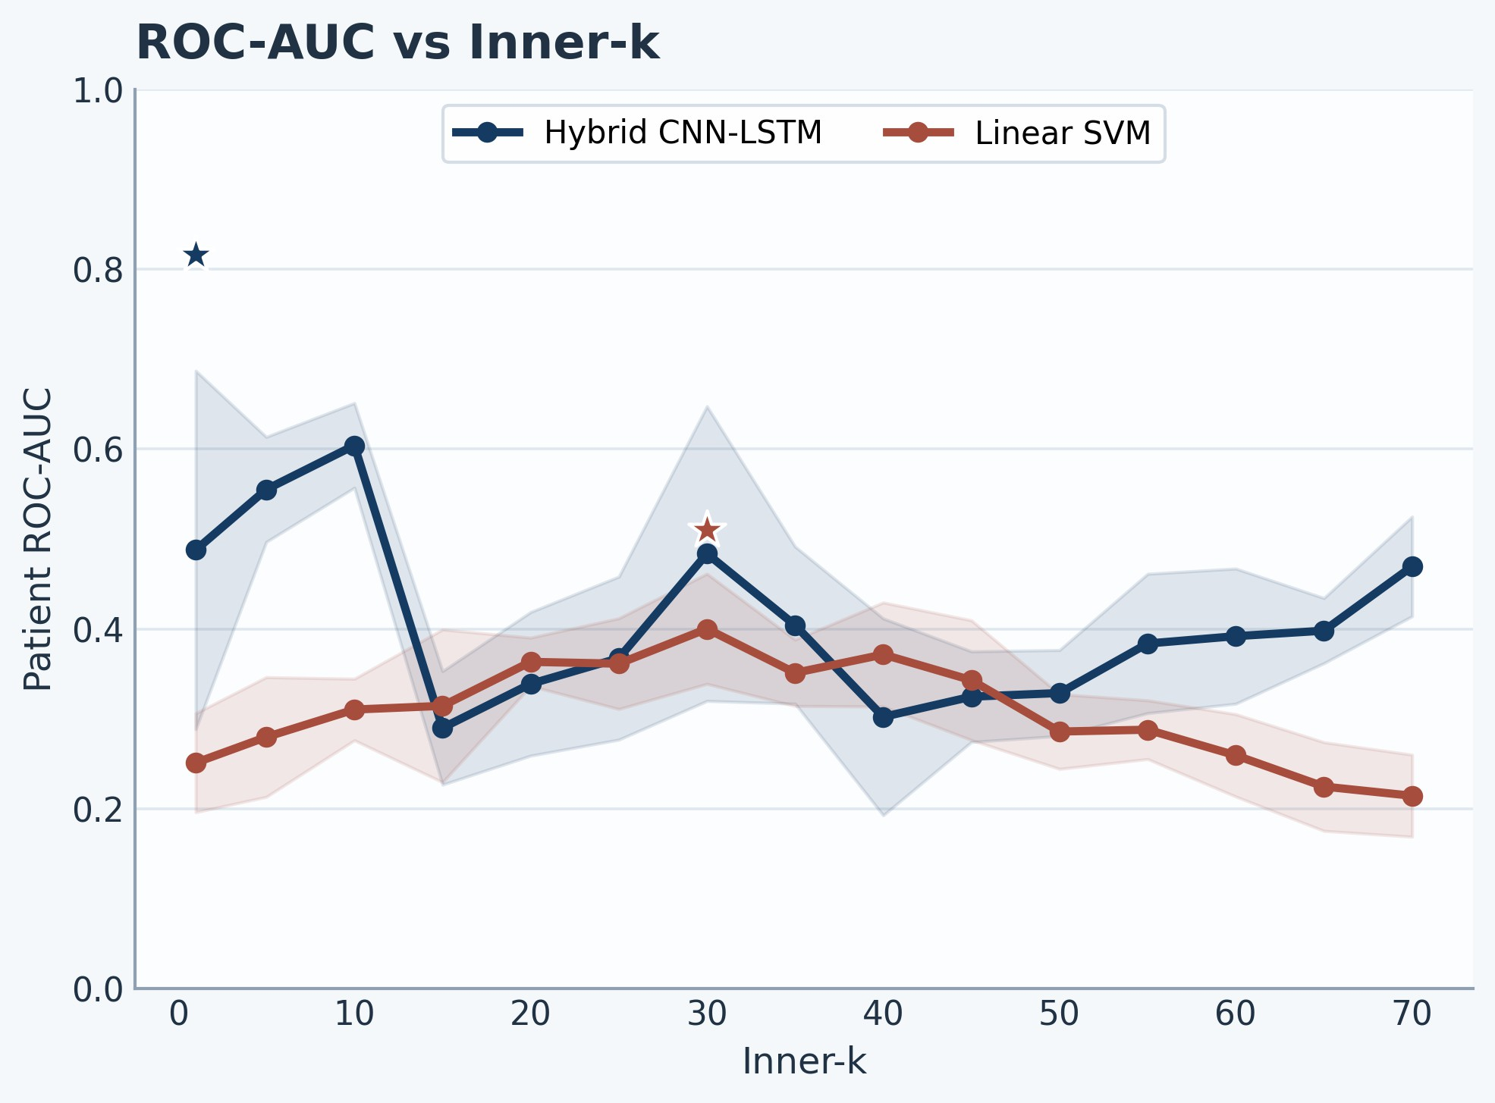
Figure 4: Patient-level ROC-AUC by inner-k across the sweep. The hybrid model retained the strongest discrimination in the sparsest budget region.

the total number of unique selected features. Larger feature budgets did not produce the strongest patient-level discrimination. The sweep concentrated its best hybrid performance at the sparsest end of the per-fold selection range. This pattern motivates the paper’s focus on sparse biomarker discovery and suggests that model capacity and per-fold sparsity mattered together rather than independently.

Best-run patient-level performance
The best hybrid configuration achieved patient-level ROC-AUC 0.816, PR-AUC 0.579, balanced accuracy 0.786,
accuracy 0.810, F1 0.714, and MCC 0.571 over 21 held-out participants (Figure 7; Table 4). Its ROC-AUC bootstrap interval ranged from 0.600 to 0.990, and the permutation test remained significant (𝑝 = 0.008), which is notable given the relatively small cohort. The PR-AUC of 0.579 indicates that the model retained useful precision-recall behavior despite the remission minority at the participant level.
Figure 5: Mean pairwise Jaccard overlap by inner-k. Hard-set overlap increased with larger per-fold feature budgets.
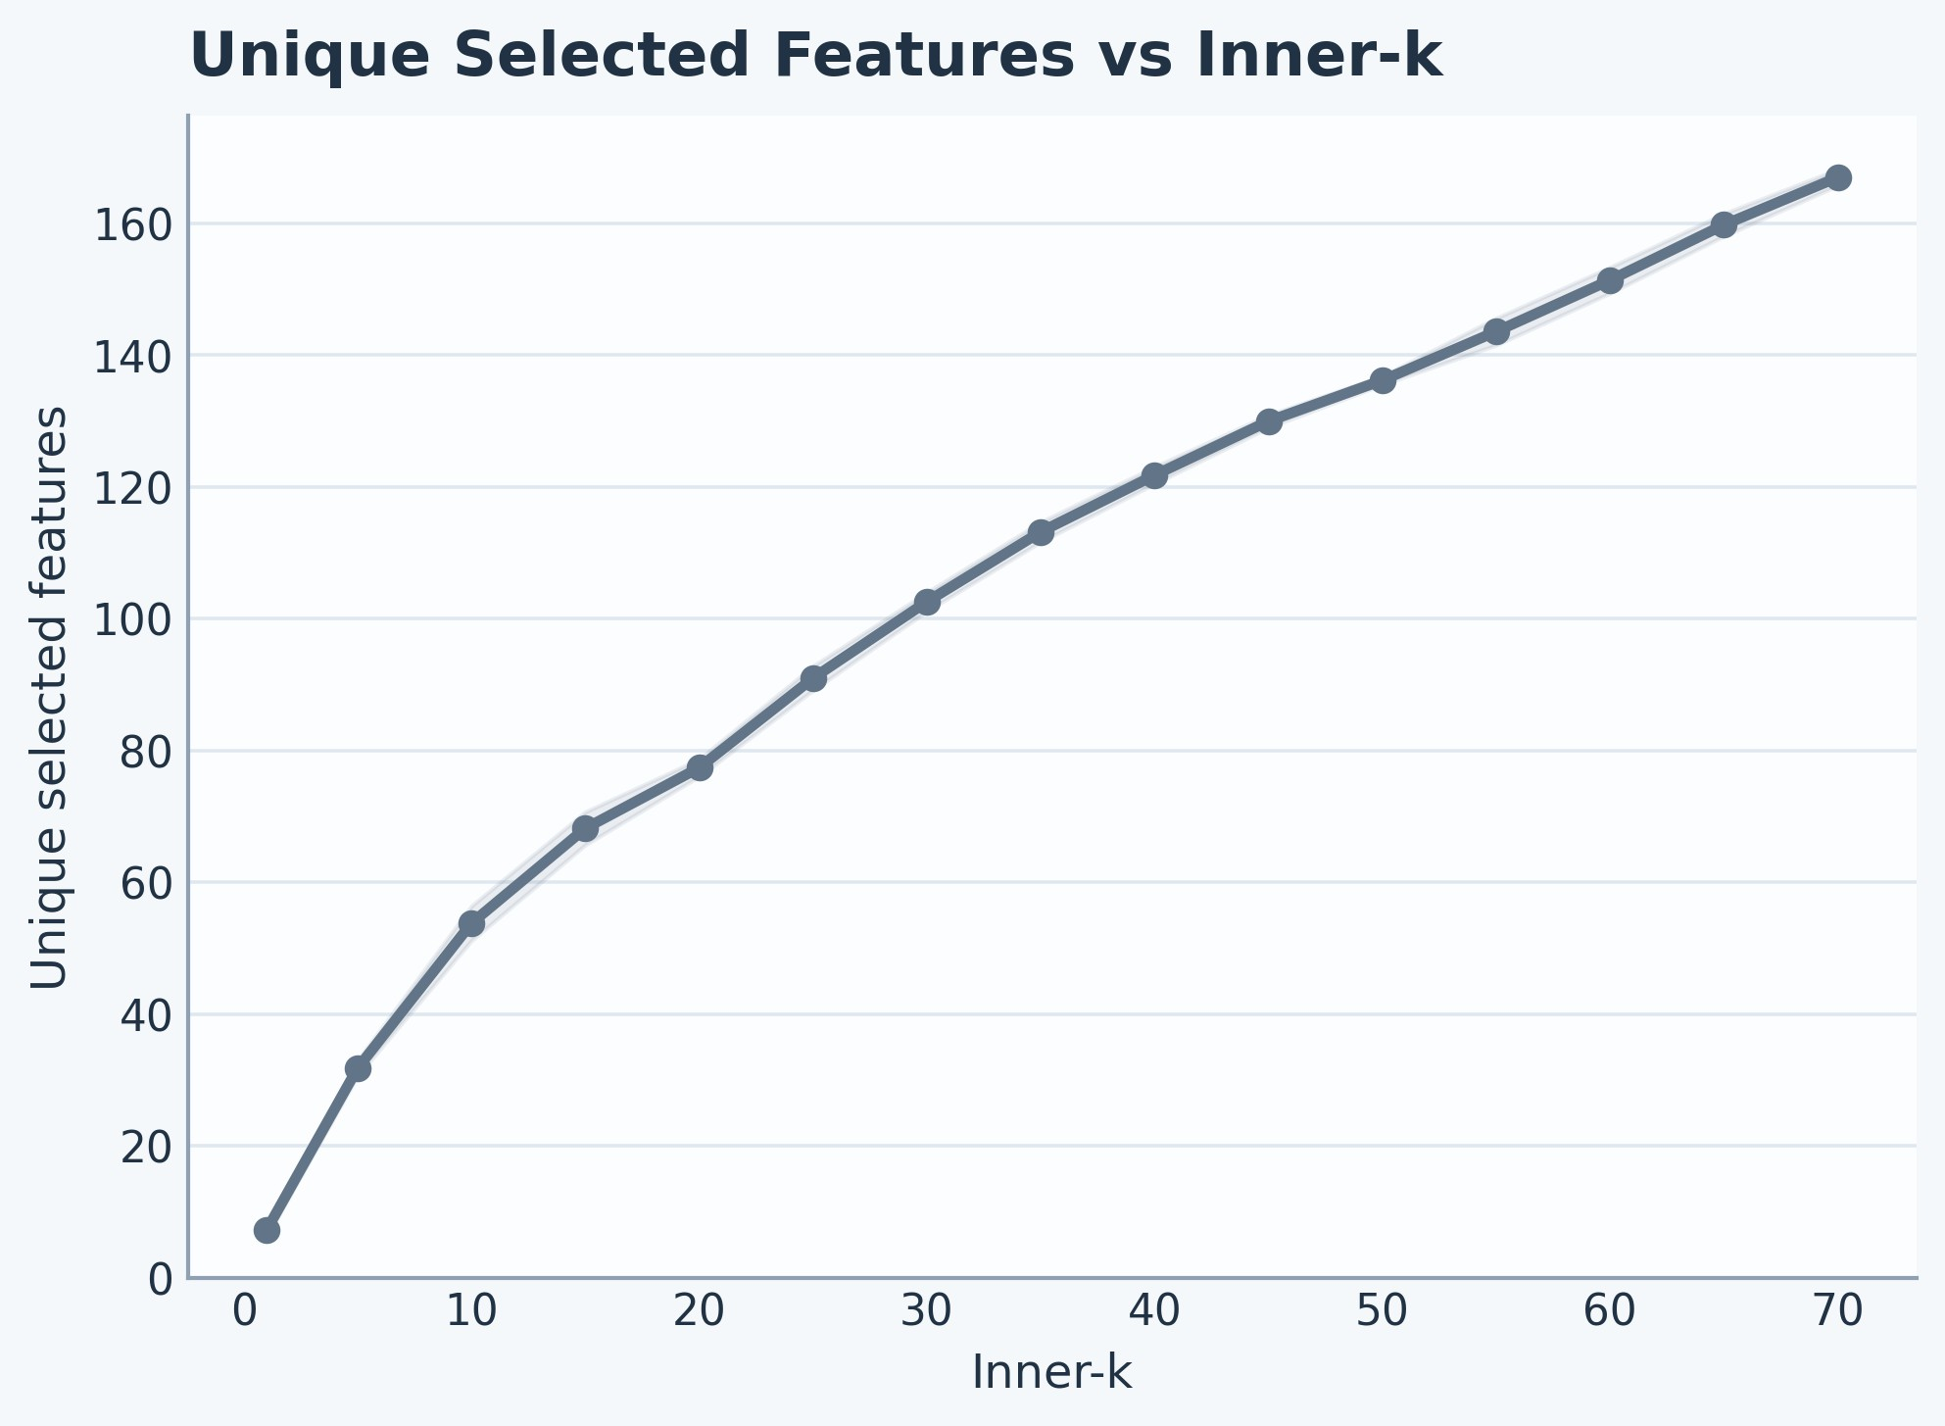
Figure 6: Unique selected features by inner-k. Larger per-fold budgets produced markedly larger discovered feature pools.

The corresponding participant-level confusion counts were 12 true negatives, 5 true positives, 2 false positives, and 2 false negatives. This error profile is consistent with the balanced-accuracy summary and shows that the strongest run retained useful sensitivity without giving up specificity. Figure 8 shows the same run in condensed metric form.
The best SVM baseline reached balanced accuracy 0.643 and ROC-AUC 0.510, with a non-significant permutation result (𝑝 = 0.469). This weaker performance came with a much larger per-fold feature budget (inner-k=30) and a far larger overall candidate set. The contrast indicates that the sparse hybrid pipeline extracted stronger patient-level discrimination from a much smaller subset.

Sparse biomarker set with modest hard-set overlap
The winning hybrid run selected an average of 1 feature per fold and yielded only 7 unique recurrent features across the entire participant-level validation process (Table 5). That degree of sparsity is one of the most distinctive findings in the sweep. Hard-set overlap was modest, with a mean pairwise Jaccard value of 0.190 and a mean Kuncheva index

Best-performing configuration for each model family.

Model | Window | Inner-k | ROC-AUC | PR-AUC | Bal. Acc. | F1 | MCC | feat/fold | Unique feat. | Mean Jaccard
Hybrid CNN-LSTM | 6 | 1 | 0.816 | 0.579 | 0.786 | 0.714 | 0.571 | 1.0 | 7 | 0.190
Linear SVM | 8 | 30 | 0.510 | 0.411 | 0.643 | 0.533 | 0.277 | 30.0 | 103 | 0.360
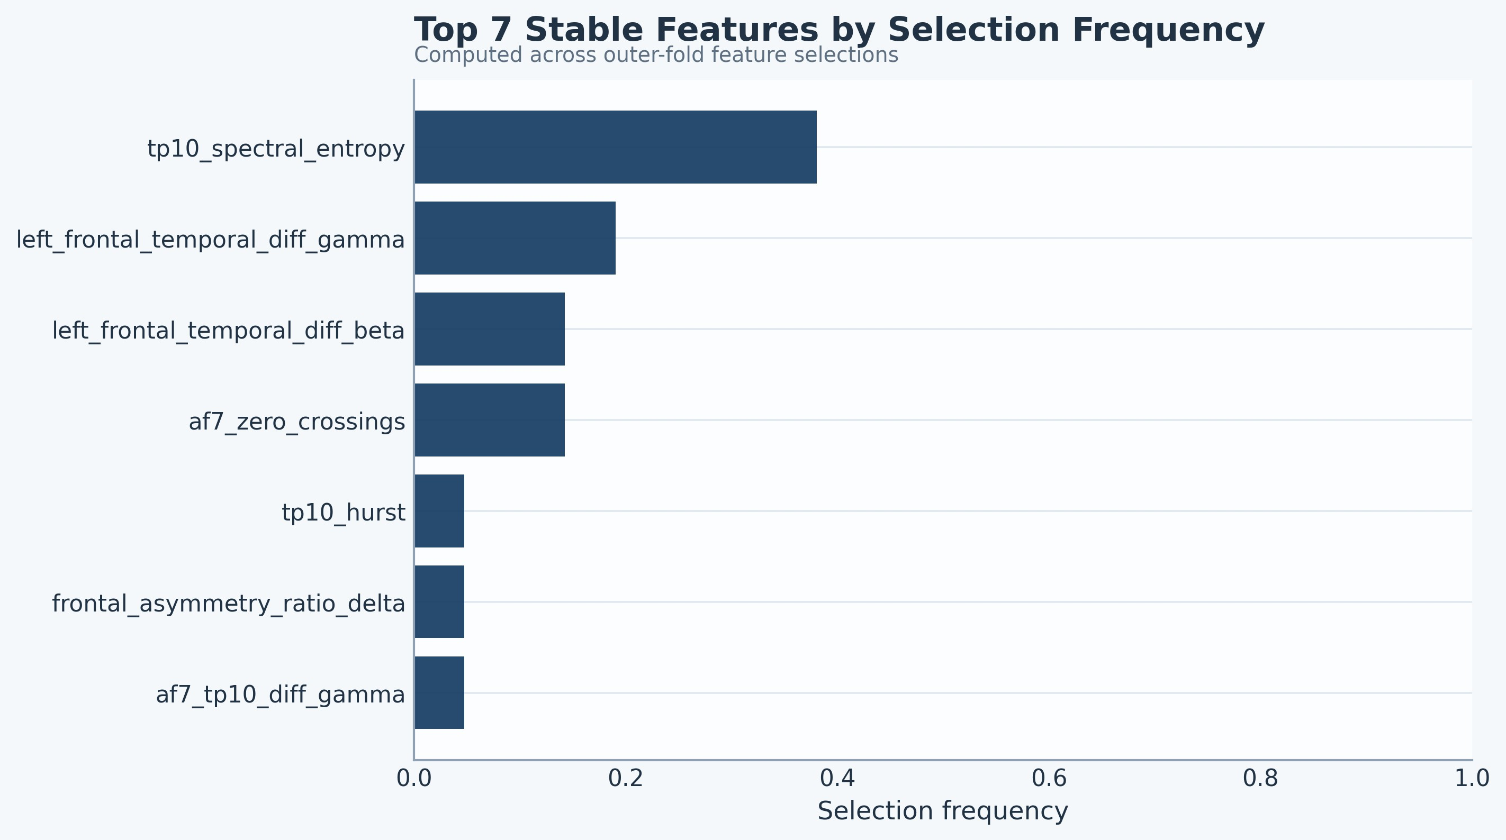

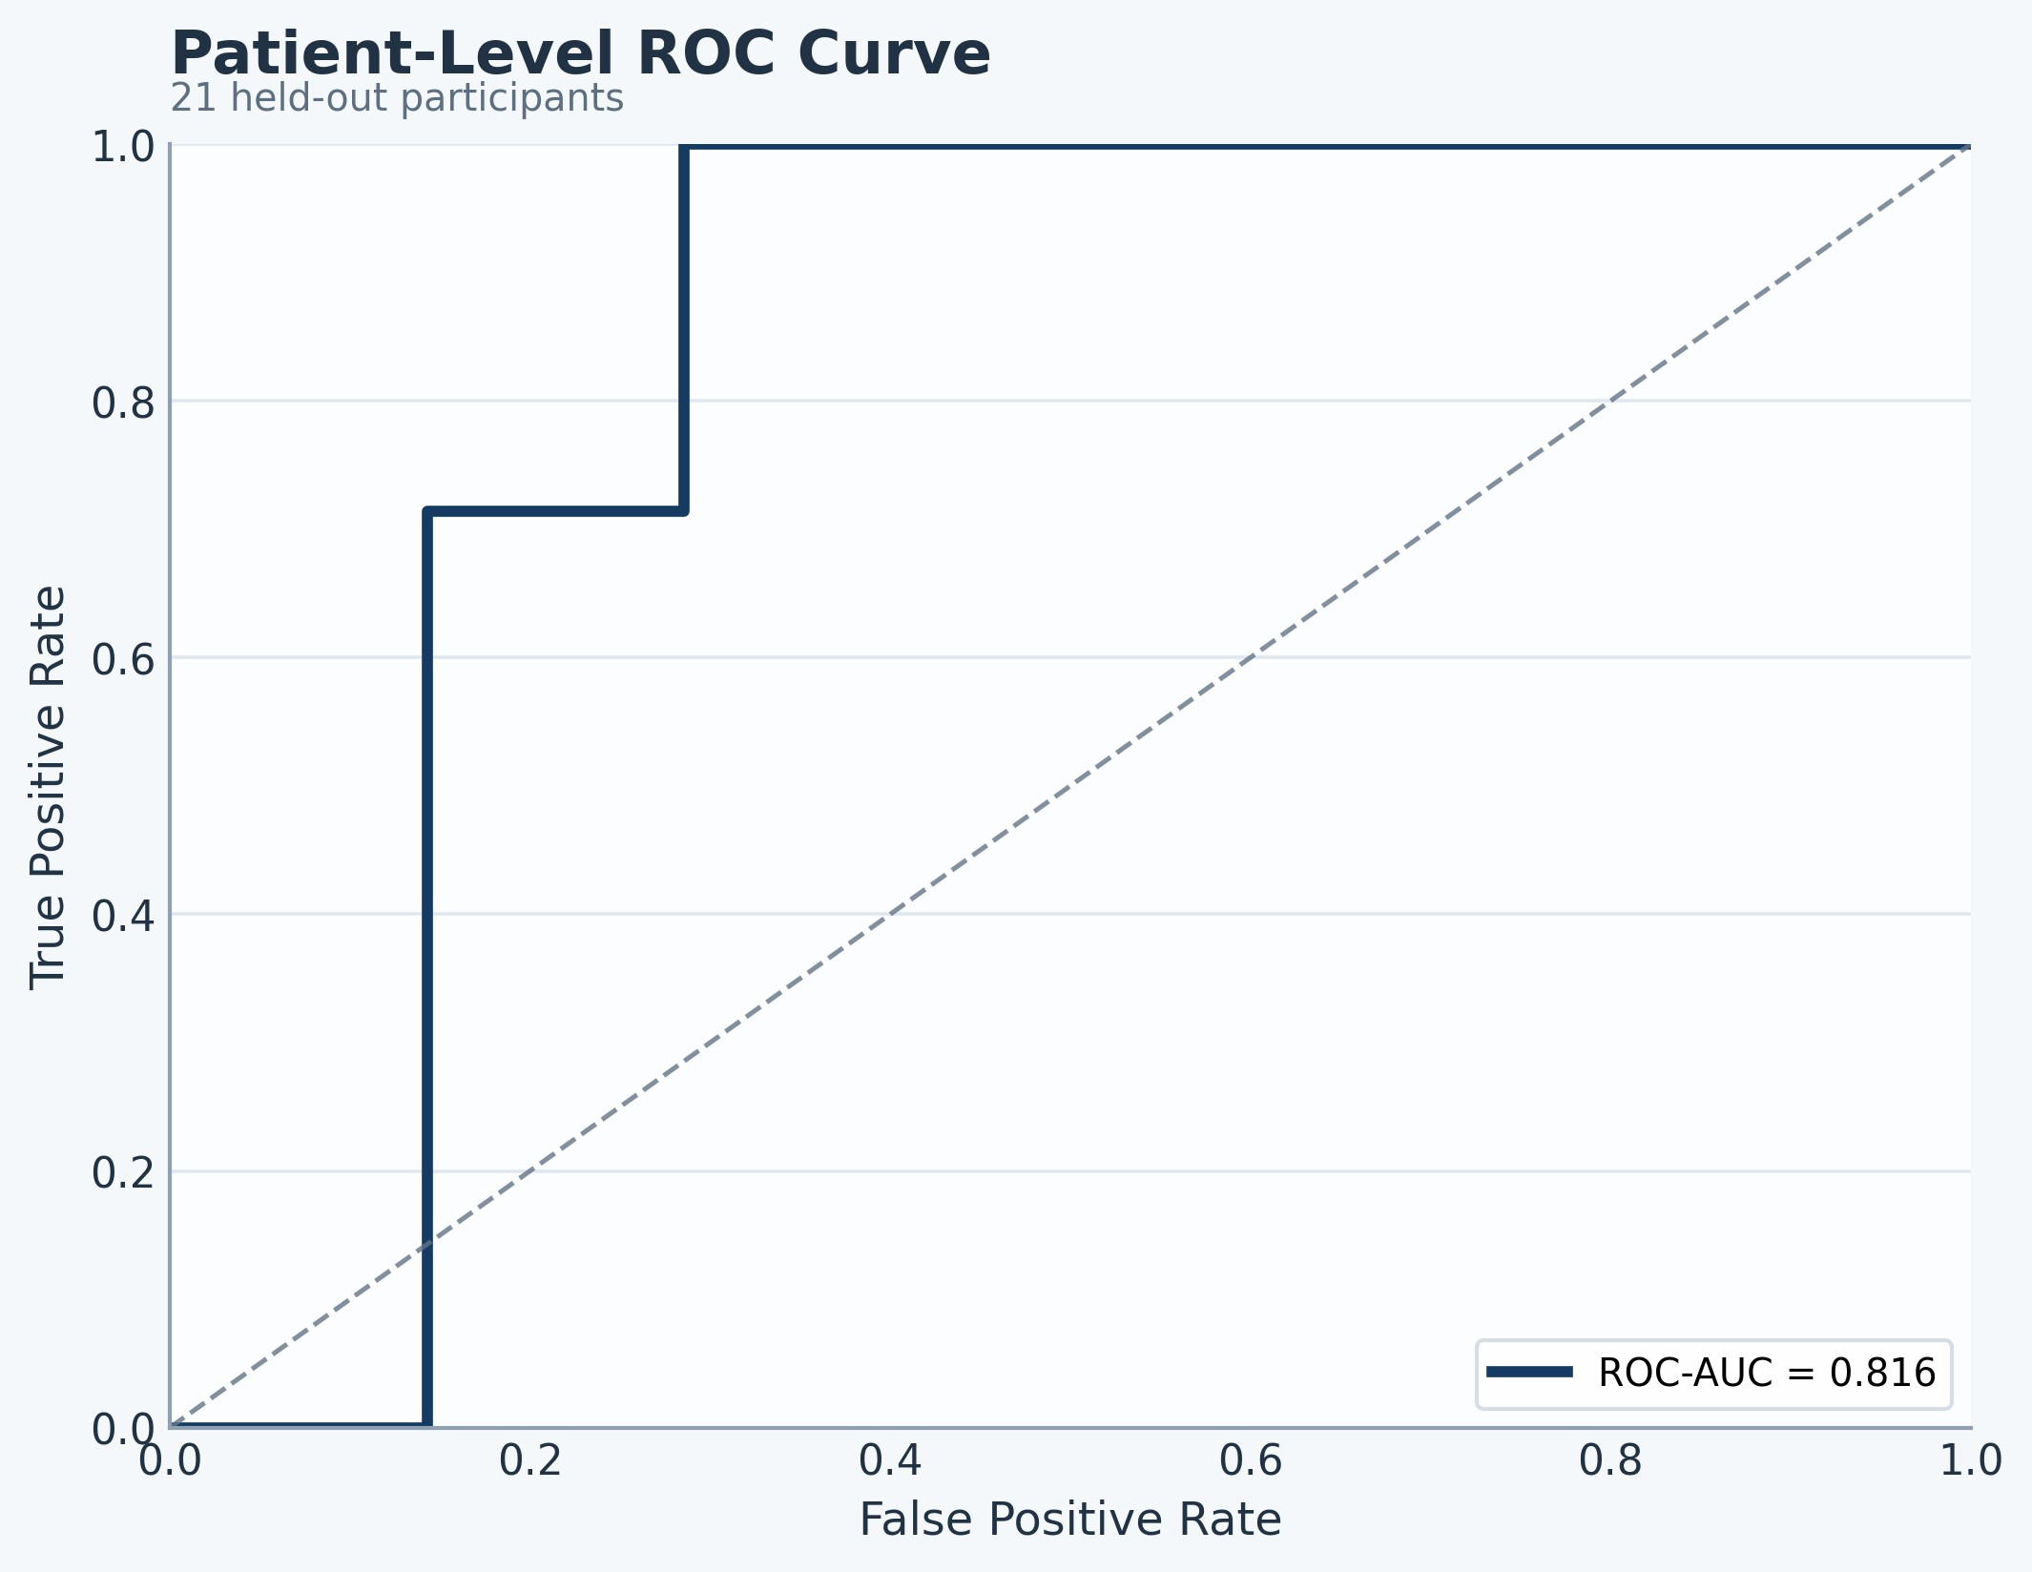
Figure 7: Patient-level ROC curve for the best hybrid run.
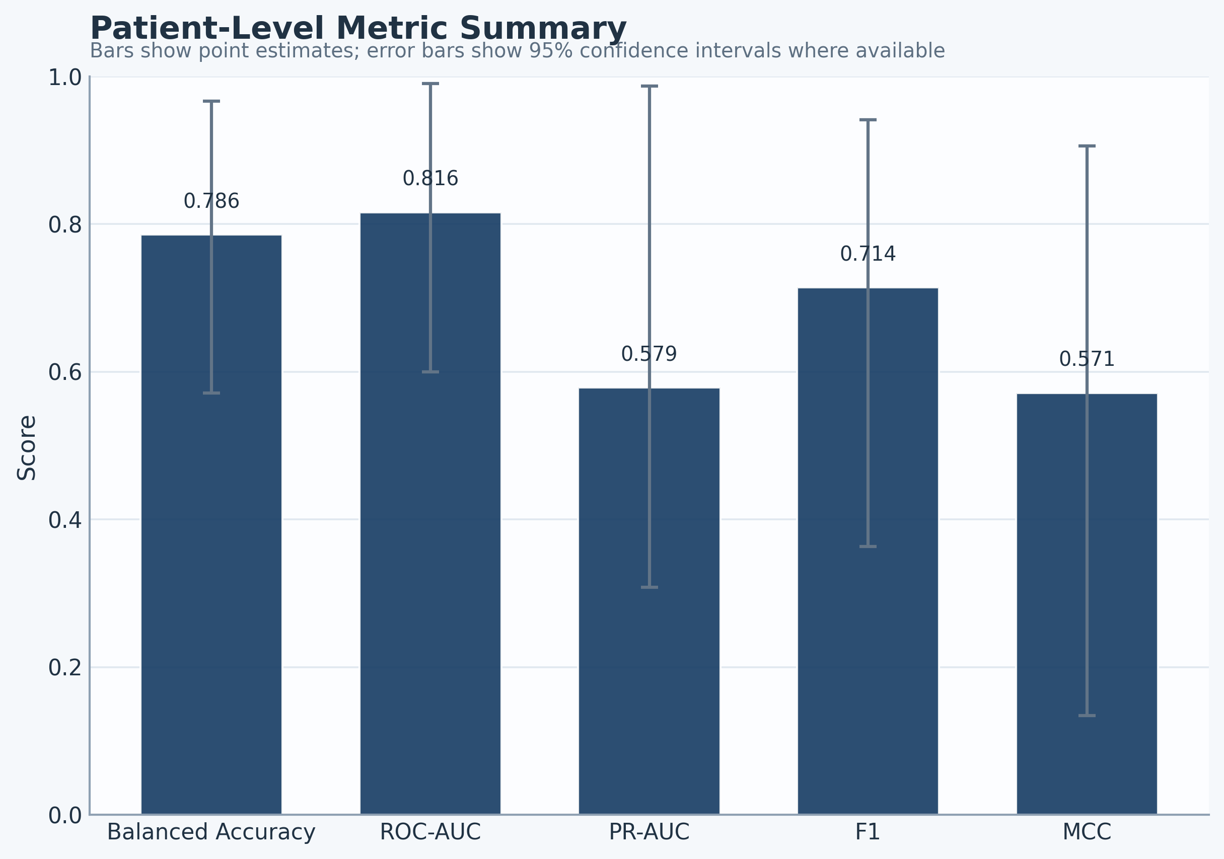

Figure 8: Patient-level metric summary for the best hybrid run.

of 0.187. Figure 9 shows the small recurrent pool, while the overlap statistics indicate that recurrence was concentrated in a few repeatedly reappearing features rather than in a broadly shared foldwise set.
A small recurring feature set emerged repeatedly, though not in every fold, and the selected set was dominated by temporal and frontal-temporal descriptors. The most recurrent feature was tp10_spectral_entropy, selected in 8 of 21 folds. The next most recurrent features were left_frontal_temporal_diff_gamma, left_frontal_temporal_diff_beta, and af7_zero_crossings.
Figure 9: Selection-frequency ranking for the recurrent biomarkers from the best hybrid run.
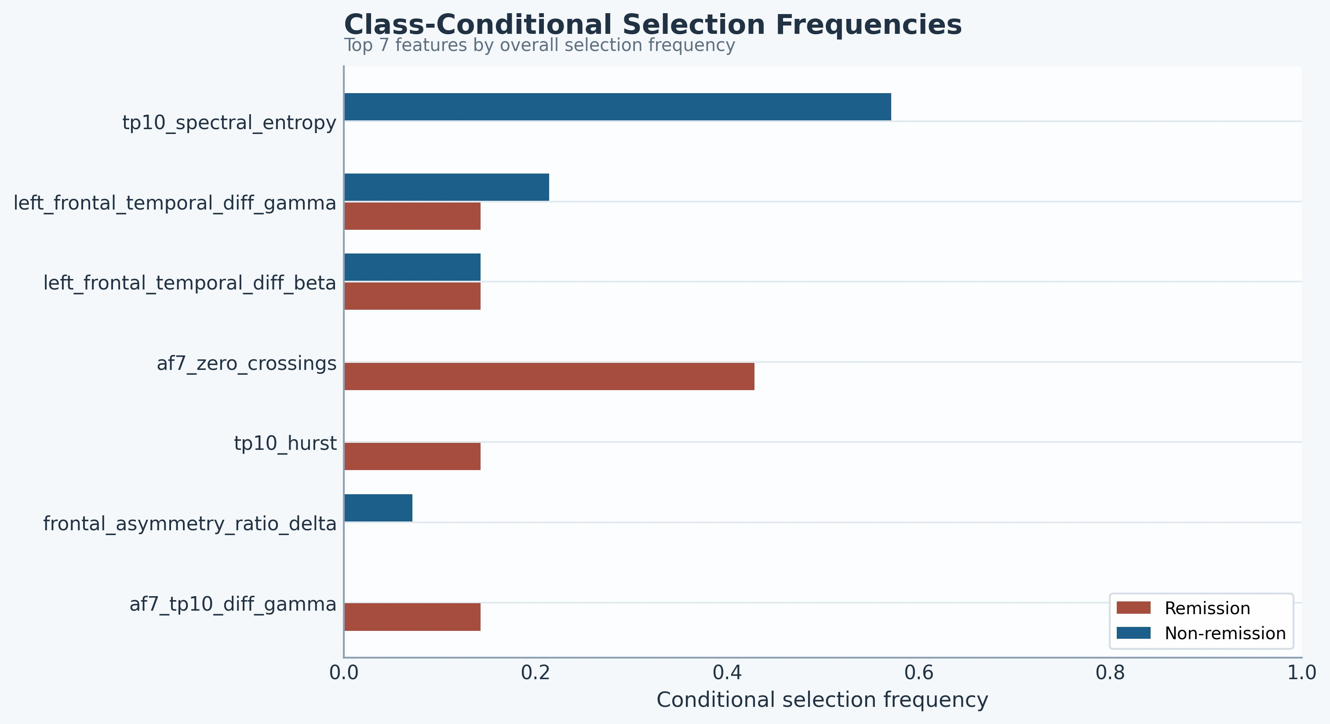
Figure 10: Class-conditional selection frequencies for the recurrent biomarkers from the best hybrid run. Remission is shown in red and non-remission in blue.

Effect-direction consistency and class-conditional patterns
The recurrent hybrid biomarkers showed perfect mean sign consistency across the effect-stability summary. All recurrent features retained the same effect direction across the folds in which they were selected, which supports treating them as promising biomarkers with stable directionality even when hard-set overlap remained modest. tp10_spectral_entropy and the frontal-temporal gamma and beta difference terms were repeatedly associated with the non-remission group, whereas af7_zero_crossings was more frequently selected in remission folds. The class-conditional selection frequencies make that separation
visible at the level of foldwise recurrence (Figure 10).
The effect-size summaries followed the same broad pattern, with af7_zero_crossings retaining a positive mean effect size and the main TP10 and frontal-temporal features retaining negative mean effects (Figure 11). This distinction matters clinically. The selection-frequency deltas do not justify definitive mechanistic claims. They

Table 5
Recurrent biomarkers from the best hybrid run. Δ selection is remission minus non-remission selection share.

Feature | Folds | Share | Δ sel. | Sign cons. | Mean 𝑑 | Effect direction
tp10_spectral_entropy | 8 | 0.381 | -0.571 | 1.000 | -0.935 | Non-remission > remission
left_frontal_temporal_diff_gamma | 4 | 0.190 | -0.071 | 1.000 | -1.059 | Non-remission > remission
left_frontal_temporal_diff_beta | 3 | 0.143 | 0.000 | 1.000 | -0.915 | Non-remission > remission
af7_zero_crossings | 3 | 0.143 | 0.429 | 1.000 | 0.814 | Remission > non-remission
tp10_hurst | 1 | 0.048 | 0.143 | 1.000 | -1.010 | Non-remission > remission
af7_tp10_diff_gamma | 1 | 0.048 | 0.143 | 1.000 | -1.203 | Non-remission > remission
frontal_asymmetry_ratio_delta | 1 | 0.048 | -0.071 | 1.000 | 0.794 | Remission > non-remission

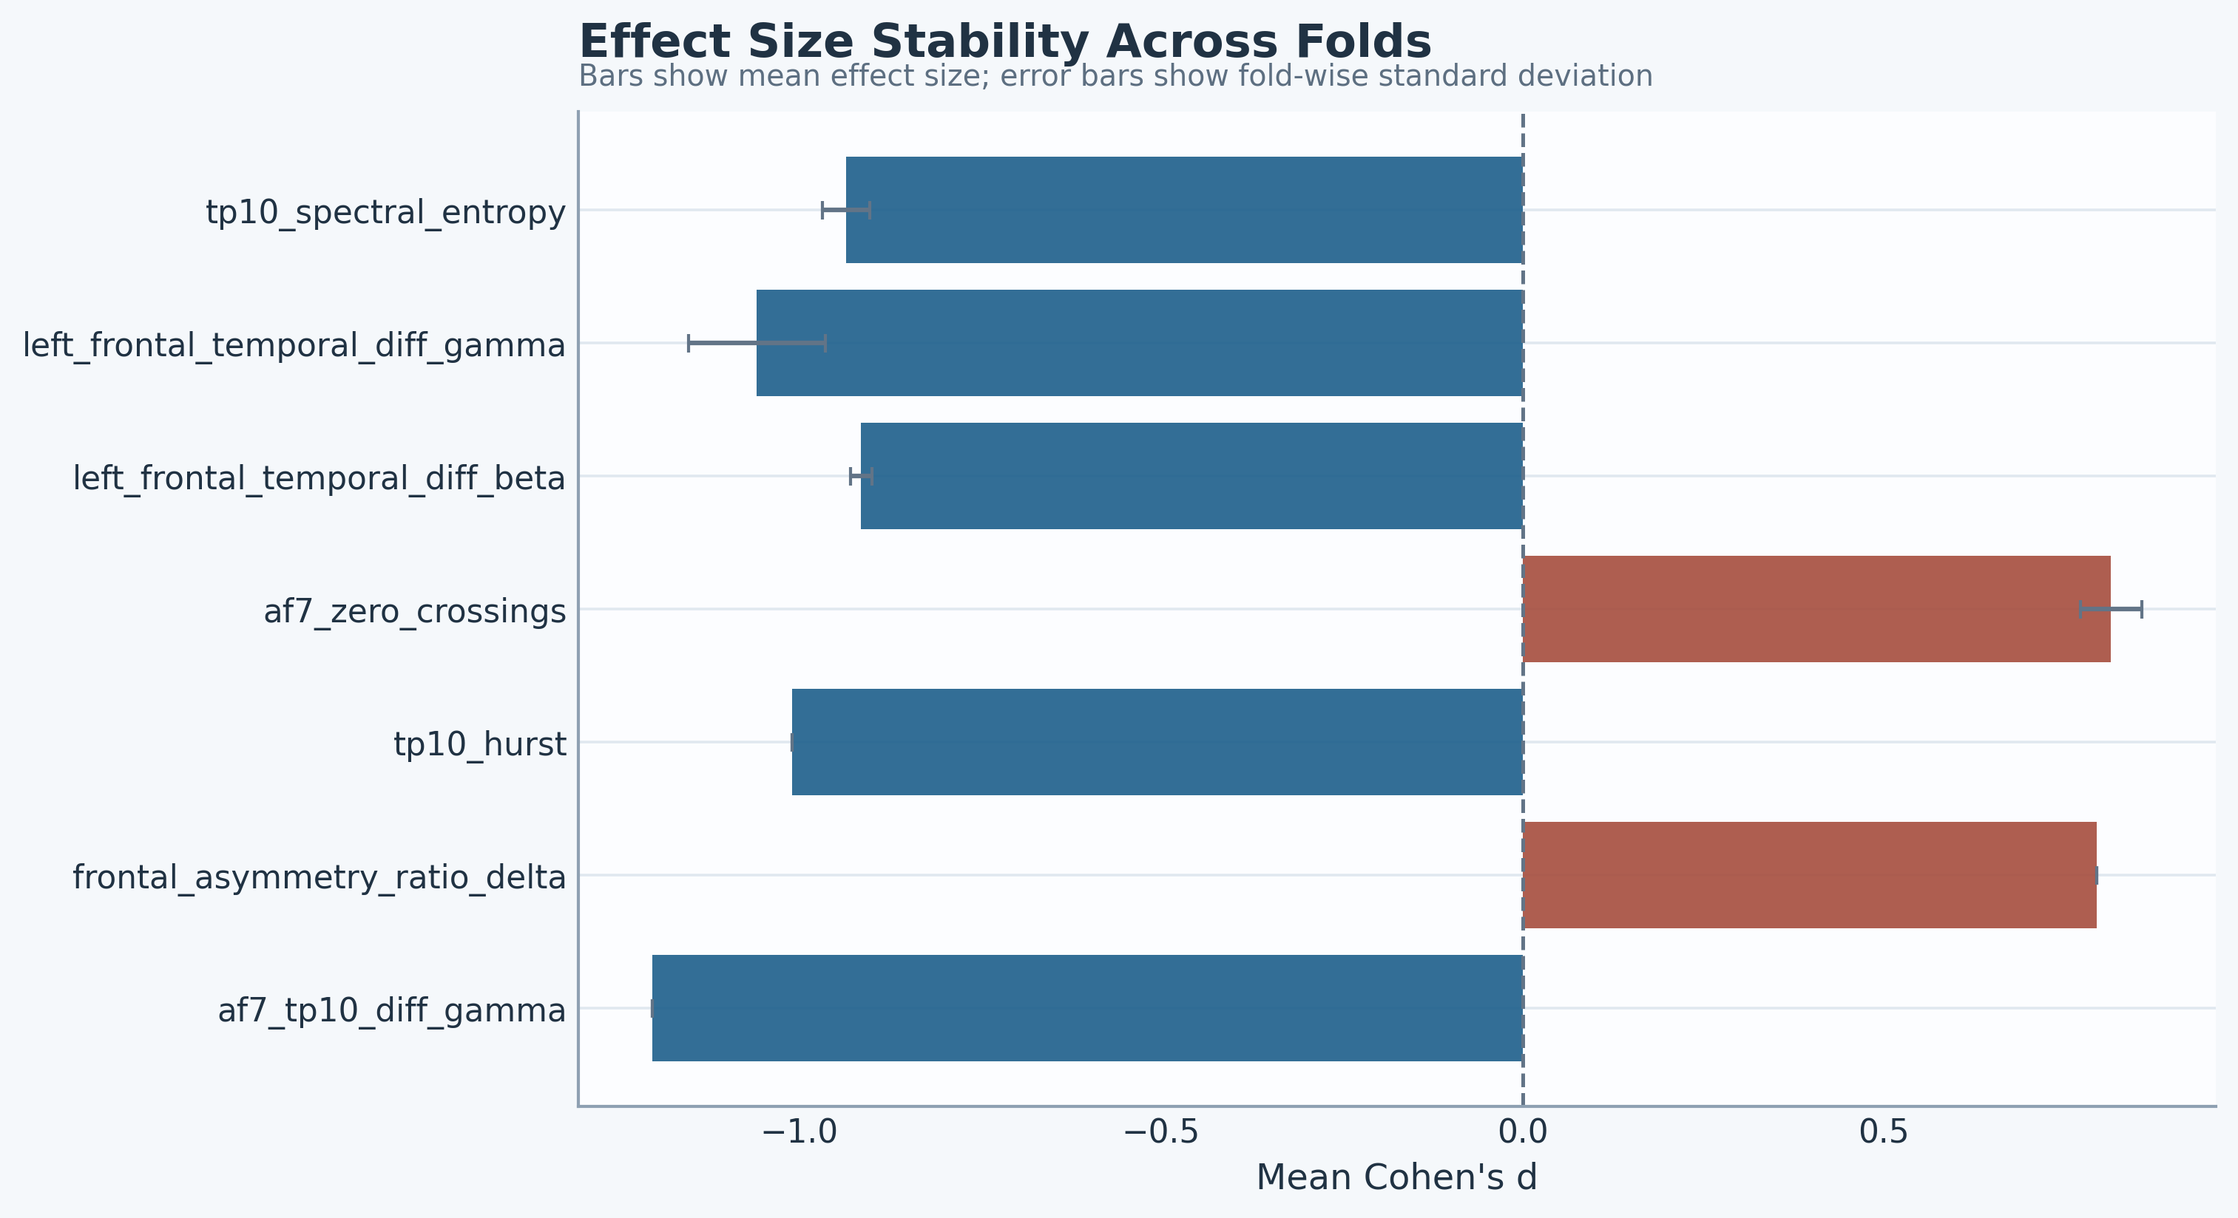
Figure 11: Effect-size stability for the recurrent biomarkers from the best hybrid run. Positive values indicate remission-skewed effects and negative values indicate non-remission-skewed effects.

provide a concrete interpretation target for follow-up validation. Taken together, these results indicate that useful patient-level discrimination can be achieved with an extremely sparse feature budget, while the recurrent biomarkers retain interpretable directionality even when fold-to-fold set overlap remains modest.

Discussion
The strongest patient-level discrimination in this sweep emerged from the sparsest tested configuration. The best hybrid run used inner-k=1, selected only 7 unique recurrent features overall, and exceeded the best linear baseline by a large margin on ROC-AUC and MCC. Figure 4 also shows that this was not a generic effect of smaller feature budgets across both models. In the low-budget region, the hybrid model retained stronger ROC-AUC than the linear SVM and reached its peak performance at the sparsest tested setting, whereas the linear model reached its best ROC-AUC only after a broader per-fold budget. In this cohort, the value of the more expressive model and the value of strong sparsity appear to have operated together.
One plausible explanation is that aggressive per-fold pruning removed weak or redundant handcrafted features and exposed a compact signal set whose interactions were more useful to the hybrid architecture than to a linear decision boundary. With only a few retained descriptors, the convolutional, recurrent, and attention stages may have
been better positioned to combine complementary temporal and frontal-temporal information without dilution from a larger pool of unstable candidates. The linear baseline appears to have depended more on accumulating a broader set of moderate additive cues before reaching its best ROC-AUC. This interpretation remains provisional, but it is consistent with the sweep pattern and with the marked separation between the best sparse hybrid run and the broader-budget linear baseline.
This result fits part of the EEG depression literature and supports a measured interpretation. Prior work has argued that EEG can provide clinically useful baseline markers in major depressive disorder and treatment-response settings [16–18]. Related discussions have also emphasized tighter biomarker discipline, better standardization, and more realistic expectations about generalization [12, 20, 59]. Machine learning studies have likewise reported encouraging treatment-response signals, including combinations of EEG and clinical covariates [24–26]. Other modelling studies reach similar conclusions while still exposing limits from data heterogeneity, cohort size, or insufficient interpretability [27–29]. Recent predictive overviews and reviews continue to highlight the same translational tension [22, 23].
The present sweep adds a feature-selection view in which larger feature budgets yield more overlap and many more unique discovered features. Those larger budgets do not improve discrimination. The panels support a small recurring biomarker set with consistent direction of class separation. That reading keeps the modest Jaccard and Kuncheva scores in view and gives appropriate weight to the stronger effect-direction signal. Methodologically, this framing matters because the depression EEG biomarker literature still contains substantial publication bias, limited out-of-sample validation, and known vulnerability to leakage from pre-cross-validation feature processing [21, 33]. The present pipeline addresses that problem by embedding selection and rebalancing inside participant-level leave-one-participant-out folds and then summarizing recurrence and directionality instead of reporting only a single global feature list [34].
The same clinical program has also supported other signal representations in prior PSD-based and PLV-based

studies, which located informative response-related signal in low-density temporal and frontal-temporal patterns [45, 46]. In the present sweep, the recurrent feature set again concentrated in TP10-derived and frontal-temporal descriptors. That regional convergence supports the view that the low-montage recordings contain response-relevant information across multiple feature families.
The specific biomarkers in the present sweep are plausible enough to deserve follow-up. tp10_spectral_entropy was the most frequently selected feature and skewed toward non-remission-associated folds. Entropy and related nonlinear descriptors have appeared repeatedly in depression EEG studies [30, 54, 55]. Pretreatment multiscale entropy and signal-variability measures have also been linked to antidepressant treatment response, although the reported direction depends on temporal scale and recording context [52]. That nuance is important because a recent large resting-state evaluation found complexity metrics to be stable but not to support a simple uniform depression-complexity association [56]. The present TP10 entropy finding therefore fits a broader complexity literature and supports a credible temporal biomarker signal in this cohort, while still needing external confirmation.
The frontal-temporal beta and gamma difference features also have prior support at the family and regional level. Temporal electrodes, higher-frequency band features, and paired asymmetry terms have been reported as informative in depression EEG studies, and pretreatment frontal-temporal features have been linked to treatment outcome in MDD [48, 51]. The current beta and gamma difference terms are therefore better read as family-level extensions of that regional pattern than as exact replications of a previously fixed biomarker.
af7_zero_crossings had the clearest remission-skewed selection pattern in the current sweep, but it has less direct precedent as a named biomarker. AF7-centered signal relevance has appeared in adjacent low-montage work [60], and broader frontal EEG literature continues to implicate asymmetry and signal-complexity families in depression [56, 57]. The specific zero-crossing formulation used here is therefore best regarded as a plausible frontal biomarker in this setting and should be tested in independent cohorts. Taken together, the recurrent set emphasized temporal and frontal-temporal descriptors, with limited concentration in any single frontal asymmetry family. This regional profile is compatible with the broader low-montage findings discussed above. The current study contributes a sparse handcrafted biomarker signature with explicit recurrence and effect-direction summaries.
Related tDCS studies in bipolar depression from the same group point in a similar low-montage direction. PSD-based modeling again highlighted AF7 and TP10 signal content, and PLV analyses emphasized frontal-temporal and temporoparietal synchronization patterns [60, 61]. These bipolar studies address a different diagnosis and treatment protocol. They support
reduced-montage feasibility and signal plausibility in adjacent affective cohorts.
A limitation of the study is the relatively small participant size (𝑛 = 21), the confidence intervals are wide, and there is no external validation set. The bottom-row sweep panels describe the selection pipeline itself because the same feature-selection layer feeds both classifiers. Class-conditional ratios also become unstable when a feature is absent from one class, so the study uses deltas and effect direction as the main descriptive summaries. The recurring features can be treated as plausible biomarkers from this cohort that now warrant follow-up validation.
Future work should test whether the same sparse feature set recurs under independent cohorts, alternative low-density montages, and explicit external validation [40]. Adjacent response-prediction work in depression and neuromodulation provides useful targets for that next stage [35, 36, 38]. Home-based and transport-oriented studies offer one clear direction for follow-up [62–64]. More recent response-signature studies also provide relevant benchmarks for that next phase [41–43]. Related protocol and review work in treatment-resistant depression can help frame that validation effort [44, 65]. These extensions should keep stringent patient-level evaluation and sparse interpretable feature budgets in the core study design.

Conclusion
This study demonstrates that low-montage resting-state EEG can support patient-level prediction of remission outcomes in a home-based tDCS trial using an extremely sparse feature-selection framework. The strongest model achieved meaningful discrimination while selecting only a small set of recurrent features.
Rather than relying on high-dimensional feature spaces, the results suggest that compact and interpretable biomarker candidates centered on temporal entropy and frontal–temporal interactions may capture clinically relevant signal. These findings extend prior PSD-based analyses in the same cohort and support a convergent regional signal interpretation.

CRediT authorship contribution statement
Abin Daniel Zorto: Writing - review & editing, writing - original draft, visualization, validation, software, methodology, formal analysis, data curation, conceptualization. Jijomon C. Moncy: Writing - review & editing, writing - original draft, visualization, validation, software, resources, methodology, formal analysis,

data curation, conceptualization. Mhd Saeed Sharif: Writing - review & editing, writing - original draft, validation, supervision, resources, project administration, methodology, investigation, funding acquisition, formal analysis, conceptualization. Cynthia H.Y. Fu: Writing - review & editing, writing - original draft, validation, supervision, resources, project administration, methodology, investigation, funding acquisition, formal analysis, conceptualization.

Acknowledgements
The authors express their gratitude to the participants who took part in the studies. This publication is based on research supported by grants from Flow Neuroscience (FL001), NIMH (R01MH134236), National Institute for Health and Care Research (NIHR) Health Technology Assessment (NIHR165425), NIHR Efficacy and Mechanisms Evaluation (NIHR167361), Rosetrees Trust (CF2024M2116, CF20212104)to C.H.Y.F.

References

URL https://doi.org/10.1093/brain/awr039
- R. D. Woodham, S. Selvaraj, N. Lajmi, H. Hobday, G. Sheehan, A.-R. Ghazi-Noori, P. J. Lagerberg, M. Rizvi, S. S. Kwon, P. Orhii,
et al., Home-based transcranial direct current stimulation treatment for major depressive disorder: a fully remote phase 2 randomized sham-controlled trial, Nature medicine 31 (1) (2025) 87–95.
- R. M. Rimmer, R. D. Woodham, S. Cahill, C. H. Fu, Acceptability of home-based transcranial direct current stimulation (tdcs) in major depression: a qualitative analysis of individual experiences, Mental Health Review Journal 29 (1) (2024) 79–91.

- P. Miranda, C. D. Cox, M. Alexander, S. Danev, J. R. Lakey, Overview of current diagnostic, prognostic, and therapeutic use of eeg and eeg-based markers of cognition, mental, and brain health, Integr. Mol. Med 6 (5) (2019).
- L. Simmatis, E. E. Russo, J. Geraci, I. E. Harmsen,
N. Samuel, Technical and clinical considerations for electroencephalography-based biomarkers for major depressive disorder, npj Mental Health Research (2023). doi:10.1038/ s44184-023-00038-7.
URL https://doi.org/10.1038/s44184-023-00038-7
- S. Siuly, Y. Li, Y. Zhang, Electroencephalogram (eeg) and its background, in: EEG signal analysis and classification: Techniques and applications, Springer, 2017, pp. 3–21.
- S. M. Stoyell, J. Wilmskoetter, M.-A. Dobrota, D. M. Chinappen,
L. Bonilha, M. Mintz, B. H. Brinkmann, S. T. Herman, J. M. Peters,
S. Vulliemoz, et al., High-density eeg in current clinical practice and opportunities for the future, Journal of clinical neurophysiology 38 (2) (2021) 112–123.
- BABILONI, CLAUDIO, B. PH, B. M, D. WH, F. DH, F. J, H. U,
H. K, I. P. E. G. C. Collaborators, J. M, K. T, K. VJ, L. D. S. FH,
M. M, M. A, N. JF, O. S, P. LS, R. GS, S. B, S. A, S. WK, v. G.
JM, W. FJ, W. RG, Guidelines for the recording and evaluation of pharmaco-eeg data in man: the international pharmaco-eeg society (ipeg) (2012). doi:10.1159/000343478.
URL https://iris.uniroma1.it/bitstream/11573/802874/1/Jobert_ Guidelines_2012.pdf
- S. Olbrich, M. Arns, Eeg biomarkers in major depressive disorder: Discriminative power and prediction of treatment response, International Review of Psychiatry (2013). doi: 10.3109/09540261.2013.816269.
URL https://doi.org/10.3109/09540261.2013.816269
- S. Olbrich, R. v. Dinteren, M. Arns, Personalized medicine: Review and perspectives of promising baseline eeg biomarkers in major depressive disorder and attention deficit hyperactivity disorder, Neuropsychobiology (2015). doi:10.1159/000437435.
URL https://doi.org/10.1159/000437435
- A. F. Leuchter, I. A. Cook, S. P. Hamilton, K. L. Narr, A. Toga,
  - M. Hunter, K. Faull, J. Whitelegge, A. M. Andrews, J. Loo,
  - Way, S. F. Nelson, S. Horvath, B. D. Lebowitz, Biomarkers to predict antidepressant response, Current Psychiatry Reports (2010). doi:10.1007/s11920-010-0160-4.
URL https://pubmed.ncbi.nlm.nih.gov/20963521/
- C. H. Fu, S. G. Costafreda, Neuroimaging-based biomarkers in psychiatry: clinical opportunities of a paradigm shift, The Canadian Journal of Psychiatry 58 (9) (2013) 499–508.
- C. H. Fu, Y. Fan, C. Davatzikos, Addressing heterogeneity (and homogeneity) in treatment mechanisms in depression and the potential to develop diagnostic and predictive biomarkers, NeuroImage: Clinical 24 (2019) 101997.
- A. S. Widge, M. T. Bilge, R. Montana, W. Chang, C. I. Rodriguez, T. Deckersbach, L. L. Carpenter, N. H. Kalin,
C. B. Nemeroff, Electroencephalographic biomarkers for treatment response prediction in major depressive illness: A meta-analysis, American Journal of Psychiatry 176 (1) (2019) 44–56. doi:10.1176/appi.ajp.2018.17121358.
- D. Watts, R. F. Pulice, J. Reilly, A. R. Brunoni, F. Kapczinski, I. C. Passos, Predicting treatment response using eeg in major depressive disorder: A machine-learning meta-analysis, Translational psychiatry

12 (1) (2022) 332.
- S. Cohen, J. Zantvoord, B. Wezenberg, J. Daams, C. Bockting,
D. Denys, G. van Wingen, Electroencephalography for predicting antidepressant treatment success: a systematic review and meta-analysis, Journal of Affective Disorders 321 (2023) 201–207.
- A. M. Al-Kaysi, A. Al-Ani, C. K. Loo, T. Y. Powell, D. M. Martin,
M. Breakspear, T. W. Boonstra, Predicting tdcs treatment outcomes of patients with major depressive disorder using automated eeg classification, Journal of affective disorders 208 (2017) 597–603.
- N. Jaworska, S. d. l. Salle, M. H. Ibrahim, P. Blier, V. Knott, Leveraging machine learning approaches for predicting antidepressant treatment response using electroencephalography (eeg) and clinical data, Frontiers in Psychiatry (2019). doi:10.3389/fpsyt.2018.00768.
URL https://doi.org/10.3389/fpsyt.2018.00768
- T. Oakley, J. Coskuner, A. Cadwallader, M. Ravan, G. Hasey, Eeg biomarkers to predict response to sertraline and placebo treatment in major depressive disorder, IEEE Transactions on Biomedical Engineering (2022). doi:10.1109/tbme.2022.3204861.
URL https://doi.org/10.1109/tbme.2022.3204861
- R. Shalbaf, C. A. Brenner, C. Pang, D. M. Blumberger, J. Downar,
Z. J. Daskalakis, J. Tham, R. W. Lam, F. Farzan, F. Vila-Rodriguez, Non-linear entropy analysis in eeg to predict treatment response to repetitive transcranial magnetic stimulation in depression, Frontiers in Pharmacology (2018). doi:10.3389/fphar.2018.01188.
URL https://doi.org/10.3389/fphar.2018.01188
- E. Ebrahimzadeh, M. Asgarinejad, S. Saliminia, S. Ashoori,
M. Seraji, Predicting clinical response to transcranial magnetic stimulation in major depression using time-frequency eeg signal processing, Biomedical Engineering Applications Basis and Communications (2021). doi:10.4015/s1016237221500484.
URL https://doi.org/10.4015/s1016237221500484
- A. Zhdanov, et al., Use of machine learning for predicting escitalopram treatment outcome from eeg in adults with depression, Human Brain MappingPlaceholder citation for Zhdanov SVM study (2020).
- S. D. Puthankattil, P. K. Joseph, Classification of eeg signals in normal and depression conditions by ann using rwe and signal entropy, J. Mech. Med. Biol. 12 (04) (2012) 1240019.
- S. Ghiasi, C. Dell’Acqua, S. Messerotti Benvenuti, E. P. Scilingo,
C. Gentili, G. Valenza, A. Greco, Classifying subclinical depression using EEG spectral and connectivity measures, in: 2021 43rd Annual International Conference of the IEEE Engineering in Medicine & Biology Society (EMBC), IEEE, 2021, pp. 2050–2053.
- S. Zhao, S.-C. Ng, S. Khoo, A. Chi, Temporal and spatial dynamics of EEG features in female college students with subclinical depression, Int. J. Environ. Res. Public Health 19 (3) (Feb. 2022).
- M. Shim, S.-H. Lee, H.-J. Hwang, Inflated prediction accuracy of neuropsychiatric biomarkers caused by data leakage in feature selection, Scientific Reports 11 (1) (apr 2021). doi:10.1038/ s41598-021-87157-3.
- A. Shen, J. Sun, X. Chen, X. Gao, A data-centric and interpretable eeg framework for depression severity grading using shap-based insights, Journal of NeuroEngineering and Rehabilitation 22 (1) (may 2025). doi:10.1186/s12984-025-01645-5.
- A. P. Funk, M. S. George, Prefrontal eeg asymmetry as a potential biomarker of antidepressant treatment response with transcranial magnetic stimulation (tms): A case series, Clinical EEG and Neuroscience (2008). doi:10.1177/155005940803900306.
URL https://doi.org/10.1177/155005940803900306
- N. Bailey, K. Hoy, C. Sullivan, B. Allman, N. Rogasch, Z. Daskalakis,
P. Fitzgerald, Concurrent transcranial magnetic stimulation and electroencephalography measures are associated with antidepressant response from rtms treatment for depression, medRxiv (2023). doi:10.1101/2023.02.10.23285794.
URL https://www.semanticscholar.org/paper/ 8278c0b8d2b48ae5ed473c09d6c3f9ba34f53391
- N. Murphy, A. J. F. Tamman, M. Lijffijt, D. Amarneh, S. Iqbal,
A. C. Swann, L. A. Averill, B. OBrien, S. J. Mathew, Neural complexity eeg biomarkers of rapid and post-rapid ketamine effects in late-life treatment-resistant depression: a randomized control trial, Neuropsychopharmacology (2023). doi:10.1038/ s41386-023-01586-4.
URL https://doi.org/10.1038/s41386-023-01586-4
- L. Guo, Z. Zhang, X. Tan, K. Phua, C. Wang, P. Tor, K. Ang, Resting-state eeg biomarkers of accelerated intermittent theta burst stimulation treatment for depression: a pilot study, in: Annual International Conference of the IEEE Engineering in Medicine and Biology Society, 2024. doi:10.1109/EMBC53108.2024.10782112.
URL https://www.semanticscholar.org/paper/ 9d00f9320f2f75435719d9cccc4133e989f8737e
- Y.-C. Tsai, C.-T. Li, C.-H. Juan, A review of critical brain oscillations in depression and the efficacy of transcranial magnetic stimulation treatment, Frontiers in Psychiatry (2023). doi:10.3389/fpsyt.2023. 1073984.
URL https://doi.org/10.3389/fpsyt.2023.1073984
- P. C. Dagnino, C. Braboszcz, E. Kroupi, M. Splittgerber, H. Brauer,
A. Dempfle, C. Breitling-Ziegler, A. Prehn-Kristensen, K. Krauel,
M. Siniatchkin, et al., Stratification of responses to tdcs intervention in a healthy pediatric population based on resting-state eeg profiles, Scientific Reports 13 (1) (2023) 8438.
- J. Sheen, F. Mazza, D. Momi, J. Miron, F. Mansouri, T. Russell,
R. Zhou, M. Hyde, L. Fox, H. Voetterl, E. B. Assi, Z. Daskalakis,
D. Blumberger, J. D. Griffiths, J. Downar, N100 as a response prediction biomarker for accelerated 1 hz right dlpfc-rtms in major depression., Journal of Affective Disorders (2024). doi:10.1016/j.jad.2024.07.131.
URL https://www.semanticscholar.org/paper/ c0dabdc70010a5fb8ea6f2546d37fe9e83a13071
- A. A. Zeidabadi, S. Rashidi, Prediction of rtms treatment response in depression using a frequency-based eeg biomarker, in: International Conference on Computer and Knowledge Engineering, 2025. doi:10.1109/ICCKE68588.2025.11273345.
URL https://www.semanticscholar.org/paper/ fa7b0c55f517ebfbaa6af5be40ba57129e5d87f2
- A. Reissmann, M. Rupprecht, B. Langguth, J. Rischer,
S. Schoisswohl, Theta-cordance as a biomarker of treatment response to intermittent theta burst stimulation in patients with treatment-resistant depression., Clinical Neurophysiology (2026). doi:10.1016/j.clinph.2026.2111710.
URL https://www.semanticscholar.org/paper/ c2c05fd78b73d7ebd82bcbd5cb8af3516e1f5751
- S. Ulrich, E. Schneider, G. Deuring, S. Erni, M. d. Ridder,
J. Sarlon, A. B. Bruhl, Alterations in resting-state eeg functional connectivity in patients with major depressive disorder receiving electroconvulsive therapy: A systematic review, Neuroscience & Biobehavioral Reviews (2025). doi:10.1016/j.neubiorev.2025. 106017.
URL https://doi.org/10.1016/j.neubiorev.2025.106017
- J. C. Moncy, Y. Fan, C. H. Fu, Prediction of treatment outcome to transcranial direct current stimulation in major depression based on deep learning of eeg data, in: 2024 IEEE Conference on Artificial Intelligence (CAI), 2024, pp. 1123–1128. doi:10.1109/CAI59869.
2024.00201.
- W. Xiao, J. C. Moncy, R. D. Woodham, S. Selvaraj, N. Lajmi,
H. Hobday, G. Sheehan, A.-R. Ghazi-Noori, P. J. Lagerberg,
R. Machado-Vieira, et al., Home-based transcranial direct current stimulation (tdcs) in major depressive disorder: enhanced network synchronization with active relative to sham and deep learning-based predictors of remission, Personalized Medicine in Psychiatry 49 (2025) 100147.
- M. I. Maula, I. Y. Afif, M. I. Ammarullah, M. D. P. Lamura, J. Jamari,
T. I. Winarni, Assessing the calming effects of a self-regulated inflatable vest: an evaluation based on visual analogue scale and electroencephalogram, Cogent Engineering 11 (1) (2024) 2313891.

arXiv:https://doi.org/10.1080/23311916.2024.2313891, doi:10.1080/ 23311916.2024.2313891.
URL https://doi.org/10.1080/23311916.2024.2313891
- S. Mahato, N. Goyal, D. Ram, S. Paul, Detection of depression and scaling of severity using six channel EEG data, J. Med. Syst. 44 (7) (2020) 118.
- H. Zhang, Q.-Q. Zhou, H. Chen, X.-Q. Hu, W.-G. Li, Y. Bai, J.-X.
Han, Y. Wang, Z.-H. Liang, D. Chen, F.-Y. Cong, J.-Q. Yan, X.-L. Li, The applied principles of eeg analysis methods in neuroscience and clinical neurology, Military Medical Research 10 (1) (dec 2023). doi:10.1186/s40779-023-00502-7.
- P. Welch, The use of fast fourier transform for the estimation of power spectra: A method based on time averaging over short, modified periodograms, IEEE Transactions on Audio and Electroacoustics 15 (2) (1967) 70–73. doi:10.1109/TAU.1967.1161901.
- W. Mumtaz, L. Xia, M. A. Mohd Yasin, S. S. Azhar Ali, A. S. Malik, A wavelet-based technique to predict treatment outcome for major depressive disorder, PLOS ONE 12 (2) (2017) e0171409. doi: 10.1371/journal.pone.0171409.
- N. Jaworska, H. Wang, D. M. Smith, P. Blier, V. Knott, A. B. Protzner, Pre-treatment eeg signal variability is associated with treatment success in depression, NeuroImage: Clinical 17 (2018) 368–377. doi: 10.1016/j.nicl.2017.10.035.
- B. Hjorth, Eeg analysis based on time domain properties, Electroencephalography and Clinical Neurophysiology 29 (3)
(1970) 306–310. doi:10.1016/0013-4694(70)90143-4.
- O. Faust, P. C. A. Ang, S. D. Puthankattil, P. K. Joseph, Depression diagnosis support system based on eeg signal entropies, Journal of Mechanics in Medicine and Biology 14 (3) (2014) 1450035. doi: 10.1142/S0219519414500353.
- U. R. Acharya, V. K. Sudarshan, H. Adeli, J. Santhosh, J. E. W. Koh,
S. D. Puthankatti, A. Adeli, A novel depression diagnosis index using nonlinear features in eeg signals, European Neurology 74 (1-2) (2015) 79–83. doi:10.1159/000438457.
- B. Lord, J. J. B. Allen, Evaluating eeg complexity metrics as biomarkers for depression, Psychophysiology 60 (8) (feb 2023). doi: 10.1111/psyp.14274.
- A. Monni, K. L. Collison, K. E. Hill, B. A. Oumeziane, D. Foti, The novel frontal alpha asymmetry factor and its association with depression, anxiety, and personality traits, Psychophysiology 59 (11) (2022) e14109. doi:10.1111/psyp.14109.
- N. V. Chawla, K. W. Bowyer, L. O. Hall, W. P. Kegelmeyer, Smote: Synthetic minority over-sampling technique, Journal of Artificial Intelligence Research 16 (2002) 321–357. doi:10.1613/jair.953.
- Alonso, Esther, Arnott, S. R., Atluri, Sravya, Blumberger, Daniel, Brenner, C. A., Daskalakis, Z. J., Dhami, Prabhjot, Dharsee, Moyez, Evans, K. R., Farzan, Faranak, Frehlich, Matthew, Frey, B. N., Kennedy, S. H., Kleffner, Killian, Lam, R. W., Liotti, Mario, Mcandrews, M. Pat, Milev, Roumen, Price, Rae, Ravindran, Arun, Rotzinger, Susan, Vila-Rodriguez, Fidel, Wong, Willy, Standardization of electroencephalography for multi-site, multi-platform and multi-investigator studies: Insights from the canadian biomarker integration network in depression, Scientific Reports (2017). doi:10.1038/s41598-017-07613-x.
URL https://www.research.unipd.it/bitstream/11577/3260320/1/ Liotti_SciRep2017.pdf
- J. C. Moncy, W. Xiao, R. D. Woodham, A.-R. Ghazi-Noori, H. Rezaei,
E. Bramon, P. Ritter, M. Bauer, A. H. Young, Y. Fan, C. H. Fu, Deep learning based treatment remission prediction to transcranial direct current stimulation in bipolar depression using eeg power spectral density, medRxiv (2025). doi:10.1101/2024.07.16.24310445.
- W. Xiao, J. C. Moncy, A.-R. Ghazi-Noori, R. D. Woodham, H. Rezaei,
E. Bramon, P. Ritter, M. Bauer, A. H. Young, C. H. Fu, Enhanced network synchronization connectivity following transcranial direct current stimulation (tdcs) in bipolar depression: effects on eeg oscillations and deep learning-based predictors of clinical remission, Journal of Affective Disorders 369 (2025) 576–587.
- R. Romero Marin, S. Lopez Rodriguez, S. Lakis Granell,
E. Buloz Osorio, M. Cabello Toscano, M. Urretavizcaya Sarachaga,
M. d. P. Alonso Ortega, M. Chopra, J. Solana Sanchez, J. Camprodon,
- Pascual Leone, D. Bartres Faz, D. Cappon, G. Cattaneo, Remotely supervised home-based tdcs in treatment-resistant depression: Feasibility, effectiveness and eeg biomarkers of response, Research Square (2026). doi:10.21203/rs.3.rs-8709698/v1.
URL https://www.semanticscholar.org/paper/ 7ba628353818d20f18ac5ecdccca2bd39bca3d77
- I. H. Kratter, C. W. Austelle, J. I. Lissemore, M. Wada,
A. Geoly, A. Chaiken, I. Kaloiani, N. Johnson, S. Wan, L. Kozyr,
E. Makarewycz, B. L. Wong, M. Sridhar, F. M. Espil, N. Bassano,
B. Kim, J. Ehrie, A. Maron Katz, C. Tischler, R. Nejad, J.-M. Batail, A. Phillips, E. Cole, T. J. Ford, B. S. Bentzley, B. Jo, A. F. Schatzberg, D. Spiegel, C. Rolle, G. L. Sahlem, N. Williams, Stanford neuromodulation therapy for treatment-resistant depression: a randomized controlled trial confirming efficacy, and an
<scp>eeg</scp> study providing insight into mechanism of action and a potentially predictive biomarker of efficacy, World Psychiatry (2026). doi:10.1002/wps.70032.
URL https://doi.org/10.1002/wps.70032
- D. A. Waller, L. L. Carpenter, S. R. Jones, Transient frontal spectral events from eeg predict antidepressant response to sertraline in depression., Journal of Psychiatric Research (2026). doi:10.1016/j.jpsychires.2026.03.010.
URL https://www.semanticscholar.org/paper/ 6a3e902c05c07569afa93b0bb3e0b484bf519824
- M. Pettorruso, G. D. Lorenzo, B. Benatti, G. dAndrea, C. Cavallotto,
R. Carullo, G. Mancusi, O. D. Marco, G. Mammarella, A. Dattilio,
E. Barlocci, I. Rosa, A. Cocco, L. P. Padula, G. Bubbico, M. G. Perrucci, R. Guidotti, A. DAndrea, L. Marzetti, F. Zoratto,
- Dellosso, G. Martinotti, Overcoming treatment-resistant depression with machine-learning based tools: a study protocol combining eeg and clinical data to personalize glutamatergic and brain stimulation interventions (selectool project), Frontiers in Psychiatry (2024). doi:10.3389/fpsyt.2024.1436006.
URL https://www.semanticscholar.org/paper/ 169e53dbe54745e1df0495183343bda9d6a8a29e

