Android Lab
Record
(cycle-1)

Submitted by,
Abin Jacob
S3 mca
20mca005

1.) Design a login page

activity_main.xml

<LinearLayout xmlns:android="http://schemas.android.com/apk/res/android"
android:layout_width="match_parent"
android:layout_height="match_parent"
android:orientation="vertical"
android:background="#ff6347">
<TextView
android:layout_width="match_parent"
android:layout_height="wrap_content"
android:text="LOGIN"
android:textColor="#000000"
android:layout_marginLeft="175dp"
android:id="@+id/tv1"/>
<EditText
android:layout_width="match_parent"
android:layout_height="wrap_content"
android:hint="Username"
android:id="@+id/et1"/>
<EditText
android:layout_width="match_parent"
android:layout_height="wrap_content"
android:hint="Password"
android:inputType="textPassword"
android:id="@+id/et2" />
<Button
android:layout_width="match_parent"
android:layout_height="wrap_content"
android:text="Login"
android:background="#32cd32"
android:textColor="#3f76ff"
android:id="@+id/btn1"/>
</LinearLayout>

MainActivity.java
package com.example.sjcet.login_page;
import android.support.v7.app.AppCompatActivity;
import android.os.Bundle;
public class MainActivity extends AppCompatActivity {
@Override
protected void onCreate(Bundle savedInstanceState) {
super.onCreate(savedInstanceState);
setContentView(R.layout.activity_main);
}
}

OUTPUT

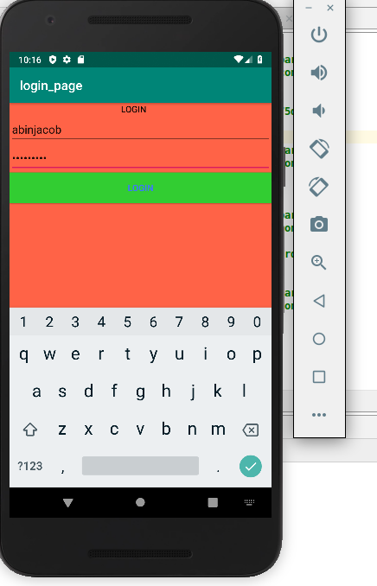

3.) Read a value/content from edit text & print it in a text view

activity_main.xml

<LinearLayout xmlns:android="http://schemas.android.com/apk/res/android"
android:layout_width="match_parent"
android:layout_height="match_parent"
android:orientation="vertical">
<EditText
android:layout_width="match_parent"
android:layout_height="wrap_content"
android:hint="Enter your Name"
android:id="@+id/et1"/>
<TextView
android:layout_width="match_parent"
android:layout_height="wrap_content"
android:text=""
android:textColor="#000000"
android:layout_marginLeft="175dp"
android:id="@+id/tv1"/>
<Button
android:layout_width="match_parent"
android:layout_height="wrap_content"
android:text="Click Here"
android:background="#32cd32"
android:textColor="#3f76ff"
android:id="@+id/btn1"
android:onClick="Click"/>
</LinearLayout>

MainActivity.java
package com.example.sjcet.text_view;
import android.support.v7.app.AppCompatActivity;
import android.os.Bundle;
import android.view.View;
import android.widget.EditText;
import android.widget.TextView;
public class MainActivity extends AppCompatActivity {
@Override
protected void onCreate(Bundle savedInstanceState) {
super.onCreate(savedInstanceState);
setContentView(R.layout.activity_main);
}
public void Click(View view) {
EditText edit = (EditText)findViewById(R.id.et1);
TextView tview = (TextView)findViewById(R.id.tv1);
String result = edit.getText().toString();
tview.setText(result);
}
}

OUTPUT

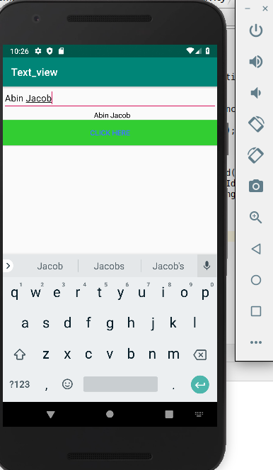

2.)Change the content in the text view on a button click

activity_main.xml

<LinearLayout xmlns:android="http://schemas.android.com/apk/res/android"
android:layout_width="match_parent"
android:layout_height="match_parent"
android:orientation="vertical">
<TextView
android:layout_width="match_parent"
android:layout_height="wrap_content"
android:text="Good Morning"
android:textColor="#000000"
android:layout_marginLeft="175dp"
android:id="@+id/tv1"/>
<Button
android:layout_width="match_parent"
android:layout_height="wrap_content"
android:text="Change Content"
android:background="#32cd32"
android:textColor="#3f76ff"
android:id="@+id/btn1"
android:onClick="Click"/>
</LinearLayout>

MainActivity.java
package com.example.sjcet.change_txt;
import android.support.v7.app.AppCompatActivity;
import android.os.Bundle;
import android.view.View;
import android.widget.TextView;
public class MainActivity extends AppCompatActivity {
@Override
protected void onCreate(Bundle savedInstanceState) {
super.onCreate(savedInstanceState);
setContentView(R.layout.activity_main);
}
public void Click(View view) {
((TextView)findViewById(R.id.tv1)).setText("Good Night");
}
}

OUTPUT

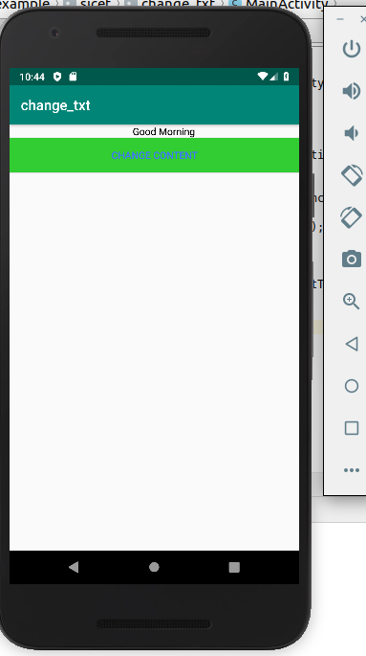
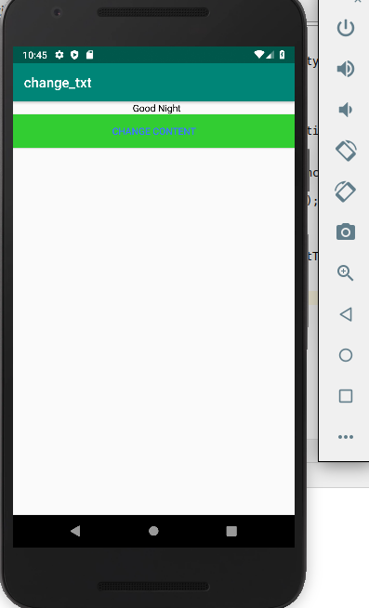

4.)Change the background colour on a button click

activity_main.xml

<LinearLayout xmlns:android="http://schemas.android.com/apk/res/android"
android:layout_width="match_parent"
android:layout_height="match_parent"
android:orientation="vertical"
android:background="#191970"
android:id="@+id/ll1">
<Button
android:layout_width="match_parent"
android:layout_height="wrap_content"
android:text="Click Here"
android:background="#32cd32"
android:textColor="#3f76ff"
android:id="@+id/btn1"
android:onClick="Click"/>
</LinearLayout>
MainActivity.java
package com.example.sjcet.background_clr;
import android.graphics.Color;
import android.support.v7.app.AppCompatActivity;
import android.os.Bundle;
import android.view.View;
import android.widget.LinearLayout;
public class MainActivity extends AppCompatActivity {
@Override
protected void onCreate(Bundle savedInstanceState) {
super.onCreate(savedInstanceState);
setContentView(R.layout.activity_main);
}
public void Click(View view) {
LinearLayout layout1;
layout1 = findViewById(R.id.ll1);
layout1.setBackgroundColor(Color.RED);
}
}
OUTPUT

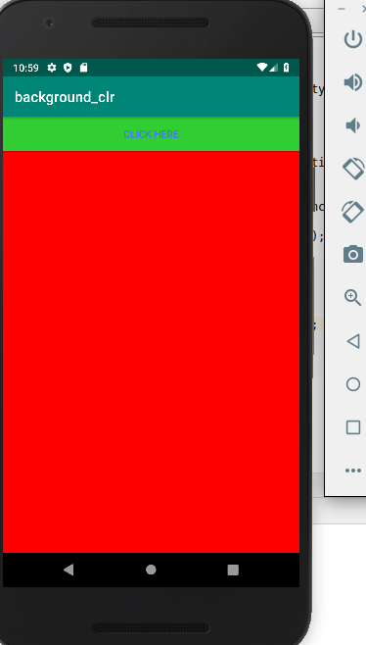

5.)create a sample calculator

activity_main.xml

<?xml version="1.0" encoding="utf-8"?>
<RelativeLayout xmlns:android="http://schemas.android.com/apk/res/android"
xmlns:tools="http://schemas.android.com/tools"
android:id="@+id/relative1"
android:layout_width="match_parent"
android:layout_height="match_parent"
tools:context=".MainActivity">
<EditText
android:id="@+id/edt1"
android:layout_width="match_parent"
android:layout_height="wrap_content" />
<Button
android:id="@+id/button1"
style="?android:attr/buttonStyleSmall"
android:layout_width="wrap_content"
android:layout_height="wrap_content"
android:layout_alignEnd="@+id/button4"
android:layout_alignRight="@+id/button4"
android:layout_below="@+id/edt1"
android:layout_marginTop="94dp"
android:text="1" />
<Button
android:id="@+id/button2"
style="?android:attr/buttonStyleSmall"
android:layout_width="wrap_content"
android:layout_height="wrap_content"
android:layout_alignTop="@+id/button1"
android:layout_toLeftOf="@+id/button3"
android:layout_toStartOf="@+id/button3"
android:text="2" />
<Button
android:id="@+id/button3"
style="?android:attr/buttonStyleSmall"
android:layout_width="wrap_content"
android:layout_height="wrap_content"
android:layout_alignTop="@+id/button2"
android:layout_centerHorizontal="true"
android:text="3" />
<Button
android:id="@+id/button4"
style="?android:attr/buttonStyleSmall"
android:layout_width="wrap_content"
android:layout_height="wrap_content"
android:layout_below="@+id/button1"
android:layout_toLeftOf="@+id/button2"
android:text="4" />
<Button
android:id="@+id/button5"
style="?android:attr/buttonStyleSmall"
android:layout_width="wrap_content"
android:layout_height="wrap_content"
android:layout_alignBottom="@+id/button4"
android:layout_alignLeft="@+id/button2"
android:layout_alignStart="@+id/button2"
android:text="5" />
<Button
android:id="@+id/button6"
style="?android:attr/buttonStyleSmall"
android:layout_width="wrap_content"
android:layout_height="wrap_content"
android:layout_alignLeft="@+id/button3"
android:layout_alignStart="@+id/button3"
android:layout_below="@+id/button3"
android:text="6" />
<Button
android:id="@+id/button7"
style="?android:attr/buttonStyleSmall"
android:layout_width="wrap_content"
android:layout_height="wrap_content"
android:layout_below="@+id/button4"
android:layout_toLeftOf="@+id/button2"
android:text="7" />
<Button
android:id="@+id/button8"
style="?android:attr/buttonStyleSmall"
android:layout_width="wrap_content"
android:layout_height="wrap_content"
android:layout_alignLeft="@+id/button5"
android:layout_alignStart="@+id/button5"
android:layout_below="@+id/button5"
android:text="8" />
<Button
android:id="@+id/button9"
style="?android:attr/buttonStyleSmall"
android:layout_width="wrap_content"
android:layout_height="wrap_content"
android:layout_alignLeft="@+id/button6"
android:layout_alignStart="@+id/button6"
android:layout_below="@+id/button6"
android:text="9" />
<Button
android:id="@+id/buttonadd"
style="?android:attr/buttonStyleSmall"
android:layout_width="wrap_content"
android:layout_height="wrap_content"
android:layout_alignEnd="@+id/edt1"
android:layout_alignRight="@+id/edt1"
android:layout_alignTop="@+id/button3"
android:layout_marginLeft="46dp"
android:layout_marginStart="46dp"
android:layout_toRightOf="@+id/button3"
android:text="+" />
<Button
android:id="@+id/buttonsub"
style="?android:attr/buttonStyleSmall"
android:layout_width="wrap_content"
android:layout_height="wrap_content"
android:layout_alignEnd="@+id/buttonadd"
android:layout_alignLeft="@+id/buttonadd"
android:layout_alignRight="@+id/buttonadd"
android:layout_alignStart="@+id/buttonadd"
android:layout_below="@+id/buttonadd"
android:text="-" />
<Button
android:id="@+id/buttonmul"
style="?android:attr/buttonStyleSmall"
android:layout_width="wrap_content"
android:layout_height="wrap_content"
android:layout_alignLeft="@+id/buttonsub"
android:layout_alignParentEnd="true"
android:layout_alignParentRight="true"
android:layout_alignStart="@+id/buttonsub"
android:layout_below="@+id/buttonsub"
android:text="*" />
<Button
android:id="@+id/button10"
style="?android:attr/buttonStyleSmall"
android:layout_width="wrap_content"
android:layout_height="wrap_content"
android:layout_below="@+id/button7"
android:layout_toLeftOf="@+id/button2"
android:text="." />
<Button
android:id="@+id/button0"
style="?android:attr/buttonStyleSmall"
android:layout_width="wrap_content"
android:layout_height="wrap_content"
android:layout_alignLeft="@+id/button8"
android:layout_alignStart="@+id/button8"
android:layout_below="@+id/button8"
android:text="0" />
<Button
android:id="@+id/buttonC"
style="?android:attr/buttonStyleSmall"
android:layout_width="wrap_content"
android:layout_height="wrap_content"
android:layout_alignLeft="@+id/button9"
android:layout_alignStart="@+id/button9"
android:layout_below="@+id/button9"
android:text="C" />
<Button
android:id="@+id/buttondiv"
style="?android:attr/buttonStyleSmall"
android:layout_width="wrap_content"
android:layout_height="wrap_content"
android:layout_alignEnd="@+id/buttonmul"
android:layout_alignLeft="@+id/buttonmul"
android:layout_alignRight="@+id/buttonmul"
android:layout_alignStart="@+id/buttonmul"
android:layout_below="@+id/buttonmul"
android:text="/" />
<Button
android:id="@+id/buttoneql"
android:layout_width="wrap_content"
android:layout_height="wrap_content"
android:layout_alignEnd="@+id/buttondiv"
android:layout_alignLeft="@+id/button10"
android:layout_alignRight="@+id/buttondiv"
android:layout_alignStart="@+id/button10"
android:layout_below="@+id/button0"
android:layout_marginTop="37dp"
android:text="=" />
</RelativeLayout>

MainActivity.java
package com.example.sjcet.sample_calculator;
import android.os.Bundle;
import android.support.v7.app.AppCompatActivity;
import android.view.View;
import android.widget.Button;
import android.widget.EditText;
public class MainActivity extends AppCompatActivity {
Button button0, button1, button2, button3, button4, button5, button6,
button7, button8, button9, buttonAdd, buttonSub, buttonDivision,
buttonMul, button10, buttonC, buttonEqual;
EditText crunchifyEditText;
float mValueOne, mValueTwo;
boolean crunchifyAddition, mSubtract, crunchifyMultiplication, crunchifyDivision;
@Override
protected void onCreate(Bundle savedInstanceState) {
super.onCreate(savedInstanceState);
setContentView(R.layout.activity_main);
button0 = (Button) findViewById(R.id.button0);
button1 = (Button) findViewById(R.id.button1);
button2 = (Button) findViewById(R.id.button2);
button3 = (Button) findViewById(R.id.button3);
button4 = (Button) findViewById(R.id.button4);
button5 = (Button) findViewById(R.id.button5);
button6 = (Button) findViewById(R.id.button6);
button7 = (Button) findViewById(R.id.button7);
button8 = (Button) findViewById(R.id.button8);
button9 = (Button) findViewById(R.id.button9);
button10 = (Button) findViewById(R.id.button10);
buttonAdd = (Button) findViewById(R.id.buttonadd);
buttonSub = (Button) findViewById(R.id.buttonsub);
buttonMul = (Button) findViewById(R.id.buttonmul);
buttonDivision = (Button) findViewById(R.id.buttondiv);
buttonC = (Button) findViewById(R.id.buttonC);
buttonEqual = (Button) findViewById(R.id.buttoneql);
crunchifyEditText = (EditText) findViewById(R.id.edt1);
button1.setOnClickListener(new View.OnClickListener() {
@Override
public void onClick(View v) {
crunchifyEditText.setText(crunchifyEditText.getText() + "1");
}
});
button2.setOnClickListener(new View.OnClickListener() {
@Override
public void onClick(View v) {
crunchifyEditText.setText(crunchifyEditText.getText() + "2");
}
});
button3.setOnClickListener(new View.OnClickListener() {
@Override
public void onClick(View v) {
crunchifyEditText.setText(crunchifyEditText.getText() + "3");
}
});
button4.setOnClickListener(new View.OnClickListener() {
@Override
public void onClick(View v) {
crunchifyEditText.setText(crunchifyEditText.getText() + "4");
}
});
button5.setOnClickListener(new View.OnClickListener() {
@Override
public void onClick(View v) {
crunchifyEditText.setText(crunchifyEditText.getText() + "5");
}
});
button6.setOnClickListener(new View.OnClickListener() {
@Override
public void onClick(View v) {
crunchifyEditText.setText(crunchifyEditText.getText() + "6");
}
});
button7.setOnClickListener(new View.OnClickListener() {
@Override
public void onClick(View v) {
crunchifyEditText.setText(crunchifyEditText.getText() + "7");
}
});
button8.setOnClickListener(new View.OnClickListener() {
@Override
public void onClick(View v) {
crunchifyEditText.setText(crunchifyEditText.getText() + "8");
}
});
button9.setOnClickListener(new View.OnClickListener() {
@Override
public void onClick(View v) {
crunchifyEditText.setText(crunchifyEditText.getText() + "9");
}
});
button0.setOnClickListener(new View.OnClickListener() {
@Override
public void onClick(View v) {
crunchifyEditText.setText(crunchifyEditText.getText() + "0");
}
});
buttonAdd.setOnClickListener(new View.OnClickListener() {
@Override
public void onClick(View v) {
if (crunchifyEditText == null) {
crunchifyEditText.setText("");
} else {
mValueOne = Float.parseFloat(crunchifyEditText.getText() + "");
crunchifyAddition = true;
crunchifyEditText.setText(null);
}
}
});
buttonSub.setOnClickListener(new View.OnClickListener() {
@Override
public void onClick(View v) {
mValueOne = Float.parseFloat(crunchifyEditText.getText() + "");
mSubtract = true;
crunchifyEditText.setText(null);
}
});
buttonMul.setOnClickListener(new View.OnClickListener() {
@Override
public void onClick(View v) {
mValueOne = Float.parseFloat(crunchifyEditText.getText() + "");
crunchifyMultiplication = true;
crunchifyEditText.setText(null);
}
});
buttonDivision.setOnClickListener(new View.OnClickListener() {
@Override
public void onClick(View v) {
mValueOne = Float.parseFloat(crunchifyEditText.getText() + "");
crunchifyDivision = true;
crunchifyEditText.setText(null);
}
});
buttonEqual.setOnClickListener(new View.OnClickListener() {
@Override
public void onClick(View v) {
mValueTwo = Float.parseFloat(crunchifyEditText.getText() + "");
if (crunchifyAddition == true) {
crunchifyEditText.setText(mValueOne + mValueTwo + "");
crunchifyAddition = false;
}
if (mSubtract == true) {
crunchifyEditText.setText(mValueOne - mValueTwo + "");
mSubtract = false;
}
if (crunchifyMultiplication == true) {
crunchifyEditText.setText(mValueOne * mValueTwo + "");
crunchifyMultiplication = false;
}
if (crunchifyDivision == true) {
crunchifyEditText.setText(mValueOne / mValueTwo + "");
crunchifyDivision = false;
}
}
});
buttonC.setOnClickListener(new View.OnClickListener() {
@Override
public void onClick(View v) {
crunchifyEditText.setText("");
}
});
button10.setOnClickListener(new View.OnClickListener() {
@Override
public void onClick(View v) {
crunchifyEditText.setText(crunchifyEditText.getText() + ".");
}
});
}
}
OUTPUT
