**VACCINE APPLICATION OUTCOMES**

1. Home Page

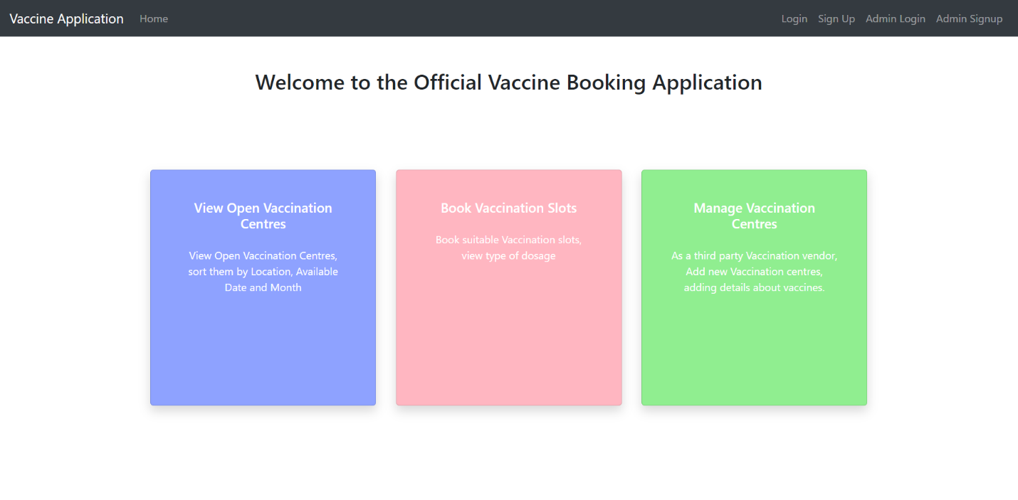

1. Login Page (Similar for both User and Admin)

1. Register Page (Similar for both User and Admin)

1. Vaccination Center Booking Page (User only)

1. View and Cancel User Bookings (User specific bookings)

1. Add Vaccination Centers (Admin Only)

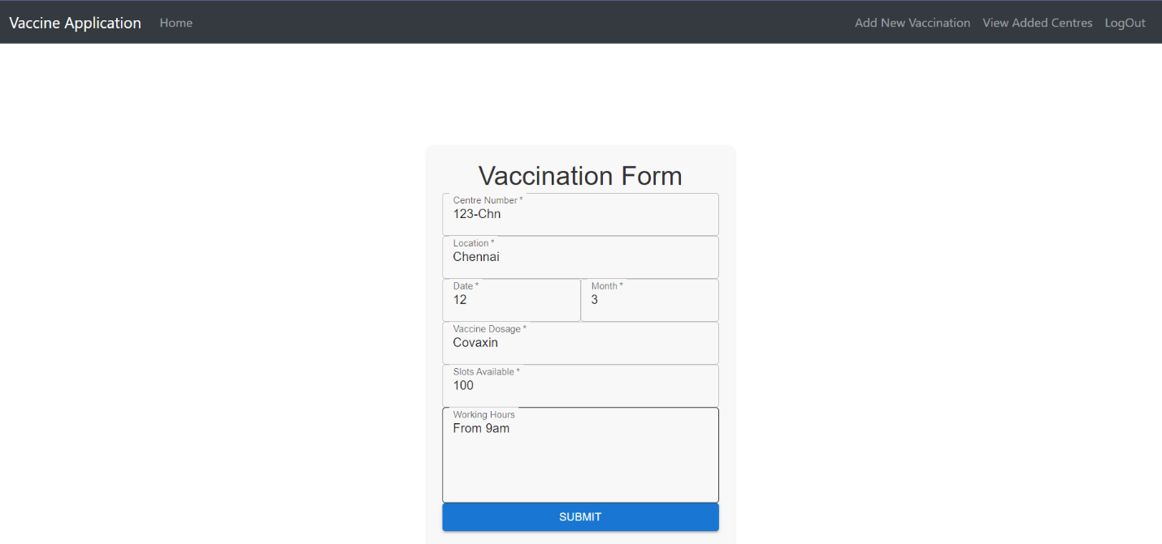

1. Update Vaccination Slots

