<!DOCTYPE html>

<html lang="en" dir="ltr">

<head>

  <meta charset="utf-8">

  <title>CALCULATOR</title>

  <link rel="stylesheet" href="cal.css">

</head>

 <center><h1><b>CALCULATOR</b></h1></center>

<body>

<table class="calculator" >

  <tr>

    <td colspan="3"> <input class="display-box" type="text" id="result" disabled /> </td>

    <!-- clearScreen() function clears all the values -->

    <td> <input type="button" value="C" onclick="clearScreen()" id="btn" /> </td>

  </tr>

  <tr>

    <!-- display() function displays the value of clicked button -->

    <td> <input type="button" value="1" onclick="display('1')" /> </td>

    <td> <input type="button" value="2" onclick="display('2')" /> </td>

    <td> <input type="button" value="3" onclick="display('3')" /> </td>

    <td> <input type="button" value="/" onclick="display('/')" /> </td>

  </tr>

  <tr>

    <td> <input type="button" value="4" onclick="display('4')" /> </td>

    <td> <input type="button" value="5" onclick="display('5')" /> </td>

    <td> <input type="button" value="6" onclick="display('6')" /> </td>

    <td> <input type="button" value="-" onclick="display('-')" /> </td>

  </tr>

  <tr>

    <td> <input type="button" value="7" onclick="display('7')" /> </td>

    <td> <input type="button" value="8" onclick="display('8')" /> </td>

    <td> <input type="button" value="9" onclick="display('9')" /> </td>

    <td> <input type="button" value="+" onclick="display('+')" /> </td>

  </tr>

  <tr>

    <td> <input type="button" value="." onclick="display('.')" /> </td>

    <td> <input type="button" value="0" onclick="display('0')" /> </td>

    <!-- calculate() function evaluates the mathematical expression -->

    <td> <input type="button" value="=" onclick="calculate()" id="btn" /> </td>

    <td> <input type="button" value="\*" onclick="display('\*')" /> </td>

  </tr>

</table>

<script type="text/javascript" src="java.js"></script>

</body>

</html>

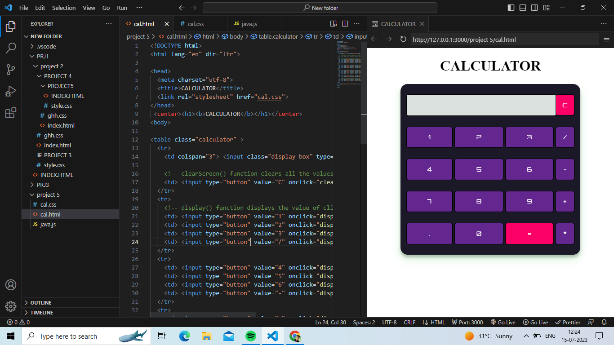

@import url('<https://fonts.googleapis.com/css2?family=Orbitron&display=swap>');

.calculator {

    padding: 10px;

    border-radius: 1em;

    height: 380px;

    width: 400px;

    margin: auto;

    background-color: #1b1928;

    box-shadow: rgba(41, 189, 53, 0.19) 0px 10px 20px, rgba(0, 0, 0, 0.23) 0px 6px 6px;

}

.display-box {

    font-family: 'Orbitron', sans-serif;

    background-color: #dbe1df;

    border: solid rgb(0, 0, 0) 0.5px;

    color: rgb(0, 0, 0);

    border-radius: 5px;

    width: 100%;

    height: 65%;

}

#btn {

    background-color: #fb0066;

}

input[type=button] {

    font-family: 'Orbitron', sans-serif;

    background-image: url();

    background-color: #64278f;

    color: white;

    border: solid black 0.5px;

    width: 100%;

    border-radius: 5px;

    height: 70%;

    outline: none;

}

input:active[type=button] {

    background: #e5e5e5;

    -webkit-box-shadow: inset 0px 0px 5px #c1c1c1;

    -moz-box-shadow: inset 0px 0px 5px #c1c1c1;

    box-shadow: inset 0px 0px 5px #c1c1c1;

}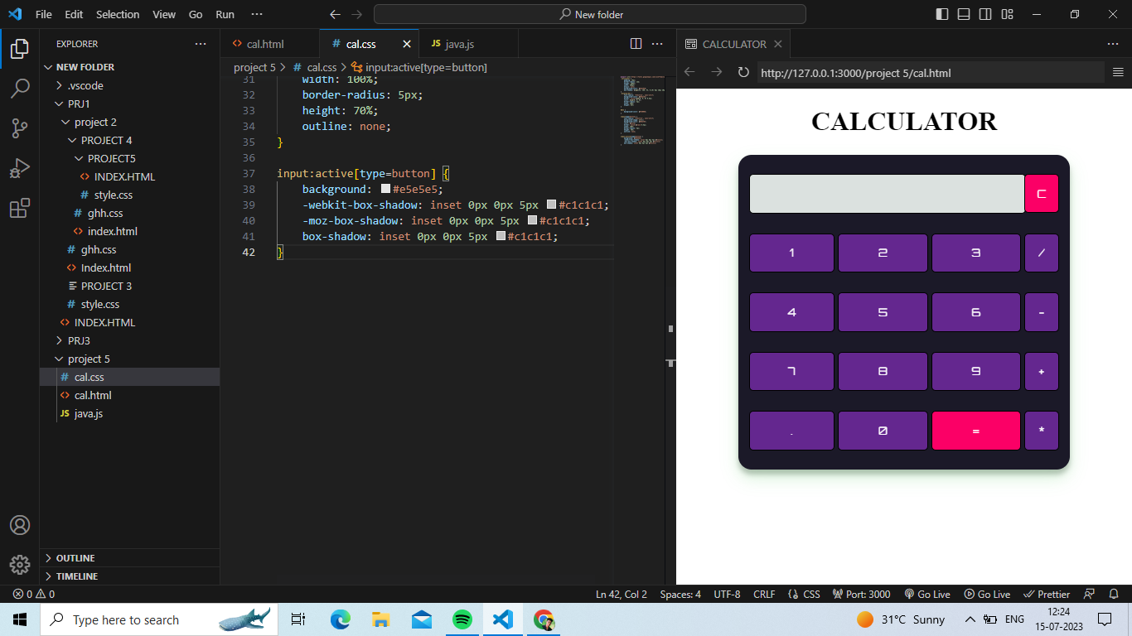

function clearScreen() {

    document.getElementById("result").value = "";

}

// This function display values

function display(value) {

    document.getElementById("result").value += value;

}

// This function evaluates the expression and returns result

function calculate() {

    var p = document.getElementById("result").value;

    var q = eval(p);

    document.getElementById("result").value = q;

}

