
Tribhuvan University
Faculty of Humanities and Social Sciences

A Project Report On
Book Recommender System

Submitted To
G.P. Koirala Memorial College
Department of Bachelor of Computer Applications
Sifal, Kathmandu

In partial fulfillment of the requirements for the Bachelor of Computer Applications

Submitted by
AbinasMahat & Sujan BK
Symbol no: 70302035 & 70302056

Under Supervision of
--------------------
2083
Tribhuvan University
Faculty of Humanities and Social Sciences
G.P. Koirala Memorial College
Sifal, Kathmandu
Bachelor of Computer Applications (BCA)

SUPERVISOR’S RECOMMENDATION
I hereby recommend that this project prepared under my supervision by Sujan BK & Abinas Mahat entitled “Book Recommender System” in the Partial Fulfillment of requirement for the degree of Bachelor of Computer Applications is recommended for that final evaluation.

Sujan Shrestha
Project Supervisor
BCA Department
G.P. Koirala Memorial College

Tribhuvan University
Faculty of Humanities and Social Sciences
G.P. Koirala Memorial College
Sifal, Kathmandu
Bachelors of Computer Applications (BCA)

LETTER OF APPROVAL
This is certified that this project prepared by Sujan BK & Abinas Mahat entitled “Book Recommender System” in the Partial Fulfillment of requirement for the degree of Bachelor of Computer Applications has been evaluated. In our opinion it is satisfactory in the scope and quality as a project for the required degree.
………………………………….  Sujan Shrestha  Supervisor  G.P. Koirala Memorial College | ………………………………….  External Examiner FOHSS, TU
………………………………….  Program Coordinator G.P. Koirala Memorial College | ………………………………….  Shiva Prasad Adhikari  Campus Chief  G.P. Koirala Memorial College

ABSTRACT
This project is about creating a “Book Recommender System” that helps users find the right books to read. The system uses two main methods: Popularity-Based Filtering and Cosine Similarity.
The popularity-based method recommends books that are liked by most people. It looks at things like how many people have rated the book and what the average rating is. This means the system can quickly suggest books that are trending, famous, or enjoyed by a large number of readers. This method is especially helpful for new users who have not rated any books yet.
The second method, Cosine Similarity, focuses on personal recommendations. It studies how users interact with books—such as which books they read, like, or rate. Then it finds users who have similar tastes and recommends books based on what those similar users enjoyed. This allows the system to give more accurate and personalized suggestions for each user.
By combining both methods, the system becomes more powerful. Popular books make sure users do not miss out on well-known titles, while Cosine Similarity helps match books to individual preferences. Together, they make the recommendations more balanced and useful. The project uses machine learning techniques to build and test the system. After creating the model, it is evaluated to check how well it recommends books and how easy it is for users to use. The main goal of this project is to make book discovery easier, help users find books they will enjoy, and improve their overall reading experience.
Keywords: Book Recommender System, Popularity Based Filtering, Cosine Similarity, Personal Recommendation, Machine Learning

ACKNOWLEDGEMENT
We would like to extend our heartfelt appreciation to our project manager for allowing us the opportunity to work on the Book Recommender System project. With the help of their guidance, we were able to acquire valuable knowledge and hands-on experience with different tools and technologies relevant to the domain. We would also like to thank Mr. Unique Karki, BCA Program Coordinator, for his relentless support, motivation, and guidance throughout the project.
We express our appreciation to our institution for offering us support, guidance, and an academic atmosphere that facilitated completing this project. We also thank the library staff and everyone at the institution for working with us and assisting us with our project.
Most importantly, we sincerely appreciate our family and friends for their unwavering support and encouragement. Extra thanks go to the educational institution for the chance to learn project ethics and real-world applications through the Computer Application course that significantly added to our knowledge.

Yours Sincerely,
Sujan BK & Abinas Mahat

TABLE OF CONTENT

SUPERVISOR’S RECOMMENDATION ii
LETTER OF APPROVAL iii
ABSTRACT iv
ACKNOWLEDGEMENT v
LIST OF FIGURES viii
LIST OF TABLES ix
ABBREVIATIONS LIST x
CHAPTER 1: INTRODUCTION 1
1.1 Introduction 1
1.2 Problem Statement 2
1.3 Objectives 2
1.4 Scope and Limitation 2
1.5 Development Methodology 3
4
1.6 Report Organization 4
CHAPTER 2: BACKGROUND STUDY AND LITERATURE REVIEW 6
2.1 Background Study 6
2.2 Literature Review 7
CHAPTER 3: SYSTEM ANALYSIS AND DESIGN 9
3.1 System Analysis 9
3.1.1 Requirement Analysis 9
3.1.2 Feasibility Analysis 11
3.1.3 Object Modelling using Class and Object Diagrams: 13
3.1.4 Dynamic Modelling using State and Sequence Diagrams: 15
3.1.5 Process Modelling using Activity Diagrams: 18
3.2 System Design 20
3.2.1 Refinement of Class, Object, State, Sequence and Activity Diagrams 20
3.2.2 Component Diagrams: 22
3.2.3 Deployment Diagrams: 23
3.3 Algorithm Details 24
CHAPTER 4 IMPLEMENTATION AND TESTING 28
4.1 Implementation 28
4.1.1 Tools Used (CASE Tools, Programming Languages, Database Platforms): 28
4.1.2 Implementation Details of Modules 29
4.2 Testing 30
4.2.1 Test Cases for Unit Testing: 30
4.2.2 Test Cases for System Testing: 31
4.2.3 Result Analysis: 32
CHAPTER 5 CONCLUSION AND FUTURE RECOMMENDATIONS 34
5.1 Conclusion 34
5.2 Future Recommendations 35
REFERENCES 37

LIST OF FIGURES
Figure 1 Agile Methodology For BRS 4
Figure 2 Use Case Diagram of BRS 10
Figure 3 Gantt chart BRS 13
Figure 4 Class Diagram of BRS 14
Figure 5 Object Diagram of BRS 15
Figure 6 State Diagram of BRS 16
Figure 7 Sequence Diagram of BRS 17
Figure 8 Activity Diagram of Book BRS 19
Figure 9 Component Diagram of Book BRS 22
Figure 10 Deployment Diagram of BRS 23

LIST OF TABLES
Table 1 Gantt Chart Table 12
Table 2 Unit Testing 31
Table 3 System Testing 32

ABBREVIATIONS LIST

API | Application Programming Interface
BRS | Book Recommender System
PBF | Popularity Based Filtering
CF | Cosine Similarity
HTML | Hyper Text Markup Language
WA | Weighted Average
ML | Machine Learning
UI | User Inerface
CS | Cosine Similarity
PR | Predict Rating
AR | Average Rating

CHAPTER 1: INTRODUCTION

Introduction
Book Recommender System is a smart software that is aimed to assist users in finding the books that suit their tastes and preferences in terms of reading. As the digital content grows rapidly, to settle on the right books, readers usually experience a challenge in filtering through big collections. This system takes care of that issue by looking at book information, the ratings of the users and the similarities among different books, in order to give meaningful suggestions. The key objective of the system is to improve the user experience by providing customized and trending book recommendations using a user-friendly web-based interface.
This project deploys the recommender system based on Flask, a lightweight Python web framework, and such libraries as NumPy, Pandas, and Scikit-learn. Pickle files are used to load preprocessed datasets and trained models to make the performance faster. The system has user sessions which are automatically created and given a unique user ID within which each user can freely interact with the system. These data are book data, user data and ratings stored in CSV files which make the system easy, transparent and simple to manage.
The system employs two significant approaches to recommendations. The first is a Popularity-Based Recommendation, where the most popular books are shown in terms of average rating and the number of votes by the users. Popularity and quality of rating are also divided by the use of a weighted rating formula. The second is Cosine Similarity where some similarity between the books and books is determined based on the cosine similarity. In case the user picks a book, the system will locate other similar books and predict their ratings by adding similarity scores with the current user ratings.
Furthermore, the system enables the user to get more in-depth details on the books, such as the author, images, and descriptions, which are dynamically retrieved by the use of the Google Books API. Users are able to rate books and the system will guarantee that it will not allow duplicate ratings to be made just to hold the integrity of the data. The flash messages give real time and feedback on successful or invalid actions. On the whole, this Book Recommender System shows that machine learning methods and the web technologies can be successfully integrated to create an efficient but easy-to-use recommendation system.

1.2 Problem Statement
The main problems addressed by this project include:
- As the number of online books grows at a high rate, customers struggle to find out books that are of their interest given the overload of information online.
- Traditional book browsing methods do not provide personalized recommendations based on user preferences and reading behavior.
- Popular books with fewer ratings may be ignored, while books with many ratings may dominate recommendations without proper weighting.

1.3 Objectives
The main objective of Book Recommender System are:
- To create and develop a web-based Book Recommender System that assists users to explore the relevant books effectively based on machine learning techniques.
- To apply popularity-based and collaborative-filtering techniques so as to come up with good and relevant book recommendations.
- To enable users to rate books in a safe manner and to eliminate cases of duplication of ratings which will enhance the quality of the recommendations and the reliability of the data used.

1.4 Scope and Limitation
Some of the future scopes of the system are:
- Personalized Recommendations: The system recommends user-relevant books to them, based on an analysis of their similarities and popularity.
- User Interaction: Users can search books, view details, and rate books through a web-based interface.
- Rating Management: The system records user ratings while preventing duplicate ratings to maintain data accuracy.
- Popularity Analysis: Books are ranked using average and weighted ratings to highlight quality content.
Some of the limitations of the system are:
- Data Dependency: Recommendation quality depends on the availability and reliability of user ratings.
- Scalability Constraints: Performance may decrease when handling very large datasets.
- Limited Personalization: The system does not consider user demographics or reading behavior.

1.5 Development Methodology
The Agile development methodology is a flexible way of building software where work is done step by step instead of all at once. Rather than waiting until the end to see results, Agile focuses on developing small parts of the system and improving them continuously. This makes it easier to understand the project, fix mistakes early, and adapt to changes during development.
In this Book Recommender System, Agile was followed by dividing the work into smaller parts such as data handling, recommendation logic, user interface, and rating features. Each part was developed and tested separately before moving to the next one. This helped in managing the project better and reduced confusion while writing and testing the code.
Agile also allowed regular improvements based on testing and feedback. For example, recommendation logic and rating validation were first implemented in a basic form and then improved to make the system more accurate and user-friendly. If something didn’t work as expected, it was corrected immediately in the next step instead of waiting until the end.
Overall, using Agile made the development process smoother and less stressful. It provided flexibility, saved time, and helped in building a reliable system step by step. This approach ensured that the final Book Recommender System was functional, organized, and easy to improve in the future.
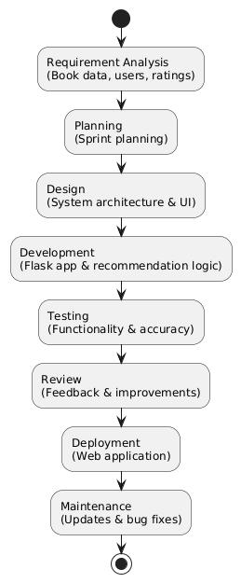

Figure 1 Agile Methodology for BRS

1.6 Report Organization
The report begins with an introduction to the proposed Book Recommender System, a Flask-based web application designed to help users discover books that match their interests. It explains the core functionality of the system, which includes analyzing book data, user ratings, and similarity scores to generate meaningful recommendations. The introduction also highlights user-focused features such as automatic user identification, viewing popular books, searching for recommendations, rating books, and viewing detailed book information including descriptions fetched through an external API. Additionally, this chapter briefly discusses the recommendation techniques used and the overall development methodology adopted for the system.
Chapter 2 focuses on the analysis of existing book recommendation systems and their commonly used approaches. It compares traditional recommendation methods with the proposed system to justify the chosen design. This chapter also presents a detailed requirement and feasibility analysis, covering both functional requirements such as book recommendation, rating management, and duplicate rating prevention, as well as non-functional requirements including system performance, usability, data reliability, and scalability.
Chapter 3 provides a detailed explanation of the system architecture and design. It describes how popularity-based filtering and Cosine Similarity techniques are implemented using cosine similarity. This chapter also explains the data flow between datasets, machine learning models, and the Flask web application. The integration of pre-trained similarity models with the web interface for real-time recommendations is discussed in detail.
Chapter 4 explains the tools and technologies used in developing the Book Recommender System, including Python, Flask, Pandas, NumPy, and Scikit-learn. It describes the implementation of core modules such as recommendation logic, user rating validation, session management, and book detail handling. This chapter also covers the testing strategies used to verify recommendation accuracy, system functionality, and overall application reliability.
Finally, Chapter 5 concludes the report by summarizing the overall achievements of the project and evaluating its performance. It also discusses future enhancements such as improved personalization, advanced user behavior analysis, scalability improvements, and integration with larger book databases to make the system more effective and suitable for real-world use.

CHAPTER 2: BACKGROUND STUDY AND LITERATURE REVIEW

2.1 Background Study
Books play an important role in education, entertainment, and personal growth, but choosing the right book from a vast collection can be difficult for readers. With the rapid growth of online bookstores and digital libraries, users are often overwhelmed by the number of available options. Manually searching through reviews, ratings, and categories is time-consuming and does not always lead to satisfactory choices, especially for new readers.
Book recommender systems help solve this problem by automatically suggesting books based on user preferences and interaction data. These systems analyse information such as book ratings, popularity, and similarities between books to generate meaningful recommendations. Popularity-based methods recommend books that are widely liked, while Cosine Similarity techniques identify relationships between books based on user rating patterns, making recommendations more personalized and relevant.
In recent years, machine learning techniques have been widely used in recommender systems to improve accuracy and user experience. Similarity measures such as cosine similarity help determine how closely related two books are. By using pre-processed datasets containing book details and user ratings, these models can efficiently predict user interest and recommend books even when direct feedback is limited.
This project develops a Book Recommender System using popularity-based filtering and Cosine Similarity techniques. The recommendation engine is integrated into a Flask-based web application that provides a simple and interactive interface. Users are automatically assigned a unique ID, can view popular books, search for similar book recommendations, rate books, and view detailed book information. By combining machine learning with web technologies, the system aims to make book selection easier, faster, and more personalized for users.

2.2 Literature Review
The rapid expansion of digital libraries, online bookstores, and reading platforms has made book selection increasingly challenging for users. With thousands of books available across multiple genres, readers often struggle to find content that aligns with their interests and preferences. Traditional browsing and keyword-based search methods are limited in their ability to provide personalized suggestions, leading to user dissatisfaction. To overcome these challenges, Book Recommender Systems have become an essential research area in information retrieval and data mining, aiming to automatically suggest relevant books by analysing user behaviour and book-related data.
Recommender systems rely heavily on machine learning techniques to identify meaningful patterns in large datasets. Among various approaches, Cosine Similarity has been widely adopted due to its effectiveness in capturing user preferences through rating data. Item-based Cosine Similarity, in particular, recommends books by analyzing similarities between items rather than users, making it more scalable and stable for large datasets. Similarity measures such as cosine similarity are commonly used to quantify the relationship between books based on user ratings [1]. Despite its success, Cosine Similarity faces challenges such as sparse rating matrices, which can affect recommendation accuracy.
Popularity-based recommendation techniques offer a simpler yet effective alternative, especially for users with little or no interaction history. These methods recommend books based on global popularity indicators such as average rating and number of reviews, ensuring that well-received books are highlighted. However, relying solely on average ratings may result in biased recommendations, as books with fewer ratings can appear disproportionately popular. To address this issue, weighted rating approaches have been introduced, balancing rating count and rating value to produce fairer and more reliable recommendations [2].
Recent research emphasizes the use of hybrid recommender systems that combine popularity-based filtering with Cosine Similarity techniques. By integrating global trends with similarity-based predictions, hybrid systems overcome the limitations of individual methods and improve overall recommendation quality [3]. These systems are better equipped to handle sparse data, new users, and evolving user preferences. Hybrid approaches also enhance recommendation diversity, ensuring users are exposed to a wider range of books rather than repetitive suggestions.
Modern Book Recommender Systems are increasingly implemented as web-based applications to improve accessibility and user engagement. Frameworks such as Flask enable seamless integration of recommendation algorithms with user interfaces, allowing real-time recommendations, user rating management, and detailed book information display. The literature suggests that deploying machine learning-based recommender systems through interactive web platforms results in scalable, efficient, and user-friendly solutions. Such systems not only improve user experience but also demonstrate strong potential for practical adoption in real-world digital reading environments.

CHAPTER 3: SYSTEM ANALYSIS AND DESIGN

3.1 System Analysis
System analysis for a Book Recommender System is a structured and systematic process that focuses on understanding user needs, book data, and recommendation requirements before system development. It involves studying existing book selection methods, identifying their limitations, and defining clear functional and non-functional requirements such as accurate recommendations, rating management, usability, and performance. By analyzing user interactions, data flow, and system constraints, system analysis provides a solid foundation for designing an efficient, reliable, and user-friendly Book Recommender System.

3.1.1 Requirement Analysis
The Book Recommender System is designed to suggest books to users based on their preferences, reading history, and ratings using popularity based filtering and Cosine Similarity algorithms. It provides a simple, intuitive interface for users to discover books they are likely to enjoy and make informed reading choices.
i. Functional Requirement
For Users:
- The user should be able to access the system and be automatically assigned a unique user identification.
- The user should be able to browse and view a list of popular and top-rated books.
- The system should display a popularity chart showing top books based on average or weighted ratings.
- The user should be able to search for a book and receive similar book recommendations.
- The system should display a cosine similarity graph on the recommendation page to visually represent similarity scores between the selected book and recommended books.
- The user should be able to view detailed information about a selected book, including author and description.

Use-Case Diagram
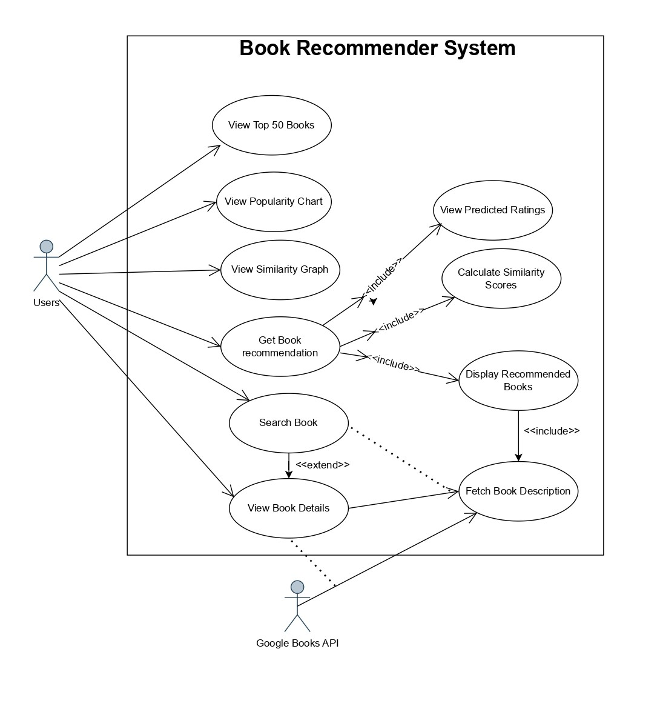
A Use-Case diagram is a graphical representation of how different actors (users or external systems) interact with this system. It showcases various use cases (functionalities) and their relationships, helping to visualize the system's behavior from a user's perspective.
Figure 2 Use Case Diagram of BRS

ii. Non-functional Requirements:
Non-functional requirements define the qualities and constraints that the Book Recommender System (BRS) must adhere to. These requirements focus on how well the system performs its functions rather than what functions it performs. Below are key non-functional requirements categorized into relevant areas:
- Performance: The system should generate and display book recommendations and charts within an acceptable response time.
- Accuracy: The system should provide relevant and accurate book recommendations based on ratings and similarity measures.
- Usability: The interface should be simple and user-friendly, allowing users to easily browse books, view recommendations, and rate books.
- Reliability: The system should handle multiple users simultaneously without data loss or system failure.
- Compatibility: The system should be compatible with standard web browsers and support common data formats used in the application.

Feasibility Analysis
Feasibility analysis is a crucial step in the development of the Book Recommender System (BRS). It evaluates various aspects to determine whether the project is practical, viable, and worth pursuing. The analysis is segmented into three key categories:
i. Technical Feasibility
- The system can be implemented using Python and Flask for backend development and web integration.
- Machine learning techniques such as Cosine Similarity and cosine similarity can be implemented using libraries like NumPy, Pandas, and Scikit-learn.
- Preprocessed datasets and trained models can be stored using pickle files to ensure faster system performance.
- The system supports standard web technologies and can be deployed on local servers or cloud platforms for scalability.
ii. Operational Feasibility
- The system interface is designed to be simple and user-friendly for readers with minimal technical knowledge.
- Users can easily browse books, search for recommendations, and rate books without requiring prior training.
- The system fits well into the existing workflow of online book browsing and reading platforms.
- Automated recommendation and rating features reduce manual effort and improve user experience.
iii. Economic Feasibility
- The system is developed using open-source tools and libraries, which significantly reduces development costs.
- No expensive hardware is required, as the system can run on standard computing environments.
- Deployment options can be chosen based on budget constraints, including local hosting or cloud-based services.
- The low operational cost makes the Book Recommender System economically viable and sustainable in the long term.
iv. Schedule Feasibility
Schedule feasibility evaluates whether the Book Recommender System can be completed within the planned time frame. The project is divided into manageable phases such as data preparation, recommendation model development, web application implementation, and testing. Since the system uses existing datasets, open-source tools, and an Agile development approach, the project timeline is realistic and achievable. Potential risks and delays can be managed through iterative development and regular testing, ensuring timely project completion.
Table 1 Gantt chart Table of BRS
S.N. | Task Name | Start Date | End Date | Duration
1 | Requirement Gathering | 01-Apr-2026 | 07-Apr-2026 | 7
2 | Designing | 08-Apr-2026 | 14-Apr -2026 | 7
3 | Construction/ iteration | 15-Apr-2026 | 24-Apr-2026 | 10
4 | Testing | 25-Apr-2026 | 20-May-2026 | 26
5 | Deployment | 21-May-2026 | 05-Jun-2026 | 16
6 | Feeback | 06-Jun-2026 | 10-Jun-2026 | 5
7 | Documentation | 11-Jun-2026 | 14-Jun-2026 | 4

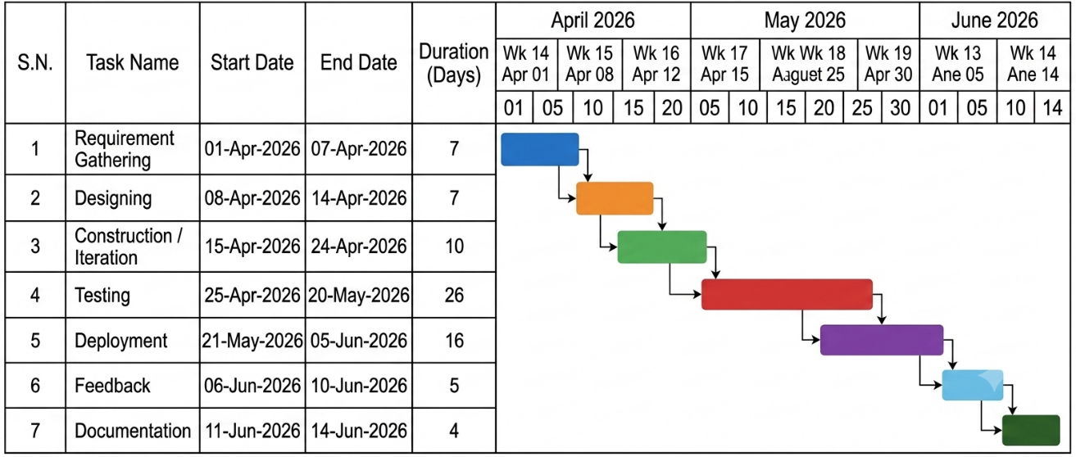
Figure 3 Gantt chart of BRS

Object Modelling using Class and Object Diagrams:
In object-oriented design, object modeling is used to represent the BRS system’s core entities and their interactions. Class and Object diagrams define the relationships and data structures necessary for system functionality.
i. Class Diagram: The class Diagram shows the classes involved in the system, such as user, image, preprocessor etc. Each class includes attributes and methods relevant to its purpose. For instance:

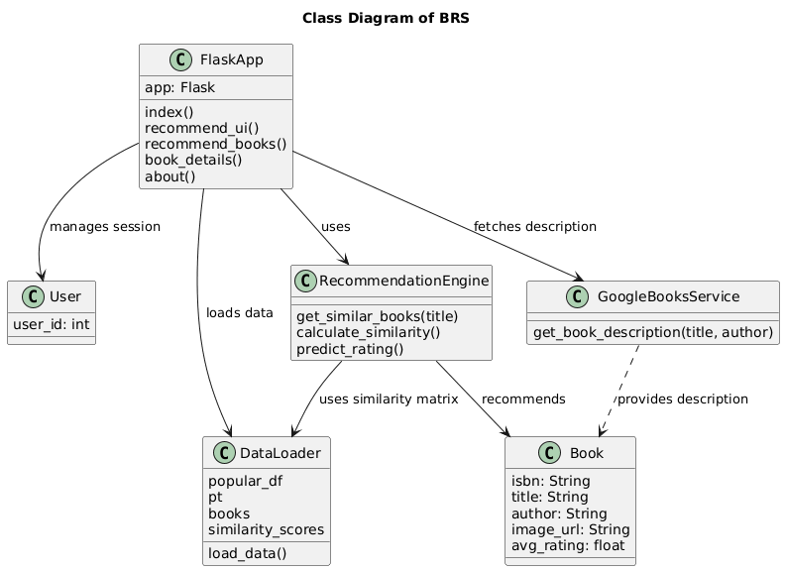
Figure 4 Class Diagram of BRS
- User: searches for books, and views recommendations.
- Book: Stores book metadata such as title, author, genre, description, and rating.
- Rating: Stores user ratings for books and methods to add or update ratings.
- Recommendation Engine: Generates personalized recommendations using popularity filtering and Cosine Similarity including rating prediction.
ii. Object Diagram: The object diagram represents an instance of the Book Recommender System during runtime. A User interacts with their Profile to manage preferences and reading history. The Recommendation Engine uses this information along with user Ratings to generate personalized book suggestions. Finally, Book objects are created and returned to the user as recommended items..

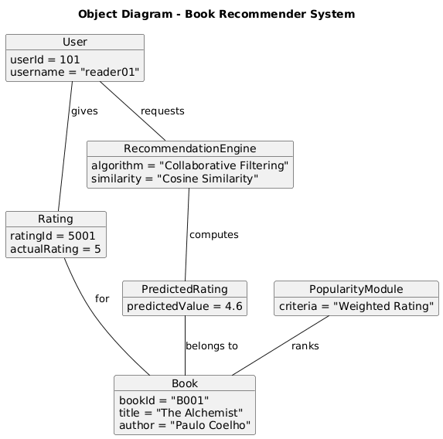

Figure 5 Object Diagram of BRS

Dynamic Modelling using State and Sequence Diagrams:
Dynamic modeling captures how objects interact over time, focusing on the flow of control and data.
i. State Diagram: The State Diagram models the states an object goes through in response to events. States might include:
- Idle: The system is waiting for the user to request book recommendations or search for books.
- Processing: The recommendation engine actively analyses the user’s profile, ratings to generate personalized book suggestions.
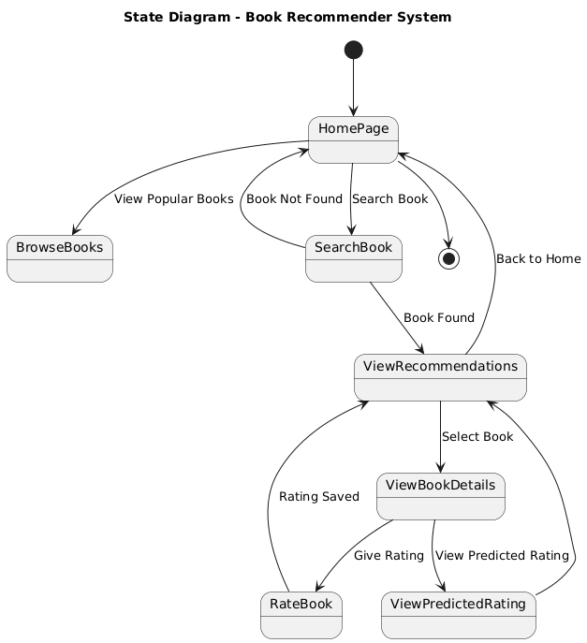
- Completed: The system has finished generating recommendations, and the results are ready for the user to view.

Figure 6 State Diagram of BRS
ii. Sequence Diagram
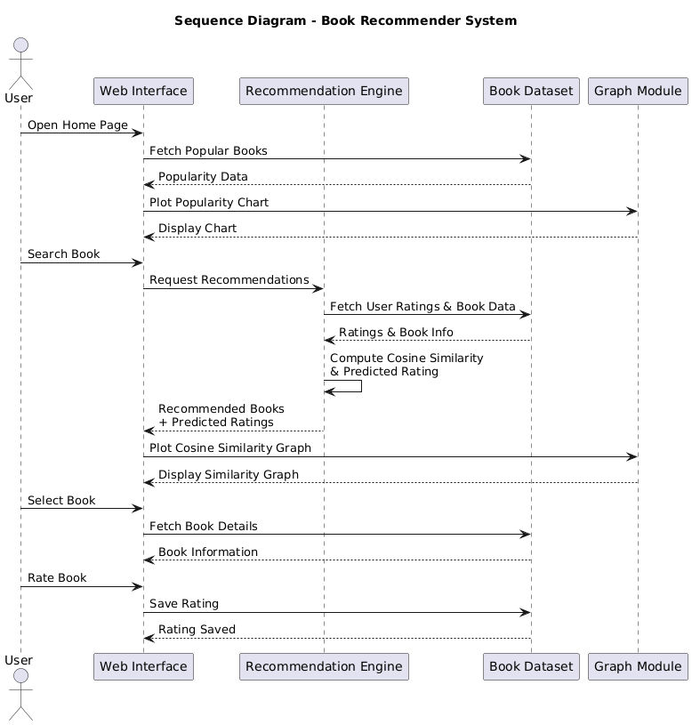
The sequence diagram represents the interaction between the user, web interface, Flask application, recommendation engine, and book database. The user accesses the system, browses popular books, searches for a book, and receives personalized recommendations generated using Cosine Similarity and cosine similarity. The system computes predicted ratings for recommended books and displays them along with visual charts. User ratings are stored in the database, allowing the system to improve future recommendations. The user can continue browsing or exit the system after completing the session.

Figure 7 Sequence Diagram of BRS
Short explanation of the sequence diagram:
- The user accesses the Book Recommender System through the web interface.
- The system displays popular books using a popularity-based filtering approach.
- The user searches for a book to receive personalized recommendations.
- The Flask application sends the request to the recommendation engine.
- The recommendation engine calculates similarity scores and predicted ratings using cosine similarity.
- The recommended books and graphical visualizations are displayed to the user.
- The user can rate books, and the ratings are stored in the database for future recommendations.

3.1.5 Process Modelling using Activity Diagrams:
Activity Diagrams describe the overall flow and decision points within the BRS, breaking down high-level processes into clear steps.
- Start: The process begins when the user opens the Book Recommender System through the web interface.
- Browse or Search Books: The user can browse popular books or search for a specific book by entering its title.
- Recommendation Processing: When a book is selected, the system processes the request by analyzing book data, user ratings, and similarity scores using cosine similarity.
- Prediction & Visualization: The system calculates predicted ratings for similar books and displays recommended books along with similarity graphs and popularity charts.
- User Interaction & Rating: The user views book details and may rate a book, after which the rating is stored in the database to improve future recommendations.
- End: The process ends with the user viewing updated recommendations or continuing to explore more books.

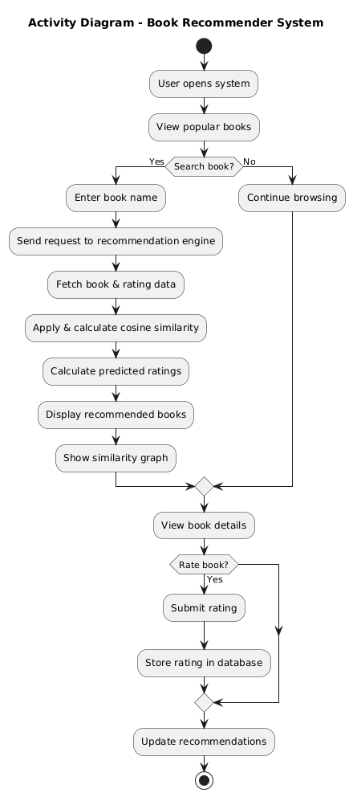

Figure 8 Activity Diagram of BRS

3.2 System Design

3.2.1 Refinement of Class, Object, State, Sequence and Activity Diagrams
After gathering the system requirements and completing the initial analysis, the design of the Book Recommender System (BRS) is refined to clearly represent the internal workflow and interactions among system components. The refined UML diagrams — including class, object, state, sequence, and activity diagrams — provide a detailed understanding of how different modules collaborate to recommend books based on popularity, similarity, and user ratings. These diagrams help visualize system behavior, improve design clarity, and ensure that all functional requirements are effectively addressed.
Class Diagram
The refined class diagram for BRS consists of core classes such as User, Book, Rating, RecommendationEngine, SimilarityCalculator, PopularityManager, and DatabaseManager. Each class is defined with clear attributes and methods that reflect its responsibilities. For example, the User class includes attributes like userId and methods such as login() and rateBook(), while the Book class stores book-related details including title, author, ISBN, and average rating. The RecommendationEngine class plays a central role by generating recommendations using methods like generateRecommendations() and predictRating(). The SimilarityCalculator computes cosine similarity between books, and the PopularityManager handles popularity-based rankings. Relationships among classes are refined to show accurate associations, such as the User interacting with the RecommendationEngine and Rating classes, and the RecommendationEngine relying on similarity and popularity data to produce accurate results.
Object Diagram
The object diagram represents a runtime snapshot of the Book Recommender System during a recommendation process. For instance, when a user searches for a book, a User object interacts with a Book object representing the selected title. A RecommendationEngine instance is created to process the request, which communicates with SimilarityCalculator and PopularityManager objects to compute similarity scores and popularity rankings. At the same time, a Rating object captures user feedback. The final recommendation list is generated and displayed to the user. This refined object diagram clearly illustrates how individual instances collaborate and exchange data during execution.
State Diagram
State transitions are essential in BRS, particularly for components such as the RecommendationEngine. The refined state diagram includes states like Idle, Searching, Calculating Similarity, Predicting Rating, Displaying Recommendations, and Completed. Initially, the system remains in the Idle state until a user initiates a search or selects a book. It then transitions to Searching and Calculating Similarity, where cosine similarity is applied. Next, the system enters the Predicting Rating state to compute predicted ratings based on user feedback. Once recommendations are ready, the system moves to Displaying Recommendations and finally returns to Completed, ready for the next user interaction. This ensures smooth transitions and effective state management.
Sequence Diagram
The sequence diagram illustrates the chronological flow of interactions in BRS during a typical recommendation request. The process begins when the User searches for a book through the web interface. The request is sent to the Flask Application, which invokes the RecommendationEngine. The engine then communicates with the SimilarityCalculator to compute cosine similarity scores and retrieves popularity data from the DatabaseManager. Predicted ratings are calculated and combined with similarity scores before the final recommendations are generated. These results are returned to the web interface and displayed to the user. This refined sequence diagram ensures proper coordination and efficient communication between system components.
Activity Diagram
The activity diagram provides a step-by-step representation of the recommendation workflow in the Book Recommender System. The process begins with the user browsing popular books or searching for a specific title. Decision points determine whether the book exists in the dataset. If found, similarity calculations and predicted rating computations are performed, followed by the display of recommendations along with graphs such as cosine similarity and popularity charts. The user may then choose to view book details or submit a rating, which is stored in the database. The process can repeat for additional searches or end when the user exits the system. This refined activity diagram captures the logical flow, decision-making, and user interaction, ensuring a smooth and intuitive experience.

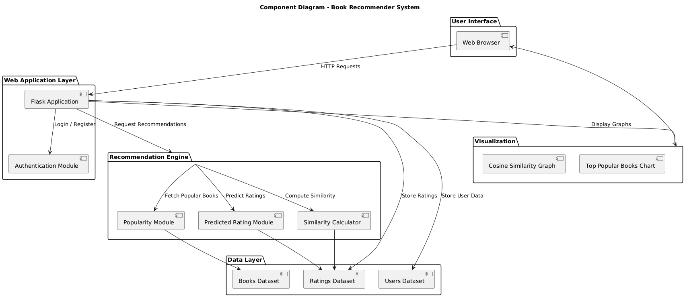
3.2.2 Component Diagrams:

Figure 9 Component Diagram of BRS

User Interface
The user interface provides an interactive and user-friendly platform that allows users to browse popular books, search for specific titles, view recommended books, and rate books. It also displays visual elements such as cosine similarity graphs and top popularity charts to help users understand recommendation results. The interface is designed to be simple and accessible for students, readers, library users, and online book shoppers.
Machine Learning Model
The recommendation engine applies popularity-based filtering and Cosine Similarity techniques to generate personalized book suggestions. It uses cosine similarity to measure relationships between books and predicts user interest through weighted rating calculations. By analysing user ratings and book interaction patterns, the model delivers relevant recommendations tailored to individual preferences.
Dataset and Storage
This component stores essential data such as book information, user profiles, and user ratings. The datasets are used by the recommendation engine to compute similarity scores, popularity rankings, and predicted ratings. Efficient data storage and retrieval ensure fast system performance and help improve recommendation quality as more user interactions are recorded.

3.2.3 Deployment Diagrams:
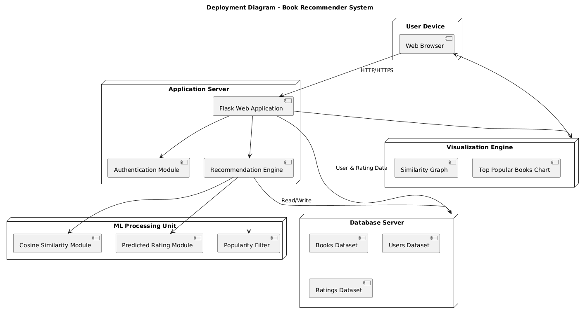
The deployment diagram illustrates the physical deployment of the Book Recommender System (BRS) across multiple hardware nodes, showing how different components communicate over the network. The primary nodes include:

Figure 10 Deployment Diagram of BRS

User Device:
The user device represents the client-side environment from which users access the Book Recommender System. It typically includes a web browser running on desktops, laptops, or mobile devices. Users interact with the system by browsing popular books, searching for titles, viewing recommendations, rating books, and visualizing similarity and popularity charts. All user actions are sent to the web server through secure network communication.
Web Server:
The web server is responsible for hosting the front-end interface of the Book Recommender System. It receives user requests from the browser, manages page rendering, and forwards recommendation-related requests to the application server. After processing, the web server delivers the generated recommendations, graphs, and book details back to the user, ensuring smooth and responsive interaction.
Application Server:
The application server hosts the core backend logic of the system. It manages user authentication, session handling, request validation, and coordination with the recommendation engine. This server processes user inputs, invokes popularity-based and Cosine Similarity algorithms, and integrates predicted ratings before sending the final results to the web server. It also handles communication with the model storage node for data retrieval and updates.
Model Storage Node:
The model storage node maintains all persistent data required by the Book Recommender System, including user profiles, reading history, book metadata, similarity matrices, and user ratings. It supports efficient data access for the application server and recommendation engine, ensuring data consistency, reliability, and fast retrieval. This node plays a crucial role in maintaining recommendation accuracy as user interactions grow over time.

3.3 Algorithm Details
The Book Recommender System (BRS) integrates machine learning algorithms for user profiling, feature extraction, and personalized recommendation generation. This section details each stage of the process, from retrieving user data to generating recommendations, and the algorithms involved.
i. Popularity-Based Recommendation
The Book Recommender System provides popularity-based recommendations to highlight books that are widely liked and trusted by a large number of readers. This method ranks books using the average rating and the total number of ratings received.
Algorithm
- Start
- For each book, calculate the total number of ratings ($v$) and the average rating ($R$).
- Filter books that satisfy a minimum rating-count threshold (e.g., at least 250 ratings).
- Sort the filtered books in descending order of average rating.
- Select the Top-N books for display on the Home page.
- Stop
ii. Weighted Popularity Recommendation (IMDb-Style)
In addition to simple popularity ranking, the system applies an IMDb Top-250 style weighted rating. This ensures fairness by considering both the average rating and the number of votes, so that books with very few ratings cannot unfairly appear at the top.
Algorithm
- Start
- For each book, calculate the total number of ratings ($v$) and the average rating ($R$).
- Compute the global average rating ($C$) across all books.
- Determine the minimum vote threshold ($m$) using quantile values
($m=0.50, 0.75, 0.90$) to control ranking strictness.
- Apply the IMDb-style weighted rating formula:
$$WR=\frac{v}{v+m}R+\frac{m}{v+m}C$$
Where:
- $v$= number of ratings for the book
- $R$= average rating of the book
- $C$= mean rating of all books
- $m$= minimum vote threshold
- Rank books based on the weighted score in descending order.
- Select the Top books with the highest weighted scores for display.
- Stop
iii. Collaborative Filtering using SVD Matrix Factorization
Collaborative Filtering recommends books based on user–book interaction patterns. The system uses Singular Value Decomposition (SVD) style matrix factorization to learn latent features of users and books from the rating matrix, and then measures similarity between books.
Algorithm
- Start
- Build a user–book rating matrix from historical ratings.
- Filter active users and popular books to reduce sparsity.
- Construct a pivot table with books as rows and users as columns.
- Fill missing values with zero for computational stability.
- Apply matrix factorization / dimensionality reduction to obtain latent factors.
- Compute cosine similarity between book latent vectors.
- For a given input book, retrieve the most similar books based on similarity scores.
- Return the Top-N recommended books.
- Stop
iv. Content-Based Filtering (TF-IDF)
Content-Based Filtering recommends books that are similar in content to a selected book. The system converts book metadata (title, author, and publisher) into numerical features using TF-IDF and then computes similarity.
Algorithm
- Start
- Extract textual features from each book: Title + Author + Publisher.
- Preprocess the text (lowercase conversion and cleaning).
- Build a TF-IDF matrix for all books.
- For a selected book, compute cosine similarity with all other books:
$$\text{similarity}\left(A , B\right)=\frac{A⋅B}{∥A∥ ∥B∥}$$
- Rank books by similarity score in descending order.
- Exclude the selected book itself from the result list.
- Return the Top-N most similar books.
- Stop
v. Improved Hybrid Recommendation (SVD + Content + Popularity)
The Improved Hybrid approach combines collaborative signals, content similarity, and popularity into a single ranking score. This balances personalization, content relevance, and overall trust/popularity.
Algorithm
- Start
- Obtain collaborative similarity score from SVD-based model ($S_{svd}$).
- Obtain content similarity score from TF-IDF model ($S_{content}$).
- Obtain normalized weighted popularity score ($S_{pop}$).
- Compute the final hybrid score using weighted fusion:
$$S_{final}=0.50⋅S_{svd}+0.30⋅S_{content}+0.20⋅S_{pop}$$
- Rank candidate books by $S_{final}$in descending order.
- Return the Top-N recommended books.
- Stop
vi. Personalized Recommendation (User Rating History)
Personalized recommendation uses the books already rated highly by the logged-in user. Similar books are collected from the collaborative similarity matrix and aggregated to form a user-specific recommendation list.
Algorithm
- Start
- Retrieve all ratings given by the logged-in user.
- Select highly rated books (rating ≥ 4), or all rated books if none qualify.
- For each liked book, find similar books using the collaborative similarity matrix.
- Accumulate similarity scores for candidate books.
- Remove books already rated by the user.
- Rank candidates by accumulated score.
- Display the Top-N books in the “Recommended For You” section.
- Stop
vii. SASRec – Self-Attention Sequential Recommendation
SASRec models the sequential order of a user’s reading history using a Transformer-based self-attention network. It predicts the next book a user is likely to prefer based on the ordered sequence of previously rated books.
Algorithm
- Start
- Collect the user’s rated books in chronological order.
- Map each book (ISBN/title) to a unique item ID.
- Construct a fixed-length sequence (pad or truncate as required).
- Pass the sequence through item embedding and positional embedding layers.
- Apply Transformer encoder layers with a causal (mask) attention mechanism.
- Use the final sequence representation to score all candidate books.
- Exclude books already present in the user’s history.
- Select the Top-N books with the highest prediction scores.
- Stop
viii. Bookshub Hybrid Recommendation (TF-IDF + SVD + SASRec)
Bookshub Hybrid is an advanced multi-algorithm fusion engine trained on an extended dataset. It combines content-based relevance, collaborative prediction, and sequential preference into one explainable recommendation score.
Algorithm
- Start
- Locate the query book in the Bookshub dataset.
- Compute TF-IDF content similarity scores for all books.
- Compute SVD collaborative prediction scores for the active user and each book.
- Compute SASRec sequential probability scores from the query context.
- Normalize fusion weights ($w_{tfidf}, w_{svd}, w_{sasrec}$) so that they sum to 1.
- Calculate the final score:
$$S_{final}=w_{tfidf}S_{tfidf}+w_{svd}S_{svd}+w_{sasrec}S_{sasrec}$$
- Rank books by $S_{final}$and exclude the query book.
- Generate explanation percentages for each component (TF-IDF / SVD / SASRec).
- Return the Top-N recommended books with match scores and explanations.
- Stop

CHAPTER 4 IMPLEMENTATION AND TESTING
In this chapter, we delve into the implementation and testing phases of the Book Recommender System System clam (BRS). This stage involves transforming theoretical designs into practical, functional modules and rigorously validating them to ensure they meet performance and quality standards.

4.1 Implementation
The implementation of the Book Recommender System (BRS) involves coding, integrating, and configuring all necessary modules such as user data handling, book metadata processing, similarity calculations, and recommendation generation. Each component is developed to ensure accurate predictions, smooth performance, and easy user interaction.

4.1.1 Tools Used (CASE Tools, Programming Languages, Database Platforms):
A wide range of tools and technologies were employed for efficient implementation:
- Programming Languages:
  - Python: Chosen for its extensive support for machine learning, image processing, and web frameworks.
- Computer-Aided Software Engineering (CASE) Tools:
  - Jupyter Notebook: Utilized for experimenting with machine learning models, parameter tuning, and initial testing.
  - VS Code: IDE for project organization.
- Libraries and Frameworks
  - Scikit-Learn:
Used for implementing similarity measures (cosine similarity), preprocessing, and evaluation.
- Pandas & NumPy:
Handle datasets, user-rating matrices, and perform numerical computations for Cosine Similarity.
- Supporting Tools
  - Matplotlib:
Used for visualizing rating patterns, distribution of genres, model accuracy trends, and correlation heatmaps.
- Documentation Tools
  - MS Office:
Used for preparing reports, proposals, and documentation.
  - Draw.io:
For creating system design diagrams such as class, sequence, state, activity, and deployment diagrams.
  - Figma:
Utilized for UI/UX design prototypes, ensuring the interface is simple and farmer-friendly.

4.1.2 Implementation Details of Modules
Each module within BRS contributes to the overall functionality and is implemented as follows:
1. User Interface Module
The User Interface module of the Book Recommender System is developed using HTML and CSS to provide an intuitive and interactive experience for users. The homepage displays a list of popular books along with their titles, authors, ratings, and cover images. The recommendation page allows users to input a book title and view a list of similar book recommendations. Additional pages such as book details and about pages enhance navigation and usability. The interface dynamically presents recommendation results and similarity scores received from the backend, ensuring a seamless user experience.
2. Web Application Framework (Flask) Module
The system backend is constructed with the Flask web framework. This module is responsible for the URL routing, request handling and interaction between backend and frontend elements. The home page, recommendation page and the book details route take advantage of code in the Flask app. This module processes user requests, calls the recommendation algorithm, and then returns to the user interface for display.
3. Data Loading and Preprocessing Module
This module loads and manages the datasets needed for the recommender system. At runtime, some pre-processed data files saved as pickle are loaded, such as popularity-based dataset, user–book interaction pivot table, book metadata and similarity score matrix. The pivot table treats books as vectors of user ratings, which allows for quick computation of similarities. Each duplicate book entry is removed as to maintain the accuracy and consistency in data used while generating recommendations.
4. Similarity-Based Recommendation with User Rating Prediction
Item-Based Cosine Similarity with Predicted Rating Estimation uses user–book interaction data to generate personalized book recommendations. In this approach, each book is represented as a rating vector based on user ratings, and cosine similarity is applied to measure how closely related different books are. When a user selects a book, the system retrieves the most similar books from a precomputed similarity matrix and selects the top-N candidates. For each recommended book, a predicted rating is calculated using a weighted average of ratings from similar books, where similarity scores act as weights. By combining similarity scores with predicted user ratings, the system delivers recommendations that are not only relevant to the selected book but also aligned with the user’s personal reading preferences, resulting in more accurate and meaningful suggestions.
5. Recommendation Presentation and Book Details Module
This module shows all relevant and presentation-ready recommendation results. For recommendations, books and their corresponding metadata like the title, author, cover image, and similarity score are displayed. To facilitate and improve understanding of the recommendation results, similarity scores were created and presented graphically. For each of the books, a combination of internal metadata and metadata descriptions obtained from the Google Books API are used to present more detailed information, enhancing the user experience.

4.2 Testing
Testing is a critical phase, conducted to confirm that BRS meets its functional and performance expectations. Testing was organized into two categories: unit testing for individual modules and system testing for end-to-end validation

4.2.1 Test Cases for Unit Testing:
Unit testing verifies each module’s isolated functionality to ensure its correctness.
Table 2 Unit Testing
ID | Module | Description | Expected Outcome | Actual Outcome
TC_01 | Data Preprocessing | Clean and normalize user ratings and book metadata | Missing values handled, data cleaned, and normalized successfully | Pass
TC_02 | Feature Extraction |  | Features successfully extracted with correct mappings | Pass
  Extract book features (genre, author, keywords) and user preference patterns
TC_03 | Recommendation Engine | Pass | Correct list of recommended books based on user profile | Pass
TC_04 | Web Interface (Streamlit) | User searches books and views recommendations | User receives accurate recommendation results in the interface

4.2.2 Test Cases for System Testing:
System testing was conducted to evaluate BRS as a fully integrated system. This testing ensured that all modules interact seamlessly to deliver accurate results.

Table 3 System Testing
ID | Description | Steps | Expected Outcome | Actual Outcome
ST_01 | End-to End Recommendation  Flow | User logs in (if required), selects preferences or searches, and receives recommendations | Accurate and relevant book recommendations generated successfully | Pass
ST_02 | Recommendation Accuracy | Test recommendation results for users with different reading histories and genres | System suggests correct and meaningful books based on user profile | Pass
ST_03 | System Response Time | Measure time taken to generate and display book recommendations | Recommendations returned within acceptable time limits | Pass
ST_04 | Data Storage and Retrieva | Verify user reading ratings and preference. | Accurate retrieval of user data from the database | Pass

4.2.3 Result Analysis:
The Book Recommender System (BRS) had detailed testing using broad dataset including books and how users interacted which had many types of genres authors and lots of reader choices. BRS worked stable and trustworthy during the evaluation by a good retrieval of the book data, trying to compute similarity numbers and made recommendations which are relevant in most cases. It was kind of impressive how the system handled different scenarios with little errors. Overall, the performance of BRS gave good insights for future improvements.
The system demonstrated strong effectiveness in identifying books that are most similar to the user-selected title. Recommendations were ranked accurately based on similarity scores, ensuring that users received meaningful and contextually relevant suggestions. The precomputed similarity matrix allowed for rapid retrieval and display of results, providing a smooth and responsive user experience without noticeable delay.
Furthermore, the recommendation engine successfully integrated additional information, such as book images, authors, and descriptions fetched via the Google Books API. This enriched the recommendation output, making it visually intuitive and informative. The system also displayed similarity scores and graphical charts to illustrate the degree of similarity between books, improving transparency and interpretability for the user.
The Flask application acted as steady platform, which combined getting data, making recommendations and showing information together. Users were able to click to move around home, the recommendations, and book detail pages without troubles, while good results also came out from system. When using a prepared datasets and pickle files that are already saved, it made recommending books quick, even if there is a big number of them; this proves how easily expandable and strong the system is.
In general, the BRS turned out to be an tool that is simple for people to use for book finding and gives suggestions both based on what users like and which are popular. The use of trained offline data and giving recommendations live makes the system reliable and helpful in things like digital libraries, online bookstores and learning websites kind of.

CHAPTER 5 CONCLUSION AND FUTURE RECOMMENDATIONS
In this final chapter, we reflect on the journey of developing Book Recommender System (BRS), summarize the key takeaways, and offer insights into future enhancements and directions for the platform.

5.1 Conclusion
The Book Recommender System (BRS) was developed to address the growing need for an efficient, automated system that helps users discover books aligned with their interests and reading behavior. By integrating Cosine Similarity and popularity-based algorithms, supported by Python libraries such as Pandas, NumPy, and Scikit-Learn, and deploying a simple web interface for accessibility, BRS provides a scalable, accurate, and user-friendly environment for book recommendation.
This project successfully demonstrates that it is possible to deliver highly relevant book suggestions with minimal computational resources while leveraging open-source technologies. The recommendation engine effectively analyzes reading history, user ratings, and global popularity trends to generate meaningful and personalized book recommendations.
The key achievements of BRS include:
- Accurate Recommendation Generation: The hybrid recommendation engine produces precise and relevant book suggestions, maintaining high accuracy even with sparse user data.
- Scalability and Modularity: Each module—including data preprocessing, similarity computation, recommendation generation, and user interaction—is designed independently. This modularity allows future integration of advanced algorithms, larger datasets, or additional features with minimal redesign.
- User Accessibility: The clean and intuitive web interface enables users to view recommendations instantly, search for books, and explore ratings, making the system useful for students, casual readers, and library systems.
- Data Management: User data, ratings, and book metadata are systematically stored and processed, supporting model updates and performance improvements over time.
During development, several challenges were addressed, such as handling sparse rating matrices, ensuring fast similarity computations, and maintaining accuracy when user data was limited. These were resolved through data normalization, optimized algorithms, and careful parameter tuning. The system meets all functional and non-functional requirements defined in the planning phase and performs effectively under real-world usage conditions.
Overall, the project demonstrates the capabilities of machine learning-based recommendation engines in improving user experience and decision-making. BRS serves as a strong functional prototype that can be further extended for library management, online bookstores, and personalized reading platforms.

5.2 Future Recommendations
While BRS performs effectively, several enhancements can significantly improve its accuracy, scalability, and user experience. The following recommendations outline potential future developments:
Integration of Advanced Recommender Algorithms:
- Implementing matrix factorization techniques such as SVD, SVD++, or NMF can improve prediction accuracy for sparse datasets.
- Hybridizing with content-based techniques using NLP (BERT, TF-IDF) could help recommend books based on descriptions and genres.
Expansion to Dataset and Metadata:
- Including additional metadata such as author profiles, book summaries, genres, and publication years can improve recommendation diversity.
- Collecting larger user-interaction datasets will enhance the Cosine Similarity component.
Mobile Application Development:
- A lightweight mobile app would increase accessibility, allowing users to browse recommendations, track reading lists, and rate books on the go.
- Integration with offline storage can support recommendations even without internet connectivity.

Integration with Cloud-Based Services:
- Cloud storage and processing (AWS, Google Cloud) could allow real-time scalability, supporting multiple users simultaneously and enabling remote access for Book readers.
- Cloud-based analytics can track user trends, helping improve system performance and user engagement.
Deployment on Low-Power Devices:
- Optimizing the model for devices like Raspberry Pi or low-cost smartphones could make the system more affordable and accessible in rural areas.
User Feedback and Adaptive Learning:
- A feedback mechanism where farmers or agricultural experts can confirm or correct system predictions could help continuously improve the model.
- Over time, adaptive learning can improve personalization and handle evolving user preferences.

REFERENCES
[1] Ishak, I., Yahya, A., & Yusri, Y. (2025). Book Recommendation System Based on Cosine Similarity: User-Based, Item-Based, and Singular Value Decomposition Analysis. Journal of System and Computer Engineering.
[2] Sahoo, P. K., Dhanish, S., Ramana, V., & Kumar, A. N. (2023). Book Recommendation Using Cosine Similarity. International Journal of Engineering Research & Technology (IJERT).
[3] Jannach, D., Zanker, M., Felfernig, A., & Friedrich, G. (2011). Recommender Systems: An Introduction. Springer.

APENDIX
- Home Page & Dashboard
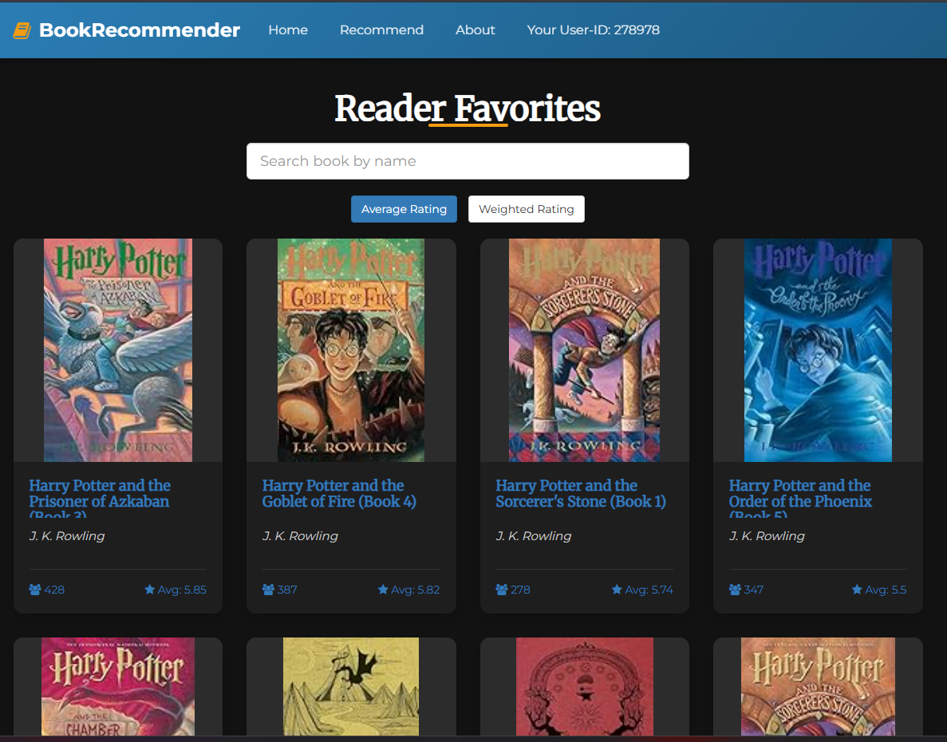

- Top Chart
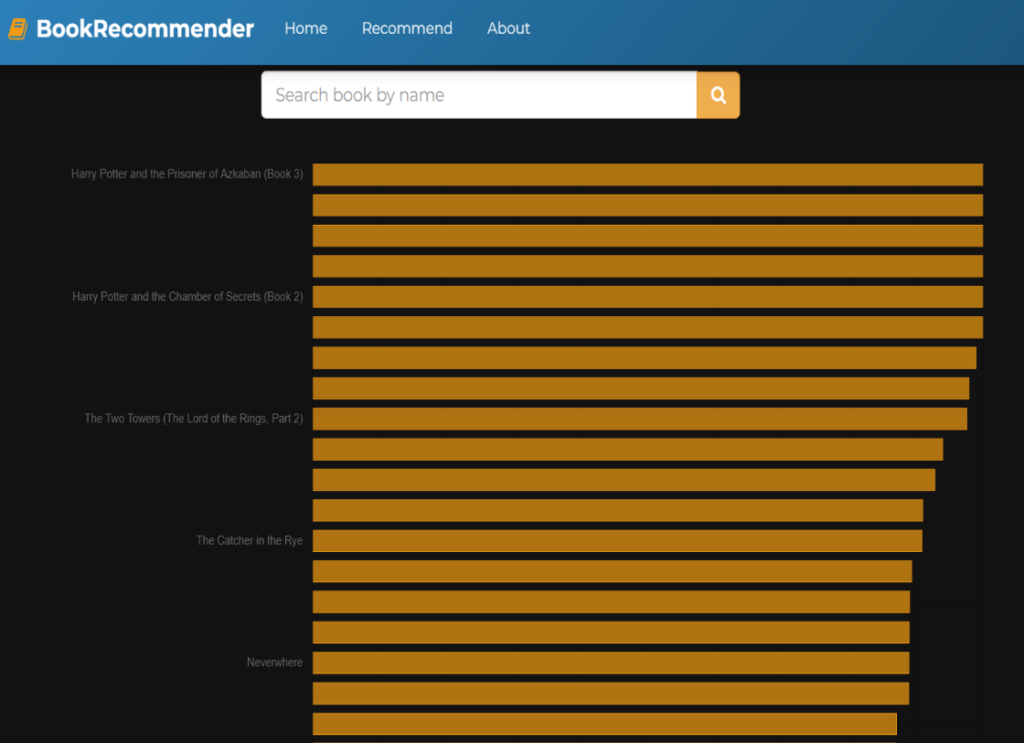

- Recommendation Page and Plotted Graph
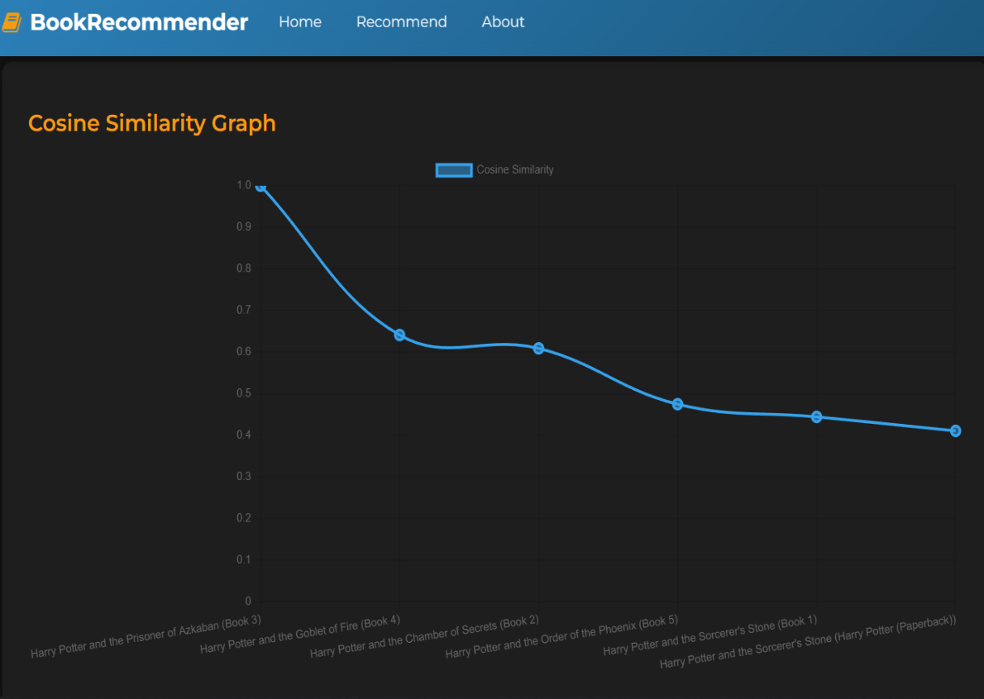
- Book Details View


- About Page


