SynthGraph
Workspace performance: before and after
Observed on production, fixed in commit 379c83c (branch perf/workspace-tab-navigation), then re-measured on production after the deploy, with the same script. A local mock-backend comparison is included for the failure cases that should not be provoked on the live site.
Bottom line
Every tab click on production re-ran the whole server page: about 33 backend calls and a 260-400 KB payload, and the screen only changed after 1.4-2.6 s (median 1.9 s; 8 clicks measured today).
On production after the deploy, the same 8 clicks take 8-24 ms (median 13 ms) and make zero server requests; a burst of 30 clicks leaves the Reproduction tab with 16 of 16 manifests loaded. That is about 150 times faster.
Not fixed: a full page load still takes about 2.0 s on production, because the three sequential backend hops are unchanged. Refresh data pays that cost on demand instead of every click.
Two reliability faults the slowness was hiding are also fixed: one user's traffic could rate-limit everyone else, and a single rate-limited request could sign a valid user out.

1. What I did
- Production, before (read-only): signed-in test account, Phase 1 experiment (16 generations, 3 runs). Clicked the six workspace tabs repeatedly with a timing script, took screenshots, read Resource Timing for every request.
- Implemented the fixes on a new branch from origin/main and committed them (379c83c). You merged and deployed it.
- Before the deploy, re-measured on local production builds against a mock backend shaped like the production experiment. The old build (origin/main) and the new build ran against the same mock, so that comparison is like for like. After the deploy, repeated the exact production script from section 2 (section 5).
Read this before trusting the numbers
Production "before" and "after" numbers are real (synthgraph.dev, 2026-10-30, same account, same experiment, same eight clicks). Local numbers (section 4) come from a mock backend with 60 ms per call and no network, so their absolute milliseconds are NOT comparable to production; they are there for the request counts and the failure cases.
Not exercised on production: the rate-limit failure path (nothing got throttled) and the per-user throttle (provoking it would stress the live site). Both were verified locally only.

2. Before: what production showed
Method: a script clicks a tab, waits until the highlighted tab and the ?tab= URL both match, and records that time, then reads Resource Timing for the requests the click caused. Same script, same experiment, run today.
Click | UI changed after | Server requests | Payload (decoded) | Note
Runs | 2229 ms | 1 (RSC) | 390 KB | time to first byte 227 ms; the rest is waiting on the server render
Lineage | 2111 ms | 1 | 390 KB | first byte 535 ms
Metrics | 1869 ms | 1 | 390 KB
Lineage (again) | 1917 ms | 1 | 390 KB | revisiting a tab is not faster
Parameters | 2601 ms | 1 | 390 KB | slowest of the eight
Reproduction | 1926 ms | 1 | 390 KB
Overview | 1587 ms | 1 | 327 KB
Lineage (again) | 1387 ms | 1 | 256 KB | fastest; payload shrank because the rate limit started dropping manifests

Median 1922 ms, range 1387-2601 ms. The compressed transfer is only about 25 KB per click and first-byte time is about 190 ms, so the cost is not the network. It is the server re-running the whole page for a click that only needs data the browser already has.
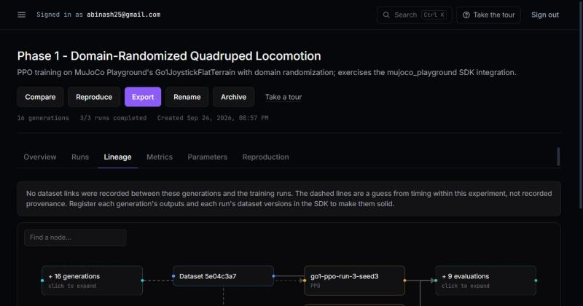
Production, Lineage tab loaded. Next step: click Metrics.
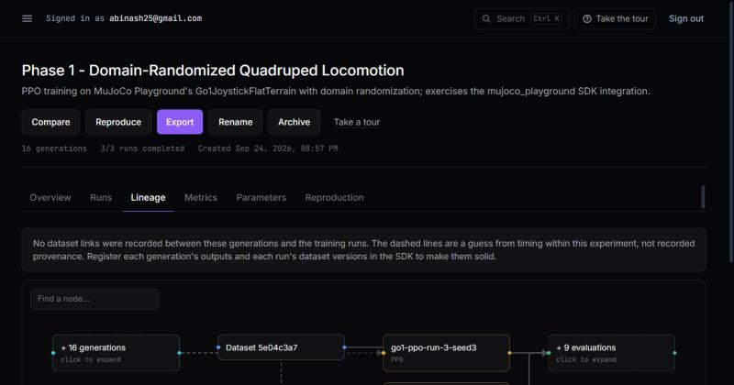
Production, captured right after clicking Metrics. The URL is still ?tab=lineage and the Lineage canvas is still on screen: the click has not done anything visible yet.
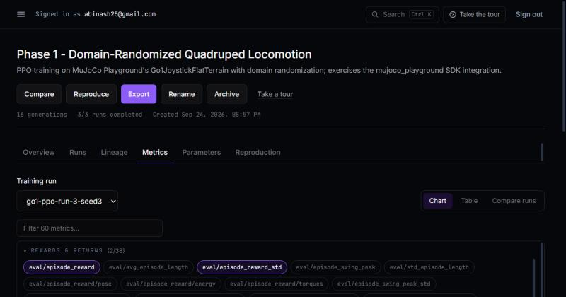
Production, about 3 seconds later: the Metrics tab has finally appeared (URL now ?tab=metrics).

The silent failure behind the slowness
Right after the click burst, the Reproduction tab showed every generation as "Unknown" with "this generation's reproduction manifest could not be loaded." The backend had rate-limited the manifest requests (120 per minute per IP, and one page render uses about 33), and the page swallowed the error. It looked like a property of the data, not a loading failure.
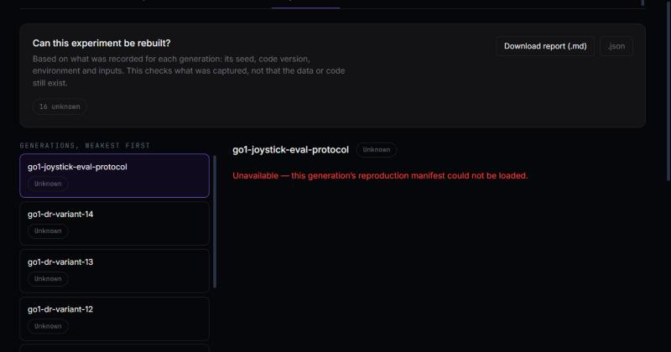
Production: 16 of 16 generations "Unknown" because the manifests were rate-limited, not because anything is wrong with the generations.
The same limit reproduced on the old build against the mock. After about four renders in a minute, the next one was refused, including the sign-in check, and the app treated that as "logged out":
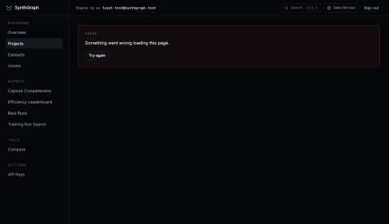
Old build, local mock: a rate-limited core call turns the whole workspace into "Something went wrong".
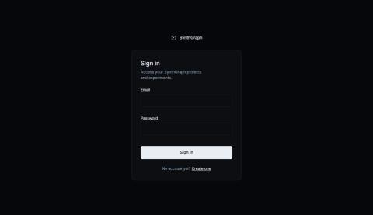
Old build, local mock: a different user sent 200 requests; this user, who did nothing, was bounced to the sign-in page. The old limit counts per IP, and every dashboard user reaches the backend from the same frontend server.

3. What I changed
Issue | Problem | Change
PERF-01 | Tab and selection clicks re-ran the server page | Switch the URL with history.pushState (Next syncs useSearchParams), so no server request is made. Back/forward still work. A "Refresh data" link reloads on demand. shared/lib/shallow-url.ts, Tabs.tsx, ExperimentWorkspace.tsx, ExperimentHeader.tsx.
PERF-02 | 33 backend calls per render | New additive backend route GET /experiments/:id/reproduction-manifests returns all manifests in one request (one query for dataset references). The frontend uses it and falls back to per-generation fetches if the backend is older. 33 calls down to 18 per render.
PERF-03 | One user's traffic rate-limited everyone; one 429 signed users out | Rate limit now counts per bearer credential (hashed), with a 3000/min per-IP ceiling; login and register stay per-IP. getSession only treats a rejected key (401/403) as logged out; any other failure shows an error instead of deleting the cookie. Reads retry briefly on a short 429.
PERF-04 | Failed manifests shown as "Unknown" | Each generation records manifestError (rate_limited or failed). The Reproduction tab shows a banner with a Retry button and per-row "Rate limited" chips, and counts them apart from "unknown".
PERF-05 | Duplicate payload | The unused normalized mirror (generation and manifest) is no longer sent to the browser. Source text duplicated in parameters remains; see limits.
PERF-07 | No server-side timing | The page logs one experiment_workspace.loaded line with duration, counts and manifest failures.
PERF-08 | Animation added a fixed delay | Tab and inspector transitions: no exit phase, 120 ms fade-in (was exit 200 ms + enter 200 ms).

4. After: local production build, same mock (failure cases)
Measure | Before (old build) | After (new build) | Change
Tab click to UI changed | 261-295 ms (3 clicks, then failed) | 6-31 ms, median 14 ms (24 clicks) | about 20x faster, and no server wait
Server requests per click | 1 render request | 0 | -100%
Backend calls per click | 33-34 | 0 | -100%
Backend calls per workspace render | 33 | 18 | -45%
Page payload (decoded) | 521 KB | 435 KB | -17%
normalized mirrors in payload | 32 (16 + 16) | 0 | removed
Another user sends 200 requests | this user signed out | no effect, 16/16 manifests loaded | fixed
Rate-limited manifests | shown as Unknown | banner + Retry; Retry loads all 16 | fixed
Backend restarts mid-session | sign-in check failure = logged out | error shown, session kept | fixed

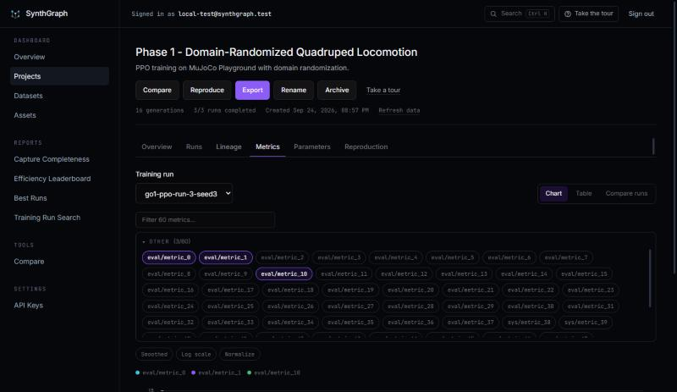
New build: Metrics tab immediately after the click; the URL and content change together, with no request.
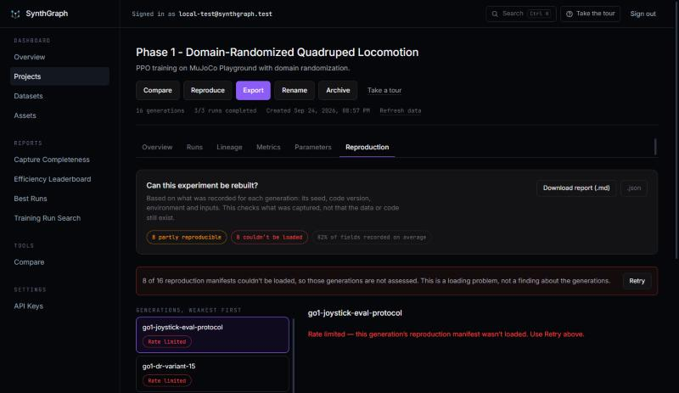
New build, with 8 of 16 manifests forced to rate-limit: an explicit banner, a "couldn't be loaded" chip, per-row "Rate limited", and a Retry button.
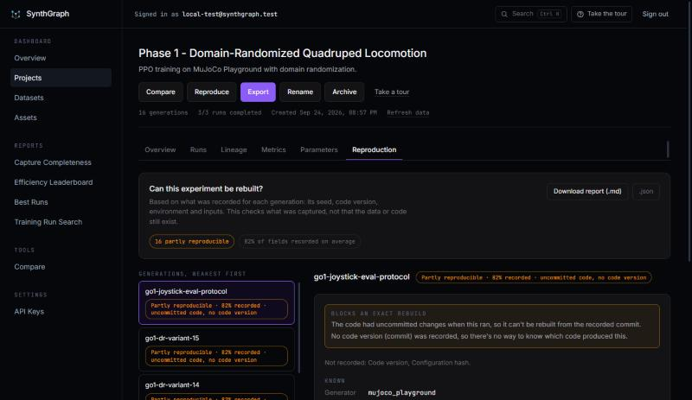
After clicking Retry: all 16 generations assessed.
New build, right after another user sent 200 requests: this user's Reproduction tab loads normally.

5. After: production, same script as section 2
Same account, same Phase 1 experiment, same eight clicks, run after the deploy of 379c83c.
Click | UI changed after | Server requests | Before | Note
Runs | 24 ms | 0 | 2229 ms
Lineage | 8 ms | 0 | 2111 ms
Metrics | 22 ms | 0 | 1869 ms
Lineage (again) | 14 ms | 0 | 1917 ms | a revisit is as fast as a first visit
Parameters | 23 ms | 0 | 2601 ms | slowest before; now 23 ms
Reproduction | 11 ms | 0 | 1926 ms
Overview | 11 ms | 0 | 1587 ms
Lineage (again) | 12 ms | 0 | 1387 ms

Median 13 ms, range 8-24 ms (before: median 1922 ms, range 1387-2601 ms). The only requests in the page after the clicks are the sidebar link prefetches from the initial load; the clicks themselves added none.
Measure | Before (production) | After (production)
30 clicks, 40 ms apart | not run; 8 slow clicks already hit the limit | 0 new requests, still signed in
Reproduction tab after the burst | 16 of 16 "Unknown" | 16 partly reproducible, 0 Unknown, 0 Unavailable
normalized mirrors in the payload | 16 | 0
Page payload with manifests loaded (decoded) | 390-403 KB | 274 KB (-32%)
Back, forward, deep link on a fresh load | worked | worked
Refresh data | did not exist | shows "Refreshing...", finishes in about 2 s
Full page load (RSC response / page ready) | about 1.9 s (median click re-ran it) | 2015 ms / 2439 ms, not faster
Source text in the payload (domain_randomize) | 30 copies (60 with manifests) | 30 copies, not removed

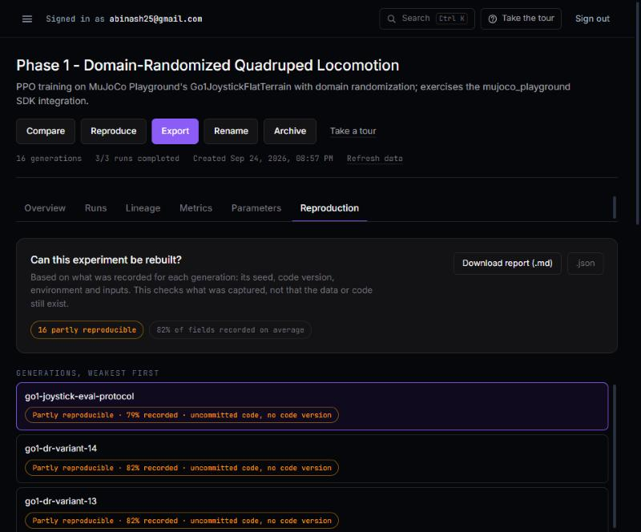
Production after the fix, straight after the rapid-click burst: the Reproduction tab shows 16 partly reproducible generations and no "Unknown". Compare the "before" screenshot in section 2.
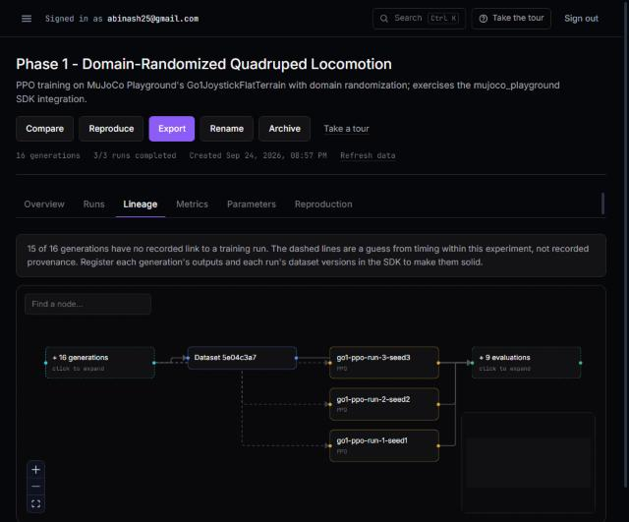
Production after the fix: the Lineage tab (URL ?tab=lineage) was on screen 8 ms after the click. Before, the same click showed the previous tab for about two seconds.
Honest reading
Tab clicks: fixed, better than the 100 ms target. The Reproduction failure: gone in this run, but nothing was throttled, so the new failure UI was not exercised on production.
Page load: unchanged at about 2 s. Calls fell from 33 to 18, but the hops did not, so the wait did not shrink. That is the next change (section 6), not a regression: it is the same cost as before, now paid once per visit instead of once per click.

6. Limits and what is not done
- Section 4 numbers use a mock backend; they prove the mechanism, the request counts and the failure handling, not production milliseconds. Section 5 is the production measurement.
- PERF-02 is partial. The page still makes 18 calls on a full render: per run it fetches metrics, evaluations, health and drift. The full load is still about 2.0 s on production. Health and drift are only needed in the run inspector and the Overview attention list, so a batched backend route for them is the next step, followed by one workspace endpoint to cut the three hops. Since tabs no longer re-render the page, this cost is paid once per visit (or per Refresh data), not once per click.
- PERF-05 is partial. The payload fell 17% on the mock and 32% on production (403 to 274 KB). The Python source in generation parameters still appears twice per generation (generation and manifest): 30 copies. Removing the manifest copy needs the raw-manifest view to rebuild it, so I left it.
- Data freshness changed. Tab switches no longer refetch, so what the SDK records while the page is open appears after "Refresh data" (running training runs still poll live).
- Backend tests: new unit tests for the trackers and the batch service pass; the pre-existing DB-backed e2e suites could not run here (no database). I did not add an e2e test for the new route.
- The per-key limit stays at 120/min as before; with 18 calls per render that is about six full renders a minute per user. Raise it if you want more headroom.
- Deploy order was backend first or together; the frontend works against either. Production now runs both.
- Not verified on production: the Retry banner under real throttling, and the per-user limit with two users. Per-call timing is not exposed; only one summary log line per load exists, and I have not read it from the hosting logs.

7. Success criteria and result
Criteria set before the deploy, with the result of repeating section 2 on production:
Check | Pass if | Result
Tab click, UI changed (8-click sequence) | under 100 ms each, 0 RSC requests | Pass: 8-24 ms, 0 requests
Reproduction tab after rapid clicking | all 16 manifests loaded, no "Unknown" from loading | Pass: 16 of 16, 0 Unknown
Initial workspace load | no slower than today; one experiment_workspace.loaded log line | Partly: about 2.0 s, same as before; log line not read from the host
Refresh data / Retry | reload works; one render request each | Refresh data: pass. Retry: local build only

Next: a batched health and drift route for all runs, then one workspace endpoint, to bring the 2 s full load down; and optionally removing the duplicate source text. Neither is started.

