***Car Dealership – Analytics***

***Reported by – Abinash Pradhan***

**Introduction:**

**This project, “*US Car Dealership Analytics*” has been done using the data from “*Car_sales.csv*” provided along with the description needed for the necessary analysis. The Car Sales dataset provides comprehensive information on various attributes of car models and their corresponding sales performance. This dataset is valuable for conducting in-depth analysis and deriving insights into the factors influencing car sales in the automotive industry.**

**Dataset Description:**



* **Manufacturer: The name of the company that produces the car.**
* **Model: The specific model’s name of the car.**
* **Sales_k: The number of car sales.**
* **Resale_value_4yrs: The estimated resale value of the car after 4 years.**
* **VehicleType: The type or category of the vehicle.**
* **Price: The retail price of the car.**
* **EngineSize: The size of the car's engine, typically measured in litres.**
* **Horsepower: The power output of the car's engine, measured in horsepower (HP).**
* **Wheelbase: The distance between the centres of the front and rear wheels of the car.**
* **Width: The width of the car.**
* **Length: The length of the car.**
* **CurbWeight: The weight of the car without any passengers or cargo.**
* **FuelCapacity: The maximum amount of fuel the car's tank can hold.**
* **FuelEfficiency: The efficiency of the car in terms of miles per gallon (MPG).**
* **LatestLaunch: The date of the car's latest launch or release.**

**Purpose:**

**The primary purpose of this dataset is to facilitate analysis and prediction of car sales trends based on various attributes of car models. It enables stakeholders in the automotive industry, including manufacturers, dealerships, and analysts, to make informed decisions regarding marketing strategies, pricing, inventory management, and product development.**

**Data Quality and Limitations:**

* **The dataset is assumed to be reliable and accurately represents the attributes and sales performance of car models.**
* **The dataset may not capture real-time market dynamics and fluctuations in sales trends.**

**Data Preparation:**

**The data has been prepared with the help of Python Programming language. Below are the steps for the preparation of data:**

1. **Importing the necessary Libraries:**
   1. **The libraries necessary for the processing and analysis of the data are the following:**

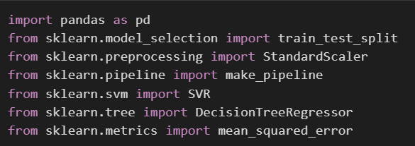

1. **Read the dataset:**
   1. **We use a variable called “*carsales*” to store the dataset and read it as shown below:**

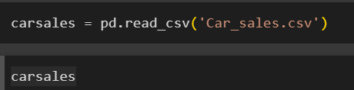

1. **Remove the unnecessary data and change the datatype of the required columns:**
   1. **The following codes were used to remove the unnecessary columns and change the datatype of the required column:**

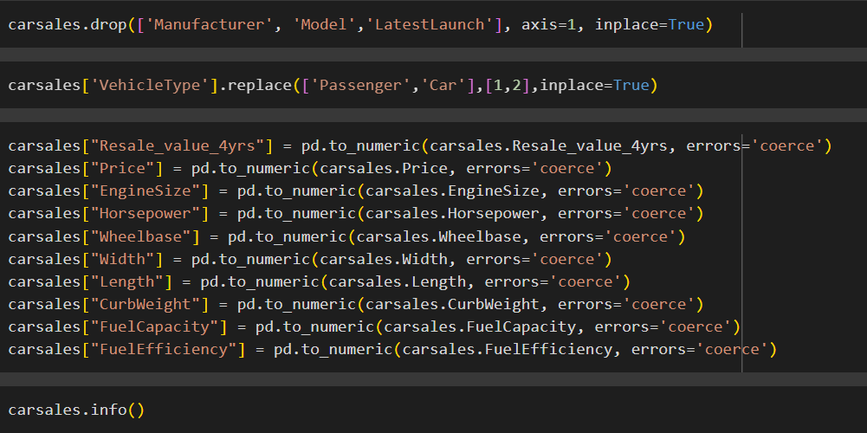

* 1. **The last code is used to check the datatype of each column after changing them to the necessary datatype.**

1. **Fill the null values:**
   1. 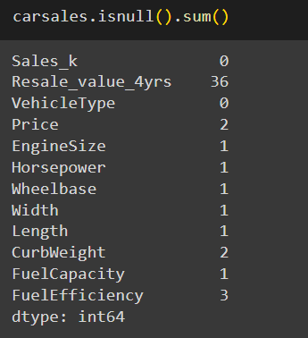**The next step was to find if the data contained any null values using the code below:**
   2. 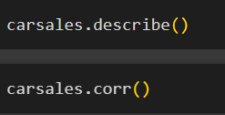**As seen in the above code, there are null values present in the dataset. In order to fill the data, we will use the below codes to describe and find the correlation between data to fill the null values using the below codes:**
   3. 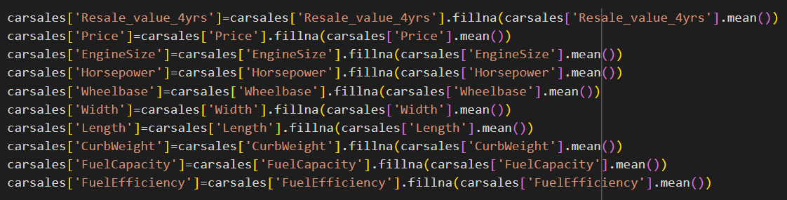**After finding the correlation in the dataset, the null values are filled using the below codes for all the columns.**
2. **Export the data to a new file:**
   1. **After the necessary changes have been made, we can save the data into a new file for further analysis using the following code:**



**Data Analysis & Visualization:**

**After performing the necessary procedures to prepare the data, the next step is to analyze and visualize the data to gain valuable insights. Below are some given charts that explain the various factors that affect the Price, Sales and Resale value in 4 years as well as the relation between them.**

1. **Sales Dashboard:**
   1. **The charts displayed illustrate key performance indicators (KPIs) that significantly influence the sales of a car model. These charts underscore the significance of engine size, horse power, fuel efficiency, fuel capacity, wheel base, Curb Weight, Length and Width as crucial determinants of car sales, providing valuable insights for car manufacturers and marketers to optimize sales strategies and meet consumer preferences effectively.**

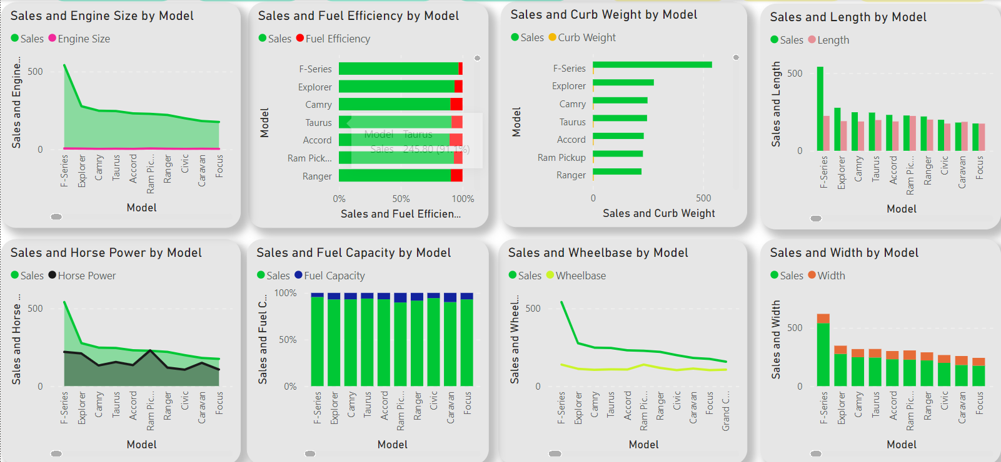

1. **Price Dashboard:**
   1. **The charts presented depict key performance indicators (KPIs) that exert a substantial influence on the pricing of a car model. These visualizations highlight the pivotal role of engine size, horsepower, fuel efficiency, fuel capacity, wheelbase, curb weight, length, and width in determining the price of a car. Each chart provides insights into how these factors contribute to the overall pricing strategy adopted by car manufacturers. For instance, variations in engine size and horsepower reflect the perceived performance of the vehicle, influencing its pricing accordingly. Similarly, factors such as fuel efficiency and curb weight contribute to operational costs and manufacturing expenses, impacting the final price tag of the car model. By understanding the interplay of these KPIs, car manufacturers and marketers can formulate effective pricing strategies tailored to market demand and consumer preferences, ultimately optimizing profitability and competitiveness in the automotive market.**

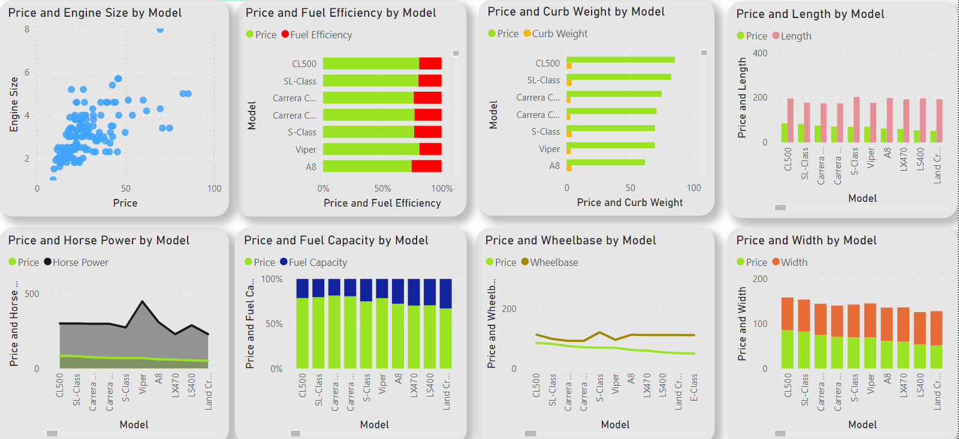

1. **Resale Dashboard:**
   1. **The showcased charts highlight key performance indicators (KPIs) significantly impacting a car model's resale value after four years. Factors like engine size, horsepower, fuel efficiency, fuel capacity, wheelbase, curb weight, length, and width play crucial roles in determining long-term value retention. Engine power and efficiency influence performance perception, while operational costs and maintenance expenses affect resale value. Understanding these KPIs enables car manufacturers to develop targeted strategies for enhancing resale value, ensuring sustained profitability and competitiveness in the market.**

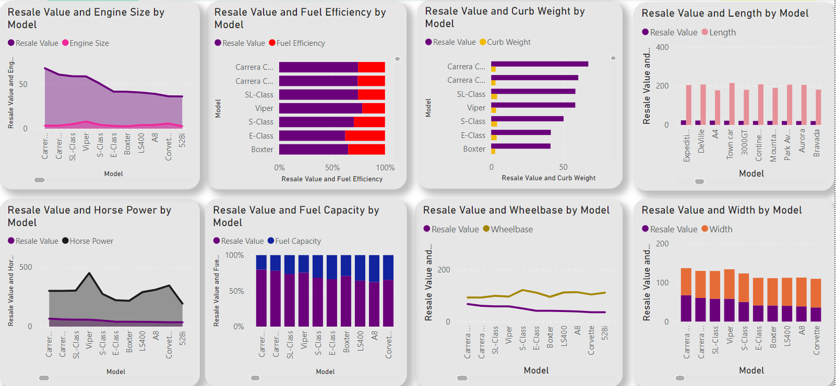

1. **Relation between Sales, Price and Resale value:**
   1. **The relationship between sales, price, and resale value of a car model is complex. Lower prices generally lead to higher sales, but pricing decisions are also influenced by long-term value retention reflected in resale value. Higher resale value indicates greater quality, positively impacting initial sales and pricing strategies. Vehicle type plays a crucial role; larger vehicles command higher prices but may have varied resale values compared to smaller passenger cars. Passenger cars may have lower initial prices but competitive resale values over time, depending on factors like fuel efficiency and reliability. Striking a strategic balance between pricing, sales volume, and resale value is essential for maximizing profitability and competitiveness in the automotive industry.**

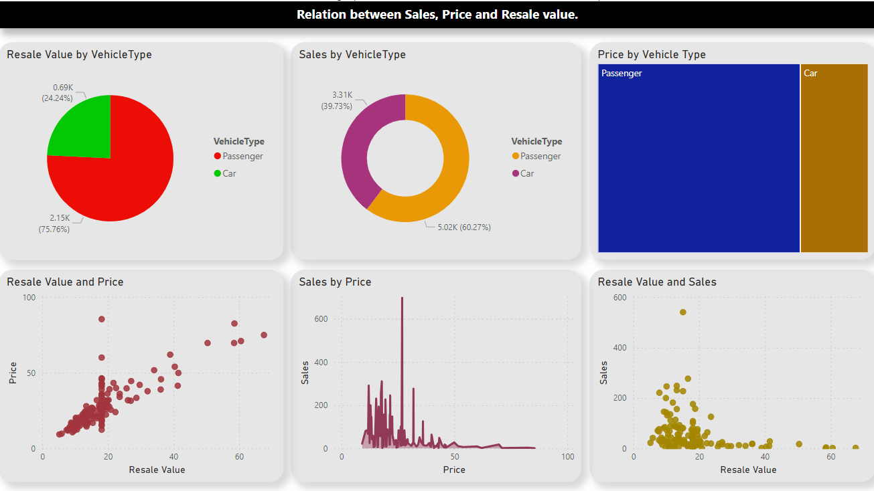

**Conclusion:**

* **In conclusion, the analysis of the car sales dataset reveals valuable insights into various aspects of car models and their sales performance. Through a thorough examination of the dataset, we gained a comprehensive understanding of its structure, including the number of entries, data types, and presence of missing values. Additionally, summary statistics provided insights into the central tendency and dispersion of numerical variables, aiding in understanding the overall distribution of the data. Visualizations, such as histograms and scatter plots, facilitated the exploration of data distributions and relationships between variables.**
* **Furthermore, the correlation analysis unveiled relationships between numerical variables, identifying potential predictors of car sales. This information can guide decision-making processes related to pricing, product development, and marketing strategies. The analysis provides a solid foundation for further exploration and in-depth analysis of the car sales dataset. The insights gained from this analysis can inform stakeholders in the automotive industry, including manufacturers, dealerships, and analysts, in making data-driven decisions to enhance business performance and competitiveness in the market.**