***PUPPET MANIFEST:***

1. To create a file with some content

PM:  
sudo vi /etc/puppet/manifests/site.pp

node "CentOs-Agent" {

file { '/tmp/abi.txt':

ensure => 'present',

content => 'Test file for ABI',

}

}

#CentOs-Agent: here the agent’s hostname

**PA: (working)**

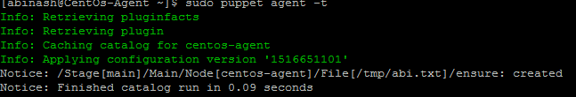

**If wrong hostname given in master’s manifest file site.pp

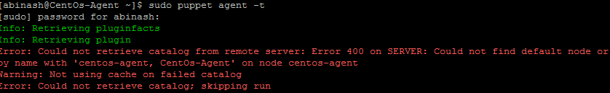

**If run the puppet agent without sudoing



1. If the file has to be removed from agent’s node.  
   PM:  
   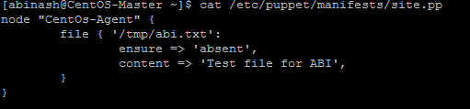

PA: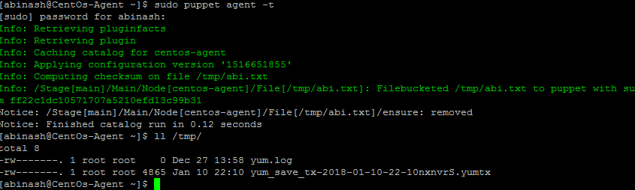

1. Create/Remove directory:  
   