**DATA ANALYTICS**

**COVID 19 CASES ANALYSIS**

**PHASE 3**

**Introduction:**

The COVID-19 pandemic, also known as the coronavirus pandemic, is an ongoing global pandemic of coronavirus disease 2019 (COVID-19) caused by severe acute respiratory syndrome coronavirus 2 (SARS-CoV-2). It was first identified in December 2019 in Wuhan, China. The World Health Organization declared the outbreak a Public Health Emergency of International Concern on 30 January 2020, and later a pandemic on 11 March 2020. As of 8 April 2021, more than 133 million cases have been confirmed, with more than 2.89 million deaths attributed to COVID-19, making it one of the deadliest pandemics in history. Symptoms of COVID-19 are highly variable, ranging from none to life-threatening illness. The virus appears to spread quickly among people, and more continue to be discovered over time about how it applies. The virus can cause a range of symptoms, ranging from mild illness to pneumonia. Signs of the disease are fever, cough, sore throat, and headaches. In severe cases, difficulty in breathing and deaths can occur. The COVID-19 virus spreads primarily through droplets of saliva or discharge from the nose when an infected person coughs or sneezes, so it is essential that you also practice respiratory etiquette. The virus spreads mainly through the air when people are near each other. It leaves an infected person as they breathe, cough, sneeze, or speak and enters another person via their mouth, nose, or eyes. It may also spread via contaminated surfaces. People remain contagious for up to two weeks and can spread the virus even if they are asymptomatic. Recommended preventive measures include social distancing, wearing face masks in public, ventilation and air-filtering, hand washing, covering one's mouth when sneezing or coughing, disinfecting surfaces, and monitoring and selfisolation for people exposed or symptomatic.

Several vaccines have been developed and widely distributed since December 2020. Current treatments focus on addressing symptoms, but work is underway to develop therapeutic drugs that inhibit the virus. The pandemic has resulted in significant global social and economic disruption, including the largest global recession since the Great Depression. It has led to widespread supply shortages exacerbated by panic buying, agricultural disruption and food shortages, and decreased emissions of pollutants and greenhouse gases. Numerous educational institutions and public areas have been partially or fully closed, and many events have been cancelled or postponed. Misinformation has circulated through social media and mass media. The pandemic has raised issues of racial and geographic discrimination, health equity, and the balance between public health imperatives and individual rights. This pandemic is the defining global health crisis of our time and the most significant challenge we have faced since World War Two.

**Source of the Data**.

An electronic health record (EHR) is the systematized collection of patient and population electronically stored health information in a digital format. These records can be shared across different health care settings. Records are shared through network-connected, enterprise-wide information systems or other information networks and exchanges. EHRs may include a range of data, including demographics, medical history, medication and allergies, immunization status, laboratory test results, radiology images, vital signs, personal statistics like age and weight, and billing information. The Electronic Health Record (EMR) software was specifically created to fully accommodate all aspects of clinical workflow, including storage, retrieval, and modification of digital patient records plus prescription writing, clinical annotation, ordering laboratory and imaging tests and viewing test results.

The Electronic-health-record software aids in interoperability for patient record sharing between physicians, hospitals and pharmacies and offers a very mature EMR solution. EMR helps with continuity of care by connecting all members of the care team throughout the healthcare cycle which improves care quality. If all members of a patient’s care team can connect about a patient’s health (from primary care doctor, to specialist, and beyond); consequently, hospital readmissions are reduced leading to better value. Utilizing a certified, interoperable electronic medical record system enables continuity of care, which provides practices with a means to thrive within a valuebased care model and enables practices to receive reimbursement.

**Data Cleaning and Methodology:**

Data cleaning is a critical step before loading data into any decision support system or GIS for spatial analysis. In this project, we received the data from 3 different Electronic-Medical-Record systems. We standardized the master data in our data file before loading the file into Microsoft Power BI software for analysis. For example, one system identifies the data as Medi-Cal while in another system, it is defined as Medicaid. Similarly, discharge disposition, patient type, patient financial class, point of origin and all other data set attributes are made consistent and streamlined across all the systems for spatial analysis.

**Data:**

The data were collected for the Spatial Analysis of COVID-19 from a hospital group located across

3 counties, Orange, Riverside and San Bernardino in Southern California over the period from March 2020 to March 2021. Data are extracted from 3 different Electronic Health Records (EHRs) and each EHR is the standard in a couple of hospitals. The organization maintains the master data for record purposes.

The data comprise around 42,000 records of patient data. Patient details are masked as per HIPPA rules. Spatial analysis is based on Zip code of the patient location. The patients are from different demographics racially, financially, and ethnically. The data comprise patients from different cities in these counties with multiple ailments who came to hospital for treatment referred by doctors and service providers from different origins. The data collected are categorized based on the following: In-patients (IP) or Outpatients (OP), Patient’s age, and Patient’s gender. The point of origin of patients may be from another hospital, service provider, hospice, clinical referral, court/ law enforcement agency, transfer from Skilled Nursing Facility (SNF), or transfer from a surgical center.

Based on a patient’s payment method and health insurance policy, financial payments are categorized as: Medicaid, Medicare, Medical, M Self-pay, Commercial health insurances,

Capitation Senior-HMO, Charity Care, Workman’s Compensation, Hard-ship Program, Government/County, Medicare-Senior, or Tricare.

Based on how, where and when the patients are discharged, patient data are categorized as follow:

Home/Self, IP to other acute hospital, Skilled nursing facility, Children’s hospital, Cancer hospital, Assisted Living/ Intermediate Care Facility, or Left against medical advice.

Covid testing data are collected as total tests performed, and covid-testing. results categorized as as Positive, Recovered, or Death.

For Data Analysis, the software packages of Microsoft Power BI, ArcGIS Pro, ArcGIS Insights and Tableau are used. Dashboards are created in Power BI using the data. Maps are created using ArcGIS Pro for visual analysis and presentation of the data.

Maps can show the locations where patients 65 years of age are concentrated, and where patients are located who require medical assistance at home and, finally, the location of hospitals and pharmacies.

Geospatial big data refers to spatial data sets exceeding the capacity of current computing systems. Having information on human mobility patterns from mobile phones, or the registration of global flight networks, is fundamental to epidemiological modelling. Using big data could help us to understand the pandemic's behavior in terms of outbreak tracking, disease treatment, and future vaccine manufacture and distribution.

With the rapid spread of COVID-19, many hospitals and health systems were faced with the possibility of sudden surges in patient volume, stressing limited resources and increasing the burden on staff. To better plan for these potential surges, organizations have implemented predictive tools that can help allocate resources. From the business perspective of the Healthcare organization, the spatial analysis of the data of COVID-19 helps in decision-making and planning. It also helps to improve the locating of health services and controls, andpoints of care. It facilitates patient access, which translates into an improvement in patient outcomes, time, and material resources. It helps in deciding the number of ICU units required per hospital, emergency service providers, lab supplies, pharmacy supplies, and ventilators needed, as well as to make decisions on logistics and supply.

As the pandemic evolves, predictive spatial analytics with ArcGIS tools will continue to play a significant role in monitoring the impact of the virus, ranging from locating patient outcomes to identifying areas of increased disease spread. The global health crisis has only further highlighted the importance of GIS and spatial analytics in healthcare and could accelerate the use of these tools in standard care going forward.

COVID-19 studies with GIS could be valuable tools in decision-making and, more importantly, social mobilization and community responses. Understanding the spatial-temporal dynamics of COVID-19 is critical to its mitigation, which is why such work is being done in all regions of the world. The future of use of GIS in health and human services is extremely bright. The increasing focus on electronic health records, and the corresponding geographic information contained within them will open many new possibilities for population health analysis and planning. GIS has been found to be an essential technology across a wide variety of health and human services agencies and activities. As we continue to battle this pandemic and prepare for future, understanding the risk and being prepared are the first steps in potential care and treatment planning.

**Technologies:**

**COVID-19 Dashboard - From Data to Spatial Insights:**

We have analyzed the above-mentioned data using ESRI ArcGIS, ESRI Insights, Business Analyst, Tableau, and Microsoft Power BI.

Finally, we build all the analysis and dashboard in Microsoft Power BI because Power BI can be integrated with ArcGIS for custom data visualization and spatial analysis. The COVID19 Dashboard provides a comprehensive overview of the key metrics of the global pandemic, their current developments, and detailed analyses at the Zip Code and City levels.

Users can quickly get an overview and check most essential Key Performance Indices (KPIs) and filter by their respective Year, Month, Patient Type, Point of Origin, and Primary Diagnosis.

The dashboard provides valuable insights on cases (Positive, Recovered and Death), mortality analysis in depth by Zip Code, City, and selected timeframe. Generally, both cumulative numbers and new cases are provided.

The dashboard design provides users with an effective management summary of the most relevant KPIs as well as detailed analyses on separate report pages.

Using the COVID dashboard example, the dashboard shows the strengths of spatial analysis with Power BI: an intuitive visualization which makes even complex data sets more comprehensible.

**Data Source for Power BI**

Power BI supports importing or connecting to workbooks created in Excel 2007 and later. Our data are stored in Excel. Moreover, the tool can connect to any RDBMS table as well and that can be refreshed automatically.

**Data Model**

With the modeling feature, we can build custom calculations on the existing tables and these columns can be directly presented into Power BI visualizations. This allows us to define new metrics and to perform custom calculations for those metrics.

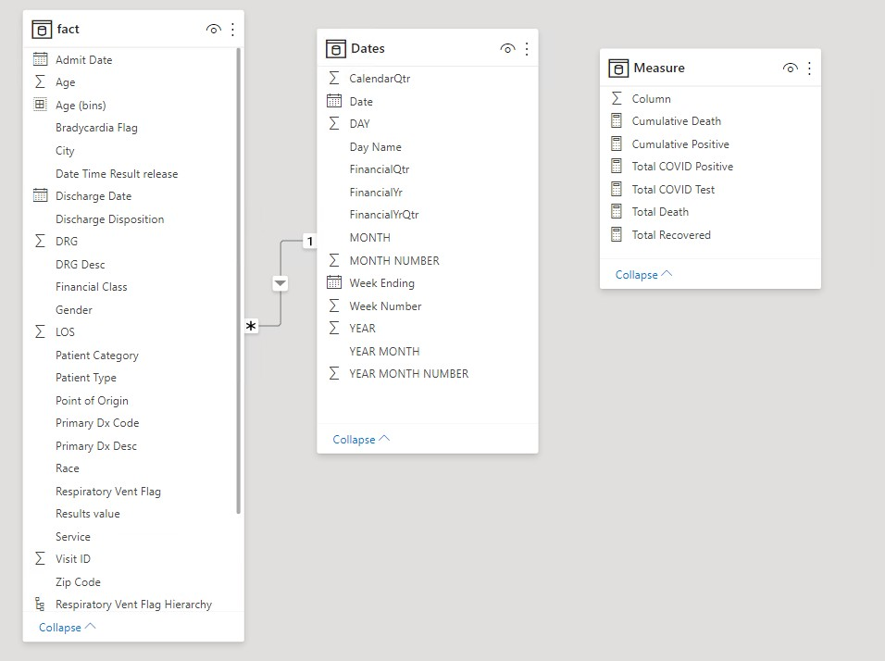

**Measures and Dimension**

The data in tabular format hold demographics for each patient in single line along with COVID test results whether positive or negative. Data visualization of the KPIs requiries some calculation on those fields, which are achieved through writing expressions in Power BI called custom measures. For example, the meansures, Total COVID Test, Total Positive, Total Recovered, Total Death, Cumulative Positive, and Cumulative Death are created by writing custom expression in power BI. An example is:

**Total COVID Positive = CALCULATE(COUNT ('Fact'[Visit ID]),'Fact'[Results value]="DETECTED")**

That means count all the records for which the visit id that has COVID resuls value equal to

DETECTED.

Here is the list of expressions for other measures.

Total COVID Test = COUNT('Fact'[Visit ID])

Total Death = CALCULATE(COUNT('Fact'[Visit ID]),'Fact'[Discharge Disposition] IN{"20EXPIRED"} ,'Fact'[Results value]="DETECTED")

Total Recovered = CALCULATE(COUNT('Fact'[Visit ID]),NOT 'Fact'[Discharge Disposition] IN {"20

EXPIRED","NULL"},'Fact'[Results value]="DETECTED",'Fact'[Discharge Disposition]<>BLANK()

**Measure tools**

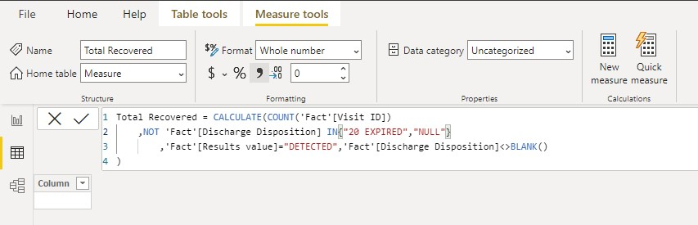

**Dashboards**

In Microsoft Power BI for analysis of the data, Histograms, Cumulative graphs, Pie charts and Maps are created through accessing data using ArcGIS Pro that is integrated in Power BI.

Analysis of this dashboard explains how unequal healthcare is, a major spatially-based factor in the spread of COVID-19. Also, sminority and poorer communities were also found to have generally lower access to testing. Studies have suggested these populations could be potentially more vulnerable to death from infection than other demographic groups.

**Main Dashboard**

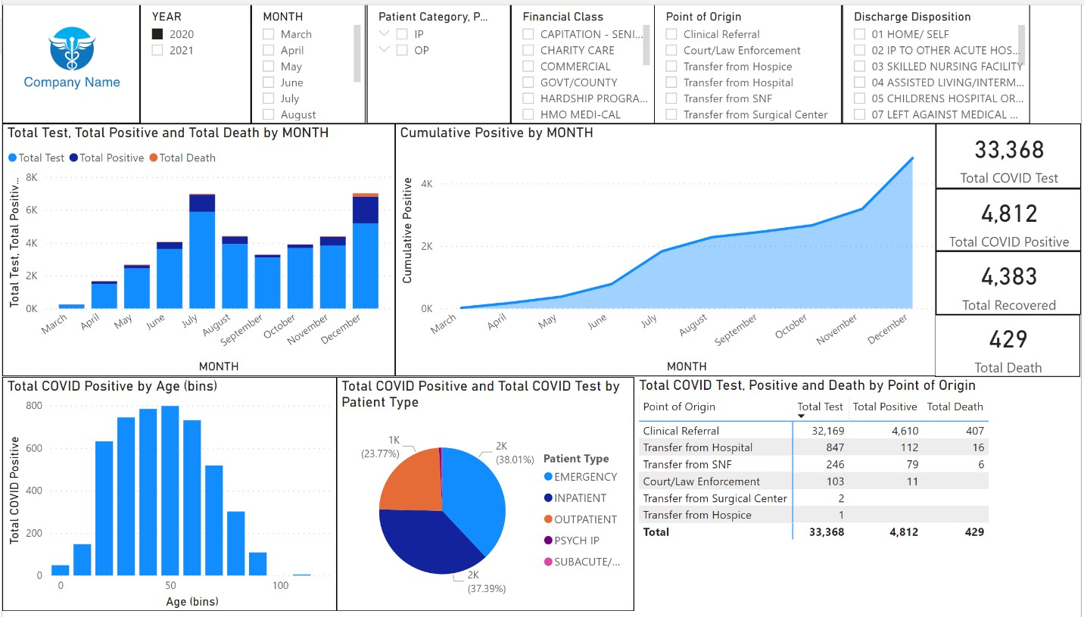

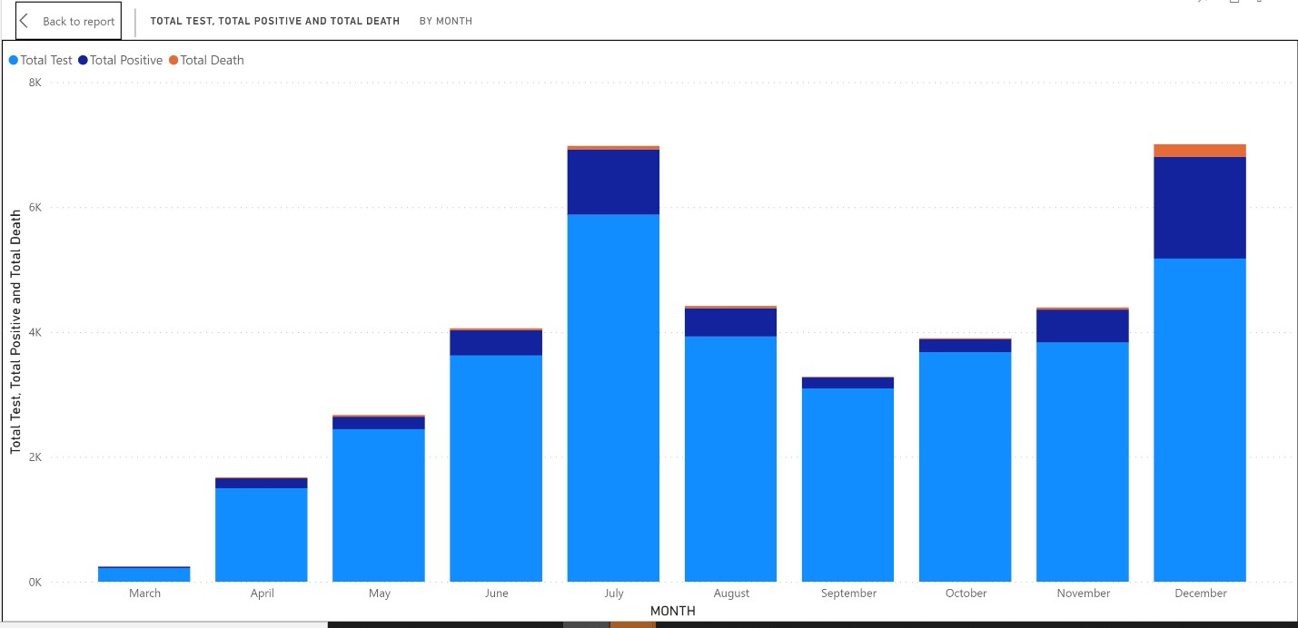

Figure-1: Total Test, Total Positive and Total Death by Month

In Figure -1, a histogram is created for total number of COVID tests, total positive and total death by month from March 2020 to December 2020. This graph depicts the surge in total tests, total positive cases and total deaths in July and December of 2020. The spike in the number of cases in these months is due to the Independence Day long weekend in July and Holidays in December. People travelling, gatherings and Holiday season can be the reason for increased cases and deaths.

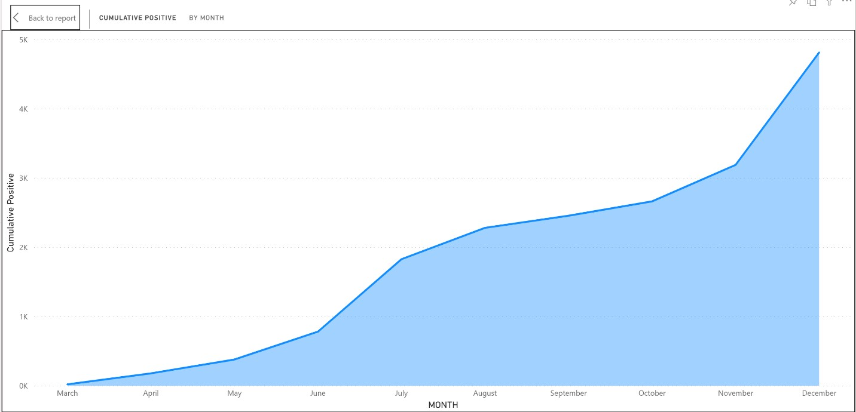

Figure-2: Cumulative Positive by Month

In Figure-2, a Cumulative graph is created for the number of COVID-19 positive cases from March 2020 to December 2020. In this graph we can observe, steady growth in the graph which indicates the increased numbers of cases of COVID-19 positive throughout 2020.

By changing the year on to 2021, Dashboard for the 2021 can be analyzed with the graphs, charts, and maps for 2021 data.

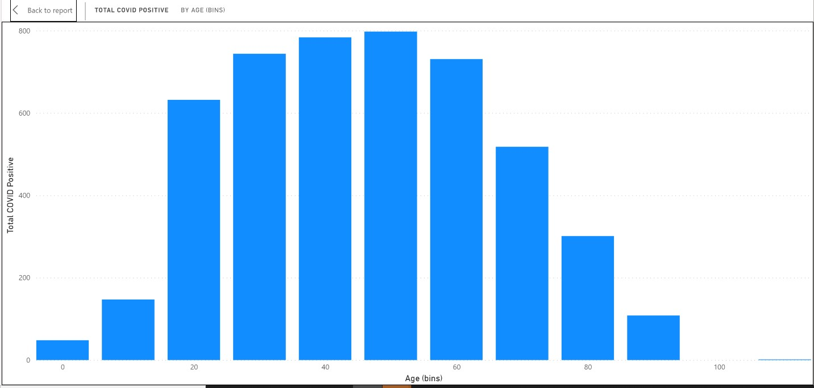

Figure-3: Positive Cases by Age.

In Figure-3, Positive cases by Age, histogram is created at 10-year intervals of age. We can observe that the age group 50-59 is affected the most with COVID-19 in this population. The age groups 60 plus are also affected more compared to other age groups.

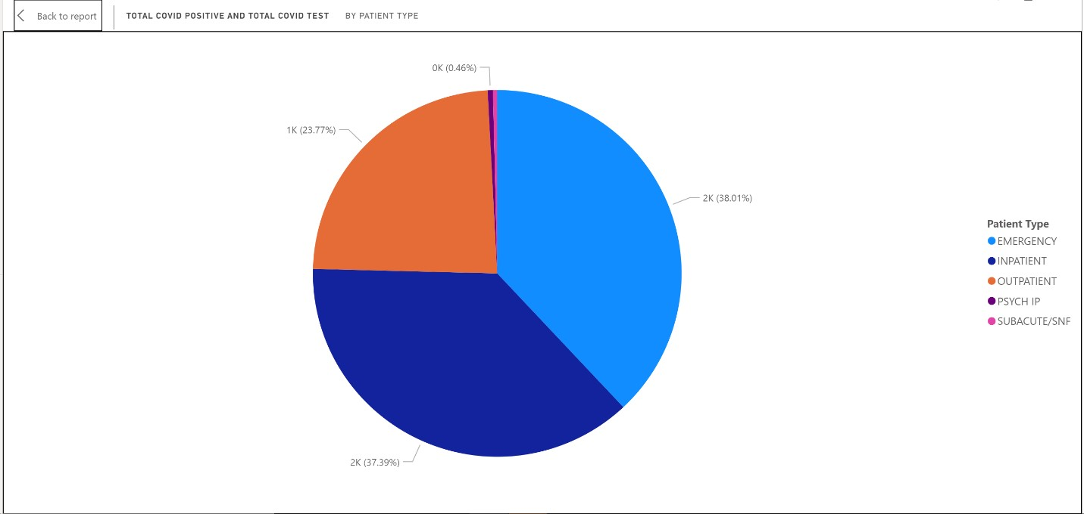

Figure-4: Total Test and Total Positive cases by Patient Type.

In Figure-4, a Pie chart is created for Total Test and Total Positive cases by Patient Type. This pie chart depicts that for all patients testing positive, the Patients in Emergency comprised 38.01 %, followed by Inpatients, with 37.39% testing positive.

In Figure-5, Table depicts the Total Test, Total Positive and Total Death by point of origin. A histogram or pie chart or any other graph can be created by this data for visual analysis of this data. Most of the patients from the Clinical referral, 4,610 patients were tested positive and 407 patients were reported dead.

In Figure-6, Total Positive Cases by Symptoms, a histogram is created to analyze the total cases by patients who came into hospital with COVID -19 symptoms and patients who came for some other treatments without any symptoms of COVID-19 or asymptomatic and, as part of mandatory COVID -19 testing, were found to test positive. We can observe in the graph, that number of asymptomatic patients who tested positive monthly in 2020 are greater in July (788 cases) and December, (1,177 cases), which can again be linked to the holidays in these months.

In figure 7, Total Covid Tests, Total Testing Positive and Total Deaths by Race and Ethic Group, which included Asian, Black, Hispanic, and White population. 27,433 patients were tested and 3,963 tested positive to COVID-19 in the population across the three counties, for which we collected data. For the category of Other Races, which comprises of Pacific Islander, Native Indians and mixed, 1,416 tested positive.

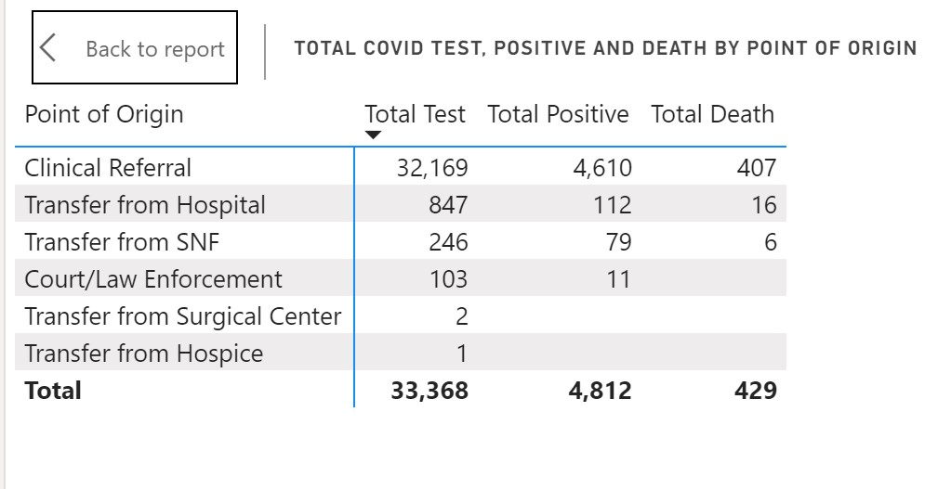

Figure-5: Total COVID Test, Positive and Death by Patient point of Origin

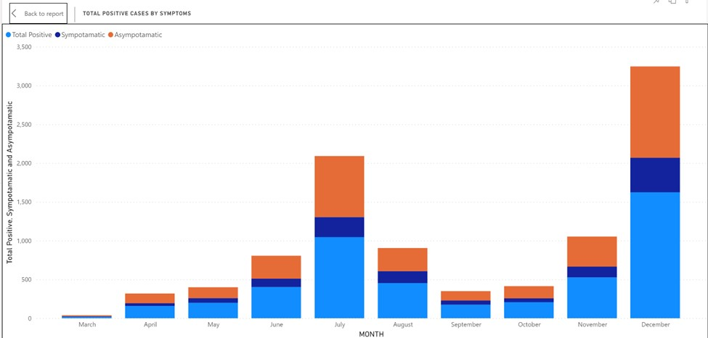

Figure-6: Total Positive Cases by Symptoms.

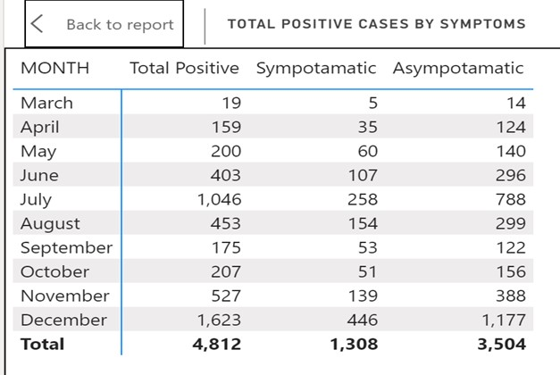

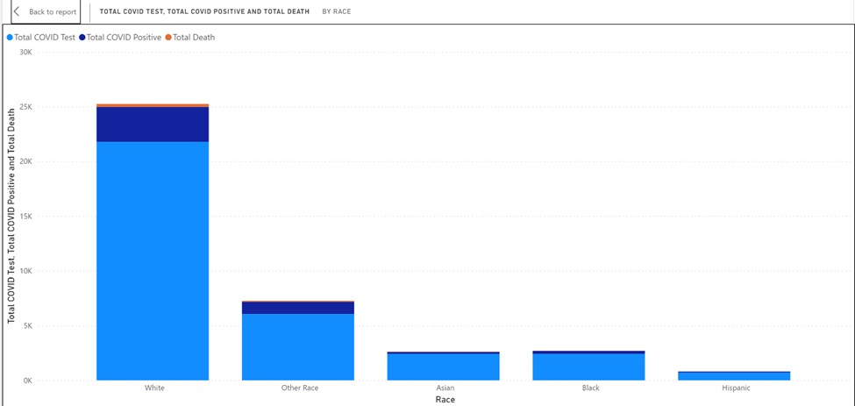

Figure-7: Total Covid Tests, Total Positive and Total Death by Race.

Within each summary, we can leverage dashboard Drill- through feature for Spatial analysis, this is shown in figure 8.

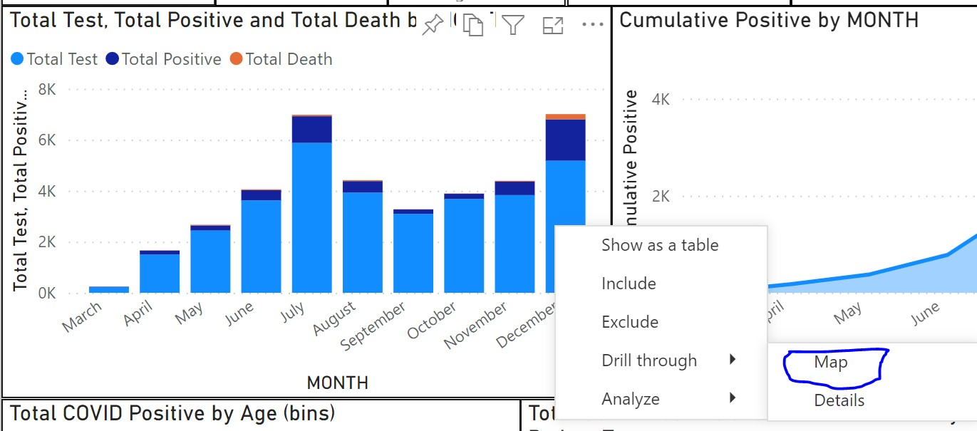

Figure-8- leverage dashboard Drill through feature for Spatial analysis.

Figure-,9,10, 11, 12: Total Covid Tests, Total Positive and Total Death by City and Zip code.

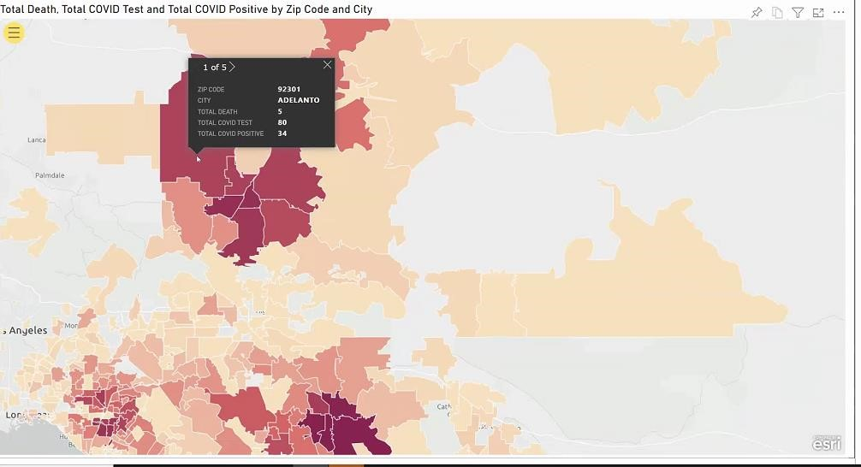

Figure-9

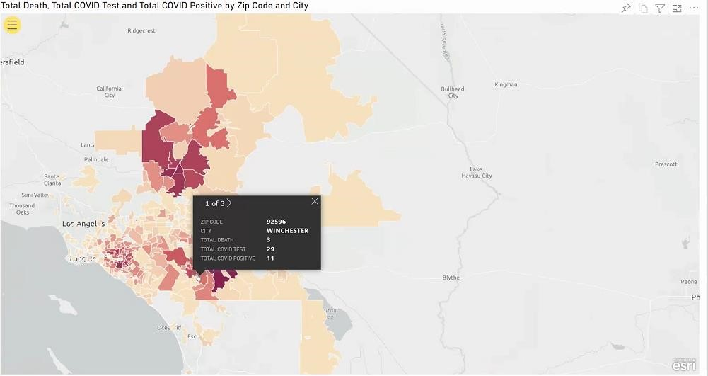

Figure-10

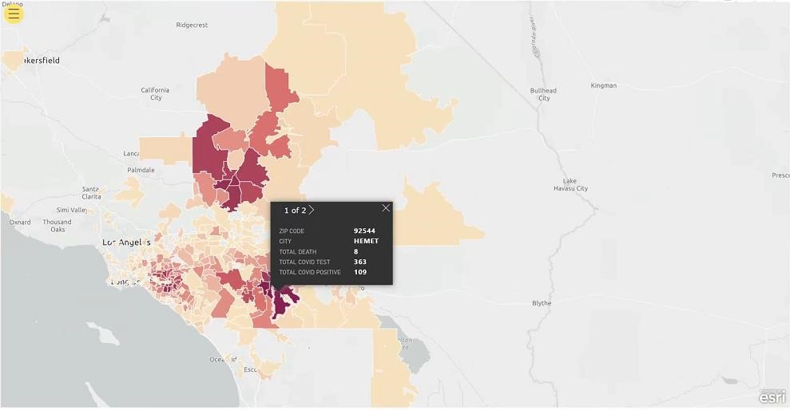

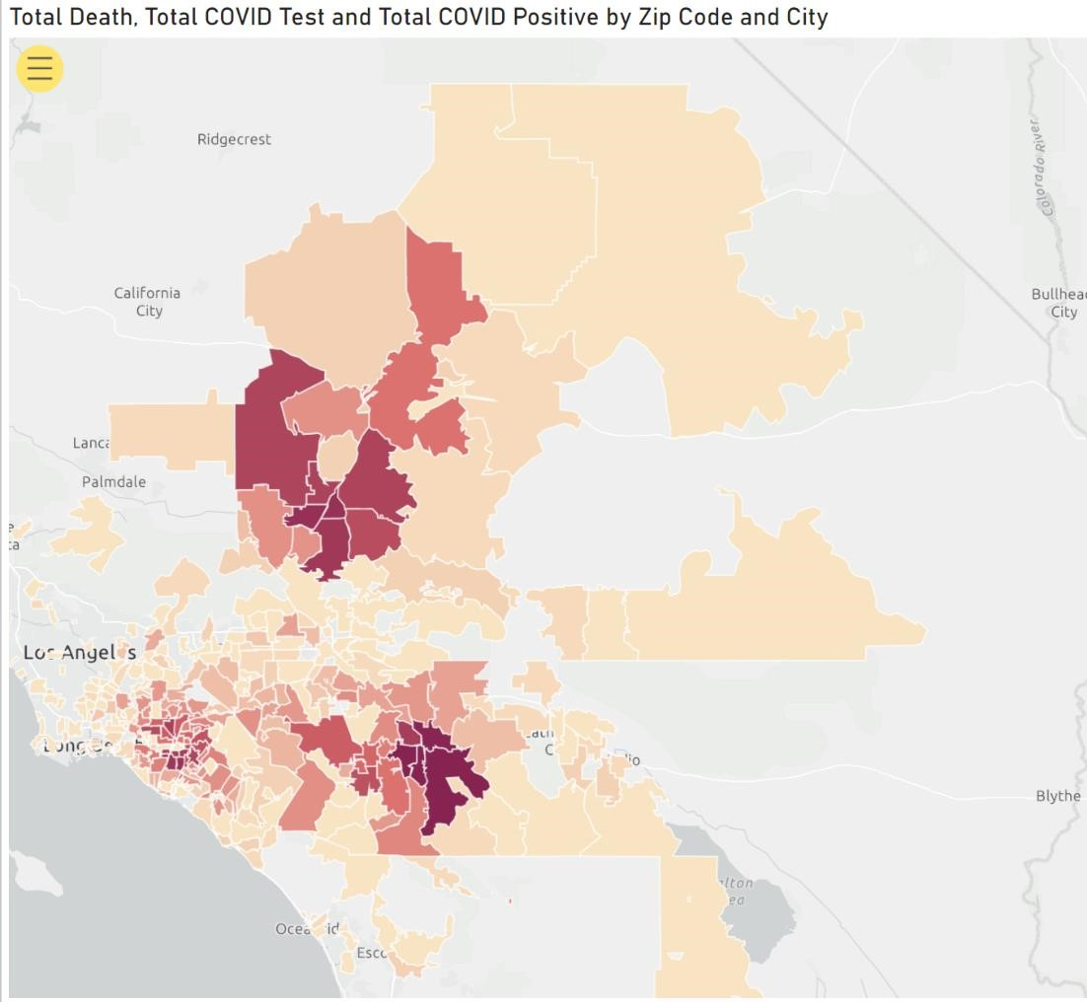

Figure-11&12

All the above maps were created using ESRI ArcGIS PRO, integrated in Microsoft Power BI, for spatial analysis of Total Covid Tests, Total Positive and Total Death by City and Zip code. We can observe, how unequal healthcare is also a major spatially-based factor in the spread of COVID-19, as minority and poorer communities were found to have generally lower access to testing and these populations could be potentially more vulnerable to death from infection than other demographic groups. Integrated map shows the total tests, total positive and total deaths by city and Zip code which helps in analyzing the data to make decisions and for predictive analysis.

Analyzing the maps, we can conclude there are a greater number of cases in Riverside county followed by San Bernardino and Orange Counties. This can be attributed to the demographics of the population as majority of the population infected are from lower financial class.

In zip code area 92544, in Hemet, in Riverside county, by hovering on the map we can see the total tests, total positive and total death. This can be done for all the cities and Zip codes in the data we collected and spatially analyzed/ Decisions can be made based on the increase or decrease in the number of positive covid-19 cases and deaths in particular Zip codes. This also helps to analyze the financial class of the population. Based on the demographic data, hospital management can make operational decisions for providing timely care and service to the population it is serving across all the three counties.

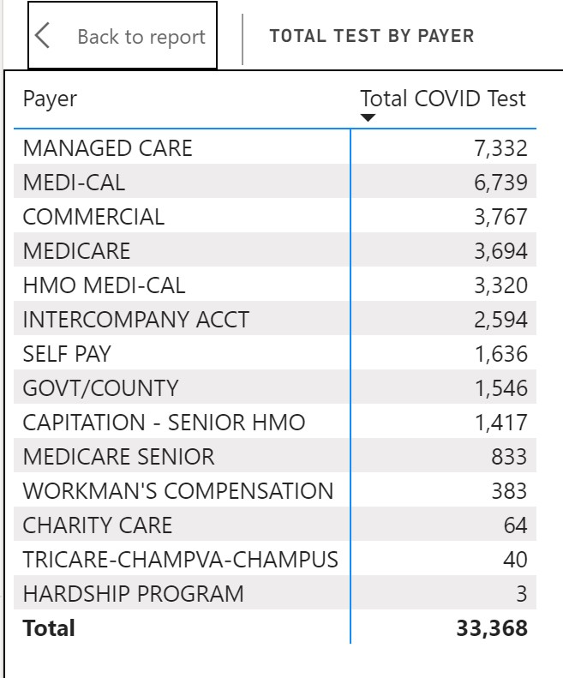

**Drill through to Patient’s details from summary**.

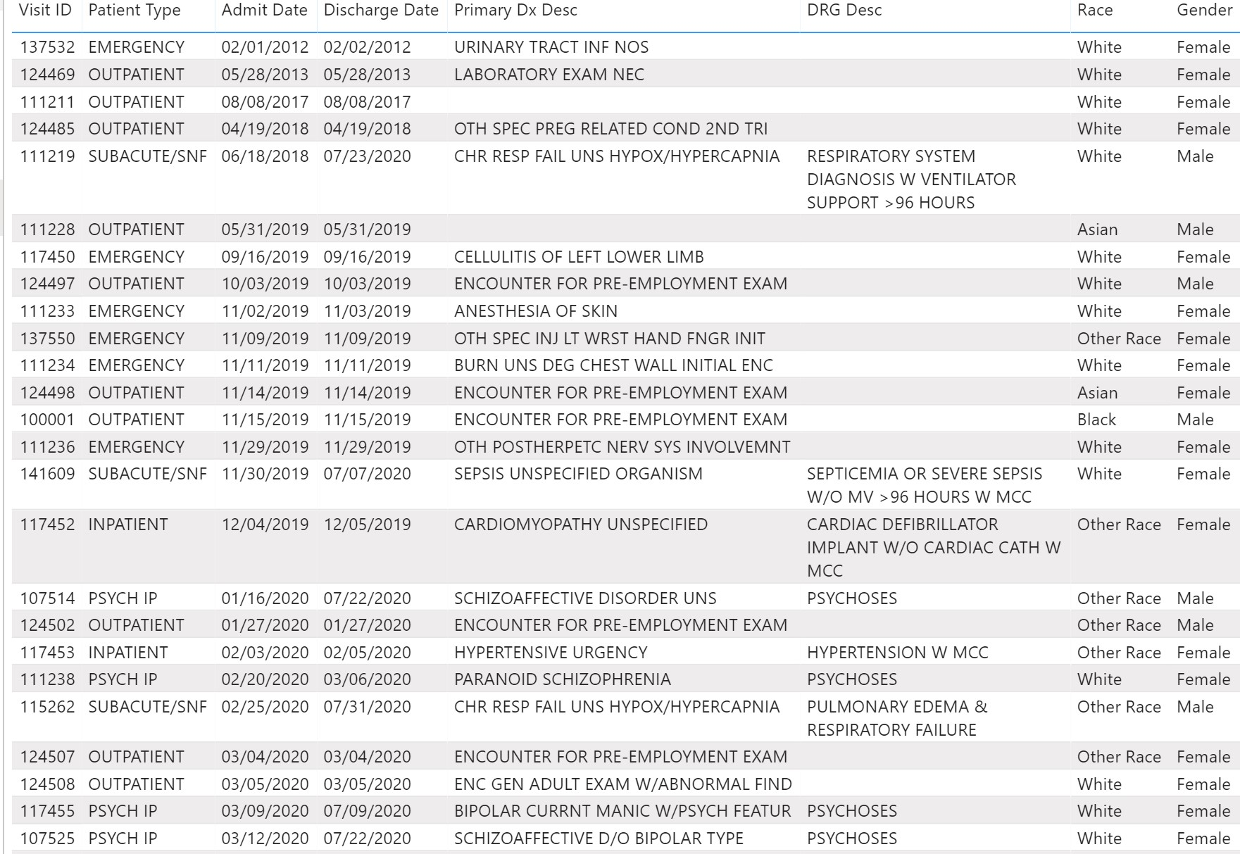

**Death Analysis:**

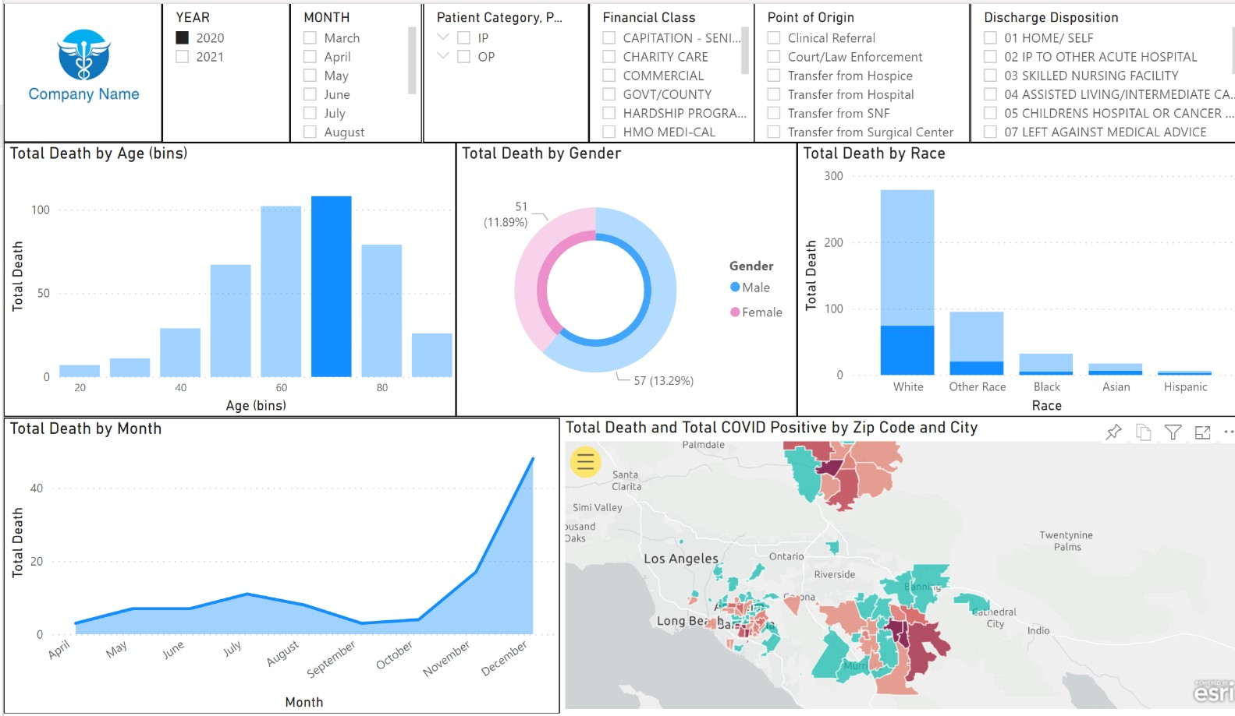

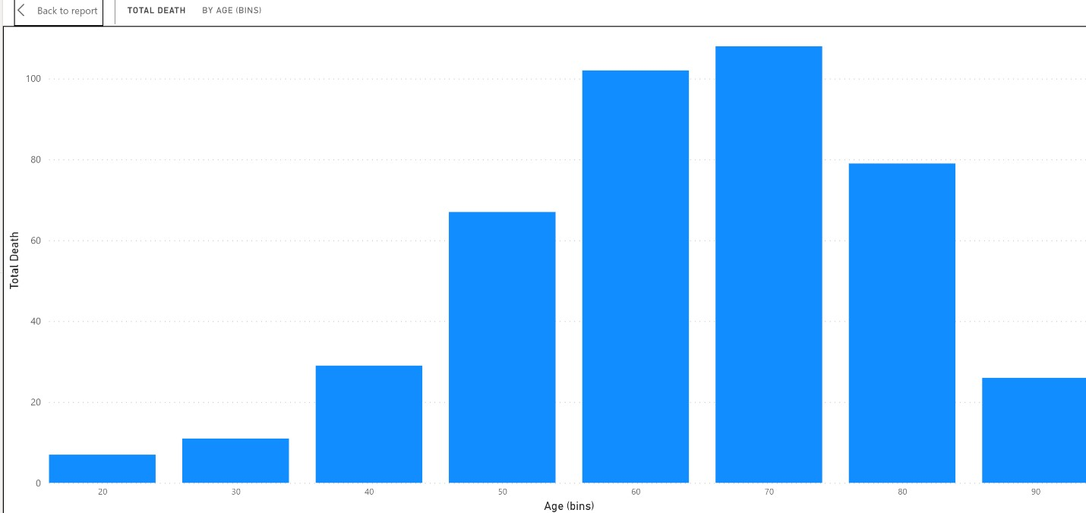

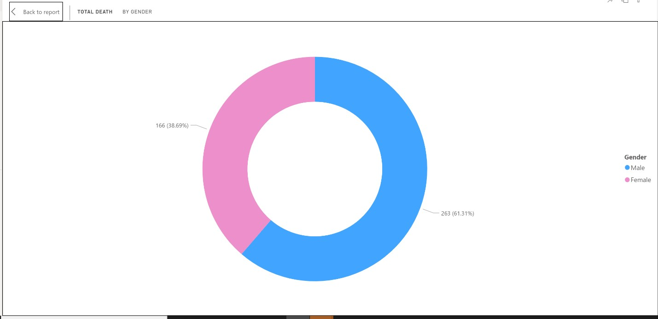

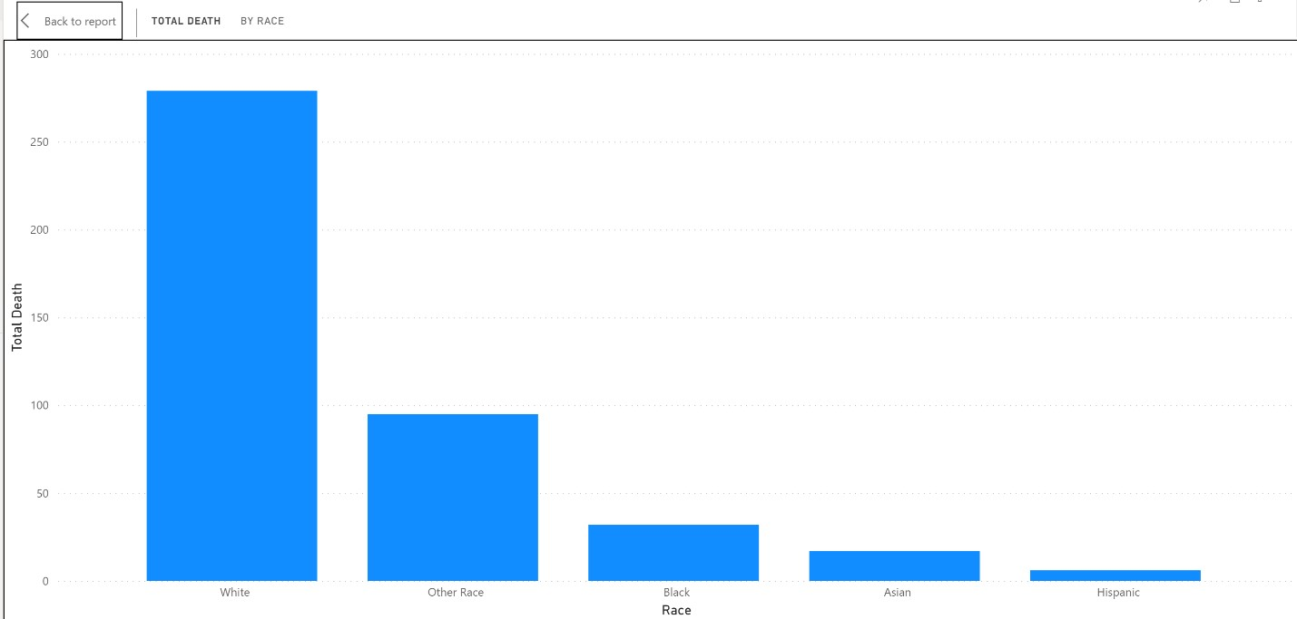

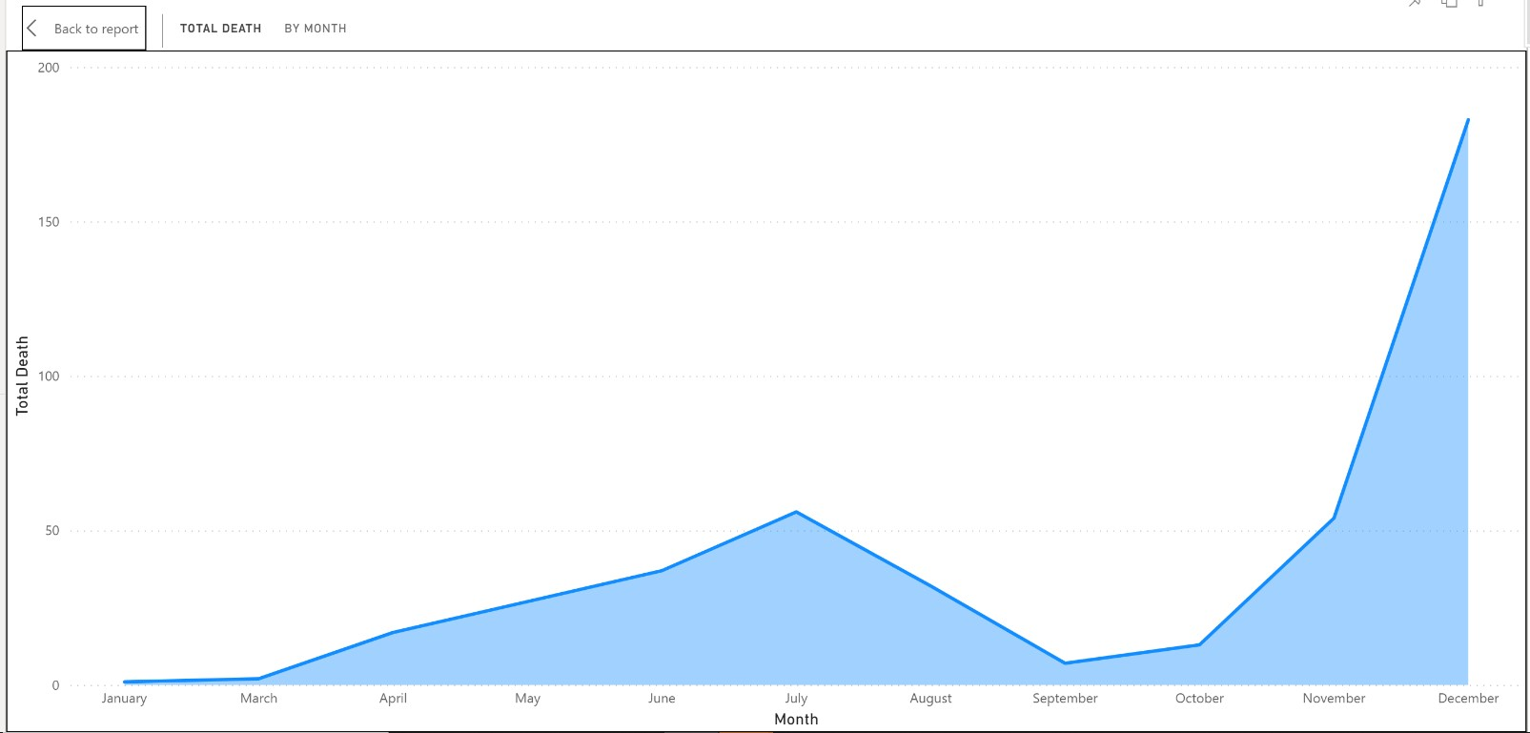

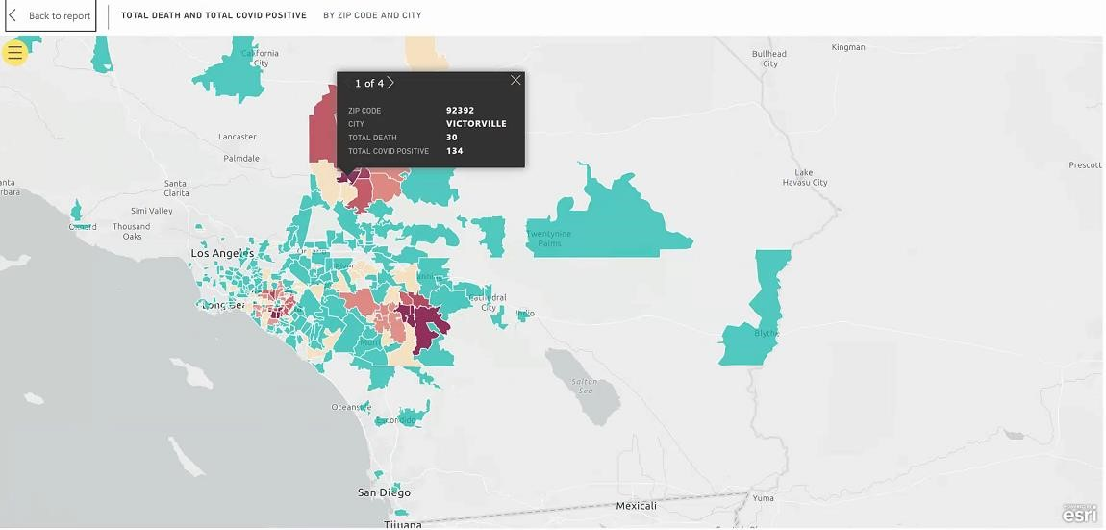

Some of the areas with the highest death rates are caused as result of overcrowding or poorer communities. For example, in Hemet and Victor Valley, a certain zip code shows a higher death rate, which is associated with more than one person per room, excluding bathrooms. A recent

*Los Angeles Times* report found that Los Angeles County has five of the 10 most crowded ZIP Codes in the United States, and public health officials said such housing conditions can accelerate the spread of the virus.

The Death analysis shows that both rates of death and hospitalization vary by age and increase with age. Children are least likely to die though infected, with death rates in confirmed cases of less than 1% in newborns to 9-year-olds. Age group 70- 79 are highly effected and followed by 80-89, 60-69, 50-59 age groups.

African Americans are much more likely to die from COVID-19, with a death rate about twice that of whites, according to the California Department of Public Health. Several factors contribute to this disparity, including underlying health conditions, differential access to care and insurance, and increased exposure to the virus related to employment and housing conditions. Moreover, evidence suggests that the stress brought on by racism itself has long-term negative health consequences. In this population of data, the dashboard shows 631 cumulative COVID deaths for year 2020 and till March 2021. These are the numbers of lives lost by group: White (126), Other Race (46), Asian (13), Black (11), and Hispanic (6).

**Spatial Analysis:**

One of the most important properties of pandemics is their spatial spread, a characteristic which mainly depends on the dynamics of the pandemic, mobility of people and the approach to pandemic control. We can use GIS and spatial statistics to respond to this, and to help mitigate the pandemic through scientific information, find spatial correlations with other variables, and identify transmission dynamics. Medical geography specializes in the application of concepts, methods, and quantitative techniques to address spatial issues in disease and medicine. Within this, health geography focuses geographical concepts and categories on the population and demographic aspects concerning health. Health geography has a predominantly utilitarian perspective and analyses the territory technically, although it incorporates structuralist approaches, such as cultural and sociological vision of social welfare, a sense of ‘place’ for people, and a critical stance. The COVID-19 pandemic is full of unknowns, and many of them have a spatial dimension that led to understanding the phenomenon as geographical and potentially mappable.

COVID-19 is characterized by a long incubation period, high infectivity, and difficulty in detection, which have contributed to the rapid outbreak and development of the epidemic. This situation has led to calls for GIS and big data technology to enable rapid responses and analysis, rapid provision of information on the dynamics of the epidemic and an understanding of the rules of its development to provide timely support for prevention and control decisions and interventions. The prospective approach is an important surveillance tool for controlling disease outbreaks as they develop, and its main strength is the ability to add updated COVID-19 counts and re-execute the statistics to identify new emerging groups. It also tracks previously detected groups to determine whether they are growing or shrinking in magnitude. Doing so can help determine whether current mitigation and isolation techniques are effective in slowing the spread of COVID-19 and suggests that they could be used more widely in public health departments.

With the emphasis on the locations that are closest to the main epicenters of the COVID-19, the vicious circle of contagion can be broken. GIS can be useful for accurate spatial segmentation of areas at epidemic risk and appropriate level of prevention, assessment of population flow and distribution, concerns about the adequacy of health services and constant monitoring of information. Public authorities can use this tool to locate the most affected regions and take appropriate action. GIS has played a key role by rapidly aggregating big data from multiple sources, quickly visualizing information, spatially tracking confirmed cases, predicting regional transmission, spatially segregating pandemic risk and level of prevention, balancing and managing supply and demand for material resources and socio-emotional guidance and elimination of panic, which provided strong spatial information support for decision making, formulating measures and evaluating the effectiveness of prevention and control of COVID-19 cases.

Mapping of the data helps in understanding the factors that can be considered impediments to achieving basic hygiene and social distancing, crowded living conditions, sharing of water and sanitation services, dependence on public health services, limited access to communication tools, and dependence on public transport. The map is the index of risk factors that increase social and health vulnerability during an outbreak or wider quarantine and helps in understanding responds to the concern about how the social distancing measures taken.

This pandemic is a time of extraordinary vigilance over older people. GIS helps to identify the areas that offer the greatest difficulties in accessing health services, where populations over 65 years of age are concentrated and which require medical assistance at home and, finally, the location of hospitals and pharmacies.

Geospatial big data refers to spatial data sets exceeding the capacity of current computing systems. Having information on human mobility patterns from mobile phones, or the registration of global flight networks, is fundamental to epidemiological modelling. Using big data, could help us to understand a pandemic's behavior in terms of outbreak tracking, disease treatment and future vaccine manufacture and distribution.

With the rapid spread of COVID-19, many hospitals and health systems were faced with the possibility of sudden surges in patient volume, resulting in limited resources and increased burden on staff. To better plan for these potential surges, organizations have implemented predictive tools that can help allocate resources. For the business perspective of the Healthcare organization, the spatial analysis of the data of COVID-19 helps in decision-making, and planning. It also helps to improve the locations of health services and controls, points of care, and facilitate access, which translates into an improvement in patient outcomes, time, and material resources. It helps in deciding the number of ICU units required hospital, emergency service providers, lab supplies, pharmacy supplies, Ventilators needed and to make decisions of logistics and supply.

**Conclusion:**

As the pandemic continues, predictive spatial analytics with ArcGIS tools will continue to play a significant role in monitoring the impact of the virus, from patient outcomes to areas of increased disease spread. The global health crisis has only further highlighted the importance of GIS and spatial analytics in healthcare and could accelerate the use of these tools in standard care going forward.

COVID-19 studies with GIS could be valuable tools in decision-making and, more importantly, social mobilization and community responses. Understanding the spatial-temporal dynamics of COVID-19 is critical to its mitigation, which is why such work is being done in all regions of the world. The future of increasing use of GIS in health and human services is extremely bright. The increasing focus on electronic health records, and the corresponding geographic information contained within them will open many new possibilities for population health analysis and planning. GIS has been found to be an essential technology in a wide variety of health and human services agencies and activities. As we continue to battle this pandemic and prepare for future, understanding the risk and being prepared is the first step in potential care and treatment planning.

THANK YOU

DONE BY

ABINASH.S

ABINASH.P

DINESH.K

DHANUSH.M