Site Sign-Off Checklist

**Checklist Type:** Joinery  
**Project Name / Block:** jshdgiid  
**Apartment / Unit:** lvnhlfne  
**Date of Inspection:** 2025-05-15  
**Subcontractor Name:** hvueu  
**CH Foreman:** dkjfhvbfu

# Checklist Items

* ⬜ Entrance door installed, plumb, and square
* ⬜ Fire rating label visible and undamaged
* ⬜ Intumescent seals fitted correctly (frame or door as required)
* ⬜ Gap tolerances compliant and packers fitted correctly
* ⬜ Door closes fully and latches without resistance
* ⬜ Door furniture/ironmongery fitted to spec
* ⬜ Entrance door liner installed straight and securely fixed
* ⬜ Pod door flat liner fitted correctly and square
* ⬜ Internal doors installed correctly with consistent gaps
* ✅ Hinges, handles, and latches fitted securely
* ⬜ Skirting fitted tight to wall, level, and flush
* ⬜ Joints (mitres, scribes) tight and filled where required
* ✅ Fixings fitted neatly
* ⬜ Architraves fitted tight to frame and wall
* ⬜ Consistent margins and clean mitres
* ✅ No gaps, damage, or poor cuts visible
* ⬜ Correct type and size of thresholds installed
* ✅ Fitted level and securely fixed
* ⬜ No sharp edges, trip hazards, or gaps
* ⬜ Doorstops fitted correctly
* ⬜ All ironmongery installed to spec
* ✅ Function tested – doors open, close, and latch smoothly with receivers adjusted
* ⬜ No missing screws or loose components
* ✅ Damaged/missing components reported
* ⬜ Area left tidy and safe
* ⬜ Installation ready for inspection/handover

Subcontractor Signature:

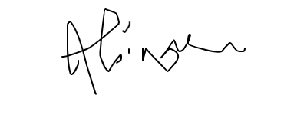

Carnehill Joinery Ltd. Carrowhatta, Scotstown, Co. Monaghan, Ireland.

H18 FH36

T: +353 (0) 4779 355 Company Registration: 639076 VAT Number:3592506TH