**Part 1**

Evaluate the following Boolean expressions in **IDLE**:

**Note down the response to each. Do they differ from what you would expect?**

7 and 5

True and True

True and False or True

False or False and True

False or 0

not (False) and True

not (True or not (False and False))

(10 > 14) and (4 == 5)

True and 5

(3 * 4)! = (14 - 2) or (‘C’ >= ’D’)

(12 * 2) == (3 * 8)

(14 * 2)! = (3 * 8)

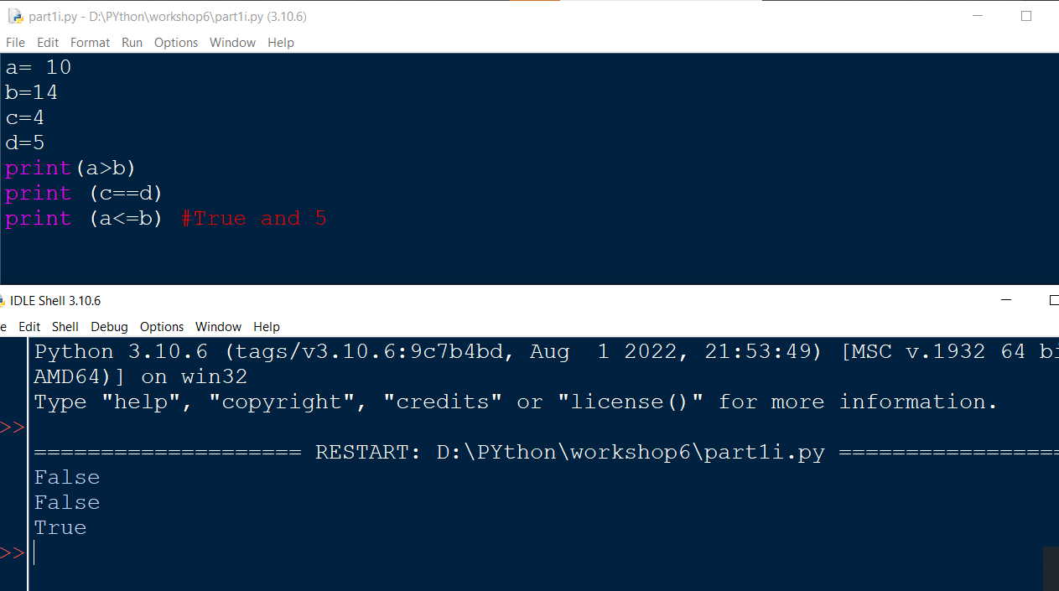

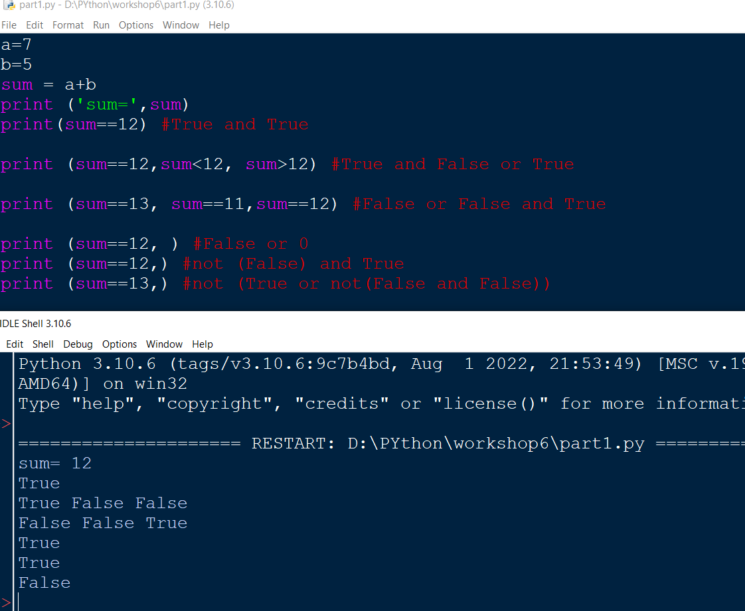

**Part 2**

**1.** Evaluate the following expressions for num1 = 10 and num2 = 20.

**(a)** not (num1 < 1) and num2 < 10

**(b)** not (num1 < 1) and num2 < 10 or num1 + num3 < 100 **(c)** not (num2 > 1) or num1 > num2 – 10

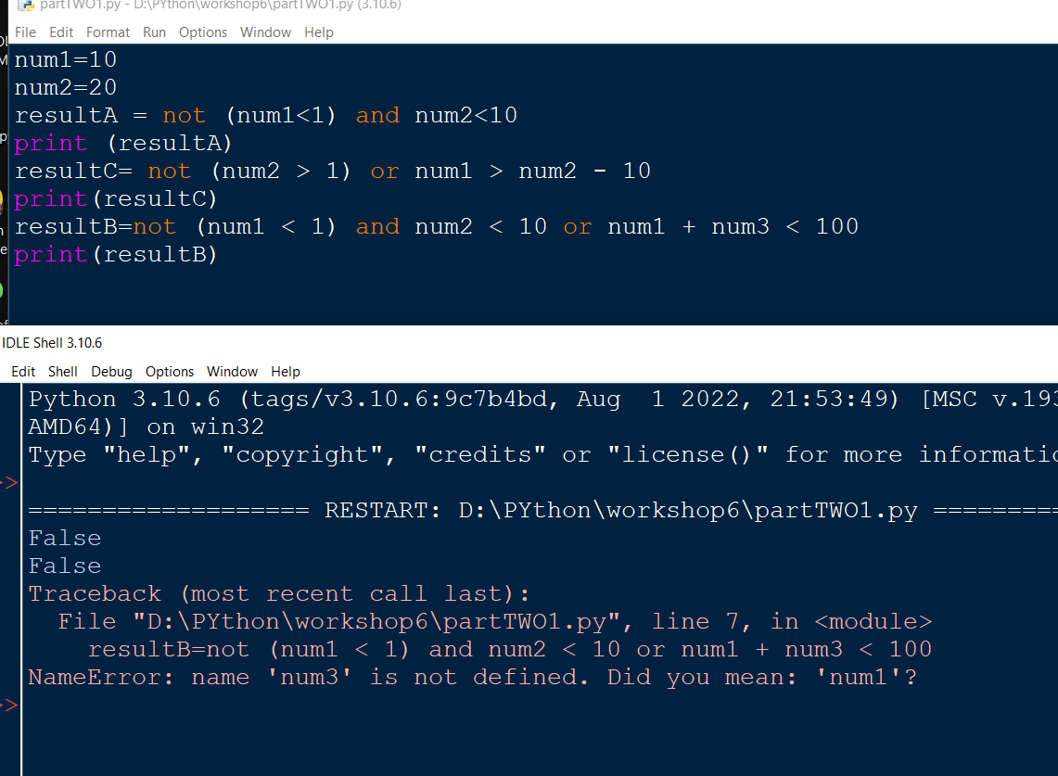

**2.** Write a python program to find the sum and product of two numbers.

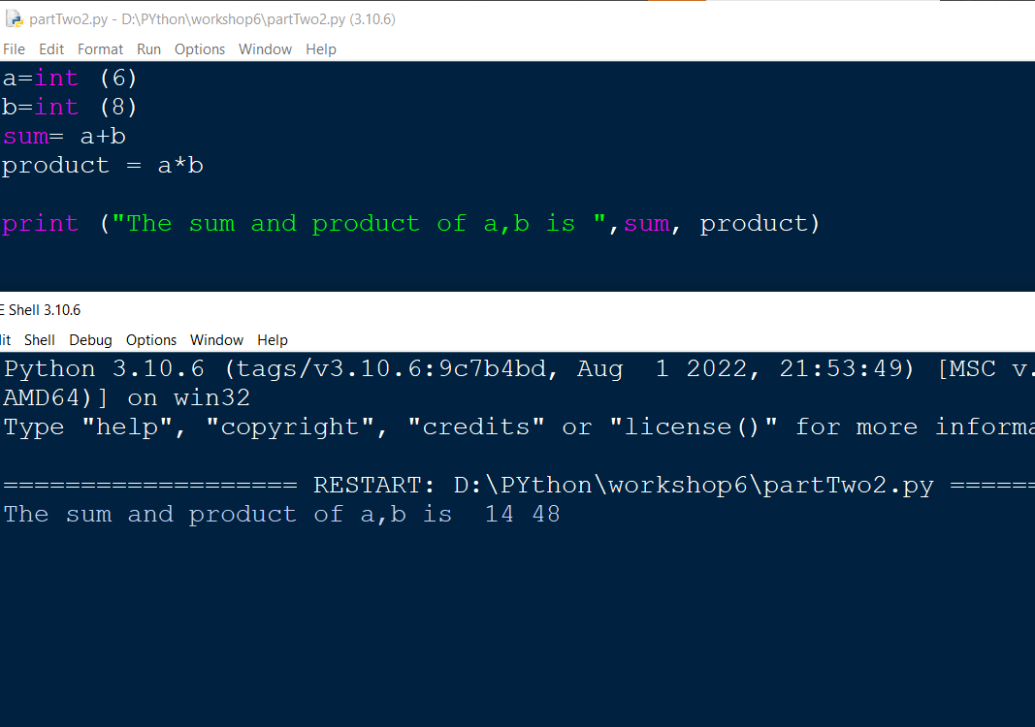

**3.** Write a python program to input first name, last name, and address. Print them.

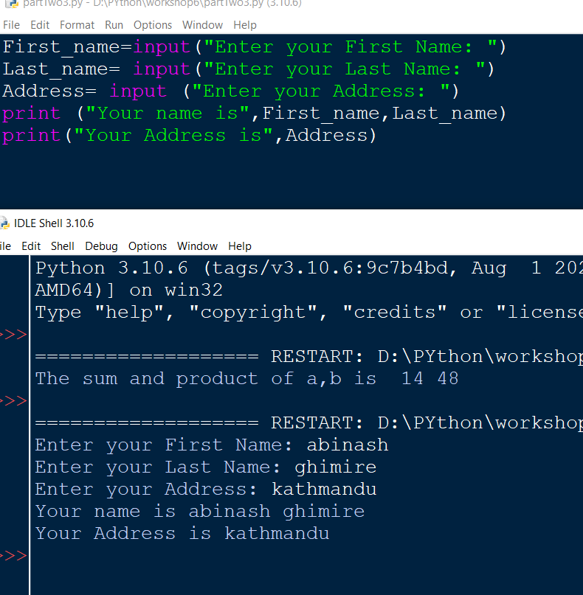

**4.** Write a python program to input three numbers and find their sum.

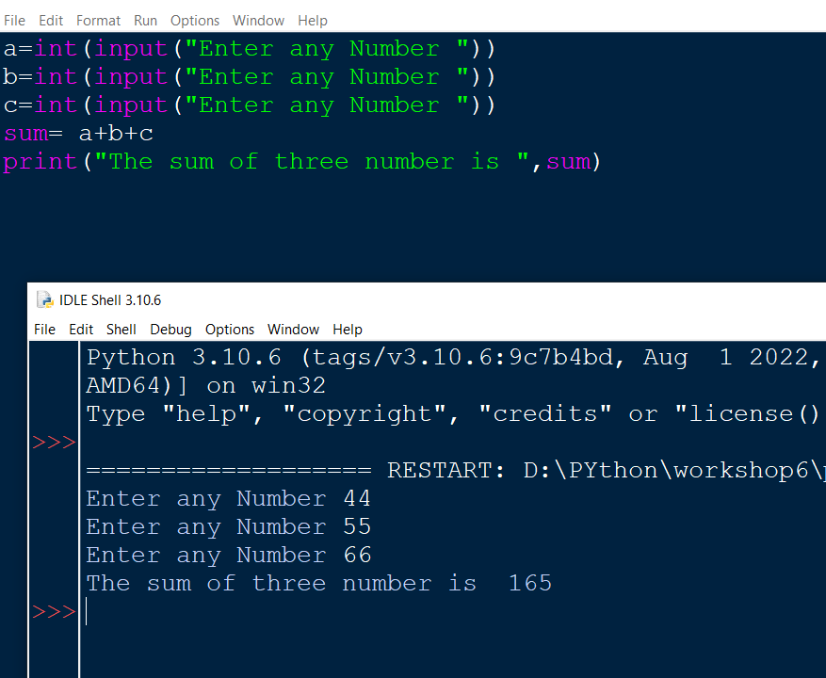**5.** Write a python program to print the area of circle. Take radius of circle as an input form the user.

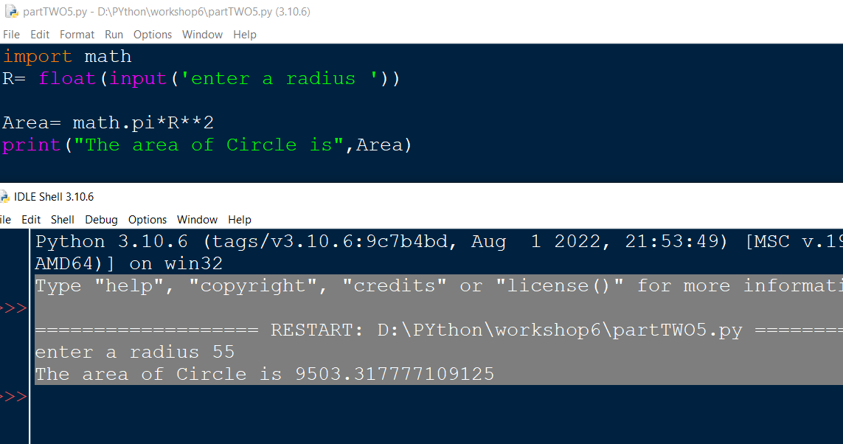

**Part 3**

**1.** Write a program that:

**(a)** Asks to input the user’s weight in kilograms

**(b)** Asks to input the user’s height in centimeters.

**(c)** Calculates the BMI (Body Mass Index).

[BMI=weight in kilograms / square of height in centimeters]

**(d)** Prints the user’s BMI.

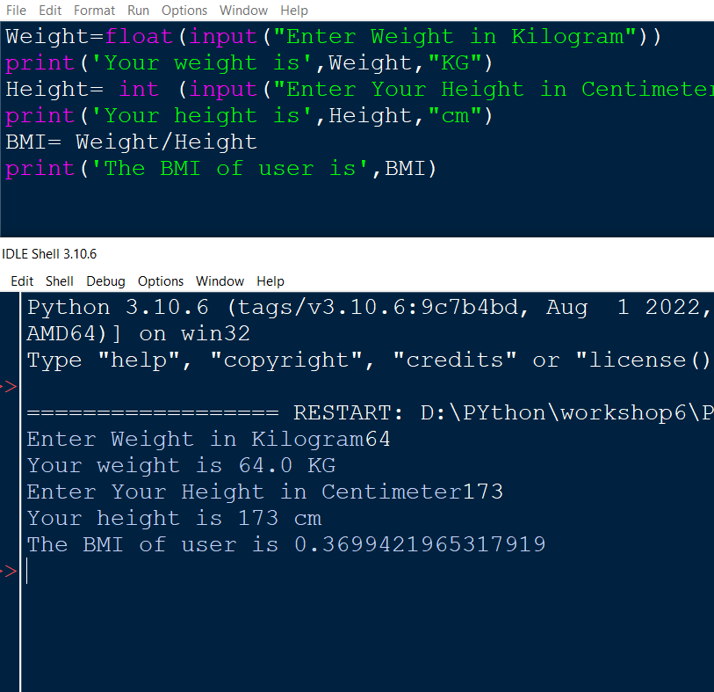

**2.** An observer sees the shadow of a bird at mid-day.

**(a)** The distance between the observer and the shadow is 15 meters.

**(b)** The perpendicular distance between the bird and its shadow is 25 meters.

**(c)** Find the total distance between the bird and the observer.

**[Use height and distance formula: h2=p2+b2]**

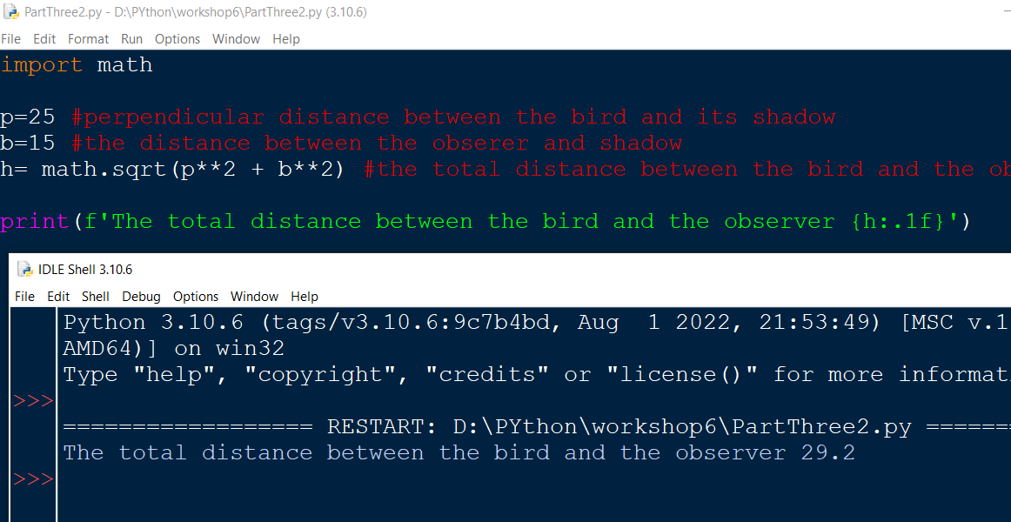

**3.** A costumer walks in a flower shop and finds the following menu:

|  |  |  |  |  |  |
| --- | --- | --- | --- | --- | --- |
| Particulars | White Roses | Lilies | Poppies | Marigold | Red Roses |
| Per piece | 50 | 50 | 40 | 20 | 100 |
| Per bouquet | 300 | 300 | 250 | 200 | 1000 |

If the user bought a bouquet of lilies and four red roses, find the total money the user spent in the flower shop.

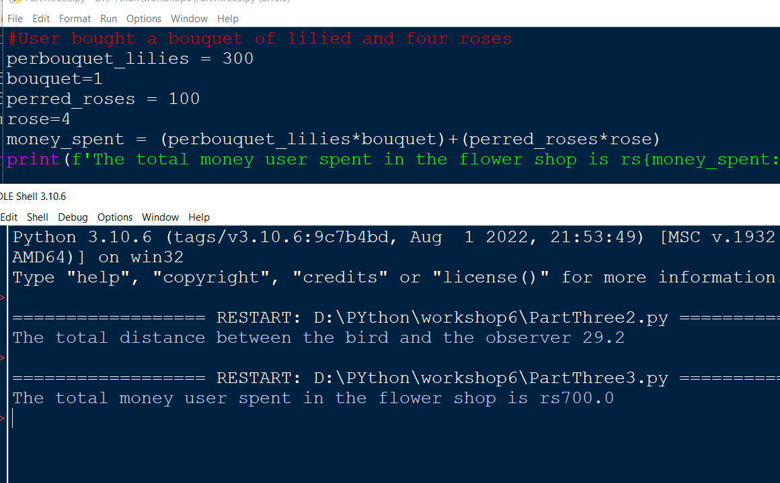

**4.** Take user’s name, age and address as input and generate a formatted output using python scripting. [Use %d and %s to generate the output]

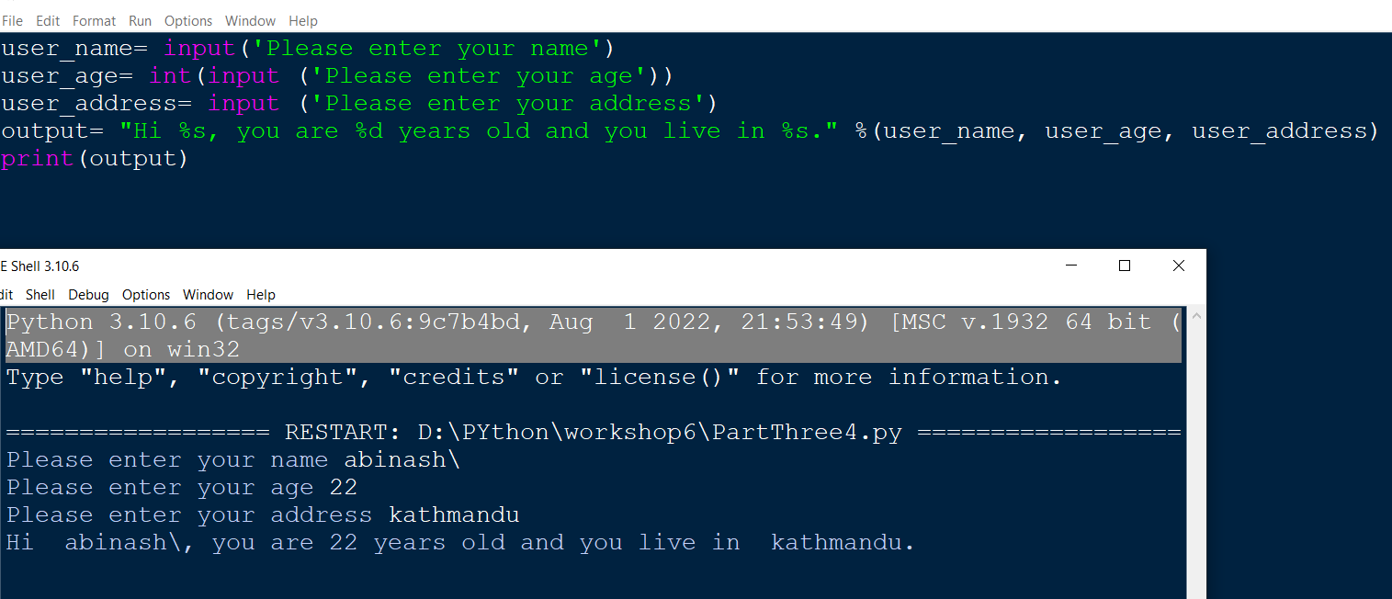

**5.** Calculate the VAT amount of a gadget the user bought using the built in python format function within two decimal digits. Input the cost price from the user. [VAT =13%]

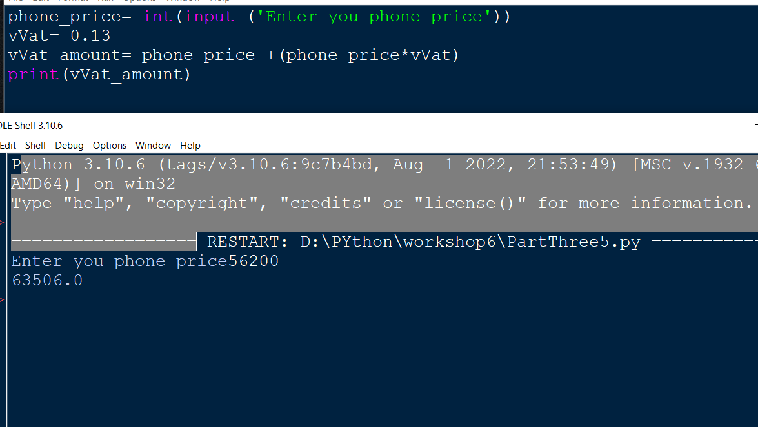

**Part 4 (Home Task)**

**1.** Give an appropriate if statement for each of the following

(The value of num is not important):

**(a)** Displays 'within range' if num is between 0 and 100, inclusive.

**(b)** Displays 'within range' if num is between 0 and 100, inclusive, and displays 'out of range' otherwise.

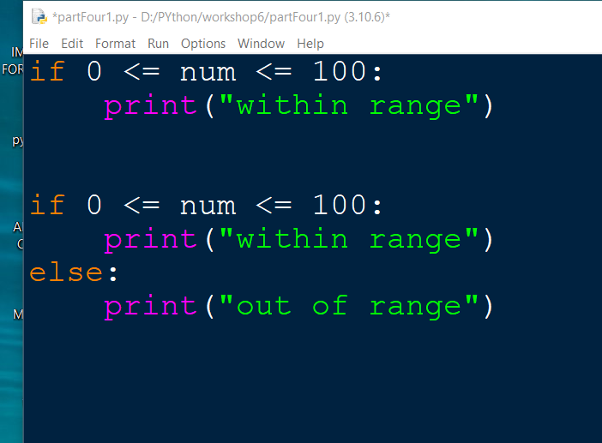

**2**. Rewrite the following if-else statements using a single if statement and elif:

if temperature >= 85 and humidity > 60:

print ('muggy day today')

else:

if temperature >= 85:

print ('warm, but not muggy today')

else:

if temperature >= 65:

print ('pleasant today')

else:

if temperature <= 45:

print ('cold today')

else:

print ('cool today')

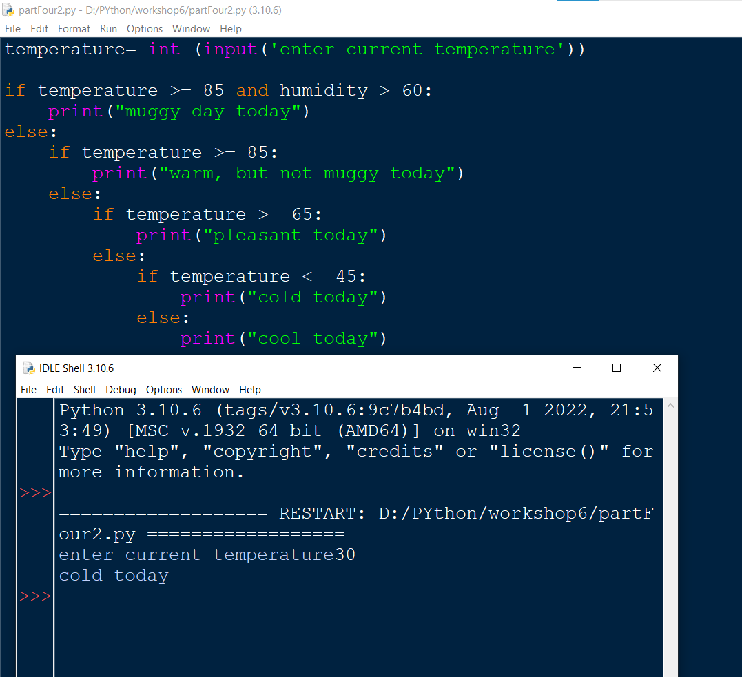

**3.** Write a Python program in which:

**(a)** The user enters either 'A', 'B', or 'C'. If 'A' is entered, the program should display the word 'Apple'; if 'B' is entered, it displays 'Banana'; and if 'C' is entered, it displays 'Coconut'. Use nested if statements for this.

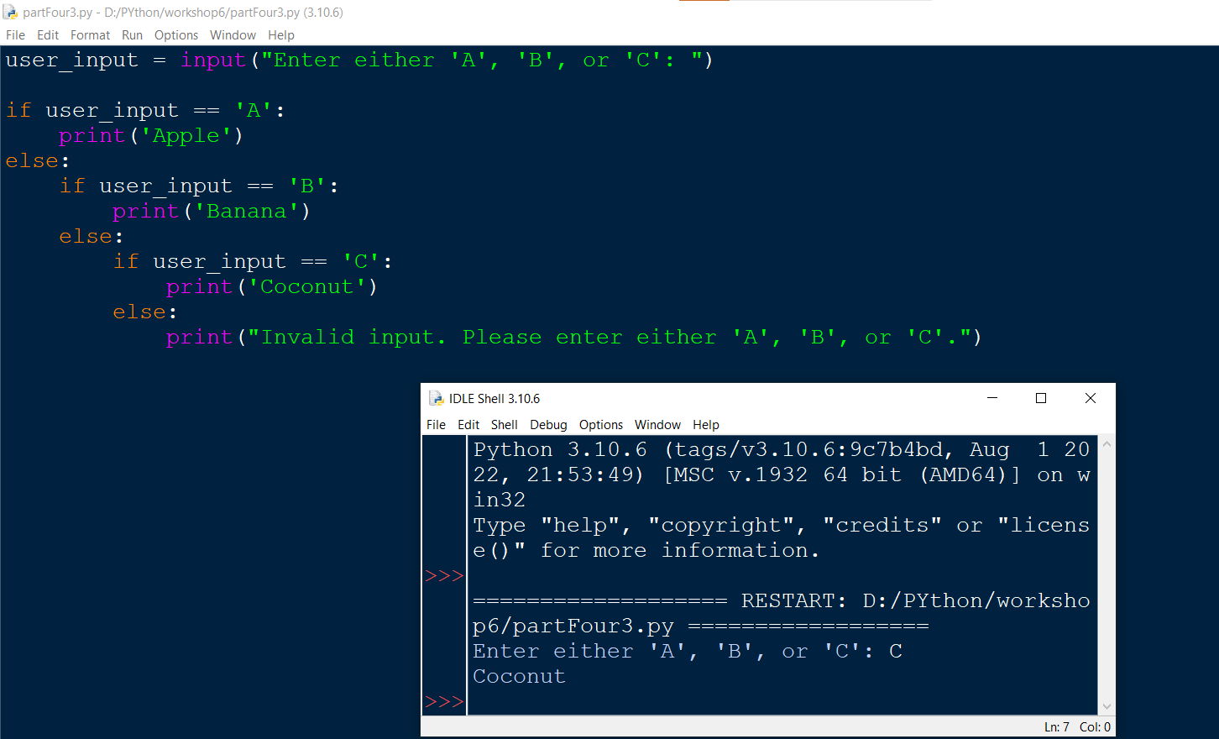 **(b)** Repeat question **(a)** using an if statement with elif headers instead.

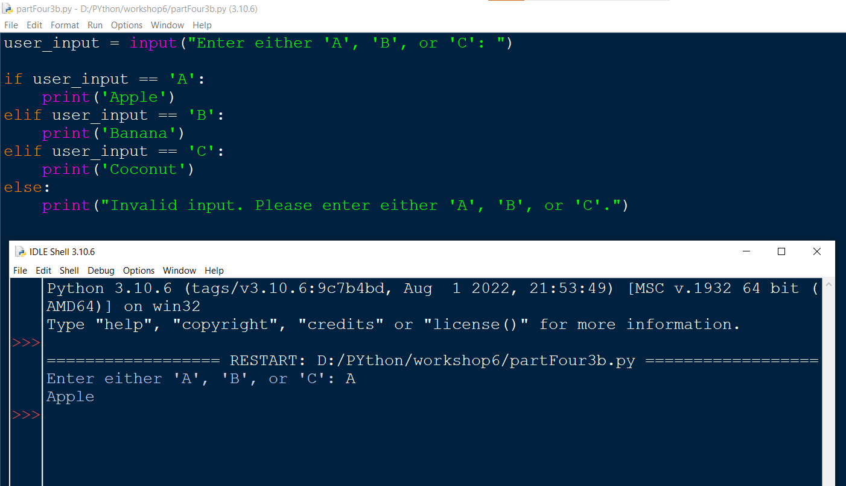

**(c)** A student enters the number of college credits earned. If the number of credits is greater than or equal to 90, 'Senior Status' is displayed; if greater than or equal to 60, 'Junior Status' is displayed; if greater than or equal to 30, 'Sophomore Status' is displayed; else, 'Freshman Status' is displayed

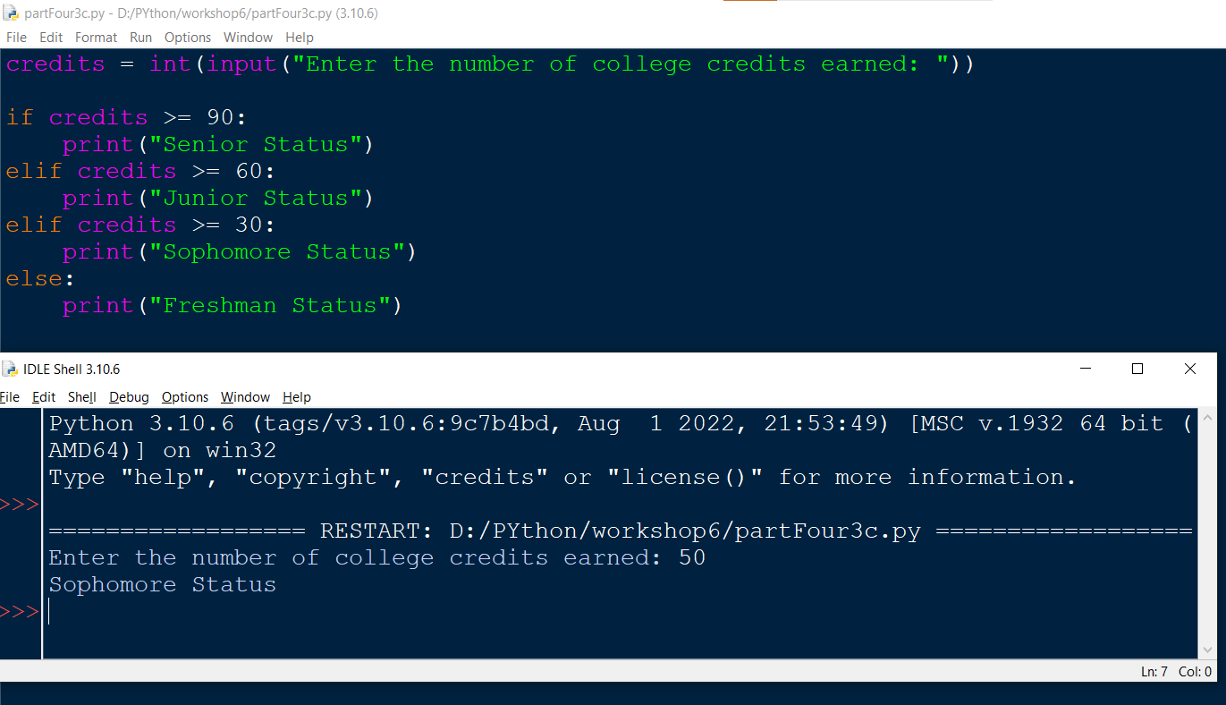.

**(e)** The user enters a number. If the number is divisible by 3, the word ‘Fizz’ should be displayed; if the number is divisible by 5 the word ‘Buzz’ should be displayed and if the number is divisible by both ‘FizzBuzz’ should be displayed.

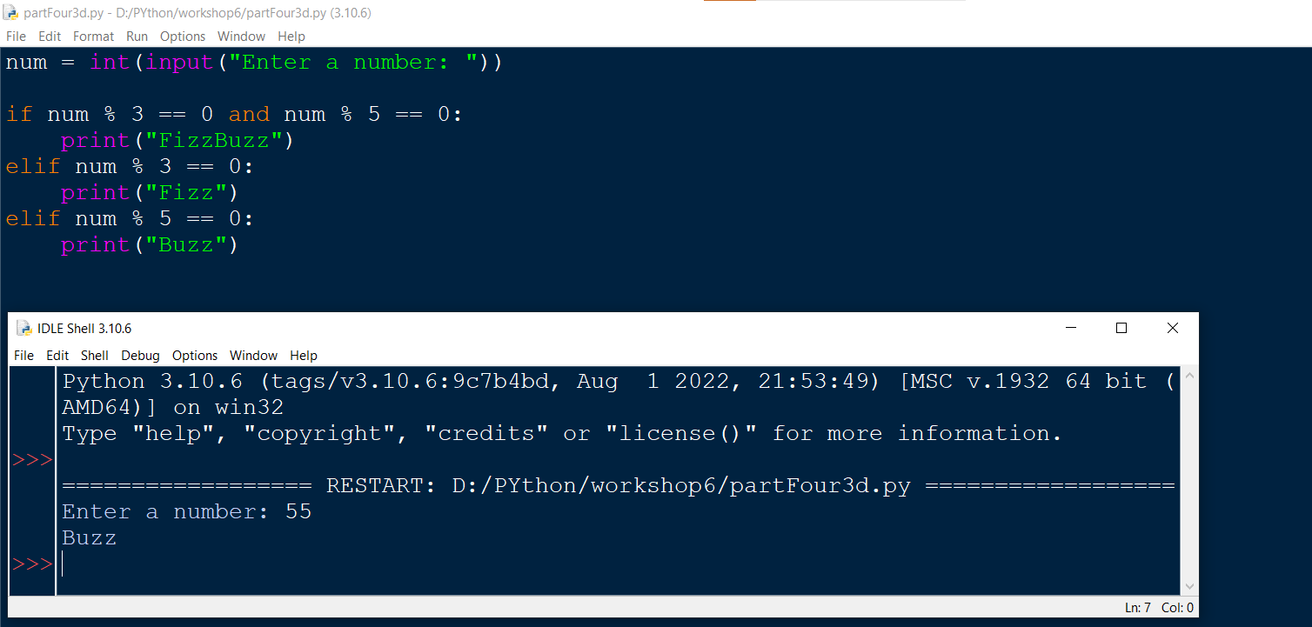

**5.** Create a program using the schematic below to help you decide whether it is okay to eat something that you dropped on the floor…

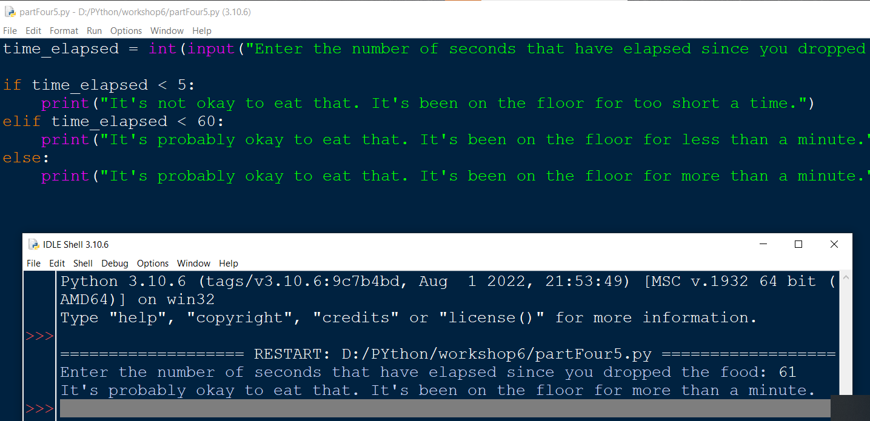

**Note:** this is not genuine advice on health and hygiene ;)

