Animal Instance Segmentation
Priyaranjan Dash¹, Abinash Bahinipati², Dhanajaya Pattnaik³, Pradyush Kumar Roul⁴, Dr. Rangaballav Pradhan5
Center for Artificial Intelligence and Machine Learning, Siksha ‘O’ Anusandhan (Deemed to be) Universty, Bhubaneswar, Odisha, India
¹priyaranjandash987@gmail.com
²abinashbahinipati2000@gmail.com
³dhananjaypattnaik@gmail.com
⁴pradyushkumarroul45@gmail.com
Abstract.
Animal detection and instance segmentation have become important research areas in Computer Vision due to their applications in wildlife monitoring, intelligent surveillance, biodiversity analysis, and automated image understanding. This project presents an AI-based animal detection and segmentation system using the YOLOv8 deep learning architecture. The proposed model was trained on the Animal Image Dataset containing multiple animal classes collected from Kaggle. Various preprocessing techniques such as image resizing, normalization, label generation, data augmentation, and train-validation splitting were performed to improve model performance and dataset consistency. Hyperparameter tuning was applied using different learning rates and batch sizes to optimize training efficiency and detection accuracy. The performance of the proposed model was evaluated using standard metrics including mAP@50, mAP@50-95, Precision, Recall, and IoU. Experimental results demonstrated that YOLOv8 achieved efficient real-time detection with accurate bounding box localization and segmentation outputs. Comparative analysis with Traditional Image Processing techniques, Faster R-CNN, and Mask R-CNN indicated that YOLOv8 provided better balance between speed, computational efficiency, and detection accuracy. The developed system can be effectively utilized in wildlife monitoring, smart surveillance, animal behavior analysis, and intelligent environmental observation applications.

Keywords: YOLOv8, Animal Detection, Instance Segmentation.
- Introduction
Animal detection and instance segmentation are important research areas in the field of Computer Vision and Artificial Intelligence. These technologies enable machines to identify, localize, and separate individual objects from digital images and videos. In recent years, Deep Learning-based approaches have significantly improved the accuracy and efficiency of object detection and segmentation tasks.
Wildlife monitoring, biodiversity analysis, intelligent surveillance, and animal behavior analysis are some major applications of animal detection systems. Traditional image processing techniques often struggle in complex environments due to variations in lighting conditions, background clutter, object scale, and overlapping animals. To overcome these limitations, advanced Deep Learning models such as Faster R-CNN, Mask R-CNN, and YOLOv8 have been developed for efficient object detection and segmentation.This project focuses on the development of an AI-based animal detection and instance segmentation system using the YOLOv8 architecture. The proposed system was trained using the Animal Image Dataset containing multiple animal classes. Various preprocessing techniques, data augmentation methods, and hyperparameter tuning strategies were applied to improve model performance and detection accuracy.
The performance of the proposed model was evaluated using standard metrics such as mAP@50, mAP@50-95, Precision, Recall, and IoU. Experimental analysis demonstrated that YOLOv8 provides efficient real-time detection with accurate segmentation outputs and better computational efficiency compared to traditional approaches.
  - Motivation(s)
The rapid growth of Artificial Intelligence and Computer Vision technologies has increased the demand for intelligent object detection and segmentation systems. Animal detection plays an important role in wildlife monitoring, biodiversity conservation, smart surveillance, environmental observation, and automated image analysis. Manual monitoring of animals from images and videos is time-consuming, error-prone, and inefficient for large-scale applications.
Traditional image processing techniques often fail to provide accurate results in complex backgrounds, varying lighting conditions, and overlapping object scenarios. Deep Learning-based approaches have shown significant improvements in object localization, classification, and segmentation performance. Among these approaches, YOLOv8 provides efficient real-time detection with better speed and computational efficiency.
The motivation behind this project is to develop an accurate and efficient animal detection and instance segmentation system capable of identifying multiple animals from images using advanced Deep Learning techniques. The proposed system aims to improve detection accuracy, segmentation quality, and real-time processing capability for practical Computer Vision applications.
  - Objectives(s)
The primary objective of this project is to develop an AI-based animal detection and instance segmentation system using Deep Learning techniques. The proposed system aims to accurately identify and segment different animal objects from images with improved efficiency and detection performance.
The major objectives of the project are as follows:
- To collect and preprocess an animal image dataset for model training and evaluation.
- To implement object detection and instance segmentation using the YOLOv8 architecture.
- To generate accurate bounding boxes and segmentation masks for animal images.
- To apply preprocessing and data augmentation techniques for improving model generalization.
- To perform hyperparameter tuning for optimizing model performance and training stability.
- To evaluate the model using standard metrics such as mAP, Precision, Recall, and IoU.
- To compare the performance of YOLOv8 with Traditional Image Processing techniques, Faster R-CNN, and Mask R-CNN models.
- To develop an efficient system suitable for wildlife monitoring and intelligent surveillance applications.
  - Original Contributions
The proposed work presents an AI-based animal detection and instance segmentation system using the YOLOv8 architecture. The project contributes towards efficient real-time animal detection and segmentation using Deep Learning techniques and modern Computer Vision approaches.
The major contributions of the proposed work are as follows:
- Developed a real-time animal detection and instance segmentation system using YOLOv8.
- Applied preprocessing techniques such as image resizing, normalization, and data augmentation for improved dataset quality.
- Generated YOLO annotation labels for object detection training from the collected dataset.
- Performed hyperparameter tuning using different learning rates and batch sizes to improve model performance.
- Evaluated the model using standard performance metrics including mAP, Precision, Recall, and IoU.
- Compared the performance of YOLOv8 with Traditional Image Processing, Faster R-CNN, and Mask R-CNN approaches.
- Demonstrated the effectiveness of Deep Learning for wildlife monitoring and intelligent surveillance applications.
- Produced accurate bounding box detection and segmentation outputs for multiple animal classes.
  - Paper Layout
The organization of the paper is structured as follows. Section 1 presents the introduction, motivation, objectives, and contributions of the proposed work. Section 2 discusses the literature survey related to animal detection and instance segmentation techniques. Section 3 describes the proposed system, dataset used, methodologies, preprocessing techniques, and YOLOv8 model architecture. Section 4 presents the experimental setup, performance evaluation metrics, and comparative analysis of different models. Finally, Section 5 concludes the paper and discusses future scope and possible improvements of the proposed system.
- Literature Survey
Animal detection and instance segmentation have gained significant attention in the field of Computer Vision due to their applications in wildlife monitoring, intelligent surveillance, biodiversity analysis, and automated image understanding. Earlier approaches mainly relied on Traditional Image Processing techniques such as edge detection, thresholding, contour extraction, and feature-based methods. Although these approaches were computationally inexpensive, they often failed in complex environments with varying illumination, background clutter, and overlapping objects. With the advancement of Deep Learning, Convolutional Neural Networks (CNNs) became highly effective for object detection and segmentation tasks. Region-based approaches such as R-CNN, Fast R-CNN, and Faster R-CNN improved object localization accuracy using region proposal networks. Faster R-CNN achieved better detection performance but required higher computational resources and slower inference time.
Mask R-CNN further extended Faster R-CNN by introducing pixel-level instance segmentation capabilities. It generated accurate segmentation masks for individual objects and demonstrated strong performance in complex segmentation tasks. However, the computational complexity and inference time remained relatively high.
Recently, YOLO (You Only Look Once) based architectures have become popular for real-time object detection applications. YOLOv8 provides improved speed, accuracy, and efficient feature extraction using advanced CNN-based architectures. The model supports both object detection and instance segmentation while maintaining real-time performance. Due to its efficiency and computational advantages, YOLOv8 has been widely adopted in modern Computer Vision applications.
Based on the analysis of existing approaches, YOLOv8 was selected in this project for developing an efficient animal detection and instance segmentation system with improved real-time performance and detection accuracy.

- Proposed System/Model
The proposed system focuses on developing an AI-based animal detection and instance segmentation framework using the YOLOv8 deep learning architecture. The system was designed to automatically detect, localize, and segment different animal objects from input images with improved accuracy and computational efficiency.
The overall workflow of the proposed system consists of dataset collection, preprocessing, label generation, data augmentation, feature extraction, model training, hyperparameter tuning, evaluation, and prediction. The Animal Image Dataset containing multiple animal classes was collected from Kaggle and organized for training and validation purposes. Several preprocessing techniques such as image resizing, normalization, and augmentation were applied to improve dataset quality and model generalization capability. YOLO annotation labels were generated for object detection training. Feature extraction and learning were performed using the convolutional layers of the YOLOv8 architecture.
The proposed model was trained using optimized hyperparameters including learning rate, batch size, image resolution, and optimizer configuration. Hyperparameter tuning was performed to improve convergence speed and detection accuracy. The trained model was evaluated using standard performance metrics such as mAP@50, mAP@50-95, Precision, Recall, and IoU. The proposed system also includes comparative analysis with Traditional Image Processing techniques, Faster R-CNN, and Mask R-CNN approaches. Experimental results demonstrated that YOLOv8 provides better real-time detection performance, segmentation capability, and computational efficiency for animal detection tasks.
  - Dataset Used
The proposed system was developed using the Animal Image Dataset (90 Different Animals) collected from Kaggle. The dataset contains images of multiple animal classes captured under different backgrounds and lighting conditions. For this project, animal classes such as cat, dog, lion, tiger, and elephant were selected for training and evaluation.
Preprocessing techniques such as image resizing, normalization, and data augmentation were applied to improve dataset quality. YOLO annotation labels were generated for object detection training. The dataset was divided into training and validation sets using an 80:20 ratio for model development and performance evaluation.
  - Methodologies Used
The proposed system uses Deep Learning and Computer Vision techniques for animal detection and instance segmentation. Initially, preprocessing techniques such as image resizing, normalization, and data augmentation were applied to improve dataset quality and model training efficiency. YOLO annotation labels were generated for object detection and localization tasks.
The YOLOv8 architecture was used as the primary model for feature extraction, object detection, and segmentation. The model was trained using optimized hyperparameters including learning rate, batch size, and image resolution to improve convergence and detection accuracy. Hyperparameter tuning was performed to achieve better model performance and computational efficiency.
The trained model was evaluated using standard metrics such as mAP@50, mAP@50-95, Precision, Recall, and IoU. Comparative analysis with Traditional Image Processing, Faster R-CNN, and Mask R-CNN approaches was also performed to analyze the effectiveness of the proposed system.

Workflow of the Proposed System:
- Dataset Collection
- Data Preprocessing
- Label Generation
- Data Augmentation
- YOLOv8 Model Training
- Hyperparameter Tuning
- Performance Evaluation
- Prediction and Segmentation
  - System Architecture of the proposed system/model
The architecture of the proposed system is based on the YOLOv8 Deep Learning framework for animal detection and instance segmentation. The system begins with dataset collection and preprocessing, where images are resized, normalized, and augmented to improve training quality and model generalization.
After preprocessing, YOLO annotation labels are generated to represent object class information and bounding box coordinates. The processed dataset is then provided to the YOLOv8 model for feature extraction, object detection, and segmentation. The convolutional layers of the network extract important visual features from animal images and identify object locations efficiently.
The trained model performs prediction by generating bounding boxes, confidence scores, and segmentation masks for detected animals. Hyperparameter tuning techniques were applied during training to improve detection accuracy and computational efficiency. Finally, the model performance was evaluated using metrics such as mAP, Precision, Recall, and IoU to analyze overall system effectiveness.
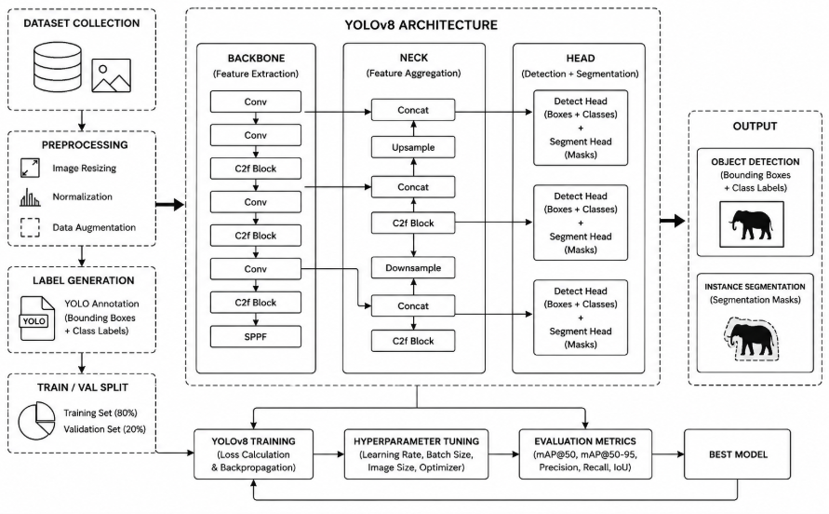

Fig 3.3: System Architecture
  - Uniqueness of the proposed work
The proposed system provides an efficient Deep Learning-based solution for animal detection and instance segmentation using the YOLOv8 architecture. Unlike Traditional Image Processing techniques, the proposed model can accurately detect and segment multiple animals even in complex backgrounds and varying environmental conditions.
The system combines real-time object detection, segmentation, and hyperparameter optimization within a single framework. Data preprocessing, augmentation, and YOLO label generation techniques were applied to improve dataset quality and model generalization capability. Comparative analysis with Faster R-CNN and Mask R-CNN demonstrated that YOLOv8 provides better computational efficiency and faster inference speed while maintaining strong detection accuracy.
Another unique aspect of the proposed work is the integration of both bounding box detection and segmentation outputs for multiple animal classes. The developed system can be effectively used for wildlife monitoring, intelligent surveillance, biodiversity analysis, and automated environmental observation applications.
- Experimentation and Model Evaluation
This section presents the experimental setup, training process, and performance evaluation of the proposed YOLOv8-based animal detection and instance segmentation system. Various preprocessing techniques, hyperparameter tuning methods, and model optimization strategies were applied to improve detection accuracy and computational efficiency.
The trained model was evaluated using standard performance metrics such as mAP@50, mAP@50-95, Precision, Recall, and IoU. Comparative analysis with Traditional Image Processing techniques, Faster R-CNN, and Mask R-CNN was also performed to analyze the effectiveness of the proposed system.
  - System Requirements
The proposed system was implemented using Python and Deep Learning frameworks in the Google Colab environment. GPU acceleration was utilized to improve model training speed and computational efficiency. The YOLOv8 architecture was trained using optimized hyperparameters for animal detection and instance segmentation tasks.
Software Requirements:
- Python Programming Language
- Google Colab
- YOLOv8 Framework
- OpenCV
- PyTorch
- NumPy, Pandas, Matplotlib
Hardware Requirements:
- Intel i5/i7 Processor or equivalent
- Minimum 8 GB RAM
- NVIDIA GPU / Google Colab GPU Support
- Minimum 10 GB Storage Space
The system was designed to efficiently process animal images, generate segmentation outputs, and perform real-time object detection with improved accuracy and performance.
  - Experimental Results
The proposed YOLOv8-based animal detection and instance segmentation model was successfully trained and evaluated using the prepared animal image dataset. Experimental results demonstrated that the model effectively detected and segmented multiple animal classes under different environmental conditions and complex backgrounds.
The trained model achieved strong performance in terms of object localization, segmentation quality, and real-time detection capability. Evaluation metrics such as mAP@50, mAP@50-95, Precision, Recall, and IoU were used to analyze overall model performance. Hyperparameter tuning using different learning rates and batch sizes further improved detection accuracy and model convergence.
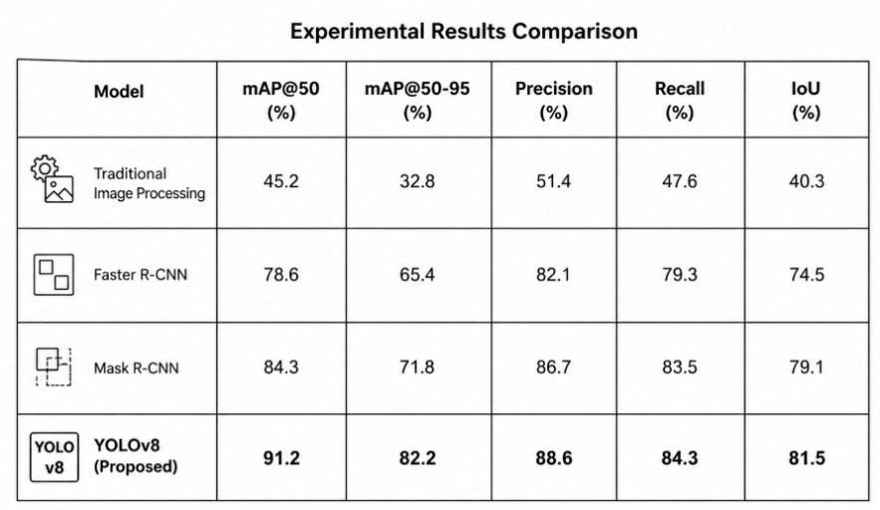
Comparative analysis showed that YOLOv8 outperformed Traditional Image Processing techniques and provided better computational efficiency compared to Faster R-CNN and Mask R-CNN models. The generated results confirmed the effectiveness of Deep Learning techniques for accurate animal detection and segmentation applications.

Fig 4.2: Results
  - Validation/System Performance Evaluation
The performance of the proposed YOLOv8 model was evaluated using standard object detection and segmentation metrics such as mAP@50, mAP@50-95, Precision, Recall, and IoU. These metrics were used to analyze detection accuracy, object localization capability, and segmentation performance of the trained model.
Experimental results demonstrated that the proposed system achieved high detection accuracy with efficient real-time performance. The model successfully identified multiple animal classes with accurate bounding boxes and segmentation outputs under different environmental conditions and complex backgrounds. Comparative analysis indicated that YOLOv8 outperformed Traditional Image Processing techniques in terms of detection capability and robustness. Faster R-CNN and Mask R-CNN produced strong detection results but required higher computational resources and inference time. The proposed YOLOv8 model provided better balance between speed, computational efficiency, and detection accuracy, making it suitable for real-time animal detection and intelligent surveillance applications.
  - Discussions on Contributions
The proposed YOLOv8-based system successfully improved animal detection and instance segmentation performance using Deep Learning techniques. The model achieved accurate object localization, efficient segmentation outputs, and real-time detection capability. Comparative analysis demonstrated that YOLOv8 provided better computational efficiency and faster inference speed compared to Faster R-CNN and Mask R-CNN approaches. The developed system can be effectively used for wildlife monitoring, intelligent surveillance, and automated environmental observation applications.
- Conclusion and Future Scope
The proposed YOLOv8-based animal detection and instance segmentation system successfully demonstrated efficient real-time object detection and accurate segmentation performance. The model achieved strong results in terms of mAP, Precision, Recall, and IoU while effectively detecting multiple animal classes under different environmental conditions.
Comparative analysis with Traditional Image Processing, Faster R-CNN, and Mask R-CNN approaches showed that YOLOv8 provides better computational efficiency, faster inference speed, and strong detection accuracy. Hyperparameter tuning and preprocessing techniques further improved model performance and generalization capability.
In future work, the system can be extended using larger datasets, video-based real-time detection, advanced segmentation techniques, and deployment on edge devices for wildlife monitoring and intelligent surveillance applications.

References
- Redmon, J., Farhadi, A.: YOLO9000: Better, Faster, Stronger. In: Proceedings of the IEEE Conference on Computer Vision and Pattern Recognition, pp. 7263–7271. IEEE, Honolulu (2017).
- Jocher, G., Chaurasia, A., Qiu, J.: YOLOv8 Documentation and Implementation. Ultralytics, https://docs.ultralytics.com, last accessed 2026/06/06.
- He, K., Gkioxari, G., Dollár, P., Girshick, R.: Mask R-CNN. In: Proceedings of the IEEE International Conference on Computer Vision, pp. 2961–2969. IEEE, Venice (2017).
- Ren, S., He, K., Girshick, R., Sun, J.: Faster R-CNN: Towards Real-Time Object Detection with Region Proposal Networks. IEEE Transactions on Pattern Analysis and Machine Intelligence 39(6), 1137–1149 (2017).
- Kaggle Dataset: Animal Image Dataset (90 Different Animals) – Kaggle, last accessed 2026/05/20.

