Center for Artificial intelligence and Machine Learning
Department of Computer Sc. & Engg.
FET (ITER), SOA Deemed to be University, Bhubaneswar, Odisha

UNDERTAKING BY 2nd YEAR CAIML (Section-24E1N3) STUDENTS (AS AUTHORS)
Project/Article Title: Animal Instance Segmentation using YOLO
Name of Students (with Regd. No.)
1. Priyaranjan Dash (24E104B25)
2. Abinash Bahinipati (24E102A05)
3. Dhanajaya Pattnaik (24E116C56)
4. Pradyush Kumar Roul (24E118A99)
Supervisor Name: Dr. Rangaballav Pradhan

We declare that, we contributed significantly towards the implementation and design/development of the above-mentioned project and we undertake that, we hereby, transfer the rights, especially processing, reproduction, representation, printing and distribution, and online transmittal to our Supervisor Dr. Rangaballav Pradhan (Associate Professor/ CSE(AI & ML)) with due authorship credit to us.
[Signature of Students]
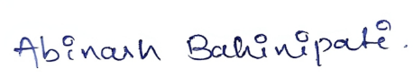



3.
4.
As a Supervisor, I will collect and make necessary changes in the prepared article (if needed) and shall maintain the authorship credit of the concerned students.

[Signature of Supervisor]

