**PROCEDURE:**

1. Begin by watching the provided video for reference and better understanding of the process.
2. **Review the functional and non-functional reports, as well as the prerequisite RTM (Requirements Traceability Matrix) file.**
3. Open the "TestingBrowser" folder.
4. Inside the folder, you can find the POM.xml and "src" files.
5. Navigate to the following path: TestingBrowser\src\test\java.
6. To locate the feature file, go to TestingBrowser\src\test\java\Feature.
7. If you need access to the screenshots, they can be found at TestingBrowser\src\test\java\Screenshots.
8. For the step definitions, code, and properties file, go to TestingBrowser\src\test\java\Code.
9. **Launch Eclipse and open the TestingBrowser project.**
10. **Within Eclipse, open the file TestingBrowser\src\test\java\Code\MapCode.java, and execute it.**

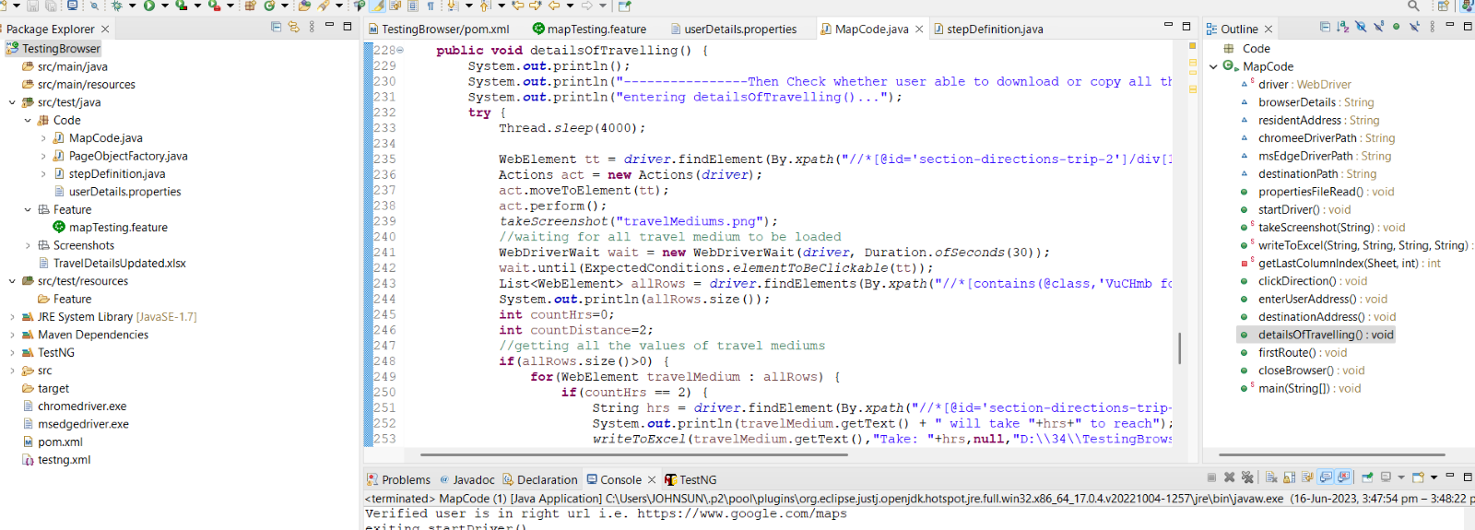

1. **Retrieve the required user details from the UserDetails.properties file.**

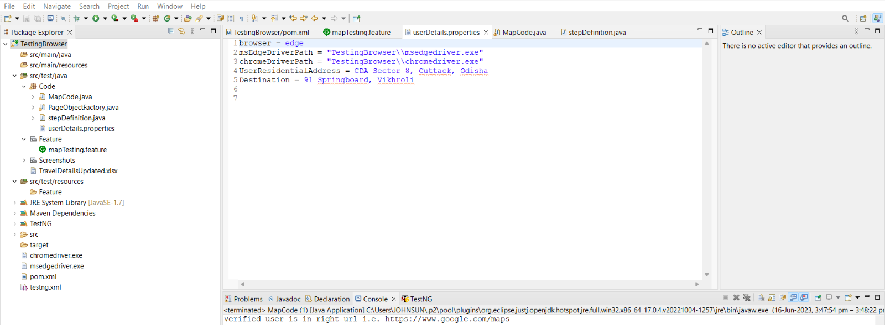

1. **After completing the above steps, verify the route and travel details by checking the file located at D:\34\TestingBrowser\src\test\java\TravelDetailsUpdated.**

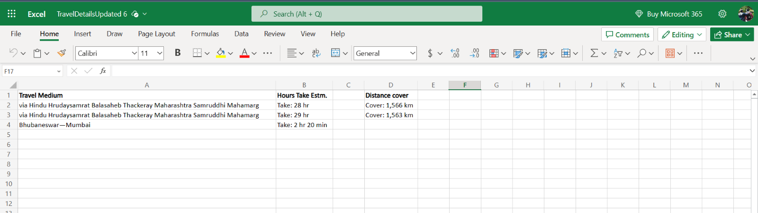

By following these instructions in a systematic manner, you will be able to successfully proceed with the testing procedure.