SMARTVEST – INTELLIGENT FINANCIAL DECISION SUPPORT SYSTEM
A project report submitted to ICT Academy of Kerala
in partial fulfillment of the requirements
for the certification of
ADVANCED PYTHON

submitted by
ABINASH S
ABHIRAMI A J
SAI POOJA
ANANDHU KRISHNA S S



ICT ACADEMY OF KERALA
THIRUVANANTHAPURAM, KERALA, INDIA
MAY 2026

TABLE OF CONTENTS

- ABSTRACT 1
- PROBLEM DEFINITION 2
2.1 OVERVIEW 2
2.2 PROBLEM STATEMENT 2
- INTRODUCTION 3
- SYSTEM ANALYSIS 4
4.1 EXISTING SYSTEM 4
4.2 PROPOSED SYSTEM 4
4.3 FEASIBILITY STUDY 5
4.3.1 TECHNICAL FEASIBILITY 5
4.3.2 ECONOMIC FEASIBILITY 5
4.3.3 OPERATIONAL FEASIBILITY 6
4.4 TECHNOLOGIES USED 6
4.5 LANGUAGE SPECIFICATIONS 6
- SYSTEM DESIGN 9
5.1 SYSTEM ARCHITECTURE 9
- PROJECT DESCRIPTION 11
- SYSTEM TESTING AND IMPLEMENTATION 15
7.1 SYSTEM TESTING 15
7.2 SYSTEM IMPLEMENTATION 16
- SYSTEM MAINTENANCE 18
- FUTURE ENHANCEMENTS ... 19
- CONCLUSION .................................................................. 21
- BIBLIOGRAPHY ................................................................ 22
- APPENDIX ......................................................................... 23
12.1 SYSTEM CODING ....................................................... 23
12.2 SCREENSHOTS .......................................................... 25

LIST OF FIGURES
SL NO. | FIGURES | PAGE NO.
Fig 5.1 | SYSTEM ARCHITECTURE | 9
fig 5.1 | HOME PAGE
fig 5.2 | STUDENT REGISTRATION PAGE
fig 5.3 | STUDENT LOGIN PAGE
fig 5.4 | STUDENT DASHBOARD
fig 5.5 | SKILL SELF-ASSESSMENT FORM
fig 5.6 | RADAR CHART VISUALIZATION
fig 5.7 | PLACEMENT HUB
fig 5.8 | COMPANY ELIGIBILITY CHECK
fig 5.9 | CONTACT PAGE
fig 5.10 | OFFICER PANEL
fig 5.11 | COMPANY MANAGEMENT PAGE
fig 5.12 | MENTOR MANAGEMENT PAGE
fig 5.13 | SEARCH AND FILTERING MODULE
fig 5.14 | CSV EXPORT FUNCTION

1. ABSTRACT
SMARTVEST – Intelligent Financial Decision Support System is a modern web-based financial management platform designed to help users manage personal finances, analyze spending behavior, plan financial goals, and receive intelligent investment-related insights through an interactive and user-friendly environment. The system is developed to address the growing need for organized financial planning and decision-making support in daily life. Traditional expense tracking applications mainly focus on recording transactions, whereas SmartVest extends beyond basic financial management by integrating analytics, portfolio planning, goal feasibility analysis, and investment readiness evaluation into a single platform.
The system is developed using the Flask framework with Python as the core backend technology and SQLite as the database management system. The frontend is designed using HTML, CSS, and JavaScript with a modular and responsive architecture that supports accessibility, dynamic rendering, and modern user experience principles. SmartVest follows a structured modular architecture that separates infrastructure utilities, financial analytics, user operations, and administrative governance systems for improved maintainability and scalability.
The platform provides several major functional modules including user authentication, expense management, income tracking, financial analytics dashboards, goal management, investment recommendation support, feedback handling, review moderation, and administrative monitoring. The analytics engine processes financial data to generate spending insights, category-based breakdowns, portfolio feasibility checks, savings recommendations, and financial health indicators. The goal management system supports lifecycle-based financial planning by allowing users to create, track, pause, complete, and archive financial goals according to priority and deadlines.
SmartVest also incorporates modern software engineering practices such as centralized caching mechanisms, database migration support, environment-based configuration management, accessibility-focused interface design, responsive layouts, secure API error handling, and operational monitoring workflows. The system is designed as a scalable, modular monolith architecture capable of supporting future enhancements including AI-driven recommendation systems, real-time market integration, cloud database migration, and advanced predictive analytics.
The primary objective of SmartVest is to provide users with an intelligent financial decision-support environment that improves financial awareness, promotes effective money management, and assists users in making structured financial decisions through analytics-driven insights and modern financial planning tools.

2. PROBLEM DEFINITION

2.1 OVERVIEW
In today’s digital world, managing personal finances has become more complex due to increasing expenses, multiple financial responsibilities, and the lack of proper financial planning tools. Many people find it difficult to track their income, manage expenses, monitor savings, and plan future financial goals effectively. Traditional methods such as manual record keeping or basic expense tracking applications only provide limited functionality and fail to deliver meaningful financial insights.
Most existing systems focus mainly on recording transactions without offering intelligent financial analysis, goal feasibility evaluation, investment readiness support, or portfolio-based planning. Users often need to use multiple separate applications for expense tracking, financial analysis, and investment planning, which makes financial management inefficient and time-consuming.
There is a need for an integrated platform that combines expense management, financial analytics, goal tracking, and intelligent decision-support features into a single system. SMARTVEST – Intelligent Financial Decision Support System is developed to solve these problems by providing users with a centralized and user-friendly platform for managing and analyzing their financial activities. The system helps users make informed financial decisions through analytics-driven insights, financial monitoring tools, and structured goal management features.

2.2 PROBLEM STATEMENT
Managing personal finances effectively has become difficult due to increasing expenses, lack of proper financial planning, and limited functionality in traditional expense tracking systems. Most existing applications only record transactions and fail to provide advanced features such as financial analytics, goal management, investment readiness evaluation, and intelligent financial insights.
Users often depend on multiple disconnected applications for expense tracking, savings planning, and financial analysis, which reduces efficiency and makes financial management more complicated. Manual methods such as spreadsheets and notebooks are also time-consuming and lack analytical capabilities.
SMARTVEST – Intelligent Financial Decision Support System is developed to solve these problems by providing an integrated platform for expense management, financial analytics, goal tracking, and intelligent financial decision support through a secure, responsive, and user-friendly environment.

3. INTRODUCTION
In the modern digital era, personal financial management has become an essential part of daily life. Increasing living expenses, multiple income sources, changing financial priorities, and growing investment opportunities have made financial planning more complex than before. Many individuals struggle to properly manage their expenses, monitor savings, and make informed financial decisions due to the lack of intelligent and organized financial management systems.
Traditional methods such as manual bookkeeping and spreadsheet-based tracking are time-consuming, difficult to maintain, and do not provide analytical insights. Existing expense tracking applications mainly focus on recording transactions and generating simple summaries, but they often lack advanced features such as financial analytics, portfolio-based goal management, investment readiness evaluation, and intelligent financial decision support.
SMARTVEST – Intelligent Financial Decision Support System is developed as a modern web-based platform that helps users manage and analyze their financial activities through an integrated and user-friendly environment. The system combines expense management, income tracking, financial analytics, goal planning, investment support, and operational monitoring into a single platform. SmartVest is designed to provide meaningful financial insights that help users understand spending patterns, improve savings habits, and plan financial goals effectively.
The platform is developed using Python and Flask for backend operations, SQLite for database management, and HTML, CSS, and JavaScript for frontend development. The system follows a modular architecture that separates financial operations, analytics systems, infrastructure utilities, and administrative management modules for better scalability, maintainability, and performance.
SmartVest also incorporates modern software engineering features such as responsive user interface design, accessibility support, caching mechanisms, centralized error handling, database migration support, and secure configuration management. The system aims to provide users with an intelligent financial decision-support environment that promotes financial awareness, simplifies financial planning, and assists users in making structured and data-driven financial decisions.

4. SYSTEM ANALYSIS

4.1 EXISTING SYSTEM
Existing financial management systems mainly focus on basic expense tracking and transaction recording. Most traditional applications allow users to add expenses, view simple summaries, and maintain financial records. Some users still depend on manual methods such as notebooks, spreadsheets, or offline calculations to manage their finances. These methods are time-consuming, difficult to maintain, and prone to errors.
Many currently available systems lack intelligent financial analysis and advanced decision-support features. They do not provide portfolio-based goal management, investment readiness evaluation, financial health monitoring, or detailed analytics for spending behavior. Users often need to use multiple separate applications for expense tracking, savings planning, and financial analysis, which creates fragmented financial data and reduces overall efficiency.
Another limitation of existing systems is the absence of proper administrative monitoring, feedback handling, accessibility support, and responsive user interface design. Most systems are designed only for basic transaction management and do not focus on scalability, operational workflows, or modern software engineering practices.
Due to these limitations, users are unable to gain meaningful financial insights or make well-structured financial decisions based on analytical data. This creates the need for an integrated financial management platform that combines financial tracking, analytics, goal management, and intelligent decision-support features into a single system.
.

4.2 PROPOSED SYSTEM
SMARTVEST – Intelligent Financial Decision Support System is proposed as a modern web-based platform that provides an integrated environment for financial management, analytics, and decision support. The system is designed to overcome the limitations of traditional financial management applications by combining expense tracking, income management, financial analytics, goal planning, and investment readiness evaluation into a single platform.
The proposed system allows users to securely manage their financial activities through interactive dashboards and analytics-driven insights. Users can add and manage expenses, track monthly income, analyze spending patterns, create financial goals, and monitor savings progress. The system also provides intelligent financial insights such as category-wise expense analysis, financial health indicators, goal feasibility checks, and portfolio-based recommendations.
SmartVest includes separate user and admin modules for efficient system management. The admin module supports review moderation, feedback monitoring, and operational management through a dedicated dashboard. The system also incorporates responsive user interface design, accessibility support, caching mechanisms, centralized error handling, and database migration support for better performance and maintainability.
The platform is developed using Python and Flask for backend operations, SQLite for database management, and HTML, CSS, and JavaScript for frontend development. The modular architecture of the system improves scalability, maintainability, and future enhancement capabilities.
The proposed system aims to provide users with a secure, intelligent, and user-friendly financial decision-support environment that simplifies financial planning, improves financial awareness, and supports structured financial decision-making.

Area | Existing System | Proposed SmartVest System
Expense Tracking | Manual expense recording | Smart expense management system
Financial Analysis | Simple summaries only | Detailed financial analytics
Goal Management | No goal planning | Financial goal tracking system
Investment Support | No investment guidance | Investment readiness analysis
Data Storage | Spreadsheets and manual records | Centralized database system
User Interface | Basic interface | Responsive and modern dashboard
Admin Management | Limited admin features | Admin dashboard with monitoring
Security | Basic security | Secure login and error handling
Performance | Slow manual processing | Optimized system with caching
Reporting | Limited reports | CSV import and export support

4.3 FEASIBILITY STUDY

4.3.1 TECHNICAL FEASIBILITY
The SMARTVEST – Intelligent Financial Decision Support System is technically feasible because it is developed using modern and reliable technologies such as Python, Flask, SQLite, HTML, CSS, and JavaScript. These technologies are open-source, easy to maintain, and suitable for developing web-based financial management systems.
The system follows a modular architecture that improves scalability, performance, and maintainability. Features such as caching, database migration support, responsive UI design, and centralized error handling further enhance the technical efficiency of the platform.
The required software tools and development environments are easily available, and the system can be deployed on modern hosting platforms such as PythonAnywhere and Render. Therefore, the implementation and maintenance of the proposed system are technically achievable.
In addition, the technologies used in SmartVest provide flexibility for future enhancements such as cloud database integration, advanced analytics, and AI-based financial recommendation features, making the system adaptable for future development and scalability.

4.3.2 ECONOMIC FEASIBILITY
The SMARTVEST – Intelligent Financial Decision Support System is economically feasible because it is developed using open-source technologies such as Python, Flask, SQLite, HTML, CSS, and JavaScript, which reduce software and licensing costs. The system does not require expensive hardware or high-cost infrastructure for development and deployment.
The project can be developed and maintained using commonly available development tools and hosting platforms such as PythonAnywhere and Render, which offer affordable or free deployment options. Since the system follows a modular architecture, future updates and maintenance can also be performed with minimal cost and effort.
The implementation of SmartVest helps reduce manual financial management efforts and improves efficiency through centralized financial tracking and analytics, making the system cost-effective and beneficial for users.

4.3.3 OPERATIONAL FEASIBILITY
The SMARTVEST – Intelligent Financial Decision Support System is operationally feasible because it provides a simple, responsive, and user-friendly interface for managing financial activities. The system includes expense tracking, financial analytics, goal management, and admin monitoring features that improve usability and operational efficiency.
Separate user and admin modules make system management easier and more effective. Features such as accessibility support, responsive design, and centralized error handling improve system reliability and user experience.
Since the platform automates financial tracking and analysis, it reduces manual effort and helps users make informed financial decisions efficiently.

4.4 TECHNOLOGIES USED
Technology | Purpose in SkillRadar
Flask | Backend routing, request handling, template rendering, and application management
SQLite | Database management for users, expenses, goals, reviews, and analytics data
Python | Core backend development and financial analytics processing
HTML | Web page structure and form design
CSS | Responsive layout, dashboard styling, and user interface design
JavaScript | Client-side interaction, dynamic rendering, and API handling
Jinja2 | Dynamic server-side template rendering and template inheritance
Flask-Caching | Performance optimization and cache management
Flask-Mail | Sending contact and notification emails through SMTP
Werkzeug | Secure password hashing and session management
Gunicorn | Production server deployment and application hosting
Pandas | Financial data processing and analytical calculations
NumPy | Numerical operations and analytics support
Matplotlib | Financial chart and graph generation
PythonAnywhere / Render | Cloud deployment and hosting platform support

4.5 LANGUAGE SPECIFICATIONS

Flask
Flask is the Python web framework used to develop the backend of SmartVest. It handles routing, API processing, session management, template rendering, and modules such as authentication, analytics, expense management, and admin operations. Flask supports modular application development using Blueprints for better scalability and maintainability. The framework is lightweight, flexible, and suitable for full-stack web application development.

SQLite
SQLite is the relational database management system used in SmartVest to store users, expenses, income, goals, reviews, and feedback data. It is lightweight, easy to maintain, and suitable for web-based financial management systems. The database ensures structured and consistent data storage and retrieval.

Python
Python is the core programming language used for backend development and financial analytics processing in SmartVest. It is used for financial calculations, goal analysis, caching systems, and server-side business logic. Python provides simplicity, readability, and extensive library support for web application development.

HTML
HyperText Markup Language (HTML) is used to create the structure of the web pages in SmartVest. Login forms, dashboards, expense forms, analytics sections, admin panels, and financial reports are designed using HTML elements. HTML is integrated with Jinja2 templates to display dynamic data from the backend.

CSS
Cascading Style Sheets (CSS) are used to design the visual appearance of SmartVest. CSS provides responsive layouts, dashboards, forms, buttons, tables, and accessibility-focused styling. The system uses a modular CSS architecture to maintain a modern and consistent fintech-style interface.

JavaScript
JavaScript is used for client-side interactions and dynamic behavior in SmartVest. It supports API communication, dashboard updates, analytics rendering, and responsive user interface operations to improve user experience.

Jinja2 Templates
Jinja2 is Flask’s template engine used for server-side rendering and displaying dynamic financial data. It supports variables, loops, conditions, and template inheritance to maintain consistent layouts across dashboards and modules.

Flask-Caching
Flask-Caching is used to improve the performance of SmartVest by storing frequently accessed financial analytics data temporarily in memory. It reduces repeated calculations and database queries, improving response time and dashboard performance.

Flask-Mail
Flask-Mail is used to manage email communication in SmartVest. It supports contact form messages and SMTP-based email functionality for system communication and notifications.

Pandas and NumPy
Pandas and NumPy are used for financial data processing and analytical calculations. These libraries help process expense records, generate financial summaries, calculate spending insights, and support analytics-based financial decision-making features.

Matplotlib
Matplotlib is used for generating charts and financial visualizations. It helps represent financial data graphically for analytics and reporting purposes.

Werkzeug
Werkzeug is used for secure password hashing, request handling, and session management. It improves authentication security and supports protected user operations within the system.

Gunicorn
Gunicorn is used as the production WSGI server for deploying SmartVest on hosting platforms such as PythonAnywhere and Render. It helps run the Flask application efficiently in a production environment.

5. SYSTEM DESIGN

5.1 SYSTEM ARCHITECTURE
The SMARTVEST – Intelligent Financial Decision Support System follows a modular web-based architecture designed to provide scalability, maintainability, and efficient financial data management. The system is developed using a client-server architecture where the frontend interface communicates with the backend server through Flask-based API routes and request handling mechanisms.
The frontend layer is developed using HTML, CSS, JavaScript, and Jinja2 templates. It provides responsive dashboards, financial forms, analytics pages, admin panels, and interactive user interfaces. JavaScript is used for dynamic content updates and asynchronous API communication, while CSS provides responsive layouts and modern fintech-style design.
The backend layer is developed using Python and Flask. It handles user authentication, financial analytics, expense management, goal tracking, investment readiness analysis, feedback handling, review moderation, and administrative operations. Flask Blueprints are used to organize different modules separately for better scalability and maintainability.
The database layer uses SQLite to store and manage structured financial data such as users, expenses, income records, goals, reviews, and feedback. The system also includes infrastructure utilities such as caching systems, database migration support, centralized error handling, and SMTP-based email communication.
The architecture is designed to support smooth interaction between frontend components, backend processing modules, and the database system, providing users with a secure, responsive, and analytics-driven financial management environment.
The modular architecture of SmartVest improves code organization and simplifies future enhancements. Features such as caching mechanisms, accessibility support, responsive design systems, and centralized utility modules help improve system performance, reliability, and user experience. The architecture also allows easy integration of future technologies such as cloud databases, real-time financial APIs, and AI-based financial recommendation systems.

Architecture Diagram

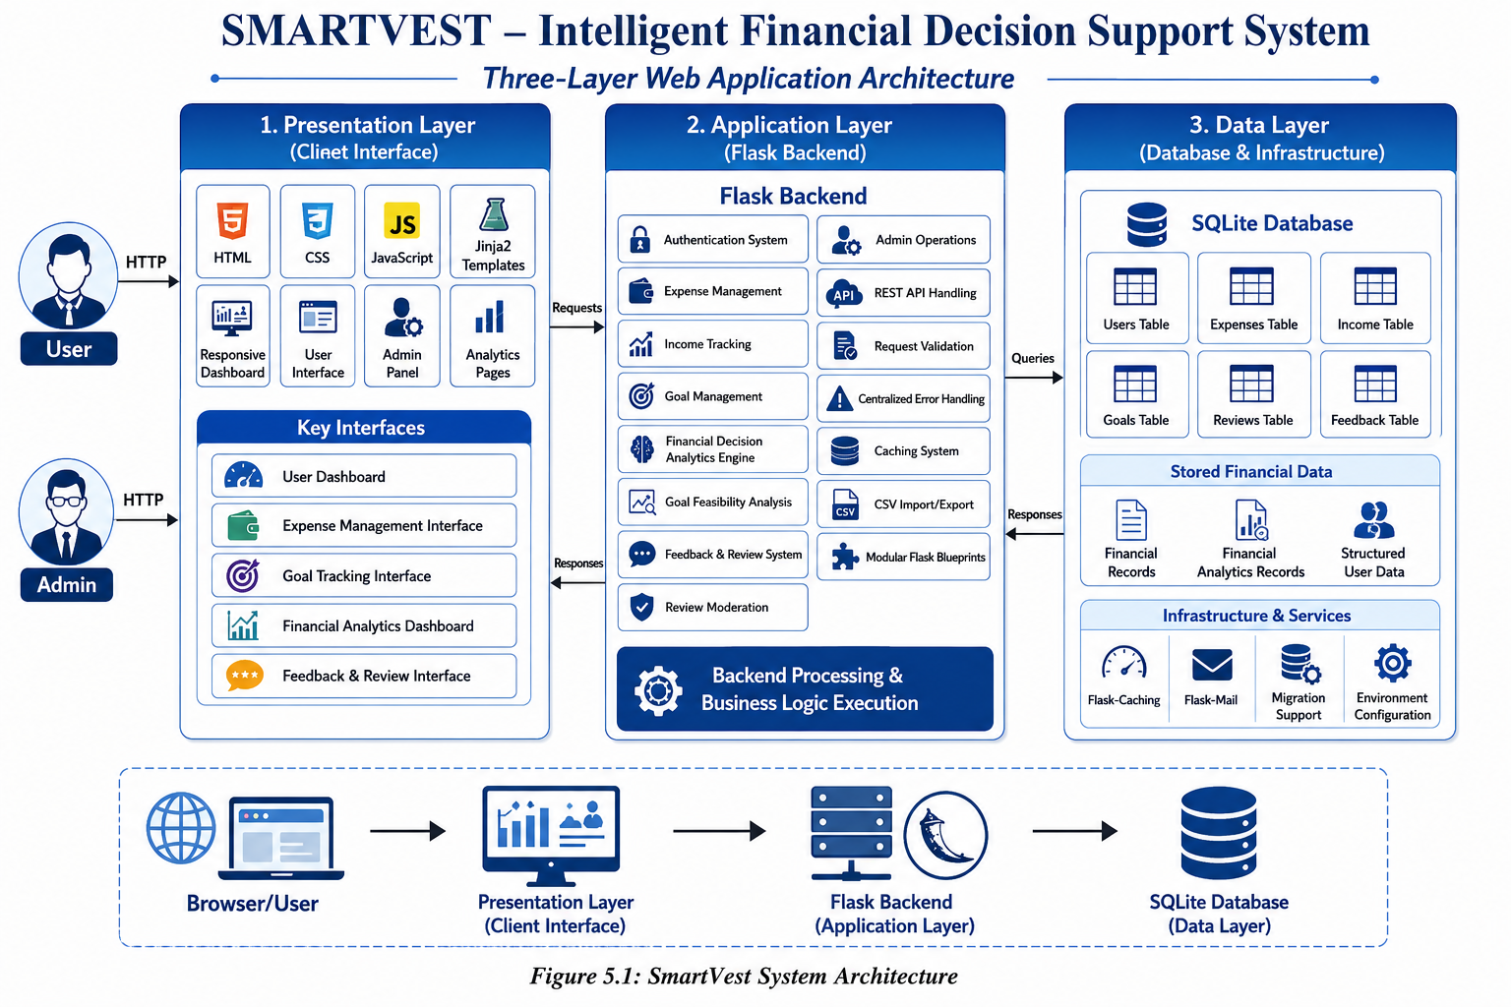

Layer | Components | Responsibility
Presentation Layer | HTML, CSS, Jinja2, JavaScript | Displays dashboards, forms, analytics pages, tables, charts, and user interfaces
Application Layer | Flask routes, REST APIs, validation functions, business logic, caching system | Processes requests, manages authentication, handles financial analytics, goal management, and admin operations
Data Layer | SQLite database, SQL queries, Flask-Caching, Flask-Mail | Stores and retrieves users, expenses, income, goals, reviews, feedback, and financial records

Frontend-Backend Workflow
- The user accesses SmartVest through the browser by opening pages, submitting forms, or interacting with dashboards.
- Flask receives the HTTP request and routes it to the appropriate backend module using Flask Blueprints.
- The backend validates user input and manages authentication and session handling.
- Flask processes financial operations such as expense management, income tracking, goal management, analytics processing, and feedback handling.
- REST-style API routes are used for asynchronous communication between the frontend and backend.
- The application interacts with the SQLite database to store and retrieve users, expenses, income records, goals, reviews, and feedback data.
- Flask-Caching improves performance by reducing repeated analytics processing and database queries.
- Flask renders Jinja2 templates with dynamic financial data and dashboard information.
- The browser displays the final interface using HTML and CSS, while JavaScript handles dashboard updates, analytics rendering, and interactive user operations.

Database Design
The database design of SmartVest uses relational tables with primary keys, foreign keys, and validation constraints to maintain structured financial data. The users table stores user and admin information, while other tables manage expenses, income records, goals, reviews, feedback, and analytics-related data.
The expenses and income tables store financial transaction details linked to users through user_id. The goals table manages financial goals, priorities, deadlines, and progress tracking. Additional tables such as reviews and feedback support user interaction and administrative moderation workflows.
SQLite is used as the database management system because it is lightweight, reliable, and suitable for web-based financial management applications. The database structure ensures consistent data storage, efficient retrieval, and easy system maintenance.

Table | Important Fields | Description
users | id, name, email, password_hash, role | Stores user and admin account information with login details
expenses | user_id, amount, category, date | Stores user expense records and transaction details
income | user_id, amount, source, date | Stores monthly income records for users
goals | user_id, goal_name, target_amount, deadline, priority, status | Stores financial goals, deadlines, priorities, and progress status
reviews | user_id, rating, comment, status, date | Stores user reviews and moderation status
feedback | user_id, subject, message, date | Stores user feedback and system suggestions
market_data | symbol, price, trend, updated_at | Stores financial and market-related analytical data
cache_records | cache_key, version, created_at | Stores cache-related processing information for performance optimization

Data Relationship Explanation
The most important relationship in SmartVest is between users and financial records. A user can have multiple expense records, income entries, goals, reviews, and feedback records, which are connected through the user_id field. This relationship helps maintain organized and user-specific financial data.
The expenses, income, goals, reviews, and feedback tables are linked to the users table using foreign key relationships. When a user account is removed, the related financial records can also be managed consistently through database relationships.
The goals table stores financial planning information such as priorities, deadlines, and progress status, while reviews and feedback tables support user interaction and admin moderation workflows. The database structure ensures proper data consistency, efficient retrieval, and smooth financial data management throughout the system.

6. PROJECT DESCRIPTION

User Registration Module
This module allows users to create an account by entering name, email, and password details. The system validates required fields, checks email uniqueness, and securely stores passwords using hashing techniques. Separate roles are supported for users and administrators.

User Login Module
The login module authenticates registered users through email and password verification. After successful authentication, the system creates a secure session and redirects users to their dashboard. Role-based access control ensures proper access to user and admin modules.

Expense Management Module
This module allows users to add, update, delete, and manage expense records. Users can categorize expenses, track spending patterns, and maintain organized financial records through a responsive dashboard interface.

Income Tracking Module
The income module helps users manage monthly income records. It stores income details and supports financial calculations required for analytics, savings analysis, and goal feasibility evaluation.

Financial Analytics Module
The analytics module processes financial records and generates insights such as category-wise expense analysis, spending trends, savings summaries, and financial health indicators. This module converts raw financial data into meaningful analytical information.

Goal Management Module
The goal management module allows users to create, monitor, pause, complete, and archive financial goals. Users can set target amounts, priorities, and deadlines for better financial planning and tracking.

Goal Feasibility Analysis Module
This module evaluates whether users can realistically achieve their financial goals based on income, expenses, and savings patterns. It helps users understand financial readiness and planning feasibility.

Dashboard Module
The dashboard acts as the central workspace of SmartVest. It displays financial summaries, analytics charts, expense reports, goal progress, and financial insights through an interactive and responsive interface.

Feedback Management Module
This module allows users to submit feedback, suggestions, and system-related messages. The feedback is stored in the database and can be monitored through the admin dashboard.

Review Management Module
The review module allows users to submit ratings and reviews about the platform. Reviews are moderated by the admin before becoming publicly visible.

Admin Management Module
The admin module provides administrative control over users, reviews, feedback, and financial records. Administrators can monitor platform activities, moderate reviews, and manage operational workflows through a dedicated admin dashboard.

Search and Filtering Module
The search and filtering system helps users and administrators quickly locate financial records, goals, reviews, and expense data using filtering and query-based operations.

CSV Import and Export Module
This module supports CSV-based financial data import and export operations. Users can upload expense records through CSV files and export filtered financial reports for offline analysis and reporting purposes.

Caching and Performance Optimization Module
This module uses Flask-Caching to improve system performance by reducing repeated analytics processing and database queries. It helps improve dashboard loading speed and application responsiveness.

Email Communication Module
The email module uses Flask-Mail and SMTP services to manage contact form communication and system notifications. It supports secure email-based communication within the platform.

Algorithm and Logic Explanation

Financial Analytics Logic
The financial analytics logic processes user income and expense records to generate spending summaries, savings analysis, and category-wise financial insights. Expenses are grouped by category and compared with income to calculate financial health indicators and spending patterns.

Goal Feasibility Logic
The goal feasibility logic evaluates whether a user can achieve a financial goal based on current income, expenses, savings, and target amount. The system analyzes available savings capacity and estimates whether the goal is financially achievable within the specified deadline.

Role-Based Access Logic
The role-based access logic uses Flask sessions and authentication controls to restrict access to user and admin modules. After login, the system checks the role of the current user and allows access only to authorized routes and dashboard sections.

Search and Filtering Logic
The search and filtering system uses optional query parameters to filter expenses, goals, reviews, and financial records. Filters such as category, date range, priority, and status help users and administrators quickly locate relevant data.

CSV Import and Export Logic
The CSV module reads uploaded financial records, validates the file structure, and stores the data in the database. For export operations, the system generates CSV files dynamically using filtered financial records and downloadable reports.

Caching Logic
The caching system stores frequently accessed analytics data temporarily in memory using Flask-Caching. This reduces repeated database queries and improves dashboard loading speed and application performance.

Error Handling Logic
The centralized error handling system captures runtime exceptions and returns safe API responses without exposing internal system details. Errors are logged internally for debugging and system maintenance purposes.

Investment Planning Logic
The investment planning logic analyzes user income, expenses, savings, and financial goals to evaluate financial readiness and planning feasibility. The system helps users understand whether they can manage future financial goals based on their current financial condition.

Expense Analysis Logic
The expense analysis logic groups expenses based on categories such as food, transport, shopping, healthcare, and utilities. The system calculates total spending in each category and identifies major spending areas to help users improve financial management.

Dashboard Analytics Logic
The dashboard analytics logic collects financial data from multiple modules and generates summaries, charts, and financial indicators for the user dashboard. It provides real-time financial insights through interactive analytics and visual reports.

7. SYSTEM TESTING AND IMPLEMENTATION

7.1 SYSTEM TESTING
System testing verifies that the SMARTVEST – Intelligent Financial Decision Support System satisfies functional requirements, handles invalid inputs correctly, protects restricted modules, stores financial data accurately, and provides the expected user interface and analytical outputs. Since SmartVest includes both user-facing and admin-facing operations, testing covers authentication, expense management, income tracking, goal management, analytics processing, review moderation, feedback handling, CSV import/export, and access control mechanisms.
Testing was performed on the major modules of the system individually and then as part of the integrated workflow. Special attention was given to form validation, financial calculations, REST API handling, database consistency, session management, caching behavior, responsive interface rendering, and role-based route protection. The system was also tested for secure error handling, dashboard updates, search and filtering operations, and financial analytics accuracy to ensure reliable performance and smooth user experience.

Unit Testing
Unit testing focuses on individual functions and small logic components within SmartVest, such as financial calculations, goal feasibility analysis, authentication checks, expense validation, caching behavior, and database helper functions. Modules such as expense processing, income calculations, search filtering, and review validation were tested independently using valid, invalid, missing, and boundary input values.
For example, the financial analytics logic was tested by providing sample income and expense records and verifying the generated savings summaries and category-wise analysis. Goal feasibility logic was tested using different financial conditions to confirm correct goal evaluation and financial readiness calculations.

Integration Testing
Integration testing verifies that routes, templates, backend logic, and database operations work together correctly in SmartVest. User registration testing checks whether submitted forms create user records in the SQLite database, securely hash passwords, and redirect users to the login page.
Expense and income management tests verify that submitted financial records are stored correctly and later displayed in dashboards and analytics pages. Goal management testing ensures that goal creation, updates, progress tracking, and feasibility analysis work properly across different modules.
Admin management tests verify that review moderation, feedback handling, search, filtering, and CSV import/export operations function correctly within the integrated workflow.

Functional Testing
Functional testing verifies whether each feature of SmartVest works correctly from the user’s perspective. Modules such as user registration, login, dashboard access, expense management, income tracking, financial analytics, goal management, review submission, feedback handling, and admin operations were tested as complete functions.
The testing also verified dashboard updates, analytics rendering, CSV import/export operations, search and filtering features, and role-based access control. Expected outputs, validation messages, redirects, and user interactions were checked to ensure smooth system functionality and reliable user experience.

UI Testing
UI testing verifies readability, layout consistency, form alignment, dashboard structure, table display, button behavior, and responsive interface design in SmartVest. Since the system includes dashboards, analytics cards, financial tables, forms, and interactive panels, UI testing ensures that users can navigate and operate the platform easily.
Testing also checks responsive behavior by resizing the browser and verifying that dashboards, forms, charts, and cards remain properly aligned and usable on different screen sizes. Accessibility features such as focus visibility, responsive layouts, and smooth user interaction were also verified during testing.

Security Testing
Security testing verifies that protected routes in SmartVest require proper authentication and role-based access permission. Normal users should not access admin-only modules such as admin dashboard, review moderation, feedback management, user management, and protected financial operations.
Password security is verified to ensure that passwords are stored using secure hashing techniques instead of plain text. Input validation is also tested to prevent invalid financial values, duplicate user accounts, invalid CSV uploads, and unauthorized API access.
The testing also checks session management, centralized error handling, and secure route protection to ensure safe and reliable system operation.

Test Case | Input/Action | Expected Result
User registration | Valid user details | Account created and redirected to login
Duplicate email | Email already stored | Validation message displayed
User login | Valid email and password | User redirected to dashboard
Invalid login | Wrong password entered | Authentication error message displayed
Expense entry | Valid expense details | Expense record saved successfully
Income entry | Valid income details | Income record stored successfully
Goal creation | Valid financial goal data | Goal added and displayed in dashboard
Goal feasibility analysis | Income and expense comparison | Financial feasibility result displayed
Financial analytics | Existing financial records | Analytics summaries and charts displayed
CSV import | Valid CSV expense file | Expense records imported successfully
CSV export | Filtered financial records | CSV report generated successfully
Search and filtering | Category and date filters | Filtered financial records displayed
Review submission | Valid review and rating | Review stored for moderation
Access control | User opens admin URL | Unauthorized access blocked
Error handling | Invalid financial input | validation or error message displayed

7.2 SYSTEM IMPLEMENTATION
The SMARTVEST – Intelligent Financial Decision Support System is implemented using a modular Flask architecture. The backend handles routing, API processing, authentication, financial analytics, CSV operations, caching, and error handling, while the frontend uses Jinja2 templates, HTML, CSS, and JavaScript for responsive dashboards and dynamic user interaction.
SQLite is used for storing users, expenses, income records, goals, reviews, and feedback data. Flask-Caching improves performance, and Flask-Mail supports email communication.
The system can be deployed by installing dependencies, configuring environment variables, initializing the database, and running the Flask application using Gunicorn or the Flask development server.
The system also includes role-based access control, centralized error handling, responsive UI support, and CSV import/export functionality for efficient financial data management. The modular structure of the application improves scalability, maintainability, and future enhancement capabilities.
File/Folder | Implementation Role
app.py | Main Flask application, routes, API handling, business logic, and request processing
migrate.py | Database migration and compatibility updates
config.py | Application configuration, database path, and environment settings
templates/ | Jinja2 HTML templates for dashboards, authentication, analytics, and admin pages
static/css/ | Responsive styling, accessibility support, and fintech UI design
static/js/ | Dashboard interaction, API communication, analytics rendering, and dynamic frontend operations
utils/cache.py | Flask-Caching configuration and performance optimization logic
utils/mail.py | SMTP email handling and contact form communication
utils/api_errors.py | Centralized API error handling and safe error responses
database (SQLite) | Stores users, expenses, income, goals, reviews, feedback, and analytics data
requirements.txt | Python dependencies and external library management
Gunicorn | Production WSGI server deployment support

8. SYSTEM MAINTENANCE
System maintenance is required to keep the SMARTVEST – Intelligent Financial Decision Support System reliable, secure, and efficient after deployment. Maintenance activities include database backup, dependency updates, monitoring financial records, reviewing user and admin accounts, updating analytics logic, and applying software improvements. Since financial data changes frequently, regular maintenance is important for accurate system operation.
Database maintenance includes periodic backups of SQLite database records such as users, expenses, income data, goals, reviews, and feedback information. Backup files should be securely stored and tested regularly to prevent data loss. Future versions may include optimization techniques and indexing for better query performance and scalability.
Application maintenance includes updating Python dependencies, monitoring authentication behavior, verifying CSV import/export operations, checking email communication services, and ensuring proper cache management. Environment variables, secret keys, and sensitive credentials should be securely managed and never exposed publicly.
User and admin maintenance is also important. Administrators should regularly review user feedback, moderate reviews, manage inactive accounts, and monitor system operations. Users should periodically update financial records, expenses, income details, and financial goals to maintain accurate analytics and planning results.
Maintenance Area | Activity
Database | Backup, restore testing, data validation, financial record cleanup
Security | Secret key protection, credential review, role-based access verification
Application | Dependency updates, API testing, deployment monitoring, route validation
Financial Data | Expense updates, goal tracking updates, analytics verification
Performance | Cache monitoring, query optimization, dashboard performance checks
Users | User account management, admin moderation, inactive account review
Reviews & Feedback | Review moderation, feedback monitoring, content management
Infrastructure | Environment configuration, mail service checks, migration support maintenance

9. FUTURE ENHANCEMENTS

AI-Based Financial Recommendations
The system can be extended with AI-based recommendation models that analyze income, expenses, savings, and financial goals to provide personalized financial planning suggestions and smart budgeting insights.

Investment Planning Support
Future versions can include investment planning modules for tracking investment portfolios, savings growth, and financial risk analysis with real-time market integration.

Mobile Application Support
A mobile application or progressive web app can provide users with quick access to expenses, goals, analytics, and notifications through smartphones.

Real-Time Notifications
The system can support email, SMS, or in-application notifications for bill reminders, goal deadlines, unusual spending activity, and financial updates.

OCR-Based Expense Scanning
An OCR-based receipt scanning system can automatically extract expense information from bills and receipts to simplify expense entry operations.

Audit Logging System
A detailed audit logging mechanism can record admin activities, financial record changes, review moderation actions, and system operations for better accountability and monitoring.

AI Chatbot Integration
An AI-powered financial assistant chatbot can be integrated to provide users with instant financial guidance, budgeting tips, and goal-planning support.

10. CONCLUSION
SMARTVEST – Intelligent Financial Decision Support System successfully demonstrates how a full-stack web application can improve personal financial management and financial decision-making. The project provides an organized platform where users can manage expenses, track income, monitor financial goals, analyze spending patterns, and receive financial insights through interactive dashboards and analytics. At the same time, administrators receive centralized management tools for handling users, reviews, feedback, and system operations.
The system uses practical and modern technologies such as Python, Flask, SQLite, Jinja2, HTML, CSS, JavaScript, Flask-Caching, and Flask-Mail. The architecture follows a modular three-layer design that separates presentation, application, and database responsibilities. Role-based access control, centralized error handling, caching systems, and responsive UI design improve system reliability, security, and user experience.
The project addresses a real-world need by reducing manual financial tracking efforts and helping users make informed financial decisions through structured analytics and planning tools. Features such as financial analytics, goal feasibility analysis, CSV operations, and responsive dashboards make SmartVest more than a basic expense management system. With future enhancements such as AI-based financial recommendations, investment planning, OCR-based expense scanning, mobile applications, and cloud integration, SmartVest can evolve into a complete intelligent financial management ecosystem.

11. BIBLIOGRAPHY
- Flask Documentation, Pallets Projects, https://flask.palletsprojects.com/
- Flask-Caching Documentation, https://flask-caching.readthedocs.io/
- SQLite Documentation , https://www.sqlite.org/docs.html
- Jinja Documentation, Pallets Projects, https://jinja.palletsprojects.com/
- Werkzeug Documentation, https://werkzeug.palletsprojects.com/
- Gunicorn Documentation, https://gunicorn.org/
- Mozilla Developer Network Web Docs for HTML, CSS, and JavaScript, https://developer.mozilla.org/
- Python Documentation, https://docs.python.org/3/
- Chart.js Documentation, https://www.chartjs.org/docs/latest/
- SmartVest Project Source Code, local project repository files including app.py, config.py, migrate.py, templates, static assets, and utility modules.

12. APPENDIX

12.1 SYSTEM CODING
This appendix contains representative coding sections from the SMARTVEST – Intelligent Financial Decision Support System. The complete source code is maintained in the project directory. The snippets below demonstrate important logic used for financial analytics, role-based access control, centralized error handling, caching, and CSV export operations.

Financial Analytics Logic
def calculate_financial_summary(income, expenses):
total_expense = sum(expenses)
savings = income - total_expense

if income > 0:
savings_percentage = round((savings / income) * 100, 2)
else:
savings_percentage = 0

return {
"income": income,
"expense": total_expense,
"savings": savings,
"savings_percentage": savings_percentage
}

Role-Based Access Logic
def role_required(role):
def decorator(function):
@wraps(function)
def wrapper(*args, **kwargs):
if current_user.role != role:
abort(403)
return function(*args, **kwargs)
return wrapper
return decorator

Centralized API Error Handling
def safe_api_error(error, status_code=500,
message="Something went wrong. Please try again."):

logger.exception("API exception: %s", error)

return jsonify({
"success": False,
"status": "error",
"message": message
}), status_code

Cache Version Management
def bump_cache_version(namespace, identifier=None):
key = _version_key(namespace, identifier)

version = get_cache_version(namespace, identifier) + 1

cache.set(key, version, timeout=_VERSION_TIMEOUT_SECONDS)

return version

CSV Export Logic
output = StringIO()

writer = csv.writer(output)

writer.writerow([
"Category",
"Amount",
"Date"
])

for expense in expenses:
writer.writerow([
expense["category"],
expense["amount"],
expense["date"]
])

return Response(
output.getvalue(),
mimetype="text/csv",
headers={
"Content-Disposition":
f"attachment; filename={filename}"
}
)

Expense API Endpoint
@app.route("/api/expenses/add", methods=["POST"])
@login_required
def add_expense():

data = request.get_json()

amount = float(data.get("amount", 0))
category = data.get("category")
date = data.get("date")

save_expense(current_user.id, amount, category, date)

return jsonify({
"success": True,
"message": "Expense added successfully"
})

12.2 SCREENSHOTS

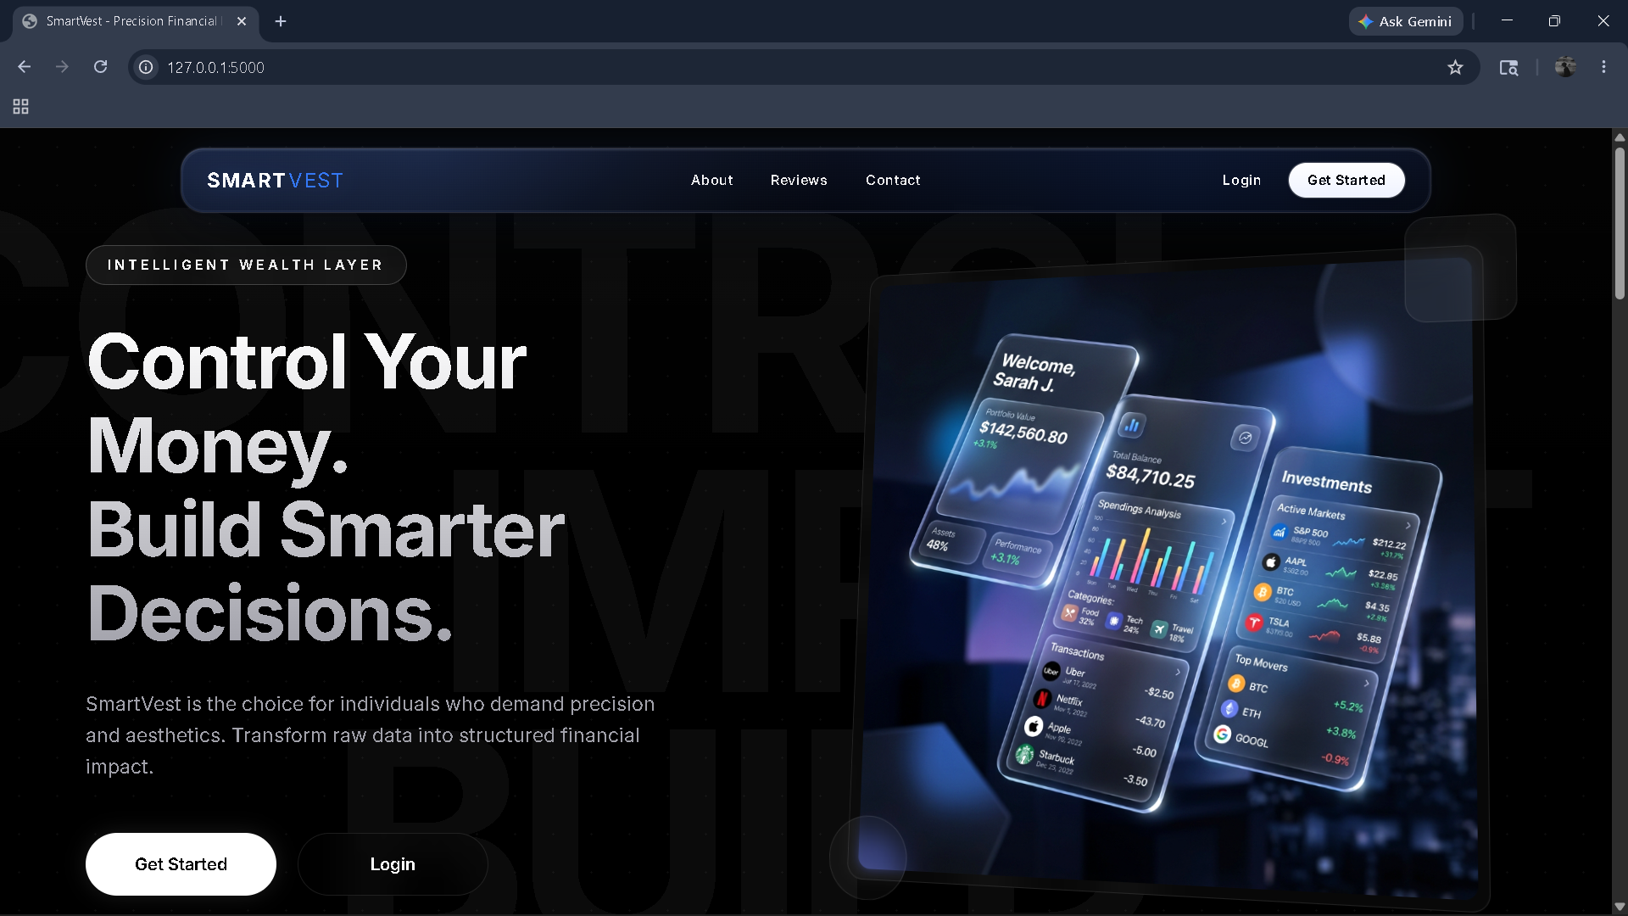
Figure : Home page
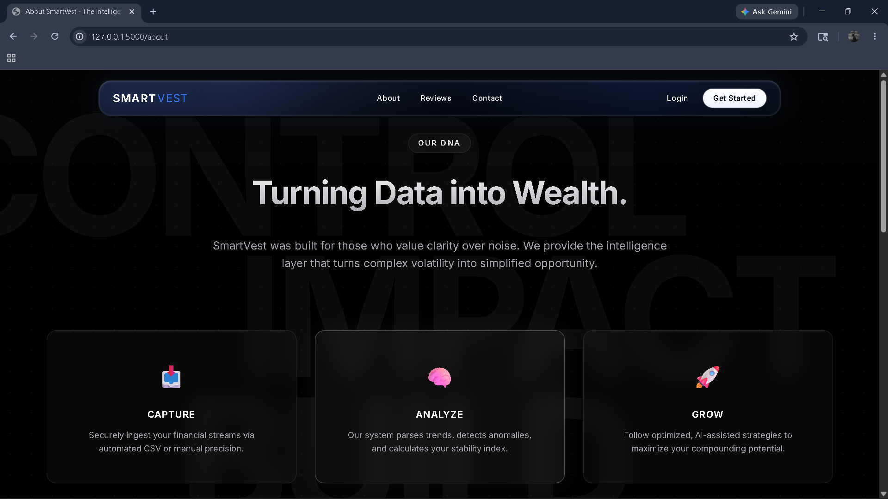
Figure: About Page
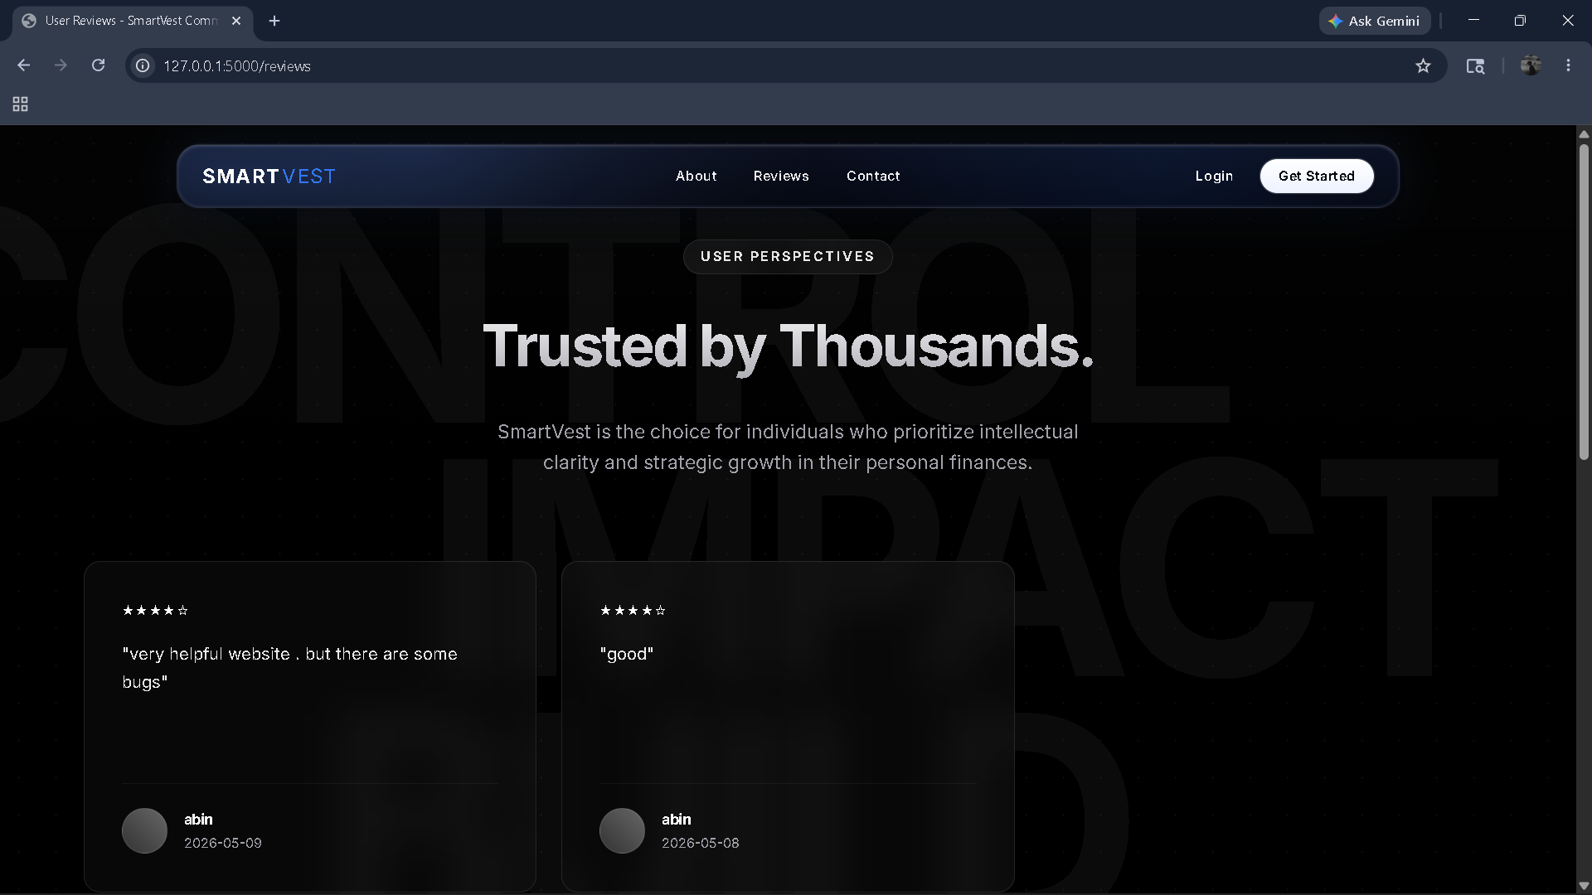
Figure: Review page
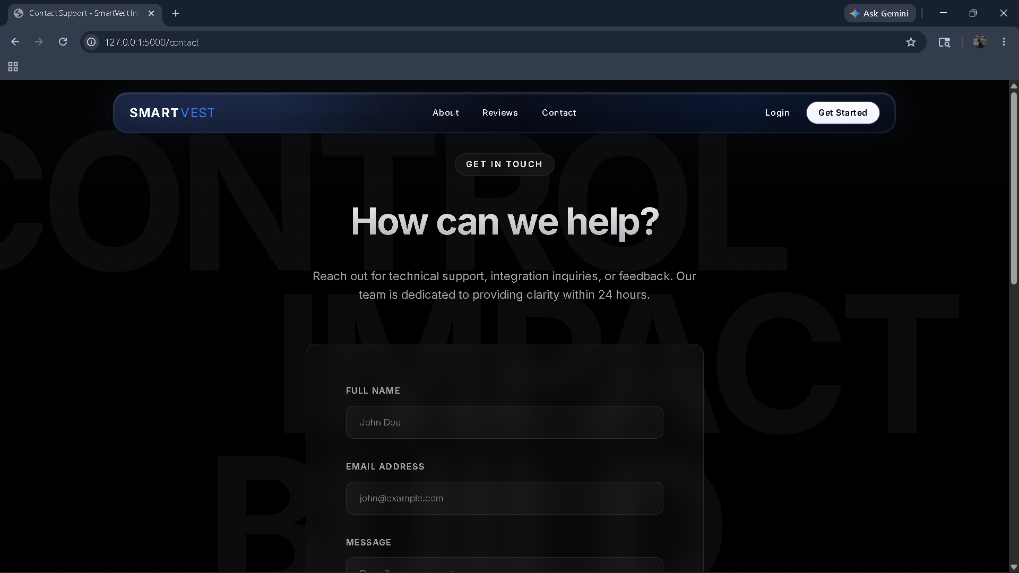
Figure: Contact Page

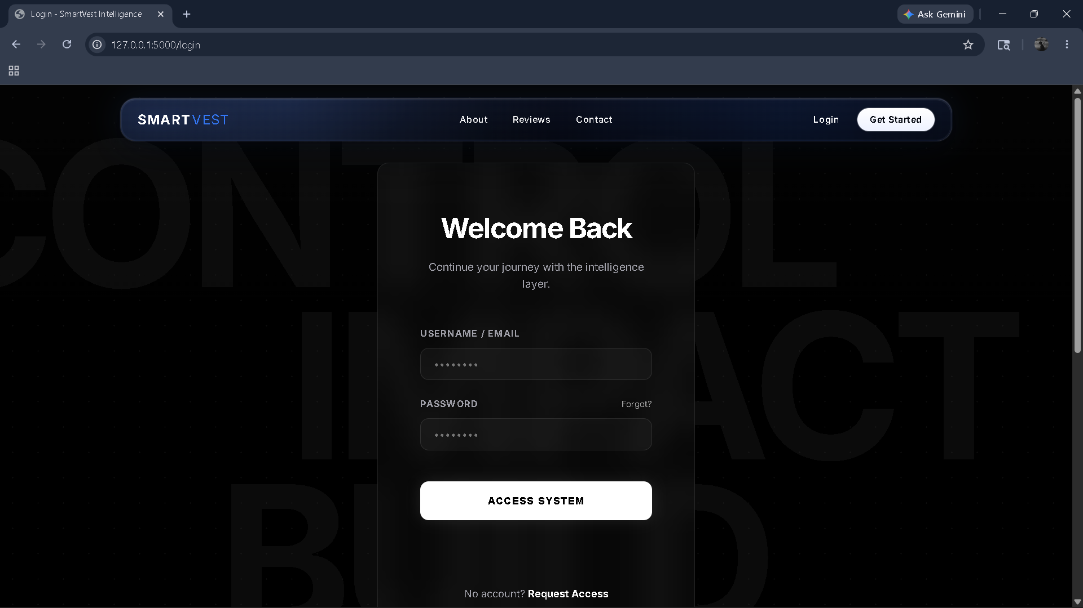
Figure: Login Page
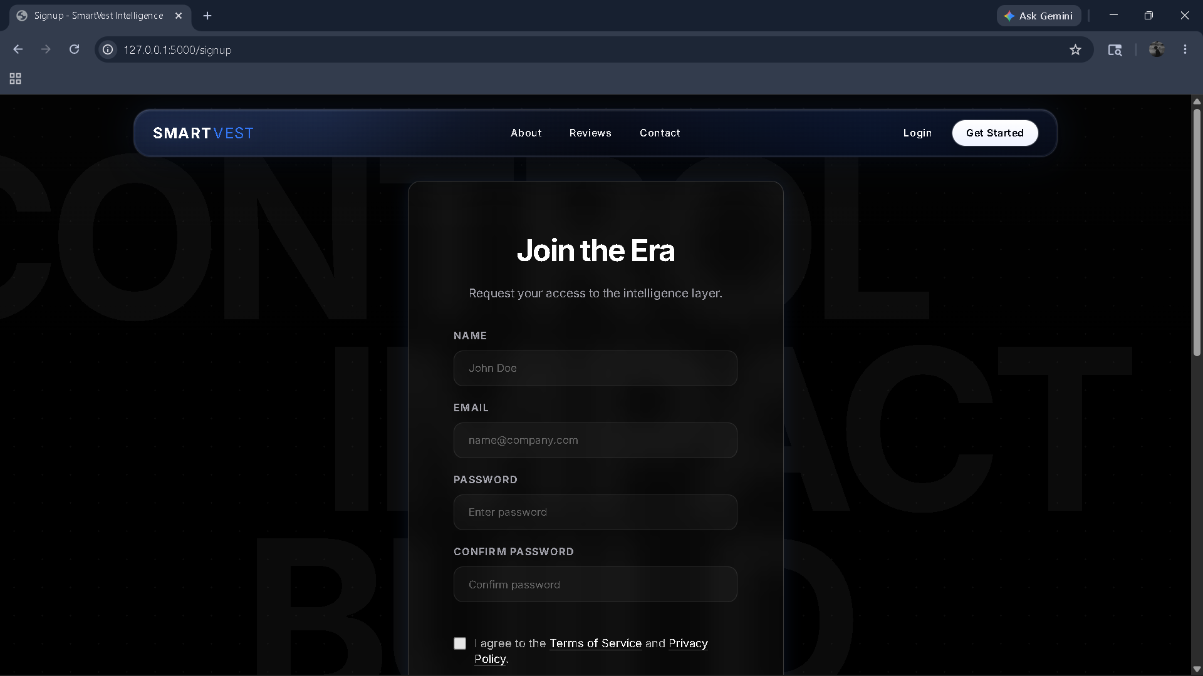
Figure : Signup Page

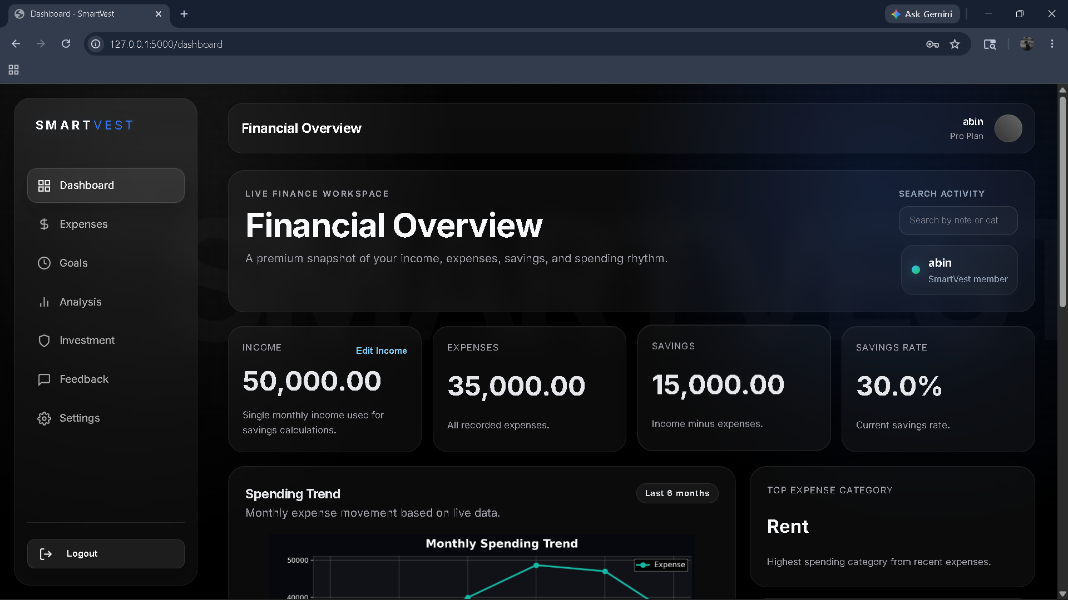
Figure : User Dashboard page
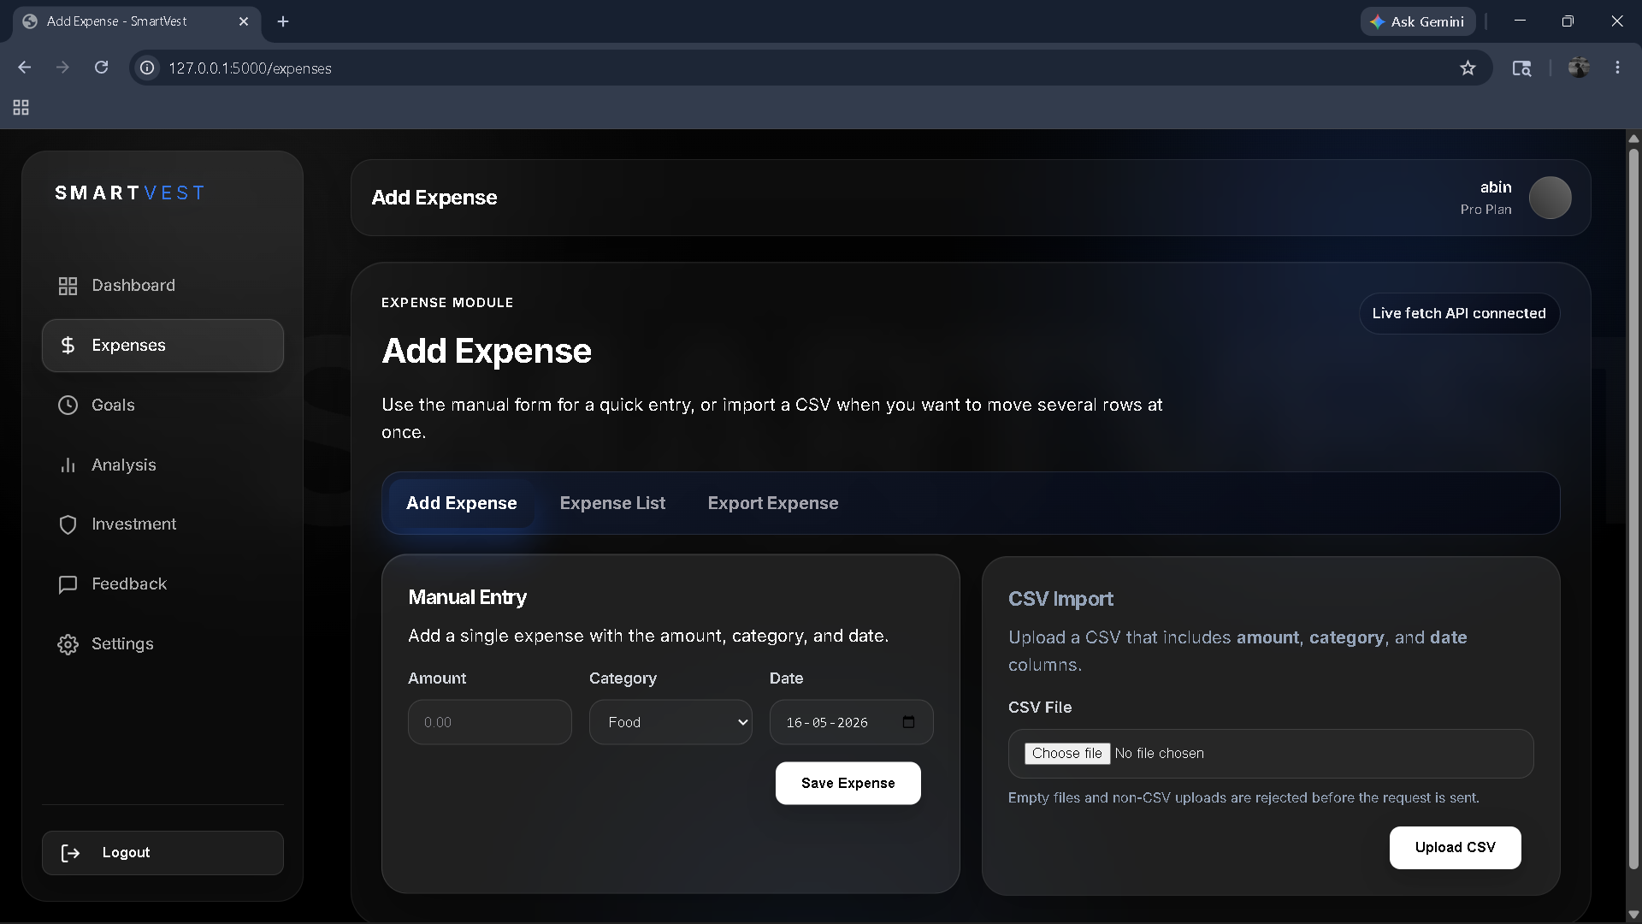
Figure: Expense module page

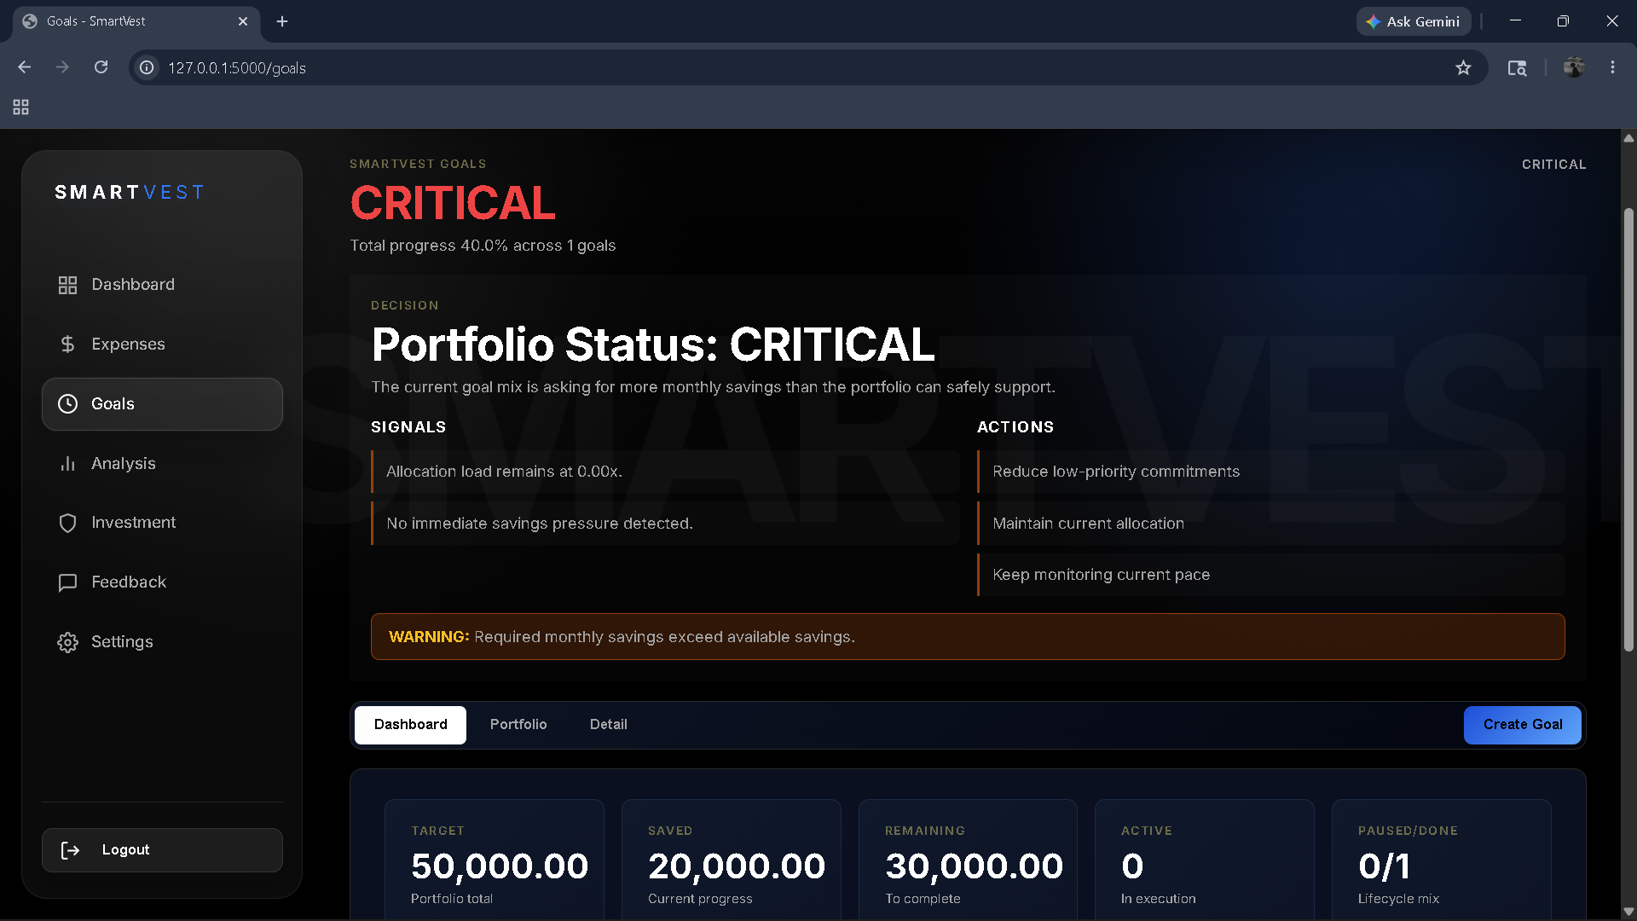
Figure: Goal module Page
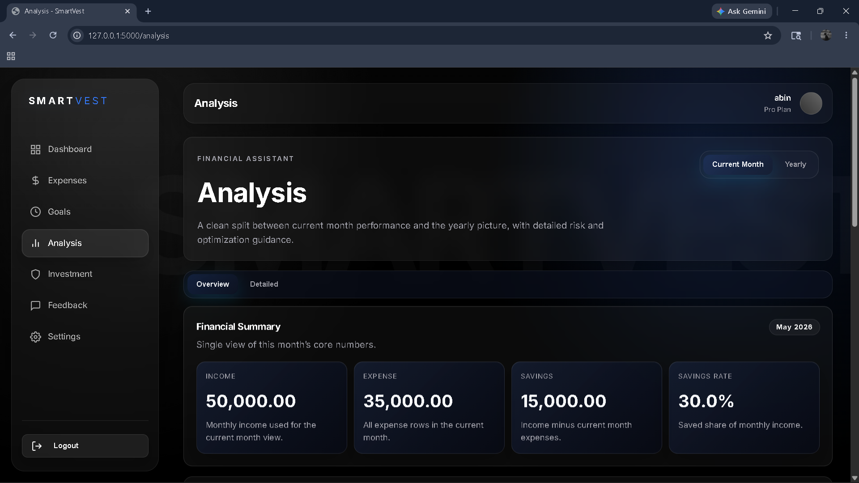
Figure: Analysis module page

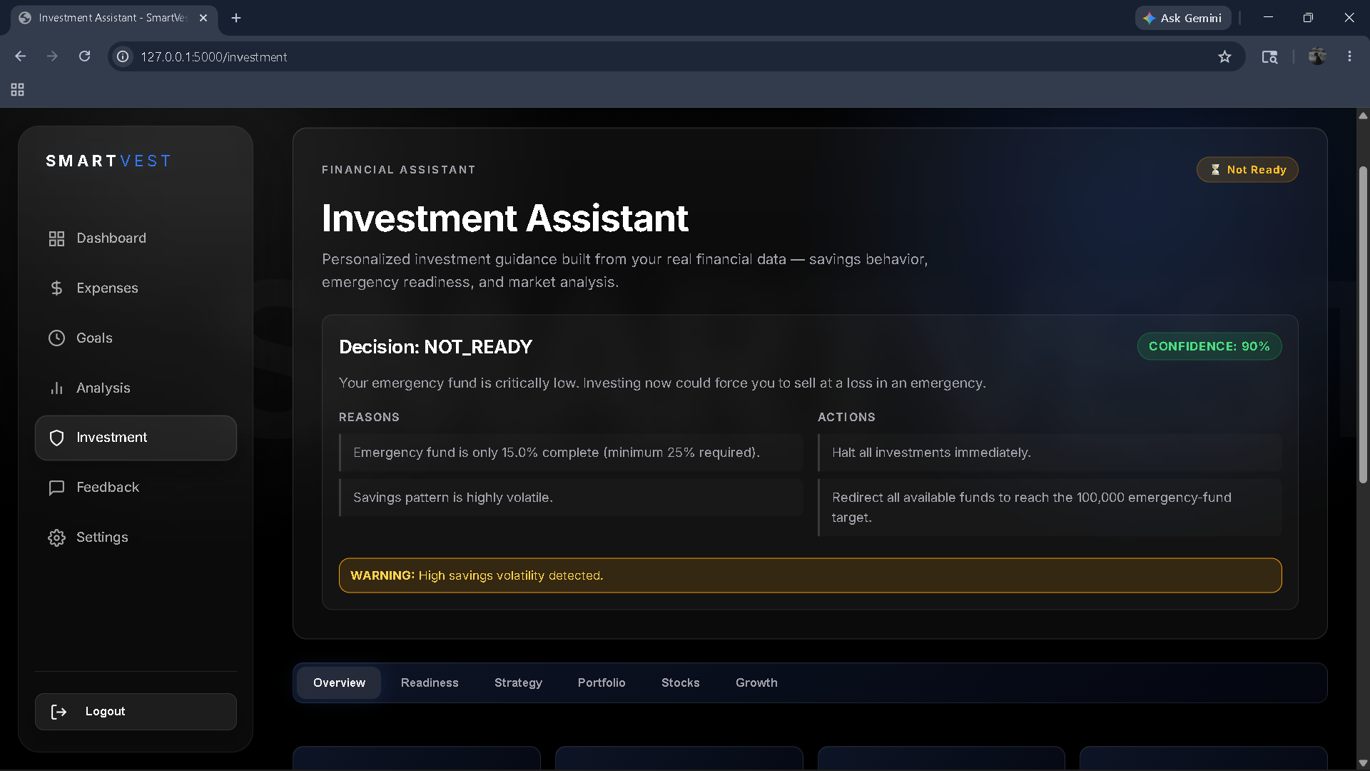
Figure: Investment Module page

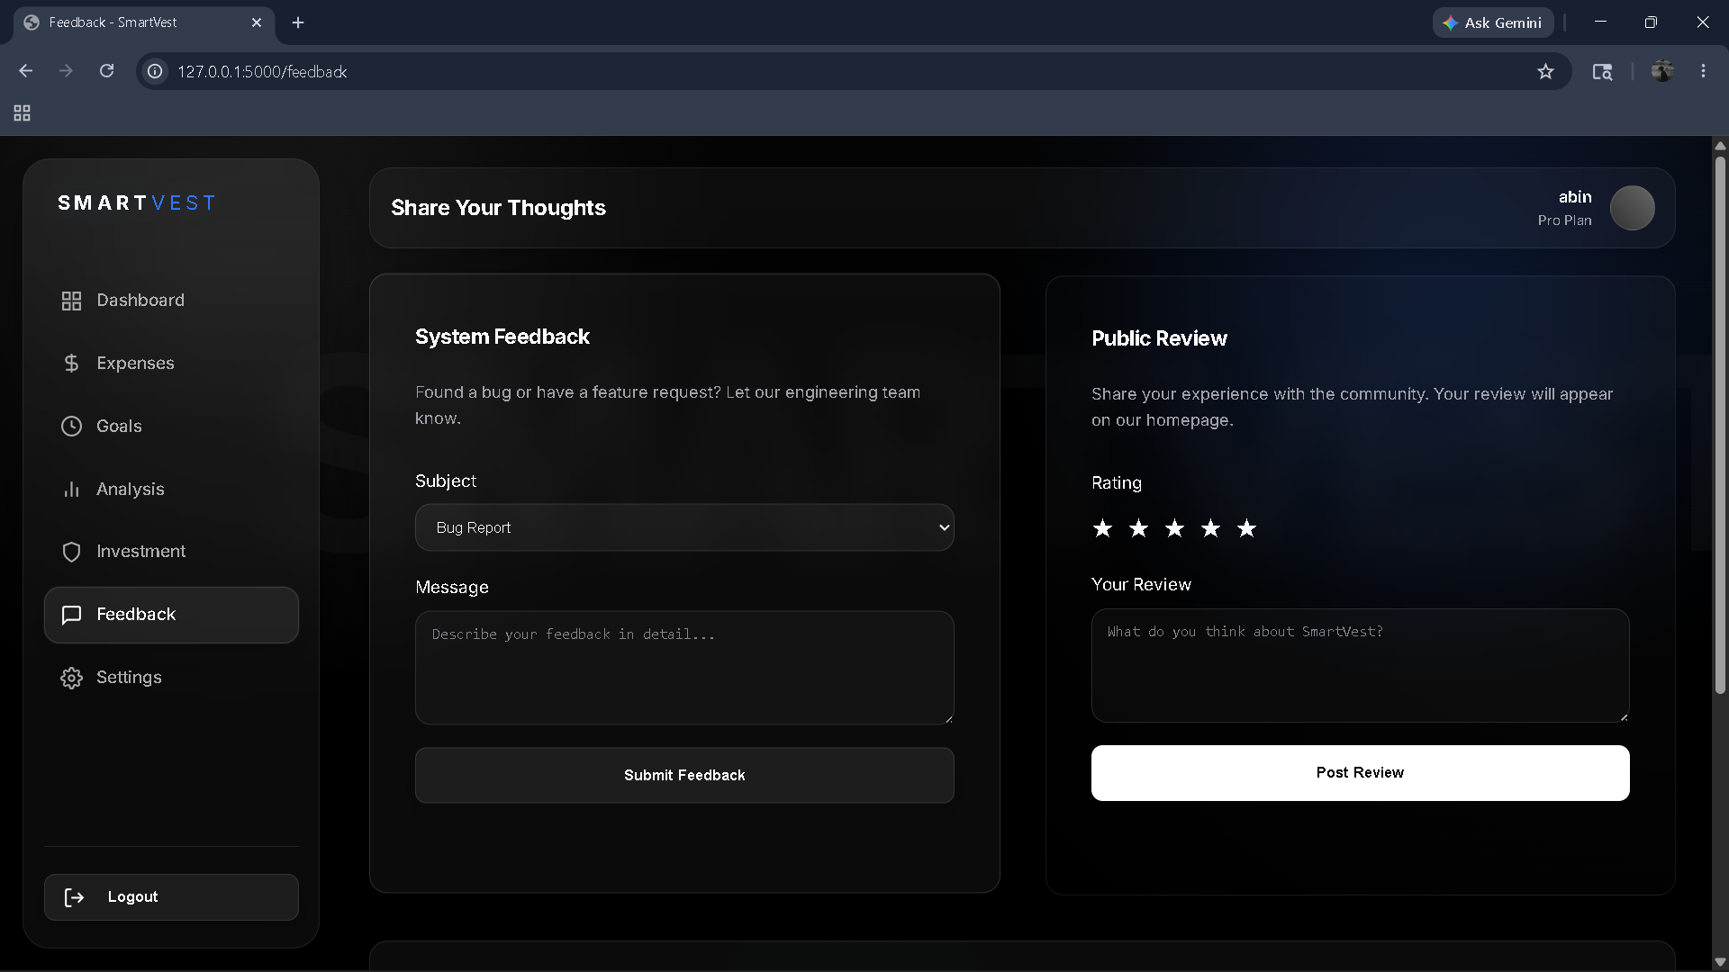
Figure : Feedback & Review page

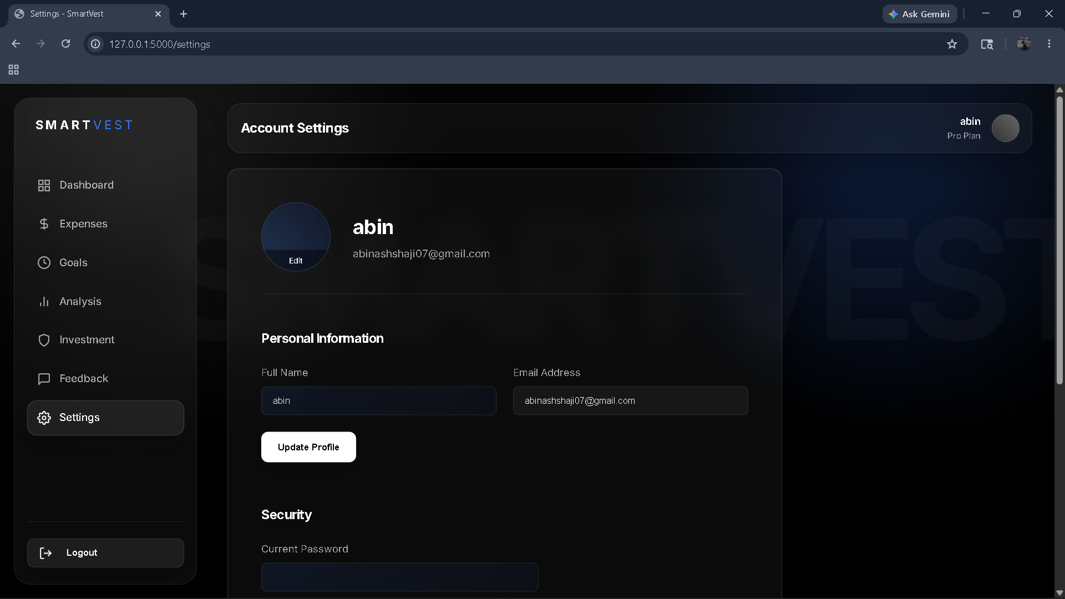
Figure: Settings page
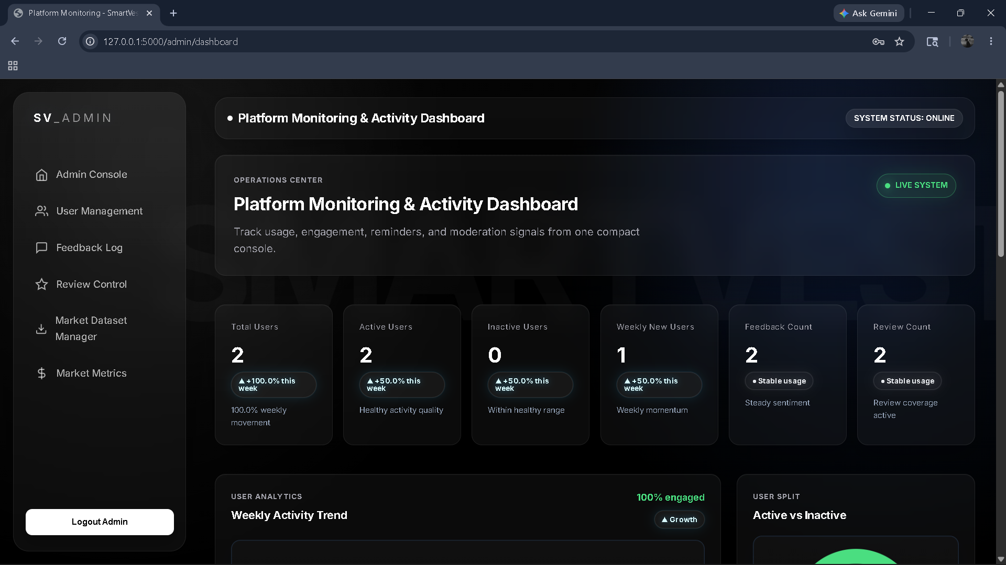
Figure : Admin Dasboard page

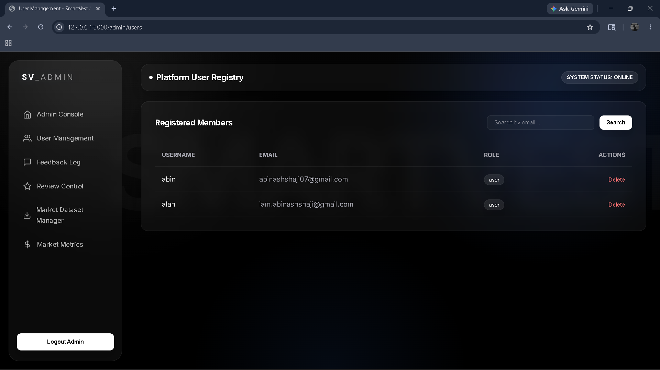
Figure: User Management page
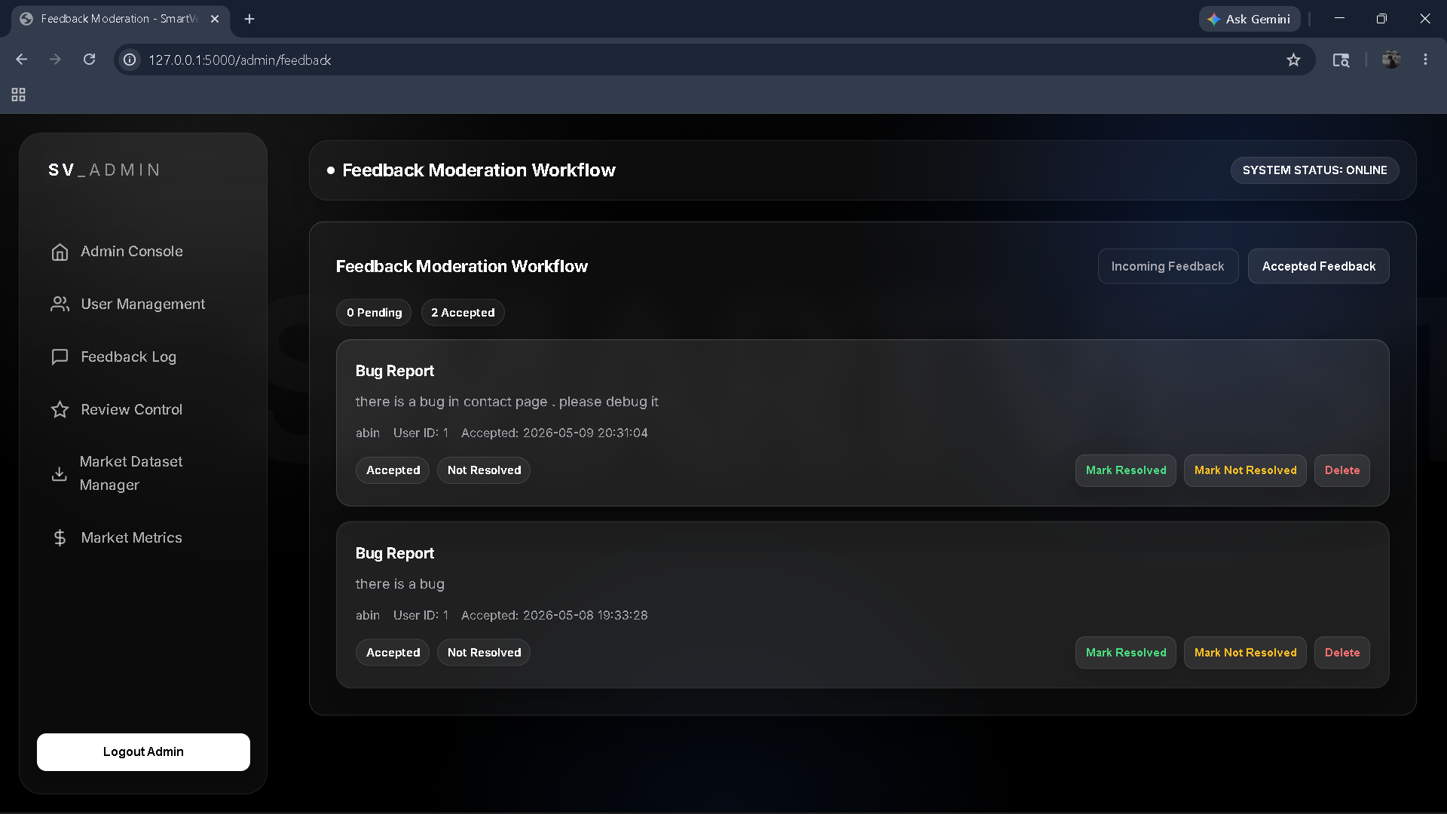
Figure: Feedback Management page
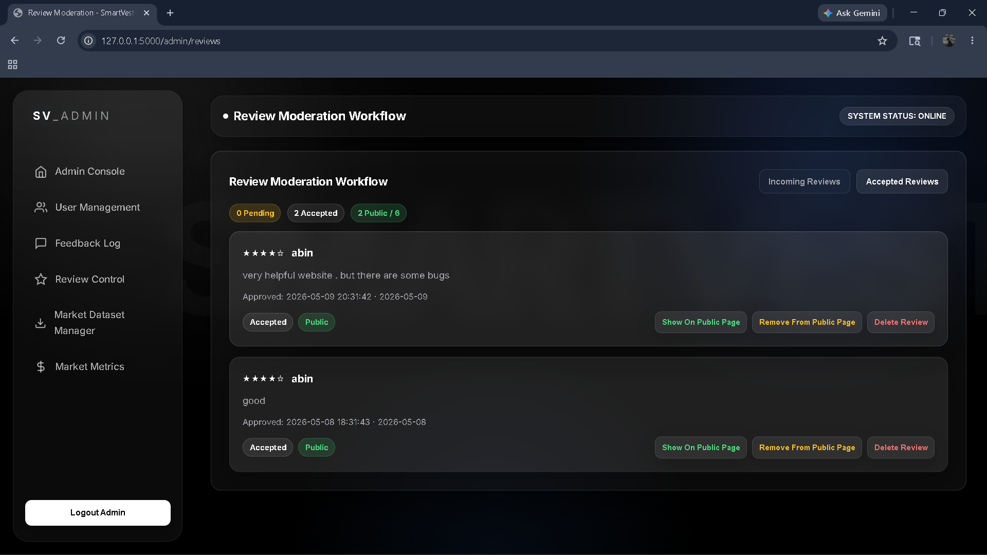
Figure : Review Mangement page
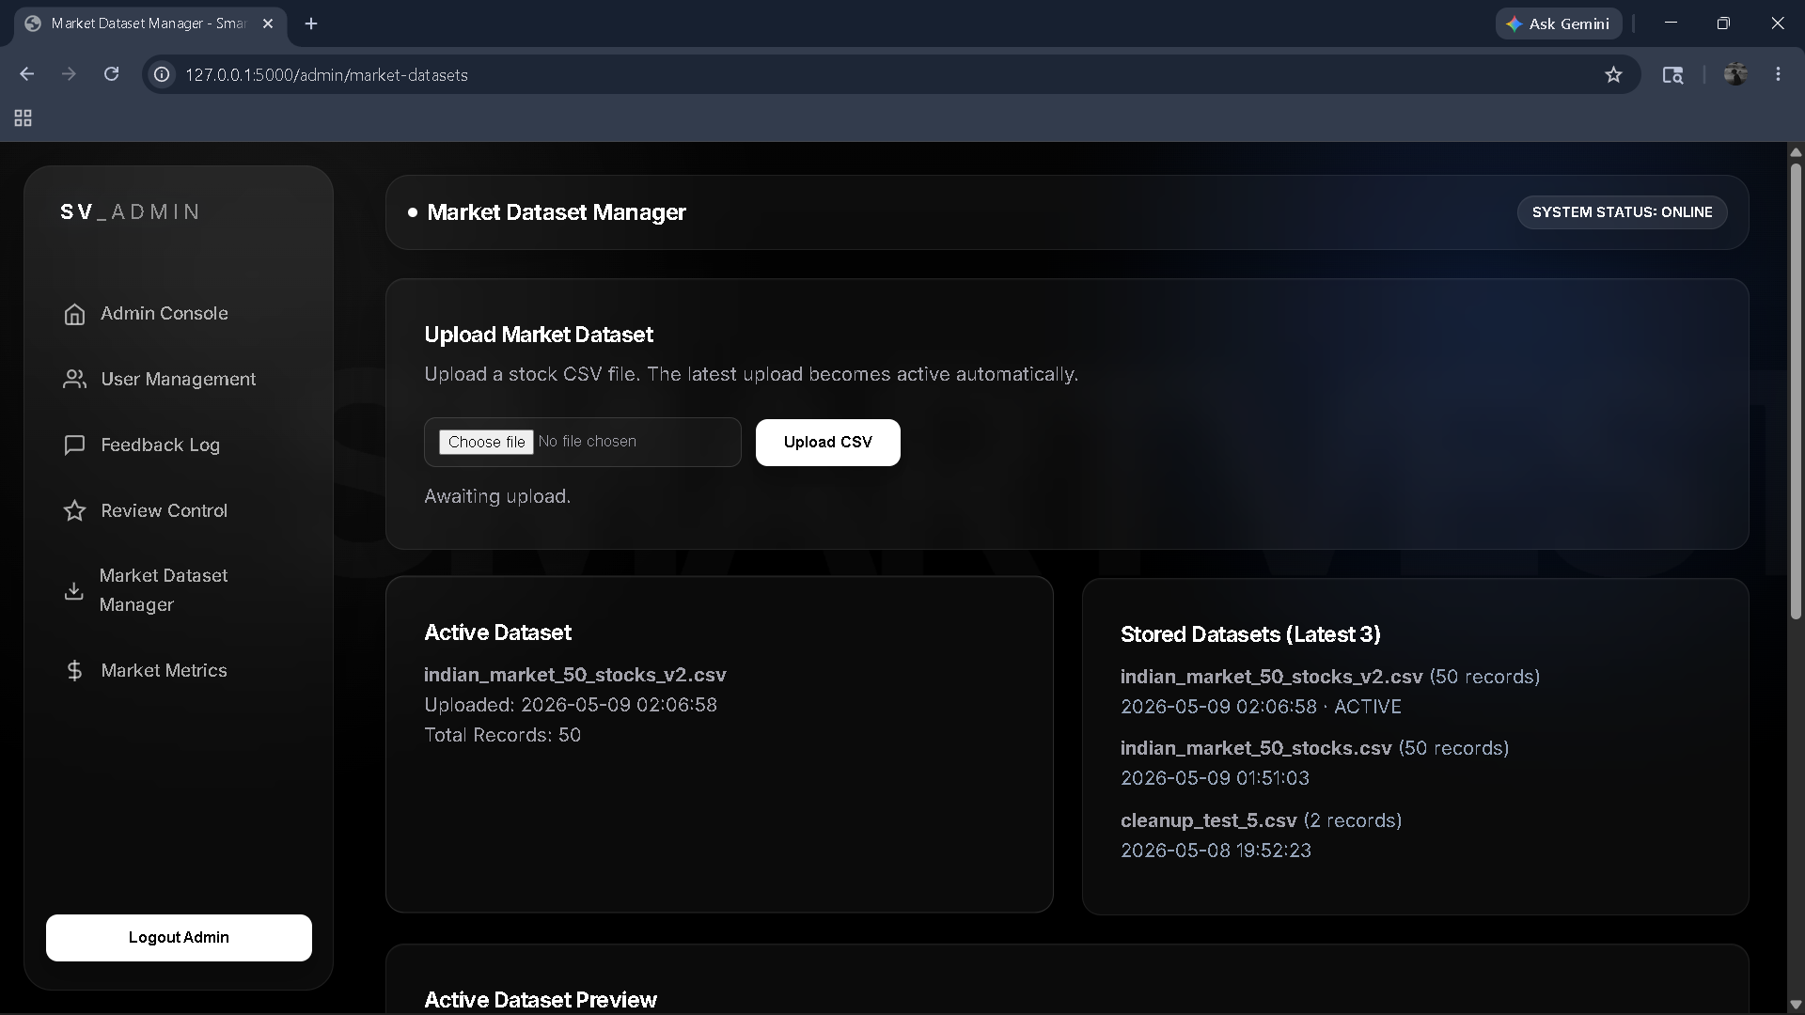
Figure : Market Dataset

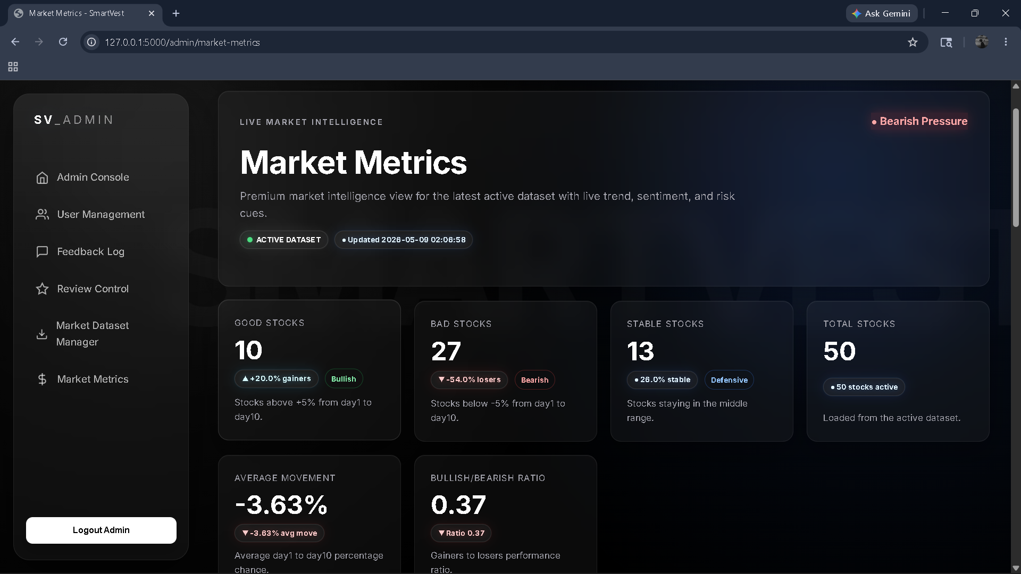
Figure : Market metrics

SCREENSHOT PLACEHOLDER
Insert the relevant SkillRadar application screenshot here.
Figure 5: Placement Hub

SCREENSHOT PLACEHOLDER
Insert the relevant SkillRadar application screenshot here.
Figure 6: Officer Panel

