**V.S. Niketan College**

**Minbhawan, Kathmandu**

**­­­­**

**Lab Report On: File Handling**

**Lab Report No: 1**

|  |  |
| --- | --- |
| **Submitted By** | **Submitted To** |
| Name: Aayush Timilsina  Class: 12  Section: P4  Roll. No:02 | Department of Computer  Science |

**Signature: ____________**

1. **Write a program to record data of any 3 employee and store them in employe.dat.**

#include <stdio.h>

int main() {

FILE *file;

char name[100];

int salary, age;

file = fopen("employee.dat", "w");

for (int i = 0; i < 3; i++) {

printf("Enter data for employee %d\n", i + 1);

printf("Enter name: ");

scanf("%s", name);

printf("Enter salary: ");

scanf("%d", &salary);

printf("Enter age: ");

scanf("%d", &age);

fprintf(file, "%s %d %d\n", name, salary, age);

}

fclose(file);

printf("Data for 3 employees has been successfully recorded in 'employee.dat'.\n");

return 0;

}

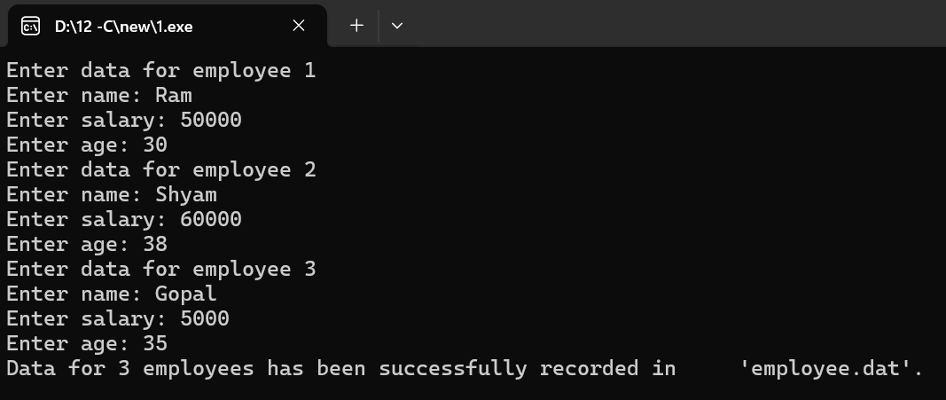**OUTPUT**

1. **Write a program to read all the data from employe.dat.**

#include <stdio.h>

int main() {

FILE *file;

char n[10];

int r,a;

file = fopen("employee.dat", "r");

if (file == NULL) {

printf("Error: Could not open file 'employee.dat'.\n");

return 1;

}

while (fscanf(file, "%s%d%d", n, &r, &a) != EOF)

{

printf("%s %d %d \n",n,r,a);

}

fclose(file);

return 0;

}

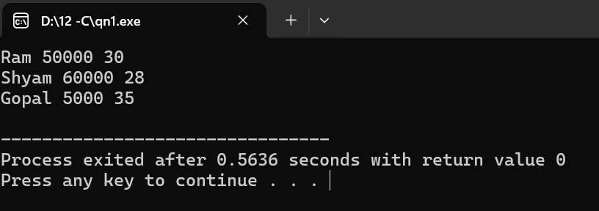**OUTPUT**

1. **Write a program to copy all the data from student.txt and to student2.txt.**

#include <stdio.h>

int main() {

FILE *src, *dest;

src = fopen("student.txt", "r");

if (src == NULL) {

printf("Error: Could not open source file\n");

return 1;

}

dest = fopen("student2.txt", "w");

if (dest == NULL) {

printf("Error: Could not open destination file\n");

fclose(src);

return 1;

}

char ch;

while ((ch = fgetc(src)) != EOF) {

fputc(ch, dest);

}

fclose(src);

fclose(dest);

printf("Data copied successfully.\n");

return 0;

}

**OUTPUT**

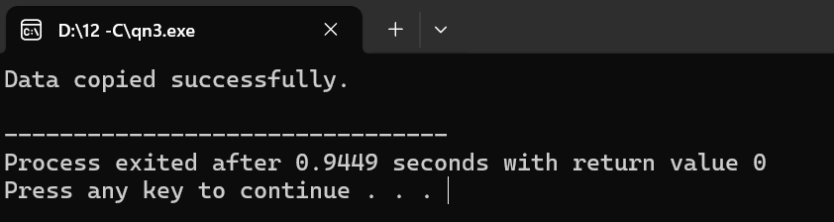

1. **Write a program to record data of 3 students and also read them from student.txt.**

#include <stdio.h>

int main() {

FILE *file;

char name[50];

int age;

float grade;

printf("Enter details for 5 students:\n");

file = fopen("student.txt", "w");

for (int i = 0; i < 3; i++) {

printf("\nStudent %d:\n", i + 1);

printf("Name: ");

scanf("%s", name);

printf("Age: ");

scanf("%d", &age);

printf("Grade: ");

scanf("%f", &grade);

fprintf(file, "Student %d:\n", i + 1);

fprintf(file, "Name: %s\n", name);

fprintf(file, "Age: %d\n", age);

fprintf(file, "Grade: %.2f\n\n", grade);

}

fclose(file);

printf("\nData read from student.txt:\n");

char ch;

while ((ch = fgetc(file)) != EOF) {

putchar(ch);

}

fclose(file);

return 0;

}

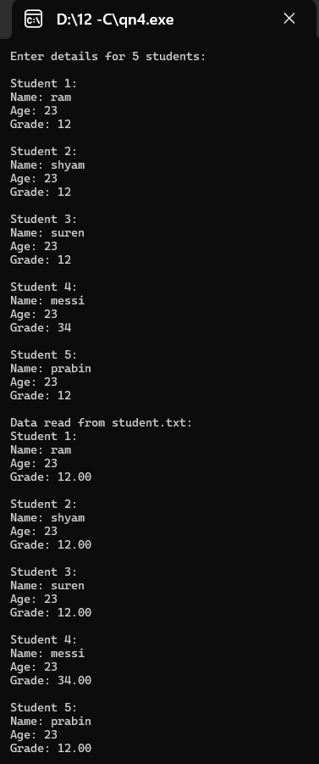**OUTPUT**

1. **Write a program to change the data of student from employe.txt.**

#include <stdio.h>

int main() {

FILE *file;

FILE *tempFile;

char name[50], newName[50];

int age, newAge;

float grade, newGrade;

int studentToUpdate;

char line[100];

int studentCount = 0;

file = fopen("student.txt", "r");

if (file == NULL) {

printf("Error opening file.\n");

return 1;

}

tempFile = fopen("temp.txt", "w");

printf("Enter student number (1-5) to update: ");

scanf("%d", &studentToUpdate);

printf("Enter new name: ");

scanf("%s", newName);

printf("Enter new age: ");

scanf("%d", &newAge);

printf("Enter new grade: ");

scanf("%f", &newGrade);

while (fgets(line, sizeof(line), file) != NULL) {

studentCount++;

if (studentCount == studentToUpdate) {

fprintf(tempFile, "Student %d:\n", studentToUpdate);

fprintf(tempFile, "Name: %s\n", newName);

fprintf(tempFile, "Age: %d\n", newAge);

fprintf(tempFile, "Grade: %.2f\n", newGrade);

} else {

fprintf(tempFile, "%s", line);

}

}

fclose(file);

fclose(tempFile);

remove("student.txt");

rename("temp.txt", "student.txt");

printf("Data updated successfully.\n");

return 0;

}

**OUTPUT**

