**V.S. Niketan College**

**Minbhawan, Kathmandu**

**­­­­**

**Lab Report On: PHP**

**Lab Report No: 1**

|  |  |
| --- | --- |
| **Submitted By** | **Submitted To** |
| Name: Kapil Rawal  Class: 12  Section: P4  Roll. No:19 | Department of Computer  Science |

**Signature:**

**INTRODUCTION**

PHP (Hypertext Preprocessor) is a widely used server-side scripting language designed for web development. It enables developers to create dynamic and interactive websites by embedding PHP code directly within HTML. PHP is open-source, easy to learn, and runs on various platforms, including Windows, Linux, and macOS. It is especially known for its seamless integration with databases like MySQL, PostgreSQL, and SQLite, making it a popular choice for web applications that require data storage and retrieval.

PHP scripts are executed on the server, and the resulting output is sent to the user's browser as plain HTML. The language supports various data types, including strings, integers, floats, booleans, arrays, and objects. Variables in PHP are declared using the $ symbol and do not require explicit data type definitions. PHP also offers control structures such as if-else statements, loops (for, while, foreach), and functions to enhance code reusability.

With PHP, developers can perform CRUD (Create, Read, Update, Delete) operations, handle form data, manage sessions and cookies, and build secure authentication systems. Since PHP can be embedded within HTML, it allows for easy dynamic content generation. Its large community and extensive documentation make it an excellent choice for beginners and experienced developers alike.

1. **Write a PHP script to calculate the area of a rectangle given its length and width.**

<?php

$length = 10;

$width = 5;

$area = $length * $width;

echo "The area of the rectangle is: " . $area;

?>

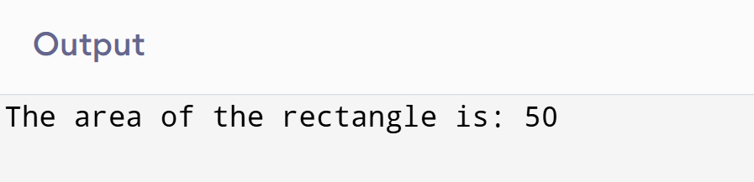

1. **Write a PHP script to find the largest of two numbers.**

<?php

$num1 = 15;

$num2 = 10;

if ($num1 > $num2) {

echo "$num1 is larger.";

} else {

echo "$num2 is larger.";

}

?>

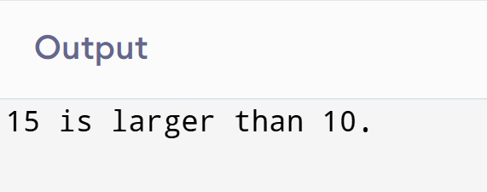

1. **Write a PHP script to check if a number is positive, negative, or zero.**

<?php

$number = -5;

if ($number > 0) {

echo "$number is positive.";

} elseif ($number < 0) {

echo "$number is negative.";

} else {

echo "$number is zero.";

}

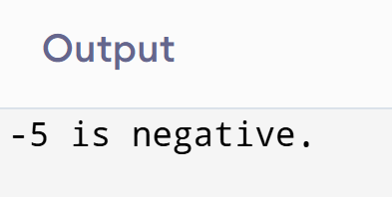?>

1. **Write a PHP script to find the sum of the digits of a number.**

<?php

$number = 123;

$num = $number;

$sum = 0;

while ($number > 0) {

$digit = $number % 10;

$sum += $digit;

$number = (int)($number / 10);

}

echo "The sum of $num is: " . $sum;

?>

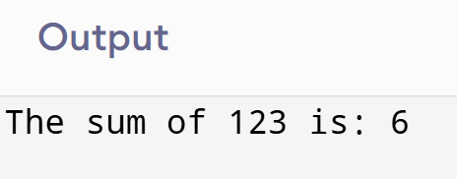

1. **Write a PHP script to check if a number is prime or not.**

<?php

$number = 7;

$isPrime = true;

if ($number <= 1) {

$isPrime = false;

} else {

for ($i = 2; $i <= sqrt($number); $i++) {

if ($number % $i == 0) {

$isPrime = false;

break;

}

}

}

echo $isPrime ? "$number is prime." : "$number is not prime.";

?>

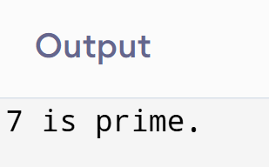

1. **Write a PHP script to calculate the factorial of a number.**

<?php

$number = 5;

$factorial = 1;

for ($i = 1; $i <= $number; $i++) {

$factorial *= $i;

}

echo "The factorial of $number is: " . $factorial;

?>

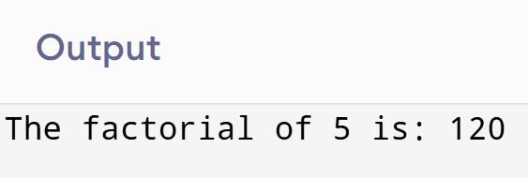

1. **Write a PHP script to calculate the area of a circle given its radius.**

<?php

$radius = 7;

$area = pi() * $radius * $radius;

echo "The area of the circle is: " . $area;

?>

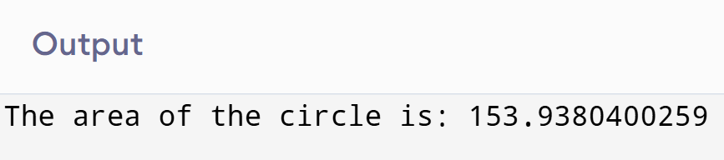

1. **Write a PHP script to reverse a number.**

<?php

$number = 123;

$reversed = 0;

while ($number > 0) {

$digit = $number % 10;

$reversed = $reversed * 10 + $digit;

$number = (int)($number / 10);

}

echo "The reversed number is: " . $reversed;

?>

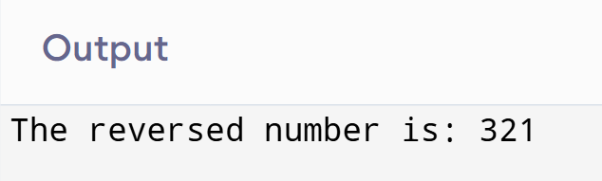

1. **Write a PHP script to check if a number is a palindrome**

<?php

$number = 121;

$original = $number;

$reversed = 0;

while ($number > 0) {

$digit = $number % 10;

$reversed = $reversed * 10 + $digit;

$number = (int)($number / 10);

}

echo ($original == $reversed) ? "$original is a palindrome." : "$original is not a palindrome.";

?>

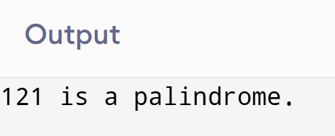

1. **Write a PHP script to calculate the area of a triangle given its base and height.**

<?php

$base = 10;

$height = 5;

$area = ($base * $height) / 2;

echo "The area of the triangle is: " . $area;

?>

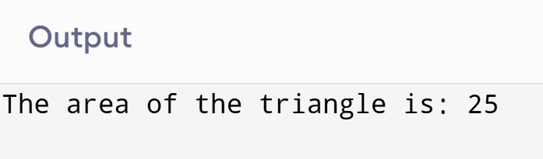

**CONCLUSION**

PHP is a powerful and widely-used server-side scripting language primarily designed for web development. Its ability to generate dynamic content makes it an essential tool for creating interactive and data-driven websites. PHP integrates seamlessly with databases like MySQL and PostgreSQL, making it ideal for applications that require user input, data processing, and real-time updates. With its vast ecosystem, including frameworks like Laravel and WordPress, PHP offers extensive tools for developers, from simple scripts to complex, full-featured websites. While PHP is often criticized for inconsistent syntax and security issues, its flexibility, ease of learning, and large community support continue to make it a popular choice for web developers around the world.

**V.S. Niketan College**

**Minbhawan, Kathmandu**

**­­­­**

**Lab Report On: PHP**

**Lab Report No: 1**

|  |  |
| --- | --- |
| **Submitted By** | **Submitted To** |
| Name: Basist Raj Shah  Class: 12  Section: P4  Roll. No:16 | Department of Computer  Science |

**Signature:**

**INTRODUCTION**

PHP (Hypertext Preprocessor) is a widely used server-side scripting language designed for web development. It enables developers to create dynamic and interactive websites by embedding PHP code directly within HTML. PHP is open-source, easy to learn, and runs on various platforms, including Windows, Linux, and macOS. It is especially known for its seamless integration with databases like MySQL, PostgreSQL, and SQLite, making it a popular choice for web applications that require data storage and retrieval.

PHP scripts are executed on the server, and the resulting output is sent to the user's browser as plain HTML. The language supports various data types, including strings, integers, floats, booleans, arrays, and objects. Variables in PHP are declared using the $ symbol and do not require explicit data type definitions. PHP also offers control structures such as if-else statements, loops (for, while, foreach), and functions to enhance code reusability.

With PHP, developers can perform CRUD (Create, Read, Update, Delete) operations, handle form data, manage sessions and cookies, and build secure authentication systems. Since PHP can be embedded within HTML, it allows for easy dynamic content generation. Its large community and extensive documentation make it an excellent choice for beginners and experienced developers alike.

1. **Write a PHP script to calculate the area of a rectangle given its length and width.**

<?php

$length = 10;

$width = 5;

$area = $length * $width;

echo "The area of the rectangle is: " . $area;

?>



1. **Write a PHP script to find the largest of two numbers.**

<?php

$num1 = 15;

$num2 = 10;

if ($num1 > $num2) {

echo "$num1 is larger.";

} else {

echo "$num2 is larger.";

}

?>



1. **Write a PHP script to check if a number is positive, negative, or zero.**

<?php

$number = -5;

if ($number > 0) {

echo "$number is positive.";

} elseif ($number < 0) {

echo "$number is negative.";

} else {

echo "$number is zero.";

}

?>

1. **Write a PHP script to find the sum of the digits of a number.**

<?php

$number = 123;

$num = $number;

$sum = 0;

while ($number > 0) {

$digit = $number % 10;

$sum += $digit;

$number = (int)($number / 10);

}

echo "The sum of $num is: " . $sum;

?>



1. **Write a PHP script to check if a number is prime or not.**

<?php

$number = 7;

$isPrime = true;

if ($number <= 1) {

$isPrime = false;

} else {

for ($i = 2; $i <= sqrt($number); $i++) {

if ($number % $i == 0) {

$isPrime = false;

break;

}

}

}

echo $isPrime ? "$number is prime." : "$number is not prime.";

?>



1. **Write a PHP script to calculate the factorial of a number.**

<?php

$number = 5;

$factorial = 1;

for ($i = 1; $i <= $number; $i++) {

$factorial *= $i;

}

echo "The factorial of $number is: " . $factorial;

?>



1. **Write a PHP script to calculate the area of a circle given its radius.**

<?php

$radius = 7;

$area = pi() * $radius * $radius;

echo "The area of the circle is: " . $area;

?>



1. **Write a PHP script to reverse a number.**

<?php

$number = 123;

$reversed = 0;

while ($number > 0) {

$digit = $number % 10;

$reversed = $reversed * 10 + $digit;

$number = (int)($number / 10);

}

echo "The reversed number is: " . $reversed;

?>



1. **Write a PHP script to check if a number is a palindrome**

<?php

$number = 121;

$original = $number;

$reversed = 0;

while ($number > 0) {

$digit = $number % 10;

$reversed = $reversed * 10 + $digit;

$number = (int)($number / 10);

}

echo ($original == $reversed) ? "$original is a palindrome." : "$original is not a palindrome.";

?>



1. **Write a PHP script to calculate the area of a triangle given its base and height.**

<?php

$base = 10;

$height = 5;

$area = ($base * $height) / 2;

echo "The area of the triangle is: " . $area;

?>



**CONCLUSION**

PHP is a powerful and widely-used server-side scripting language primarily designed for web development. Its ability to generate dynamic content makes it an essential tool for creating interactive and data-driven websites. PHP integrates seamlessly with databases like MySQL and PostgreSQL, making it ideal for applications that require user input, data processing, and real-time updates. With its vast ecosystem, including frameworks like Laravel and WordPress, PHP offers extensive tools for developers, from simple scripts to complex, full-featured websites. While PHP is often criticized for inconsistent syntax and security issues, its flexibility, ease of learning, and large community support continue to make it a popular choice for web developers around the world.