First, you'll need to choose a quotes API. One popular option is the "Quotable REST API." To use it in Python, you can make HTTP requests using the requests library.

steps:

*Step 1: Install requests*

Open your terminal or command prompt and run:



This will install the requests library that we'll use to make HTTP requests.

*Step 2: Write the Python script*

Create a new Python file (e.g., quote_generator.py) and open it in your favorite code editor.

*Step 3: Write the code*

Copy and paste the following code into your Python file:

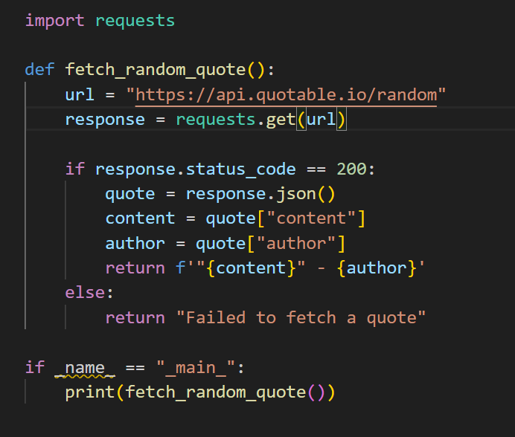

Step 4: Run the script*

In your terminal or command prompt, navigate to the directory where your script is located, and run:

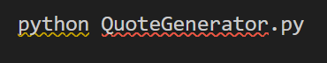

This should print a random quote each time you run the script!