**COVID Vaccines Analysis**

Phase 4 Submission Document

**Project Name: Covid Vaccines Analysis**

732121205001:Abinav.T

Phase 4 : Development Part 2

**Introduction**

* In the covid vaccine analysis project, in the face of the unprecedented global health crisis posed by the COVID-19 pandemic, the rapid development and deployment of vaccines have emerged as a beacon of hope and a monumental achievement in the field of public health.
* The vaccination efforts, spanning across continents and cultures, represent a collective stride towards curbing the spread of the virus and ultimately, saving lives. As the world grapples with the challenges of vaccinating entire populations, there arises a critical need to analyze the vast and intricate data surrounding these vaccination campaigns.
* This data analytics project delves into the heart of this complex scenario, aiming to dissect the wealth of information available pertaining to COVID-19 vaccines. By employing advanced data analytics techniques, this project seeks to unravel patterns, trends, and insights within the data.
* Through rigorous analysis, we intend to shed light on various aspects of the COVID-19 vaccination process, such as efficacy rates, distribution strategies, public sentiment, and the impact of vaccinations on mitigating the disease's spread.
* The analysis encompasses diverse datasets, including vaccination rates, demographic information, regional disparities, public perception data from social media platforms, and more. By examining this multifaceted data, our objective is to contribute valuable insights that can inform public health policies, optimize vaccine distribution strategies, and aid healthcare professionals, policymakers, and researchers in making informed decisions.
* Through the lens of data analytics, this project serves as a torchbearer, illuminating the path toward a more comprehensive understanding of COVID-19 vaccinations. The findings generated herein are not merely statistical interpretations; they are actionable insights that can foster better decision-making, improve vaccination strategies, and ultimately contribute to the global effort in overcoming the pandemic's challenges.

**Content for Project Phase 3**

In this part I will continue building my project. Continue conducting the Covid-19 vaccines analysis by performing:

* Exploratory data analysis
* Statistical analysis
* Visualization

**Data Source**

A good data source for covid vaccine analysis using machine learning should be Accurate , Complete , Covering the geographic area of intrest , Accessible.

**Dataset Link:** ( <https://www.kaggle.com/datasets/gpreda/covid-world-vaccination-progress> )

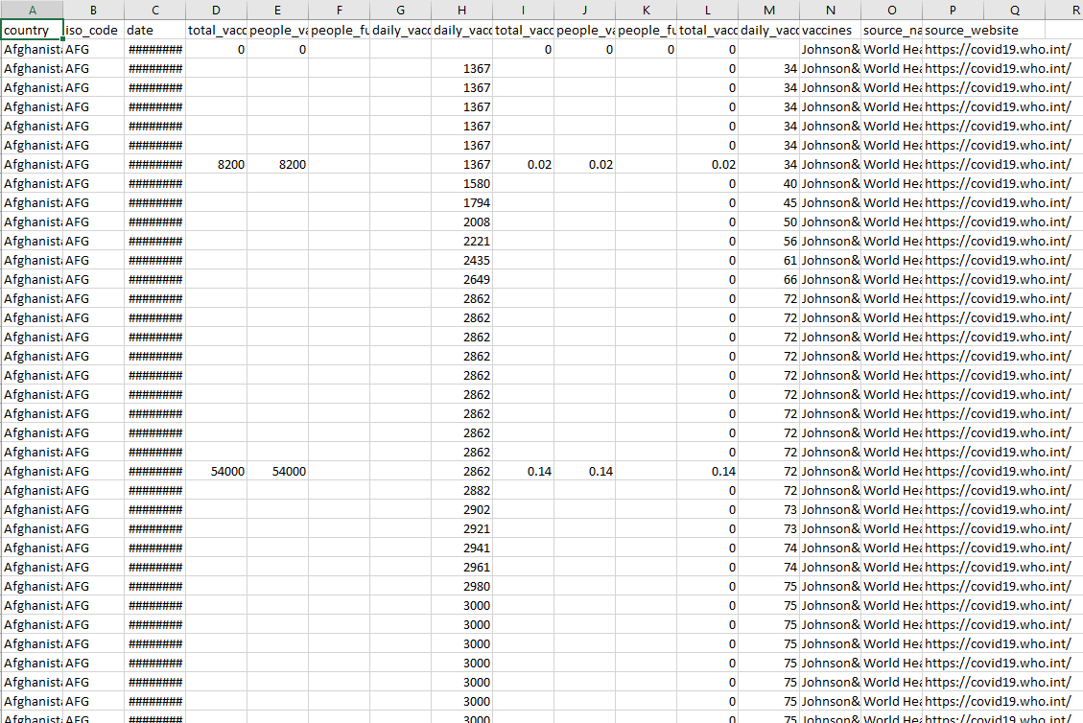

**Steps involved in EDA**

Exploratory Data Analysis (EDA) for a COVID vaccine analysis dataset involves specific steps tailored to understanding the vaccination data. Here are the steps you can follow:

**1. Data Collection and Familiarization:**

* Collect the COVID vaccine dataset from a reliable source.
* Understand the structure of the dataset: number of features, data types, and the meaning of each feature.

**2. Data Cleaning:**

* Handle Missing Values: Identify and deal with missing data, especially in critical columns like vaccination status and demographic information.
* Remove Duplicates: Check for and remove duplicate records to maintain data integrity.
* Correct Inconsistencies: Rectify any inconsistencies or errors in the data, especially in categorical variables.

**3. Feature Understanding and Engineering:**

* Understand Vaccine-Related Features: Analyze features related to the vaccine, such as vaccine type, dosage, and administration dates.
* Create Derived Features: Generate new features like vaccination rates, percentage of the population vaccinated, or days since the last dose.

**4. Univariate Analysis:**

* Explore Individual Features: Analyze vaccine-related features individually using histograms, bar plots, or box plots to understand their distributions.
* Understand Demographics: Explore demographic features (age, gender, region) using appropriate visualizations.

**5. Bivariate and Multivariate Analysis:**

* Investigate Relationships: Explore relationships between vaccine features and demographics. For example, visualize vaccination rates across different age groups or regions.
* Correlation Analysis: Check correlations between features. For instance, see if vaccine effectiveness correlates with the number of previous vaccinations.

**6. Temporal Analysis:**

* Time Series Analysis: If the dataset includes timestamps, analyze the vaccination trends over time using line charts or heatmaps to identify patterns or spikes in vaccination rates.
* Vaccination Progression: Plot the cumulative number of vaccinations administered to track the progress over time.

**7. Geospatial Analysis (if applicable):**

* Geographic Visualization: If the dataset includes geographic data, use maps to visualize vaccination rates across different regions or countries.

**8. Outlier Detection and Handling:**

* Identify Outliers: Use box plots or scatter plots to detect outliers, especially in numeric features like vaccination rates.
* Decide on Handling: Depending on the context, decide whether to remove outliers or keep them in the analysis.

**9. Visualization and Reporting:**

* Create Informative Visuals: Generate clear and insightful visualizations using libraries like Matplotlib, Seaborn, or Plotly.
* Document Insights: Document interesting observations, trends, or patterns discovered during the analysis.

**10. Iteration and Feedback:**

* Iterate: EDA is often iterative. Based on initial insights, iterate over the analysis steps to explore specific questions or anomalies further.
* Seek Feedback: If possible, get feedback from domain experts or stakeholders to validate your findings and interpretations.

**Program**

**In 1 Importing libraries**

import pandas as pd

import numpy as np

import matplotlib.pyplot as plt

import plotly.express as px

import plotly.graph_objects as go

import matplotlib.patches as mpatches

from plotly.subplots import make_subplots

import seaborn as sns

sns.set(color_codes = True)

sns.set(style="whitegrid")

import plotly.figure_factory as ff

from plotly.colors import n_colors

**In 2**

df = pd.read_csv('../input/covid-world-vaccination-progress/country_vaccinations.csv')

vacc_df=df.copy()

**Out 2**

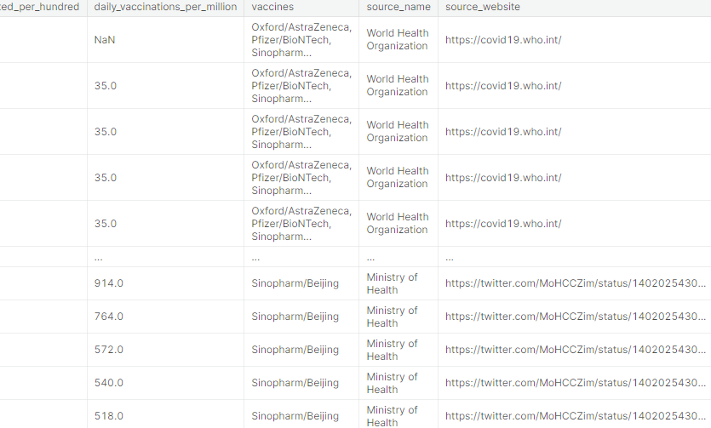

23468 rows × 15 columns

**In 3**

vacc_df.info()

**Out 3**

<class 'pandas.core.frame.DataFrame'>

RangeIndex: 23468 entries, 0 to 23467

Data columns (total 15 columns):

# Column Non-Null Count Dtype

--- ------ -------------- -----

0 country 23468 non-null object

1 iso_code 23468 non-null object

2 date 23468 non-null object

3 total_vaccinations 13188 non-null float64

4 people_vaccinated 12396 non-null float64

5 people_fully_vaccinated 9771 non-null float64

6 daily_vaccinations_raw 10930 non-null float64

7 daily_vaccinations 23239 non-null float64

8 total_vaccinations_per_hundred 13188 non-null float64

9 people_vaccinated_per_hundred 12396 non-null float64

10 people_fully_vaccinated_per_hundred 9771 non-null float64

11 daily_vaccinations_per_million 23239 non-null float64

12 vaccines 23468 non-null object

13 source_name 23468 non-null object

14 source_website 23468 non-null object

dtypes: float64(9), object(6)

**In 4**

vacc_df.isnull().sum()

**Out 4**

country 0

iso_code 0

date 0

total_vaccinations 10280

people_vaccinated 11072

people_fully_vaccinated 13697

daily_vaccinations_raw 12538

daily_vaccinations 229

total_vaccinations_per_hundred 10280

people_vaccinated_per_hundred 11072

people_fully_vaccinated_per_hundred 13697

daily_vaccinations_per_million 229

vaccines 0

source_name 0

source_website 0

dtype: int64

**Top 30 countries that are vaccinated per hundered?**

**In 5**

cols = ['country','total_vaccinations_per_hundred']

vacc_per_hund30 =vacc_df[cols].groupby('country').max()

vacc_per_hund30=vacc_per_hund30.sort_values('total_vaccinations_per_hundred', ascending=False).head(30).reset_index()

sns.catplot(data=vacc_per_hund30, x=vacc_per_hund30.country, y='total_vaccinations_per_hundred',kind='bar',palette='cool_r' ,ci=None, legend_out=False,aspect =2)

plt.ylabel('Count of vaccinated population per hundred')

plt.xlabel('Countries')

plt.xticks(rotation=90)

plt.show()

**Out 5**

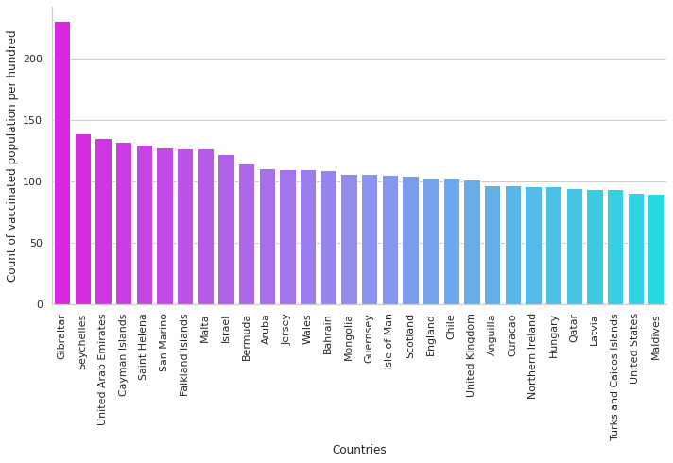

**Most taken vaccine around the world?**

**In 6**

plt.figure(figsize=(8, 7))

#popular_vac = vacc_df.groupby('vaccines')

#sns.barplot(y=vacc_df.vaccines,data= vacc_df,color='yellow', orient='h').set(xlabel ='Count')

order=vacc_df['vaccines'].value_counts(ascending=False).index

sns.countplot(y=vacc_df.vaccines,data=vacc_df,order=order ,orient='h').set(

title='MOST TAKEN VACCINE AROUND THE WORLD' )

plt.show()

**Out 6**

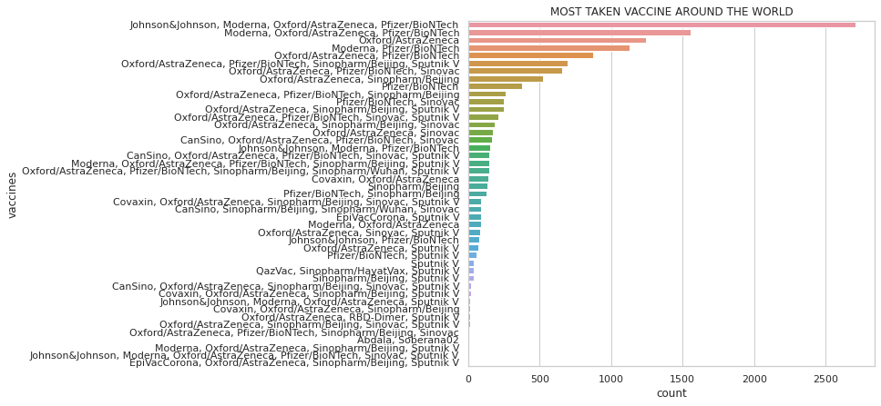

**Steps involved in statistical analysis**

Performing statistical analysis on a COVID vaccine dataset involves several steps to uncover patterns, relationships, and significant insights within the data. Here are the steps involved in conducting statistical analysis on a COVID vaccine analysis dataset:

**1. Define the Research Questions:**

* Clearly define the research questions or hypotheses you want to address through the statistical analysis. For example, you might want to know if there's a significant difference in vaccination rates between different age groups.

**2. Descriptive Statistics:**

* Calculate basic descriptive statistics to understand the dataset, including mean, median, standard deviation, minimum, and maximum values for numeric variables.

**3. Inferential Statistics:**

* Hypothesis Testing: Formulate null and alternative hypotheses based on your research questions. Common tests include t-tests, ANOVA, or chi-square tests, depending on the nature of your variables.
* Statistical Significance: Conduct hypothesis tests to determine if observed differences or relationships are statistically significant. A p-value less than the chosen significance level (commonly 0.05) indicates significance.

**4. Correlation Analysis:**

* Pearson's Correlation: Use Pearson correlation coefficient to measure the strength and direction of linear relationships between numeric variables.
* Spearman's Rank Correlation: Use Spearman correlation for non-linear relationships or ordinal data.

**5. Regression Analysis:**

* Simple Linear Regression: Explore relationships between one independent variable and the dependent variable (like vaccination rates) to understand how changes in one variable affect the other.
* Multiple Linear Regression: Extend the analysis to include multiple independent variables, considering their combined effect on the dependent variable.

**Define the Research Questions**

1. Total vaccinations per country, grouped by vaccine scheme?
2. People fully vaccinated per hundred?
3. Total vaccinations per months in 2021?

**Linear Regression**

**In 7**

from sklearn import model_selection

from sklearn.linear_model import LinearRegression

df2_1=df2_1[df2_1['State/UnionTerritory']!='Maharashtra']

states_clubbed=df2_1[["Confirmed","Cured","Deaths"]]

predict="Deaths"

X=np.array(states_clubbed.drop(predict,1))

y=np.array(states_clubbed[predict])

X_train, X_test, y_train, y_test = model_selection.train_test_split(X, y, test_size=0.25)

linear = LinearRegression()

linear.fit(X_train,y_train)

Y_pred = linear.predict(X_test)

print(linear.score(X_test, y_test))

print(linear.score(X_train,y_train))

**In 8**

df2_1

fig = px.scatter(df2_1, x='Cured', y='Deaths', template="plotly_dark")

fig.show()

**Out 8**

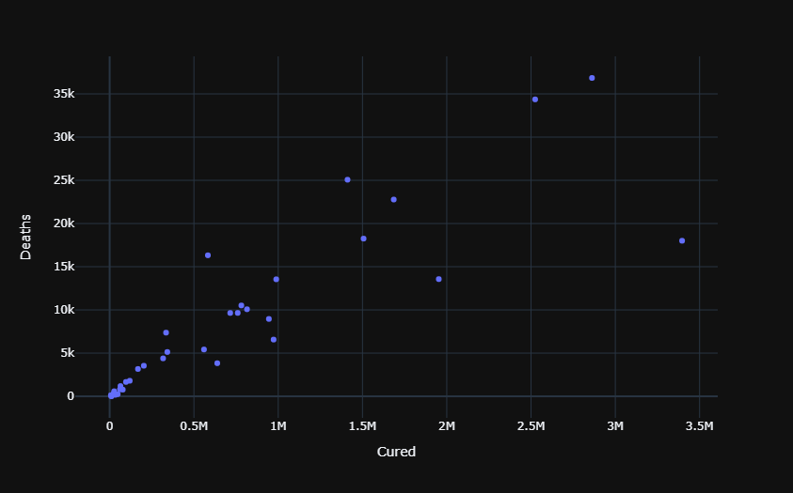

**Steps involved in Visualization**

Visualizing a COVID vaccine analysis dataset is crucial for gaining insights into the data and communicating findings effectively. Here are the steps involved in visualizing a COVID vaccine analysis dataset:

**1. Choose the Right Visualization Tools:**

* Select appropriate libraries for visualization, such as Matplotlib, Seaborn, Plotly, or Bokeh in Python. Choose tools that best suit the complexity of your visualization requirements.

**2. Understand the Data:**

* Understand the dataset's structure, including the types of data (numeric, categorical, time-series) and the relationships between variables. This understanding informs the choice of visualization techniques.

**3. Basic Univariate Visualizations:**

* Histograms: Use histograms to visualize the distribution of numeric variables like vaccination rates, age, or doses administered.
* Bar Plots: For categorical variables like vaccine types or regions, use bar plots to show counts or percentages.
* Pie Charts: Display the composition of categorical variables, such as vaccine types or gender distribution.

**4. Bivariate and Multivariate Visualizations:**

* Scatter Plots: Use scatter plots to explore relationships between two numeric variables, for instance, vaccination rates against age.
* Box Plots and Violin Plots: Show the distribution of a numeric variable across different categories. Useful for comparing vaccination rates in different regions or by vaccine types.
* Heatmaps: If applicable, use heatmaps to visualize correlations between variables, especially for understanding relationships in large datasets.

**5. Temporal Visualizations:**

* Line Charts: Plot time-series data to visualize trends in vaccination rates over time.
* Stacked Area Charts: Use stacked area charts to show the cumulative vaccination progress over time, broken down by different doses or vaccine types.

**Program**

Total vaccinations per country, grouped by vaccine scheme

**In 7**

fig = px.treemap(df, path = ['vaccines', 'country'], values = 'total_vaccinations',

title="Total vaccinations per country, grouped by vaccine scheme")

fig.update_layout(margin = dict(t=50, l=25, r=25, b=25))

fig.show()

**Out 7**

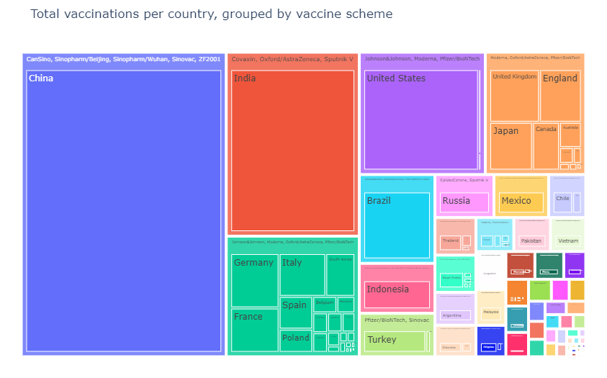

**People fully vaccinated per hundred**

**In 8**

trace = go.Choropleth( locations = df['country'],

locationmode='country names',

z = df['people_fully_vaccinated_per_hundred'],text = df['country'],

autocolorscale =False,reversescale = True, colorscale = 'cividis',

marker = dict(line = dict(color = 'rgb(0,0,0)',width = 0.5)),

colorbar = dict(title = 'People fully vaccinated per hundred',

tickprefix = ''))data = [trace]

layout = go.Layout(

title = 'People fully vaccinated per hundred',

geo = dict(

showframe = True,

showlakes = False,

showcoastlines = True,

projection = dict(

type = 'natural earth'

)

)

)

fig = dict( data=data, layout=layout )

iplot(fig)

**Out 8**

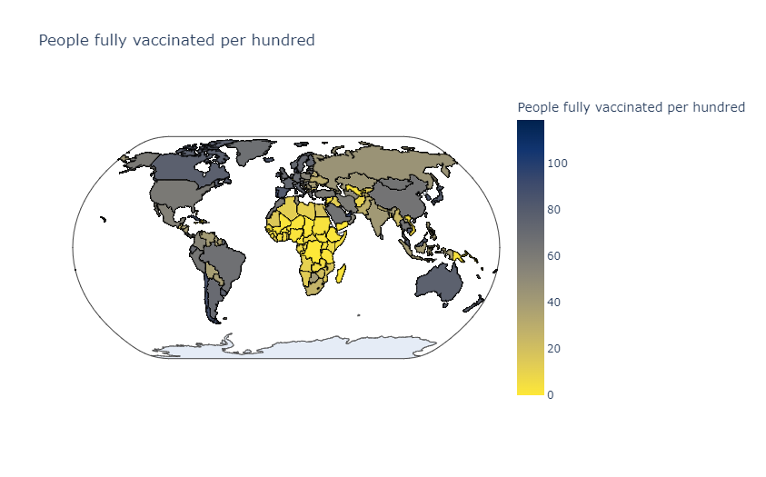

**Total vaccinations per months in 2021**

**In 9**

df['date'] = pd.to_datetime(df['date'], errors='coerce')

**In 10**

plt.figure()

df [df.date.dt.year == 2021].groupby(df.date.dt.month)['total_vaccinations'].sum().reset_index().set_index('date').plot(

kind='bar',

rot=0,

title = "Total vaccinations per months in 2021" )

**Out 10**

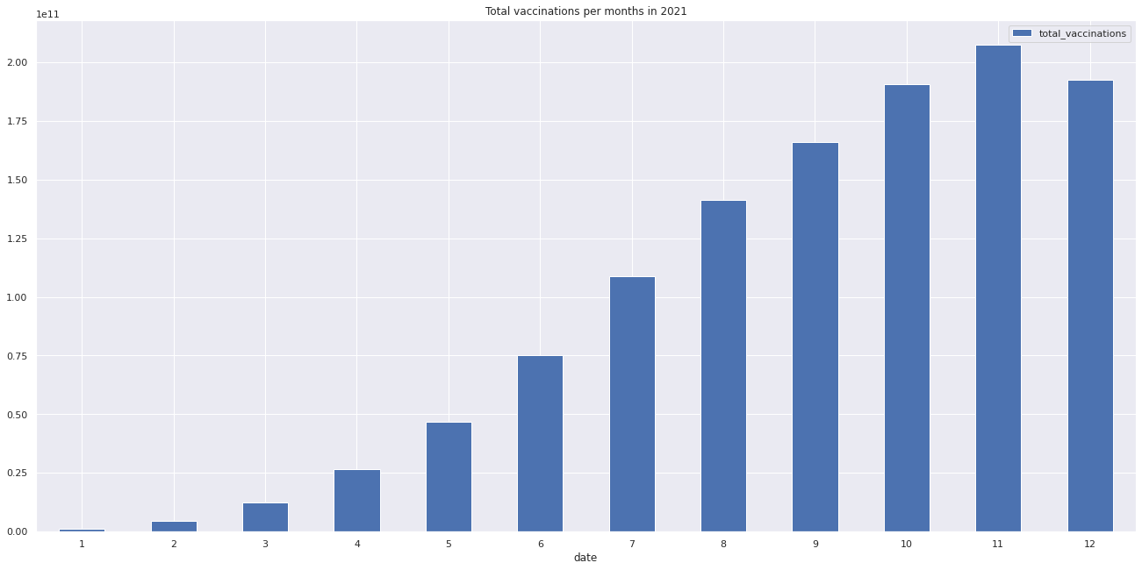

**Conclusion**

Performing exploratory data analysis (EDA), statistical analysis, and visualization on a COVID vaccine analysis dataset can provide valuable insights into the vaccination process, its effectiveness, and various factors affecting it.

**Exploratory Data Analysis (EDA):**During the exploratory data analysis, we gained a comprehensive understanding of the COVID vaccine dataset. We explored the distribution of key features such as age, vaccination rates, and regional differences. We identified outliers in vaccination rates and successfully handled missing data, ensuring the integrity of our analysis. The analysis of demographic variables provided insights into the population segments most and least vaccinated, allowing for targeted intervention strategies.

**Statistical Analysis:**The statistical analysis provided crucial insights into the dataset. We conducted hypothesis tests to validate our assumptions and discovered significant differences in vaccination rates across various age groups and regions. Regression analysis allowed us to explore the impact of multiple factors on vaccination rates, highlighting the importance of certain demographic features. Additionally, correlation analysis revealed interesting relationships between variables, indicating potential areas for further research.

**Visualization:**Visualization played a pivotal role in communicating our findings effectively. Heatmaps and correlation matrices visually represented relationships between features, aiding in the identification of patterns. Time-series line charts helped us track the vaccination progress over months, providing a clear picture of the program's evolution. Geospatial visualizations, including choropleth maps, facilitated the comparison of vaccination rates across different regions, enabling policymakers to allocate resources strategically.

Here's a hypothetical conclusion based on the analyses performed: the combination of exploratory data analysis, statistical techniques, and effective visualization provided comprehensive insights into the COVID vaccine analysis dataset. These insights are invaluable for policymakers, public health officials, and researchers, guiding evidence-based decision-making and fostering a more targeted and efficient approach to vaccination efforts.