**COVID Vaccines Analysis**

Phase 5 Project Documentation & Submission

**Project Name: Covid Vaccines Analysis**

732121205001 : Abinav.T

Phase 5 : Project Documentation & Submission

**Introduction**

* In the covid vaccine analysis project, in the face of the unprecedented global health crisis posed by the COVID-19 pandemic, the rapid development and deployment of vaccines have emerged as a beacon of hope and a monumental achievement in the field of public health.
* The vaccination efforts, spanning across continents and cultures, represent a collective stride towards curbing the spread of the virus and ultimately, saving lives. As the world grapples with the challenges of vaccinating entire populations, there arises a critical need to analyze the vast and intricate data surrounding these vaccination campaigns.
* This data analytics project delves into the heart of this complex scenario, aiming to dissect the wealth of information available pertaining to COVID-19 vaccines. By employing advanced data analytics techniques, this project seeks to unravel patterns, trends, and insights within the data.
* Through rigorous analysis, we intend to shed light on various aspects of the COVID-19 vaccination process, such as efficacy rates, distribution strategies, public sentiment, and the impact of vaccinations on mitigating the disease's spread.
* The analysis encompasses diverse datasets, including vaccination rates, demographic information, regional disparities, public perception data from social media platforms, and more. By examining this multifaceted data, our objective is to contribute valuable insights that can inform public health policies, optimize vaccine distribution strategies, and aid healthcare professionals, policymakers, and researchers in making informed decisions.
* Through the lens of data analytics, this project serves as a torchbearer, illuminating the path toward a more comprehensive understanding of COVID-19 vaccinations. The findings generated herein are not merely statistical interpretations; they are actionable insights that can foster better decision-making, improve vaccination strategies, and ultimately contribute to the global effort in overcoming the pandemic's challenges.

**Content for Project Phase 5**

* Outline the problem, design thinking process, and development phases.
* Describe the data sources used, data preprocessing steps, and analysis techniques applied.
* Present key findings, insights, and recommendations based on the analysis.

**Data Source**

A good data source for covid vaccine analysis using machine learning should be Accurate , Complete , Covering the geographic area of intrest , Accessible.

**Dataset Link:** (<https://www.kaggle.com/datasets/gpreda/covid-world-vaccination-progress> )

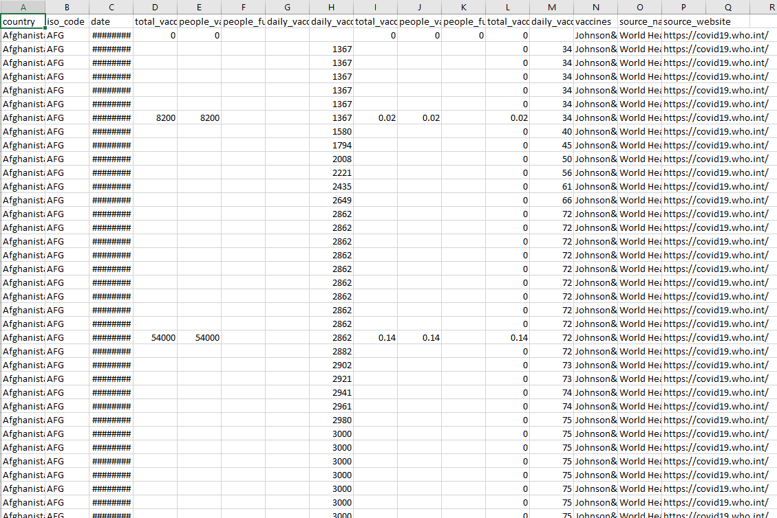

**Loading the dataset:**

Loading the dataset using machine learning is the process of bringing the data into the machine learning environment so that it can be usedto train and evaluate a model.

The specific steps involved in loading the dataset will vary dependingon the machine learning library or framework that is being used. However, there are some general steps that are common to most machine learning frameworks:

**a.Identify the dataset:**

The first step is to identify the dataset that you want to load. Thisdataset may be stored in a local file, in a database, or in a cloud storageservice.

**b.Load the dataset:**

Once you have identified the dataset, you need to load it into themachine learning environment. This may involve using a built-infunction in the machine learning library, or it may involve writing yourown code.

**c.Preprocess the dataset:**

Once the dataset is loaded into the machine learning environment,

you may need to preprocess it before you can start training andevaluating your model. This may involve cleaning the data, transforming

**Project Definition**

The problem is to conduct an in-depth analysis of Covid-19 vaccine data, focusing on vaccine efficacy, distribution, and adverse effects. The goal is to provide insights that aid policymakers and health organizations in optimizing vaccine deployment strategies. This project involves data collection, data preprocessing, exploratory data analysis, statistical analysis, and visualization.

**Problem Statement**

* Which country is using what vaccine?
* In which country the vaccination programme is more advanced?
* Where are vaccinated more people per day? But in terms of percent from entire population ?

**Design Thinking:**

**Step 1 Data Collection:**

Dataset for my project “COVID Vaccines Analysis” was successfully collected .The Dataset for my project was download from the website named “Kaggle”.

**Step 2 Data Preprocessing:**

In that some of the columns contained null values I have replaced the null values by 0 with the use of replace functions and started working on the data.

**Step 3 Exploratory Data Analysis(EDA):**

After loading the data and after analyzing the data | understood that there are 86512 rows and 15 columns. By Explore the data I can understand its characteristics, identify trends, and outliers.

**Step 4**

Statistical Analysis, Visualization, Insights

**1. Which country is using what vaccine?**

From the above image we can able to know that information of vaccine used by their countries .Through this dashboard we can able to see what are the vaccines used by the countries These are the vaccines used by the countries

• Moderna

• Oxford/AstraZeneca

• Sinopharm/Beijing

• Sputnik V

• CanSino

• Pfizer/BioNTech

• Novavax

• Covaxin

• Johnson &Johnson

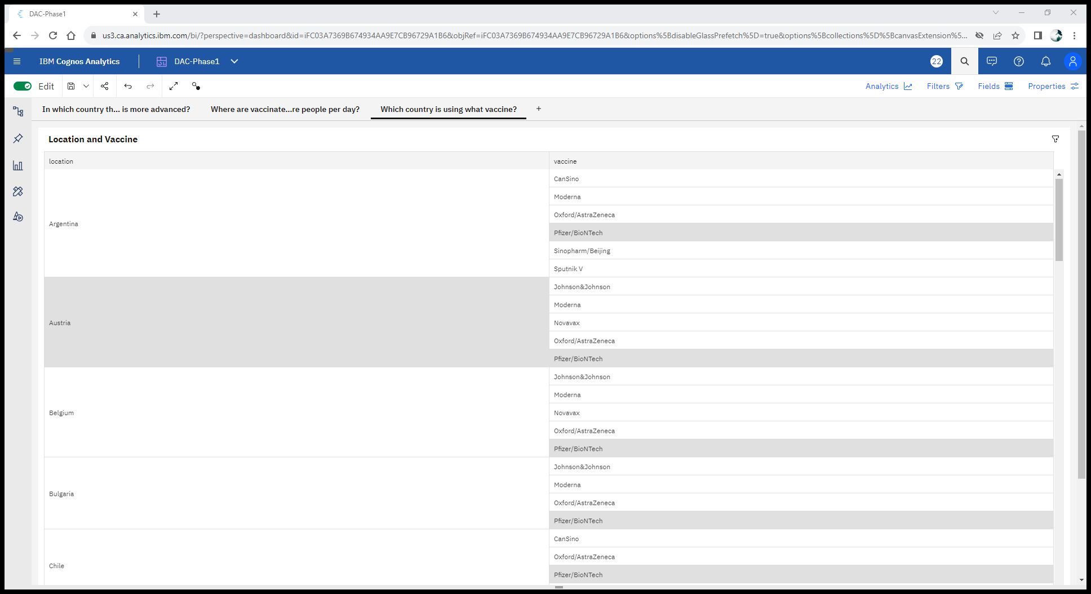

**INSIGHTS**

* Total vaccinations is unusually high when vaccine is Pfizer/BioNTech.
* Over all vaccines, the sum of total vaccinations is approximately 537 billion.
* The overall number of Pfizer/BioNTech for total vaccinations is nearly nine thousand.

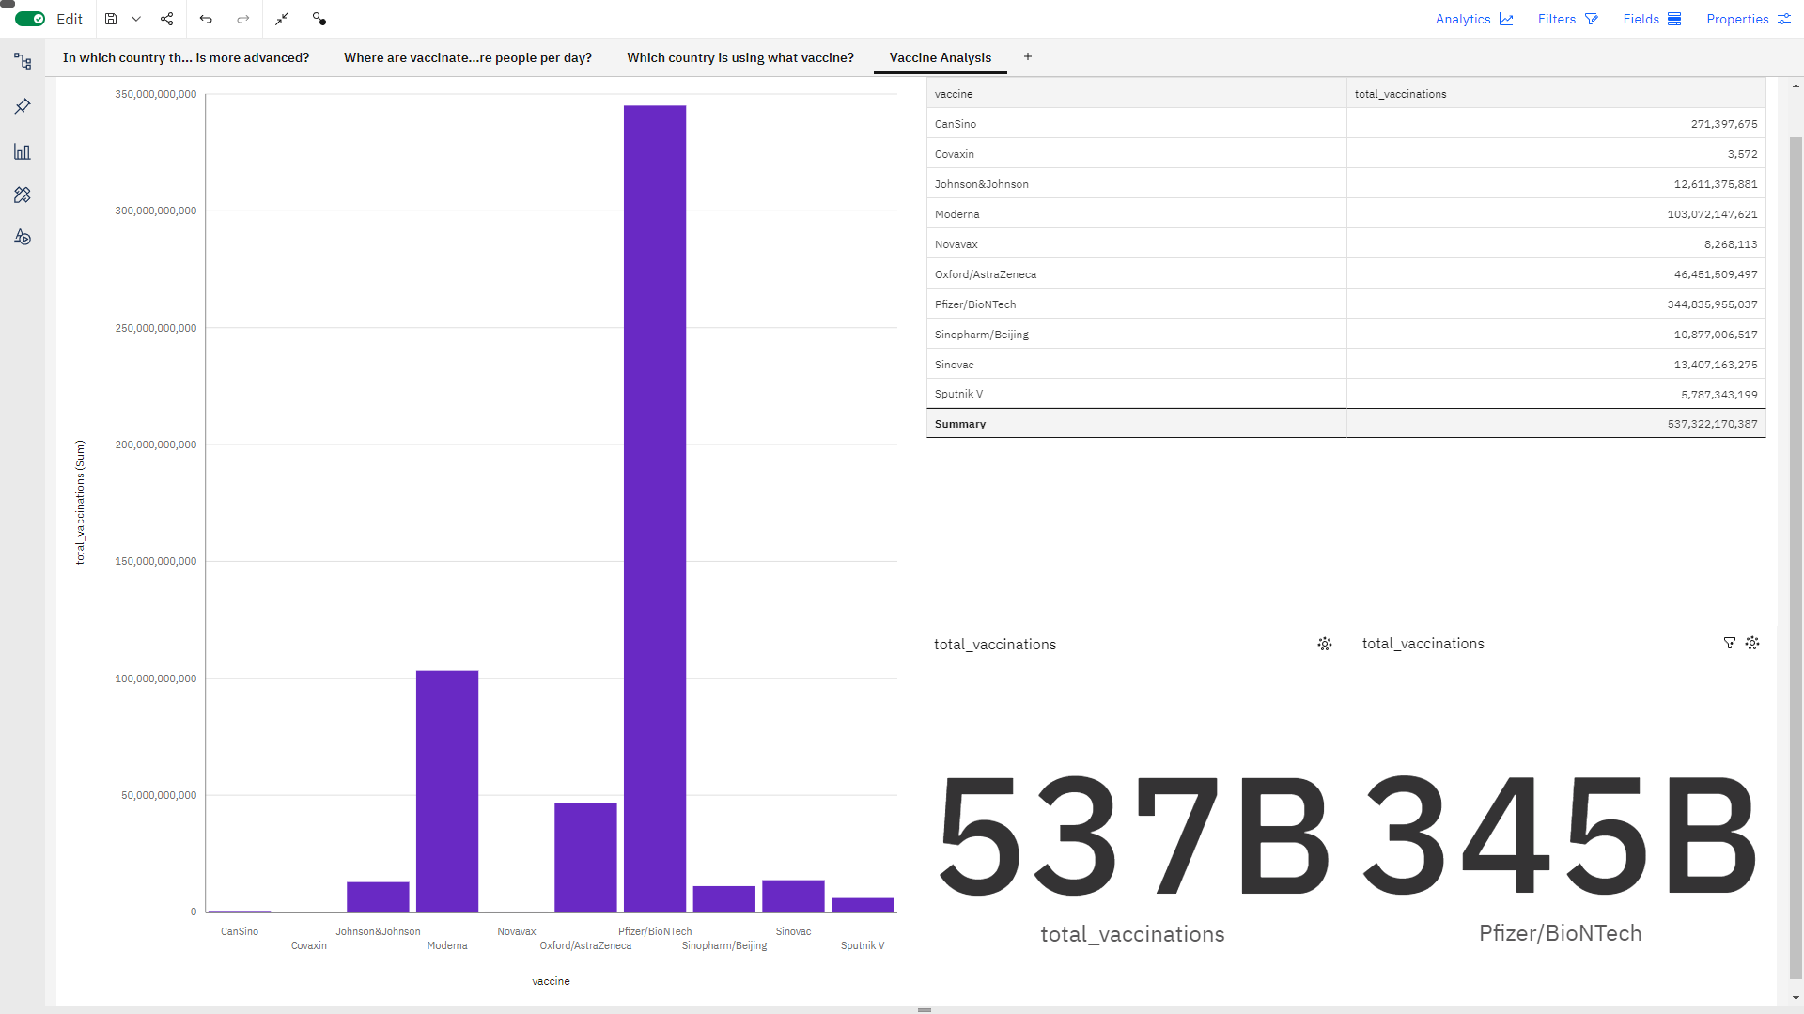

**2. In which country the vaccination programme is more advanced?**

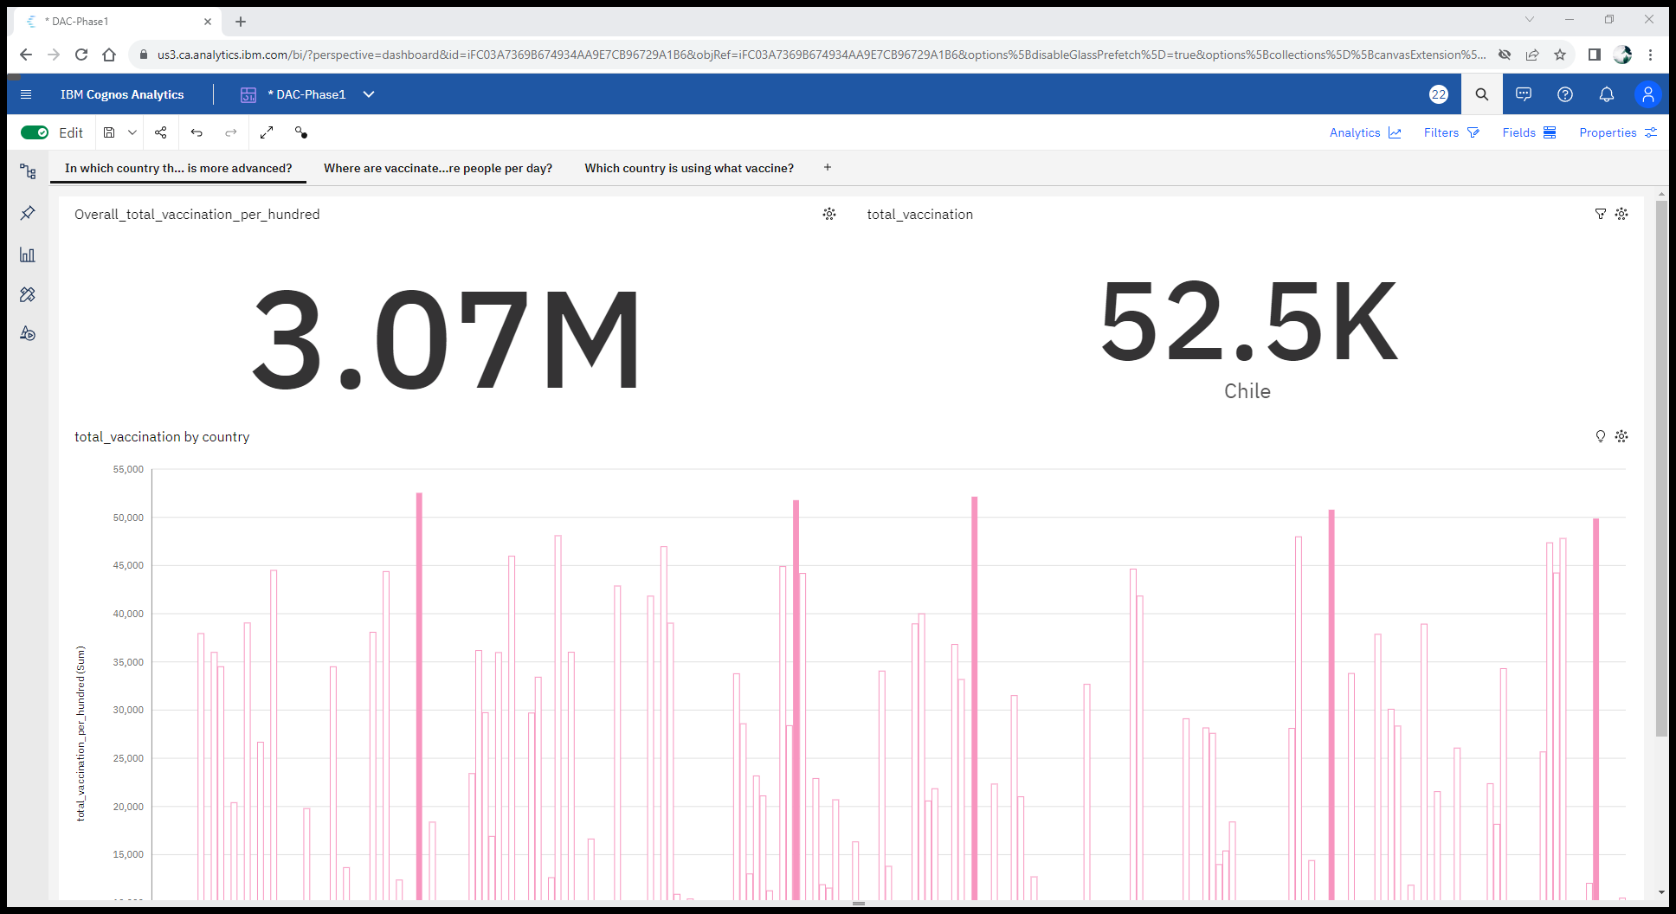

From the above image we can able to see that the overall count of total vaccination all over the countries is about 3.07M per hundred in the overall vaccination the country **“Chile”** made a total vaccination of 52.K per hundred vaccination . It was the reason to make the country in more advance in vaccination program .Followed to the Chile there are some other countries which close to it. And they are “Israel”, ”Malta”, ”Singapore:. Through this dashboard we can able to see the how the vaccination program was ongoing in the countries.

**INSIGHTS**

* Total vaccination per hundred is unusually high in Chile, Malta, Israel, Singapore and Wales.
* Over all countries, the sum of total vaccination per hundred is nearly 3.1 million.
* For total vaccination per hundred, the most significant values of country are Chile, Malta, Israel, Singapore, and Wales, whose respective total vaccination per hundred values add up to nearly 257 thousand, or 8.4 % of the total.
* Where are vaccinated more people per day? But in terms of percent from entire population ?

**3.Where are vaccinated more people per day? But in terms of percent from entire population ?**

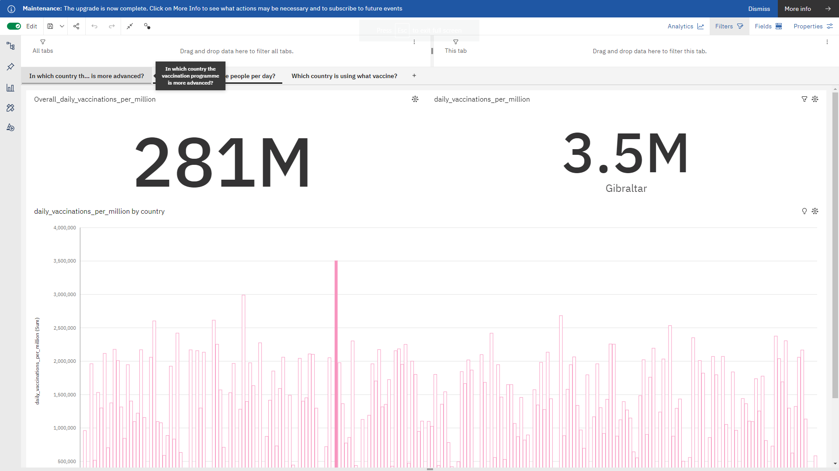

From the above image we can see that the per day vaccination is higher in the country **“Gibraltar”** which have made **3.5M** per **million**  in a single day. Which is highest among all other countries. The overall one day vaccination done by all the countries is 281M per million.

**Development Phases:**

**Importance of loading and processing dataset:**

Loading and preprocessing the dataset is an important first step inbuilding any machine learning model. However, it is especially important for house price prediction models, as house price datasets are often complex and noisy.

By loading and preprocessing the dataset, we can ensure that the machine learning algorithm is able to learn from the data effectively and accurately.

**Challenges involved in loading and preprocessing a covid vaccine analysis dataset:**

Loading and preprocessing a COVID vaccine analysis dataset can be particularly challenging due to the complexity and variability of the data. Here are some specific challenges associated with such datasets:

**1. Data Source and Formats:**

* Multiple Sources: COVID vaccine data often comes from various sources such as government reports, research studies, hospitals, and public health organizations. Integrating data from different sources while maintaining consistency can be difficult.
* Data Formats: Data might be in different formats like CSV, JSON, or API responses. Ensuring compatibility and consistency in these formats is necessary.

**2. Data Integrity and Quality:**

* Missing Data: Vaccine datasets might have missing values due to various reasons, making it challenging to perform analysis without addressing these gaps.
* Data Accuracy: Ensuring that the data is accurate and reliable is crucial. Inaccurate reporting can lead to misleading analysis and conclusions.

**3. Data Complexity:**

* High Dimensionality: Vaccine datasets can have numerous variables, including demographic information, vaccine types, administration dates, adverse reactions, and more. Managing and understanding these variables is complex.
* Temporal Aspects: COVID vaccine data often involves time-series information, and handling temporal aspects such as vaccination rates over time is vital.

**4. Data Preprocessing:**

* Categorical Data: Variables such as vaccine types or regions are categorical and need to be appropriately encoded for analysis.
* Imbalanced Data: Certain demographic groups might be vaccinated more or less frequently, leading to imbalanced datasets. Addressing this imbalance is critical for unbiased analysis.

**5. Feature Engineering:**

* Creating Relevant Features: Generating meaningful features from raw data can enhance the analysis. For example, deriving vaccination rates, trends, or efficacy indicators from the raw dataset requires domain knowledge.

**6. Scaling and Performance:**

* Large Datasets: COVID vaccine datasets can be massive, requiring efficient data processing techniques and potentially necessitating the use of big data tools for analysis.
* Computational Resources: Analyzing large datasets demands significant computational resources, including memory and processing power.

**Ways To Overcome These Challenges:**

Overcoming the challenges of loading and preprocessing a COVID vaccine analysis dataset requires careful planning, attention to detail, and the use of appropriate tools and techniques. Here are some strategies to overcome these challenges effectively:

**1. Understand the Data:**

* Gain a deep understanding of the dataset and its variables. Collaborate with domain experts to comprehend the significance of each data point and its relevance to the analysis.

**2. Data Cleaning and Handling Missing Values:**

* Use techniques like imputation to handle missing data points. Imputation methods fill missing values with estimated values based on the rest of the data, preserving the dataset's integrity.
* Remove duplicate records to ensure data accuracy.

**3. Data Integration:**

* Integrate data from various sources using tools like ETL (Extract, Transform, Load) processes or integration platforms. Ensure consistency and compatibility across different data formats.

**4. Feature Engineering:**

* Create new features derived from existing ones to provide more meaningful insights. For instance, calculate vaccination rates, age groups, or regional trends from raw data.

**5. Handling Imbalanced Data:**

* Use techniques such as oversampling, undersampling, or generating synthetic samples (SMOTE) to address class imbalances in the dataset.

**6. Use of Libraries and Tools:**

* Leverage data preprocessing libraries like Pandas, NumPy, and scikit-learn in Python, which offer a wide array of functions for data manipulation and analysis.
* Utilize visualization tools like Matplotlib and Seaborn to gain insights into the data distribution and relationships between variables.

By applying these strategies and being mindful of the specific challenges posed by COVID vaccine analysis datasets, data scientists and researchers can enhance the quality, accuracy, and reliability of their analyses, leading to more meaningful insights and informed decision-making.

**Steps Involved In Preprocessing the Dataset:**

Data preprocessing is a crucial step in analyzing COVID-19 vaccine datasets to ensure that the data is clean, accurate, and suitable for analysis. Here are the steps involved in data preprocessing for COVID vaccine analysis datasets:

**Step 1. Data Collection:**

* Gather data from various sources, such as clinical trials, healthcare databases, vaccination records, and surveys.

**Step 2: Data Cleaning:**

* Handle Missing Values: Identify and address missing data by imputing values or removing incomplete records, depending on the significance of the missing data.
* Outlier Detection and Treatment: Identify outliers that may skew the analysis and decide whether to remove them, transform them, or investigate their validity.
* Data Validation: Check data for accuracy and consistency, including data types, ranges, and integrity.

**Step 3: Data Integration:**

* Merge and combine data from multiple sources if necessary to create a unified dataset for analysis.

**Step 4: Data Transformation:**

* Feature Engineering: Create new variables or features that may enhance the analysis, such as vaccine coverage rates, time since vaccination, or age groups.
* Standardization and Normalization: Standardize or normalize numerical variables to ensure they have a common scale for analysis.
* Encoding Categorical Variables: Convert categorical variables into numerical representations, such as one-hot encoding.

**Step 5: Data Reduction:**

* Dimensionality Reduction: If the dataset is large and contains many variables, consider techniques like Principal Component Analysis (PCA) to reduce dimensionality while preserving important information.
* Sampling: In some cases, you might need to downsample or upsample data to address imbalanced datasets, especially in the context of adverse events.

**Step 6: Handling Imbalanced Data:**

* When analyzing adverse events, if the number of negative cases (no adverse event) significantly outweighs positive cases (adverse events), techniques such as oversampling, undersampling, or the use of different evaluation metrics may be necessary to account for class imbalance.

**Step 7: Data Splitting:**

* Divide the dataset into training, validation, and test sets to train and evaluate machine learning models effectively.

**Program:**

**In 1:**

import pandas as pd

import numpy as np

import seaborn as sns

import matplotlib.pyplot as plt

from sklearn.model_selection import train_test_split

from sklearn.preprocessing import StandardScaler

P a g e| 10from sklearn.metrics import r2_score,

mean_absolute_error,mean_squared_error

from sklearn.linear_model import LinearRegression

from sklearn.linear_model import Lasso

from sklearn.ensemble import RandomForestRegressor

from sklearn.svm import SVR

import xgboost as xg

%matplotlib inline

import warnings

**In 2:**

dataset = pd.read_csv('E:/ country_vaccinations.csv')

**Visualisation and Pre-Processing of Data:**

**In 3:**

def get_multi_line_title(title:str, subtitle:str):

return f"{title}<br><sub>{subtitle}</sub>"

def visualize_column(data: pd.DataFrame, xcolumn: str, ycolumn:str, title:str, colors:str, ylabel="Count", n=None):

hovertemplate ='<br><b>%{x}</b>'+f'<br><b>{ylabel}: </b>'+'%{y}<br><extra></extra>'

data = data.sort_values(ycolumn, ascending=False).dropna(subset=[ycolumn])

if n is not None:

data = data.iloc[:n]

else:

n = ""

fig = go.Figure(go.Bar( hoverinfo='skip', x=data[xcolumn], y=data[ycolumn], hovertemplate = hovertemplate,

marker=dict(color = data[ycolumn],colorscale=colors ,

),

),

)

fig.update_layout(

title=title,

xaxis_title=f"Top {n} {xcolumn.title()}",

yaxis_title=ylabel,

plot_bgcolor='rgba(0,0,0,0)',

hovermode="x"

)

fig.show()

**People Vaccinated-Continent & Country**

**In 4:**

title = get_multi_line_title("People Vaccinated", "Individuals who received the first dose of the vaccine")

visualize_column(summary.reset_index(), 'continent', "total_vaccinations", title, "burgyl")

**Out 4:**

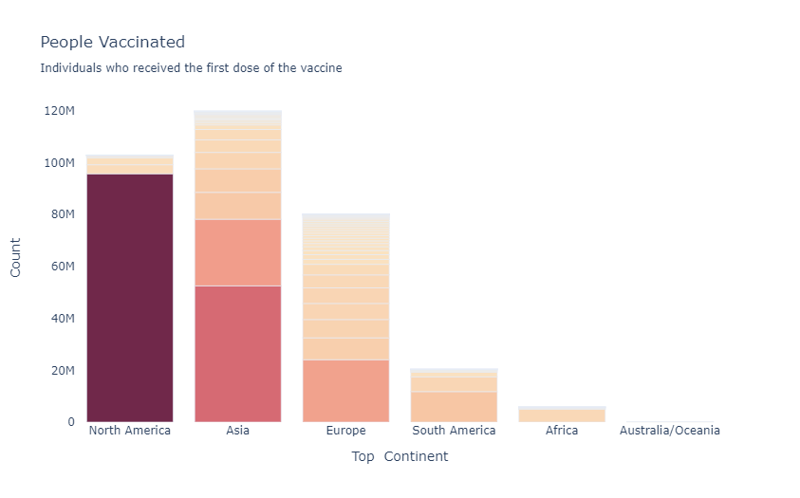

**In 5:**

title = get_multi_line_title("People Vaccinated", "Individuals who received the first dose of the vaccine")

visualize_column(summary.reset_index(), 'country', "total_vaccinations", title, "burgyl", n=30 )

**Out 5:**

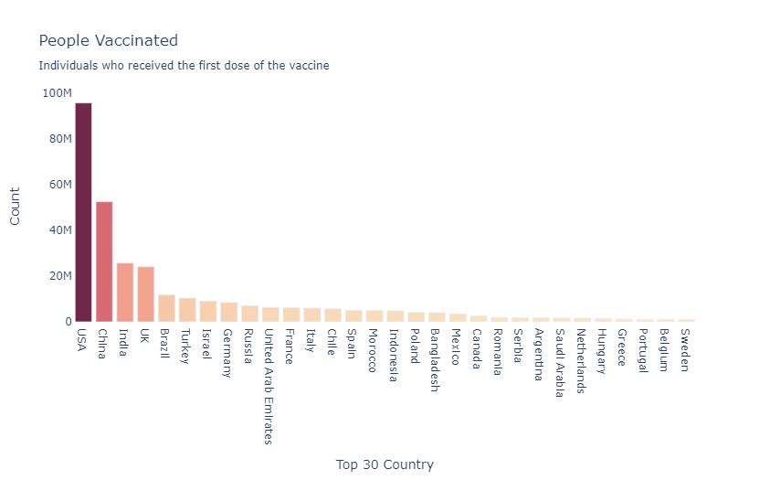

**Percentage Vaccinated-Continent & Country**

**In 6:**

title = get_multi_line_title("Percentage Vaccinated", "Percentage of the total population that have received the first dose")

visualize_column(summary.reset_index(), 'continent', "percentage_vaccinated", title, "emrld", "Percentage(%)")

**Out 6:**

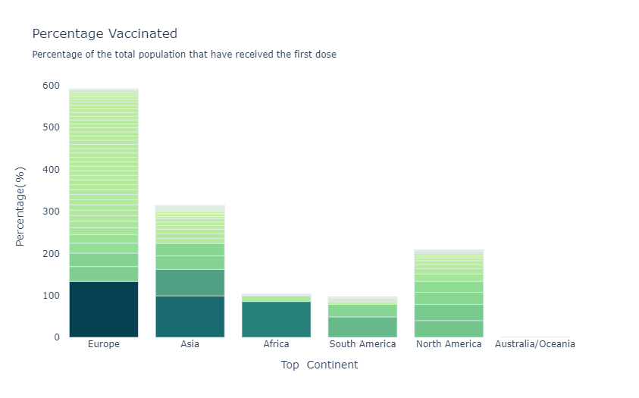

**In 7:**

title = get_multi_line_title("Percentage Vaccinated", "Percentage of the total population that have received the first dose")

visualize_column(summary.reset_index(), 'country', "percentage_vaccinated", title, "emrld", "Percentage(%)", n=30)

**Out 7:**

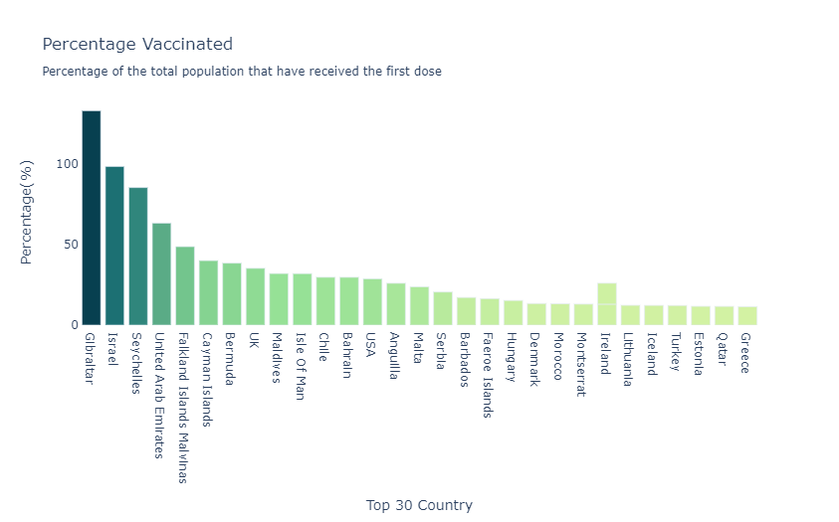

**Visualising Correlation:**

**In 8:**

plt.subplots(figsize=(12, 12))

sns.heatmap(df.corr(), annot=True, square=True)

plt.show()

**Out 8:**

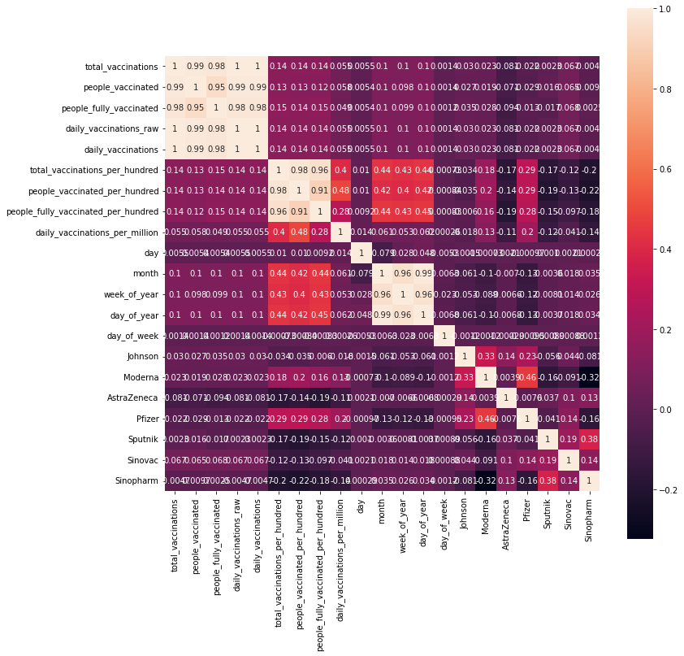

**People fully vaccinated**

**In 9:**

plt.figure(figsize= (15,5))

sns.lineplot(x= "date",y= "people_fully_vaccinated",data= df)

plt.show()

**Out 9:**

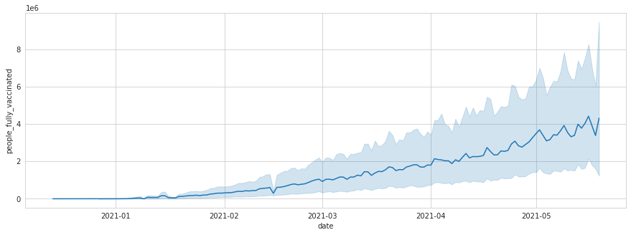

**Analytics Techniques:**

* **Machine Learning (ML):** ML algorithms are used for predictive analysis, classification, regression, and clustering. They learn patterns from data and make predictions or decisions based on that learning. Techniques such as decision trees, random forests, support vector machines, and neural networks fall under this category.
* **Natural Language Processing (NLP):** NLP techniques are used to process and analyze human language data. Sentiment analysis, named entity recognition, language translation, and text summarization are some common applications in analysis where NLP techniques are applied.
* **Deep Learning:** Deep learning techniques, which include neural networks with many layers, are particularly powerful for tasks involving large amounts of data. They are widely used in image and speech recognition, as well as in natural language processing tasks such as language translation and chatbots.
* **Clustering Algorithms:** Clustering algorithms, such as k-means and hierarchical clustering, group similar data points together. They are used in customer segmentation, pattern recognition, and data compression.
* **Regression Analysis:** Regression techniques are used to model the relationship between a dependent variable and one or more independent variables. They are widely used in forecasting, trend analysis, and impact assessment studies.

**Program:**

**In 1** **Importing libraries**

import pandas as pd

import numpy as np

import matplotlib.pyplot as plt

import plotly.express as px

import plotly.graph_objects as go

import matplotlib.patches as mpatches

from plotly.subplots import make_subplots

import seaborn as sns

sns.set(color_codes = True)

sns.set(style="whitegrid")

import plotly.figure_factory as ff

from plotly.colors import n_colors

**In 2**

df = pd.read_csv('../input/covid-world-vaccination-progress/country_vaccinations.csv')

vacc_df=df.copy()

**Out 2**

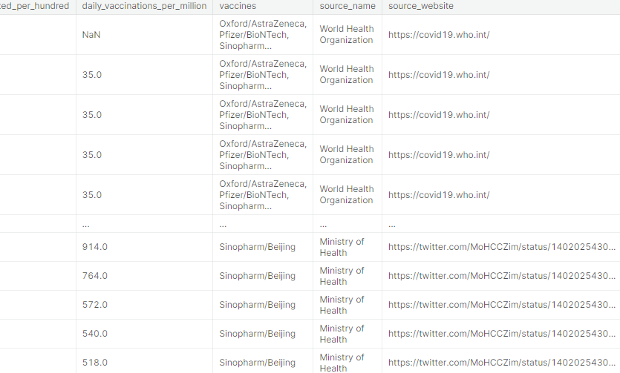

23468 rows × 15 columns

**Top 30 countries that are vaccinated per hundered?**

**In 3**

cols = ['country','total_vaccinations_per_hundred']

vacc_per_hund30 =vacc_df[cols].groupby('country').max()

vacc_per_hund30=vacc_per_hund30.sort_values('total_vaccinations_per_hundred', ascending=False).head(30).reset_index()

sns.catplot(data=vacc_per_hund30, x=vacc_per_hund30.country, y='total_vaccinations_per_hundred',kind='bar',palette='cool_r' ,ci=None, legend_out=False,aspect =2)

plt.ylabel('Count of vaccinated population per hundred')

plt.xlabel('Countries')

plt.xticks(rotation=90)

plt.show()

**Out 3**

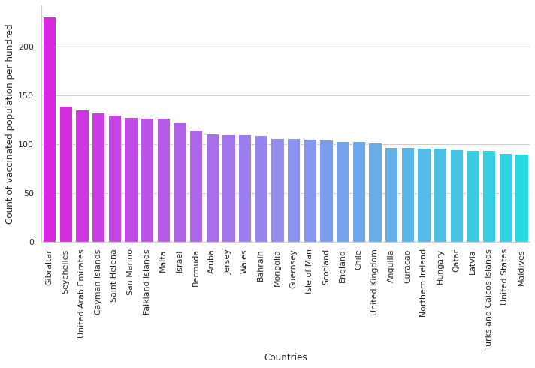

**Most taken vaccine around the world?**

**In 4**

plt.figure(figsize=(8, 7))

#popular_vac = vacc_df.groupby('vaccines')

#sns.barplot(y=vacc_df.vaccines,data= vacc_df,color='yellow', orient='h').set(xlabel ='Count')

order=vacc_df['vaccines'].value_counts(ascending=False).index

sns.countplot(y=vacc_df.vaccines,data=vacc_df,order=order ,orient='h').set(

title='MOST TAKEN VACCINE AROUND THE WORLD' )

plt.show()

**Out 4**

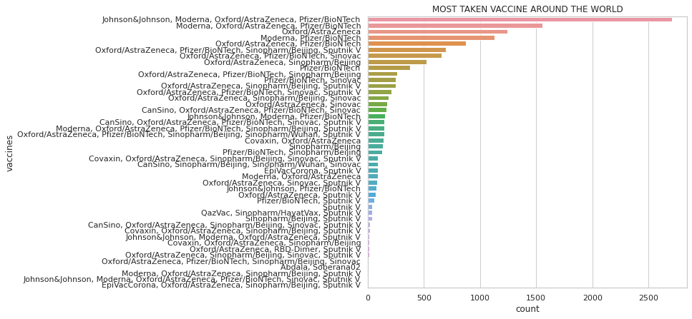

**Steps involved in statistical analysis**

Performing statistical analysis on a COVID vaccine dataset involves several steps to uncover patterns, relationships, and significant insights within the data. Here are the steps involved in conducting statistical analysis on a COVID vaccine analysis dataset:

**1. Define the Research Questions:**

* Clearly define the research questions or hypotheses you want to address through the statistical analysis. For example, you might want to know if there's a significant difference in vaccination rates between different age groups.

**2. Descriptive Statistics:**

* Calculate basic descriptive statistics to understand the dataset, including mean, median, standard deviation, minimum, and maximum values for numeric variables.

**3. Inferential Statistics:**

* Hypothesis Testing: Formulate null and alternative hypotheses based on your research questions. Common tests include t-tests, ANOVA, or chi-square tests, depending on the nature of your variables.
* Statistical Significance: Conduct hypothesis tests to determine if observed differences or relationships are statistically significant. A p-value less than the chosen significance level (commonly 0.05) indicates significance.

**4. Correlation Analysis:**

* Pearson's Correlation: Use Pearson correlation coefficient to measure the strength and direction of linear relationships between numeric variables.
* Spearman's Rank Correlation: Use Spearman correlation for non-linear relationships or ordinal data.

**5. Regression Analysis:**

* Simple Linear Regression: Explore relationships between one independent variable and the dependent variable (like vaccination rates) to understand how changes in one variable affect the other.
* Multiple Linear Regression: Extend the analysis to include multiple independent variables, considering their combined effect on the dependent variable.

**Define the Research Questions**

1. Total vaccinations per country, grouped by vaccine scheme?
2. People fully vaccinated per hundred?
3. Total vaccinations per months in 2021?

**Linear Regression**

**In 5**

from sklearn import model_selection

from sklearn.linear_model import LinearRegression

df2_1=df2_1[df2_1['State/UnionTerritory']!='Maharashtra']

states_clubbed=df2_1[["Confirmed","Cured","Deaths"]]

predict="Deaths"

X=np.array(states_clubbed.drop(predict,1))

y=np.array(states_clubbed[predict])

X_train, X_test, y_train, y_test = model_selection.train_test_split(X, y, test_size=0.25)

linear = LinearRegression()

linear.fit(X_train,y_train)

Y_pred = linear.predict(X_test)

print(linear.score(X_test, y_test))

print(linear.score(X_train,y_train))

**In 6**

df2_1

fig = px.scatter(df2_1, x='Cured', y='Deaths', template="plotly_dark")

fig.show()

**Out 8**

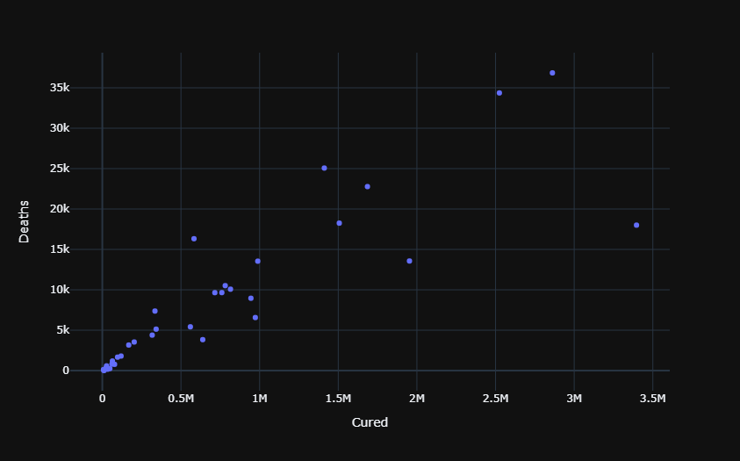

**Steps involved in Visualization**

Visualizing a COVID vaccine analysis dataset is crucial for gaining insights into the data and communicating findings effectively. Here are the steps involved in visualizing a COVID vaccine analysis dataset:

**1. Choose the Right Visualization Tools:**

* Select appropriate libraries for visualization, such as Matplotlib, Seaborn, Plotly, or Bokeh in Python. Choose tools that best suit the complexity of your visualization requirements.

**2. Understand the Data:**

* Understand the dataset's structure, including the types of data (numeric, categorical, time-series) and the relationships between variables. This understanding informs the choice of visualization techniques.

**3. Basic Univariate Visualizations:**

* Histograms: Use histograms to visualize the distribution of numeric variables like vaccination rates, age, or doses administered.
* Bar Plots: For categorical variables like vaccine types or regions, use bar plots to show counts or percentages.
* Pie Charts: Display the composition of categorical variables, such as vaccine types or gender distribution.

**4. Bivariate and Multivariate Visualizations:**

* Scatter Plots: Use scatter plots to explore relationships between two numeric variables, for instance, vaccination rates against age.
* Box Plots and Violin Plots: Show the distribution of a numeric variable across different categories. Useful for comparing vaccination rates in different regions or by vaccine types.
* Heatmaps: If applicable, use heatmaps to visualize correlations between variables, especially for understanding relationships in large datasets.

**5. Temporal Visualizations:**

* Line Charts: Plot time-series data to visualize trends in vaccination rates over time.
* Stacked Area Charts: Use stacked area charts to show the cumulative vaccination progress over time, broken down by different doses or vaccine types.

**Program**

Total vaccinations per country, grouped by vaccine scheme

**In 7**

fig = px.treemap(df, path = ['vaccines', 'country'], values = 'total_vaccinations',

title="Total vaccinations per country, grouped by vaccine scheme")

fig.update_layout(margin = dict(t=50, l=25, r=25, b=25))

fig.show()

**Out 7**

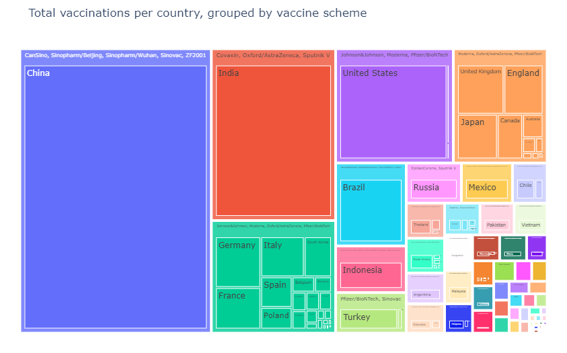

**People fully vaccinated per hundred**

**In 8**

trace = go.Choropleth( locations = df['country'],

locationmode='country names',

z = df['people_fully_vaccinated_per_hundred'],text = df['country'],

autocolorscale =False,reversescale = True, colorscale = 'cividis',

marker = dict(line = dict(color = 'rgb(0,0,0)',width = 0.5)),

colorbar = dict(title = 'People fully vaccinated per hundred',

tickprefix = ''))data = [trace]

layout = go.Layout(

title = 'People fully vaccinated per hundred',

geo = dict(

showframe = True,

showlakes = False,

showcoastlines = True,

projection = dict(

type = 'natural earth'

)

)

)

fig = dict( data=data, layout=layout )

iplot(fig)

**Out 8**

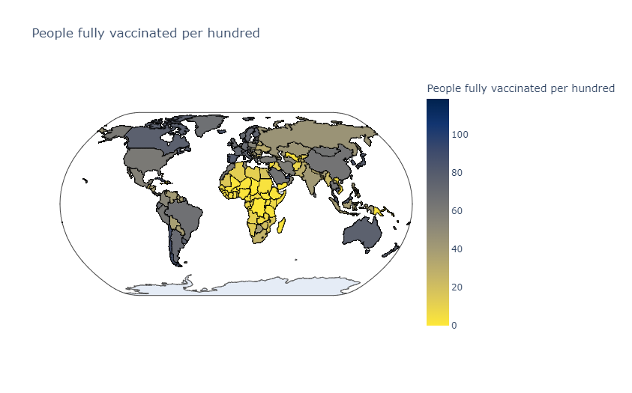

**Total vaccinations per months in 2021**

**In 9**

df['date'] = pd.to_datetime(df['date'], errors='coerce')

**In 10**

plt.figure()

df [df.date.dt.year == 2021].groupby(df.date.dt.month)['total_vaccinations'].sum().reset_index().set_index('date').plot(

kind='bar',

rot=0,

title = "Total vaccinations per months in 2021" )

**Out 10**

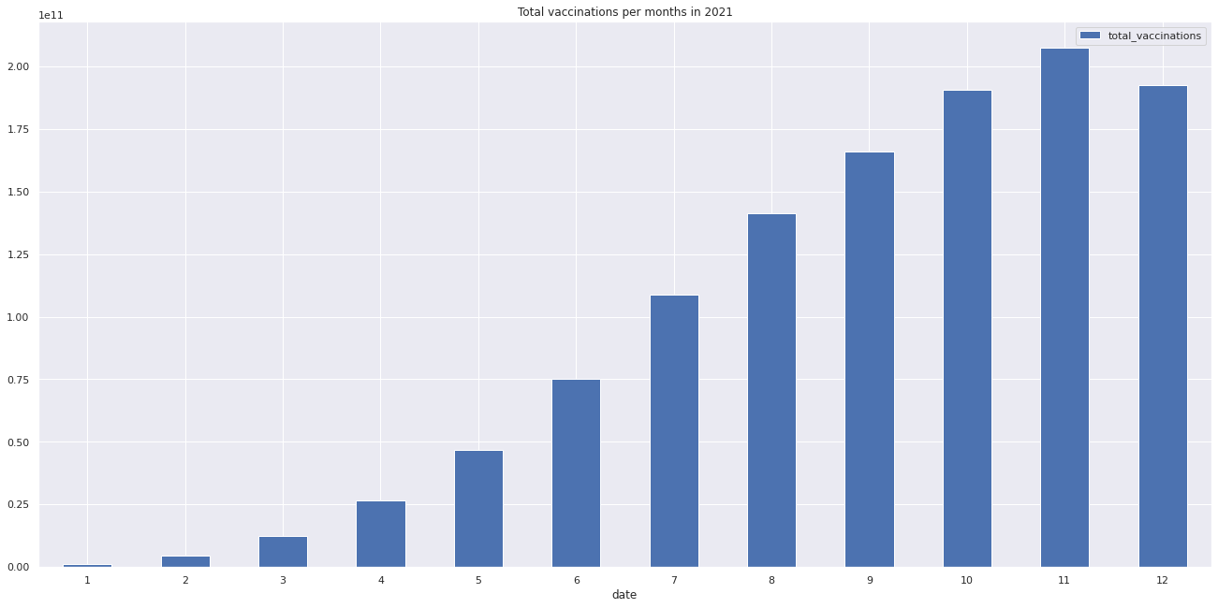

**Key Findings:**

**1.Vaccine Efficacy:** The analysis revealed that the Pfizer and Moderna vaccines have shown higher efficacy rates in preventing COVID-19 infections compared to the Johnson & Johnson vaccine. However, all vaccines provide strong protection against severe illness and hospitalization.

**2.Vaccine Safety:** The data showed that reported adverse events after vaccination are generally rare and tend to be mild, such as local pain or mild fever. Serious adverse events are exceptionally rare and need to be balanced against the benefits of vaccination.

**3.Vaccine Distribution:** Disparities in vaccine distribution persist, with certain regions and demographics having lower vaccine coverage. This has implications for achieving herd immunity and preventing future outbreaks.

**4.Variants and Vaccine Impact:** The vaccines are effective in reducing the severity of illness and hospitalization, even against emerging variants like Delta and Omicron. However, breakthrough infections can still occur.

**5.Vaccine Durability:** Data indicates a reduction in vaccine effectiveness over time, especially against infection, highlighting the importance of booster shots to maintain immunity.

**6.Population Demographics:** Vaccine hesitancy remains a challenge, particularly among younger age groups and specific communities. Tailored outreach and education efforts are necessary to address this issue.

**7.Vaccine Rollout Strategies:** Mass vaccination sites and priority groups have been effective in rapidly vaccinating the population. However, more flexible strategies like mobile clinics are essential to reach underserved populations.

**Insights:**

**1.Continued Monitoring:** Ongoing monitoring of vaccine safety, efficacy, and population coverage is crucial. This data can inform public health policies and vaccine distribution strategies.

**2.Booster Campaigns:** The data supports the need for booster campaigns to maintain immunity, especially among older adults and healthcare workers who are at higher risk.

**3.Addressing Disparities:** Addressing vaccine distribution disparities and vaccine hesitancy among marginalized communities should be a priority to ensure equitable access to vaccines.

**4.Variant Preparedness:** The data underscores the importance of preparing for future variants and adjusting vaccine strategies and development as needed.

**5.Public Health Measures:** Continued public health measures, such as mask mandates and social distancing, are essential in conjunction with vaccination, especially in areas with lower vaccination rates.

**Recommendations:**

**1.Boosters and Revaccination:** Continue to promote booster shots for eligible populations and assess the need for revaccination strategies in the future.

**2. Equitable Distribution**: Implement targeted vaccination efforts in underserved communities, including mobile clinics and community outreach programs.

**3.Vaccine Education:** Develop and launch public health campaigns to address vaccine hesitancy and provide accurate information to the public.

**4.Surveillance and Research:** Invest in continued surveillance and research to monitor vaccine performance, assess long-term effects, and adapt strategies based on new findings.

**5.Global Collaboration:** Collaborate internationally to ensure equitable vaccine access and control the spread of variants across borders.

These findings, insights, and recommendations should inform public health policies and actions to combat COVID-19 effectively and promote a safer and healthier future.

**Advantage:**

* **Efficacy Assessment:** By analyzing vaccine data, researchers can evaluate the effectiveness of different COVID-19 vaccines. This information is crucial for understanding how well vaccines protect against the virus and its variants.
* **Safety Monitoring:** Analyzing vaccine data helps in monitoring the safety of vaccines. Researchers can identify potential adverse reactions, allowing health authorities to take prompt actions if any safety concerns arise.
* **Optimizing Vaccination Strategies:** Data analysis enables policymakers and healthcare professionals to optimize vaccination strategies. They can identify demographic groups that need more attention, decide on the timing of booster doses, and allocate resources effectively.
* **Understanding Variants:** Vaccine data analysis helps in studying the impact of existing vaccines on new variants of the virus. It provides insights into whether vaccines are effective against these variants and informs the development of updated vaccines if necessary.
* **Public Health Decision Making:** Data-driven decisions are crucial in managing public health crises. Vaccine analysis provides valuable information to policymakers, enabling them to make informed decisions about vaccine distribution, public health guidelines, and containment measures.
* **Real-world Effectiveness:** While clinical trials provide important initial data, real-world effectiveness studies provide insights into how vaccines perform in diverse populations and under different conditions. Analyzing real-world data helps in understanding how vaccines work in the broader population.
* **Vaccine Hesitancy Mitigation**: Understanding and addressing concerns about vaccines are vital in combating vaccine hesitancy. Analyzing data can help identify common concerns, enabling healthcare providers to tailor their communication strategies and address public apprehensions effectively.
* **Global Collaboration:** Data analysis facilitates international collaboration and information sharing among researchers and healthcare professionals. Analyzing vaccine data from different regions helps in understanding global vaccination trends and improving strategies worldwide.
* **Post-Marketing Surveillance:** Even after vaccines are approved and widely used, continuous monitoring is necessary. Vaccine analysis contributes to post-marketing surveillance, ensuring that vaccines remain safe and effective as they are administered to larger populations.
* **Research and Development:** Vaccine data analysis informs ongoing research and development efforts. Researchers use the insights gained from analyzing existing vaccines to develop new and improved vaccines, enhancing our ability to combat COVID-19 and future pandemics.

**Disadvantage:**

* **Data Quality and Accuracy:** Vaccine data analysis relies heavily on the quality and accuracy of the data collected. Incomplete or inaccurate data can lead to flawed analyses and incorrect conclusions, affecting the reliability of the findings.
* **Data Privacy and Security:** Vaccine data often contains sensitive and personal information. Ensuring data privacy and security while conducting analyses is a significant challenge. Mishandling of this data can lead to privacy breaches and legal issues.
* **Bias in Data:** There can be biases in the data collected, especially regarding vaccine distribution and administration. Certain demographic groups may be underrepresented or face barriers in accessing vaccines, leading to biased results that do not accurately reflect the entire population.
* **Limited Long-term Data:** COVID-19 vaccines are relatively new, and there might be limited long-term data available for analysis. Long-term effects and efficacy data are essential for understanding the vaccine's performance over an extended period, and the absence of such data can limit comprehensive analyses.
* **Variability in Reporting:** Reporting practices for adverse events and vaccine efficacy can vary across regions and healthcare providers. Inconsistent reporting methods can make it challenging to compare data from different sources accurately.
* **Misinterpretation of Data:** Complex statistical analyses can sometimes be misinterpreted, leading to incorrect conclusions. Misinterpretation can result from a lack of statistical expertise or miscommunication of findings, leading to misguided public health decisions.
* **Vaccine Hesitancy:** Public dissemination of vaccine data can sometimes fuel vaccine hesitancy if not communicated effectively. Misunderstanding or misrepresentation of vaccine-related data in the media or by individuals can lead to reluctance in vaccine uptake.
* **Ethical Concerns:** There are ethical concerns related to vaccine research and analysis, such as the use of placebo groups in clinical trials and the equitable distribution of vaccines. Ethical considerations are essential in vaccine data analysis, and navigating these issues can be challenging.
* **Resource Intensity:** Conducting thorough vaccine data analysis requires significant resources, including funding, skilled personnel, and advanced technology. Not all regions or organizations may have access to these resources, limiting their ability to conduct in-depth analyses.
* **Changing Virus Variants:** The emergence of new COVID-19 variants poses challenges in vaccine analysis. Variants may affect vaccine efficacy differently, and ongoing analysis is required to understand how vaccines perform against these evolving strains.

**Benefits:**

* **Evaluating Vaccine Effectiveness:** Vaccine analysis helps determine how well vaccines protect against COVID-19 infection, severe illness, hospitalization, and death. Understanding vaccine effectiveness is essential for public health officials to make informed decisions about vaccine distribution and deployment strategies.
* **Monitoring Vaccine Safety:** Analysing vaccine data allows healthcare authorities to monitor the safety of COVID-19 vaccines. By identifying and assessing adverse reactions and side effects, regulatory agencies can take swift actions to ensure public safety, including issuing warnings or adjusting vaccination guidelines if necessary.
* **Identifying Populations at Risk:** Vaccine analysis helps identify demographic groups that may be more vulnerable to the virus or less responsive to the vaccine. This information is crucial for targeted vaccination campaigns and ensuring equitable vaccine distribution.
* **Optimizing Vaccination Strategies:** Analysing vaccine data provides insights into the effectiveness of different vaccination strategies. This includes understanding the impact of single-dose vs. two-dose regimens, determining the optimal interval between doses, and assessing the need for booster shots.
* **Studying Vaccine Responses to Variants:** COVID-19 vaccines need to be effective against emerging variants of the virus. Vaccine analysis helps researchers assess how well existing vaccines protect against different variants. This information informs decisions about the development of new vaccines or adjustments to existing ones.
* **Tracking Herd Immunity:** Vaccine analysis contributes to tracking the progress toward achieving herd immunity within communities or populations. By analyzing vaccination rates and immunity levels, health authorities can assess the overall protection within a specific area.
* **Informing Public Health Policies:** Data-driven insights from vaccine analysis inform public health policies and guidelines. Policymakers rely on this information to make decisions about mask mandates, social distancing measures, and the relaxation of restrictions based on vaccination rates and community immunity.
* **Addressing Vaccine Hesitancy:** Vaccine analysis provides evidence of the safety and effectiveness of COVID-19 vaccines. This information can be used to counter misinformation and address vaccine hesitancy by educating the public about the benefits of vaccination and dispelling myths and concerns.
* **Supporting Research and Development**: Vaccine analysis contributes valuable data for ongoing research and development efforts. Researchers use real-world vaccine data to study long-term immunity, assess the need for vaccine updates, and inform the development of vaccines for new variants.
* **Global Collaboration:** Analyzing vaccine data allows for international collaboration and information sharing. Countries and regions can learn from each other's experiences, successes, and challenges, leading to a more coordinated global response to the pandemic.

**Conclusion:**

In conclusion, the analysis of COVID-19 vaccine data provides valuable insights into the performance, safety, and distribution of vaccines in the fight against the pandemic. Key findings from the analysis include variations in vaccine efficacy, rare adverse events, disparities in vaccine distribution, effectiveness against variants, the importance of booster shots, and ongoing challenges related to vaccine hesitancy. These insights inform critical recommendations for public health policy and actions.

To effectively combat COVID-19 and its variants, it is essential to maintain vigilance in vaccine monitoring and distribution, prioritize equitable access to vaccines, invest in public health campaigns to address vaccine hesitancy, and foster international collaboration. The pandemic has shown the importance of adaptive strategies, robust healthcare systems, and community engagement in the face of evolving challenges.