- Database set up and Table Creation

create database e_commerce;
use e_commerce;

Customers Table
create table customers (
Customer_id varchar(100) primary key,
Customer_name varchar(100),
Gender varchar(100),
City varchar(50),
State varchar(50));

select * from customers;
describe customers;

Products Table
create table products (
product_id varchar(50) primary key ,
product_name varchar(100),
category varchar(100),
sub_category varchar(100),
price decimal(10,2));

select * from products;
describe products;

Orders Table
create table orders (
order_id varchar(100) primary key,
customer_id varchar(100),
order_date varchar(100),
ship_date varchar(100),
payment_method varchar(50),
foreign key (customer_id) references customers(Customer_id));

select * from orders;
desc orders;

Order Items Table
create table order_items (
order_item_id int primary key,
order_id varchar(100),
product_id varchar (100),
quantity int,
sales_amount decimal(10,2),
profit decimal(10,2),
foreign key (order_id) references orders(order_id),
foreign key (product_id) references products(product_id));

select * from order_items;
desc order_items;

- Data Validation

Checking NULL Values
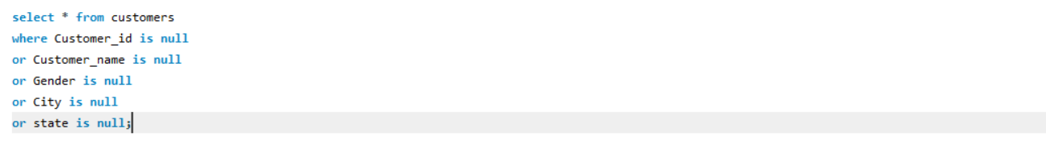
Output
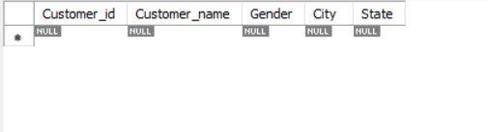

- Part 1

- Total Sales
output
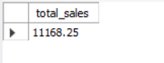

- Total Number of Customers
Output
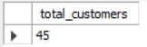

- Total Orders
Output
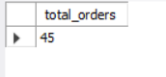

- Average Sales Amount
Output
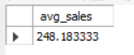

- Highest and Lowest Sales
Output


- Part 2

- Category Wise Sales
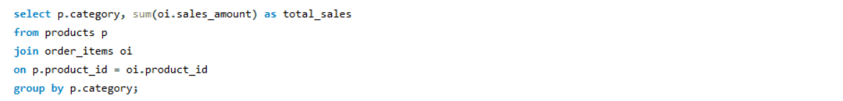
Output
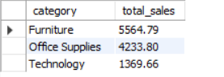

- Region Wise Sales
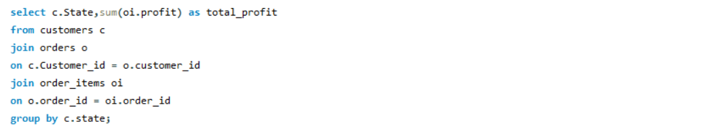
Output
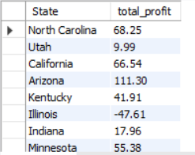

- State Wise Order Count
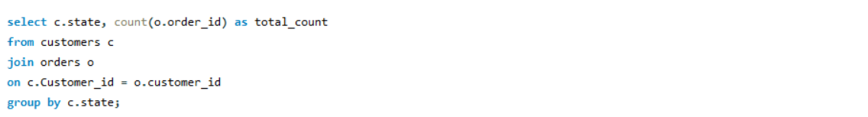
Output
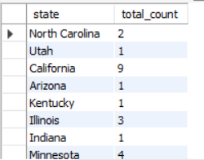
- Top 5 Customers by Sales
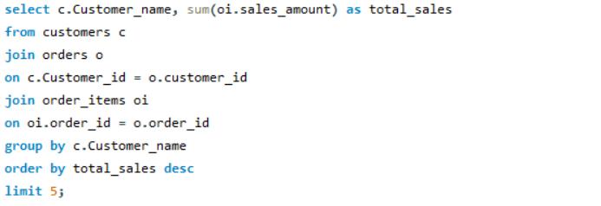
Output
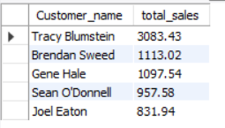

- Least Profitable Categories
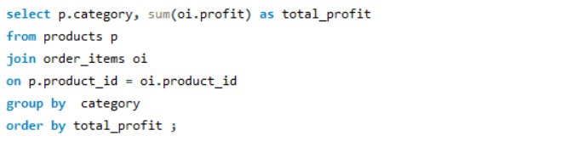
output
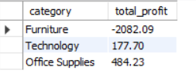
- Part 3
- Customer Order with Product Details
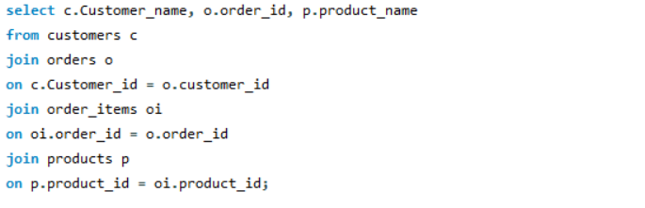
Output
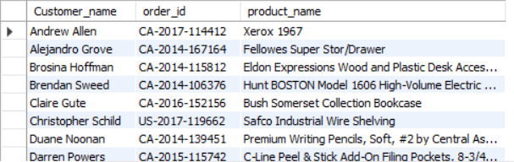

- Product Sold in Each Region
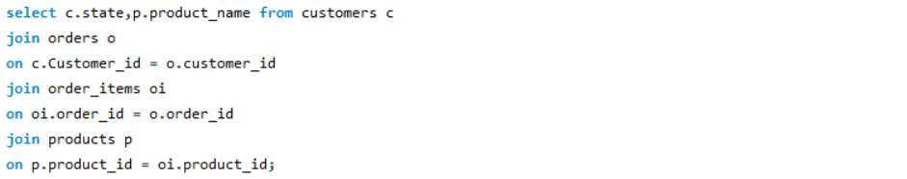
Output
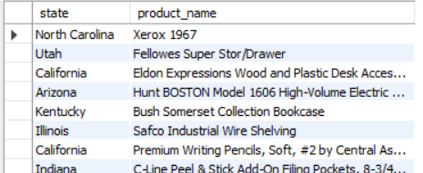

- Part 4
- Classify Customers by High Value, Medium Value and Low Value Based on Total Purchase
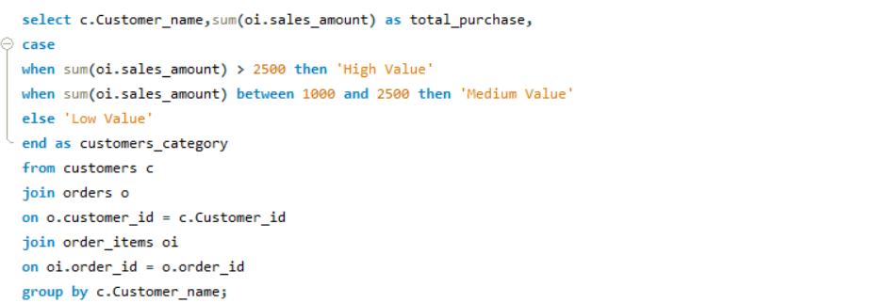
Output
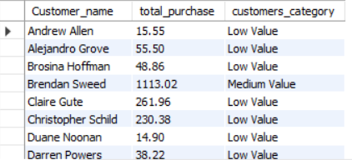

- Classify Products by High Profit, Low Profit and Loss
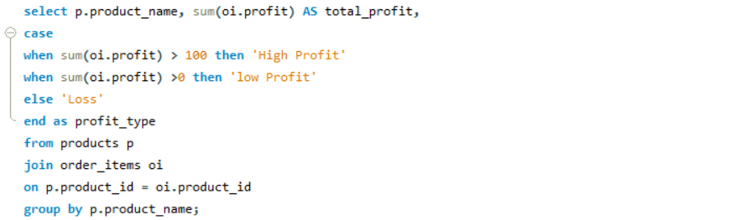
Output
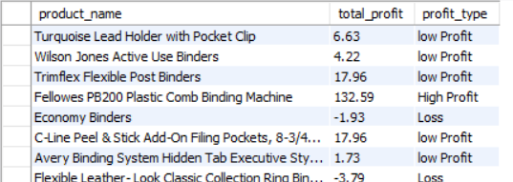

- Part 5
- Product with Above Average sales
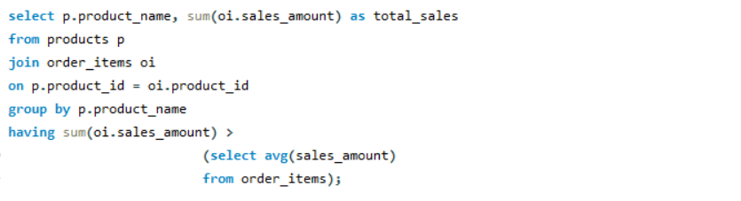
Output
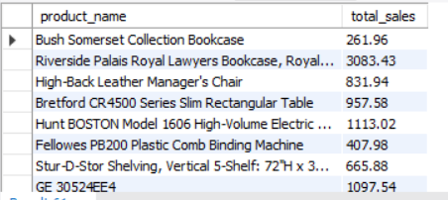

- Second Highest Selling Product
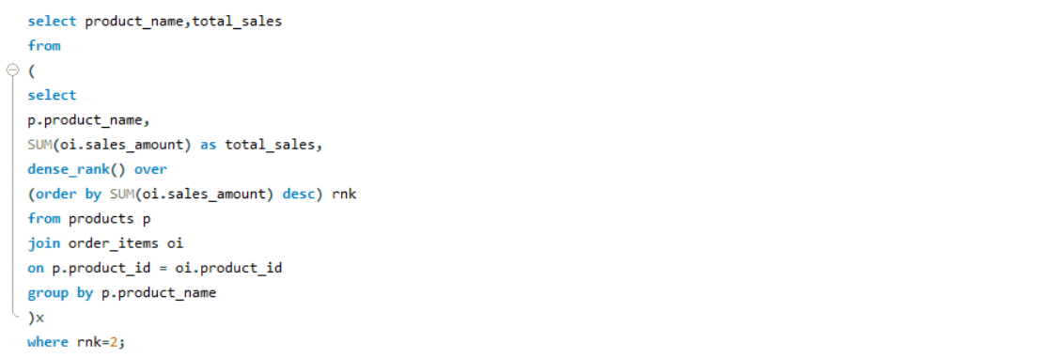
Output
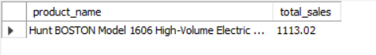

- Part 6
- Rank Customers Based on Sales using RANK()
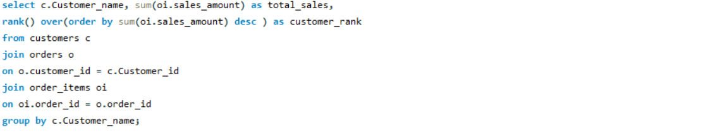
Output
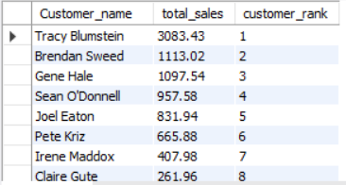

- Top 3 Products in Each Category Using DENSE_RANK()
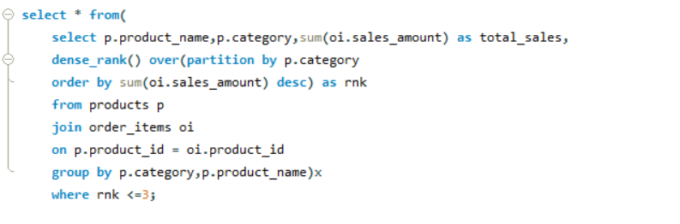
Output
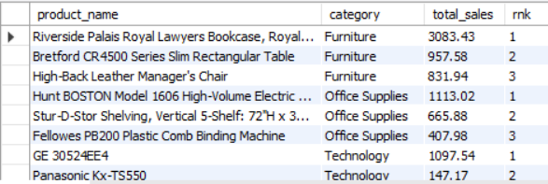

- Running Total
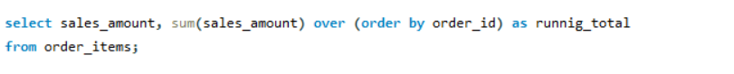
Output
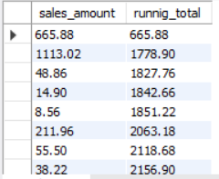

- Part 8

Business Insights
- The product with the highest sales contributes significantly to the company’s revenue.
- Furniture category generated the highest sales and Technology category generated lower sales.
- Focusing on high sales and high profit product can increase overall business performance.
- Low profit product should be reviewed to improve pricing and profitability.
- Furniture category recorded a loss (-2082.09).
- High sales do not always result in high profit, as seen in the furniture category.

