**5/3/25** **AEM COMPONENT CREATION**

1.Creating an Author component which will have 3 fields

Author Name-single line text field-Mandatory

Author Bio-multiline text field-Mandatory

Dob-date picker-Mandatory

create the component with above dialog fields

Fetch this value directly using htl properties tag.

* AEM----TOOLS----CRXDE Lite

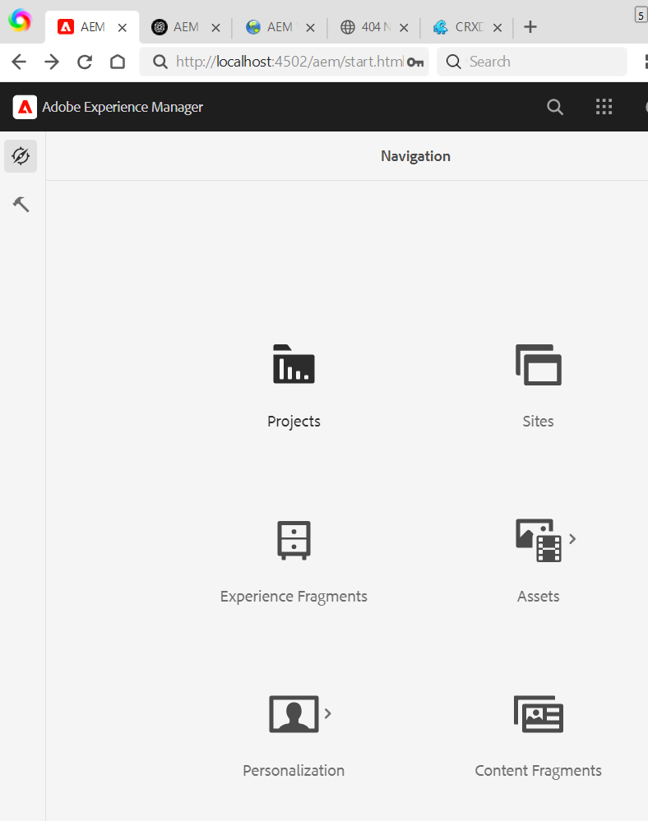

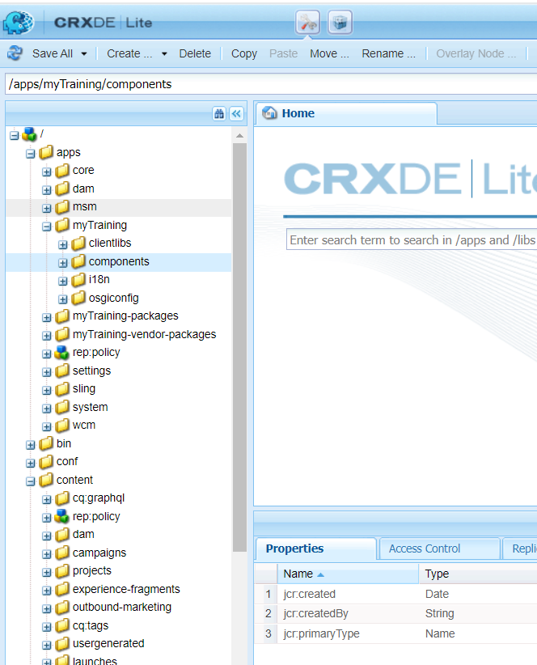

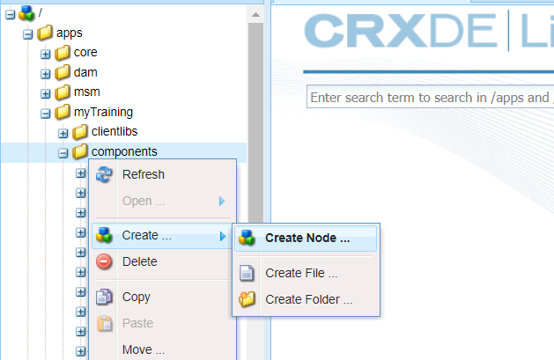

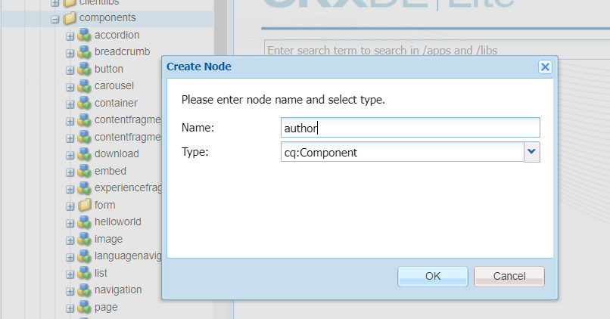

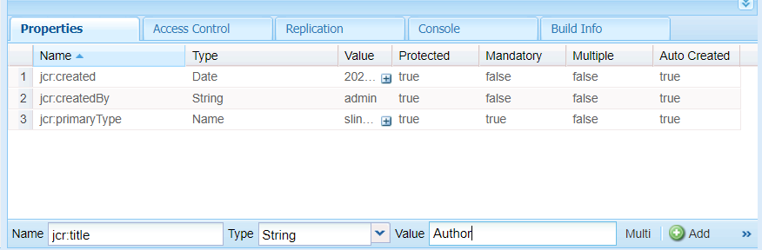

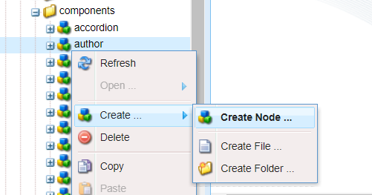

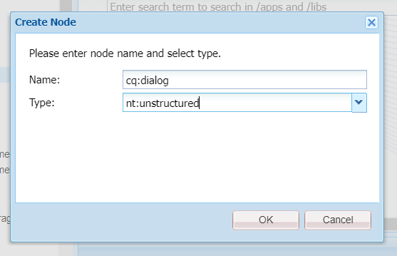

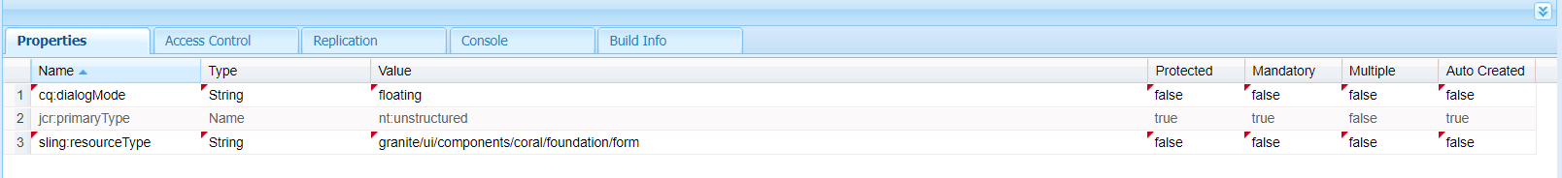

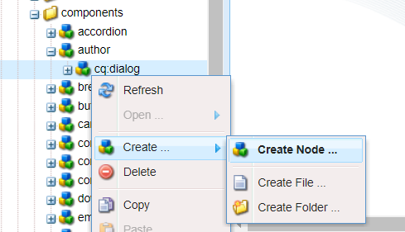

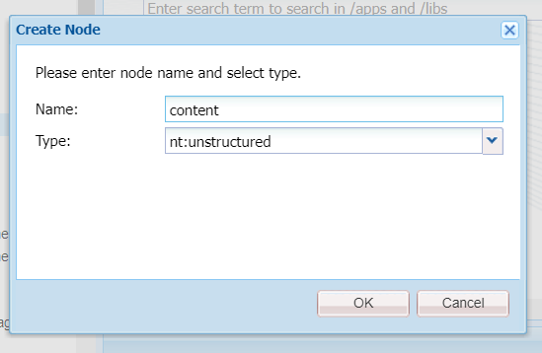

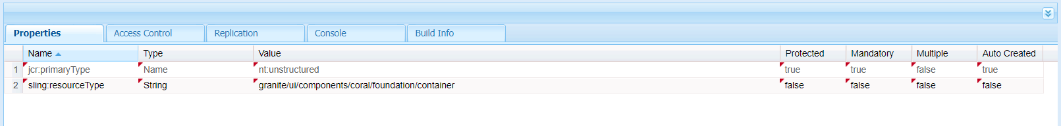

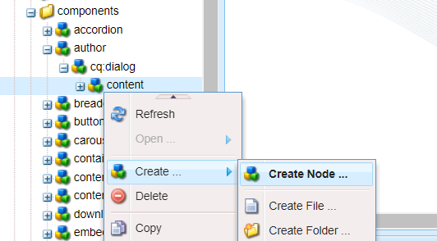

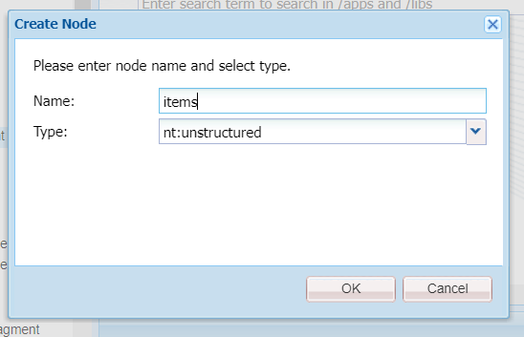

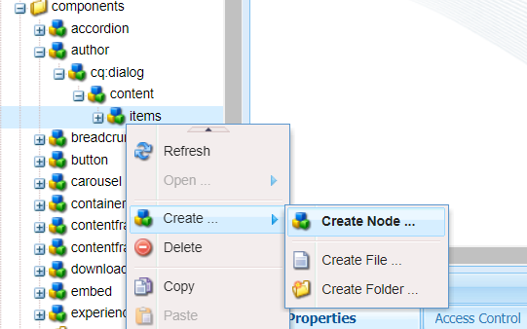

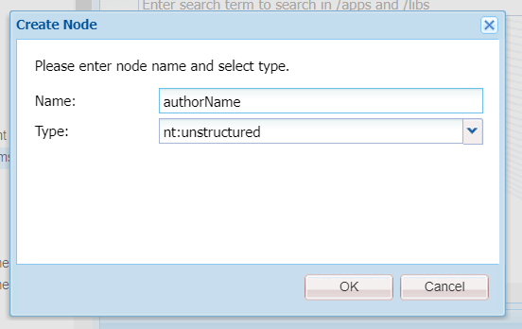

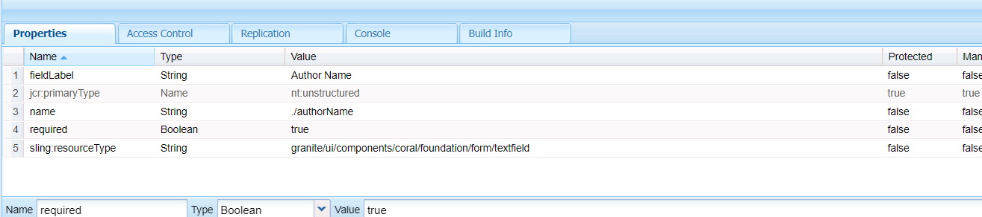

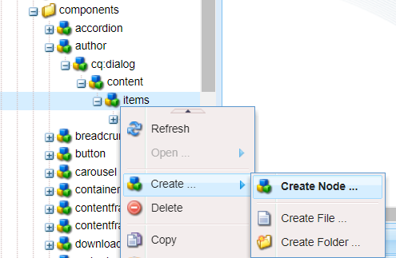

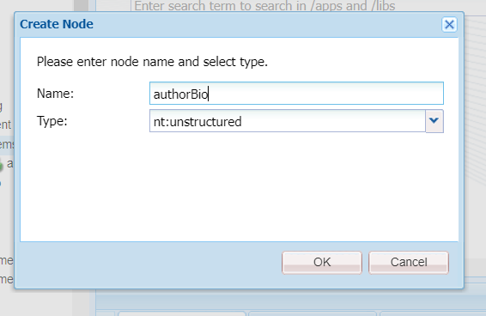

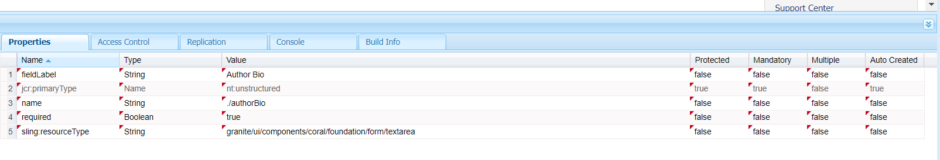

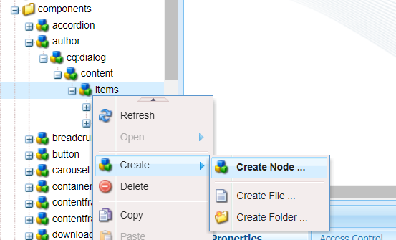

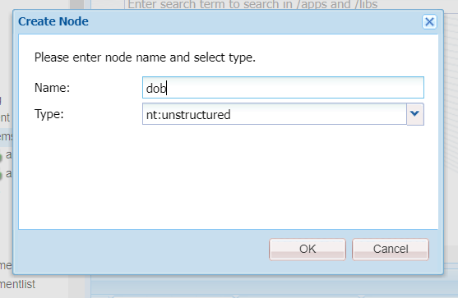

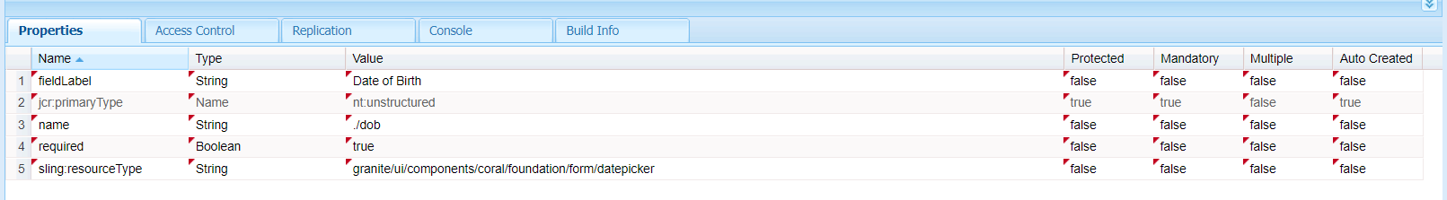

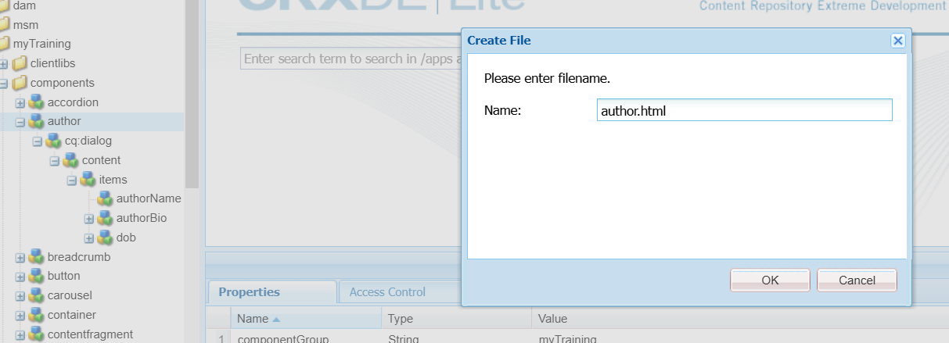

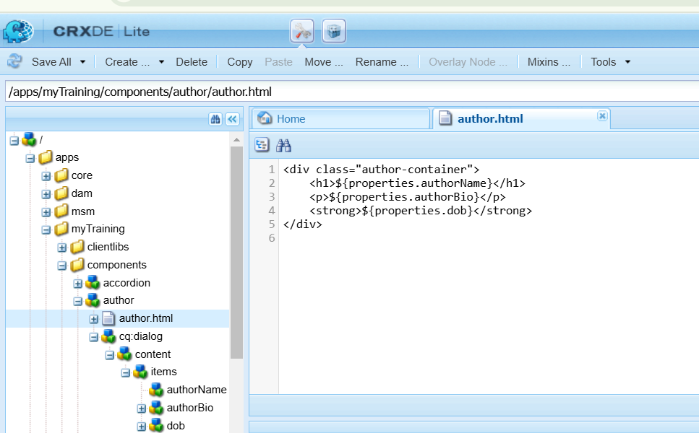

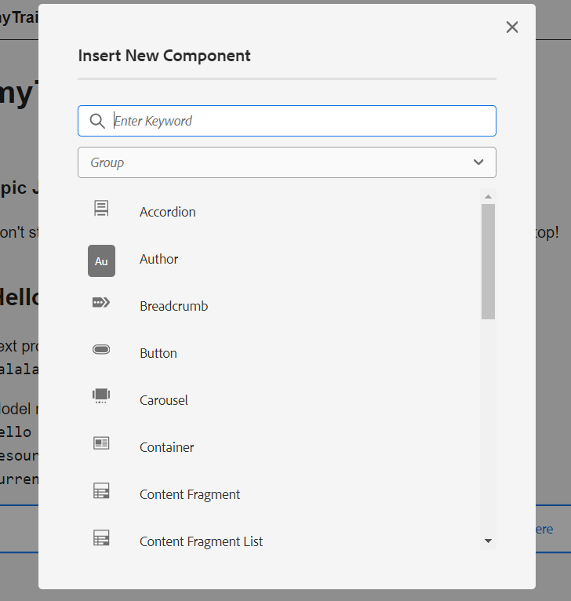

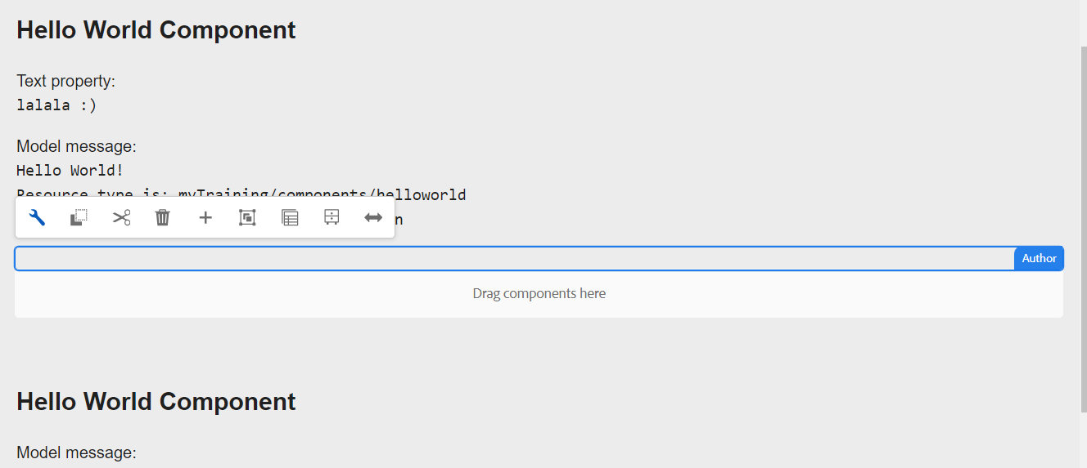

2. What is Dialog validation how to use them?

Dialog validation in AEM ensures that authors enter valid data in component dialogs. It helps prevent incorrect or missing values before saving the content.

Eg:



3.What is client lib?

AEM Client Libraries (Clientlibs) manage CSS, JavaScript, and other frontend assets efficiently. They help optimize performance by bundling and minifying assets.

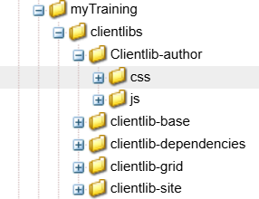

4. Implement client lib

Make authorName h1, make author bio normal body text, Bold the dob.

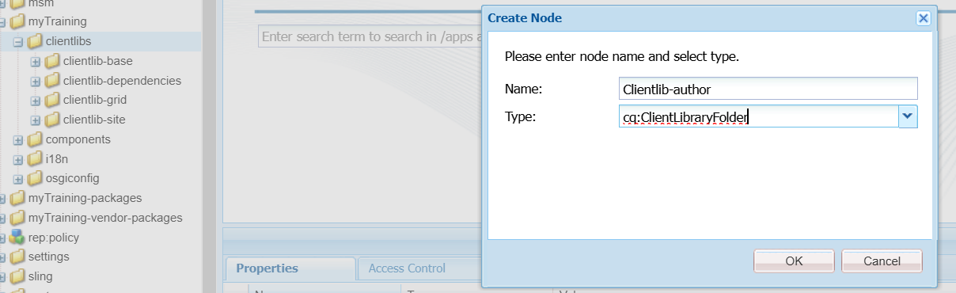

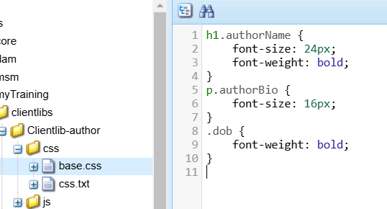

5. What is extraclientlib and how to create custom?

ExtraClientLibs is a custom category that loads additional CSS/JS only when needed.

