**Date : 7/3/2025 TASK 3**

**Apply Styling  
• Style the header and footer using the AEM Style System.  
• Update CSS in the ui.frontend module.**

**ECLIPSE IDE**

myTraining-> UI.FRONTEND ->SRC -> MAIN -> COMPONENTS -> create header.scss and footer.scss file

**Header**

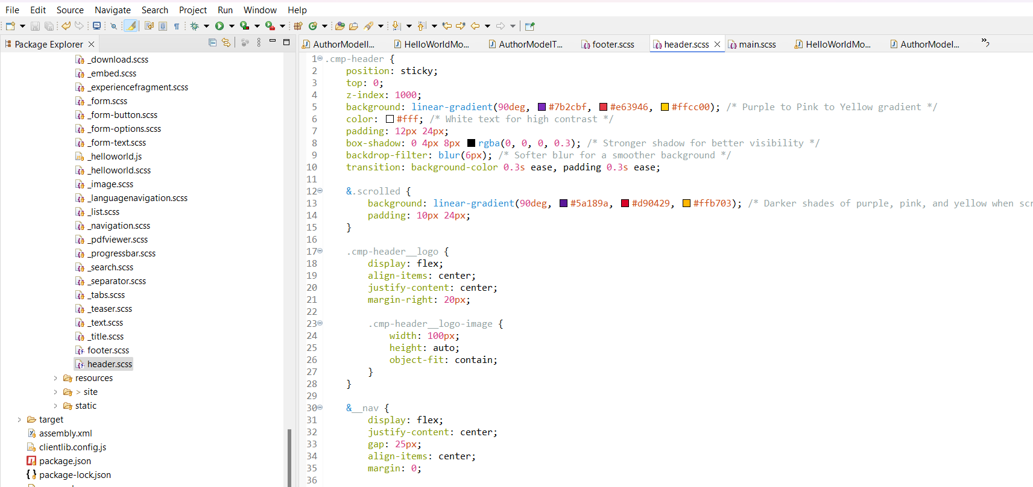

**Footer**

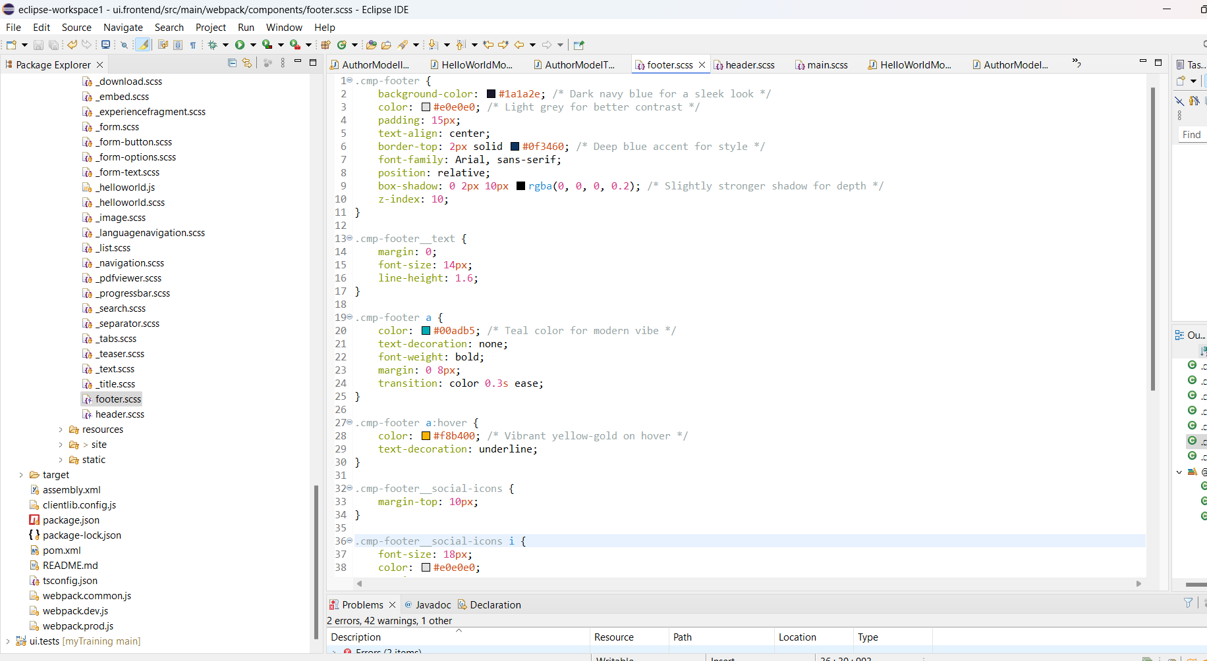

**AEM**

**TOOL-> TEMPLATES**

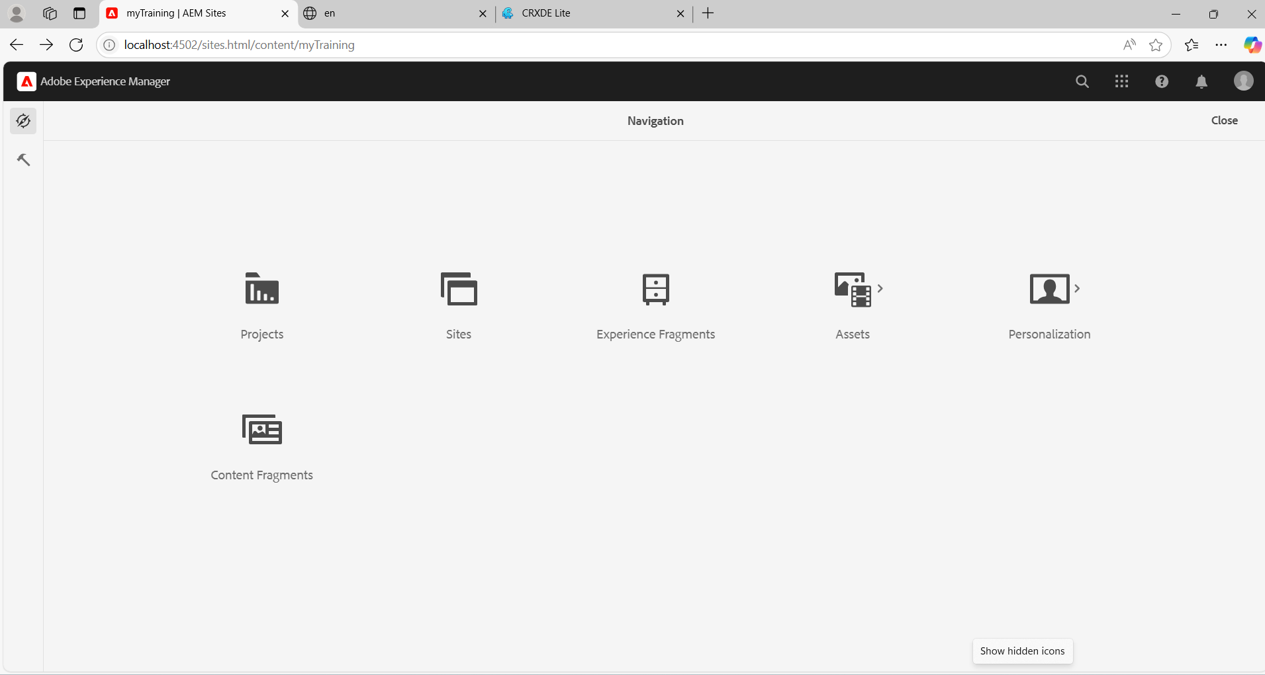

**EDIT book-detail TEMPLATE**

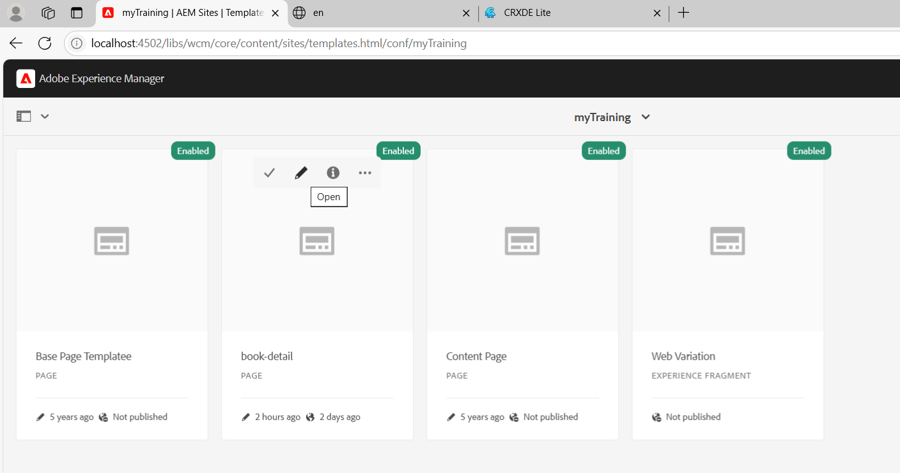

**Add Experience fragments (Header,Footer)to the book template.**

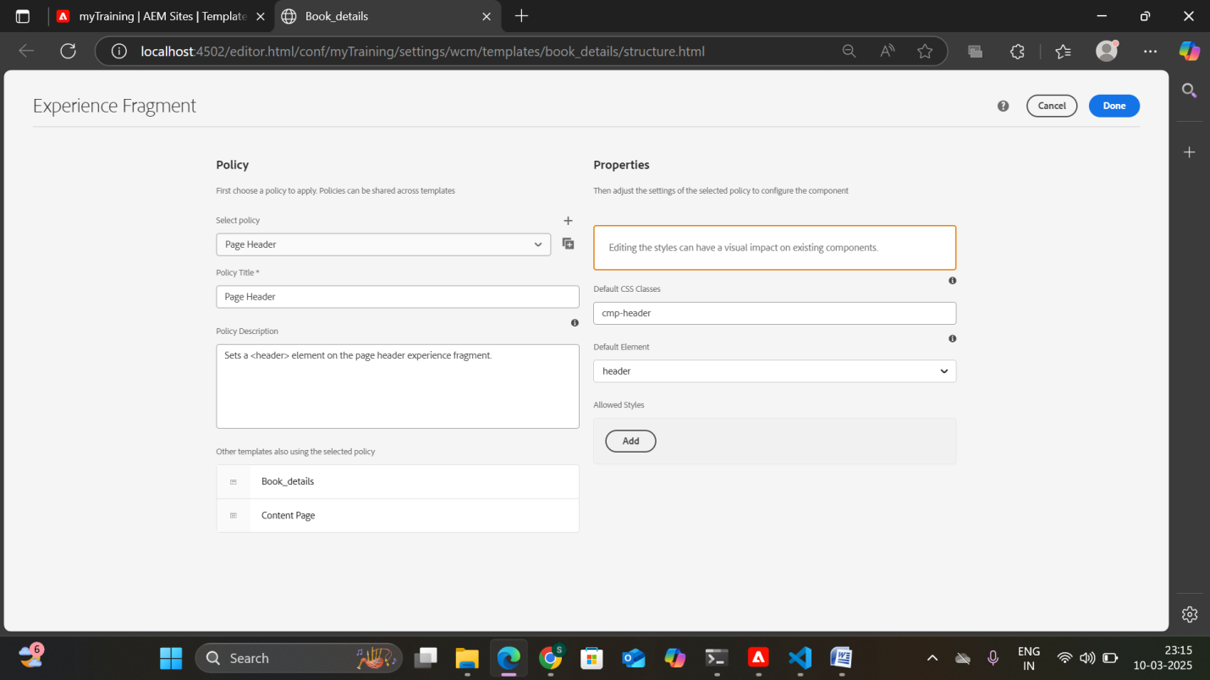

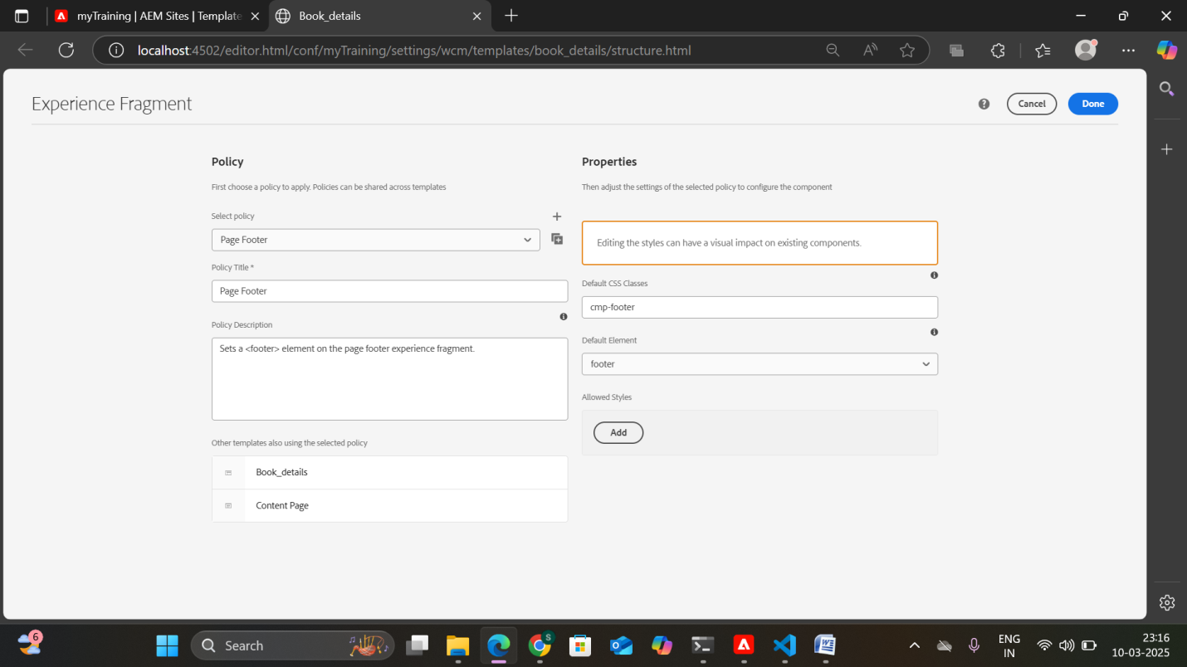

Run the project using the command **mvn clean install -PautoInstallPackage -Dmaven.test.skip=true**

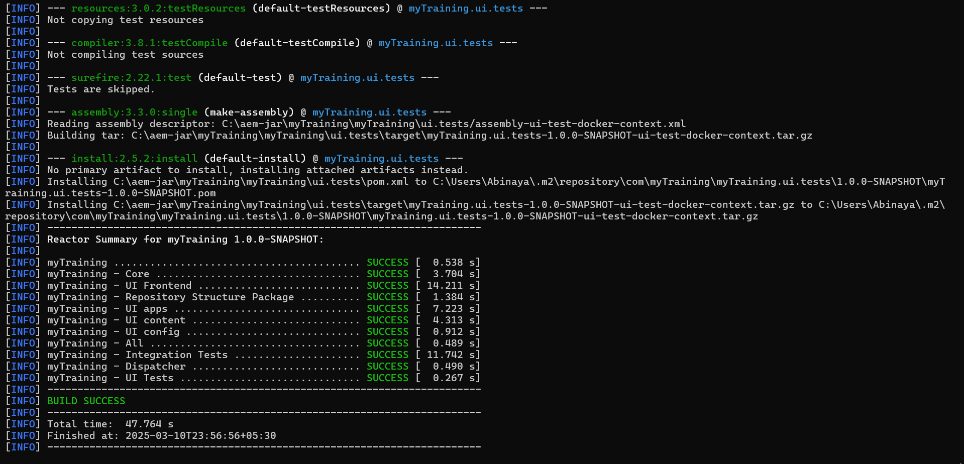

**BUILD SUCCESS**

**Output**:

**HEADER**



**FOOTER**



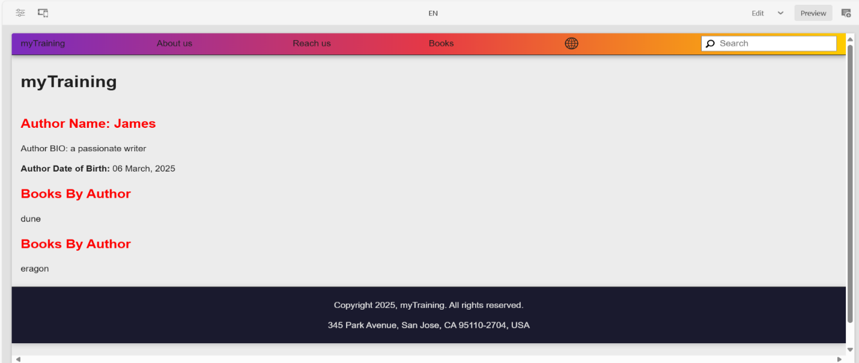

**Addscript**

**A new textarea property, 'addScript', has been added to the Book Page component, allowing authors to dynamically embed custom scripts as needed.**

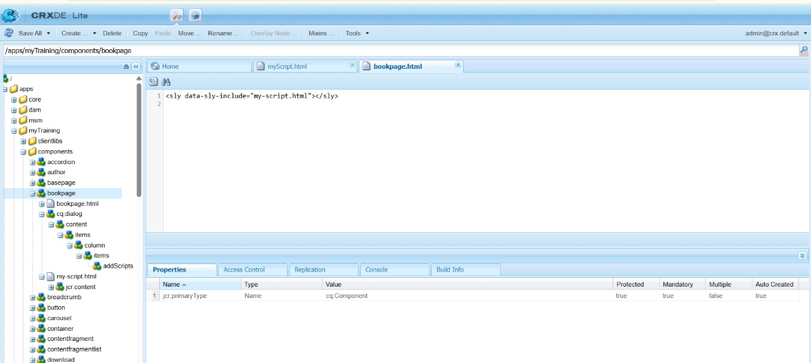

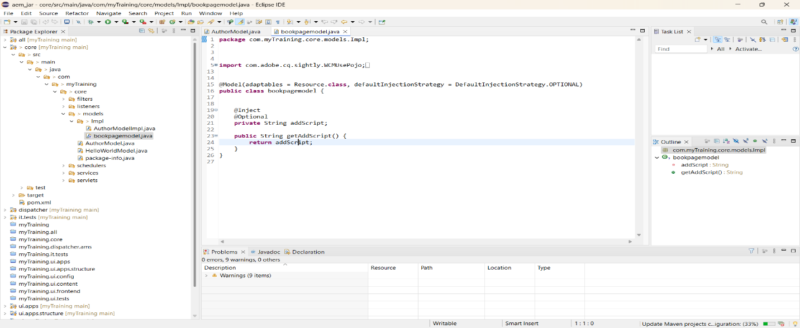

**Alert message**

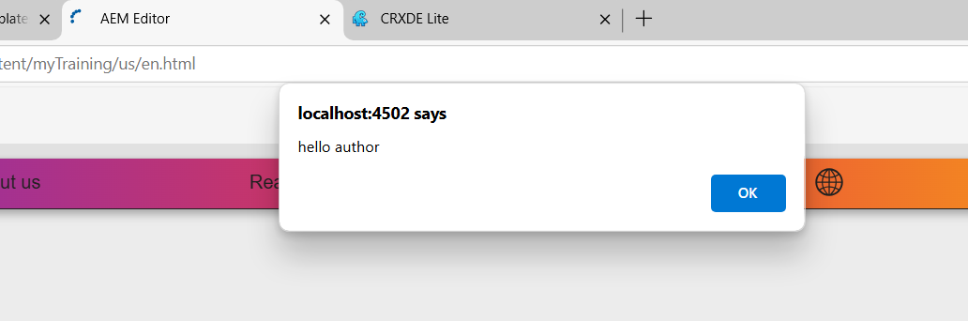

**Multifield component**

**Enhanced the Author Component by adding a new text property and a multifield for books. Additionally, a Sling model has been implemented to retrieve these properties efficiently.**

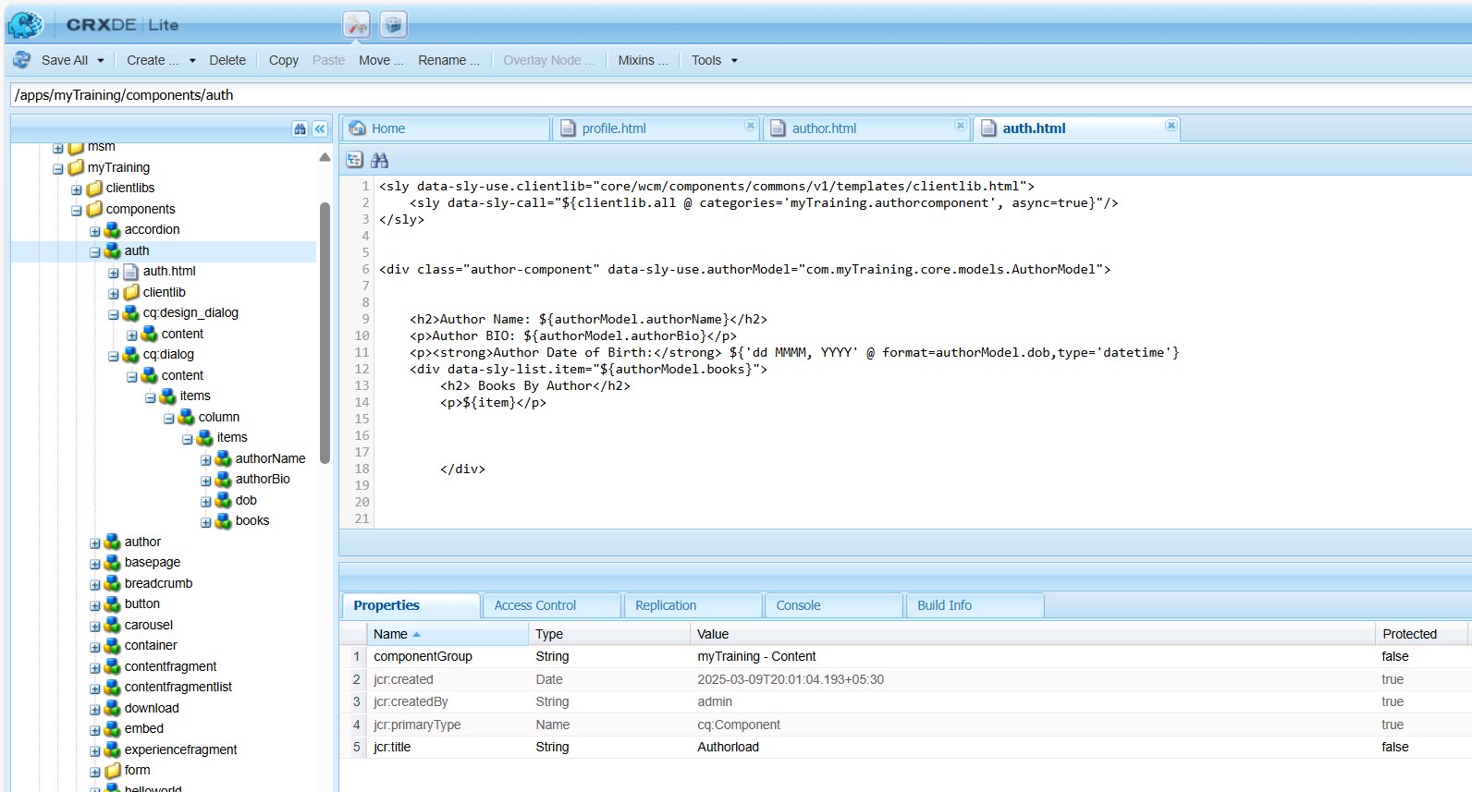

**UPDATE AUTHORMODEL.JAVA IN ECLIPSE**

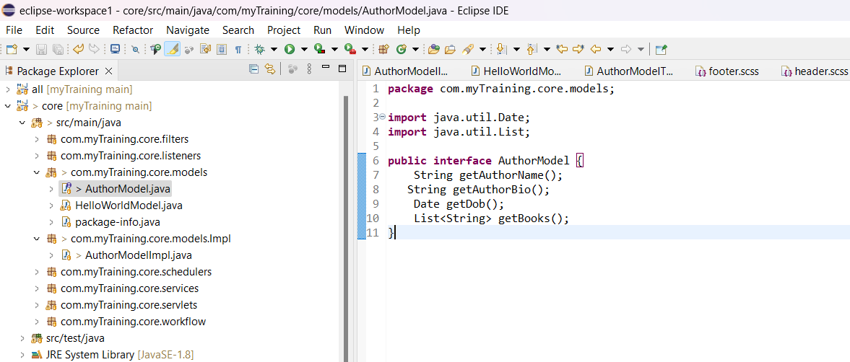

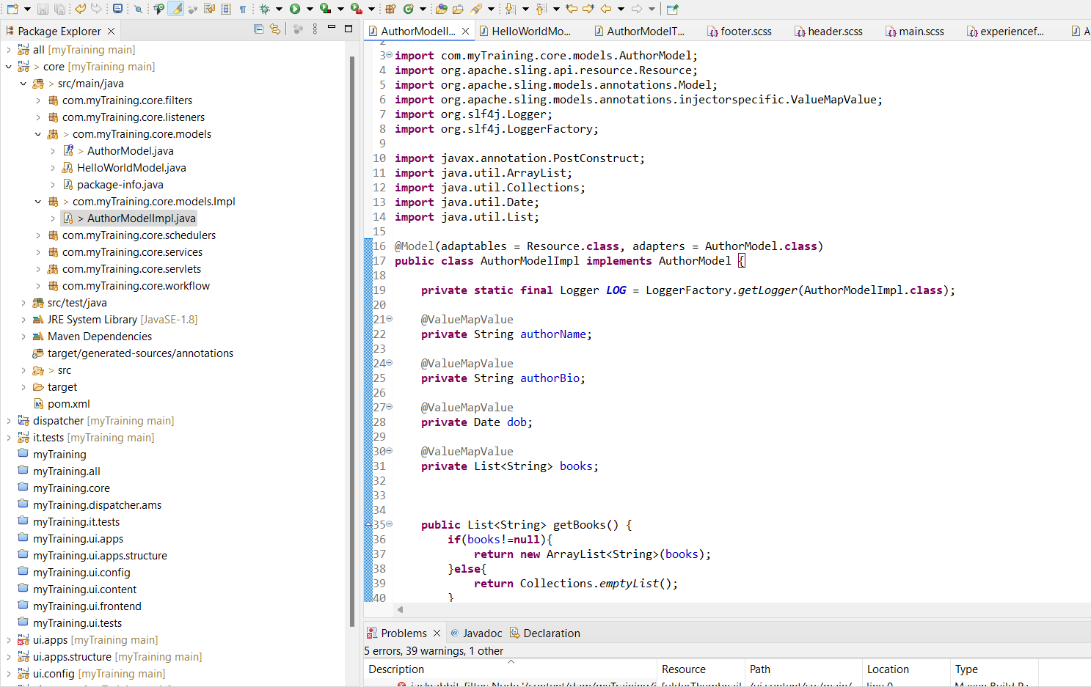

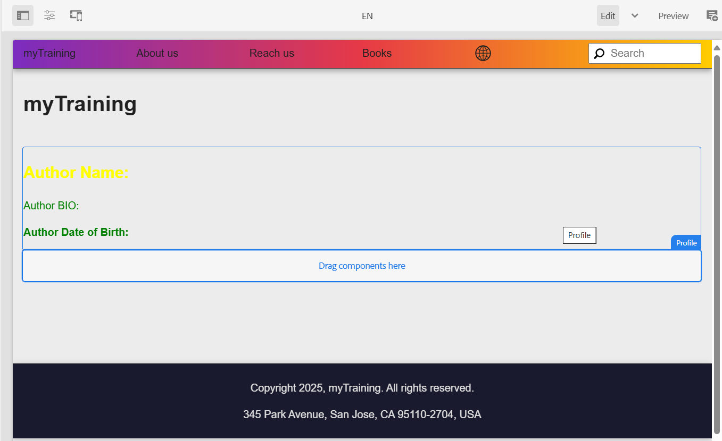

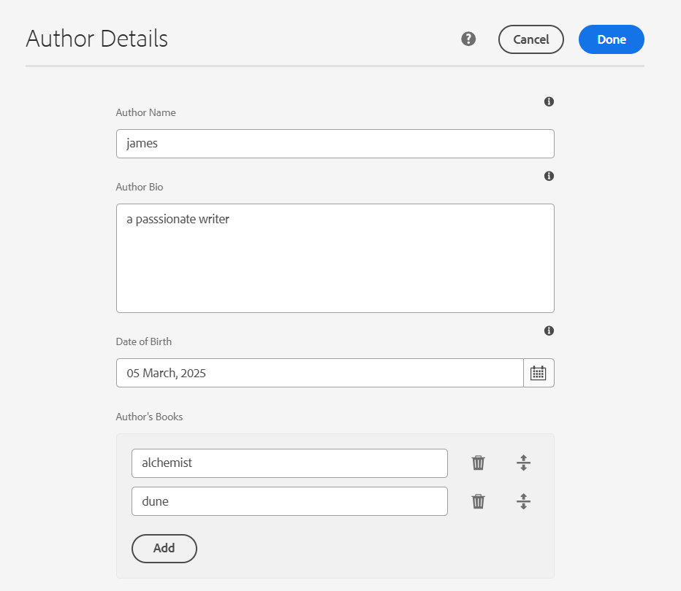

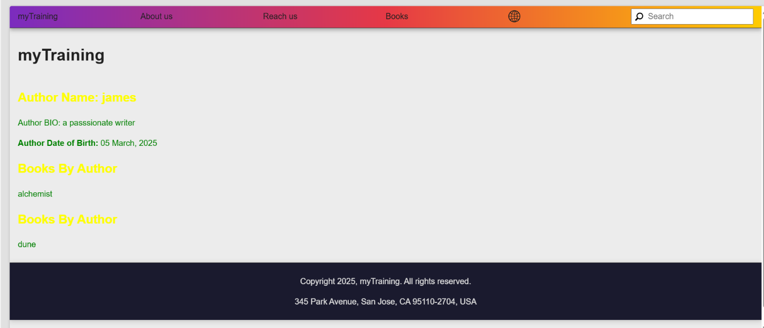

**Created the 'About Book' template using the base page template to enable authors to efficiently generate book-related pages.**

