**Date : 7/3/2025 TASK 3**

**AEM**

**TOOL-> TEMPLATES**

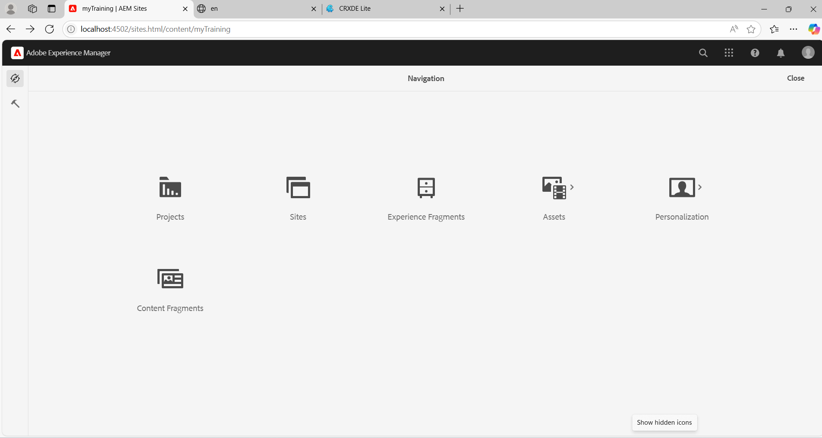

**EDIT book-detail TEMPLATE**

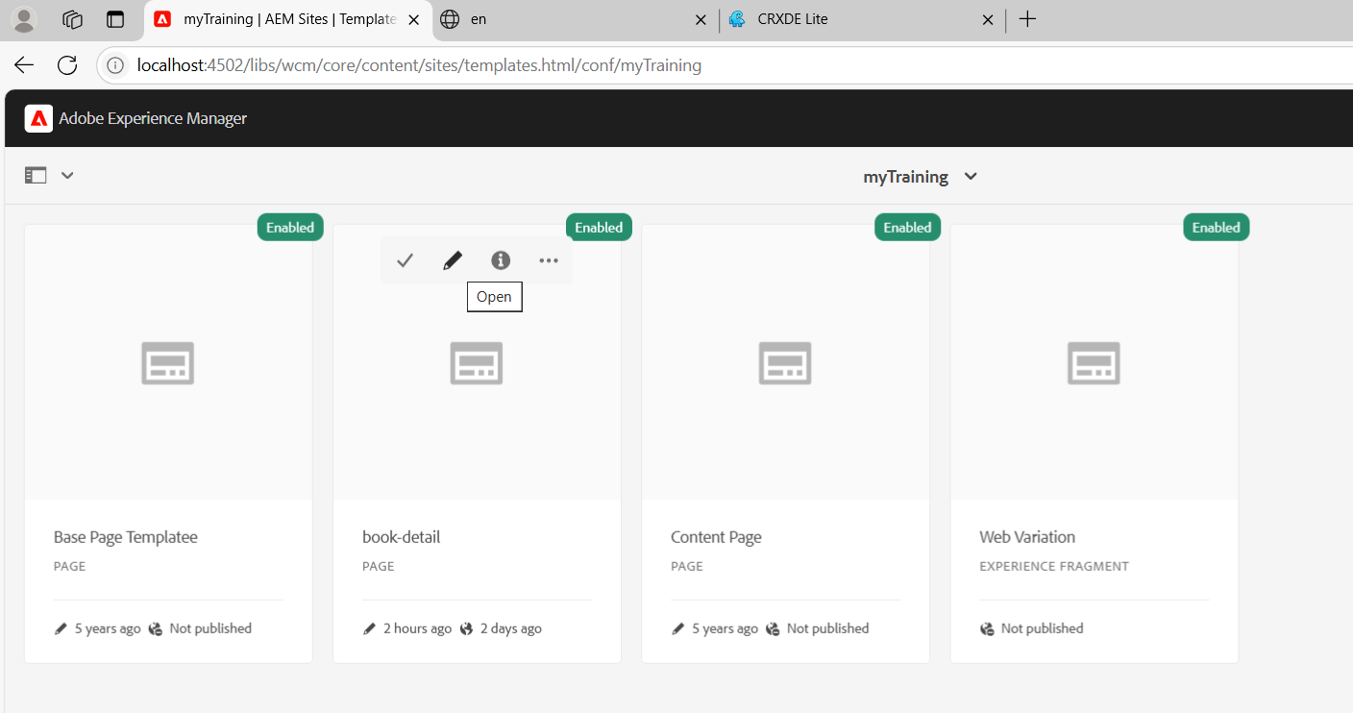

**ECLIPSE IDE**

**myTraining-> UI.FRONTEND ->SRC -> MAIN -> COMPONENTS -> create header.scss and footer.scss file**

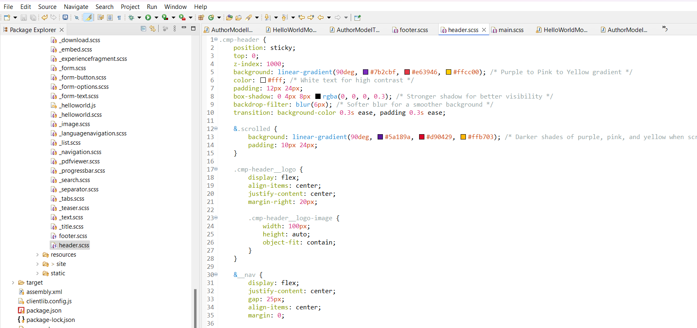

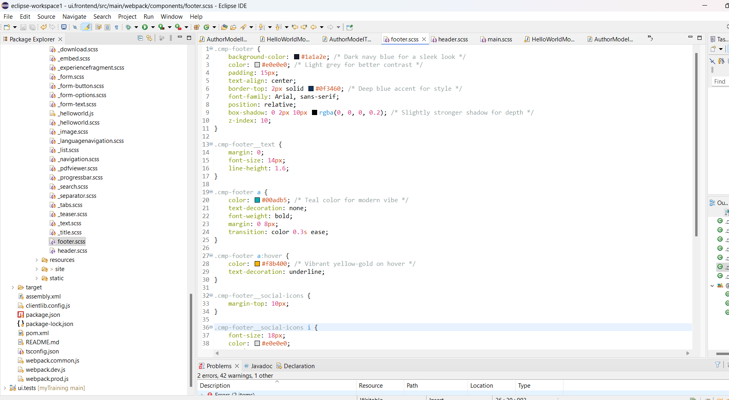

**Add Experience fragments (Header,Footer)to the book template.**

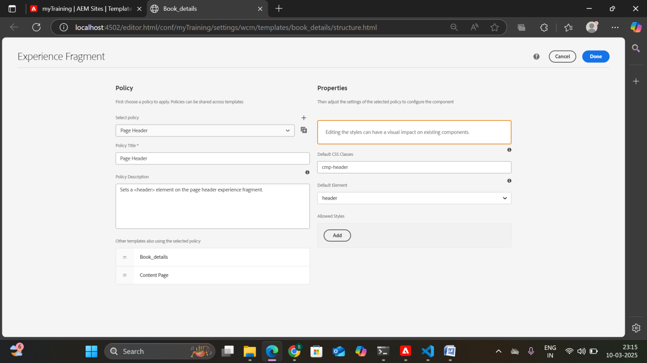

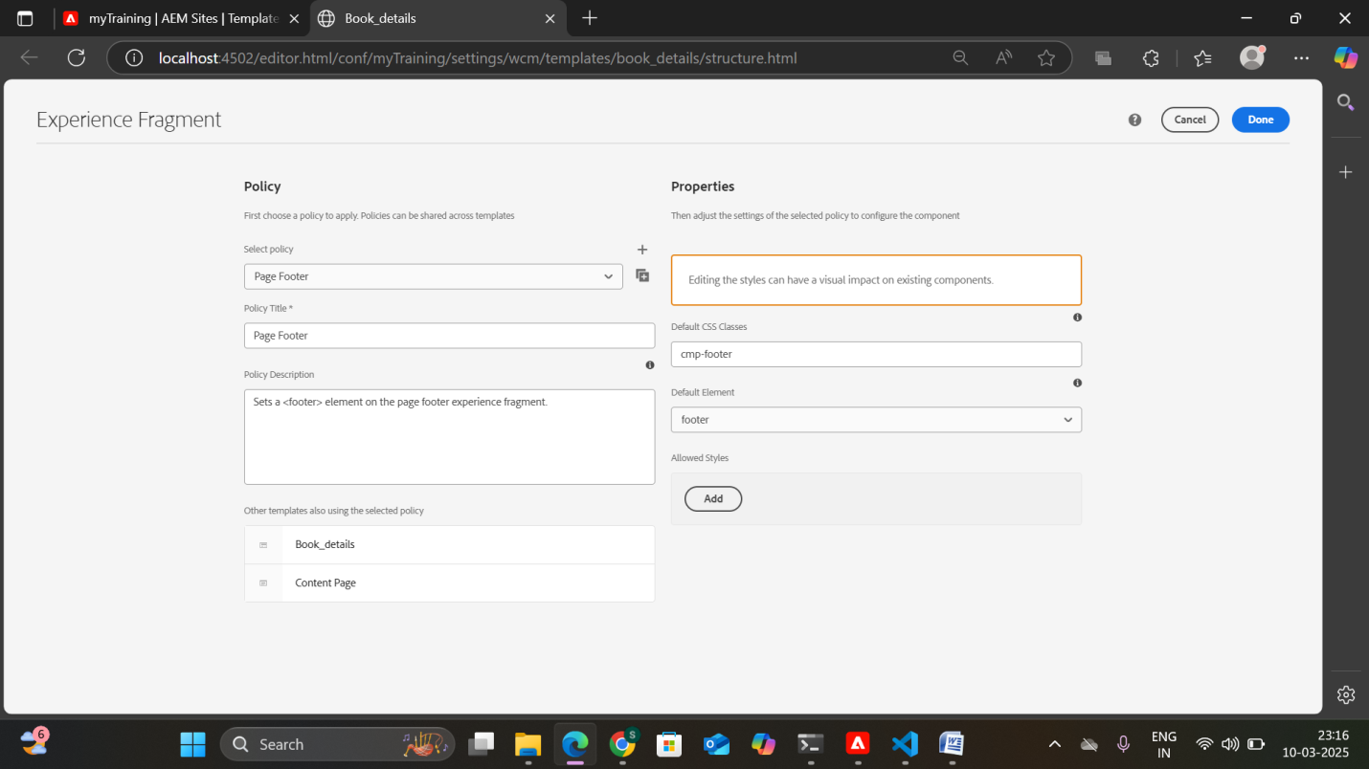

Run the project using the command **mvn clean install -PautoInstallPackage -Dmaven.test.skip=true**

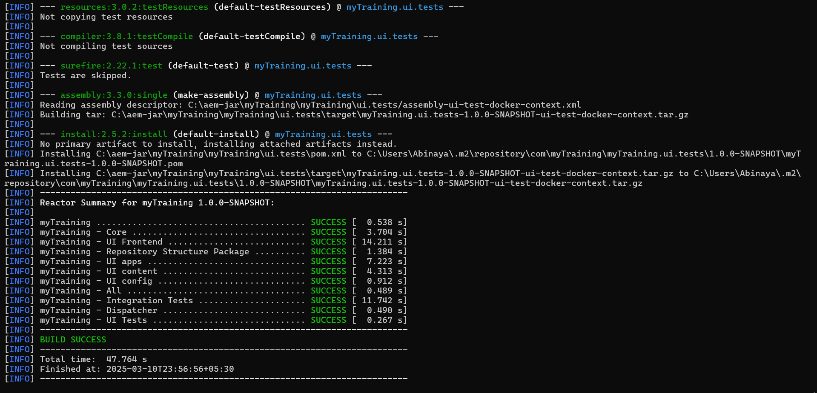

**BUILD SUCCESS**

**Output**:

**HEADER**



**FOOTER**

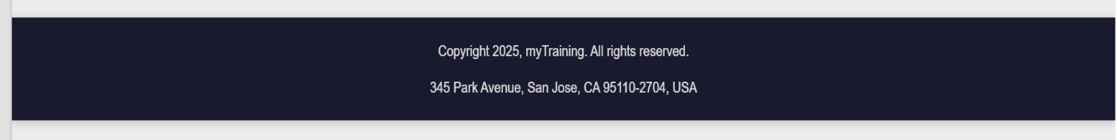

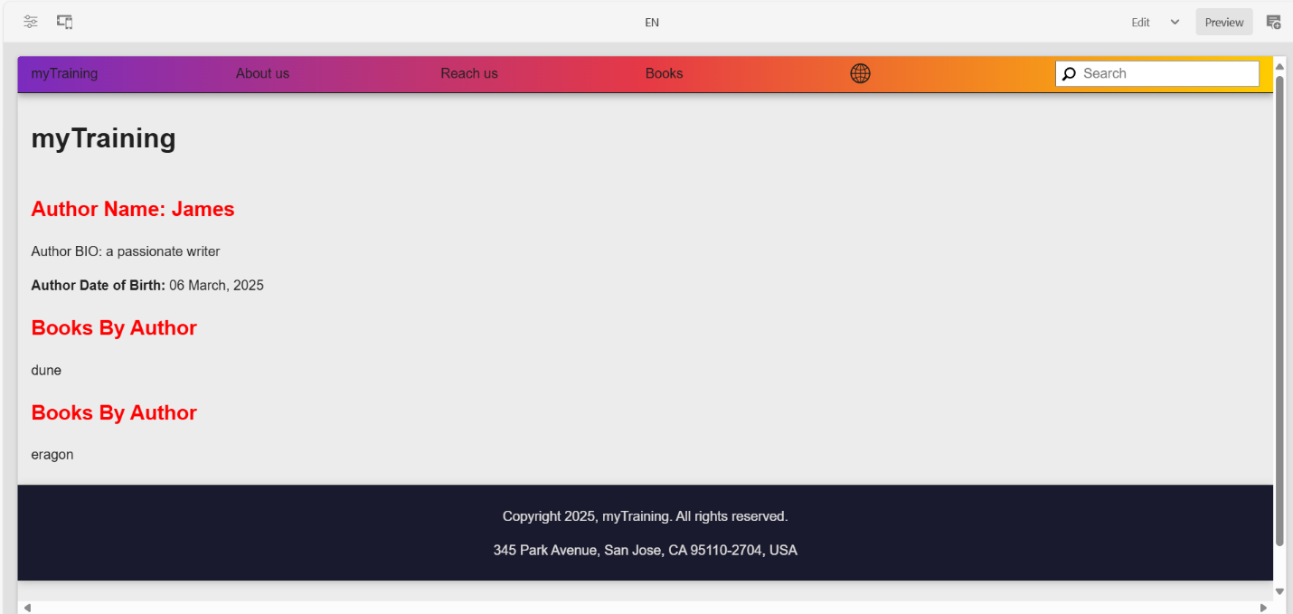

**Alert message**

**Alert**

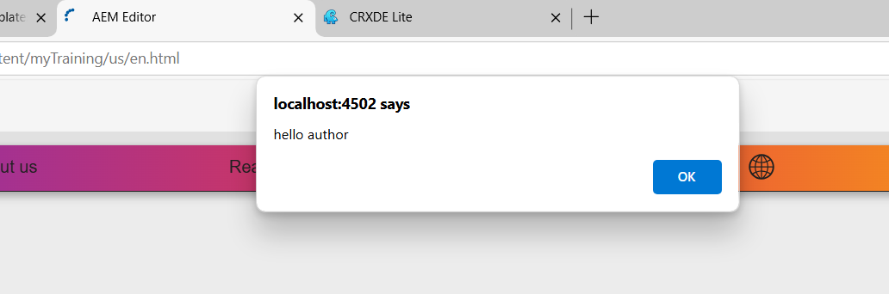

**Multifield component**

**Create profile(component) that contains author details**

