 

**Placement Empowerment Program**

**Cloud Computing and DevOps Centre**

**Host a Static Website Locally**

**“Set Up a Local Server Apache and Host a Simple HTML page**

**with your name”**

Name: ABINAYA S DEPARTMENT: **IT**



**Introduction**

Hosting a static website locally involves setting up a local web server to serve HTML content. This approach is useful for testing and previewing web applications before deploying them to a production environment.

**Overview**

In this POC, we will:

* Install and configure a local server (Apache or Nginx) on a Windows machine.
* Host a simple HTML page with your name as the content.
* Test the setup by accessing the hosted webpage in a browser.

**Objective**

The primary objective is to demonstrate the ability to host a static website locally using an open-source server Apache on a Windows environment.

**Importance**

* Enables testing and debugging web applications locally.
* Provides insights into web server configuration.
* Lays the foundation for learning advanced web hosting and deployment techniques.

**Step-by-Step Overview**

Step1:

Search for "Apache Lounge" on Google and click the first link to access the official website.

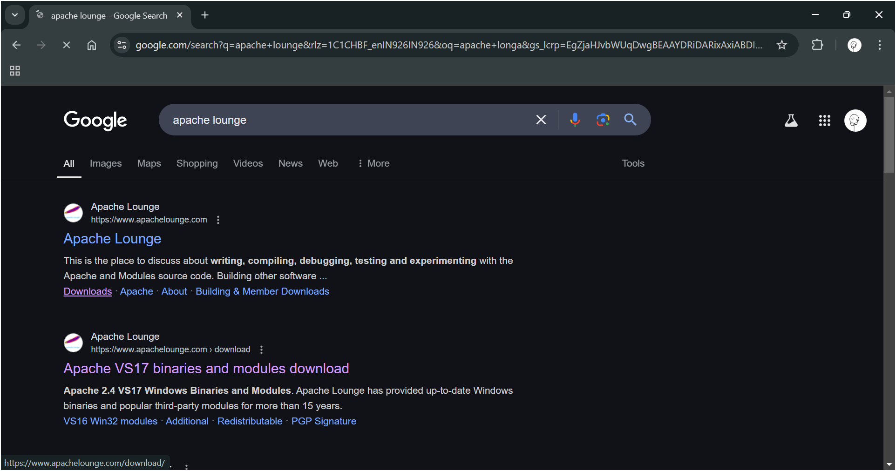

Step 2 :

Click on the "Downloads" option located on the left-hand side of the Apache Lounge website.

Step 3 :

Click on the link **"Apache 2.4.62-240904 Win64"** (Windows version), download the file, and extract all its contents.

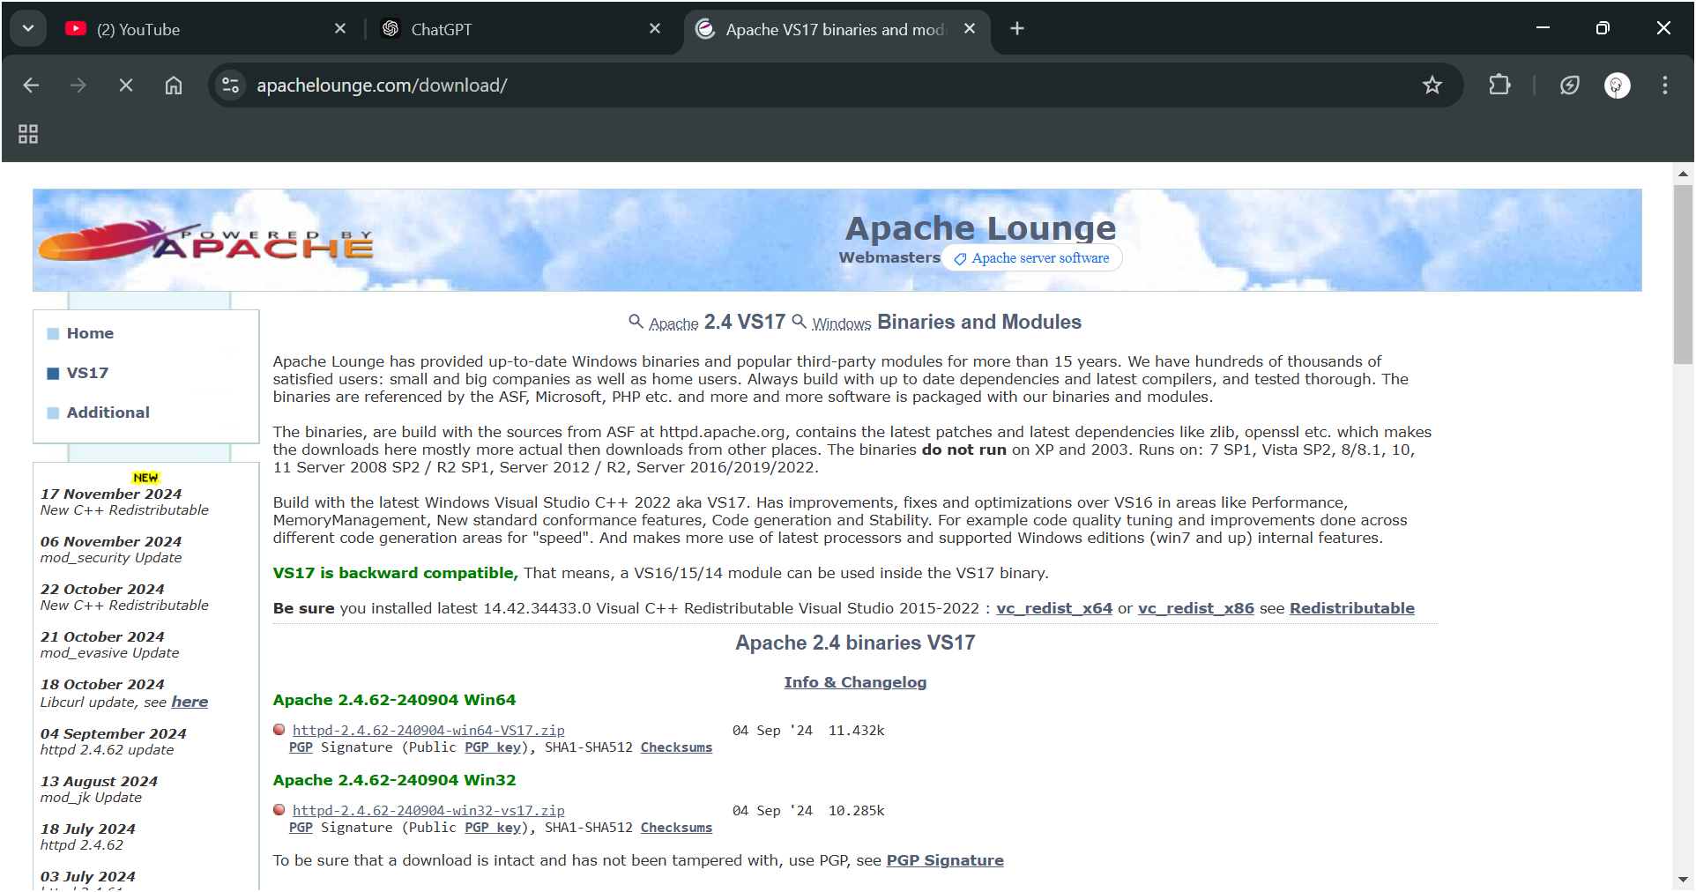

Step 4 :

Open Command Prompt as Administrator (Windows + R, type cmd, right-click and select 'Run as Administrator') and use the command **cd C:\path\to\apache\bin** to set the path to the Apache bin folder.

Then Run the installation command :

**httpd -k install**

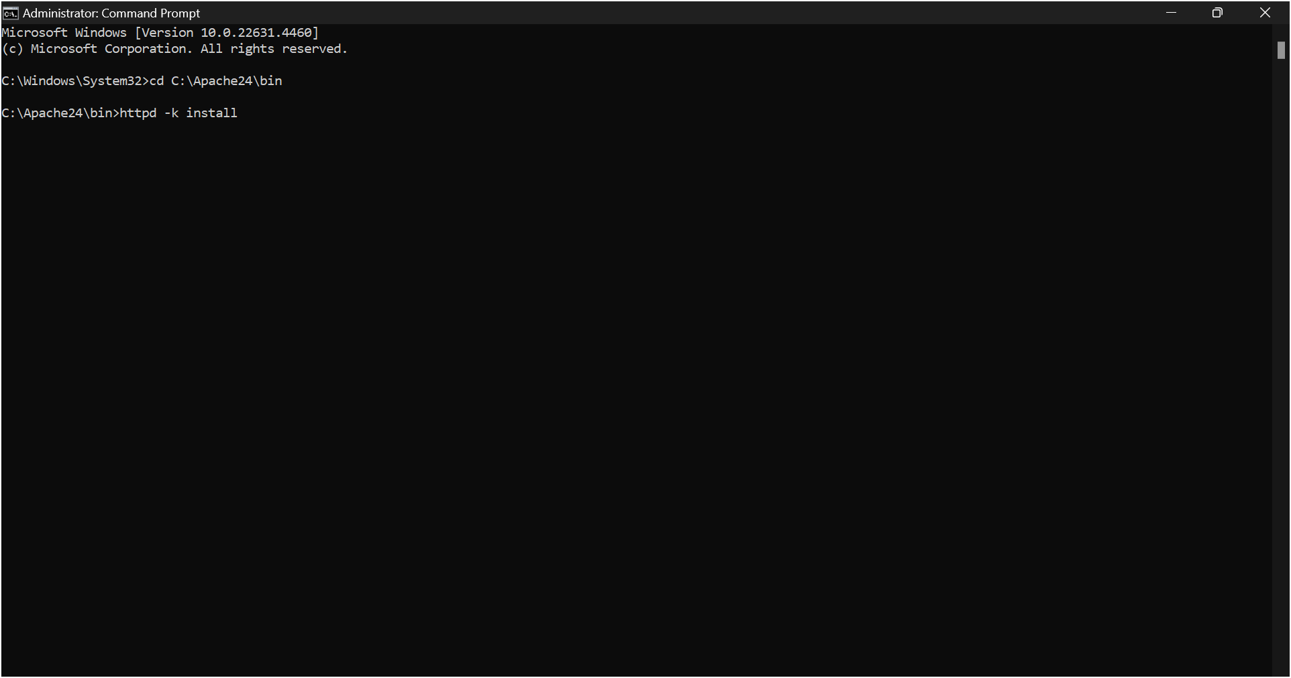

Step 5 :

go to the services in the PC and search for apache2.4 and click the start button to start apache in your pc

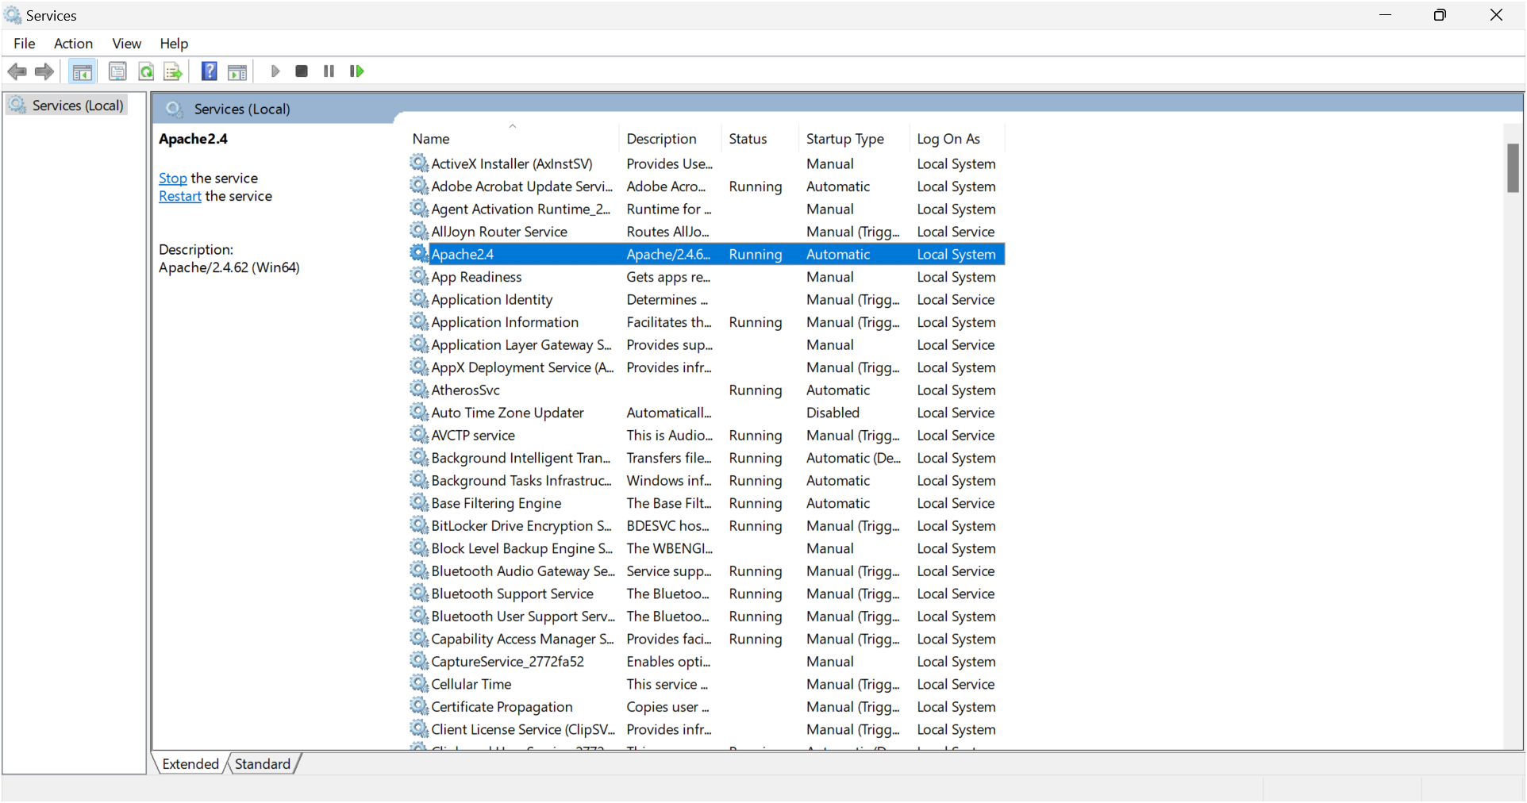

Step 6 :

* Apache’s Document Root Directory

The document root is the directory where Apache serves files from. By default, it's often:

**C:\Apache24\htdocs** (if installed manually)

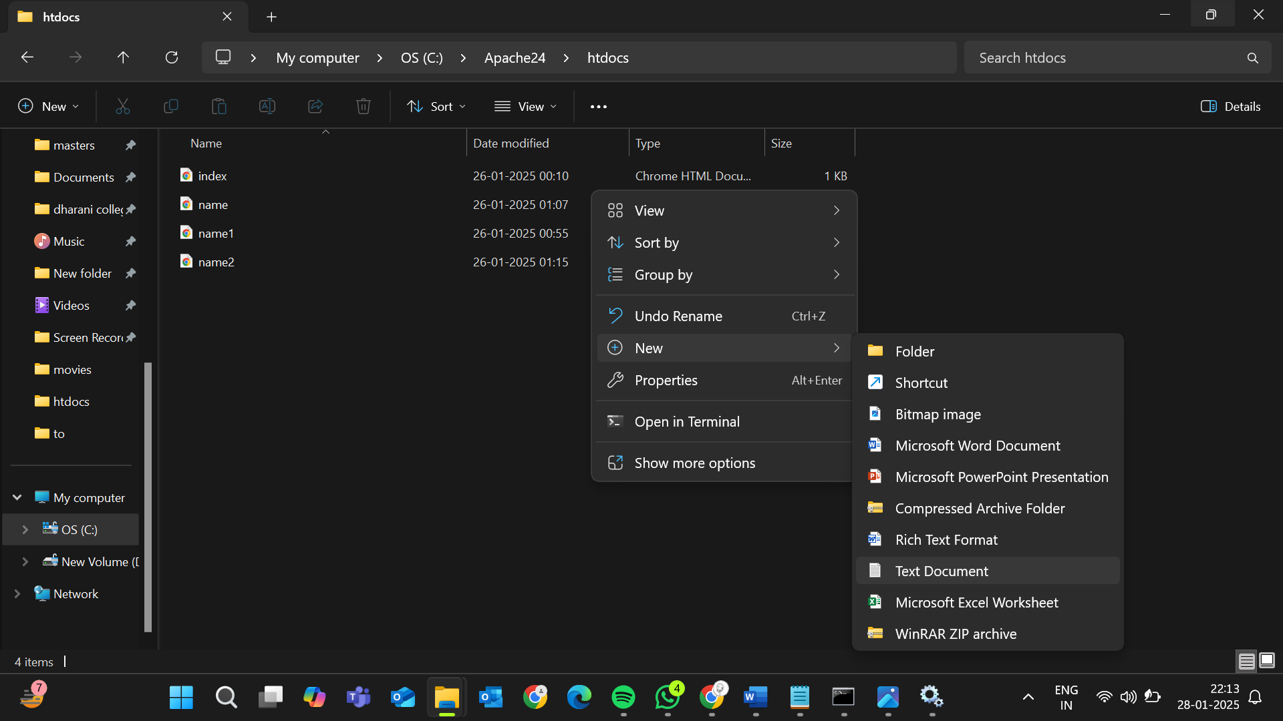

* Navigate to the Document Root

Open File Explorer and go to the document root directory.

* Create a New File

You can create a new file in the document root directory:

Using Notepad:

1. Right-click inside the folder, select New > Text Document.

2. Rename it (e.g., index.html).

3. Open the file with Notepad, add html code to create simple model to display your name, and save.

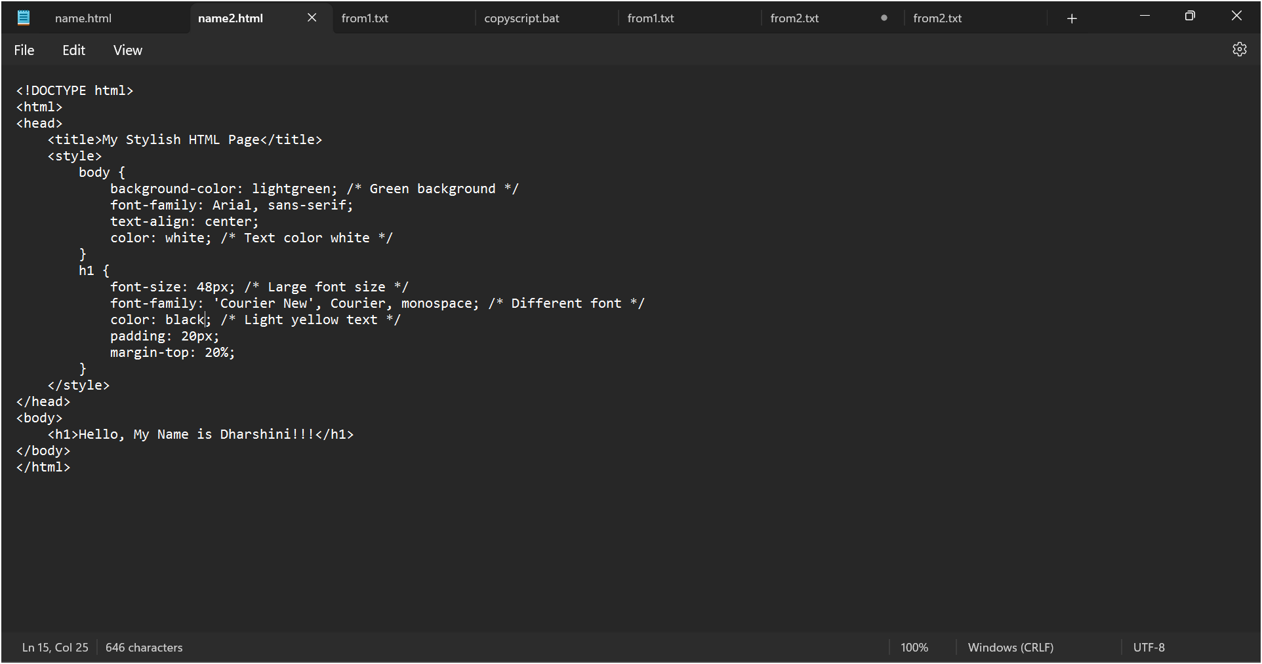

Step 7:

Open the chrome browser and type **localhost/index.html** in the address bar. You should be able to see the website hosted successfully.

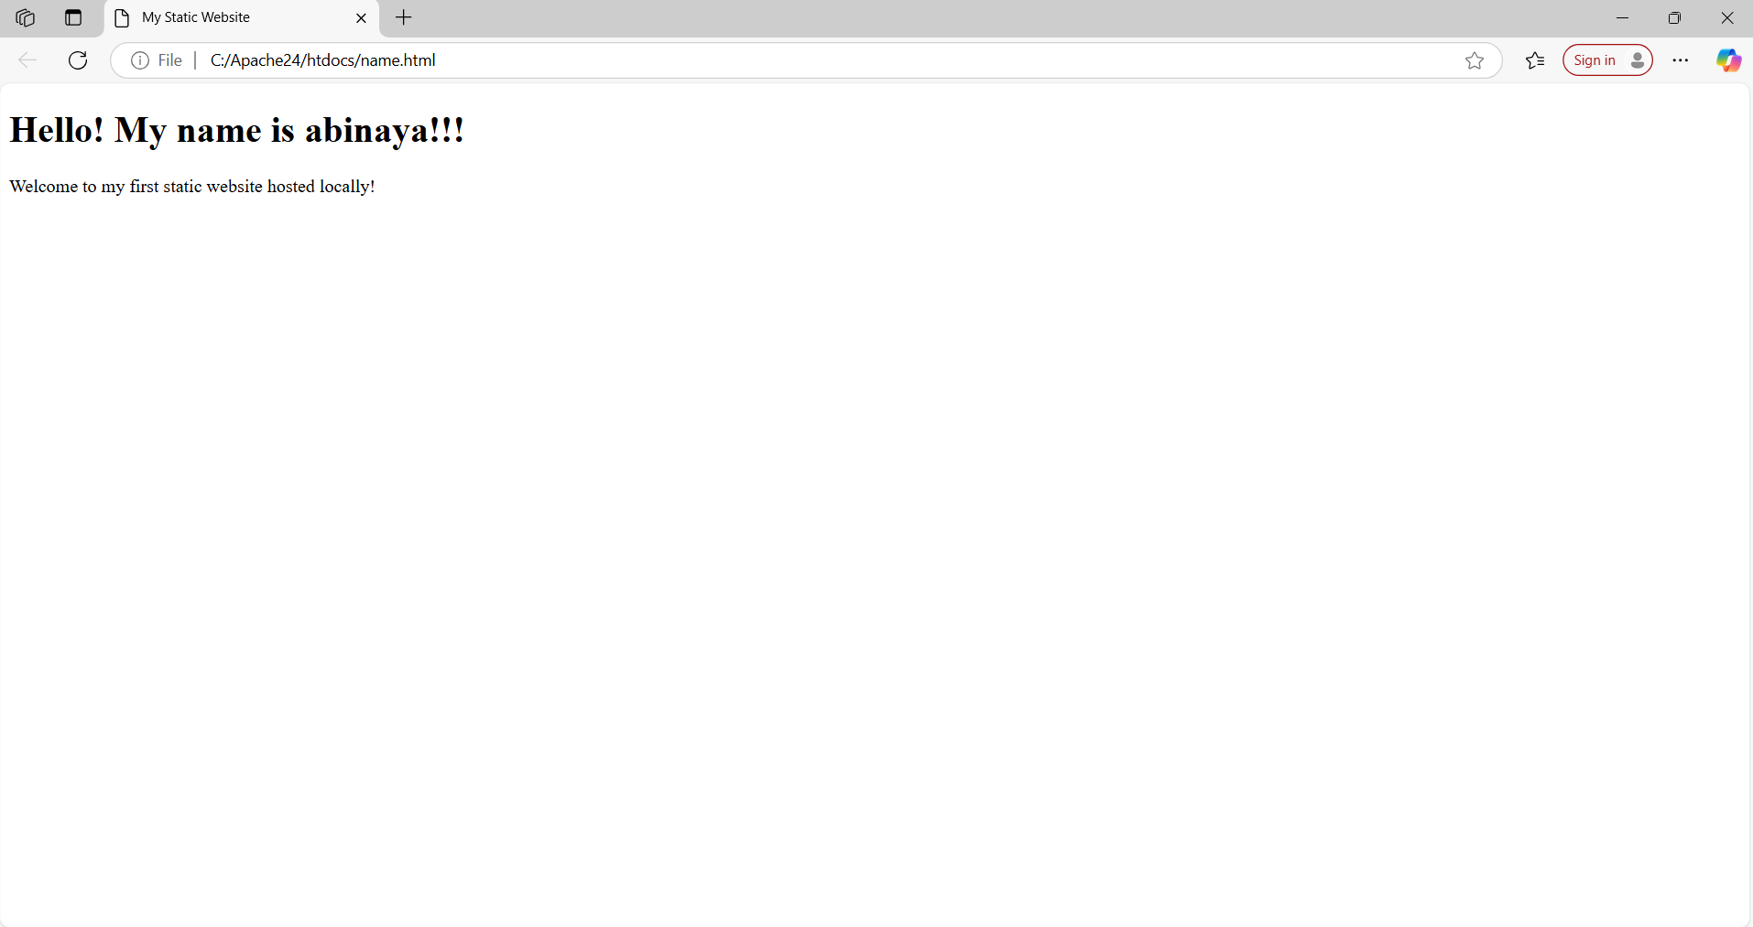

**Expected Outcome**

By completing this POC, you will:

1. Successfully configure and run an Apache server locally.

2. Host a static HTML website that displays your name.

3. Understand the basics of web server configuration and file hosting.