 

**Placement Empowerment Program**

**Cloud Computing and DevOps Centre**

**Automate File Copying with a Script**

**“**Create a script to copy files from one folder to another automatically.”

Name: **ABINAYA S** DEPARTMENT: **IT**



**Introduction**

Automating file copying with a script simplifies the process of transferring files from one folder to another. This method is especially useful for backing up files, synchronizing folders, or managing data efficiently. By using a simple batch script in Windows, you can save time and eliminate manual intervention.

**Overview**

A batch script in Windows is a text-based file containing a sequence of commands executed by the command prompt. It can automate repetitive tasks like copying files or directories. Using such a script ensures consistency, reduces human error, and enhances productivity.

**Objective**

The primary objective of this script is to:

1. Copy files from a source folder to a destination folder automatically.

2. Maintain the folder structure and include all subfolders and files.

3. Optionally overwrite existing files without user confirmation.

**Important Considerations**

* Ensure both the source and destination paths are accessible.
* Have appropriate permissions for reading and writing files in the respective folders.
* Test the script on a sample dataset before applying it to important files.

**Steps to Set Up and Automate File Copying**

**STEP 1.**

**Prepare the Environment**

* Identify the source folder containing the files you want to copy.
* Create or identify a destination folder where the files will be copied.



**STEP 2.**

**Create the Batch Script**

* Open Notepad or any text editor.
* Write the following script:

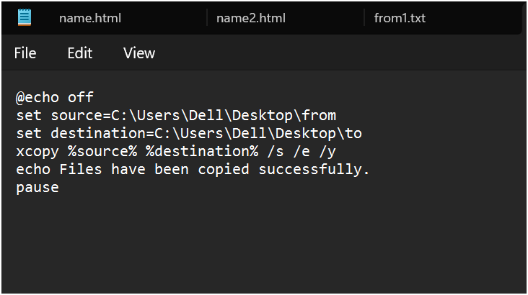

**Explanation:**

* set source and set destination: Set the source and destination folder paths.
* xcopy: Copy files and directories.
* /s: Copy subdirectories (excluding empty ones).
* /e: Copy empty subdirectories as well.
* /y: Suppress overwrite confirmation prompts.

**STEP 3.**

**Save the Script**

Save the file with a .bat extension (e.g., copy_files.bat).

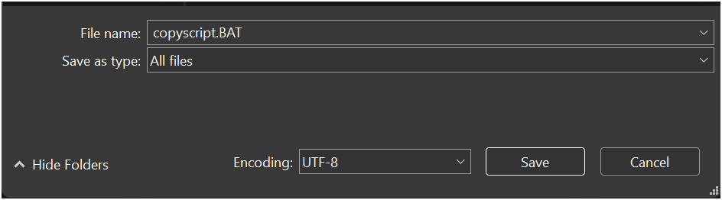

**STEP 4.**

**Test the Script**

Double-click the .bat file to execute it and verify the results.



**Benefits of Automation**

* Saves time by avoiding manual copying.
* Ensures regular backups or synchronization of files.
* Reduces errors and improves efficiency.

**Conclusion**

Automating file copying using a batch script in Windows is a simple yet powerful technique for managing files effectively. By following the steps outlined, you can create a reliable system for regular file transfers or backups with minimal effort.