OPTIMIZATION PROJECT
Objective: Building a multi-AGV system for energy optimization with A* algorithm and a battery station logic. The system aims to improve the communication of AGVs and optimize energy usage for the transportation of loads.
Steps:
Step 1: Requirements of a single AGV
Step 2: Define AGV state and build the AGV node in ROS
Step 3: Implement the A* path planner node
Step 4: AGV controller node
Step 5: Simulation Loop node
Step 6: Multi-AGV architecture + Dispatcher
Step 7: Gazebo visualization for Multi-AGV simulation
Step 8: GUI panel for updates
STEP 1: Requirements of a single AGV
Core components :
- AGV node – AGVs' logic, state, and movement.
- Path planning node – Uses A* to generate paths
- AGV controller – follows path (velocity controller)
- Environmental setup – Map with stations and obstacles
- Simulation loop – Updates position, battery, and state over a fixed time
- Visualization – Rviz to visualize the map and AGV path
Communication and node layout :
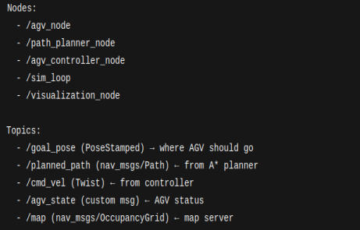
ROS package and Setup:
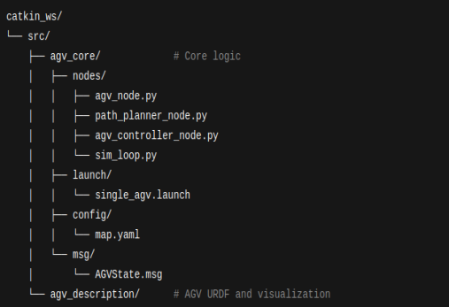

STEP 2: Define AGV state and build the AGV node in ROS
Here we create a custom message that describes AGV's current status, and then build the AGV_node.py, which gives
1) POSE
2) Battery level
3) AGV state
Here we create code for AGVState.msg to provide the status
Then, the code for AGVnode from the class AGV in the algorithm, and make it executable.

Step 3: Implement the A* path planner node
The node is responsible for
- Listening to a goal pose,
- Running your A* algorithm,
- Publishing the planned path
The goal is to create a path_planner_node.py that :
- Subscribes to /goal_pose (user-defined goal)
- Publishes to /planned_path(as nav_msgs/Path)
- Uses Custom A* to plan on the grid

Step 4: AGV Controller Node

Build agv_controller_node.py to :
- Subscribe to the planned path(/planned_path)
- Convert path points to velocity commands (/cmd_vel)
- Send those to the AGV to simulate

Step 5: Simulation Loop Node
Create a sim_loop_node.py that :
- Receives velocity commands from /cmd_vel
- Updates the AGV’s Pose, battery and status over time
- Publishes to /agv_state to reflect the updates
- Timesteps: simulate every 0.1 sec
- Update pose based on linear/angular velocity
- Energy and battery consumption for all the states with values
- Detect if AGV is at the charging station -> recharge

Step 6: Multi-AGV architecture + Dispatcher
Goal:
Spin up to multiple AGV’s with their own
- State node
- Path planner
- Controller
- Sim loop
Add a dispatcher node that
- Manage a queue of transport orders
- Assigns them to AGVs using FCFS(first-come-first-served)
- Sends /goal_pose to the selected AGV’s namespace
Name the AGVs as /agv_1, /agv_2
The dispatcher node does –
- Load a list of transport orders
- Listen to each AGVs state (/agv_1/agv_state, …)
- Assign goals by publishing to /agv_X/goal_pose

Step 7:
Goal :
Simulate the AGV's environment inside Gazebo
Visualize real-time movement, charging, and navigation
Sync the existing ROS stack with Gazebo’s physics

