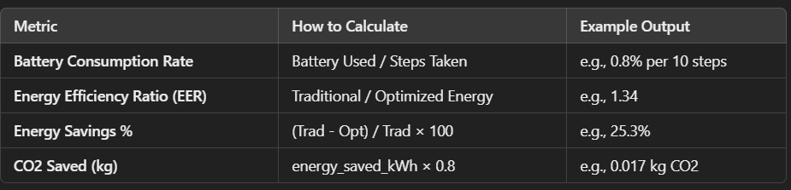

Concept from Paper | How You Used It in Your Work
Battery Level Monitoring | ➤ You introduced battery level tracking per step.  ➤ Reroute logic to charging station if battery < threshold (20%).
Battery Threshold Management | ➤ Defined BATTERY_THRESHOLD and switched goal to charging station dynamically in A* if battery is low.
Task Reassignment Based on Battery Level | ➤ Modeled as battery-aware rerouting (low-battery robot seeks charging).  In future, this can trigger task handover to another AGV.
Energy Modeling with Drive & Control Power | ➤ Incorporated P_DRIVE and P_CONTROL in your cost function for energy-optimized A*.  ➤ Penalized turns (like the paper's use of control energy) to avoid unnecessary direction changes.
Workflow Optimization Using A* | ➤ Improved A* with energy as cost metric, not just distance.  Similar to the paper's use of A* for shortest path with workflow efficiency.
Overhead Localization via Grid Mapping | ➤ Modeled environment as a 40x40 grid, simulating obstacle detection.  Paper used overhead webcam for mapping; you used random obstacle generation.
Energy Efficiency Focus | ➤ Calculated Energy Efficiency Ratio (EER) and % energy savings similar to paper’s goal of reducing energy consumption and downtime.
Monitoring via GUI | ➤ While you didn’t use a GUI, you printed detailed battery and energy metrics, simulating a monitoring dashboard (paper used GUI for battery signals).
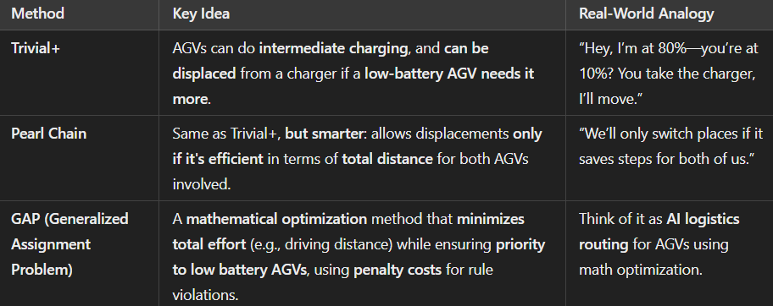

🔹 Key Concepts Explained
1. Intermediate Charging
- AGVs don't wait for full discharge; they can top up their battery between tasks.
2. Displacement of Charging AGVs
- If a low-battery AGV needs to charge and a station is occupied by a higher battery AGV, the lower one can ask it to move.
- There’s a threshold difference: e.g., if the low-battery AGV is 25% lower than the occupying AGV, it gets priority.

🔹 Pearl Chain Method Formula
Used to decide if it’s worth it to displace an AGV:
C=DVS+DVD+MDC = D_{VS} + D_{VD} + MDC=DVS​+DVD​+MD
Where:
- DVSD_{VS}DVS​ = Distance the seeking AGV needs to travel to occupied charger
- DVDD_{VD}DVD​ = Distance the displaced AGV must travel to another charger
- MDMDMD = Extra distance/effort to maneuver out of the charger
Efficiency Conditions:
- Displacement allowed if battery difference ≥ 40%
- If difference 20–40%, only allow if total travel effort is lower than alternatives.

🔹 GAP (Generalized Assignment Problem)
Mathematically assigns AGVs to stations by:
- Minimizing total cost (distance, displacement penalties)
- Prioritizing low-battery AGVs by giving them lower costs for nearby chargers.
- Violations (like blocking low-battery AGVs) get huge penalties (10,000 units) to prevent bad allocations.

