Case Study: Cleaning Robots
Name | Abinaya
Roll No | CB.SC.P2AIE26002

I. Cleaning Robots (Robot Vacuum Cleaners)

What is a Cleaning Robot?
- A cleaning robot is an autonomous mobile robot that cleans a surface without continuous human control. The most common type is the robot vacuum cleaner, a small, disc-shaped robot that vacuums (and often mops) floors in homes and offices.
- It combines sensors (to perceive the environment), algorithms (to build a map, decide where to go and avoid obstacles) and actuators (wheels, brushes, suction fan) into a closed sense → think → act loop.
- Early robot vacuums, such as the first iRobot Roomba (2002), moved in a largely random pattern. Modern robots use LiDAR or cameras with SLAM (Simultaneous Localization and Mapping) to clean in systematic lanes, remember the floor plan and recognise objects such as cables, socks and pet waste.

Why use Cleaning Robots?
 | Manual Cleaning | Robot Vacuum
Human effort | High – person must push the cleaner | Low – runs on a schedule or app command
Frequency | Usually weekly or less | Can run daily, even when nobody is home
Hard-to-reach areas | Under beds/sofas often skipped | Low profile fits under most furniture
Consistency | Depends on the person | Repeatable; map-based robots track what is cleaned
Limitations | Time consuming | Cannot climb stairs; small bins; struggles with clutter and thick rugs

How does a Robot Vacuum work?
A robot vacuum works as a continuous Sense → Think → Act loop. Sensor readings are processed to understand the surroundings, the robot updates its map and position, plans where to go next and then drives its motors. This loop repeats many times per second.
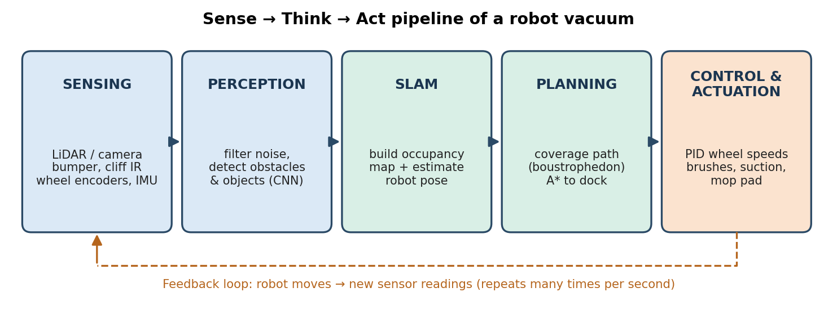
Figure 1.1 Working pipeline of a robot vacuum
Step 1: Sensing the environment
A robot vacuum carries several types of sensors, each solving a different problem:
Sensor | What it measures | Purpose
LiDAR / Laser Distance Sensor (LDS) | 360° distance to walls and furniture using a rotating laser | Accurate mapping and localization, works in the dark
Camera (vSLAM / AI camera) | Images of the ceiling, walls or the floor ahead | Visual mapping and object recognition
Structured light / 3D ToF | Depth of small objects in front of the robot | Avoid low obstacles such as cables and shoes
Bump sensor | Physical contact with an obstacle | Last-resort collision detection
Cliff sensors (IR) | Distance to the floor below the robot | Prevent falling down stairs
Wall / edge sensor | Distance to a wall on the side | Clean close along walls
Wheel encoders + IMU (gyroscope) | Wheel rotation and turning rate | Odometry: estimate how far and in which direction the robot moved
Dirt detection (acoustic / optical) | Amount of debris being picked up | Clean dirtier spots more thoroughly

Step 2: Localization and mapping (SLAM)
The robot must know where it is and what the room looks like at the same time. SLAM combines odometry (how far the wheels moved) with LiDAR or camera observations to build an occupancy grid map (each cell marked free, occupied or unknown) and to correct the robot's estimated position as it moves.
Step 3: Planning the cleaning path
Using the map, a coverage path planning algorithm decides a route that passes over every reachable part of the floor, while a point-to-point planner (such as A*) finds the shortest path to a specific room, back to an unfinished area, or back to the charging dock.
Step 4: Obstacle avoidance and control
While following the plan, the robot reacts to obstacles detected in real time. A motion controller (commonly a PID controller) converts the desired path into left and right wheel speeds, while the brushes and suction fan perform the actual cleaning.
Step 5: Docking and recharging
When the battery is low or cleaning is complete, the robot plans a path to the dock and aligns using infrared signals from the dock. Many robots then resume cleaning from where they stopped, which is only possible because they have a map.

Analysis of Algorithms –
a. Localization and Mapping (SLAM) Algorithms -
SLAM is the core technology that separates modern map-based robots from early random robots. The main families of SLAM algorithms are:
Algorithm | Approach | Strengths | Limitations
EKF-SLAM | Extended Kalman Filter tracks the robot pose and landmark positions together | Simple, well studied | Cost grows quickly with the number of landmarks
Particle filter SLAM (FastSLAM, GMapping) | Many particles, each a guess of the robot's path with its own map | Handles non-linear motion; popular with 2D LiDAR | Needs many particles in large areas
Graph-based SLAM (Google Cartographer, SLAM Toolbox) | Poses are nodes, measurements are edges; the graph is optimised and loops are closed | Accurate, large maps, loop closure | More computation
Visual SLAM (ORB-SLAM) | Tracks visual features across camera frames | Cheap sensor; rich information | Sensitive to lighting and blank walls

In consumer robots, the choice of SLAM mainly depends on the main sensor:
 | Gyro / odometry only | Camera-based vSLAM | LiDAR SLAM
Map quality | Rough or none | Good | Very good
Works in the dark | Yes | Limited | Yes
Cost | Lowest | Low–medium | Medium
Object recognition | No | Yes (with AI) | No (needs an extra camera or 3D sensor)
Typical use | Budget robots | Mid-range robots, AI obstacle avoidance | Most mid- to high-end robots today

Many current high-end robots use a hybrid of LiDAR for mapping and a front camera or 3D sensor for recognising small obstacles.
b. Coverage Path Planning Algorithms -
Coverage path planning (CPP) aims to pass the cleaning head over every reachable part of the floor with as little overlap and travel as possible. The four classic patterns are shown below.
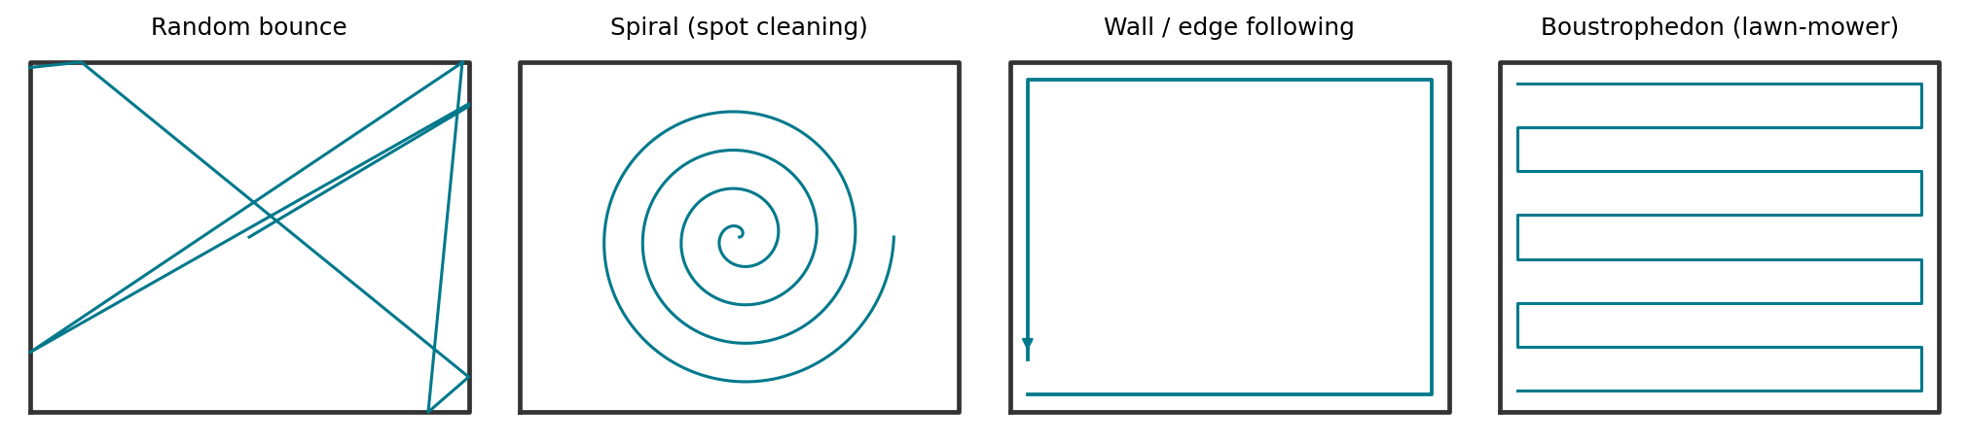
Figure 1.2 Common coverage patterns used by cleaning robots
Pattern | How it works | Needs a map? | Remarks
Random bounce | Drive straight; on bump, turn to a random angle | No | Very simple and cheap; heavy overlap, slow to reach full coverage
Spiral | Expanding spiral from a point | No | Good for spot cleaning of a dirty patch
Wall / edge following | Keep a wall on one side | No | Cleans edges and helps escape rooms
Boustrophedon (lawn-mower) | Parallel back-and-forth lanes; the map is split into cells, each cell is cleaned in lanes (Boustrophedon Cellular Decomposition) | Yes | Near-complete coverage with minimal overlap; used by most modern map-based robots

Early robots combined random bounce, spiral and wall following as simple behaviours that were switched based on time and sensor events. Map-based robots split the map into rooms (room segmentation) and clean each room in boustrophedon lanes.
c. Point-to-Point Path Planning Algorithms -
Algorithm | Idea | Use in cleaning robots
Dijkstra | Expands nodes in order of distance from the start; guarantees the shortest path | Shortest routes on a grid map; explores in all directions
A* | Dijkstra + a heuristic h(n) (estimated distance to goal); f(n) = g(n) + h(n) | Return to dock, travel to a selected room; faster than Dijkstra
D* Lite | Incremental re-planning when the map changes | Re-plan quickly when a new obstacle blocks the path
BFS / wavefront | Spreads outward from the goal on a grid | Find the nearest uncleaned area

d. Obstacle Detection and Avoidance -
- Reactive (rule-based): bump, cliff and wall sensors trigger simple rules such as stop, reverse and turn. These are reliable but only act after contact or when very close.
- Geometric (3D sensing): structured light or 3D ToF sensors measure the shape of objects in front of the robot so it can steer around low obstacles.
- Learning-based (AI vision): a front camera with a convolutional neural network (CNN) object detector (YOLO / MobileNet-style models) classifies objects such as cables, socks, shoes and pet waste, so the robot can avoid them and mark them on the map. For example, iRobot's Roomba j7 series uses a front camera for this, marketed as PrecisionVision navigation.
e. Motion Control -
A PID (Proportional–Integral–Derivative) controller adjusts the wheel speeds so that the robot follows the planned lane or keeps a constant distance to the wall. A differential-drive robot turns by rotating its two wheels at different speeds.

Tools and Software –
Tool | Category | Use in cleaning-robot development
ROS / ROS 2 | Robotics middleware | Connects sensors, SLAM, planners and motor drivers as nodes
Nav2 (ROS 2 Navigation) | Navigation stack | Path planning, obstacle avoidance and recovery behaviours
Gazebo | 3D simulator | Test robots in virtual homes before using real hardware
SLAM Toolbox, Cartographer, GMapping | SLAM libraries | Build 2D maps from LiDAR data
OpenCV | Computer vision library | Image processing and visual features for vSLAM
TensorFlow Lite / PyTorch / ONNX Runtime | Deep learning | Train and run object detectors on the robot
Python, C++, MATLAB | Programming | Algorithm prototyping (Python/MATLAB) and real-time code (C++)
NumPy + Matplotlib | Simulation | Used in this study for the coverage simulation

Simulation and Analysis –
To compare the coverage algorithms, a simple grid-based simulation was written in Python (NumPy and Matplotlib).
a. Simulation Setup -
- Environment: a 40 × 30 cell floor plan with two rooms connected by a doorway, containing a sofa, a table, a cabinet and two chairs as obstacles. Each cell is one robot width (about 30 cm), so the area is roughly 12 m × 9 m, with 957 free cells to clean.
- Start position: the charging dock in the bottom-left corner.
- Algorithms compared: (1) random bounce, (2) a behaviour mix of spiral, wall following and random bounce, and (3) map-based boustrophedon lanes that jump to the nearest uncleaned area (found with BFS) when a lane ends.
- Runs: the two random strategies were run 20 times each (results averaged) because they give different results each time; boustrophedon is deterministic, so one run was enough. Each run was limited to 6,000 steps.
- Metrics: percentage of floor covered, steps needed to reach 90% and 95% coverage, and redundancy (average number of times each cleaned cell was passed over during the run).
b. Coverage Results -
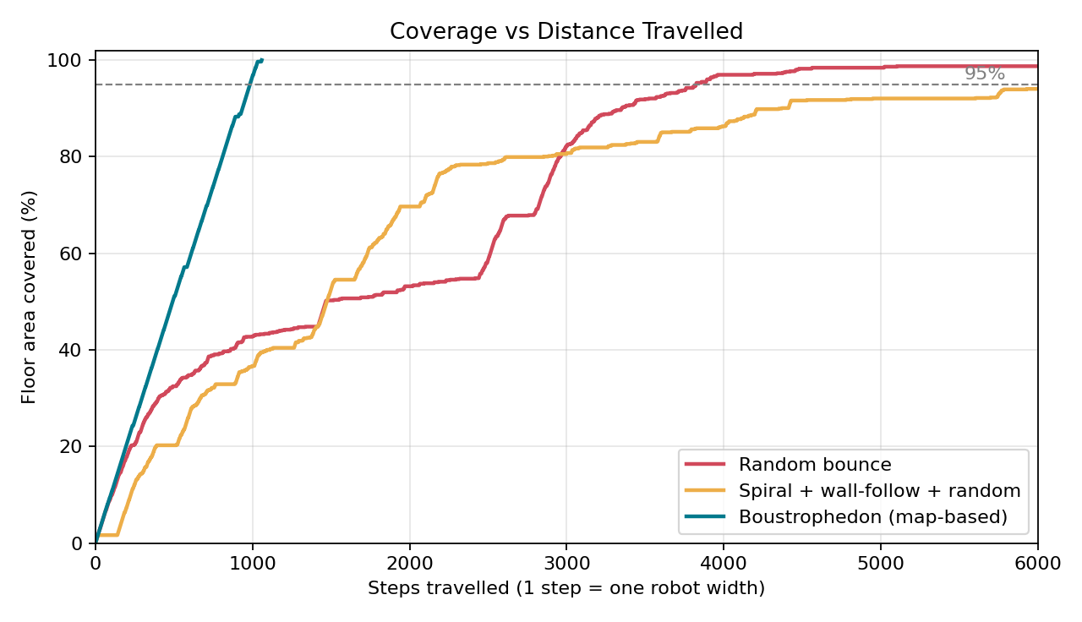
Figure 1.3 Coverage vs distance travelled (one example run of each)
Metric | Random bounce | Spiral + wall + random | Boustrophedon (map)
Coverage after 1,000 steps | 53.7% | 42.4% | 96.8%
Coverage after 3,000 steps | 89.8% | 80.8% | 100.0%
Final coverage (≤ 6,000 steps) | 99.0% | 95.4% | 100.0%
Steps to 90% coverage | 3,040 | Not reached in all runs (19/20) | 936
Steps to 95% coverage | 3,821 | Not reached in all runs (14/20) | 984
Redundancy (passes per cleaned cell) | 6.3× | 6.6× | 1.11×

The map-based boustrophedon planner reached 95% coverage in about 984 steps and cleaned the entire floor in 1,058 steps. Random bounce needed on average 3,821 steps to reach 95% — about 3.9 times longer. The behaviour mix of spiral, wall following and random did not reach 95% in 6 of the 20 runs within the 6,000-step limit.
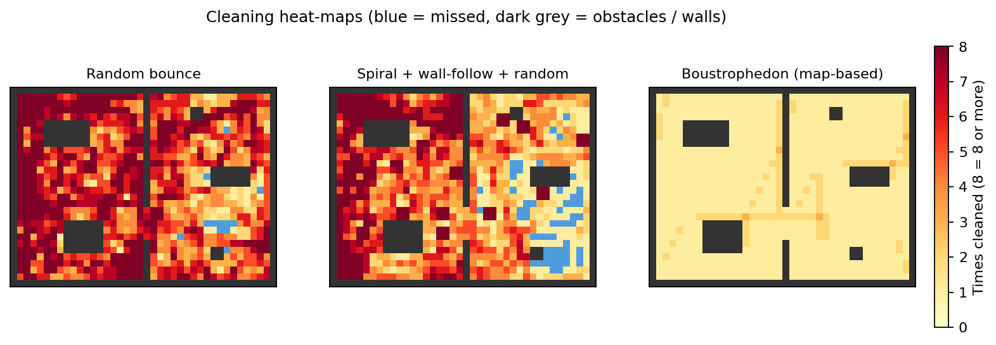
Figure 1.4 Cleaning heat-maps showing how many times each cell was cleaned
The heat-maps show where each algorithm spent its time:
- Random bounce: dark red areas are cleaned 8 or more times, while a few blue cells behind furniture are still missed. The robot spends a long time in the room it starts in before it randomly finds the doorway.
- Spiral + wall + random: wall following keeps re-cleaning the same edges, and the right-hand room has large blue patches that were never reached.
- Boustrophedon: almost every cell is cleaned exactly once (light yellow). The only overlap (redundancy 1.11×) comes from short transit paths between areas.
c. A* Path Planning for Return to Dock -
A* was used to plan a path from the far corner of the right-hand room back to the dock. It was compared with Dijkstra's algorithm on the same map.
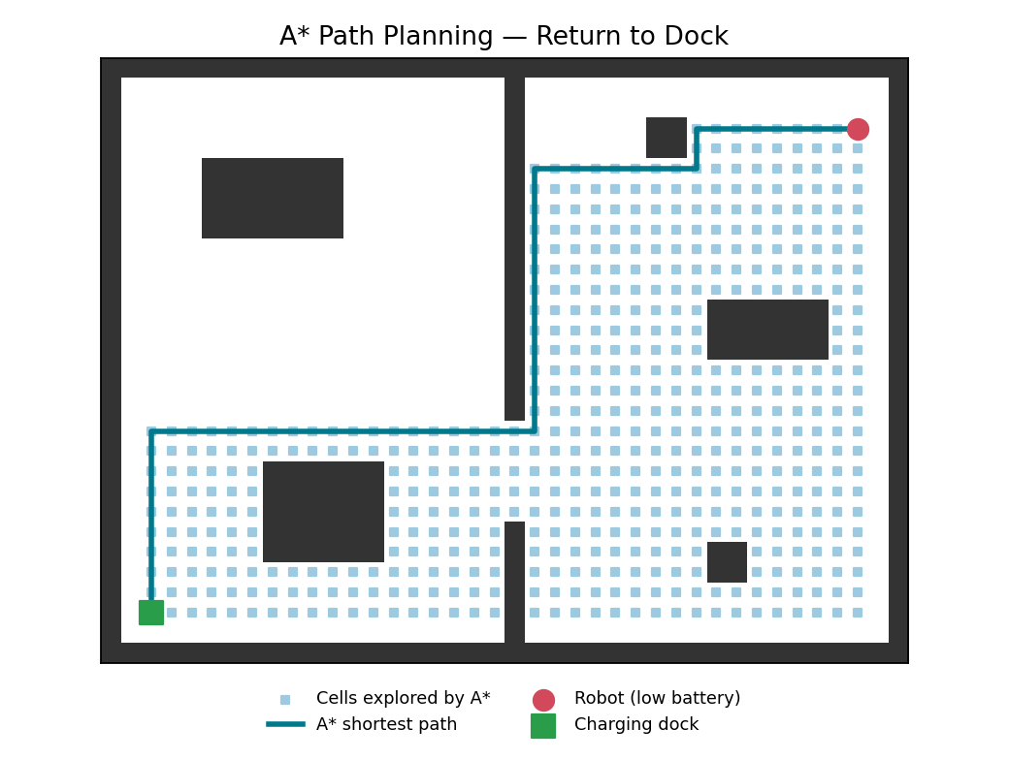
Figure 1.5 A* shortest path from the robot to the charging dock
Algorithm | Path length (cells) | Cells explored
Dijkstra | 59 | 909
A* (Manhattan heuristic) | 59 | 542

Both algorithms found the same shortest path of 59 cells, through the doorway. A* explored 542 cells compared with 909 for Dijkstra, about 40% fewer, because the heuristic directs the search towards the dock. On a robot with a small processor, this saves computation time and energy.

Findings –
1. A map is the biggest improvement. With SLAM and a map, the boustrophedon planner cleaned the same area about 3.9× faster than random bounce and with almost no overlap. This means less battery use, shorter cleaning time and less wear.
2. Random strategies still work, but slowly. Random bounce eventually covered about 99% of the floor, which explains why early robots without maps were useful. However, the time needed is unpredictable, and areas behind furniture or in other rooms are often cleaned last.
3. More behaviours do not always help without a map. The spiral + wall + random mix was not better than pure random bounce in this layout because wall following repeatedly cleaned the same edges.
4. Heuristic search saves computation. A* found the same shortest path as Dijkstra while exploring about 40% fewer cells.
5. Sensors decide what the robot can do. LiDAR gives accurate maps, cameras with AI enable object recognition, and simple IR/bump sensors are still needed for safety (cliffs and collisions).

Challenges and Future Scope –
- Clutter and small objects: cables, socks and pet waste remain difficult; better AI object detection and 3D sensing are active areas of development.
- Dynamic environments: people, pets and moved furniture change the map; the robot must re-plan (e.g. D* Lite) and update the map over time.
- Privacy: camera-based robots capture images inside homes, so on-device processing and data protection are important.
- Reflective and dark surfaces: mirrors, glass and black carpets can confuse LiDAR and cliff sensors.
- Future directions: multi-floor mapping, cooperation between several robots, reinforcement learning for adaptive cleaning, and voice/app integration with smart homes.

Conclusion –
Robot vacuum cleaners are a practical example of autonomous mobile robotics in everyday life. They work through a sense → think → act loop that combines sensors, SLAM, path planning, obstacle avoidance and motion control. The analysis and simulation in this study show that the move from random navigation to map-based SLAM with boustrophedon coverage is the most important improvement: it cleans the same area several times faster with almost no repetition, and A* planning allows the robot to return to its dock efficiently. Open-source tools such as ROS 2, Nav2, Gazebo and SLAM Toolbox make it possible to develop and test these algorithms before deploying them on real robots.

Note on the Simulation –
The simulation is a simplified 2D grid model: the robot is one cell wide, sensing is perfect and wheel slip is ignored. The numbers are therefore useful for comparing algorithms under the same conditions, not as measurements of any commercial robot.

References –
[1] H. Choset and P. Pignon, “Coverage Path Planning: The Boustrophedon Cellular Decomposition,” Field and Service Robotics, Springer, 1998.
[2] H. Choset, “Coverage of Known Spaces: The Boustrophedon Cellular Decomposition,” Autonomous Robots, vol. 9, no. 3, pp. 247–253, 2000.
[3] S. Thrun, W. Burgard and D. Fox, Probabilistic Robotics, MIT Press, 2005.
[4] G. Grisetti, C. Stachniss and W. Burgard, “Improved Techniques for Grid Mapping with Rao-Blackwellized Particle Filters,” IEEE Transactions on Robotics, 2007 (GMapping).
[5] W. Hess, D. Kohler, H. Rapp and D. Andor, “Real-Time Loop Closure in 2D LIDAR SLAM,” IEEE ICRA, 2016 (Cartographer).
[6] R. Mur-Artal, J. M. M. Montiel and J. D. Tardós, “ORB-SLAM: A Versatile and Accurate Monocular SLAM System,” IEEE Transactions on Robotics, 2015.
[7] P. E. Hart, N. J. Nilsson and B. Raphael, “A Formal Basis for the Heuristic Determination of Minimum Cost Paths,” IEEE Transactions on Systems Science and Cybernetics, 1968 (A*).
[8] iRobot, “Camera, PrecisionVision™, and Obstacle Image Review,” iRobot Home Support.
[9] TechRadar, “LiDAR vs vSLAM: which robot vacuum navigation technology is better?”

