Case Study: El Niño and La Niña
Name | Abinaya S
Roll No | CB.SC.P2AIE26002

I. El Niño and La Niña (ENSO)

What are El Niño and La Niña?
- El Niño and La Niña are the warm and cold phases of a natural climate pattern in the tropical Pacific Ocean called the El Niño–Southern Oscillation (ENSO). "El Niño" (Spanish for "the little boy") was named by Peruvian fishermen who noticed warm coastal water around Christmas.
- El Niño: the central and eastern equatorial Pacific becomes warmer than normal.
- La Niña: the central and eastern equatorial Pacific becomes colder than normal.
- Neutral: conditions close to the long-term average.
- ENSO is a coupled ocean–atmosphere system: the ocean temperature changes the winds, and the winds in turn change the ocean. The "Southern Oscillation" is the see-saw in air pressure between Tahiti and Darwin (Australia), measured by the Southern Oscillation Index (SOI).

Why study El Niño and La Niña?
 | El Niño | La Niña
Equatorial Pacific SST | Warmer than normal (≥ +0.5 °C) | Colder than normal (≤ −0.5 °C)
Trade winds | Weaken or reverse | Strengthen
Indian monsoon | Often weaker, higher risk of drought | Often normal or above-normal rainfall
Australia / Indonesia | Drier, higher bushfire risk | Wetter, flooding risk
Peru / Ecuador | Heavy rain and floods; fisheries collapse | Drier; strong upwelling helps fisheries
Global temperature | Tends to raise global average temperature | Tends to lower it slightly
Typical duration | 9–12 months, recurs every 2–7 years | 1–3 years (can last several years)

Because ENSO affects rainfall, agriculture, water supply, fisheries, disease outbreaks and disaster planning around the world, predicting it months in advance has large economic and social value. For India, El Niño years are closely watched because of their association with weaker monsoons.

How do El Niño and La Niña work?
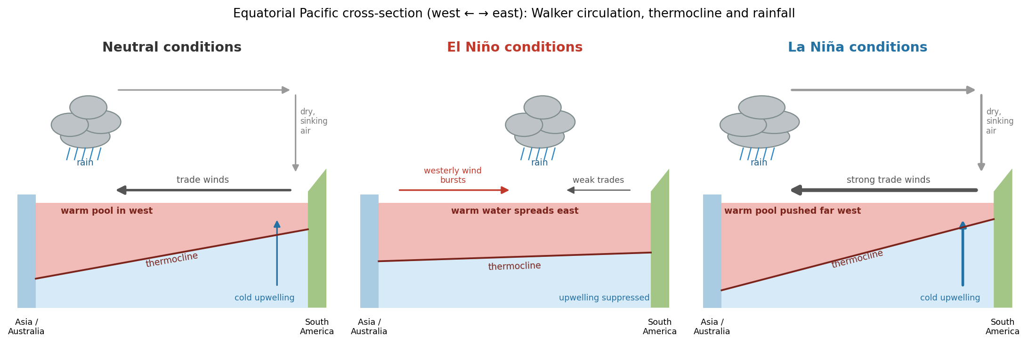
Figure 1.1 Ocean and atmosphere in neutral, El Niño and La Niña conditions
Neutral conditions
The trade winds blow from east to west along the equator. They push warm surface water towards Indonesia and Australia, creating a warm pool in the west and a deep thermocline (the boundary between warm surface water and cold deep water). In the east, cold water rises to the surface near South America (upwelling). Warm water in the west causes rising air and heavy rain; the air returns eastward aloft and sinks over the dry eastern Pacific. This loop is the Walker circulation.
El Niño
The trade winds weaken (sometimes with bursts of westerly wind). Warm water flows back towards the central and eastern Pacific, the thermocline flattens and upwelling of cold water is suppressed. The area of rising air and rainfall moves east, so rainfall increases over Peru and the central Pacific but decreases over Indonesia, Australia and often India.
La Niña
The trade winds become stronger than normal. More warm water piles up in the west, upwelling in the east strengthens and the eastern Pacific becomes colder. Rainfall increases over Indonesia and Australia, while the eastern Pacific becomes drier.
Feedback that drives ENSO (Bjerknes feedback)
A warmer east reduces the east–west temperature difference, which weakens the trade winds, which warms the east further. This positive feedback grows an El Niño. Slow ocean waves (Kelvin and Rossby waves) that travel along the thermocline eventually reverse the anomaly, which is why ENSO swings between warm and cold phases every few years.
How ENSO is measured
Index | Definition | Used for
Niño 3.4 | SST anomaly in 5°N–5°S, 170°W–120°W | Main index for official ENSO monitoring
ONI (Oceanic Niño Index) | 3-month running mean of Niño 3.4 anomaly; El Niño ≥ +0.5 °C, La Niña ≤ −0.5 °C for at least 5 overlapping seasons | NOAA's official El Niño / La Niña definition
Niño 1+2 | SST in 0–10°S, 90°W–80°W (coast of Peru/Ecuador) | Coastal El Niño; used in this study
SOI | Pressure difference Tahiti − Darwin | Atmospheric side of ENSO
Relative ONI (RONI) | ONI adjusted for tropical-wide warming | Newer NOAA index that separates ENSO from global warming

Current situation (September 2026)
According to NOAA's ENSO diagnostic discussion issued on 10 September 2026, an El Niño Advisory is in effect. El Niño is strengthening, with the Niño 3.4 anomaly reaching about +1.8 °C, and NOAA gives a greater than 90% chance of a very strong event during the Northern Hemisphere fall and winter 2026–27.

Machine Learning in El Niño and La Niña –
ENSO has traditionally been forecast using two kinds of models: dynamical models (physics-based coupled ocean–atmosphere general circulation models) and statistical models (regression on past observations). Machine learning adds a third approach that learns patterns directly from large amounts of climate data.
a. Types of ML tasks for ENSO -
Task | Input | Output | ML type
Index forecasting | Past SST, heat content, wind maps or index values | Niño 3.4 value 1–24 months ahead | Regression
Phase classification | Same as above | El Niño / Neutral / La Niña | Classification
Event type | SST patterns | Eastern-Pacific vs Central-Pacific El Niño | Classification / clustering
Impact prediction | ENSO indices + local data | Monsoon rainfall, crop yield, fish catch | Regression
Explainability | Trained model | Which regions/variables act as precursors | Explainable AI (XAI)

b. ML models used for ENSO -
Model | How it is used for ENSO | Strengths / weaknesses
Linear / ridge regression | Predict a Niño index from lagged index values | Simple, interpretable baseline; cannot capture non-linearity
Random forest, gradient boosting (XGBoost) | Tabular features: lagged indices, wind, heat content | Handle non-linearity; need hand-made features
Artificial neural network (MLP) | Non-linear mapping of predictors to the index | Flexible; can overfit small datasets
CNN (Convolutional Neural Network) | Learns spatial patterns from global SST and ocean heat content maps | Ham, Kim & Luo (Nature, 2019): skilful forecasts up to about 1.5 years ahead
LSTM / ConvLSTM | Learn how patterns evolve over time | Capture temporal memory; data hungry
Transformer (e.g. 3D-Geoformer) | Self-attention over 3D ocean temperature and wind fields | Zhou & Zhang (Science Advances, 2023); strong long-lead skill
Graph neural network | Treats ocean grid points as connected nodes | Captures long-distance links (teleconnections)

c. Key research example: CNN for multi-year ENSO forecasts -
- Ham, Kim and Luo (2019) trained a CNN on SST and ocean heat content maps from CMIP5 climate model simulations, then fine-tuned it on observed reanalysis data (transfer learning). This addressed the main problem in ENSO ML: only about 150 years of observations, which is too little to train deep networks.
- The CNN kept a useful correlation skill (above 0.5) for Niño 3.4 at lead times of up to about 17 months, longer than the leading dynamical forecast systems in their comparison.
- Heat-map analysis of the CNN showed which ocean regions it relied on, helping scientists identify ENSO precursors.
d. Challenges of ML for ENSO -
- Small data: only a few dozen El Niño and La Niña events have been observed, so models easily overfit.
- Spring predictability barrier: forecasts made in northern spring (March–May) lose skill quickly, because ENSO is weakest and most sensitive to random weather at that time.
- Non-stationarity: climate change and decade-to-decade variations change ENSO behaviour over time.
- Data leakage: careless preprocessing (for example, computing anomalies or scaling with future data) gives unrealistically good results.
- Interpretability: scientists and forecasters need to understand why a model predicts an event.

Tools used for El Niño and La Niña –
Category | Tool / Dataset | Purpose
Ocean observations | TAO/TRITON moored buoy array | Real-time temperature and winds along the equatorial Pacific
 | Argo profiling floats | Temperature and salinity down to 2,000 m (ocean heat content)
 | Satellites (SST, sea level, winds) | Global coverage of the ocean surface
Datasets | NOAA ERSST v5, HadISST, OISST | Historical and current sea surface temperature
 | NCEP/NCAR, ERA5, GODAS reanalysis | Consistent 3D atmosphere and ocean fields
 | CMIP5 / CMIP6 climate model outputs | Thousands of simulated years for training deep learning models
Indices / forecasts | NOAA CPC ONI & ENSO discussions, IRI ENSO forecast plume, BoM, IMD | Official monitoring, outlooks and probabilities
Programming | Python: NumPy, pandas, xarray, netCDF4 | Read and process gridded climate data
 | Cartopy, Matplotlib | Maps and plots
ML frameworks | scikit-learn, XGBoost | Classical ML models
 | TensorFlow / Keras, PyTorch | Deep learning (CNN, LSTM, Transformer)
Other | Google Colab, Jupyter, CDO/NCO | Notebooks, GPUs and command-line climate data tools

Connecting Machine Learning and El Niño / La Niña –
ENSO forecasting maps naturally onto a supervised machine-learning problem:
ML concept | ENSO equivalent
Features (X) | Past SST anomalies, ocean heat content, wind stress, month of the year
Target (y) | Future Niño index value (regression) or phase label (classification)
Label definition | ONI-style rule: El Niño ≥ +0.5 °C, La Niña ≤ −0.5 °C for ≥ 5 overlapping seasons
Time-series split | Train on older years, test on later years (never shuffle randomly)
Baseline | Persistence (the future equals the present) and climatology
Lead time | How many months ahead the prediction is made
Evaluation metrics | Correlation (r), RMSE, accuracy, F1-score, skill vs lead time
Transfer learning | Pre-train on climate model simulations, fine-tune on observations
Explainability | Feature importance and saliency maps reveal physical precursors

The physics also guides feature design. For example, ocean heat content (thermocline depth) in the western Pacific is known to lead surface temperature changes by several months (the "recharge oscillator" theory), so it is a valuable predictor for long-lead forecasts. ML contributes by finding non-linear combinations of such predictors, while physical knowledge helps avoid spurious patterns.

Implementation –

Forecasting El Niño and La Niña with Machine Learning –
Dataset: NOAA ERSST v3b – Niño 1+2 sea surface temperature
The dataset contains the monthly average sea surface temperature (°C) in the Niño 1+2 region (0–10°S, 90°W–80°W, off the coast of Peru and Ecuador) from 1950 to 2010, published by NOAA and distributed with the Python statsmodels library.
a. Understanding the Dataset -
Dataset shape: (61, 13) — one row per year with 12 monthly columns. After reshaping into a single time series, there are 732 monthly values with 0 missing values. The mean SST is 23.09 °C, ranging from 18.95 °C (Sep 1954, La Niña) to 29.24 °C (Mar 1998, during the 1997–98 El Niño).
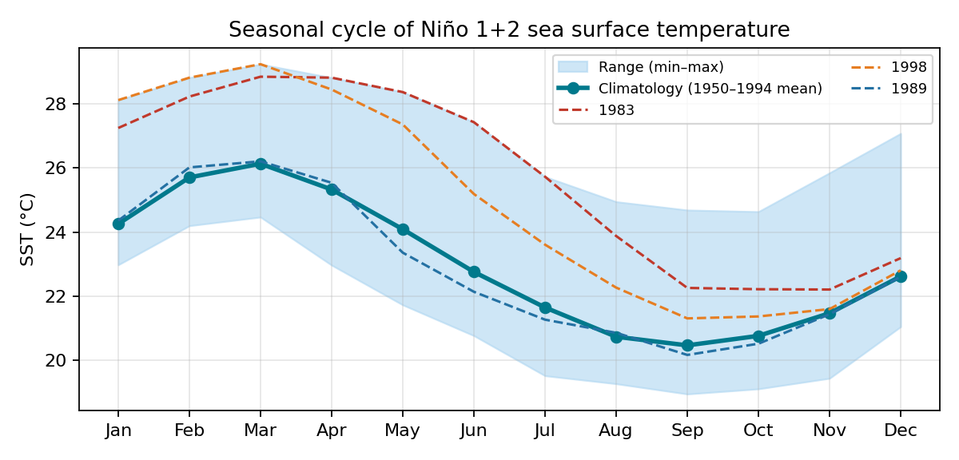
Figure 1.2 Seasonal cycle of Niño 1+2 SST with example El Niño and La Niña years
The region has a strong seasonal cycle: it is warmest in March (about 26.1 °C) and coolest in September (about 20.5 °C). This ~5.7 °C seasonal swing is larger than most ENSO anomalies, so the seasonal cycle must be removed before El Niño and La Niña can be identified. In the strong El Niño years 1983 and 1998, SST stayed far above normal for most of the year, while in the La Niña year 1989 it stayed below normal.
b. Data preprocessing -
- Reshaping: the year × month table was converted into one continuous monthly time series.
- Anomalies: the monthly climatology (average SST for each calendar month) was calculated using only the training period (1950–1994) and subtracted from every value. Using only training data prevents information from the test period leaking into the model.
- ONI-style smoothing and labelling: a 3-month running mean of the anomaly was computed. Months were labelled El Niño (≥ +0.5 °C) or La Niña (≤ −0.5 °C) if the threshold was exceeded for at least 5 consecutive months, and Neutral otherwise.
This labelling produced 365 Neutral, 195 El Niño and 172 La Niña months, containing 19 El Niño and 17 La Niña events.
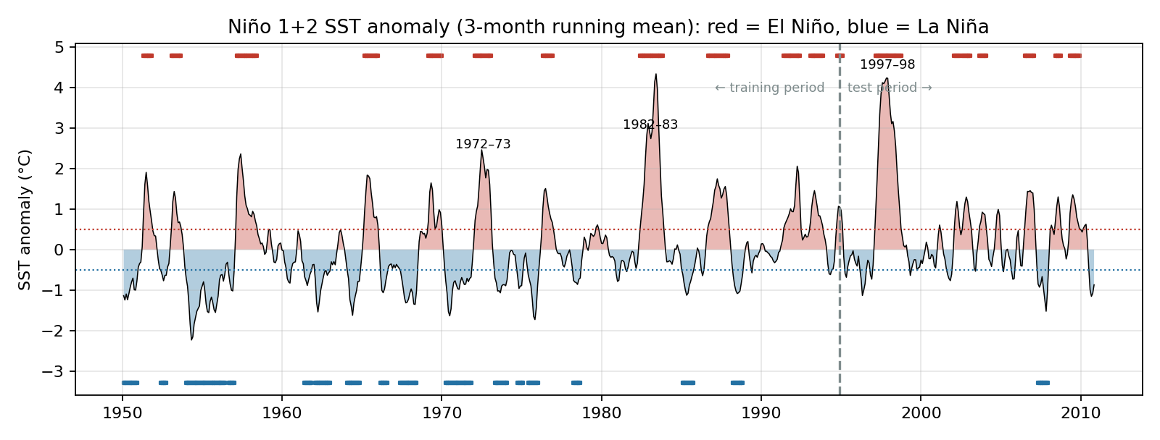
Figure 1.3 Niño 1+2 SST anomaly with detected El Niño (red) and La Niña (blue) periods
Rank | Event | Period | Duration (months) | Peak anomaly (°C)
1 | El Niño | Jun 1982 – Nov 1983 | 18 | +4.34
2 | El Niño | Mar 1997 – Oct 1998 | 20 | +4.24
3 | El Niño | Feb 1972 – Feb 1973 | 13 | +2.46
4 | El Niño | Mar 1957 – Jun 1958 | 16 | +2.36
5 | La Niña | Jan 1954 – Jun 1956 | 30 | -2.24
6 | El Niño | Jun 1991 – Jun 1992 | 13 | +2.06

The detected events agree with the well-known history of ENSO: the 1982–83 and 1997–98 events are the two strongest El Niños of the 20th century, each with anomalies above +4 °C near the Peruvian coast. This confirms that the preprocessing and labelling are correct.
c. Feature engineering -
For each month t, 15 features were created:
- Lagged anomalies: the anomaly in the current month and each of the previous 11 months (lag 0 to lag 11).
- Seasonality: sin and cos of the month number, so the model knows the time of year (important because of the spring predictability barrier).
- Trend: the change in anomaly over the last 3 months (warming or cooling).
The target is the SST anomaly at month t + lead, for leads of 1, 2, 3, 4, 5, 6, 9 and 12 months. Data was split chronologically: training on 1950–1994 and testing on 1995–2010 (about 526 training and 189 testing samples at a 3-month lead). The test period contains the 1997–98 super El Niño, which the models never saw during training.
d. Models -
Model | Configuration
Persistence (baseline) | Forecast = current anomaly (no learning)
Ridge regression | StandardScaler + Ridge (α = 1.0)
Random forest | 400 trees, min_samples_leaf = 5
Neural network (MLP) | StandardScaler + MLP with hidden layers (32, 16), L2 = 0.01, early stopping

e. Forecast results (regression) -
Lead | Persistence r / RMSE | Ridge r / RMSE | Random forest r / RMSE | MLP r / RMSE
1 mo | 0.91 / 0.49 | 0.92 / 0.47 | 0.90 / 0.51 | 0.89 / 0.54
3 mo | 0.66 / 0.98 | 0.68 / 0.89 | 0.61 / 0.96 | 0.63 / 0.95
6 mo | 0.40 / 1.30 | 0.47 / 1.08 | 0.37 / 1.15 | 0.41 / 1.11
9 mo | 0.14 / 1.56 | 0.32 / 1.20 | 0.31 / 1.20 | 0.21 / 1.21
12 mo | -0.06 / 1.74 | 0.30 / 1.24 | 0.29 / 1.24 | 0.10 / 1.30

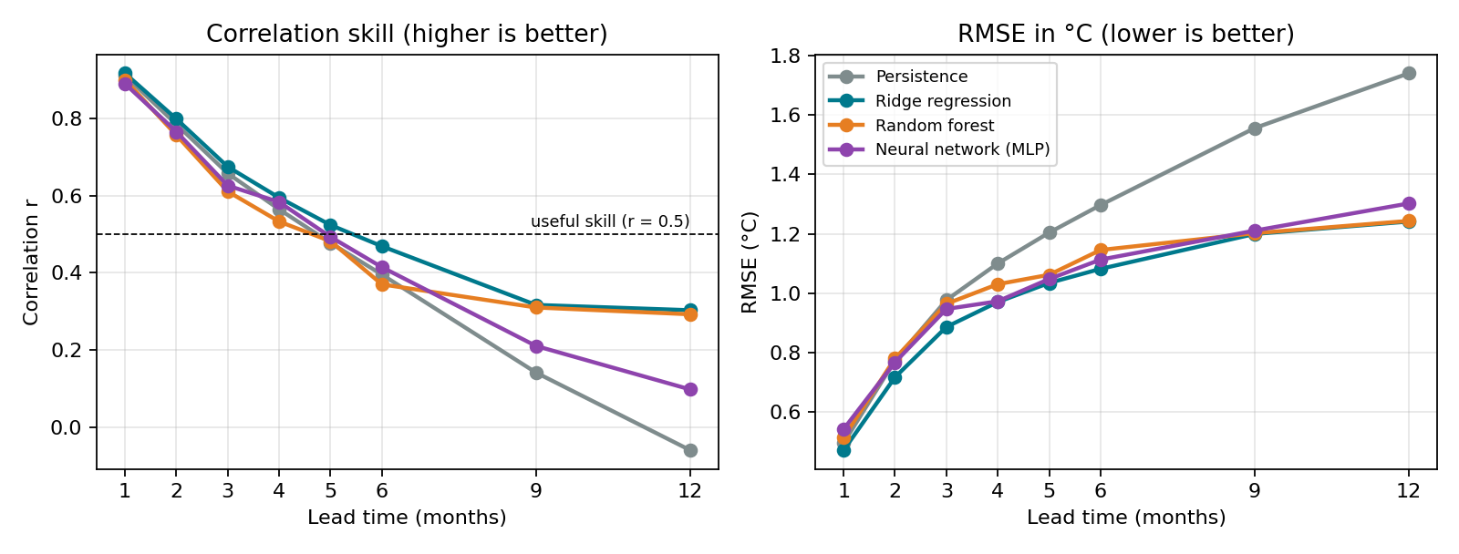
Figure 1.4 Forecast skill of each model as the lead time increases
At a 1-month lead, all models have high correlation (about 0.91) because the ocean changes slowly and persistence is already a strong forecast. As the lead time increases, persistence loses skill quickly: its correlation falls to 0.40 at 6 months and about zero at 12 months.
Ridge regression gave the best overall results. At a 6-month lead it achieved r = 0.47 and RMSE = 1.08 °C, compared with r = 0.40 and RMSE = 1.30 °C for persistence. At 12 months, it reduced the RMSE from 1.74 °C to 1.24 °C. The random forest and MLP were similar to or slightly worse than ridge regression: with only a few hundred training samples, the extra flexibility of these models is not fully used and they are more prone to overfitting.
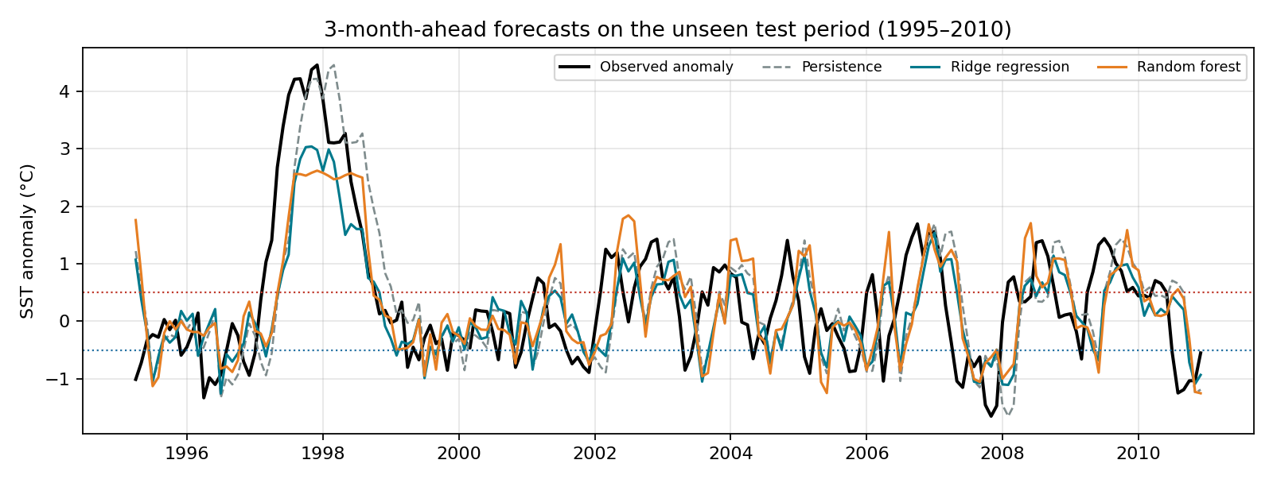
Figure 1.5 3-month-ahead forecasts compared with the observed anomaly in the test period
The forecasts follow the major events in the test period, including the 1997–98 El Niño, the 2007–08 La Niña and the 2009–10 El Niño. However, all ML models underestimated the peak of the 1997–98 event: the observed peak was +4.46 °C (Dec 1997), while ridge regression predicted at most +3.04 °C and the random forest +2.62 °C. A random forest cannot predict values outside the range seen in training, and such an extreme event is rare in the training data. Persistence reproduces the peak value but always 3 months late, which is not useful as an early warning.
In the random forest (3-month lead), the most important feature was the current anomaly (importance 0.63), followed by anomalies 5–7 months earlier and the 3-month trend. This matches the physical understanding that ENSO has strong memory, and that the recent direction of change helps predict whether an event is growing or decaying.
f. Phase classification (El Niño / Neutral / La Niña) -
The same features were used to predict the phase label 3 and 6 months ahead. Three approaches were compared: persistence (the phase given by the current 3-month mean anomaly), ridge regression followed by the ±0.5 °C threshold, and a random forest classifier with balanced class weights.
Method | Accuracy (3 mo) | Macro F1 (3 mo) | Accuracy (6 mo) | Macro F1 (6 mo)
Persistence (current phase) | 58.5% | 0.48 | 44.9% | 0.33
Ridge regression + threshold | 65.4% | 0.54 | 62.2% | 0.47
Random forest classifier | 64.4% | 0.54 | 56.8% | 0.45

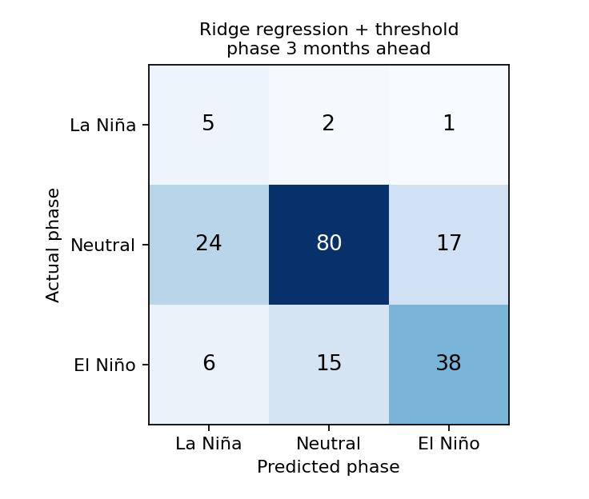
Figure 1.6 Confusion matrix of ridge regression + threshold for the phase 3 months ahead
Both ML approaches were more accurate than persistence at both lead times. At a 6-month lead, ridge + threshold reached 62.2% accuracy compared with 44.9% for persistence. From the confusion matrix (3-month lead), 38 of 59 El Niño months and 5 of 8 La Niña months were correctly identified, while most errors came from Neutral months predicted as La Niña (24) or El Niño (17).
The test period contains only 8 La Niña months out of 188, so the La Niña results are based on very few examples. This is a typical difficulty in ENSO machine learning: rare events and small datasets make evaluation noisy.
g. Key code (simplified) -
import statsmodels.api as sm, pandas as pd, numpy as np
from sklearn.linear_model import Ridge
from sklearn.preprocessing import StandardScaler
from sklearn.pipeline import make_pipeline

raw = sm.datasets.elnino.load_pandas().data # 61 years x 12 months
sst = reshape_to_monthly_series(raw) # 732 monthly values
clim = sst[:'1994'].groupby(sst[:'1994'].index.month).mean() # train-only climatology
anom = sst - clim.reindex(sst.index.month).values

X = pd.DataFrame({f'lag{k}': anom.shift(k) for k in range(12)})
X['month_sin'] = np.sin(2*np.pi*anom.index.month/12)
X['month_cos'] = np.cos(2*np.pi*anom.index.month/12)
X['trend3'] = anom - anom.shift(3)
y = anom.shift(-lead) # value 'lead' months ahead

train, test = (X.index <= '1994-12'), (X.index > '1994-12') # chronological split
model = make_pipeline(StandardScaler(), Ridge(alpha=1.0)).fit(X[train], y[train])
pred = model.predict(X[test])

Findings –
1. ML beats the persistence baseline at longer leads. Ridge regression reduced the 6-month RMSE from 1.30 °C to 1.08 °C and kept a positive correlation (0.30) at 12 months, where persistence has none.
2. Simple models can be as good as complex ones on small datasets. With about 45 years of training data from a single index, ridge regression performed as well as or better than the random forest and MLP. Deep learning becomes useful when large datasets (climate model simulations, full 3D ocean fields) are available.
3. Extreme events are hard to predict. All ML models underestimated the 1997–98 super El Niño, because such events are rare in the training data.
4. Correct preprocessing matters. Computing anomalies and labels without using future data, and splitting the data chronologically, are essential for a fair evaluation.
5. Physics and ML complement each other. The most important features (current anomaly, recent trend, seasonality) match known ENSO behaviour, and adding physical predictors such as ocean heat content and winds is the natural next step to extend forecast skill.

Limitations and Future Scope –
- Only one variable (Niño 1+2 SST) was used; adding Niño 3.4, ocean heat content, winds and the SOI would likely improve long-lead forecasts.
- The dataset ends in 2010; newer data (for example the 2015–16 and 2023–24 El Niños and the current 2026 event) would give a larger test set.
- Niño 1+2 is a coastal region; official ENSO status is based on Niño 3.4, so labels here may differ slightly from NOAA's official list.
- Future work: CNN or ConvLSTM models on gridded SST maps, transfer learning from CMIP6 simulations, probabilistic (ensemble) forecasts, and explainable AI to identify precursors.

Conclusion –
El Niño and La Niña are the warm and cold phases of ENSO, a coupled ocean–atmosphere cycle in the tropical Pacific that affects weather, agriculture and economies worldwide, including the Indian monsoon. The Bjerknes feedback grows the events, while slow ocean waves and heat content changes reverse them every few years. Machine learning, from simple regression to CNNs and Transformers, is now an important part of ENSO forecasting, supported by tools such as buoy and satellite observations, reanalysis data, climate model outputs and Python ML libraries. In the small implementation, machine learning models trained on 45 years of NOAA sea surface temperature data forecast the anomaly and the El Niño / La Niña phase better than persistence at longer lead times, while also showing the typical challenges of small data and rare extreme events.

References –
[1] Y.-G. Ham, J.-H. Kim and J.-J. Luo, “Deep learning for multi-year ENSO forecasts,” Nature, vol. 573, pp. 568–572, 2019.
[2] L. Zhou and R.-H. Zhang, “A self-attention–based neural network for three-dimensional multivariate modeling and its skillful ENSO predictions,” Science Advances, 2023.
[3] NOAA Climate Prediction Center, “ENSO Diagnostic Discussion,” issued 10 September 2026.
[4] NOAA Climate Prediction Center, Oceanic Niño Index (ONI) and ENSO indices.
[5] J. Bjerknes, “Atmospheric teleconnections from the equatorial Pacific,” Monthly Weather Review, 1969.
[6] F.-F. Jin, “An equatorial ocean recharge paradigm for ENSO,” Journal of the Atmospheric Sciences, 1997.
[7] IRI – International Research Institute for Climate and Society, ENSO forecast.
[8] statsmodels, “El Niño – Sea Surface Temperatures” dataset (NOAA ERSST v3b, Niño 1+2).

