Machine Learning Case Study
Name | Abinaya S
Roll No | CB.SC.P2AIE26002

I.KNN (K-Nearest Neighbour)

What is KNN?
- K-Nearest Neighbors (KNN) is a supervised machine learning algorithm used for both classification and regression tasks.
- It operates on the principle of proximity, predicting the output for a new data point based on the labels or values of its nearest neighbors in the training dataset.

Why use KNN?
 | Classification | Regression
Output | Class/category | Number
Example | Cat/Dog | House price
KNN uses | Voting  Predicted class = most common class among K neighbours | Averaging  Predicted class = Average of the K neigbours
Prediction | Majority class | Mean of neighbors
Example neighbors | A, A, B, A, B | 10, 20, 30
Prediction | A | 20

How does KNN work?
- K = number of nearest neighbors we consider.
- KNN also called as a Lazy Learner because it does not learn from the training set immediately instead it stores the entire dataset and performs computations only at the time of classification.
Step 1: Choose K
Rules:
- Choosing the right k is important for good results.
- If the data has lots of noise or outliers, using a larger k can make the predictions more stable.
- But if k is too large the model may become too simple and miss important patterns and this is called underfitting.

Methods:
Cross-Validation | Elbow Method | Odd Values for k
Dataset is Divided into K parts  The model is trained on some of these pars and tested in the remaining | Graph is plotted showing the accuracy for different K values.  As K increases the error usually drops at first and gradually stops decreasing | Odd number for k especially in classification problems.  This helps avoid ties.

Step 2: Calculate distance
We need to determine which existing points are closest to the new point.
Methods:
Euclidian Distance | Manhattan Distance | Minkowski Distance
Commonly used  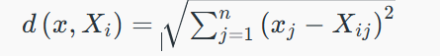 | 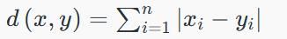 | 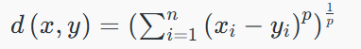

Step 3: Sort the distances and select the nearest neighbours
- The k data points with the smallest distances to the target point are nearest neighbors.
Step 4: Voting for Classification or Taking the Average for Regression
Classification – Majority Voting
Regression – Average
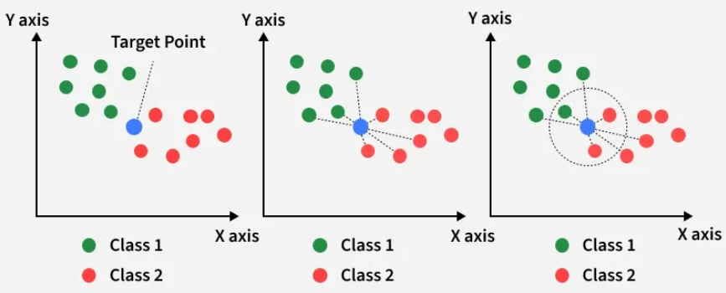
Figure 1.1 Working of KNN

Implementation of KNN-

Classification –
Dataset: Mushroom Classification
This dataset includes descriptions of hypothetical samples corresponding to 23 species of gilled mushrooms in the Agaricus and Lepiota Family Mushroom drawn from The Audubon Society Field Guide to North American Mushrooms (1981).
- Understanding the Dataset -
Attribute | Code | Meaning
Class | e / p | Edible / Poisonous
Cap shape | b, c, x, f, k, s | Bell, Conical, Convex, Flat, Knobbed, Sunken
Cap surface | f, g, y, s | Fibrous, Grooves, Scaly, Smooth
Cap color | n, b, c, g, r, p, u, e, w, y | Brown, Buff, Cinnamon, Gray, Green, Pink, Purple, Red, White, Yellow
Bruises | t, f | Bruises, No bruises
Odor | a, l, c, y, f, m, n, p, s | Almond, Anise, Creosote, Fishy, Foul, Musty, None, Pungent, Spicy
Gill attachment | a, d, f, n | Attached, Descending, Free, Notched
Gill spacing | c, w, d | Close, Crowded, Distant
Gill size | b, n | Broad, Narrow
Gill color | k, n, b, h, g, r, o, p, u, e, w, y | Black, Brown, Buff, Chocolate, Gray, Green, Orange, Pink, Purple, Red, White, Yellow
Stalk shape | e, t | Enlarging, Tapering
Stalk root | b, c, u, e, z, r | Bulbous, Club, Cup, Equal, Rhizomorphs, Rooted
Stalk surface (above ring) | f, y, k, s | Fibrous, Scaly, Silky, Smooth
Stalk surface (below ring) | f, y, k, s | Fibrous, Scaly, Silky, Smooth
Stalk color (above ring) | n, b, c, g, o, p, e, w, y | Brown, Buff, Cinnamon, Gray, Orange, Pink, Red, White, Yellow
Stalk color (below ring) | n, b, c, g, o, p, e, w, y | Brown, Buff, Cinnamon, Gray, Orange, Pink, Red, White, Yellow
Veil type | p, u | Partial, Universal
Veil color | n, o, w, y | Brown, Orange, White, Yellow
Ring number | n, o, t | None, One, Two
Ring type | c, e, f, l, n, p, s, z | Cobwebby, Evanescent, Flaring, Large, None, Pendant, Sheathing, Zone
Spore-print color | k, n, b, h, r, o, u, w, y | Black, Brown, Buff, Chocolate, Green, Orange, Purple, White, Yellow
Population | a, c, n, s, v, y | Abundant, Clustered, Numerous, Scattered, Several, Solitary
Habitat | g, l, m, p, u, w, d | Grasses, Leaves, Meadows, Paths, Urban, Waste, Woods

Dataset shape: (8124, 23); using the pandas library, the first 5 rows are extracted [5 rows x 23 columns]
The target variable, class, contains two categories:
- e – Edible: 4,208 samples
- p – Poisonous: 3,916 samples
The dataset is therefore relatively balanced, with edible mushrooms accounting for approximately 51.8% and poisonous mushrooms approximately 48.2% of the observations.

- Data preprocessing -
Initially, the dataset contained no duplicate rows and no conventional missing values. However, the value “?” was used to represent missing information in the stalk-root attribute. This attribute contained 2,480 missing entries after replacing “?” with NaN.

Since all predictor variables are categorical, they must be converted into numerical representations before applying KNN.
The categorical features were encoded so that Euclidean distance could be calculated between observations.

- Simple KNN Model Development–
The target variable class was separated from the predictor variables, resulting in 22 categorical features and one binary target variable. The dataset was divided into training and testing subsets using an 80:20 split, with random_state=42 and stratification based on the target class. This resulted in 6,499 training samples and 1,625 testing samples.
Since the predictor variables were categorical, a preprocessing pipeline was created using ColumnTransformer. Missing categorical values were handled using most-frequent imputation, followed by One-Hot Encoding.
The preprocessing operations were included within the same pipeline as the KNN classifier to ensure that the preprocessing parameters were learned only from the training data and then applied to the test data.
A K-Nearest Neighbors classifier with (K=5) was used with the Euclidean distance metric. The complete pipeline was fitted using the training data and subsequently used to predict the classes of the unseen test samples.
The model was evaluated using accuracy, precision, recall, F1-score, and a confusion matrix. The KNN model achieved an accuracy of 100% (1.00) on the test set.
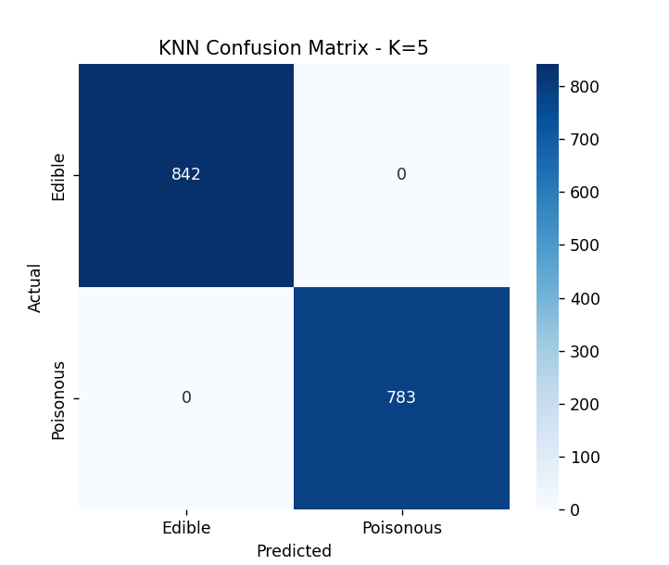
Class | Precision | Recall | F1-score | Samples
Edible | 1.00 | 1.00 | 1.00 | 842
Poisonous | 1.00 | 1.00 | 1.00 | 783
Overall | 1.00 | 1.00 | 1.00 | 1,625

- Accuracy for different K values
To study the effect of the number of nearest neighbors on classification performance, the KNN model was evaluated for values of (K) ranging from 1 to 30.
The results show that the model achieved an accuracy of 1.00 (100%) for (K=1) through (K=9). For (K=10) through (K=25), the accuracy slightly decreased to 0.998154 (99.82%). For (K=26) through (K=30), the accuracy further decreased slightly to 0.997538 (99.75%).
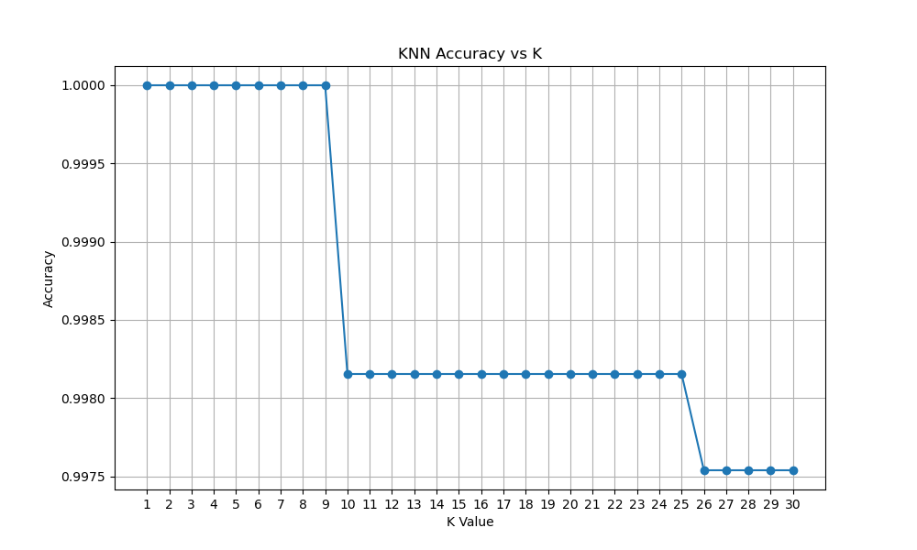

Based on the evaluated test accuracy, the highest accuracy was 1.00, obtained for multiple values of (K) from 1 to 9. The code selected (K=1) as the best (K) because it is the first value achieving the maximum accuracy.
However, since several values of (K) produced the same maximum accuracy, (K=1) should not necessarily be interpreted as uniquely optimal. The results indicate that the model performs equally well on this particular test split for (K=1) through (K=9).
- K Selection Using Cross-Validation
To determine an appropriate value of (K), cross-validation was performed on the training dataset for values of (K) ranging from 1 to 30. The mean cross-validation accuracy and standard deviation were recorded for each value of (K).
The results show that (K=1) achieved the highest mean cross-validation accuracy of 1.0000, with a standard deviation of 0.0000. The next highest performance was obtained for (K=3), with a mean accuracy of 0.999538 and a standard deviation of 0.000923.
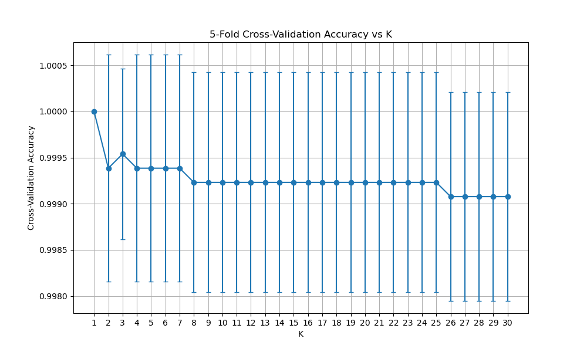

Based on the highest mean cross-validation accuracy, (K=1) was selected as the KNN parameter.
The model using the cross-validation-selected value of (K=1) was then evaluated on the previously unseen test set. It achieved a test accuracy of 1.0 (100%).
Therefore, for this particular train-test split and cross-validation procedure:
- Best (K): 1
- Cross-validation accuracy: 100%
- Test accuracy: 100%
- Cross-validation standard deviation for (K=1): 0.0

- K Selection Using Odd Values of K
To evaluate the effect of using odd values of (K), the KNN classifier was evaluated for odd values of (K) ranging from 1 to 29. Cross-validation accuracy was calculated for each value.
The results show that (K=1) achieved the highest cross-validation accuracy of 1.0 (100%). The accuracy gradually decreased as larger values of (K) were considered, although the overall performance remained above 99.9%.
The best odd value of (K) was therefore selected as (K=1) based on cross-validation performance. When evaluated on the independent test set, the model achieved a test accuracy of 1.0 (100%).
K | CV Accuracy
1 | 1.000000
3 | 0.999538
5 | 0.999385
7 | 0.999385
9 | 0.999231
11 | 0.999231
13 | 0.999231
15 | 0.999231
17 | 0.999231
19 | 0.999231
21 | 0.999231
23 | 0.999231
25 | 0.999231
27 | 0.999077
29 | 0.999077

- K Selection Using the Elbow-Style Method
An elbow-style analysis was performed by plotting the cross-validation accuracy against different values of (K), as shown in the KNN accuracy curve. The purpose of this analysis was to identify a point beyond which increasing (K) produces only marginal changes in classification performance.
The graph shows that the highest cross-validation accuracy occurs at (K=1), followed by a sharp decrease at (K=2). A small increase is observed at (K=3), after which the accuracy remains relatively stable with only minor variations as (K) increases.
Based on the elbow criterion implemented in the experiment, (K=2) was selected as the elbow point. The model using this value was then evaluated on the independent test set and achieved a test accuracy of 1.000000 (100%).
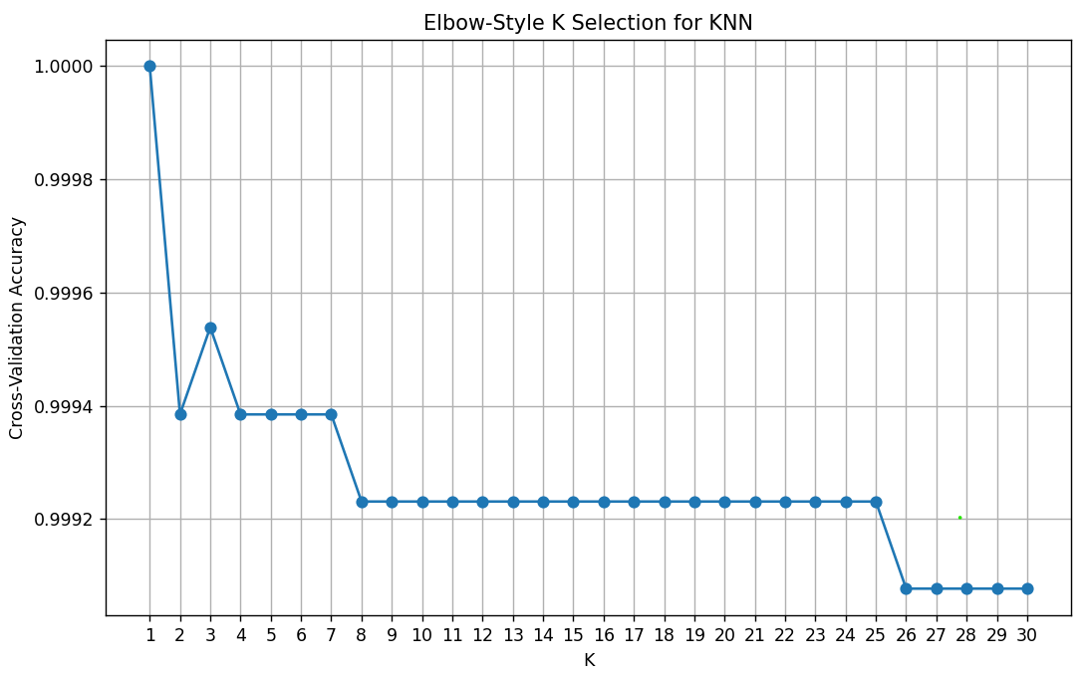
Thus, although (K=2) does not provide the highest cross-validation accuracy, it represents the selected elbow point in the accuracy curve, and it still provides perfect classification accuracy on the test set.
- Comparison of K Selection Methods
Three different approaches were used to select the value of $K$for the KNN classifier: cross-validation, the elbow method, and odd-$K$ selection.
The cross-validation approach selected $K=1$based on the highest mean cross-validation accuracy. The odd-$K$ approach also selected $K=1$. The elbow-style analysis selected $K=2$based on the identified elbow point in the validation-accuracy curve.
Despite the difference in selected values, all three methods achieved a test accuracy of 1.000000 (100%) on the held-out test dataset.
Method | Selected K | Test Accuracy
Cross Validation | 1 | 1.000000
Elbow Method | 2 | 1.000000
Odd K | 1 | 1.000000

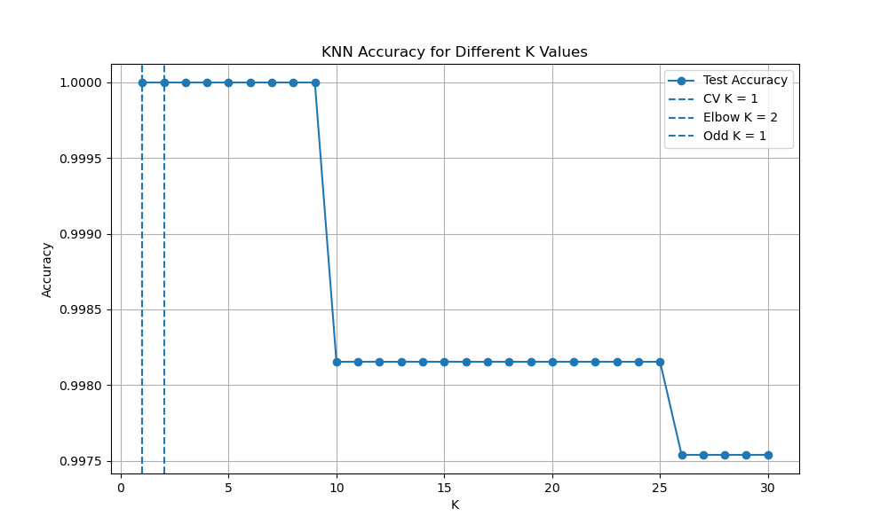

These results indicate that the KNN classifier maintains the same test performance for the $K$values selected by the three methods on this dataset.

