Machine Learning Case Study
Name | Abinaya
Roll No | CB.SC.P2AIE26002

I. Linear Regression

What is Linear Regression?
- Linear Regression is a supervised machine learning algorithm used to predict a continuous numerical output (dependent variable) from one or more input features (independent variables).
- It assumes that the relationship between the inputs and the output can be approximated by a straight line (or a hyperplane when there are several inputs), and it finds the line that best fits the observed data.

Why use Linear Regression?
 | Simple Linear Regression | Multiple Linear Regression
Number of inputs | One independent variable | Two or more independent variables
Model | ŷ = θ₀ + θ₁x | ŷ = θ₀ + θ₁x₁ + θ₂x₂ + … + θₙxₙ
Geometry | Straight line | Hyperplane
Example | Rentals from temperature | Rentals from temperature, humidity, hour, season, …
Output | Continuous number | Continuous number

- It is simple, fast to train and highly interpretable: each coefficient tells how much the output changes for a one-unit change in that feature, keeping the others constant.
- It is commonly used as a baseline model before trying more complex regressors.

How does Linear Regression work?
Step 1: Define the hypothesis function
The hypothesis maps an input x to a predicted output ŷ using two parameters: the intercept θ₀ (value of ŷ when x = 0) and the slope θ₁ (change in ŷ per unit change in x).
$$\hat{y}=h_{θ}\left(x\right)=θ_{0}+θ_{1}x$$
Step 2: Measure the error (residual)
For every observation, the residual (random error) is the difference between the observed value and the predicted value.
$$e_{i}=y_{i}-{\hat{y}}_{i}$$
Step 3: Define the cost function
The cost function measures how well the line fits all m training samples. Linear regression uses the (half) Mean Squared Error:
$$J\left(θ_{0},θ_{1}\right)=\frac{1}{2m}\sum_{i=1}^{m}{{\left({\hat{y}}_{i}-y_{i}\right)}^{2}}$$
Step 4: Find the parameters that minimise the cost
Methods:
Ordinary Least Squares (Closed Form) | Gradient Descent (Iterative)
Parameters are computed directly using a formula:  θ₁ = Σ(x − x̄)(y − ȳ) / Σ(x − x̄)²  θ₀ = ȳ − θ₁x̄  Exact solution in a single step. | Parameters start from an initial value and are repeatedly updated in the direction that reduces the cost:  θⱼ := θⱼ − α · ∂J/∂θⱼ  α is the learning rate. Scales well to large datasets.

Step 5: Evaluate the model
Metric | Formula | Meaning
MAE | (1/n) Σ|y − ŷ| | Average absolute error, in the units of the target
MSE | (1/n) Σ(y − ŷ)² | Average squared error; penalises large errors more
RMSE | √MSE | Error in the units of the target
R² | 1 − SS_res / SS_tot | Proportion of variance in y explained by the model
Adjusted R² | 1 − (1 − R²)(n − 1)/(n − p − 1) | R² corrected for the number of features p

Implementation of Linear Regression -

Regression –
Dataset: Bike Sharing Demand
The dataset contains hourly bike rental data from the Capital Bikeshare programme in Washington, D.C., for the years 2011 and 2012, together with weather and calendar information. The goal is to predict the total number of bikes rented in a given hour (count).
a. Understanding the Dataset -
Attribute | Type | Meaning
datetime | Date/time | Hourly date and timestamp
season | Categorical (1–4) | 1 = Spring, 2 = Summer, 3 = Fall, 4 = Winter
holiday | Binary (0/1) | Whether the day is a holiday
workingday | Binary (0/1) | 1 if the day is neither a weekend nor a holiday
weather | Categorical (1–4) | 1 = Clear / few clouds, 2 = Mist / cloudy, 3 = Light snow / light rain, 4 = Heavy rain / snow / fog
temp | Numerical | Temperature in °C
atemp | Numerical | “Feels like” temperature in °C
humidity | Numerical | Relative humidity (%)
windspeed | Numerical | Wind speed
casual | Numerical | Rentals by non-registered users
registered | Numerical | Rentals by registered users
count | Numerical (target) | Total rentals (casual + registered)

Dataset shape: (10886, 12); using the pandas library, the first 5 rows are extracted [5 rows x 12 columns]. The dataset has 8 integer columns, 3 float columns (temp, atemp, windspeed) and one object column (datetime).
Statistical summary of the target variable count:
Statistic | Mean | Std | Min | 25% | Median | 75% | Max
count | 191.57 | 181.14 | 1 | 42 | 145 | 284 | 977

The mean (191.57) is considerably larger than the median (145), and the standard deviation is almost as large as the mean. This indicates that the target is right-skewed: most hours have a low number of rentals, while a small number of hours have very high demand (up to 977).
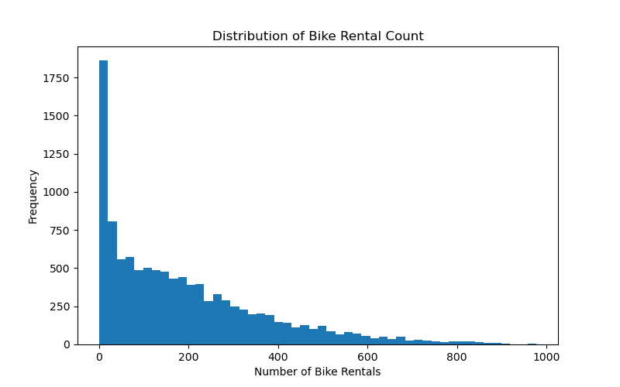
Figure 1.1 Distribution of Bike Rental Count
The histogram confirms the skew. The tallest bar is near zero (roughly 1,850 hours with very few rentals, typically late-night hours), and the frequency decreases steadily as the rental count increases, forming a long tail to the right.
b. Data preprocessing -
The dataset contained no missing values in any column and no duplicate rows, so no imputation or removal was required.
- Feature extraction from datetime: the datetime column was converted to a pandas datetime type, and five new features were extracted: year, month, day, hour and weekday.
- Removal of leakage columns: casual and registered were dropped, because count = casual + registered. Keeping them would allow the model to reconstruct the target directly (data leakage).
- Removal of datetime: the original datetime column was dropped after the useful components were extracted.
After these steps, the modelling dataframe contained 15 columns: season, holiday, workingday, weather, temp, atemp, humidity, windspeed, count, year, month, day, hour and weekday.
c. Relationship between Temperature and Bike Rentals -
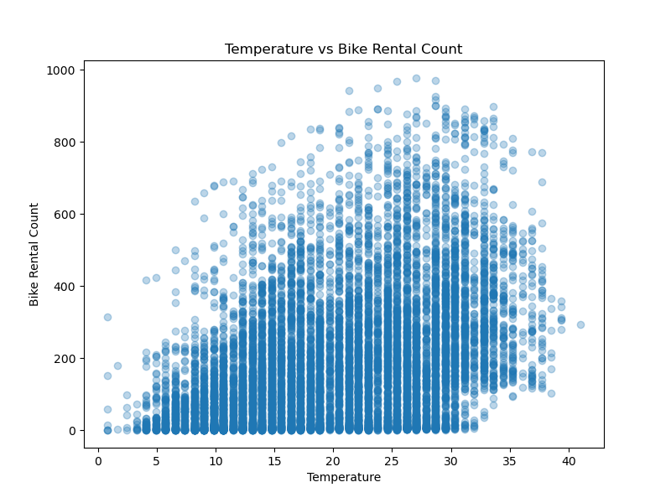
Figure 1.2 Temperature vs Bike Rental Count
The scatter plot shows a positive relationship between temperature and bike rentals: as the temperature increases, both the typical and the maximum number of rentals increase. At low temperatures (below about 10 °C) rentals rarely exceed 300, while between 20 °C and 32 °C they frequently exceed 600.
The relationship is not perfectly linear. Demand appears to level off and slightly decrease above about 32–35 °C, and there is a large vertical spread at every temperature, indicating that temperature alone cannot explain all of the variation in rentals.
d. Simple Linear Regression Model Development -
Temperature (temp) was used as the single independent variable and count as the dependent variable. The data was divided into training and testing subsets using an 80:20 split with random_state=42, giving 8,708 training samples and 2,178 testing samples.
A LinearRegression model from scikit-learn was fitted on the training data. The learned parameters were:
Parameter | Value
Intercept (θ₀) | 7.8550
Slope (θ₁) | 9.0645

Best-fit line:
$$\hat{y}=7.8550+9.0645×\text{temp}$$
Interpretation: for every 1 °C increase in temperature, the model predicts approximately 9 additional bike rentals per hour. The intercept (7.86) is the predicted number of rentals at 0 °C; it has little practical meaning because very few observations lie near 0 °C.
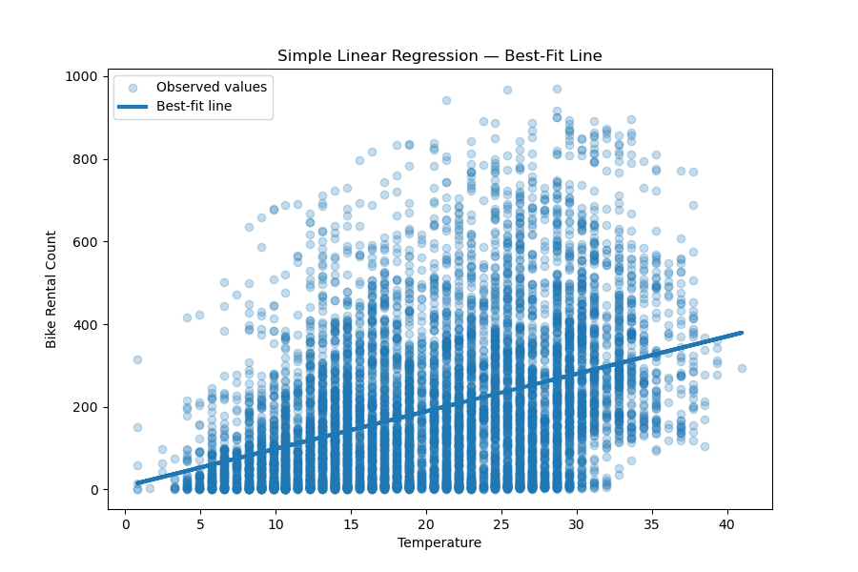
Figure 1.3 Simple Linear Regression — Best-Fit Line
The best-fit line rises from about 15 rentals at 1 °C to about 380 rentals at 41 °C. It captures the overall upward trend, but many points lie far above and below the line, showing that a single feature leaves a large amount of unexplained variation.
e. Observed Value, Predicted Value and Residual -
The trained model was used to predict the rental count for the test samples. The first 10 test predictions are shown below, where Error = Actual − Predicted.
# | Actual | Predicted | Error | Absolute Error
0 | 127 | 312.60 | −185.60 | 185.60
1 | 13 | 45.02 | −32.02 | 32.02
2 | 163 | 97.05 | 65.95 | 65.95
3 | 233 | 275.44 | −42.44 | 42.44
4 | 222 | 238.28 | −16.28 | 16.28
5 | 166 | 134.21 | 31.79 | 31.79
6 | 144 | 134.21 | 9.79 | 9.79
7 | 376 | 320.04 | 55.96 | 55.96
8 | 601 | 104.48 | 496.52 | 496.52
9 | 53 | 141.65 | −88.65 | 88.65

Rows 5 and 6 have the same predicted value (134.21) because they have the same temperature; the simple model cannot distinguish between them even though their actual counts differ. Row 8 shows a very large error (496.52): the actual demand was 601, but the model predicted only 104 based on a low temperature.
For the first test sample, the residual was examined in detail:
Quantity | Value
Observed value (y) | 127
Predicted value (ŷ) | 312.60
Random error (y − ŷ) | −185.60

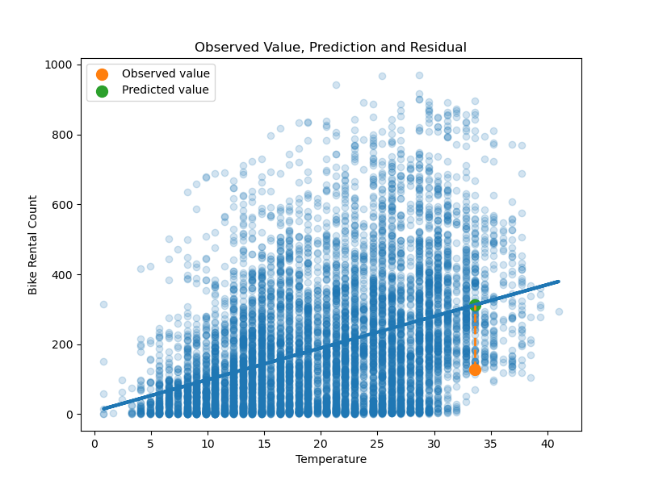
Figure 1.4 Observed Value, Prediction and Residual
The orange point is the observed value and the green point, which lies on the regression line, is the predicted value. The dashed vertical line between them is the residual. Since the observed value lies below the line, the residual is negative, meaning the model over-predicted demand for this hour by about 186 rentals.
f. Verification using the Least Squares Method -
To verify the scikit-learn result, the slope and intercept were computed manually from the training data using the ordinary least squares formulas:
$$θ_{1}=\frac{\sum_{i=1}^{m}{\left(x_{i}-\overset{‾}{x}\right)}\left(y_{i}-\overset{‾}{y}\right)}{\sum_{i=1}^{m}{{\left(x_{i}-\overset{‾}{x}\right)}^{2}}} θ_{0}=\overset{‾}{y}-θ_{1}\overset{‾}{x}$$
Parameter | scikit-learn | Least Squares (manual)
Slope (θ₁) | 9.064522 | 9.064522
Intercept (θ₀) | 7.855005 | 7.855005

The manually computed values match the scikit-learn values to six decimal places (they differ only at the 13th decimal place due to floating-point rounding). This confirms that LinearRegression uses the ordinary least squares solution.
g. Hypothesis Function -
A hypothesis function h(x) = θ₀ + θ₁x was implemented using the learned parameters and used to predict the demand for a sample temperature of 20 °C:
$$h\left(20\right)=7.8550+9.0645×20=189.15$$
The model predicts approximately 189 bike rentals per hour at 20 °C, which is close to the overall mean of 191.57.
h. Cost Function -
The cost function J(θ₀, θ₁) = (1/2m) Σ(ŷ − y)² was implemented and evaluated on the training data using the least squares parameters.
Quantity | Value
Cost J(θ₀, θ₁) | 13,888.78
Equivalent training MSE (2 × J) | 27,777.56
Equivalent training RMSE | ≈ 166.7

Because the least squares parameters minimise the squared error, 13,888.78 is the lowest possible cost for a straight line using temperature alone. An RMSE of about 167 rentals is large compared with the mean of 191.57, which again shows that temperature alone is a weak predictor.
i. Gradient Descent -
The parameters were also learned iteratively using batch gradient descent. The temperature feature was first standardised using StandardScaler (mean 0, standard deviation 1) so that gradient descent converges quickly and stably. Both parameters were initialised to 0.
$$θ_{0}:=θ_{0}-α\frac{1}{m}\sum_{i=1}^{m}{\left({\hat{y}}_{i}-y_{i}\right)}$$
$$θ_{1}:=θ_{1}-α\frac{1}{m}\sum_{i=1}^{m}{\left({\hat{y}}_{i}-y_{i}\right)} x_{i}$$
Setting / Result | Value
Learning rate (α) | 0.01
Iterations | 1000
Initial θ₀, θ₁ | 0, 0
Final θ₀ | 191.5765
Final θ₁ | 70.5913

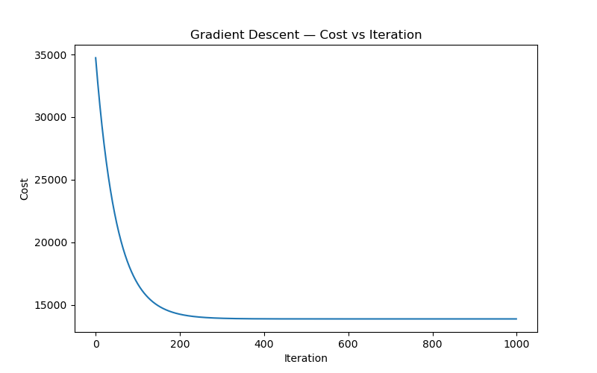
Figure 1.5 Gradient Descent — Cost vs Iteration
The cost starts at about 34,700 (when both parameters are 0) and drops rapidly during the first 200 iterations. It flattens out by about 400 iterations and remains at approximately 13,889 until iteration 1000. This final value matches the least squares cost (13,888.78), showing that gradient descent has converged to the same optimal solution.
The gradient descent parameters look different from the least squares parameters only because they are expressed on the standardised scale:
- θ₀ = 191.58 is the predicted rental count at the mean temperature, which equals the mean rental count of the training set.
- θ₁ = 70.59 is the change in rentals for a one standard deviation increase in temperature. Dividing by the least squares slope (70.59 / 9.0645 ≈ 7.79) gives the standard deviation of temperature in °C, so both methods describe the same line.
j. Multiple Linear Regression Model Development -
To improve on the single-feature model, a multiple linear regression model was built using 13 input features: season, holiday, workingday, weather, temp, atemp, humidity, windspeed, year, month, day, hour and weekday.
season and weather are nominal categorical variables, so they were one-hot encoded with drop_first=True to avoid the dummy variable trap. This replaced the 2 categorical columns with 6 dummy columns (season_2, season_3, season_4, weather_2, weather_3, weather_4), giving a total of 17 features.
The same 80:20 split with random_state=42 was used, giving a training set of shape (8708, 17) and a testing set of shape (2178, 17). A LinearRegression model was fitted on the training data and evaluated on the unseen test data.
k. Model Evaluation -
Metric | Value
MAE | 105.09
MSE | 19,777.08
RMSE | 140.63
R² | 0.4008
Adjusted R² | 0.3961

- MAE = 105.09: on average, the predicted rental count differs from the actual count by about 105 bikes per hour.
- RMSE = 140.63: larger than the MAE, which indicates that some predictions have very large errors (squaring gives these large errors more weight).
- R² = 0.4008: the model explains about 40% of the variance in bike rentals on the test set; the remaining 60% is not captured.
- Adjusted R² = 0.3961: very close to R², so the 17 features are not inflating the score; most of them contribute useful information relative to the test sample size of 2,178.
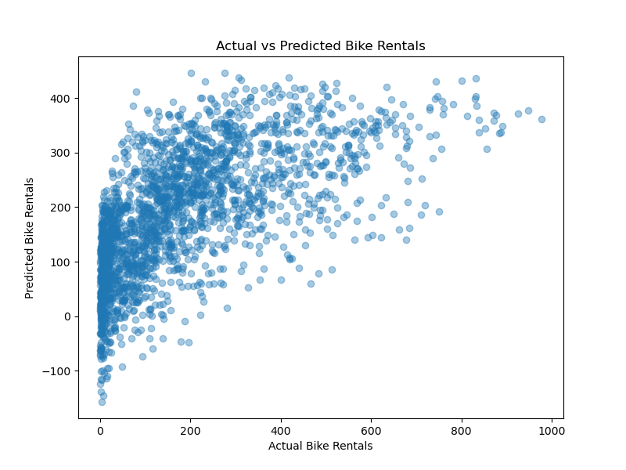
Figure 1.6 Actual vs Predicted Bike Rentals
For a perfect model, all points would lie on the diagonal line where predicted = actual. The plot shows several limitations:
- Under-prediction of high demand: predictions never exceed about 450, even when actual rentals are between 600 and 977. The model cannot capture peak-hour demand.
- Negative predictions: for some hours with near-zero actual rentals, the model predicts negative values (down to about −150), which are not physically possible. Linear regression does not restrict the output range.
- Wide spread at low counts: for actual values close to 0, predictions range from about −150 to 230, showing that the model has difficulty identifying low-demand hours.
These errors are expected because the relationship between the features and demand is not linear. For example, hour was treated as a single numeric feature, but rentals peak during morning and evening commute hours rather than increasing steadily through the day. The right-skewed target (Figure 1.1) also violates the assumption of normally distributed errors.
l. Comparison of Simple and Multiple Linear Regression -
Aspect | Simple Linear Regression | Multiple Linear Regression
Features | 1 (temp) | 17 (after one-hot encoding)
Training / Testing samples | 8,708 / 2,178 | 8,708 / 2,178
Model | ŷ = 7.8550 + 9.0645 × temp | ŷ = θ₀ + θ₁x₁ + … + θ₁₇x₁₇
Key result | Training cost J = 13,888.78  (training RMSE ≈ 166.7) | Test RMSE = 140.63  R² = 0.4008
Strength | Easy to interpret and visualise | Uses weather, calendar and time information
Limitation | Ignores all other factors | Cannot capture non-linear patterns such as hourly peaks

Adding calendar, time and weather features reduced the error from a training RMSE of about 167 (temperature only) to a test RMSE of about 141. Note that the simple model's figure is a training error and the multiple model's is a test error, so the comparison is indicative rather than exact.
m. Conclusion -
Linear regression was applied to the Bike Sharing Demand dataset to predict hourly rental counts. The simple model showed that temperature has a clear positive effect on demand (about 9 extra rentals per °C), and the parameters obtained by scikit-learn, the least squares formulas and gradient descent were all consistent, converging to the same minimum cost of 13,888.78.
The multiple linear regression model achieved an R² of 0.40 and an RMSE of 140.63 on the test set. While this is an improvement over using temperature alone, the model under-predicts peak demand and produces some negative predictions. Performance could be improved by one-hot encoding hour, applying a log transformation to the skewed target, adding interaction or polynomial terms, or using non-linear models such as decision trees or random forests.

