# **INTRODUCTION**

**Overview**

This our naan mudhalvan project about ***iRevolution: A data driven exploration of apples iphone impact in India .*** The introduction of Apple iPhone in 2007 marked a pivotal moment in the history of technology and consumer electronics This iconic device not only revolutionized the mobile phone industry but also had a profound impact on various aspects of our lives. Including communication, entertainment, productivity, and even the global economy .Its sleek design, intuitive user interface, and the App store ecosystem it introduced have transformed the way we connect, work and play in the digital age. The iPhone’s influence extends far beyond its original purpose as a phone, as it has redefined industries and set new standards for innovation and user experience.

**Purpose**

Here from the project we can understand the iRevolution created by Apple iPhone in India and the impacts . The sources and the Empathy map, Brainstroming map and visualities are given below.

**PROBLEM SOLVING & DESIGN THINKING**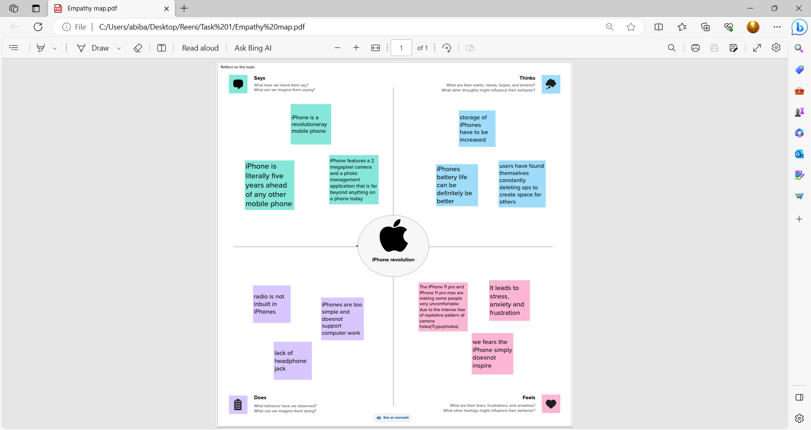

# 

# 

# **Result**

The impact of the iPhone in India, like in many other parts of the world, has been significant. Here are some key ways the iPhone has influenced India:

1. *Technological Advancement:* The iPhone played a crucial role in introducing cutting-edge technology to Indian consumers. It popularized touchscreens, app stores, and a seamless user experience, pushing other smartphone manufacturers to innovate as well.

2. *Economic Growth:* The iPhone has contributed to India's economy through increased smartphone sales and its ecosystem of apps and services. Apple's presence in India has also led to job creation and investment in the country.

3. *Digital Transformation:* The iPhone has been a catalyst for India's digital transformation. It has enabled millions of people to access the internet, use digital services, and participate in the online economy.

4. *E-commerce and Mobile Apps:* The iPhone has been instrumental in the growth of e-commerce and the app-based service industry in India. It has made it easier for users to shop online, book services, and access a wide range of apps for various purposes.

5. *Education and Productivity:* iPhones have become popular devices for education and productivity. Students and professionals use them for learning, productivity, and communication.

6. *Social Impact:* iPhones have influenced the way people in India connect and communicate. The rise of social media and messaging apps on the iPhone has changed the way people interact and share information.

7. *Status Symbol:* Owning an iPhone has also become a status symbol for many in India. It is seen as a luxury product and a symbol of success.

It's worth noting that while the iPhone has had a significant impact in India, there are also challenges related to affordability and accessibility for a large portion of the population. Many Indians still use more affordable Android-based smartphones, and efforts are ongoing to bridge the digital divide and make technology more inclusive.

**ADVANTAGES & DISADVANTAGES**

**Advantages of iPhone in India:**

1. Premium Build Quality: iPhones are known for their premium design and build quality.

2. Operating System: iOS provides a smooth and user-friendly experience.

3. App Ecosystem: iOS has a vast selection of high-quality apps on the App Store.

4. Camera Quality: iPhones offer excellent camera capabilities.

5. Regular Updates: Apple provides consistent software updates for several years.

6. Resale Value: iPhones tend to retain their value better than many other smartphones.

7. Strong Privacy Features: Apple prioritizes user privacy and data security.

**Disadvantages of iPhone in India:**

1. High Cost: iPhones are relatively expensive compared to other smartphones.

2. Limited Customization: iOS has limited customization options compared to Android.

3. No Expandable Storage: iPhones do not support external memory cards.

4. Proprietary Ecosystem: You may need to invest in other Apple products for full integration.

5. Limited Variety: Fewer iPhone models are available in India compared to other regions.

6. Import Restrictions: iPhones sold in India may have limitations on certain features.

7. Incompatibility with Local Services: Some local apps and services

**APPLICATIONS**

We can apply this is every apple iPhone product . From this we can solve more problems related to this apple phones with the feature. Changes may lead to the increase in the product sales. We can see the abundant growth of Apples product. We can fix these bugs to better experience. 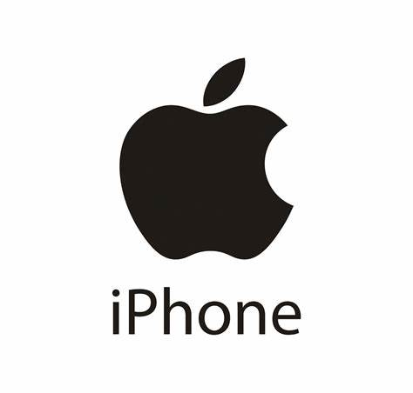

**CONCLUSION**

As from this project ,Apple had been gradually increasing its presence and impact in India. Here are some key points to consider regarding Apple's impact in India:

Manufacturing and Local Production: Apple had started assembling some of its iPhone models in India, which helped lower the prices and make the products more accessible to Indian consumers. This also aligned with the Indian government's "Make in India" initiative. Expanding Retail Presence: Apple was expanding its retail and online presence in India with more Apple stores and an improved online store experience, which enhanced its accessibility to Indian customers. Apple's presence in India was contributing to job creation, both directly and indirectly, through its supply chain and retail operations. This had a positive impact on the Indian economy. India was considered a significant growth market for Apple, with a growing middle class and increasing smartphone adoption. Apple was working to tap into this potential market . Apple faced challenges in India, including price sensitivity among consumers and competition from local and international smartphone manufacturers.

**FUTURE SCOPE**

The future scope of the iPhone is likely to continue evolving in various ways:

1. *Hardware Innovation*: Apple will likely introduce new features, designs, and technologies in future iPhone models, including advancements in camera technology, processing power, and battery life.

2. *5G Integration*: As 5G networks become more widespread, future iPhones will likely leverage this technology for faster data speeds and improved connectivity.

3. *Augmented Reality (AR)*: Apple has been investing in AR technology, and future iPhones may have enhanced AR capabilities for gaming, navigation, and other applications.

4. *Sustainability*: Apple has been working on reducing the environmental impact of its products. Future iPhones may incorporate more sustainable materials and designs.

5. *Privacy and Security*: Apple places a strong emphasis on user privacy and security. Expect ongoing improvements and features in this area.

6. *Software Updates*: Future iPhones will continue to receive iOS updates with new features and improvements.

7. *Services*: Apple is increasingly focused on its services like Apple Music, Apple TV+, and Apple Arcade. The iPhone will remain a key device for accessing these services.

8. *Integration with Other Apple Devices*: Improved integration with other Apple products like Macs, iPads, and the Apple Watch will likely be a focus.

9. *Health and Wellness*: Apple is likely to expand its health and wellness features, such as monitoring capabilities for fitness, health conditions, and wellness.

10. *Foldable iPhones*: There have been rumors about Apple working on foldable iPhone designs. This could be a significant development in the future.

11. *Smart Home and IoT*: Expect further integration of iPhones with smart home and IoT devices, making it a central hub for controlling your connected environment.

Keep in mind that these are general trends, and the specific innovations and features will depend on Apple's product development and market demands.

**APPENDIX**

https://drive.google.com/file/d/1x9H5exrWvy2cyCesZVBREFEc7Bx260sR/view?usp=drivesdk