**City of Manhattan, KS Housing Dashboard**

Abinaya Natarajan, Ruth Balaji, Divya Prasanth Paraman, Sai Srinidhi Karanam and Manishkumar Alagumalai

Abstract—This paper introduces an interactive housing dashboard tailored for the City of Manhattan, Kansas, aiming to provide local decision-makers with a comprehensive overview of the housing market. By combining data from diverse sources, the dashboard offers insights into recent trends, development hurdles, and housing availability by type and income range. A focal point of the visualization is its portrayal of housing affordability across Manhattan's neighborhoods, facilitating targeted interventions and informed policy decisions. Through this initiative, the paper demonstrates the utility of centralized data visualization in empowering stakeholders to address housing challenges effectively.

Introduction

The Manhattan Housing Dashboard aims to provide an intuitive and interactive platform to visualize the housing market dynamics in Manhattan, Kansas. This tool is designed for local government officials, policy-makers, and community planners, enabling them to grasp current housing trends, identify areas needing intervention, and support data-driven decision-making for housing policy.

Manhattan, a vibrant college town with significant military presence, faces unique housing challenges including affordability and availability. The dashboard centralizes various data sources into a coherent visual format, aiding stakeholders in addressing these challenges effectively.

# Insight Needs

**1. Housing Affordability and Trends:** Understanding how housing affordability varies across different neighborhoods in Manhattan. This includes tracking trends in homeownership and rental markets over time to identify areas where intervention is needed to improve housing affordability.

**2. Demographic and Economic Data Integration:** Integrating diverse data sets such as employment, commuting patterns, and demographic information to provide a holistic view of the housing market. This can help in understanding how economic and demographic factors influence housing demand and affordability.

**3. Community Needs and Preferences:** Gathering insights on the preferences and needs of different demographic groups, including preferences for types of housing (e.g., mixed-use, single-family, townhouses) and understanding the distribution of housing by income levels. This helps in tailoring housing policies and developments to meet community needs effectively.

**4. Visualization of Data for Stakeholder Engagement:** Creating visualizations that are not only informative but also engaging for stakeholders, facilitating easier comprehension of complex data. This includes using interactive maps, bar charts, and other graphical representations to make data accessible to non-experts.

**5. Policy Impact Analysis:** Providing insights that can guide policy decisions, such as zoning laws, housing subsidies, and development incentives. The dashboard aims to highlight areas that require policy intervention and to monitor the impact of existing policies on the housing market.

**6. Scalability and Future Enhancements:** Identifying opportunities for expanding the dashboard’s capabilities, such as incorporating predictive analytics or extending the geographic scope to include surrounding areas. This involves considering how the dashboard can evolve over time to continue meeting the needs of the community.

**7. User Interaction and Feedback:** Ensuring the dashboard allows for user interaction and feedback to continually improve its utility and relevance. This involves creating mechanisms for stakeholders to provide input on what data and visualizations are most useful for their needs.

# Data Acquisition

|  |  |  |
| --- | --- | --- |
| DATASET | NUMBER OF ENTITIES | MAJOR ENTITES ATTRIBUTES |
| Race and Ethnicity | 127 records & 12 fields | Race, Geography, Year and Ethnicity. |
| Global Diversity | 1171 records & 11 fields | Birthplace, Year, Geography, Total population. |
| Rent vs Own | 42 records & 10 fields | Year, Geography, Share. |
| Occupation | 217 records & 10 fields | Occupation, Median Earnings, Workspace growth, Workforce by occupation. |
| Commute Transportation | 81 records & 6 fields | Geography, Mode of Transportation, Number of Households, Year. |

## Descriptive Statistics of Data

Race and Ethnicity:

Race: This attribute represents the different racial categories such as White, Black or African American, American Indian and Alaska Native, Asian, Native Hawaiian, and Other Pacific Islander, etc.

Geography: This refers to the geographic area for which the data is reported, such as the city, county, or state.

Year: This indicates the year for which the data is reported.

Ethnicity: This attribute categorizes individuals as either Hispanic or Latino, or Not Hispanic or Latino.

Global Diversity: -

Birthplace: This attribute denotes the country or region of birth for individuals.

Year: This indicates the year for which the data is reported.

Geography: This refers to the geographic area for which the data is reported, such as the city, county, or state.

Total Population: This represents the total number of individuals in the given geography.

Rent vs Own: -

Year: This indicates the year for which the data is reported.

Geography: This refers to the geographic area for which the data is reported, such as the city, county, or state.

Share: This attribute represents the percentage or proportion of households that either rent or own their homes in the given geography.

Occupation: -

Occupation: This attribute categorizes individuals based on their occupation or field of work, such as management, healthcare, education, construction, etc.

Median Earnings: This represents the median income or earnings for individuals in a particular occupation.

Workspace Growth: This attribute indicates the growth or decline in the number of individuals employed in a particular occupation over a given period.

Workforce by Occupation: This represents the total number of individuals employed in a particular occupation within the given geography.

Commute Transportation: -

Geography: This refers to the geographic area for which the data is reported, such as the city, county, or state.

Mode of Transportation: This attribute categorizes individuals based on their mode of transportation for commuting, such as driving alone, carpooling, public transportation, walking, etc.

Number of Households: This represents the number of households that use a particular mode of transportation for commuting.

Year: This indicates the year for which the data is reported.

# Analysis Methods

**1. Data Integration and Preprocessing**: Before any analysis, data from various sources is integrated and cleaned. This involves handling missing values, removing duplicates, standardizing formats, and merging datasets to create a comprehensive view of the housing landscape. This foundational step ensures that the analysis is based on accurate and reliable data.

**2. Descriptive Analysis**: This method involves summarizing and describing the different aspects of the data, such as housing affordability, demographic characteristics, and market trends. Simple statistics and data aggregation are used to provide an overview of the datasets.

**3. Spatial Analysis**: Geographic data is analyzed to understand spatial patterns in housing distribution, affordability, and demographic characteristics. This involves mapping data to geographic identifiers like ZIP codes or census tracts to visualize how housing issues vary across different areas of Manhattan.

**4. Trend Analysis**: Time-series data is analyzed to identify trends over time in key metrics such as homeownership rates, rental prices, and demographic shifts. This helps in forecasting future trends and understanding the long-term impacts of housing policies.

**5. Comparative Analysis**: The dashboard compares Manhattan’s housing data with that of surrounding areas or similar regions to identify unique challenges or opportunities. This method helps in benchmarking and setting realistic goals based on comparative performance.

# Visualizations

**1. Line Charts: -**

Line charts were used to visualize trends and changes over time, such as the "Rent vs. Own" visualization, which showed the share of homeownership across different geographies over multiple years. Line charts effectively communicate patterns and allow for easy comparison of multiple entities or categories.

**2. Stacked Column Charts: -**

Stacked column charts were used to visualize the composition of a whole across different categories, such as the "Commuting Visualization" that showed the mode of transportation used by households over time. These charts are useful for displaying part-to-whole relationships and identifying the relative contribution of each category to the total.

**3. Bar Charts: -**

Bar charts were used to compare values across different categories, such as the "Occupation Visualization" that displayed median earnings and workforce growth for various occupations. Bar charts are effective for making comparisons and identifying outliers or significant differences between categories.

**4. Tree maps: -**

Tree maps were used to visualize hierarchical data, such as the distribution of households across different income brackets in the "Income Distribution" visualization. Tree maps are space-efficient and allow for easy identification of larger and smaller categories within a hierarchy.

**5. Donut Charts: -**

Donut charts were used to visualize the composition of a whole, such as the "Home Ownership Status" visualization that showed the distribution of respondents across different ownership categories (own, rent, staying with friends/family). Donut charts are effective for displaying part-to-whole relationships and are visually appealing for presenting simple categorical data.

4.1. PROTOTYPE

### 4.1.1. Prototype 1

**Line Chart:** This chart, titled "Rent vs Own," compares the percentage of homeowners to renters in Manhattan, KS, with its parent and neighbouring geographies over a span from 2012 to 2022. From the chart, we can infer that Manhattan, KS, represented by the orange line, has seen an increasing trend in the share of homeownership since around 2016, after a period of relative stability or slight decrease. The share of ownership is higher for Manhattan when compared to Junction City but falls way lower when compared to Topeka, Kansas and the US as a whole.

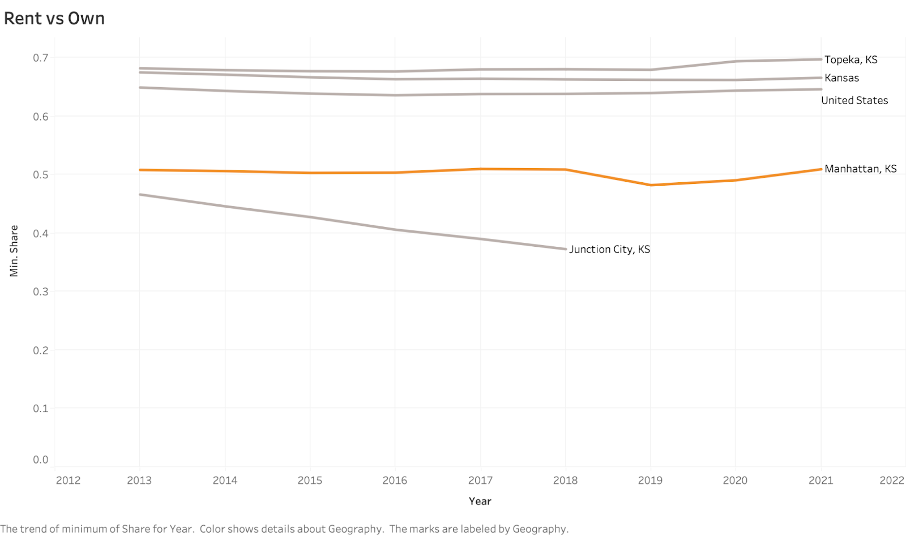

### 4.1.2. Prototype 2

Stacked Column Charts:

1. According to a 2021 study of Manhattan, Kansas commuter transportation data, 73.2% of commuters only drive alone, indicating a predominance of single-occupancy vehicle travels. Significant alternatives to traditional forms of transportation include carpooling and telecommuting, which are chosen by 10.3% and 7.55% of employees, respectively. Temporal trends show that commuter behaviour has remained stable throughout time. These results highlight the need to encourage environmentally friendly modes of transportation and put in place laws that reward carpooling and remote work, which will ultimately lessen traffic jams and the region's environmental effects.

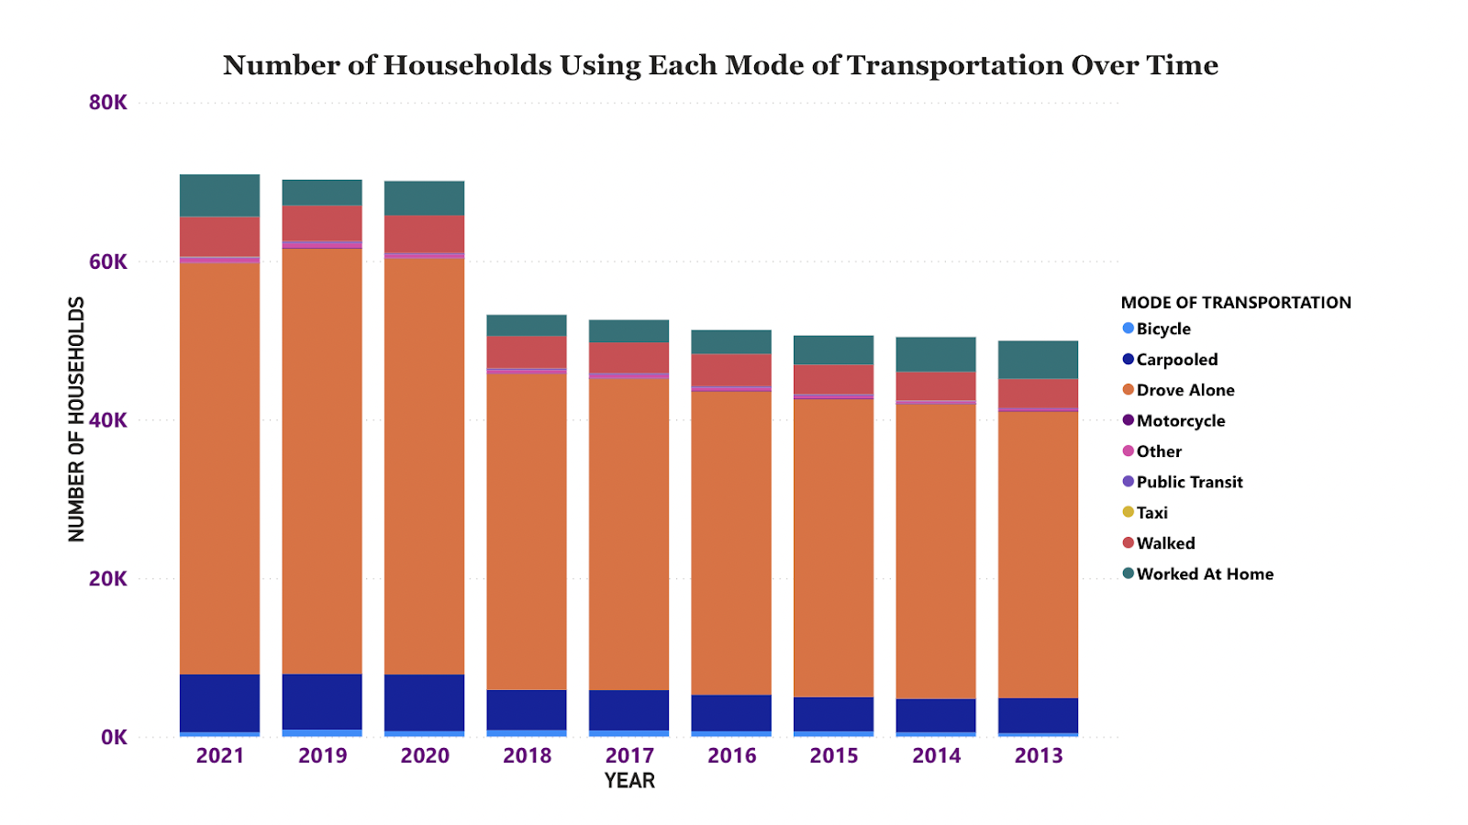

2. This visualization shows the share of housing occupied in Manhattan and the United States with respect to the Household Income bucket. From this we can infer that, In Manhattan, the maximum share of housing is occupied by the households having the income range of 75k-99k, 60k to 75k and less than 10k. Likewise in the United States the maximum share of housing is occupied by the households having the income range in 75k-99k, 60k-75k and 100k-124k.

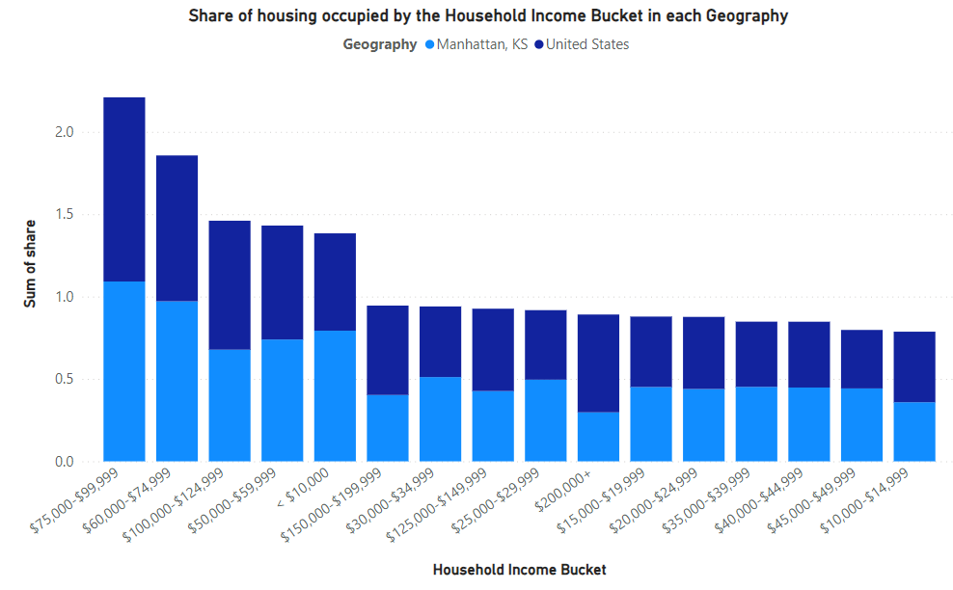

3. This stacked column chart displays the number of households paying different ranges of total monthly housing costs. A significant portion of households (370) pay $1,100 - $1,600 in total monthly housing costs, indicating a typical range for housing expenses in the area. There is a steady decline in the number of households as housing costs increase beyond $1,600 per month, suggesting fewer households can afford higher housing costs. A considerable number of households (208) have relatively low monthly costs between $800 - $1,100, potentially reflecting affordable housing options.

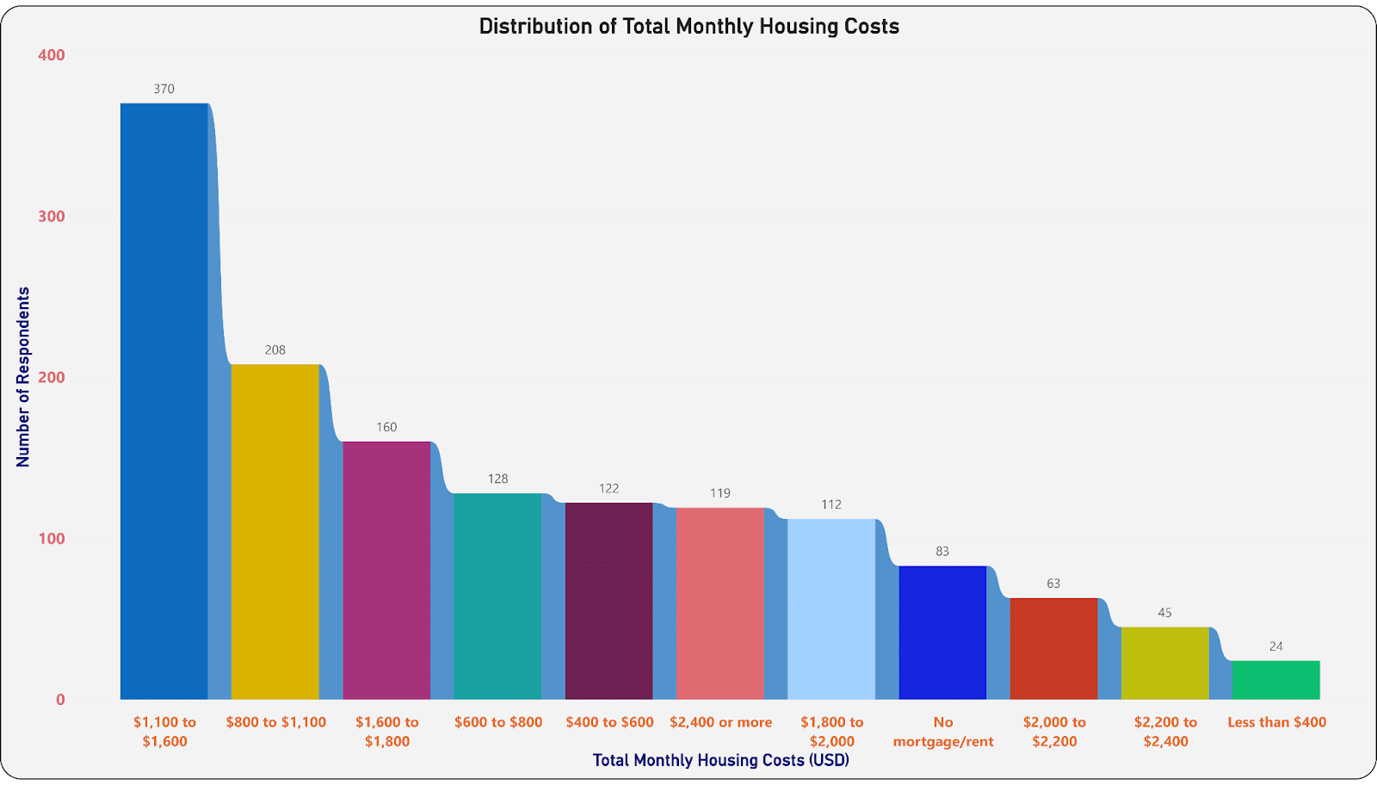

4. This stacked column chart shows the distribution of respondents based on their residential location categories. The vast majority of respondents (1,129) reside within the City of Manhattan, indicating the study's focus on the city itself. 268 respondents live in Riley, Pottawatomie, or Geary County, but outside the city limits of Manhattan, representing the surrounding suburban areas. Only a small number live outside these neighbouring counties (29 in Kansas, 8 outside Kansas), suggesting a primarily local sample.

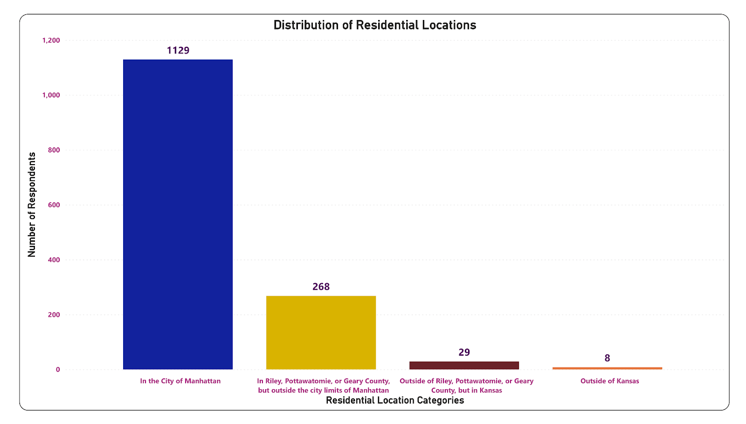

### 4.1.3. Prototype 3

### **Bar Charts:**

1. The Visualization of the "Population Distribution by Country of Origin in Kansas" alongside the slicer for years can provide stakeholders with valuable insights into the diversity and demographic trends within the state. This visualization can be helpful in three ways:

 (I) Demographic Understanding - Where this Bar graph can help stakeholders in education, public service, and community planning to tailor their programs and services to meet the needs of these diverse groups.

(II) Trend Analysis: This can inform future projections and help in understanding migration patterns, aiding in resource allocation and policy development.

(III) Cultural and Economic Impact: Understanding the size and distribution of immigrant communities from various countries can also help businesses and cultural organizations to create targeted marketing strategies, cultural events, or language services that cater to the needs of these communities.

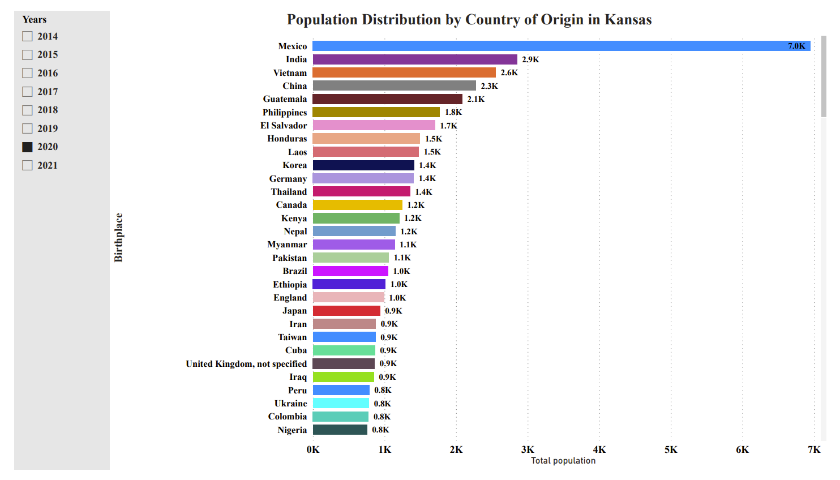

2. This is a bar graph for the house ownership type according to the income range in Manhattan.

Maximum households having their own houses are in the income range of $75k- 125k.

Maximum households staying in rented houses have their income range between $50-30k.

There are very less households in the groups of staying with friends/family, currently no permanent residence and rent to own.

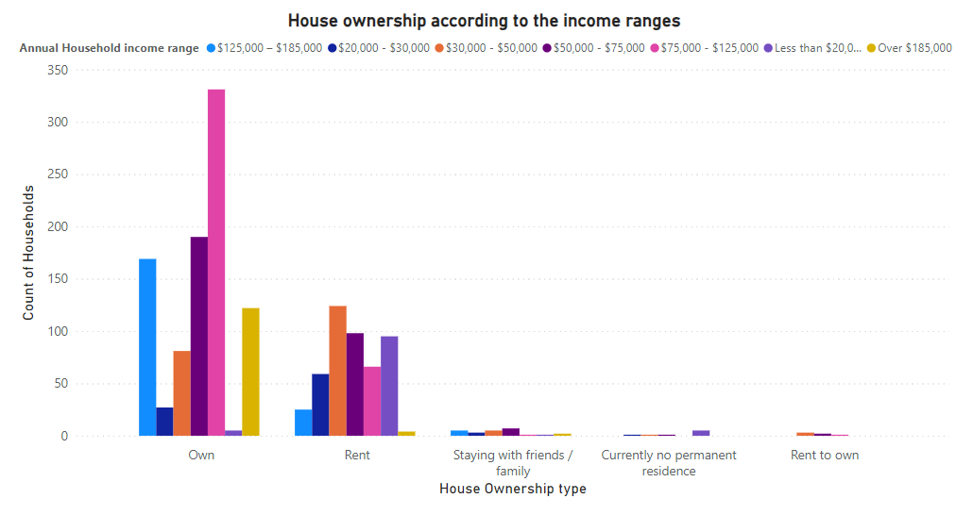

3. The chart is a stacked bar chart showing the preferred types of new housing in Manhattan, as indicated by the number of respondents for each housing type. The x-axis represents the number of respondents, and the y-axis lists the different housing types.

The most preferred type of new housing in Manhattan is mixed-use, with 448 respondents favouring this option. Mixed-use developments typically incorporate residential units along with commercial spaces or offices.

Cottage/tiny homes and single-family homes are the second and third most preferred housing types, with 277 and 221 respondents, respectively. This indicates a demand for smaller, detached housing units in Manhattan.

The preferences seem to lean towards mixed-use developments, smaller single-family homes, and townhouses, which could suggest a desire for more diverse housing options in Manhattan that combine residential and commercial spaces or offer more compact living solutions.

Overall, the chart highlights the housing preferences of respondents in Manhattan, with a clear inclination towards mixed-use developments and smaller, more affordable housing options like cottages and single-family home.

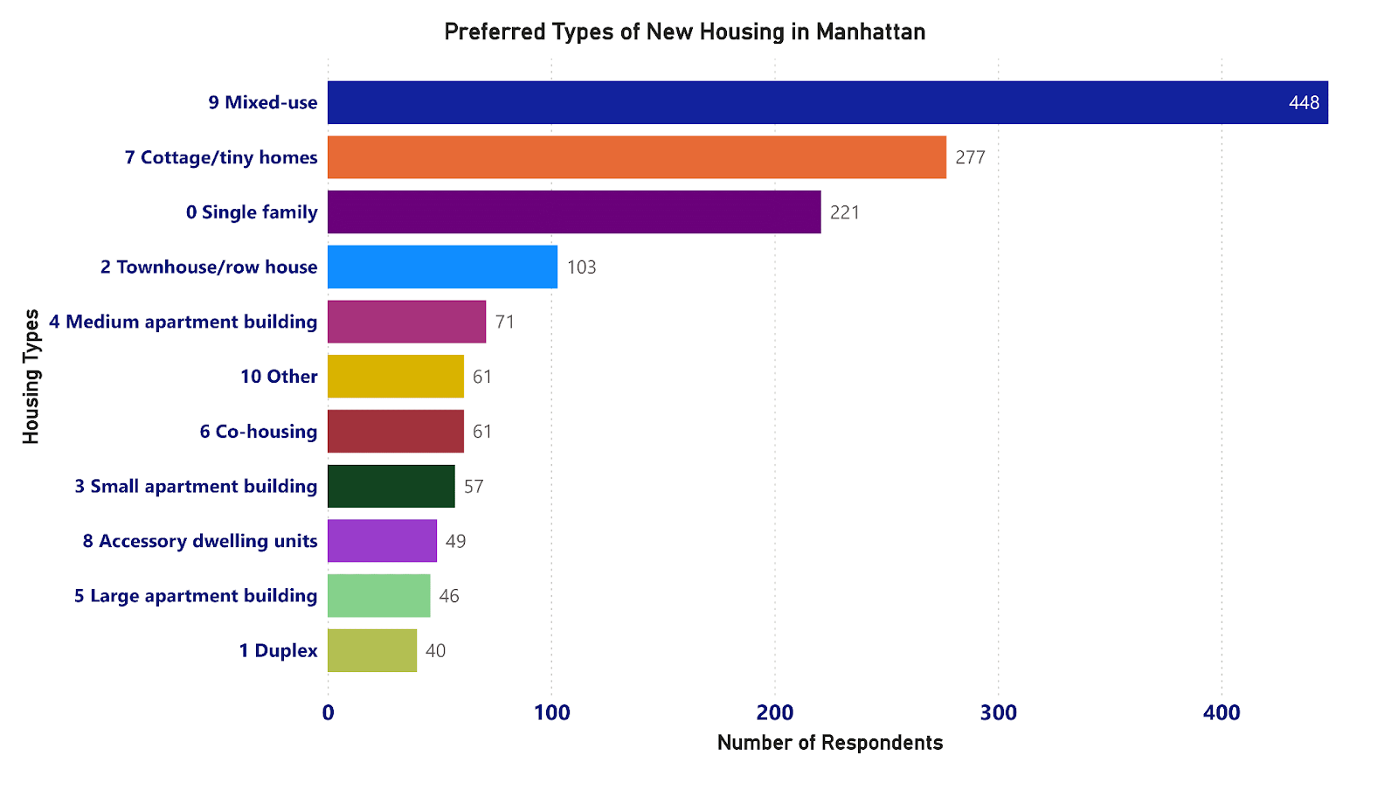

4. This graph displays the number of respondents categorized by the duration they have lived in their current homes. The categories and corresponding respondent numbers are as follows:

**2-4 years**: 168 respondents

**5-9 years**: 225 respondents

**Less than 1 year**: 248 respondents

**40-49 years**: 266 respondents

# ears or longer: 527 respondents

The y-axis represents the number of respondents (up to 500), and the x-axis represents the duration categories.

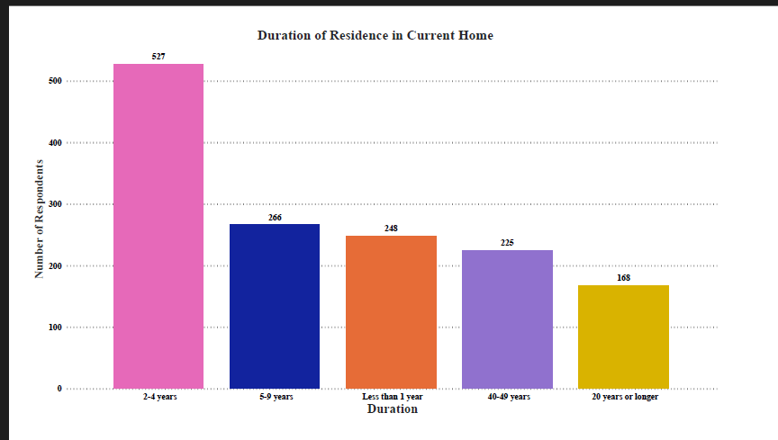

### 4.1.4. Prototype 4

**Tree Maps:**

1. This visualization provides some important insights into the occupation sector in the City of Manhattan, KS. We can see that occupations are divided into 24 different sectors. This visualization also allows users to see the performance, and salaries of the sectors in different years and how much has changed from the past. This visualization also provides details like how much the workforce has grown over the past years.

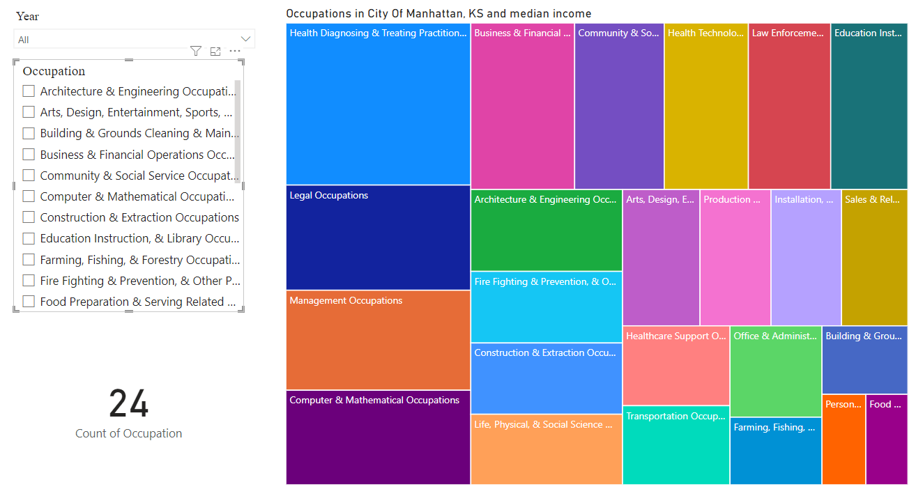

2. This tree map shows the distribution of households across different annual income brackets in the study area. The largest segments are households earning $75,000 - $125,000 (399 households) and $50,000 - $75,000 (298 households), indicating a significant middle-income population. There is a sizable number of lower-income households earning less than $30,000 annually (315 households), highlighting the need for affordable housing options. Higher income brackets above $125,000 make up a smaller portion.

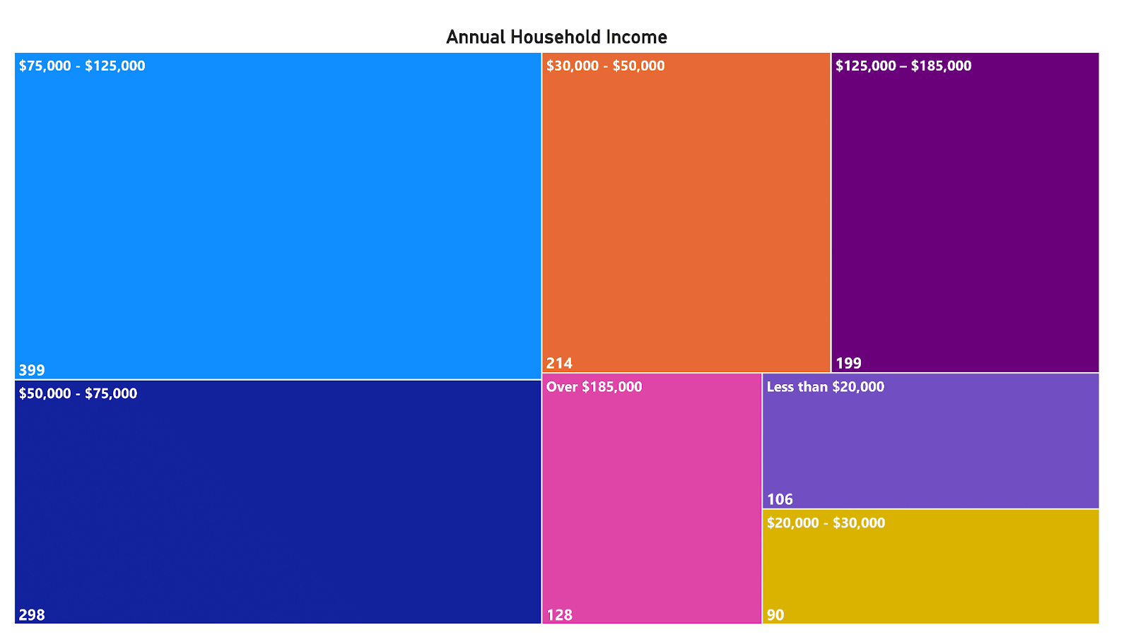

4.1.5. Prototype 5

**Donut Chart:** This donut chart illustrates the distribution of home ownership status among the respondents. 64.5% of respondents own their homes, while 32.85% rent, indicating a higher proportion of homeowners in the study area. A small percentage (1.67%) are staying with friends/family or have no permanent residence (1.67%), representing a minority group with housing insecurity.

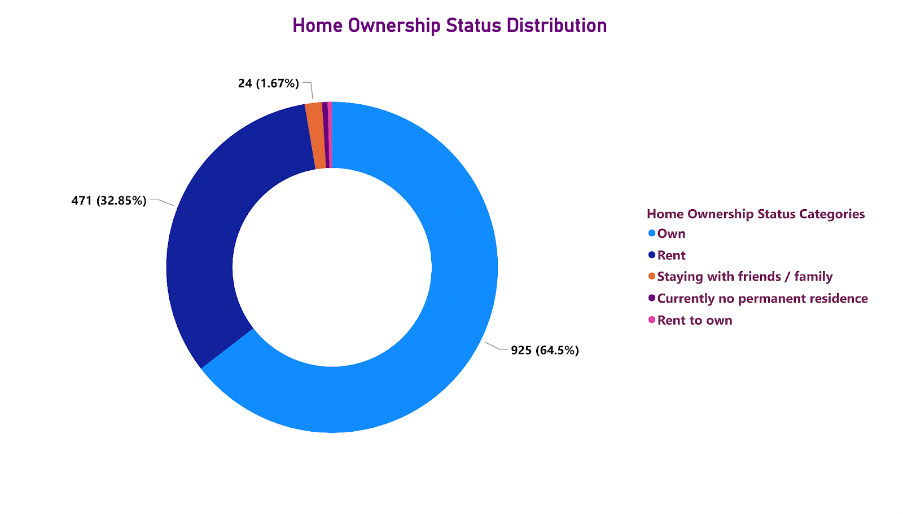

4.1.6. Prototype 6

Pie Chart:

1. The insights gained from the visualization of the composition of the population by race or ethnicity is that, this can help in quickly identifying the proportion of each race or ethnic group within the total population present in Manhattan, KS and Stakeholders could use this information to address community needs, diversity programs, or educational services to ensure representation and inclusion of all racial groups.

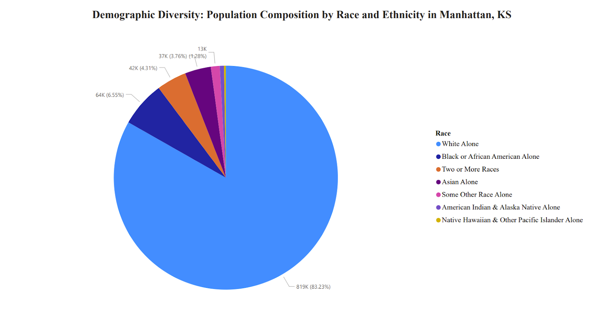

2. This pie chart shows the percentage and the approximate count of respondents living in various types of homes:

### Single-family: 1.03K (71.62%)

### Duplex: 0.1K (6.83%)

### Large apartment building (18 units or more): 0.09K (6.35%)

### Medium apartment building (6 to 17 units): 0.08K (5.86%)

### Townhouse/row house: 0.06K (4.25%)

### Other (please specify): 0.03K (2.09%)

### Small apartment building (fewer than 6 units): 0.02K (1.32%)

Co-housing/shared housing/group housing: Specific count not provided.

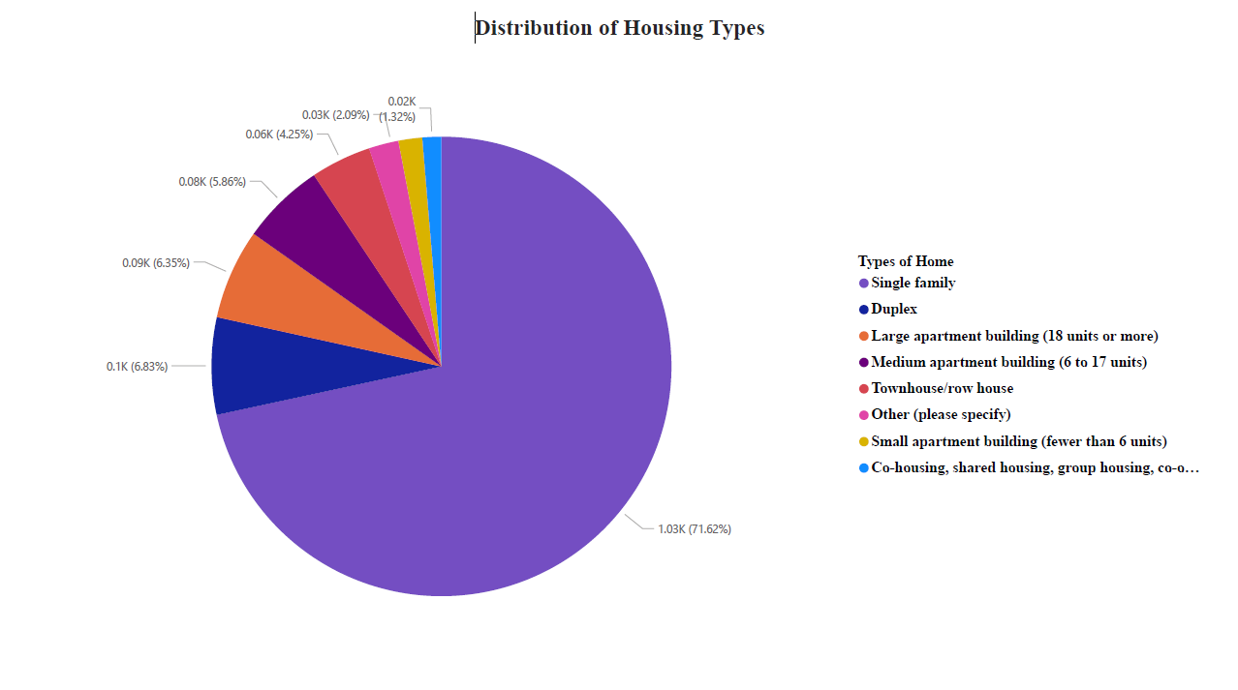

5. INTERPRETATION OF RESULTS

**1. Rent vs. Own Visualization:** This line chart shows an increasing trend in homeownership in Manhattan since around 2016, after a period of stability or slight decline. The visualization suggests a potential recovery in the housing market and highlights that while Manhattan has a higher ownership rate compared to Junction City, it lags behind Topeka and the U.S. average.

**2. Commuting Visualization:** The stacked column chart indicates that a significant majority of commuters (73.2%) drive alone, with carpooling and telecommuting being less common but notable alternatives. This stable pattern over time suggests a need for policies promoting more sustainable and communal transportation options to reduce environmental impact and traffic congestion.

**3. Occupation Visualization:** This visualization provides insights into the diversity of employment sectors in Manhattan, showing how different sectors perform in terms of salaries and growth. Such data is essential for workforce planning and economic development strategies, tailoring education and training programs to meet the demands of growing industries.

**4. Share of Housing Occupied:** The stacked bar chart reveals that the majority of housing in Manhattan is occupied by middle-income households, with significant shares at the lower and higher ends of the income spectrum. This insight can guide affordable housing strategies and economic assistance programs to ensure a balanced development that accommodates all income levels.

**5. Race and Ethnicity Visualization:** This chart helps identify the proportion of various racial and ethnic groups within the population, providing a basis for community services, diversity programs, and inclusive policy-making to ensure all groups are represented and supported adequately.

**6. Global Diversity Visualization:** The bar chart of population distribution by country of origin highlights the cultural and demographic diversity in Kansas, which can inform culturally sensitive community planning, educational programs, and public services tailored to the needs of diverse groups.

**7. Income Distribution Visualization (Tree map):** This tree map indicates the concentration of households within different income brackets, highlighting the significant presence of middle-income households while also pointing out the substantial lower-income segment that might require targeted financial and housing support.

**Home Ownership Status Visualization (Donut Chart):** Shows a higher proportion of homeowners compared to renters, which could influence local housing policies and development plans focusing on increasing homeownership opportunities and supporting rental markets.

**8. House Ownership Type by Income Range:** This chart provides insight into the correlation between income levels and housing types, revealing economic disparities in housing accessibility and affordability, which are crucial for planning and policy-making.

**9. Monthly Housing Costs Visualization:** Illustrates the economic burden of housing costs across different households, pinpointing the common ranges and highlighting the need for housing options that accommodate varying financial capabilities.

**10. Preferred Types of New Housing Visualization:** Indicates a strong preference for mixed-use and smaller detached housing units like cottages and single-family homes. This preference should guide future residential developments to meet community desires and expectations effectively.

**6. CHALLENGES AND OPPORTUNITIES**

The Challenges faced are: -

**Complexity in Data Integration**: Integrating data from multiple sources, such as housing market analysis, neighborhood surveys, and public databases, poses a significant challenge. Ensuring data consistency, accuracy, and timeliness requires sophisticated data processing and management strategies.

**User Interface and Experience**: Designing an intuitive and engaging user interface for diverse users, including policymakers, community members, and planners, is crucial. Balancing complexity and accessibility in visualization can be challenging within the limited development timeframe.

**Scalability and Performance**: As the project aims to handle potentially large datasets and accommodate future data inputs, ensuring the dashboard’s scalability and performance becomes a critical concern. High responsiveness and short loading times are essential for maintaining user engagement.

**Resource Constraints**: With only four weeks to develop the project, time and human resources are significantly restricted. This limitation affects the scope of work, depth of data analysis, and sophistication of the visualizations that can be developed.

Opportunities are: -

**Collaboration with Local Entities**: Partnering with local government, academic institutions, and community organizations could provide additional resources, data access, and validation opportunities. Such collaborations could also ensure the dashboard remains relevant and useful beyond the initial launch.

**Leveraging Open Source and Cloud Technologies**: Utilizing open-source libraries for data visualization (e.g., D3.js, Leaflet) and cloud-based platforms for hosting and data storage can accelerate development and facilitate scalability. These technologies also support collaboration among team members and with external contributors.

**Engagement and Feedback Mechanisms**: Incorporating user feedback mechanisms within the dashboard can guide iterative improvements and ensure the tool evolves to meet user needs. Post-launch, engaging with the user community through workshops or forums could provide valuable Insights for enhancements.

**Focus on Mobile Accessibility**: Designing the dashboard with mobile users in mind could significantly increase its accessibility and usage, ensuring that more community members can engage with the data irrespective of their primary internet access devices.

**Manhattan_Dashboard**: <https://app.powerbi.com/groups/me/dashboards/6d906fc6-cf58-4cf3-b437-cde62927ef3a?ctid=1113be34-aed1-4d00-ab4b-cdd02510be91&pbi_source=linkShare>

**ACKNOWLEDGEMENTS**

We extend heartfelt thanks to our peers for their invaluable feedback, our faculty advisors for their guidance, and domain experts for their insights, all of which significantly enhanced the quality of our project. We are also grateful to our families and friends for their enduring support throughout this endeavor. Special appreciation goes to Indiana University Bloomington for providing the essential resources that facilitated our research. Lastly, we thank the community stakeholders whose engagement and input have been crucial to shaping our project’s direction and impact.

References

1. City of Manhattan, Kansas. City of Manhattan Survey <https://docs.google.com/spreadsheets/d/15yJ-zKuszNu-UuGHKk6FPNEQeuyJEZw/edit?usp=drive_link&ouid=102189800991497980753&rtpof=true&sd=true>
2. Kansas Housing Resources Corporation and Kansas Housing Assessment Report from <https://drive.google.com/file/d/15yfesYB87gOSUSxHsWQhsYBs3l4O1j2Z/view?usp=drive_link>
3. United States Census Bureau. American Community Survey (ACS) from <https://www.census.gov/programs-surveys/acs/>
4. United States Department of Housing and Urban Development from <https://www.hud.gov/>
5. City of Manhattan, Kansas Risk Reduction from <https://cityofmhk.com/259/Risk-Reduction>
6. City of Manhattan, Kansas from <https://cityofmhk.com/>