Innovation:-

Travel on all roads and streets changed by +1.9% (+4.5 billion vehicle miles) for February 2023 as compared with February 2022. Travel for the month is estimated to be 233.7 billion vehicle miles,

The seasonally adjusted vehicle miles traveled for February 2023 is 270.5 billion miles, a +1.5% (+4.1 billion vehicle miles) change over February 2022. It also represents a -0.6% change (-1.5 billion vehicle miles) compared with January 2023,Cumulative Travel for 2023 changed by +3.8% (+17.8 billion vehicle miles).

The curative estimate for the year is 481.1 billion vehicle miles of8 travels

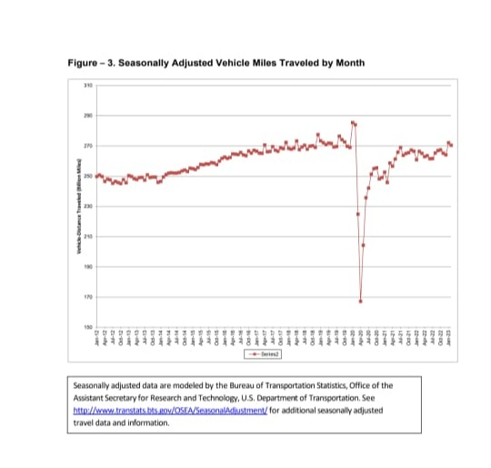

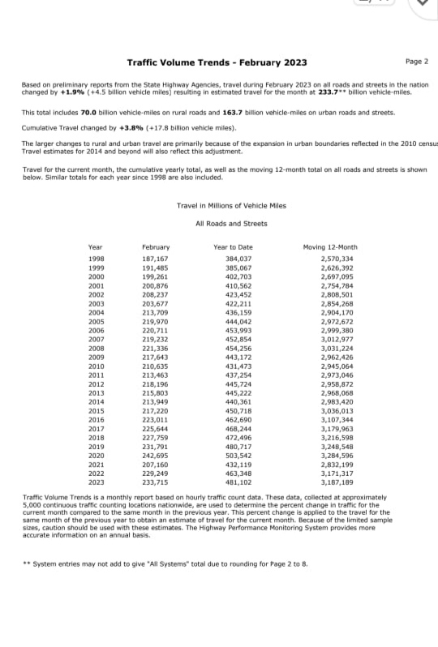

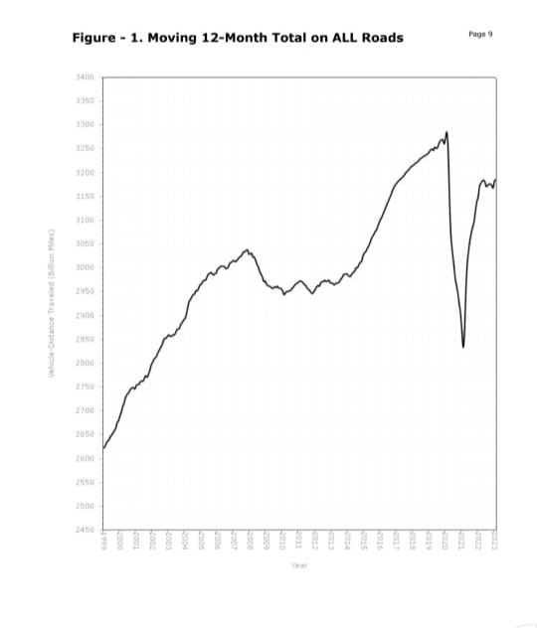

Prevention methods:-

**Use Of Autonomous Or Self-Driving Vehicles:-**

Utilizing self-driven cars can reduce traffic congestion to some level. Generally, traffic congestion is caused by human error, road rage, and the desire to reach early at someplace.

**Taxing Vehicles parking:-**

The growth in population and urbanization may have some cons in disguise that may lead to traffic congestion. It has become an urban cult in that every person likes to own a private vehicle and travel to work through it. A huge segment of the masses mostly avoids public transport systems and prefers to travel privately.



**Automated Traffic Light System:-**

Another smart way through which traffic jams can be prevented is an automated traffic light system. With IoT in transportation, the working of traffic light systems can be enhanced. With data-driven features, traffic signals can be made adaptive and automated.

The National Highway Traffic Safety Administration today released its early estimates of traffic fatalities for the first half of 2023, estimating that traffic fatalities declined for the fifth straight quarter. An estimated 19,515 people died in motor vehicle traffic crashes, representing a decrease of about 3.3% as compared to 20,190 fatalities in the first half of 2022. Fatalities declined in both the first and second quarters of 2023.

Continuing the trend identified in the first quarter estimates released in June, preliminary data shows vehicle miles traveled in the first half of 2023 increased by about 35.1 billion miles, roughly 2.3% higher than the same time last year. More miles driven combined with fewer traffic deaths resulted in a fatality rate of 1.24 fatalities per 100 million VMT, down from the projected rate of 1.31 fatalities per 100 million VMT in the first half of 2023.

"After spiking during the pandemic, traffic deaths are continuing to slowly come down—but we still have a long way to go,” U.S. Transportation Secretary Pete Buttigieg said. “Safety has always been the core mission of this Department, and thanks to President Biden, we are delivering unprecedented resources to communities across the country to make their streets safer.”

“While we are encouraged to see traffic fatalities continue to decline from the height of the pandemic, there’s still significantly more work to be done,” NHTSA Acting Administrator Ann Carlson said. “NHTSA is addressing traffic safety in many ways, including new rulemakings for lifesaving vehicle technologies and increased Bipartisan Infrastructure Law funding for state highway safety offices. We will continue to work with our safety partners to meet the collective goal of zero fatalities.”

NHTSA estimates a decrease in fatalities in 29 states, while 21 states, Puerto Rico, and the District of Columbia, are projected to have experienced increases.

NHTSA has announced several safety initiatives aimed at reducing traffic deaths, including proposed rulemakings to require automatic emergency braking systems in passenger cars, light trucks and heavy vehicles.