**Cognizant Deep Skilling - Digital Nurture 4.0**

**Microservices with Spring Boot 3 and Spring Cloud**

**Filename - 2. Microservices with API gateway**

**Creating Microservices for account and loan**

**Objective:**

To create two independent Spring Boot Microservices for a bank:

* **Account Microservice**
* **Loan Microservice**

**Account Microservice**

**AccountApplication.java:**

package com.cognizant.account;

import org.springframework.boot.SpringApplication;

import org.springframework.boot.autoconfigure.SpringBootApplication;

*@SpringBootApplication*

public class AccountApplication {

public static void main(String[] args) {

SpringApplication.*run*(AccountApplication.class, args);

}

}

**AccountController.java:**

package com.cognizant.account;

import org.springframework.web.bind.annotation.*;

*@RestController*

*@RequestMapping*("/accounts")

public class AccountController {

*@GetMapping*("/{number}")

public Account getAccount(*@PathVariable* String number) {

return new Account(number, "savings", 234343);

}

}

class Account {

private String number;

private String type;

private double balance;

public Account(String number, String type, double balance) {

this.number = number;

this.type = type;

this.balance = balance;

}

public String getNumber() {

return number;

}

public String getType() {

return type;

}

public double getBalance() {

return balance;

}

}

**pom.xml:**

<?xml version="1.0" encoding="UTF-8"?>

<project xmlns="http://maven.apache.org/POM/4.0.0" xmlns:xsi="http://www.w3.org/2001/XMLSchema-instance"

xsi:schemaLocation="http://maven.apache.org/POM/4.0.0 https://maven.apache.org/xsd/maven-4.0.0.xsd">

<modelVersion>4.0.0</modelVersion>

<parent>

<groupId>org.springframework.boot</groupId>

<artifactId>spring-boot-starter-parent</artifactId>

<version>3.5.3</version>

<relativePath/> <!-- lookup parent from repository -->

</parent>

<groupId>com.cognizant</groupId>

<artifactId>account </artifactId>

<version>0.0.1-SNAPSHOT</version>

<name>account </name>

<description>Demo project for Spring Boot</description>

<url/>

<licenses>

<license/>

</licenses>

<developers>

<developer/>

</developers>

<scm>

<connection/>

<developerConnection/>

<tag/>

<url/>

</scm>

<properties>

<java.version>24</java.version>

</properties>

<dependencies>

<dependency>

<groupId>org.springframework.boot</groupId>

<artifactId>spring-boot-starter-web</artifactId>

</dependency>

<dependency>

<groupId>org.springframework.boot</groupId>

<artifactId>spring-boot-devtools</artifactId>

<scope>runtime</scope>

<optional>true</optional>

</dependency>

<dependency>

<groupId>org.springframework.boot</groupId>

<artifactId>spring-boot-starter-test</artifactId>

<scope>test</scope>

</dependency>

</dependencies>

<build>

<plugins>

<plugin>

<groupId>org.springframework.boot</groupId>

<artifactId>spring-boot-maven-plugin</artifactId>

</plugin>

</plugins>

</build>

</project>

**Output:**

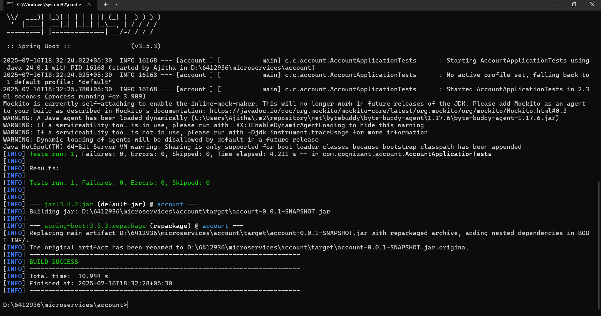

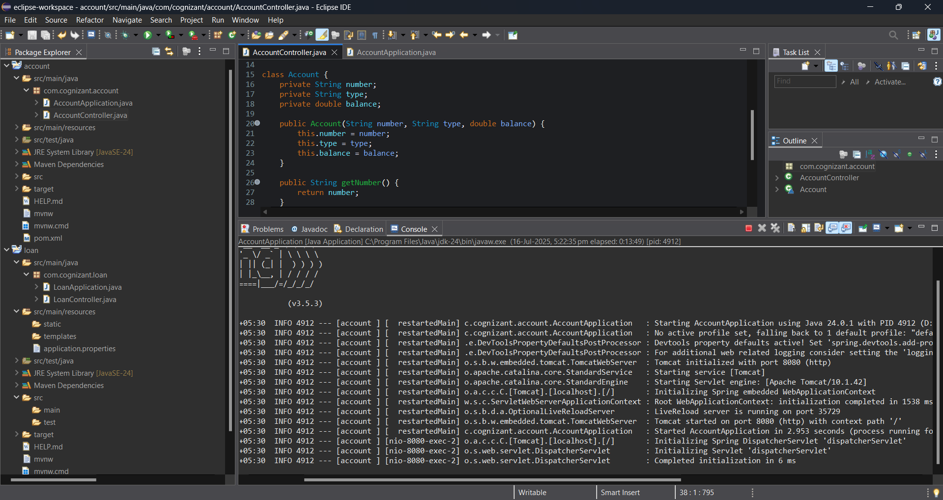

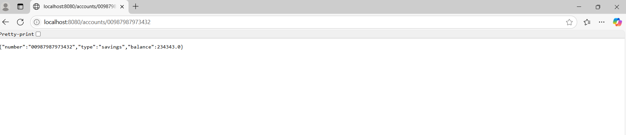

**Loan Microservice**

**LoanApplication.java:**

package com.cognizant.loan;

import org.springframework.boot.SpringApplication;

import org.springframework.boot.autoconfigure.SpringBootApplication;

*@SpringBootApplication*

public class LoanApplication {

public static void main(String[] args) {

SpringApplication.*run*(LoanApplication.class, args);

}

}

**LoanController.java:**

package com.cognizant.loan;

import org.springframework.web.bind.annotation.*;

*@RestController*

*@RequestMapping*("/loans")

public class LoanController {

*@GetMapping*("/{number}")

public Loan getLoan(*@PathVariable* String number) {

return new Loan(number, "car", 400000, 3258, 18);

}

}

class Loan {

private String number;

private String type;

private double loan;

private double emi;

private int tenure;

public Loan(String number, String type, double loan, double emi, int tenure) {

this.number = number;

this.type = type;

this.loan = loan;

this.emi = emi;

this.tenure = tenure;

}

public String getNumber() {

return number;

}

public String getType() {

return type;

}

public double getLoan() {

return loan;

}

public double getEmi() {

return emi;

}

public int getTenure() {

return tenure;

}

}

**application.properties:**

spring.application.name=loan

server.port=8081

**Output:**

