DATA ANALYSIS INTERNSHIP
Day 2 – REPORT
On Day 2, the concept of Exploratory Data Analysis (EDA) was discussed and performed using a Student Performance dataset downloaded from Kaggle.

1. Dataset Collection
Downloaded the Student Performance dataset from Kaggle for performing Exploratory Data Analysis (EDA).
The original dataset contained multiple columns.
From the original dataset, unwanted columns were removed and only the required columns were retained for analysis.
The final dataset contains:
- Student study hours
- Subject scores
- Gender
- Email
- Grade

2. Dataset Columns
STUDENT PERFORMANCE ANALYSIS (EXPLORATORY DATA ANALYSIS)
Expansion of each column:
Column | Contains
Id | It stores Unique student identification numbers like 1, 2, 3, 4(Integer)
(Gender | Gender values like Male, Female(String)
Email | Student email addresses like student1@gmail.com, student2@gmail.com(String)
weekly_self_study_hours | Study hours values like 27, 47, 13, 3, 10(Integer)
math_score | Mathematics marks like 73, 90, 81, 71(Integer)
history_score | History subject marks like 81, 86, 97, 74(Integer)
physics_score | Physics marks like 93, 96, 95, 88(Integer)
chemistry_score | Chemistry marks like 97, 100, 96, 80(Integer)
biology_score | Biology marks like 63, 90, 65, 89(Integer)
english_score | English marks like 80, 88, 77, 63(Integer)
geography_score | Geography marks like 87, 90, 94, 86(Integer)
Grade | Performance categories like Good, Excellent(String)

3. Exploratory Data Analysis (EDA)
Performed EDA to understand the dataset structure and student performance patterns.
EDA Steps Performed
- Checked dataset shape
- Identified rows and columns
- Verified data types
- Checked missing values
- Checked duplicate values
- Removed unwanted columns
- Analyzed student grades
- Studied subject-wise performance

4. Data Types
Column | Data Type
Id | Integer
weekly_self_study_hours | Integer
math_score | Integer
history_score | Integer
physics_score | Integer
chemistry_score | Integer
biology_score | Integer
english_score | Integer
geography_score | Integer
Grade | String
Gender | String
Email | String

5. Grade Analysis
The Grade column contains:
- Excellent
- Good
- Average
Observation:
- Most students belong to the Good category.
- Students with higher study hours and higher marks achieved Excellent grades.

6. Subject Score Analysis
The dataset contains scores for:
- Mathematics
- History
- Physics
- Chemistry
- Biology
- English
- Geography
Observation:
- Higher subject scores improve overall student performance.
- Balanced scores across all subjects result in better grades.

7. Gender Analysis
The Gender column contains:
- Male
- Female
Observation:
- Dataset includes both male and female students for analysis.

8. Tree Structure Creation:
The tree structure was created to show the organization of the Student Performance dataset in a simple hierarchical format.
- The root node is Student Performance, which represents the complete dataset.
- It is divided into two parent nodes:
  - Student Information
  - Academic Performance
Student Information contains:
- Id
- Gender
- Email
These columns store the personal details of students.
Academic Performance contains:
- weekly_self_study_hours
- Subject Scores
- Grade
Subject Scores includes:
- Math
- History
- Physics
- Chemistry
- Biology
- English
- Geography
Grade contains:
- Excellent
- Good
- Average
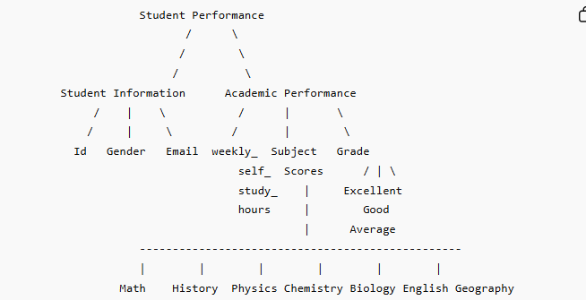

9. Conclusion
On Day 2, I learned the concept of Exploratory Data Analysis (EDA) and performed EDA on a Student Performance dataset downloaded from Kaggle. I removed unwanted columns from the original dataset and analyzed the required columns such as study hours, subject scores, gender, and grade. I also checked data types, missing values, duplicate values, and created a tree structure representation of the dataset.

