DAY 3
1.Expansion of the Dataset: (Continuation of day2)
Available Columns in the Student Performance Analysis Dataset
id
first_name
last_name
email
gender
part_time_job
absence_days
extracurricular_activities
weekly_self_study_hours
career_aspiration
math_score
history_score
physics_score
chemistry_score
biology_score
english_score
geography_score
grade(output)

Seperation of each columns
Must Needed
gender
absence_days
weekly_self_study_hours
math_score
history_score
physics_score
chemistry_score
biology_score
english_score
geography_score

Unwanted
first_name
last_name
email
Optional
id
part_time_job
extracurricular_activities
career_aspiration

2.Visualization of the Data
CANVA JS - https://canvasjs.com/
Example charts creation:
1.Piechart Creation( Student percentage in each subject)
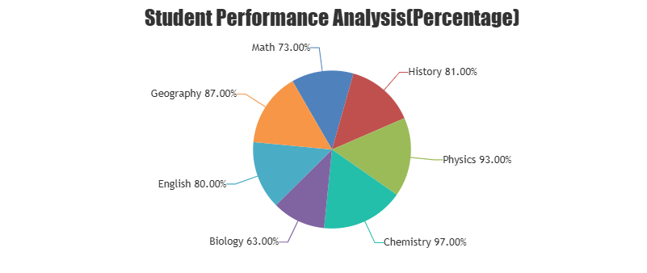
2.BarChart Creation: (to compare average marks based on study hours)
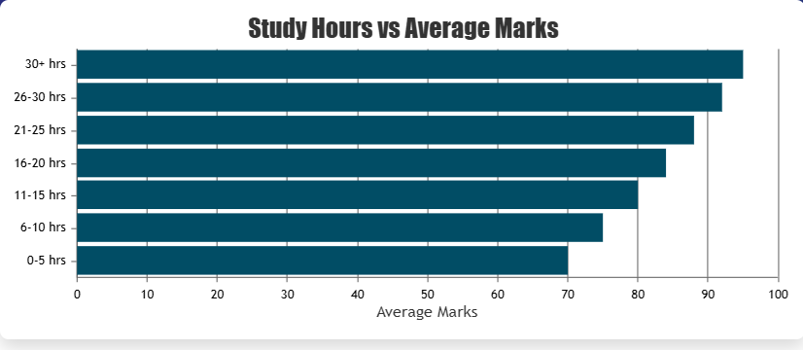

3.Line Creation: (To represent the variation in students’ marks based on the number of absence days.)
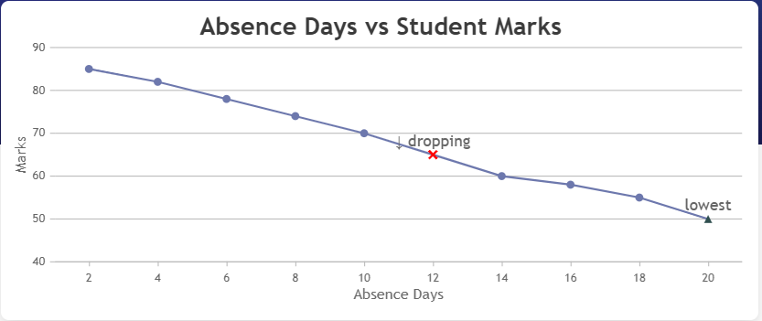
GOOGLE COLAB: https://colab.com
Connect install- virtualenv(pypi) installation+ 20 modules installation process.

