**INSTALLATION OF PYTHON 3.9.8**

|  |  |
| --- | --- |
| **Date** | 04 NOVEMBER 2022 |
| **Team ID** | PNT2022TMID23722 |
| **Project Name** | IOT BASED SMART CROP PROTECTION SYSTEM FOR AGRICULTURE |

Step 1: Type python in google and click on the first link

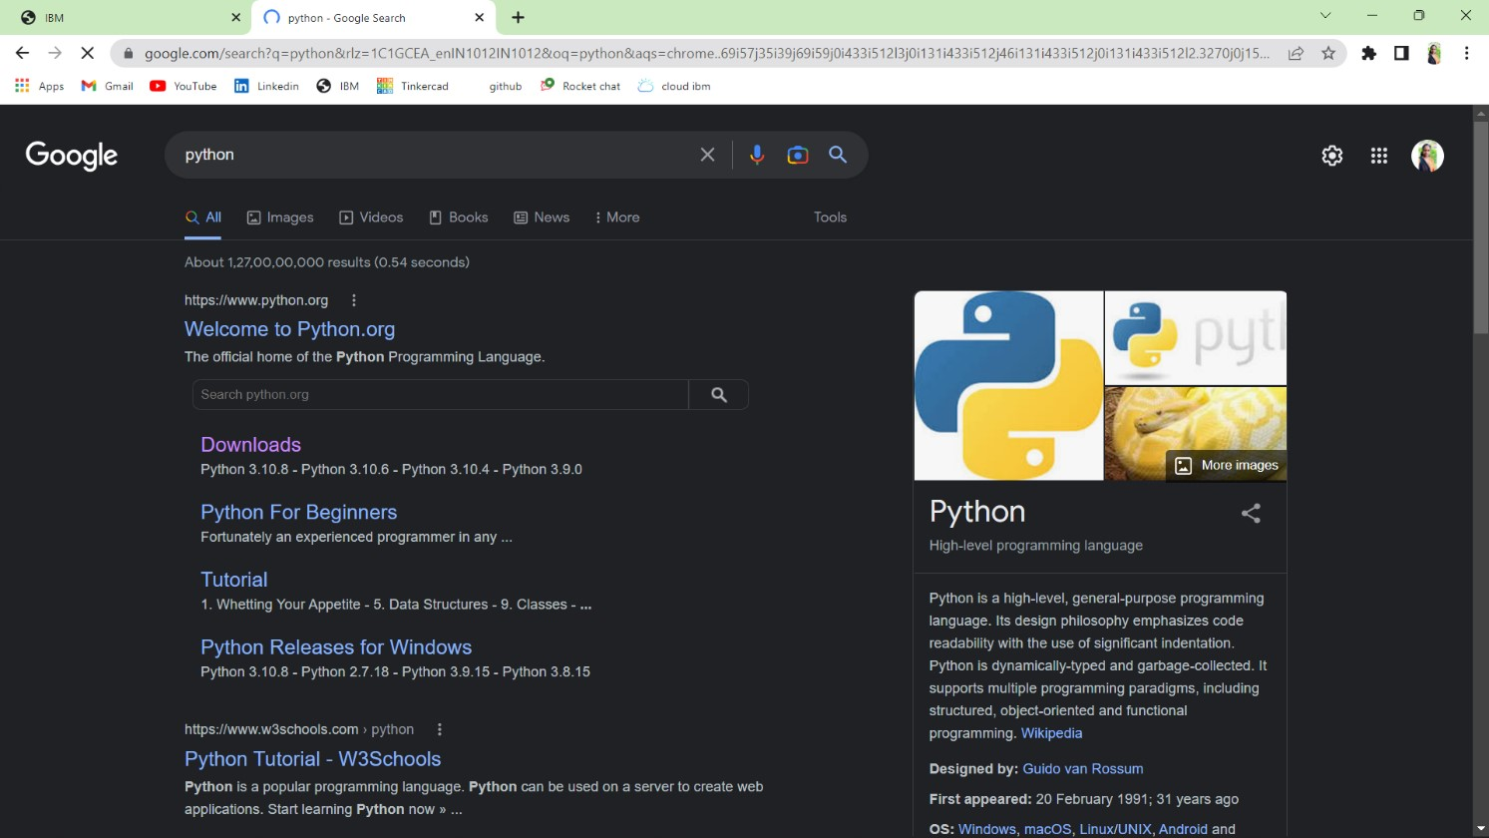

Step 2: Click the python 3.9.8

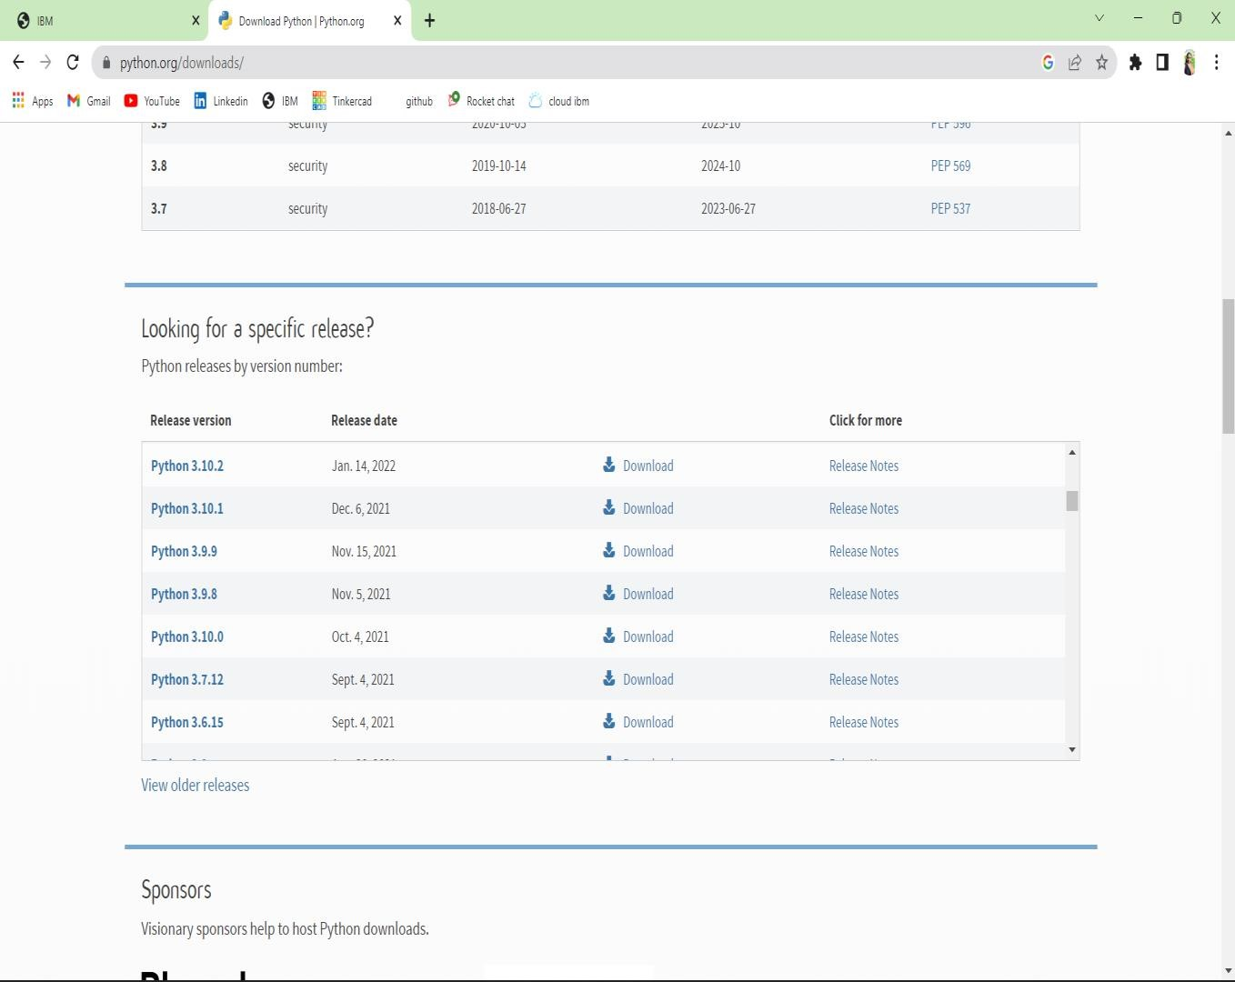

Step 3: Scroll down to reach Files and click on “Window installer (64 bit)

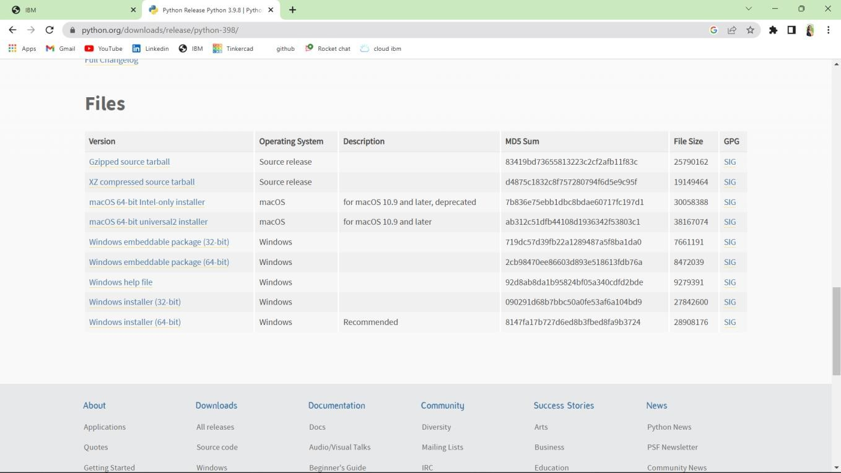

Step 4: Installation on progress

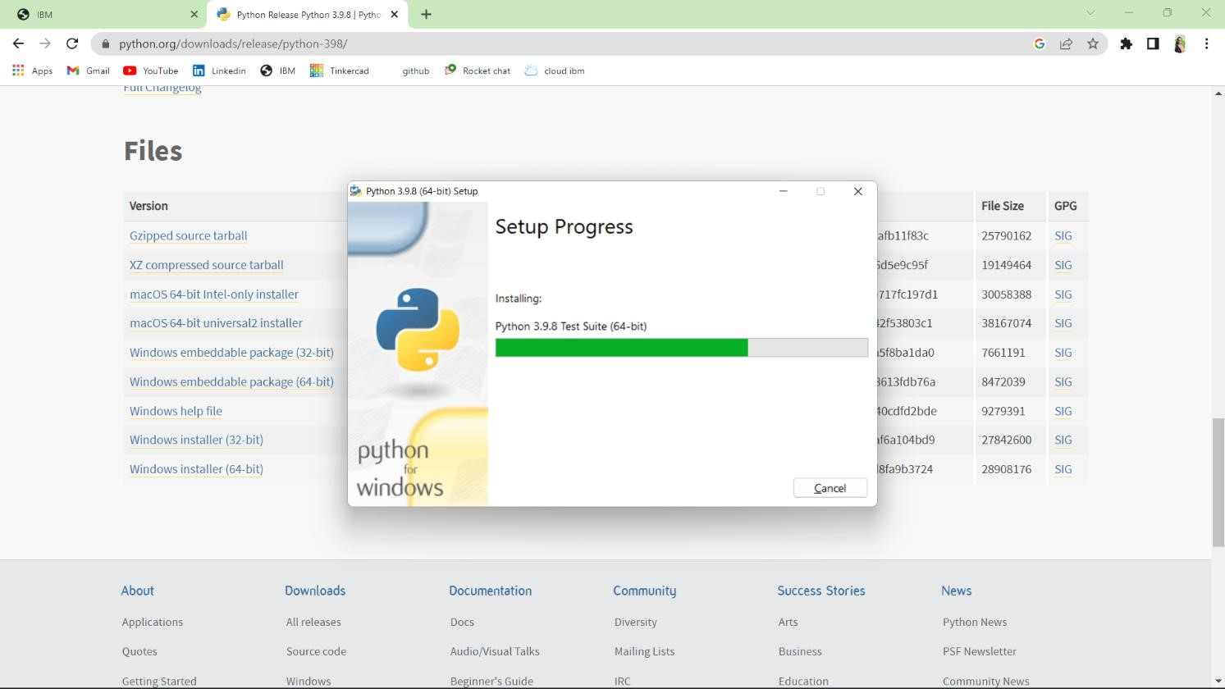

Step 5: Search IDLE

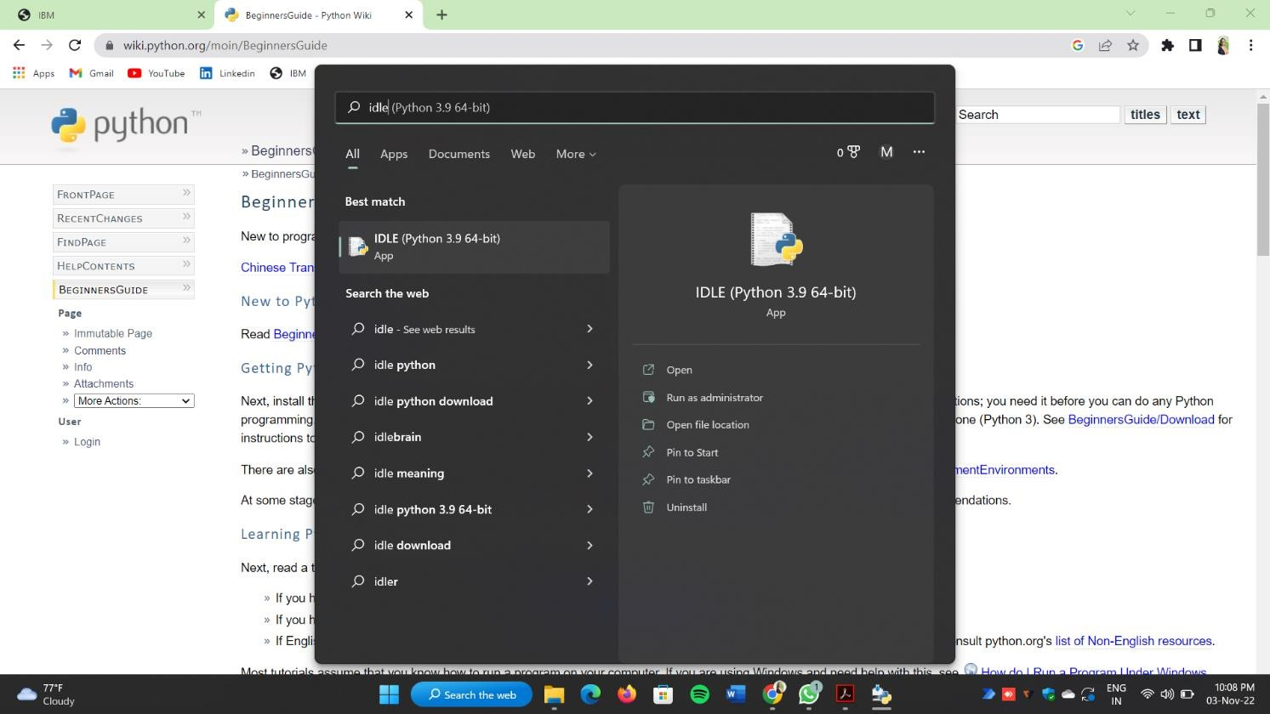

Step 6: Open it

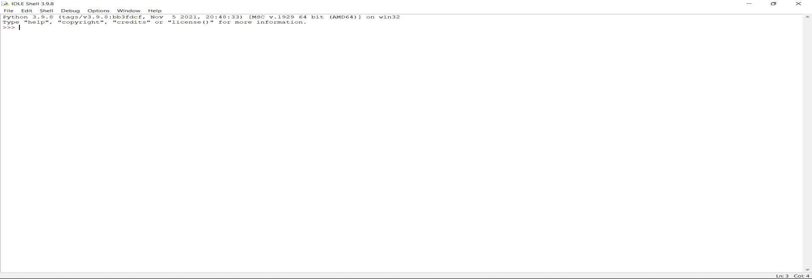

Step : Go to file and click on New File

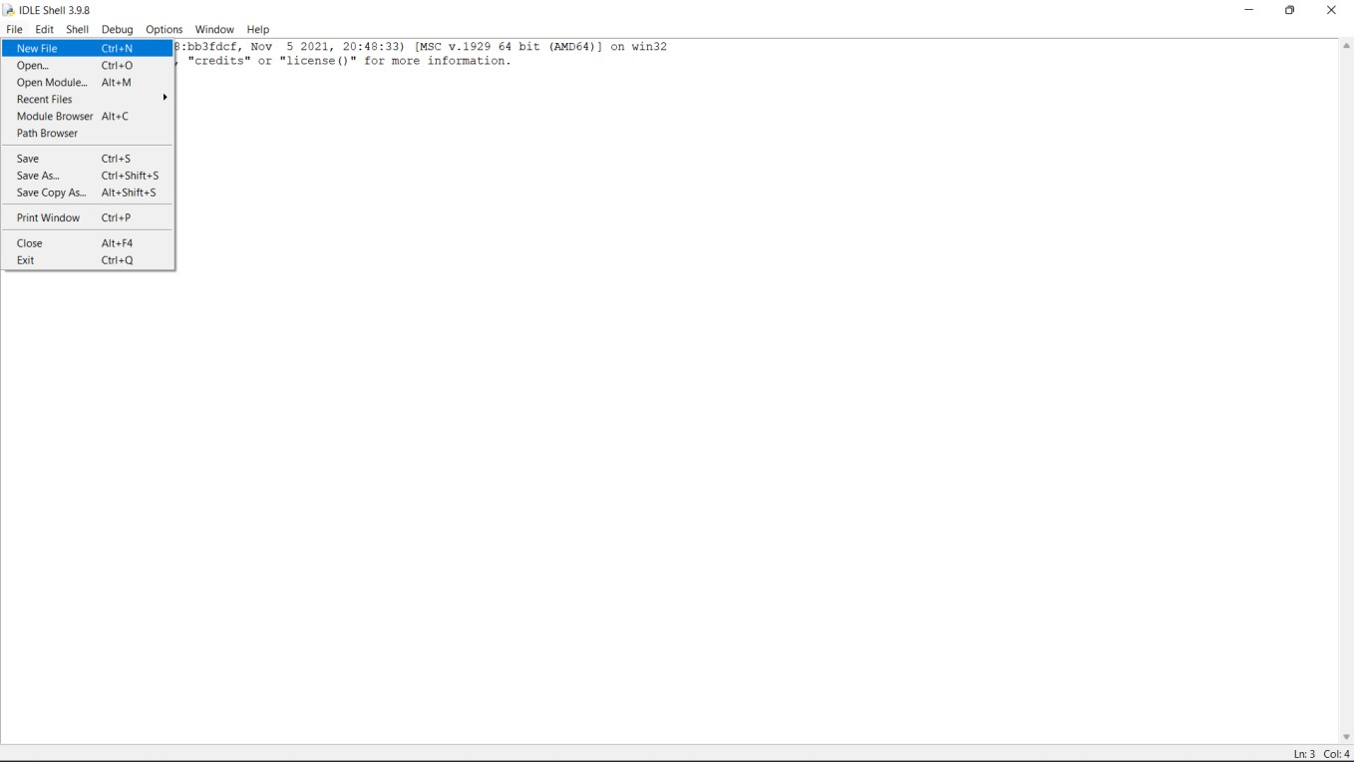

Step 8: Open it



A Python 3.9.8 is installed successfully.