**Test Case Scenarios**

**This testing document covers the testing of services using Postman.**

1. **Verify that 200 OK is obtained as response for a valid username in github.**

**Valid username: AbinayaRaghuraman**

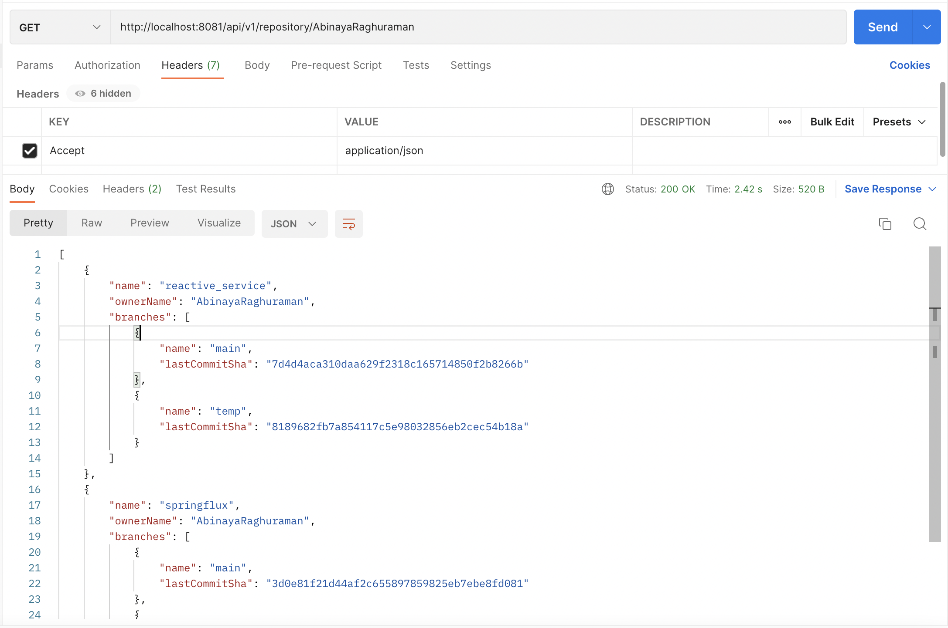

1. **Verify that 404 Not Found is obtained as response for an invalid username in github.**

**Invalid username: AbinayaRaghuraman_invalid**

1. **Verify that 406 Not Acceptable is obtained as response for an invalid content type.**

**Invalid content type: application/xml**

**Swagger UI**



