**ASSIGNMENT-10.2**

1. Move the file to Hadoop path or local file system

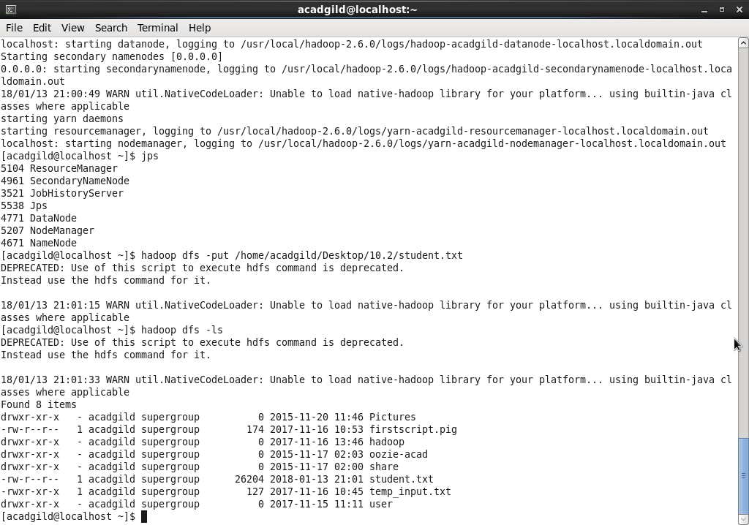

1. Set Pig_classpath jar and lib files

C:\Users\user\Desktop\Acadgild Assignments\Assignment-10.2\10.2\2.png

1. Start HBase and create table(studentAcad) and column family (student_data)

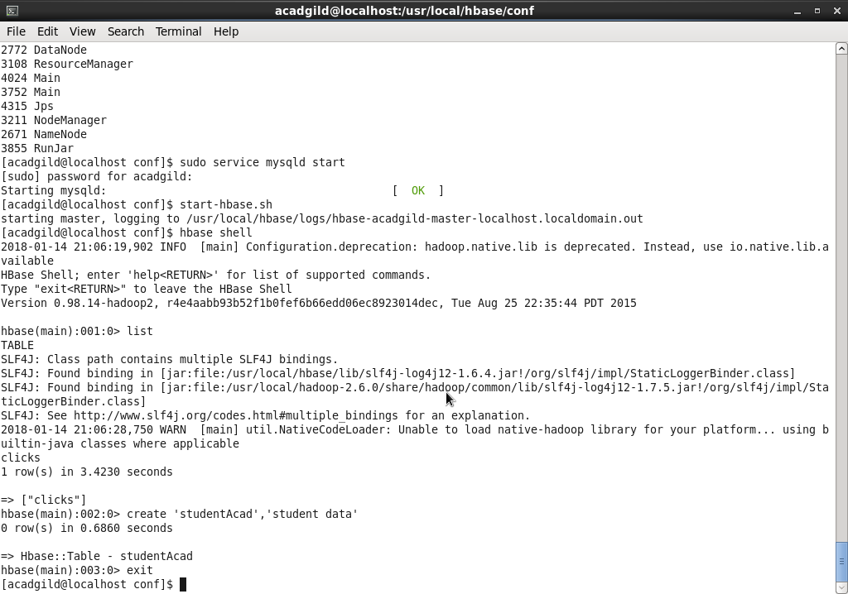

1. Start Pig to load the data from hbase using Pig Scripts

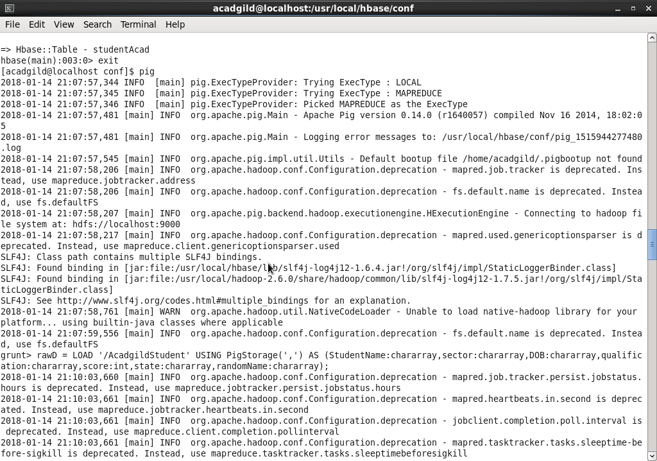

1. Load the data from file system

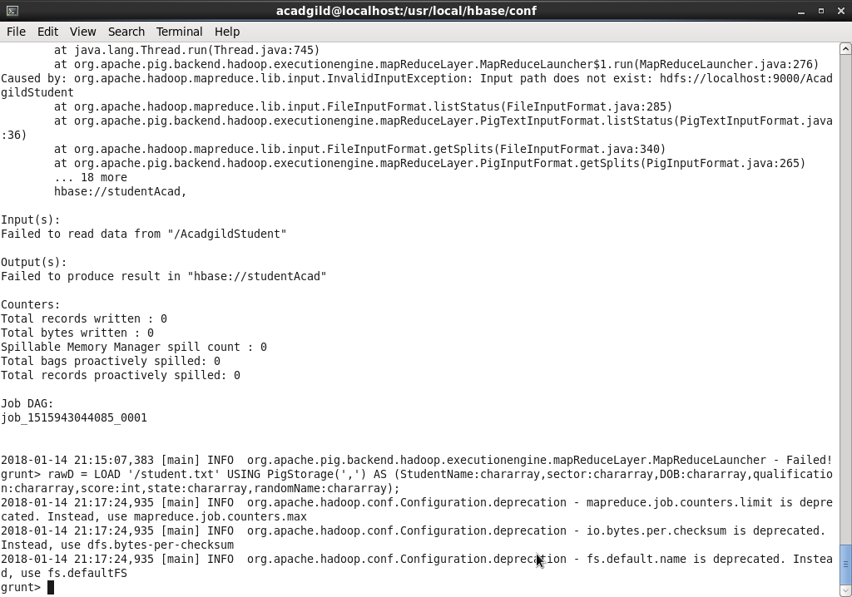

1. Store the data to hbase table via pig scripts

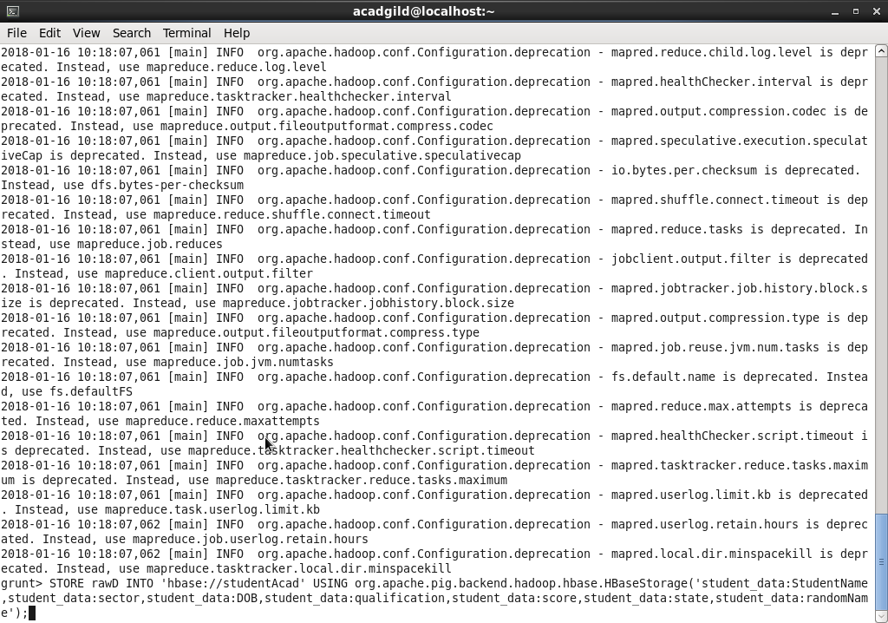

1. Store to hbase table command – Results

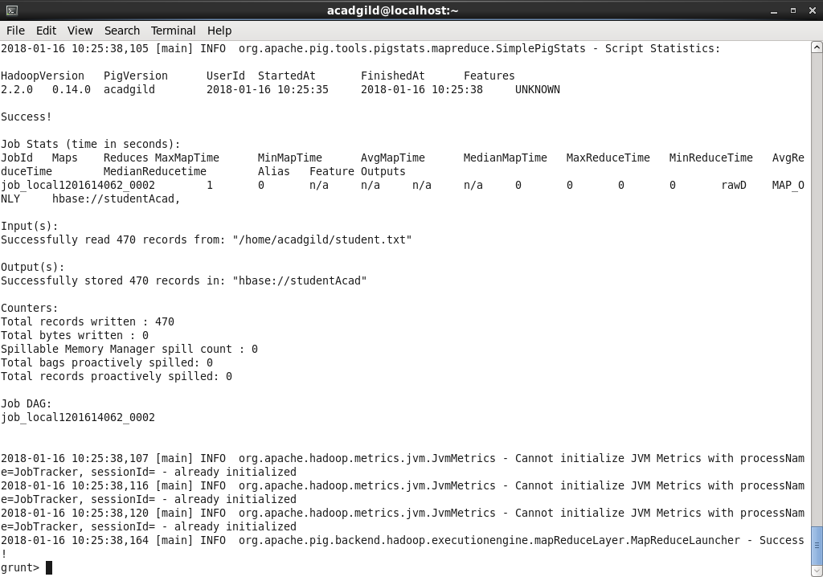

1. Scan table command and results

