**ASSIGNMENT-11.1**

1. Import data from Mysql to HDFS

* Create table **student** in database – **testDb** and insert values into it in mysql:

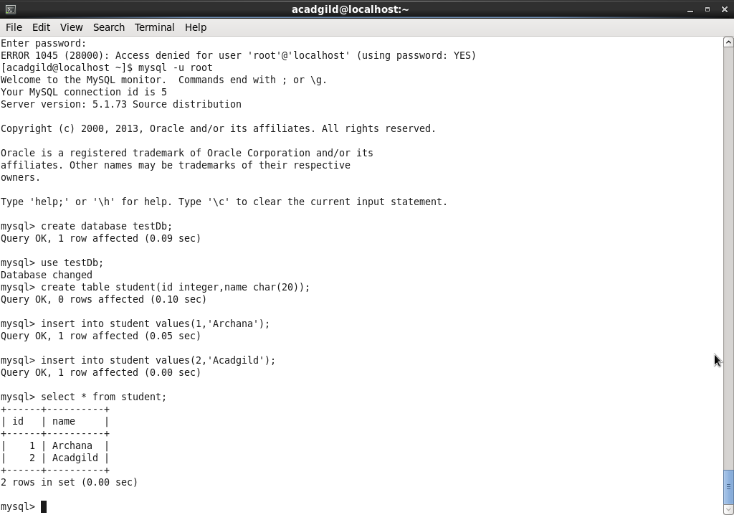

* Sqoop import command to import data in to HDFS from Mysql.

(“-m 1” in the command to be used, if no split-by clause is specified)

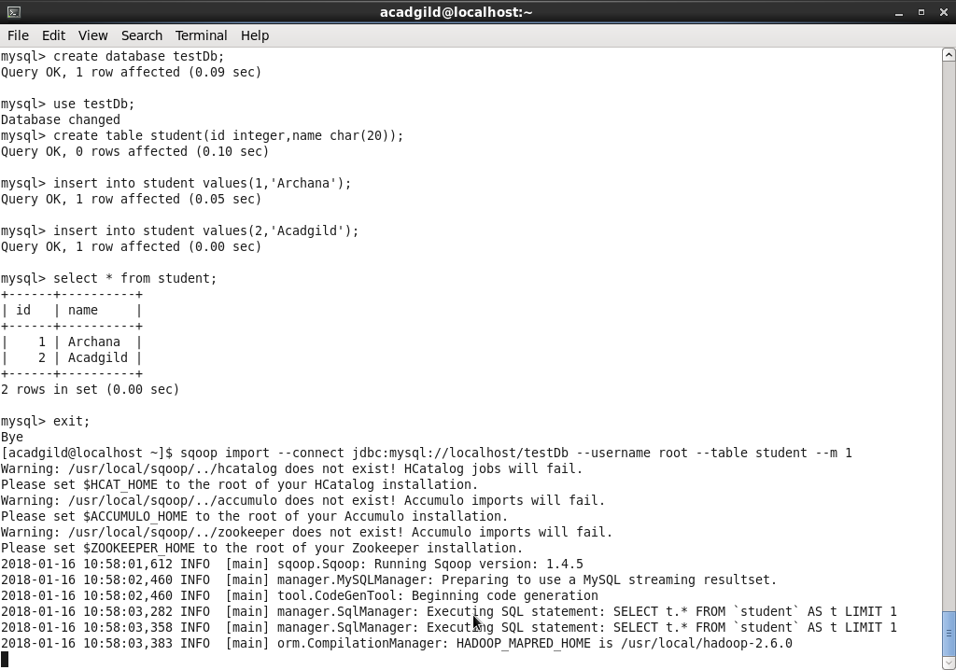

1. Export data from HDFS to mysql

* Create database – **db1** and table – **acad** in mysql

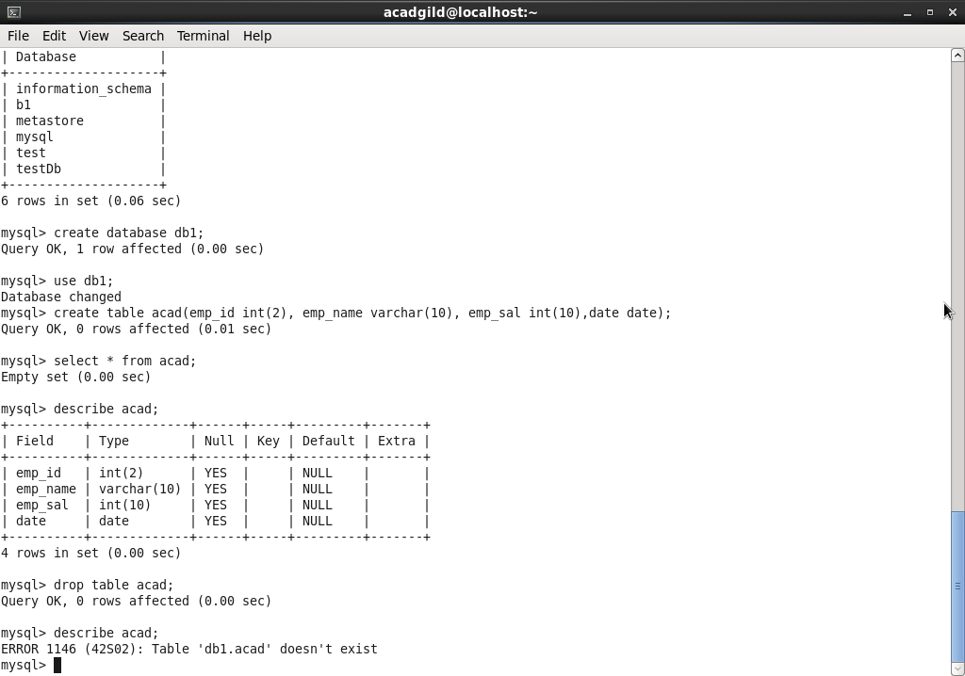

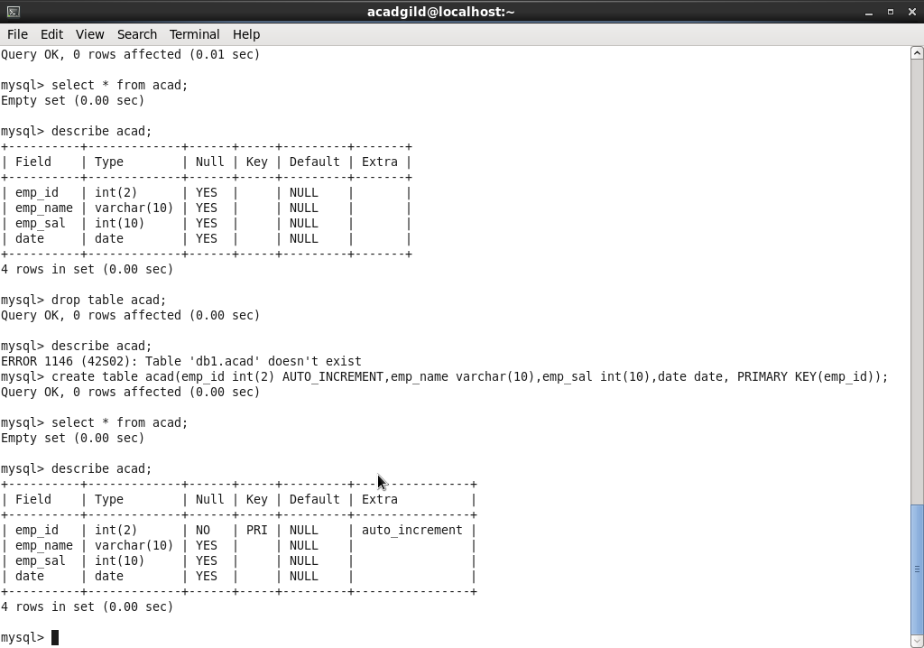

* Create a file and input data in to file created and place the same in Hadoop Directory to be exported to mysql table. File Created – **input_sql_export.txt**

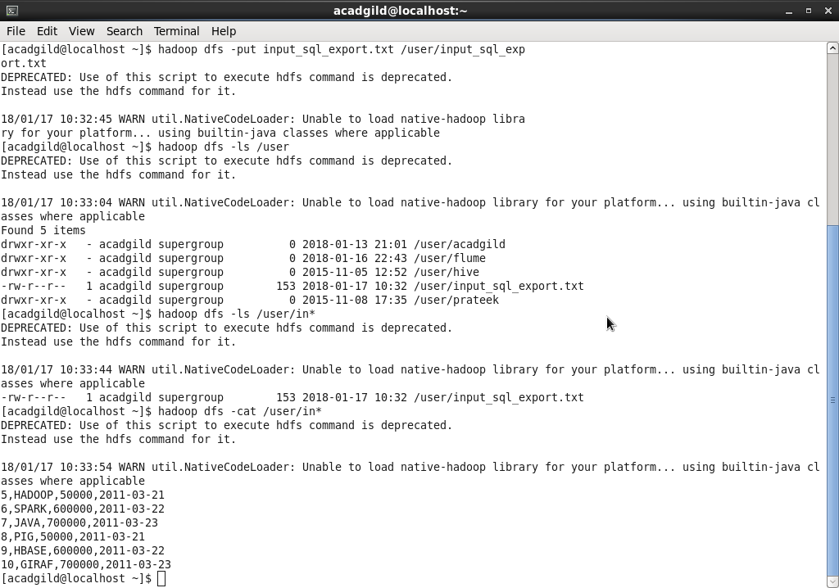

* Sqoop export command – To export data from HDFS to MySQL

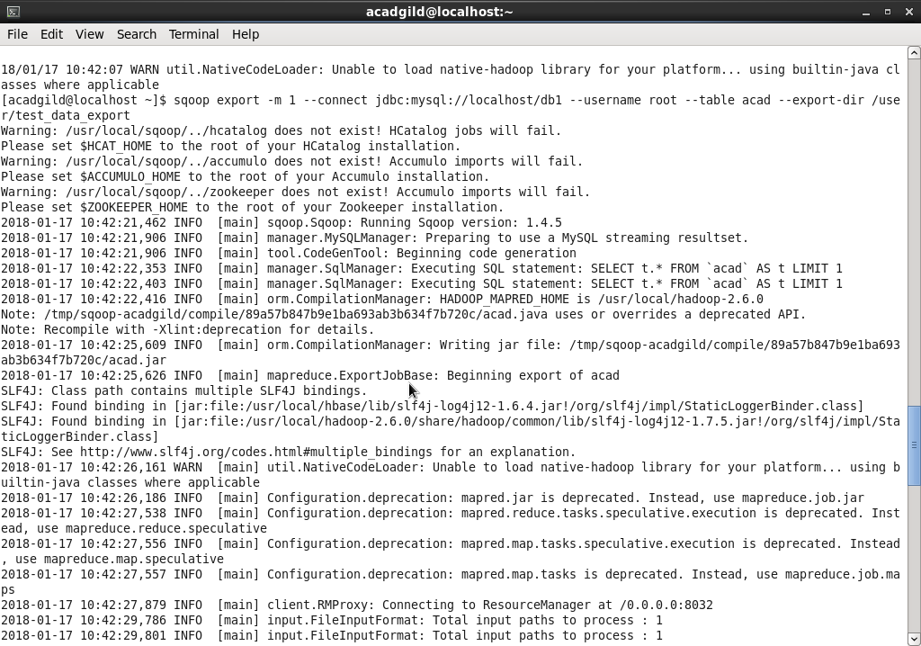

Final Result:

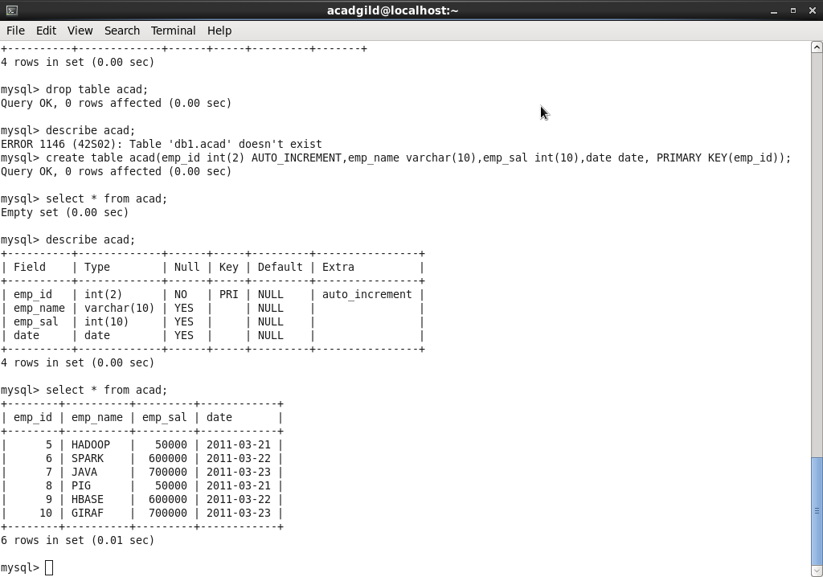

1. Import selected columns from mysql to Hive

* The data exported from HDFS previously will be imported to hive now. Below is the screenshot of data.

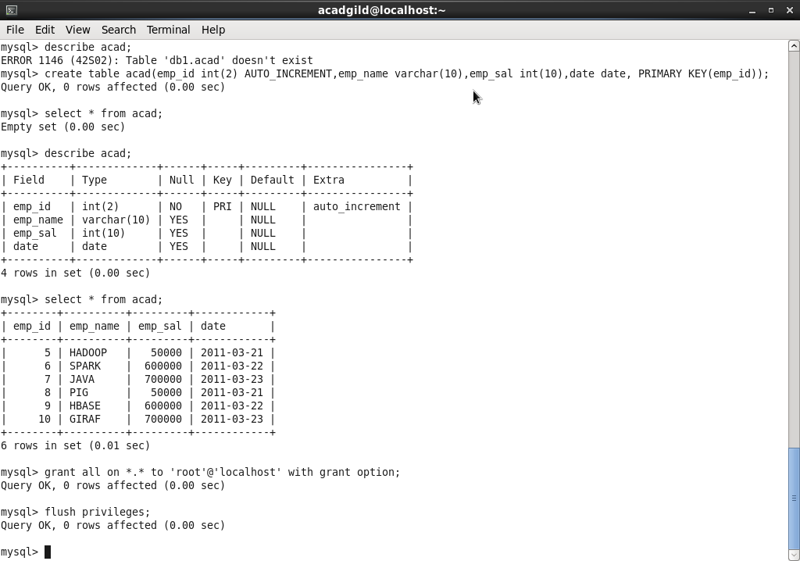

* Sqoop import command – To import data from Mysql to Hive

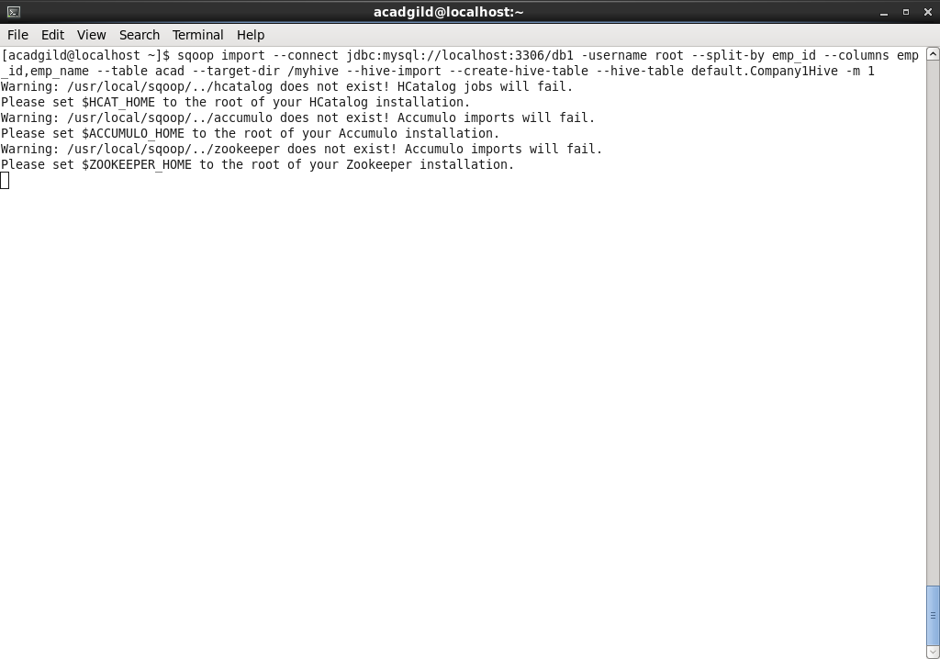

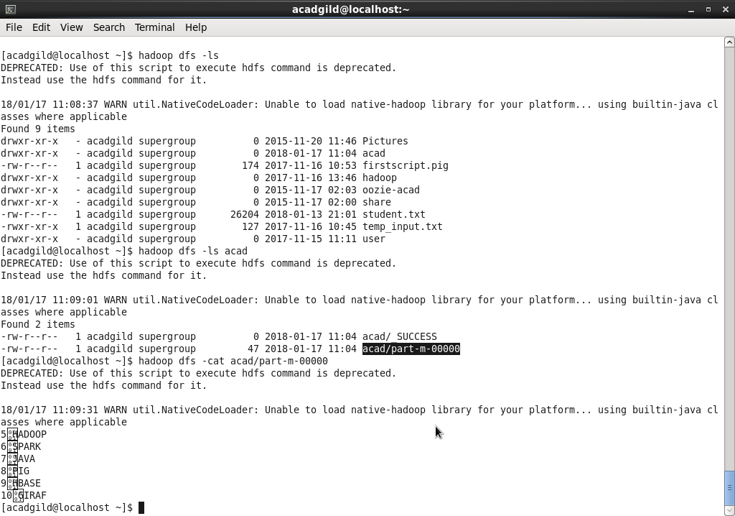

1. Export data from Hive to mysql database

* Employee’s salary details data from hive table – **salary_details** will be exported to mysql

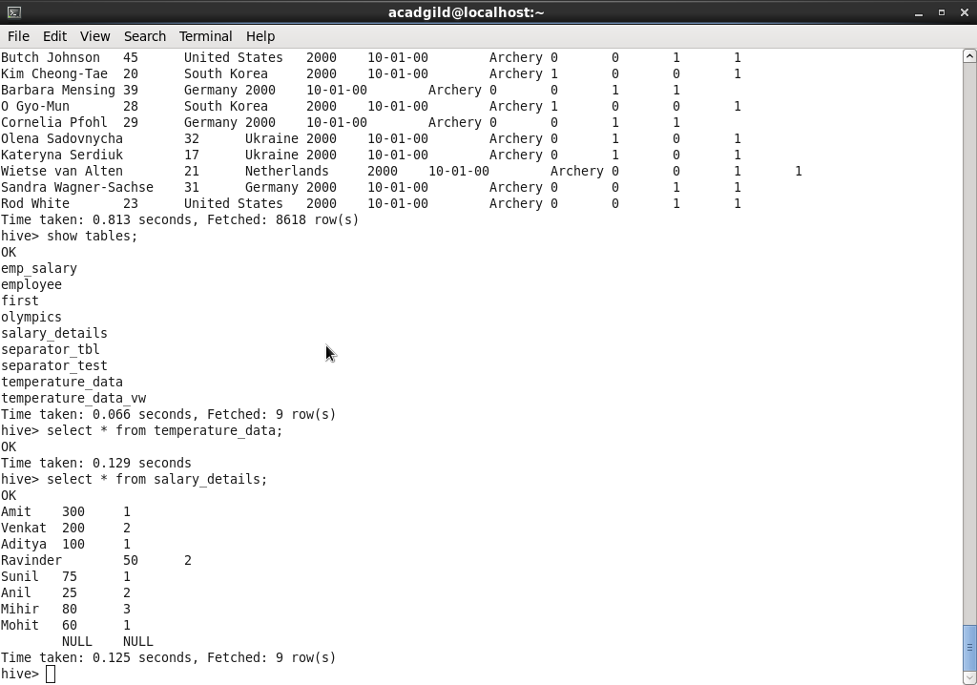

* Create a new table **salary** in mysql

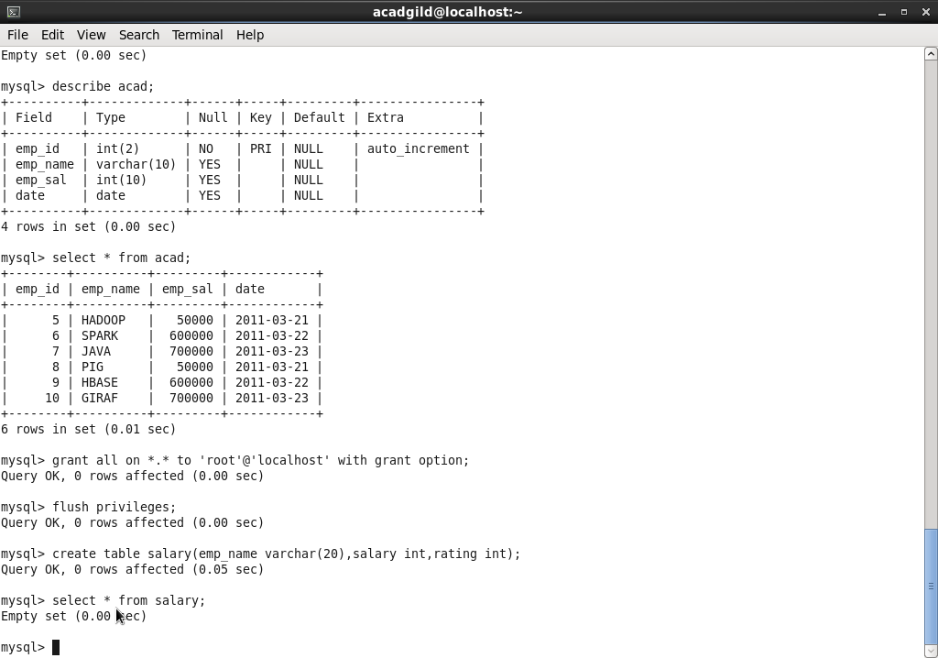

* Sqoop Export Command – To export selected columns from hive table **Salary_details** to mysql table - **salary**

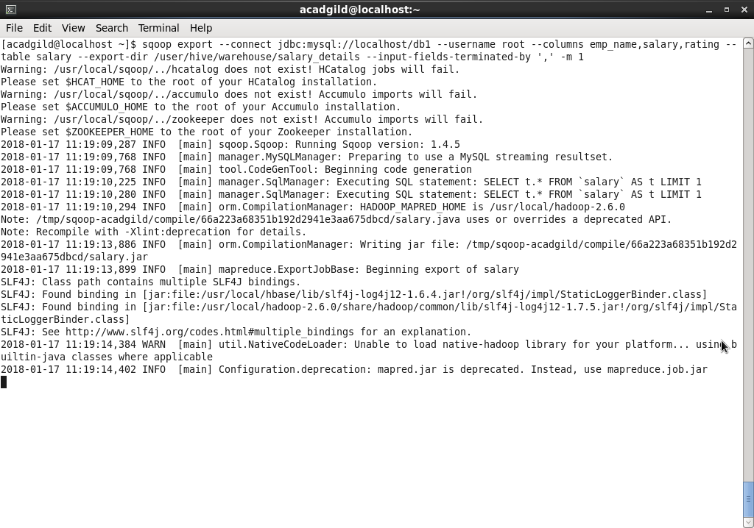

* Final result of data export from Hive to Mysql.

