**ASSIGNMENT-11.2**

1. Create a table in mysql and insert some data to be imported by hadoop

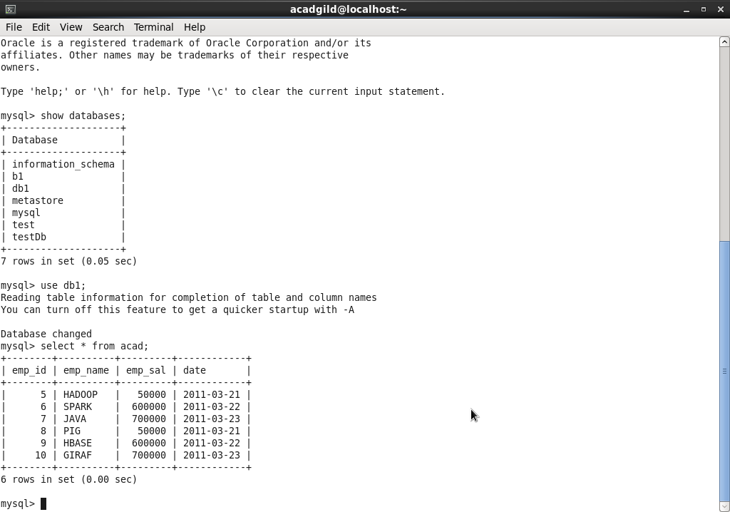

1. Sqoop import command

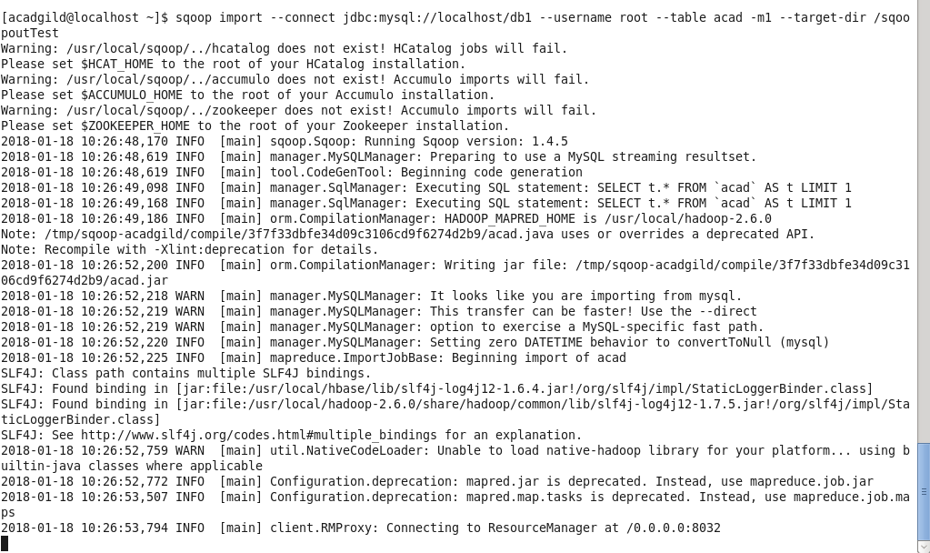

1. Listing the contents copied from mysql db to HDFS

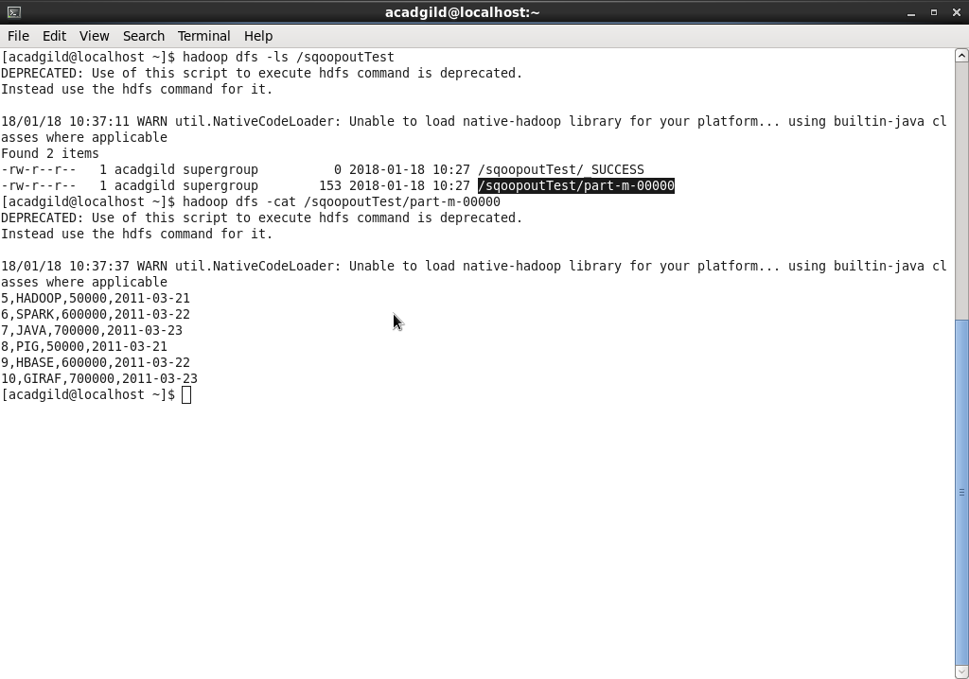

1. Inserted few more records for incremental append

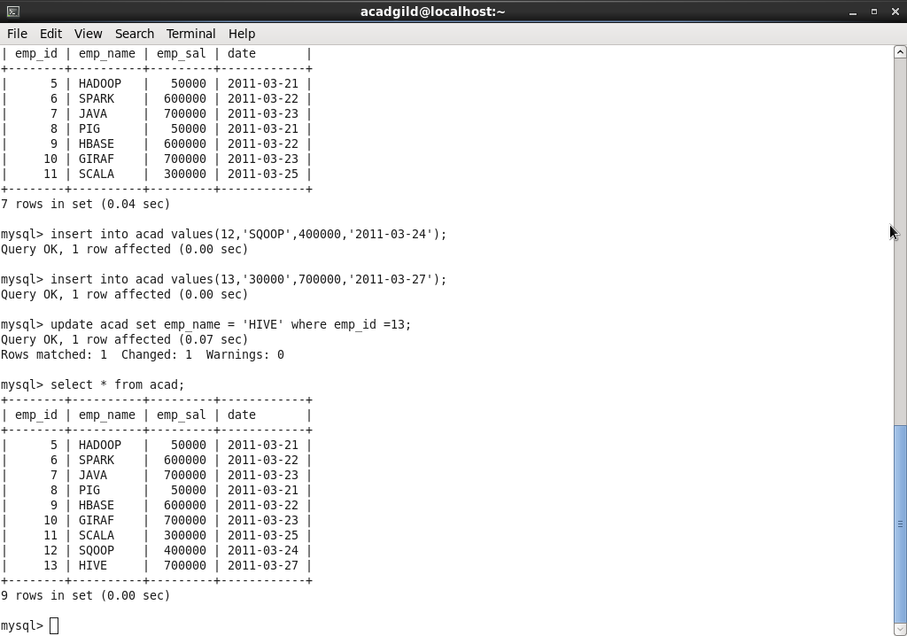

1. Sqoop incremental append command

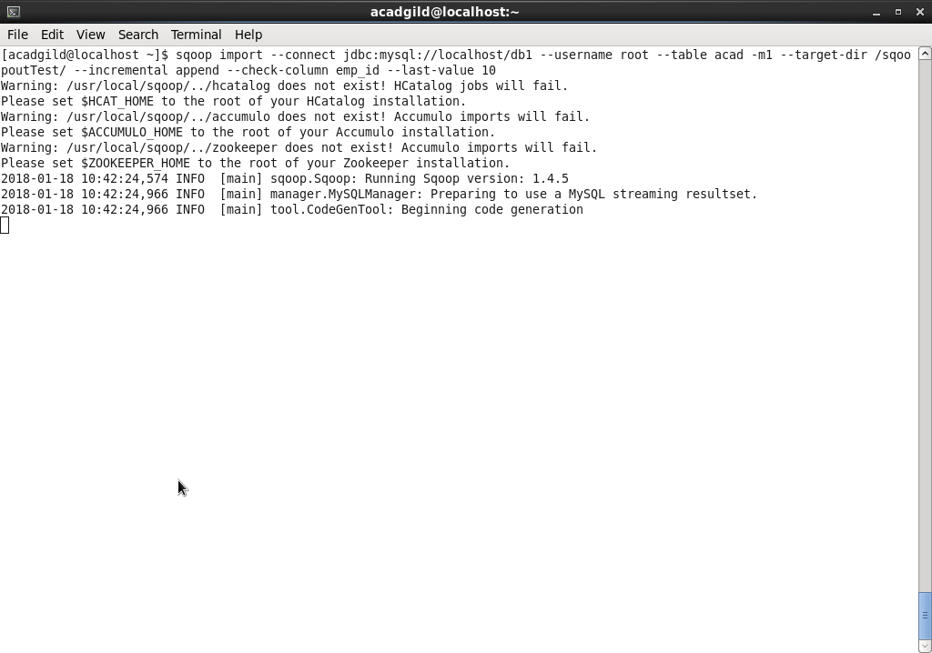

1. List the contents from HDFS which got recently appended

