**ASSIGNMENT-11.3**

1. Login to Twitter

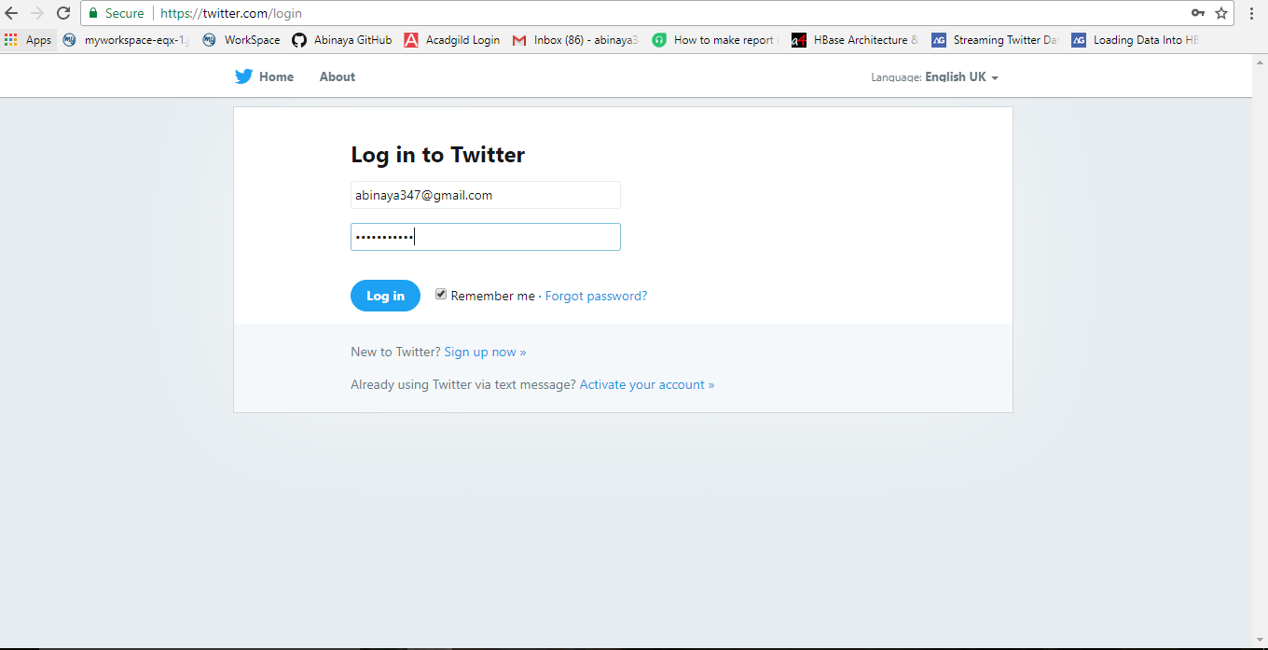

1. Navigate to create new Application Page

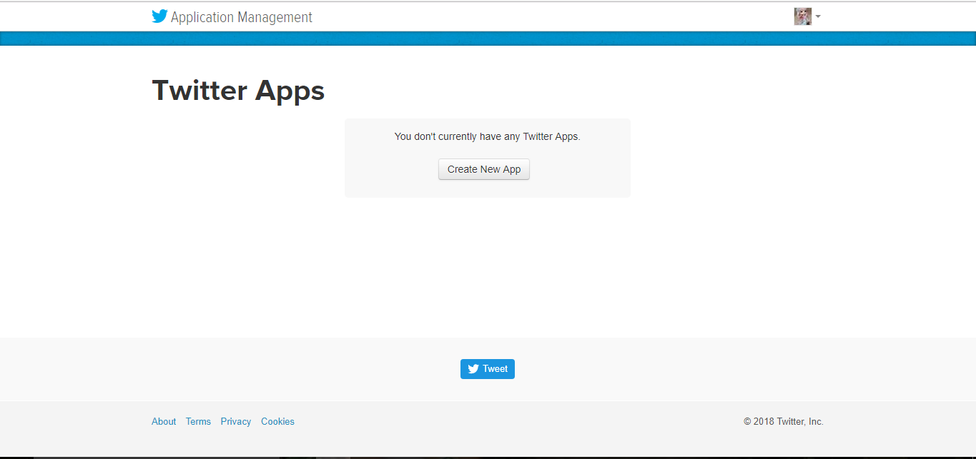

1. To create an application, enter the required details

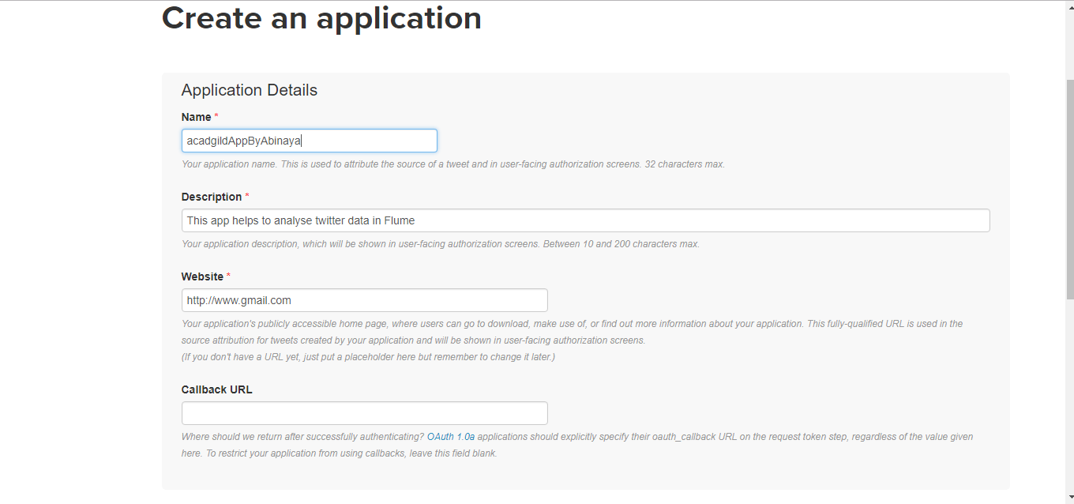

1. Sign the Developer Agreement

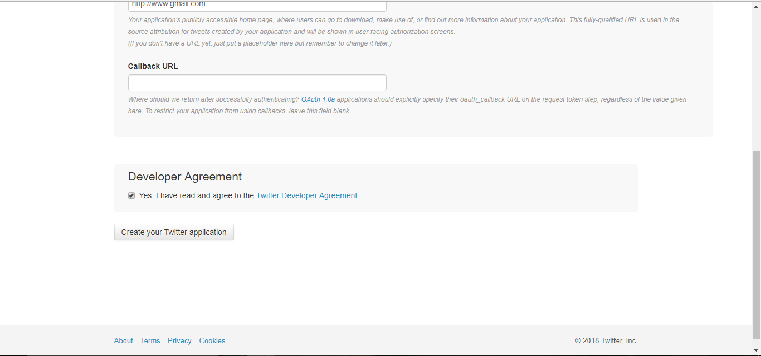

1. Generate Access Token

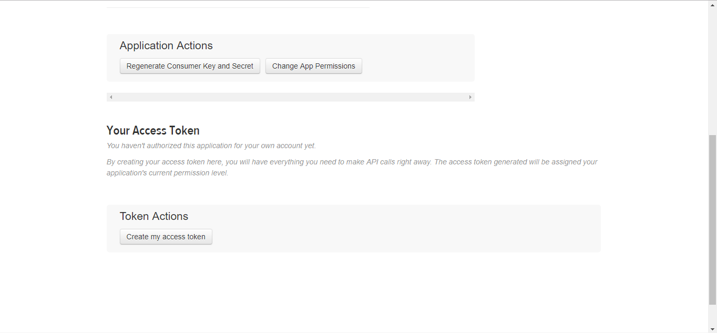

1. Download Flume from the specified path, extract and edit the .bashrc file to point to the new downloaded flume agent

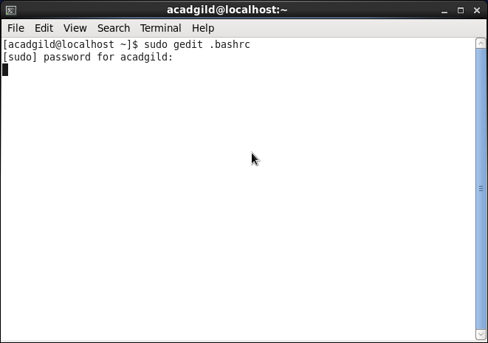

1. Update the .bashrc file to take effect

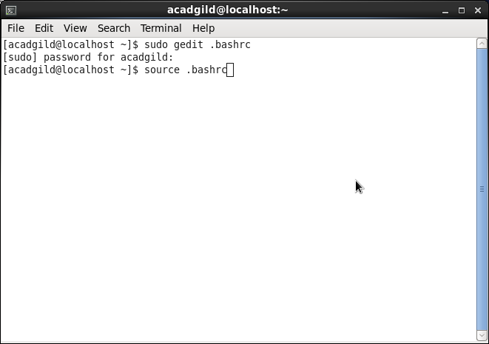

1. Check if the required Twitter jars are present in the flume agent, if not add them to the lib folder of newly downloaded Flume



1. Modify the consumerkey,consumer token values and the keywords

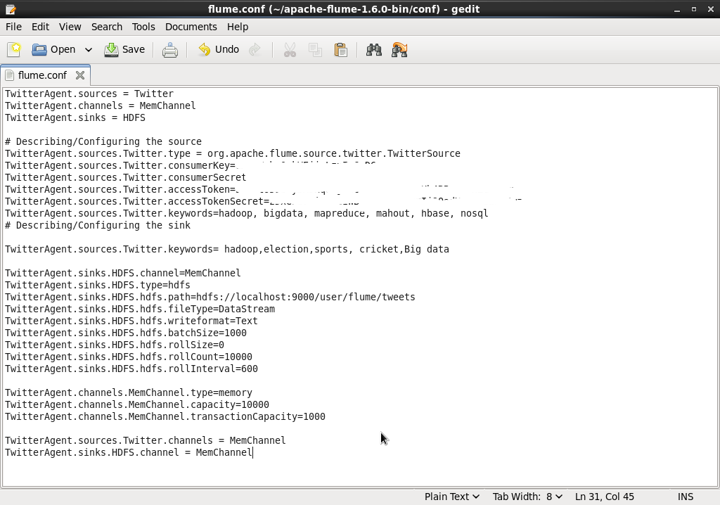

1. Start all the components of hadoop

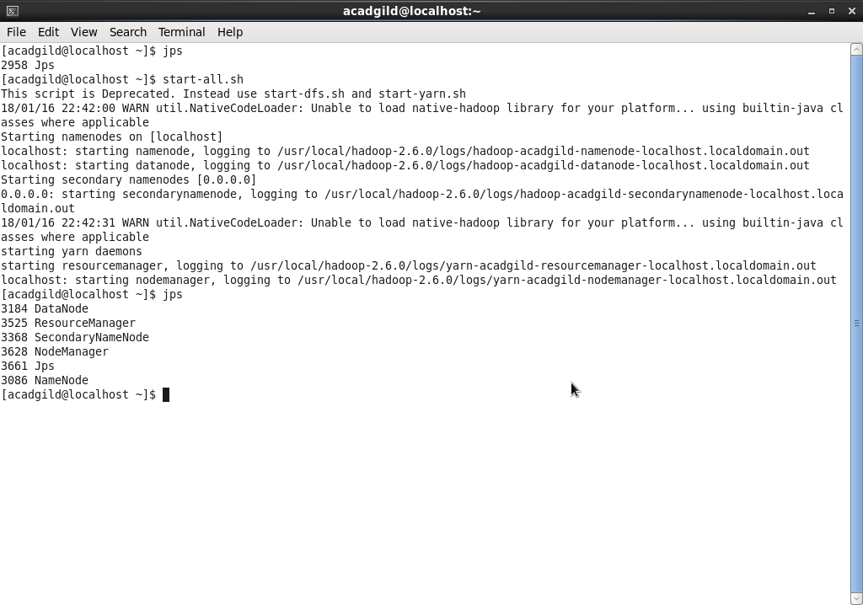

1. Create a directory in hadoop

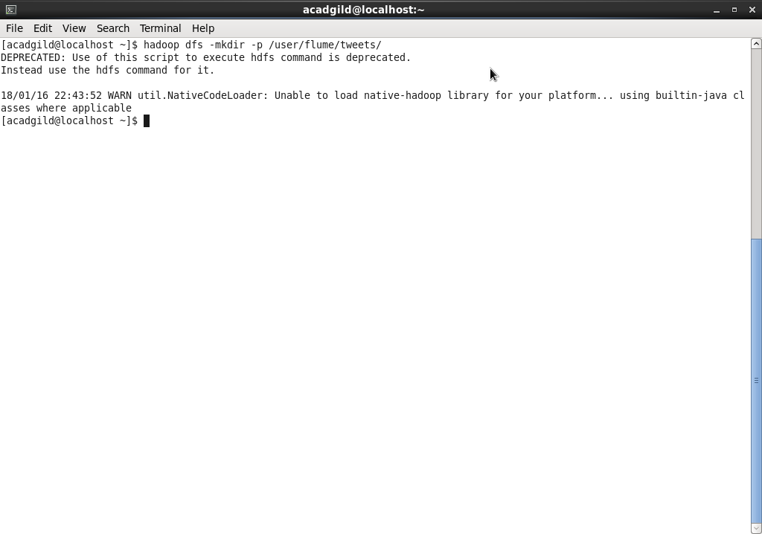

1. Command to start flume agent, point to flume_conf path

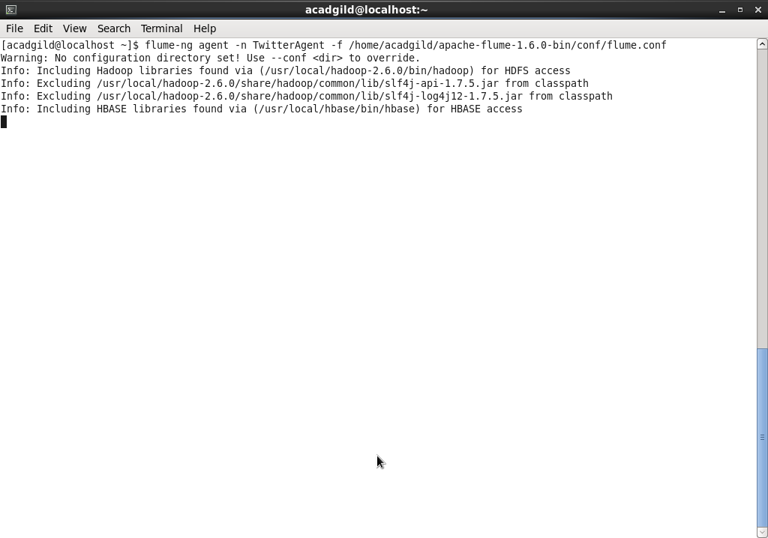

1. List the contents of hadoop directory

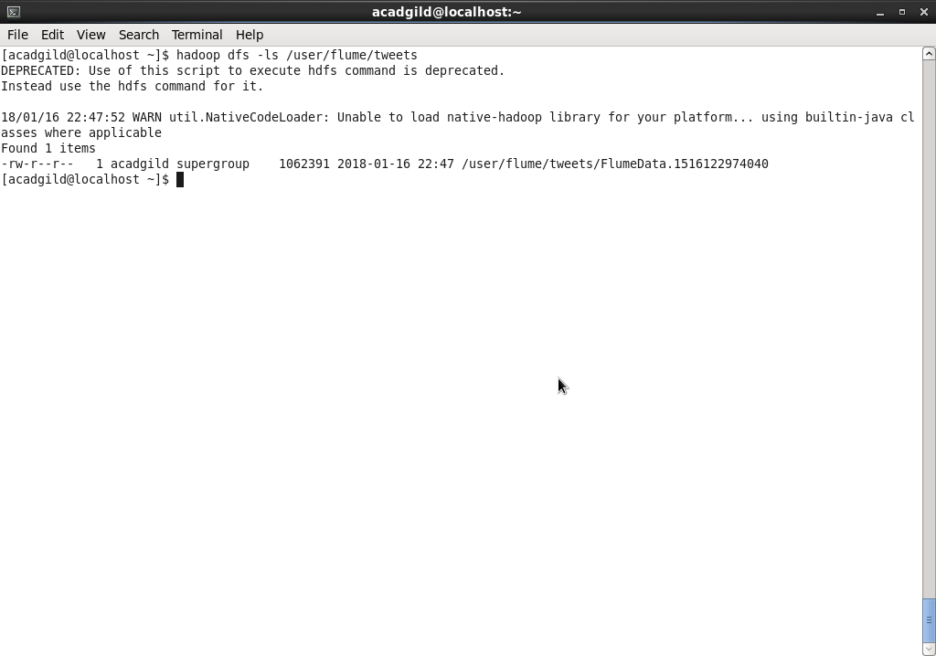

1. Cat command to view the contents of file

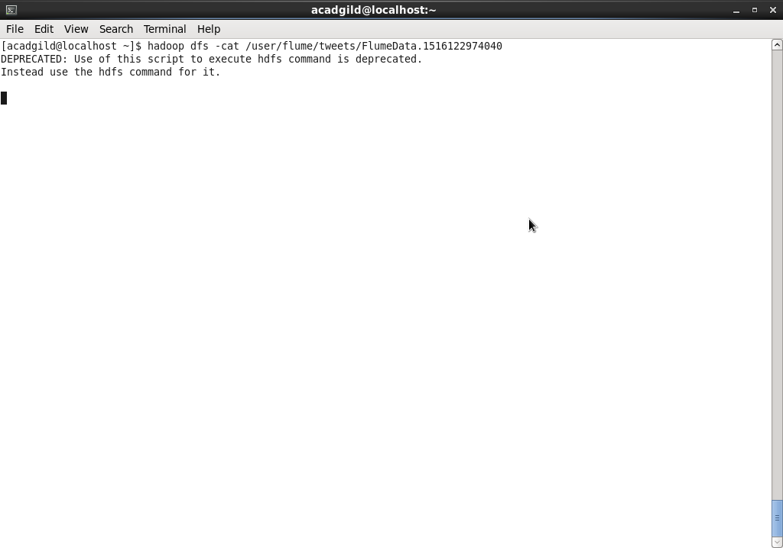

1. Result: (Font is not recognized)

