**ASSIGNMENT-12.1**

1. Open Oracle VirtualBox

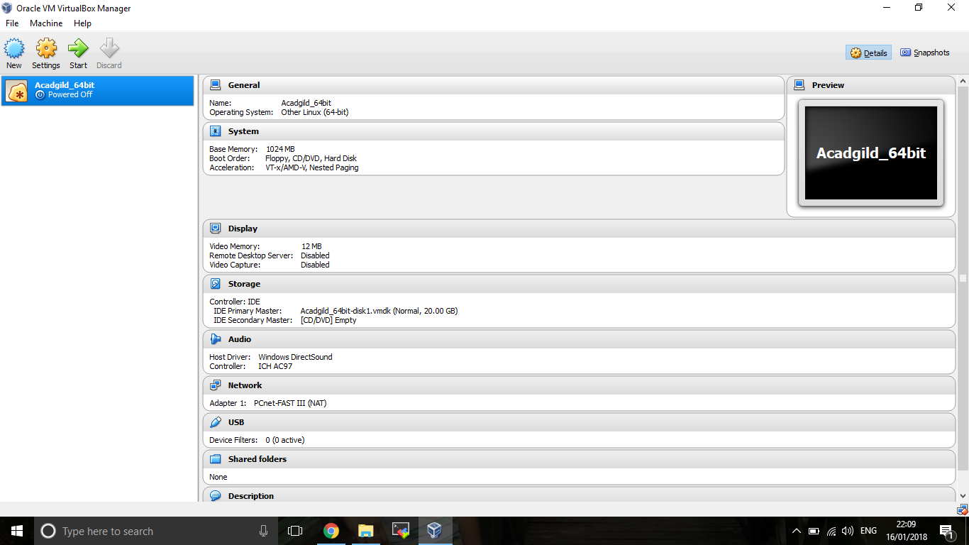

1. Choose File->Import Appliance and the dialog box shown as below appears. Enter the path of downloaded Spark VM

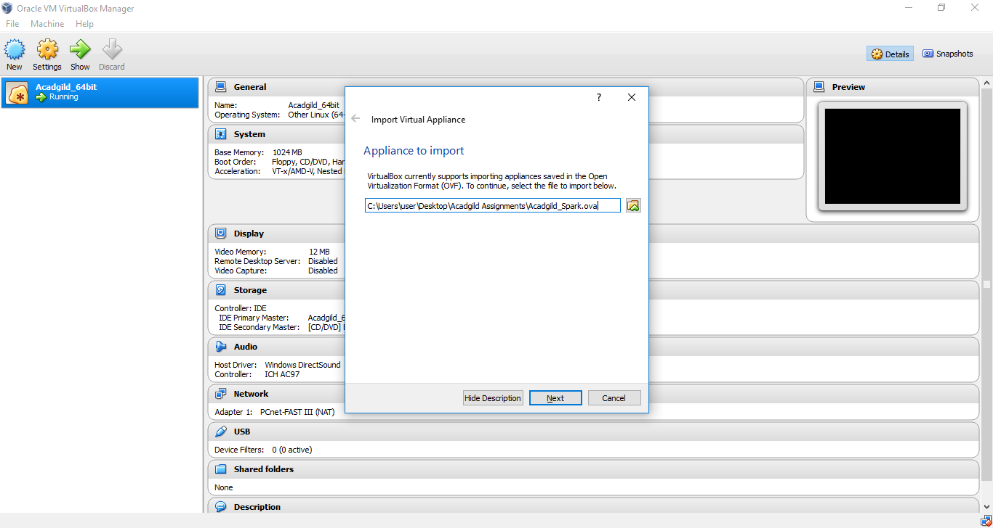

1. Click on Next, once the path has been selected in Import Appliance. Below Appliance Settings box appears and click on Import

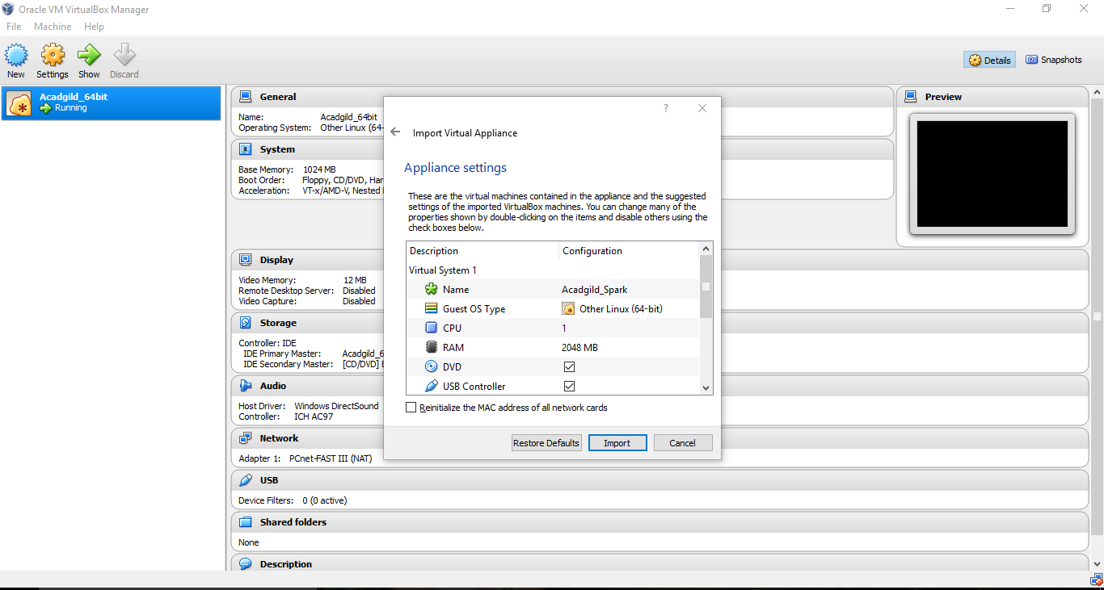

1. The VM will be imported. Below is the screenshot

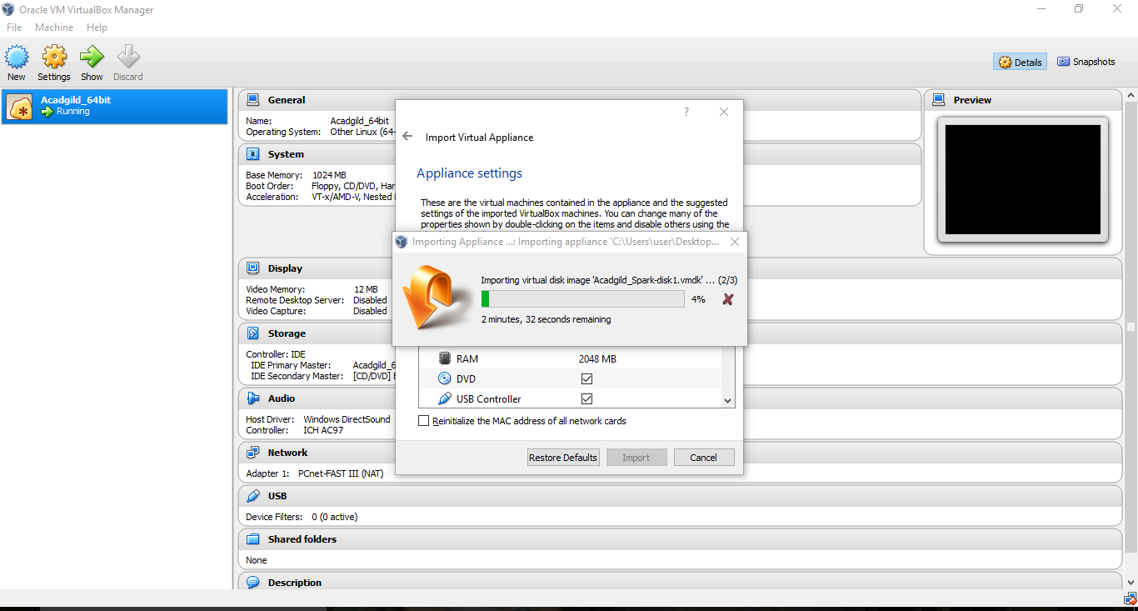

1. Once the VM is imported, start the VM from the side menu and enter the credentials. VM opens up and the below is the screenshot of loaded VM

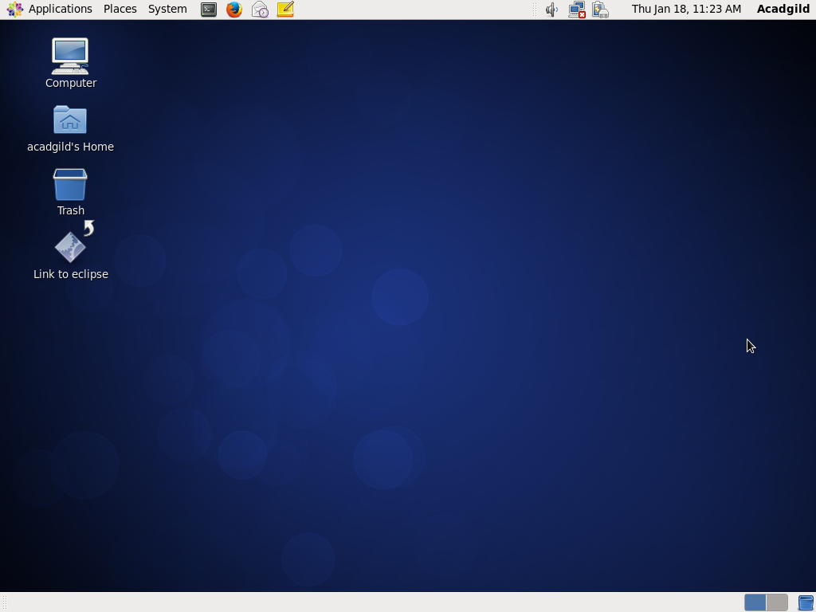

1. Jps command – To see the active daemons

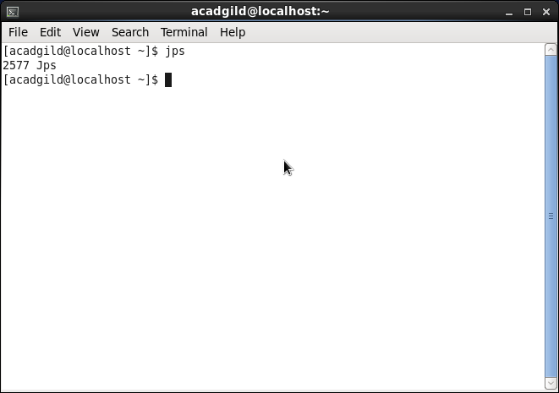

1. Change directory to - /usr/local/hadoop-2.6.0/sbin.

Using command, ./hadoop-daemon.sh start namenode

Using command, ./hadoop-daemon.sh start datanode

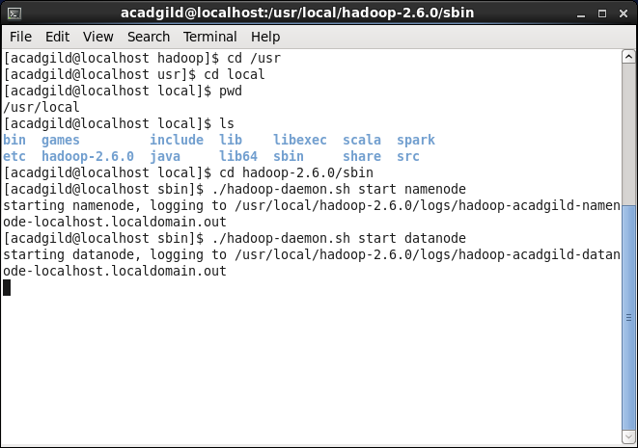

1. Start YARN – ResourceManager and NodeManager

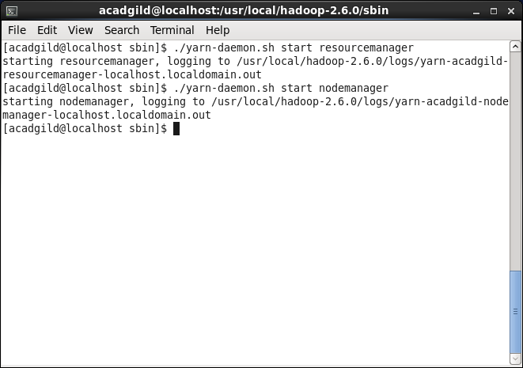

1. JPS command to check if the YARN and hadoop nodes have started

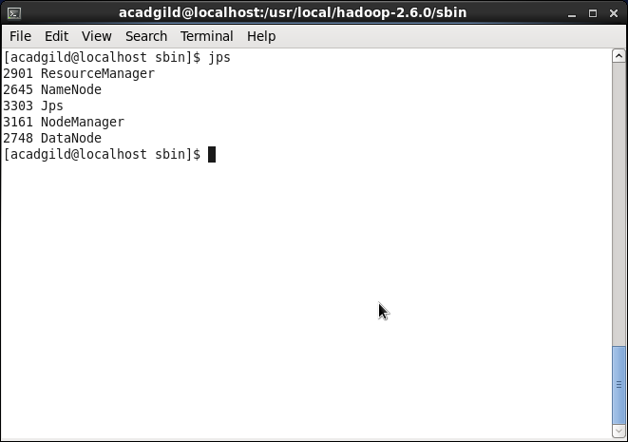

1. Using command, ./stop-all.sh – all the active daemons can be killed or stopped

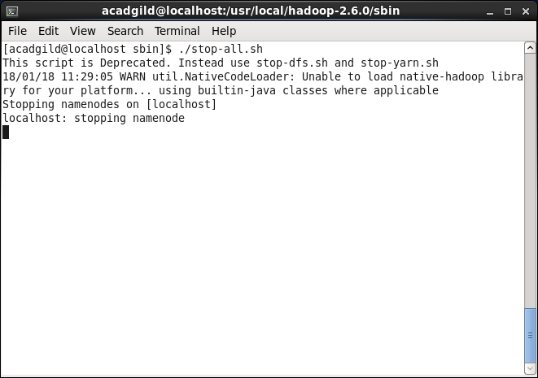

1. Navigate to path - /usr/local/spark

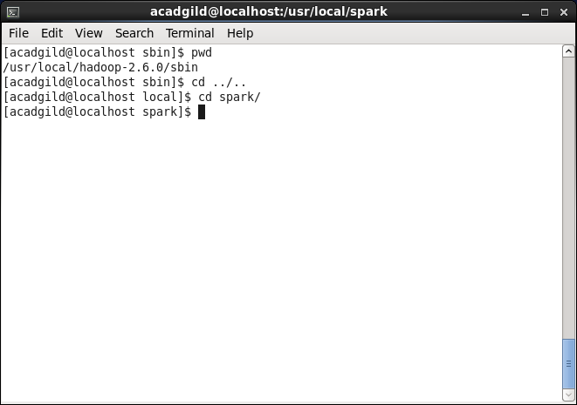

1. Go to path sbin inside Spark directory and start master using command in the screenshot

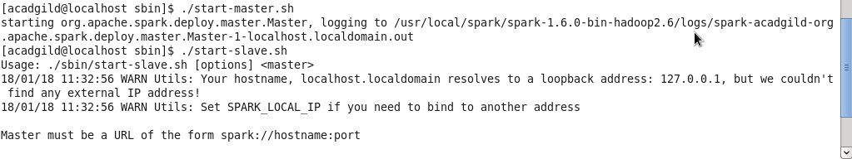

1. Start slaves using the command below and run jps – to see the active daemons running as part of Spark

