**ASSIGNMENT-12.2**

1. find count of all strings with length 4 in the List - List[String] (“alpha”, “gamma”, “omega”, “zeta”, “beta”)

**CODE:**

object Assignment_12_2_1 extends App {

val maths:List[String] = List("alpha", "gamma", "omega", "zeta", "beta")

println("Count of Strings with Length 4: " +maths.filter(_.length==4).size)

}

**RESULT:**

Count of Strings with Length 4: 2

**SCREENSHOT:**

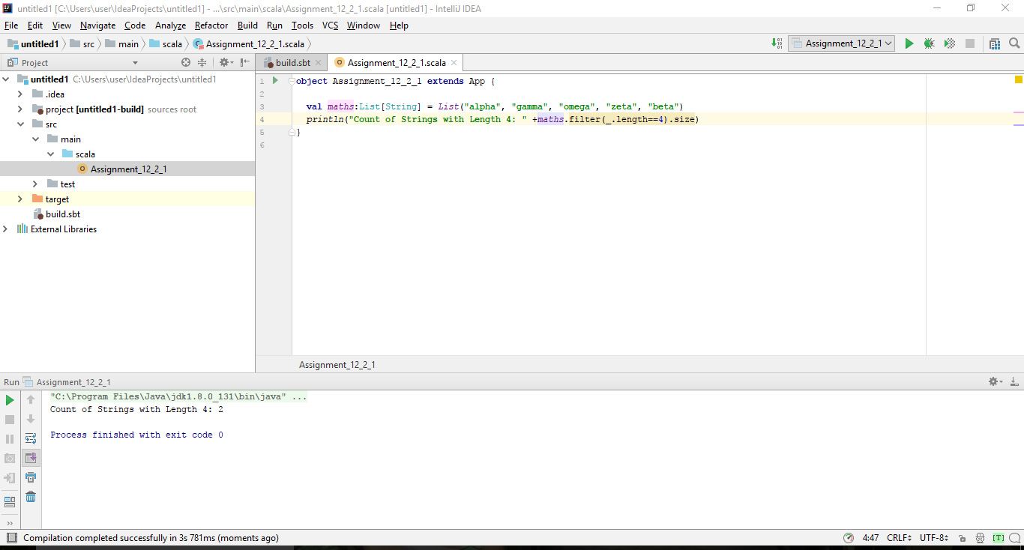

1. convert the list of string to a list of integers, where each string is mapped to its corresponding length - List[String] (“alpha”, “gamma”, “omega”, “zeta”, “beta”)

**CODE:**

object Assignment_12_2_2 extends App {

val maths:List[String] = List("alpha", "gamma", "omega", "zeta", "beta")

println("String corresponding to its length: " +maths.map(lines=>(lines,lines.length)))

}

**RESULT:**

String corresponding to its length: List((alpha,5), (gamma,5), (omega,5), (zeta,4), (beta,4))

**SCREENSHOT:**

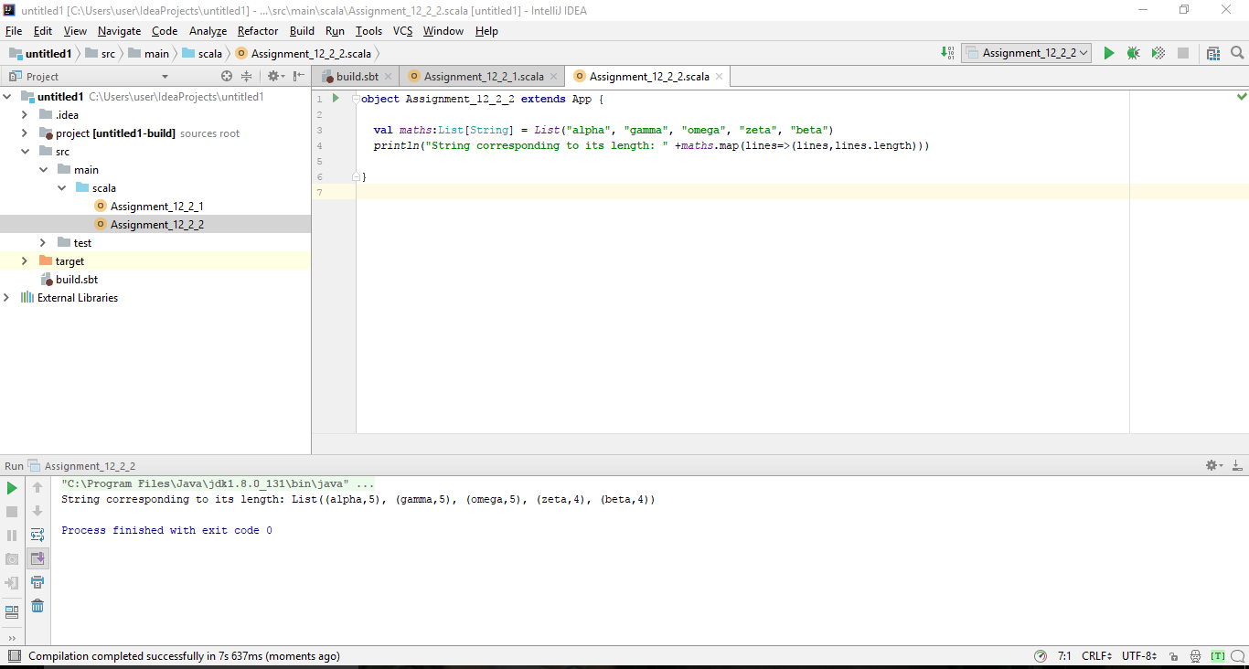

1. find count of all strings which contain alphabet ‘m’

**CODE:**

object Assignment_12_2_3 extends App{

val maths:List[String] = List("alpha", "gamma", "omega", "zeta", "beta")

val newStrings = maths.filter(_.contains("m"))

println("Count of strings which contain m: " +newStrings.length)

}

**RESULT:**

Count of Strings which contain m: 2

**SCREENSHOT:**

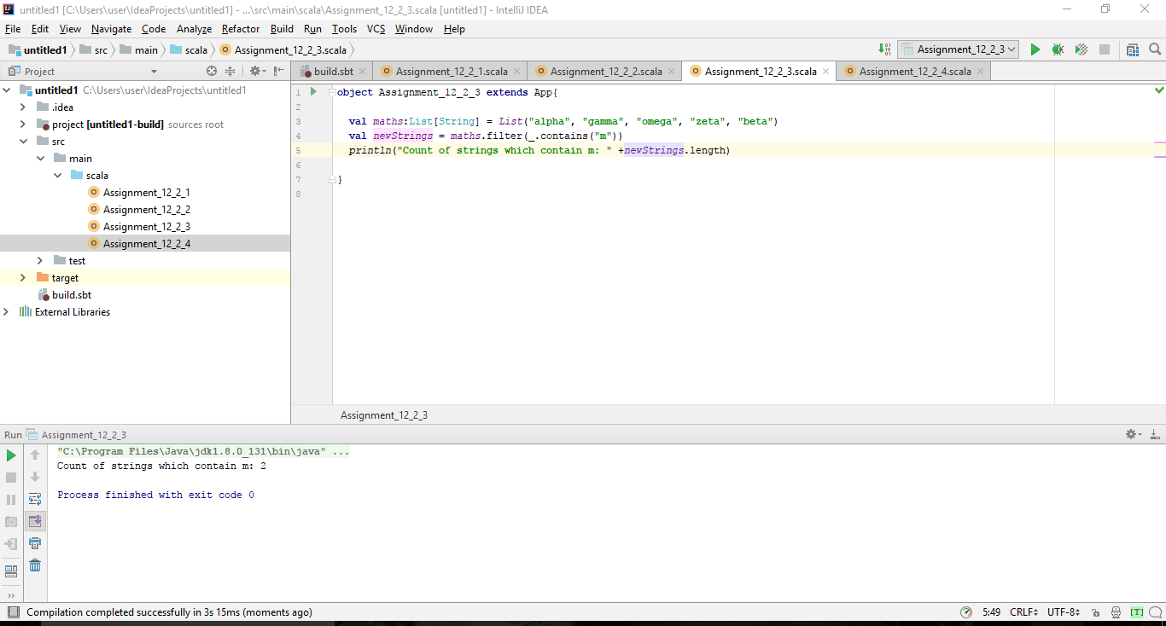

1. find the count of all strings which start with the alphabet ‘a’

**CODE:**

object Assignment_12_2_4 extends App {

val maths:List[String] = List("alpha", "gamma", "omega", "zeta", "beta")

val newStrings = maths.filter(_.startsWith("a"))

println("Count of strings starting with a: " +newStrings.length)

}

**RESULT:**

Count of strings starting with a : 1

**SCREENSHOT:**

