**ASSIGNMENT-12.3**

1. Example - ((1, ‘alpha’), (2, ‘beta’), (3, ‘gamma’), (4, ‘zeta’), (5, ‘omega’))

- for the above list, print the numbers where the corresponding string length is 4

**CODE:**

object Assignment_12_3_1 extends App{

var maths =Map((1, "alpha"), (2, "beta"), (3, "gamma"), (4, "zeta"), (5, "omega"))

println(maths.collect{case(number,string) if string.length==4=>number})

}

**RESULT:**

List(2,4)

**SCREENSHOT:**

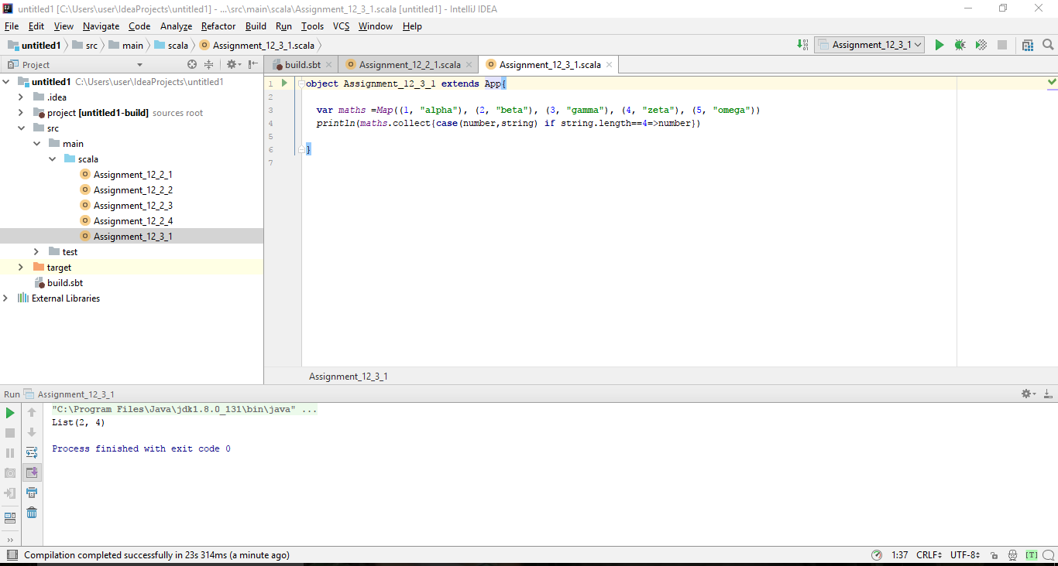

1. Example - ((1, ‘alpha’), (2, ‘beta’), (3, ‘gamma’), (4, ‘zeta’), (5, ‘omega’))

- find the average of all numbers, where the corresponding string contains alphabet ‘m’

or alphabet ‘z’

**CODE:**

object Assignment_12_3_2 extends App {

var maths =Map((1, "alpha"), (2, "beta"), (3, "gamma"), (4, "zeta"), (5, "omega"))

var total = maths.collect{case(number,string) if string.contains("m")||string.contains("z")=>number}

var total2 = total.sum

var total3 = total.size

println(total2/total3)

}

**RESULT:**

4

**SCREENSHOT:**

