**ASSIGNMENT-13.1**

1. Finding the GCD of 2 numbers in Scala:

*GCD of two numbers is the largest number that divides both of them.*

**PROGRAM:**

object Assignment_13_1_GCD {

def gcd(a:Int,b:Int): Int={

if(b==0) a else gcd(b,a%b)

}

def main(args:Array[String]): Unit ={

println("The GCD of two numbers 25 and 15 are: " +gcd(25,15))

}

}

**EXPLANATION:**

* Function is defined in scala using **def** keyword.
* First Method **gcd** takes two arguments as parameters of Integer type, that returns an Integer.
* In the method **gcd**, the logic to calculate the GCD of two numbers passed via **main** method is written.

**LOGIC:** if(b==0) a else gcd(b,a%b)

* Second method is **main**, which takes Array of string as arguments.
* Two numbers for which GCD to be calculated is passed via main method and the method **gcd** is invoked with these two integers as parameters.
* The two parameters here are : 25 and 15

**PROGRAM SCREENSHOT:**

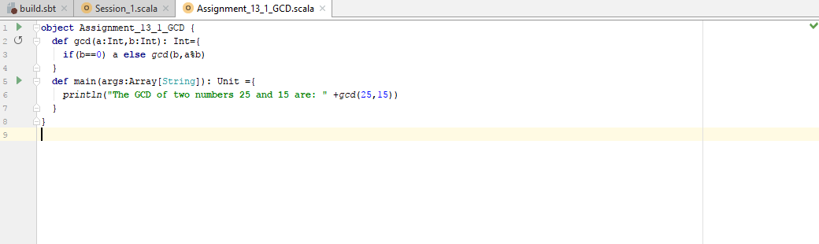

**RESULT:**

