**ASSIGNMENT-13.2**

1. Fibonacci Series - find nth digit using for loop

*A series of numbers in which each number ( Fibonacci number ) is the sum of the two preceding numbers. The simplest is the series 1, 1, 2, 3, 5, 8, etc.*

**PROGRAM:**

import scala.collection.mutable.ListBuffer

object fibonacci_nth_forloop {

def fib(a:Int){

var first = 0

var last = 0

var temp = 0

var A = new ListBuffer[Int]()

for (x <- 1 to a) {

if (x == 1) {

last=1

A += 1

}

else {

temp = first + last

A += temp

first = last

last = temp

}

}

println("Fibonacci series for " + a + "th term is " + A.toList.mkString(""))

}

def main(args:Array[String]): Unit ={

var second_term = fib(2)

var seventh_term = fib(7)

}

}

**EXPLANATION:**

* Function is defined in scala using **def** keyword.
* First Method **fib** takes one argument as parameter of Integer type, that returns a sequence of Integer.
* In the method **fib**, the logic to generate the Fibonacci series of numbers passed via **main** method is written. Using for loop to populate list with fibonnaci series numbers till the entered nth number.

**LOGIC:** for (x <- 1 to a) {

if (x == 1) {

last=1

A += 1

}

else {

temp = first + last

A += temp

first = last

last = temp

}

* Second method is **main**, which takes Array of string as arguments.
* Form **main** method, the nth digit is passed to the method **fib** and it prints the sequence till nth digit.
* The two digits passed as nth value is: 2 and 7

**PROGRAM SCREENSHOT:**

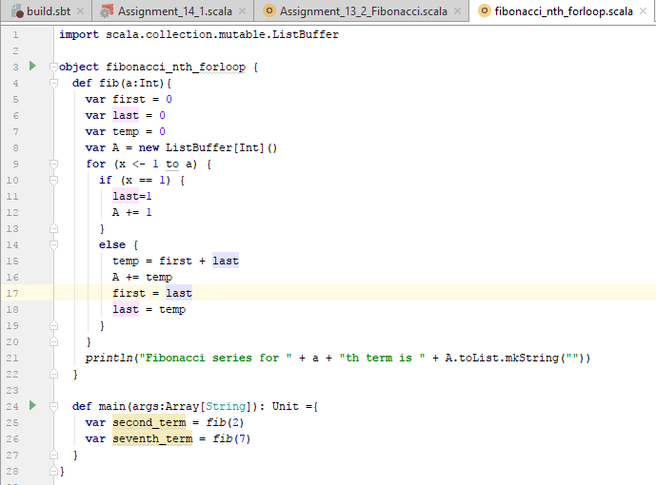

**RESULT SCREENSHOT:**

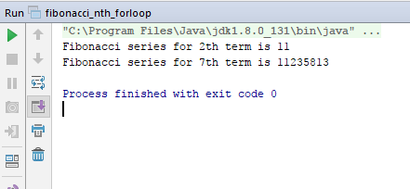

1. Fibonacci series using recursion to find nth term.

**PROGRAM:**

import fibonacci_nth_forloop.fib

import scala.collection.mutable.ListBuffer

class fib(a:Int){

var temp =0

var A = new ListBuffer[Int]()

A += 0

A += 1

fibonacci(A.head)

def fibonacci(last:Int): Unit = {

if (a >= (A.length)) {

temp = A.last

A += (A.last + last)

fibonacci(temp)

}

}

println("Fibonacci series till " + a + "th term is : " + A.drop(1).mkString(""))

}

object fibonacci_nth_recursion extends App{

var second_term = fib(2)

var seventh_term = fib(7)

}

**EXPLANATION:**

* Function is defined in scala using **def** keyword.
* First class **fib** takes one argument as parameter of Integer type, that returns a sequence of Integer.
* The class **fib** contains method Fibonacci which accepts one integer value.In the method **fibonacci**, the logic to generate the Fibonacci series of numbers passed via **main** method is written. Using Recursion method to populate fibonnaci series terms into list.

**LOGIC:** if (a >= (A.length)) {

temp = A.last

A += (A.last + last)

fibonacci(temp)}

* Second method is **main**, which takes Array of string as arguments.
* Form **main** method, the nth digit is passed to the method **fib** and it prints the sequence till nth digit.
* The two digits passed as nth value is: 2 and 7

**PROGRAM SCREENSHOT:**

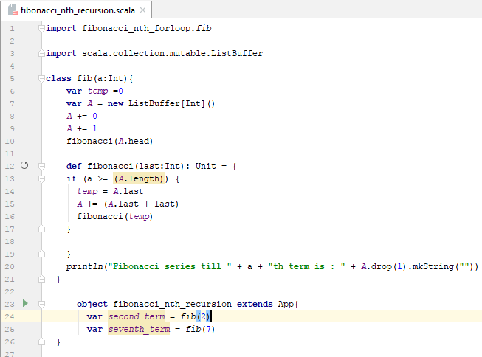

**RESULT SCREENSHOT:**

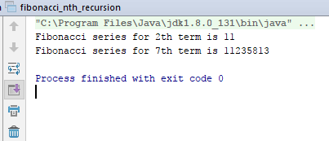

*Below are the scala files used for execution.*

**