**ASSIGNMENT-15.2**

1. Write a partial function to add three numbers in which one number is constant and two

numbers can be passed as inputs and define another method which can take the partial

function as input and squares the result.

**PROGRAM:**

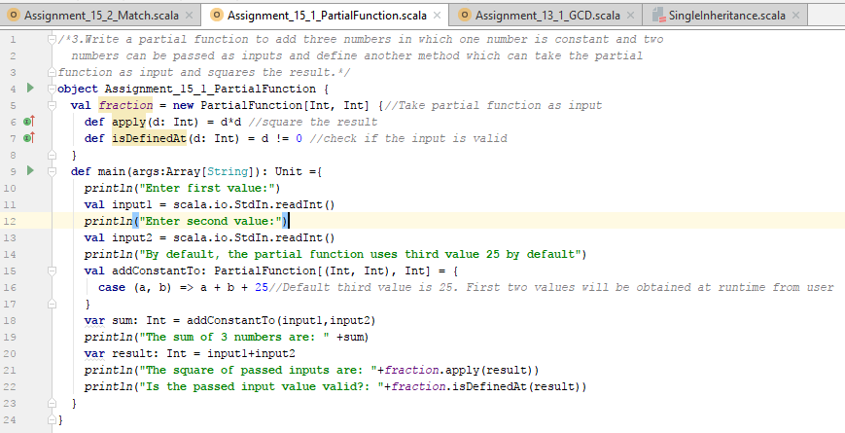

**RESULT:**

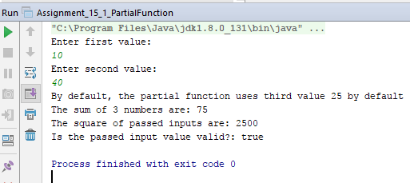

A PartialFunction must provides a method isDefinedAt, which allows the caller of the partial function to know, beforehand, whether the function can return a result for a given input value.

1. Write a program to print the prices of 4 courses of Acadgild: Android-12999,Big Data

Development-17999,Big Data Development-17999,Spark-19999 using match and add a

default condition if the user enters any other course.

**PROGRAM:**

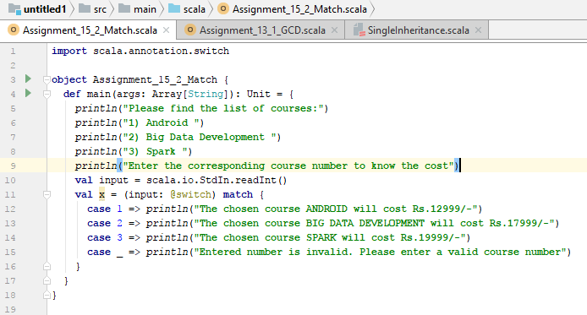

In the above program, the courses available are displayed to the user and once the user enters the corresponding input, the particular course name along with the cost will be displayed. Incorrect scenario has also been handled.

**RESULT:**

* Number 1 has been selected which is a valid scenario, hence the course cost is displayed.

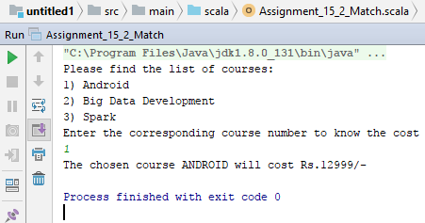

* Number 2 has been selected which is a valid scenario, hence the course cost is displayed.

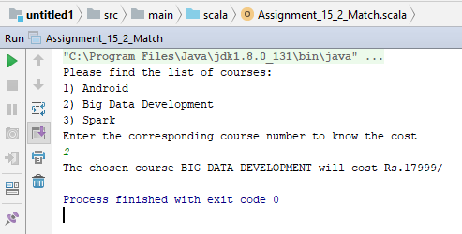

* Number 3 has been selected which is a valid scenario, hence the course cost is displayed.

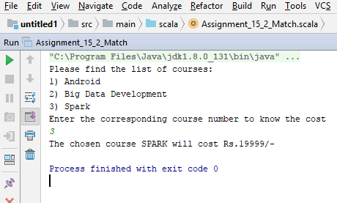

* Below is an example of an invalid value provided as input by the user.

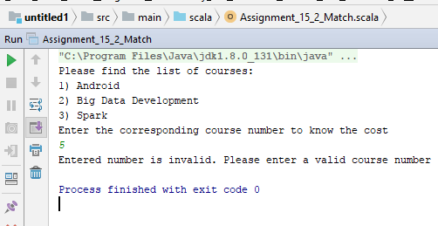

*Below are the files attached for reference:*

**

**